ANSWER-1

Create Database student;

use student;

Create table tblparent(

parent_id int ,

parent_name varchar(20) ,

city varchar(20),

age int ,

annual_income int ,

occupation varchar(20) ,

email_id varchar(20)

);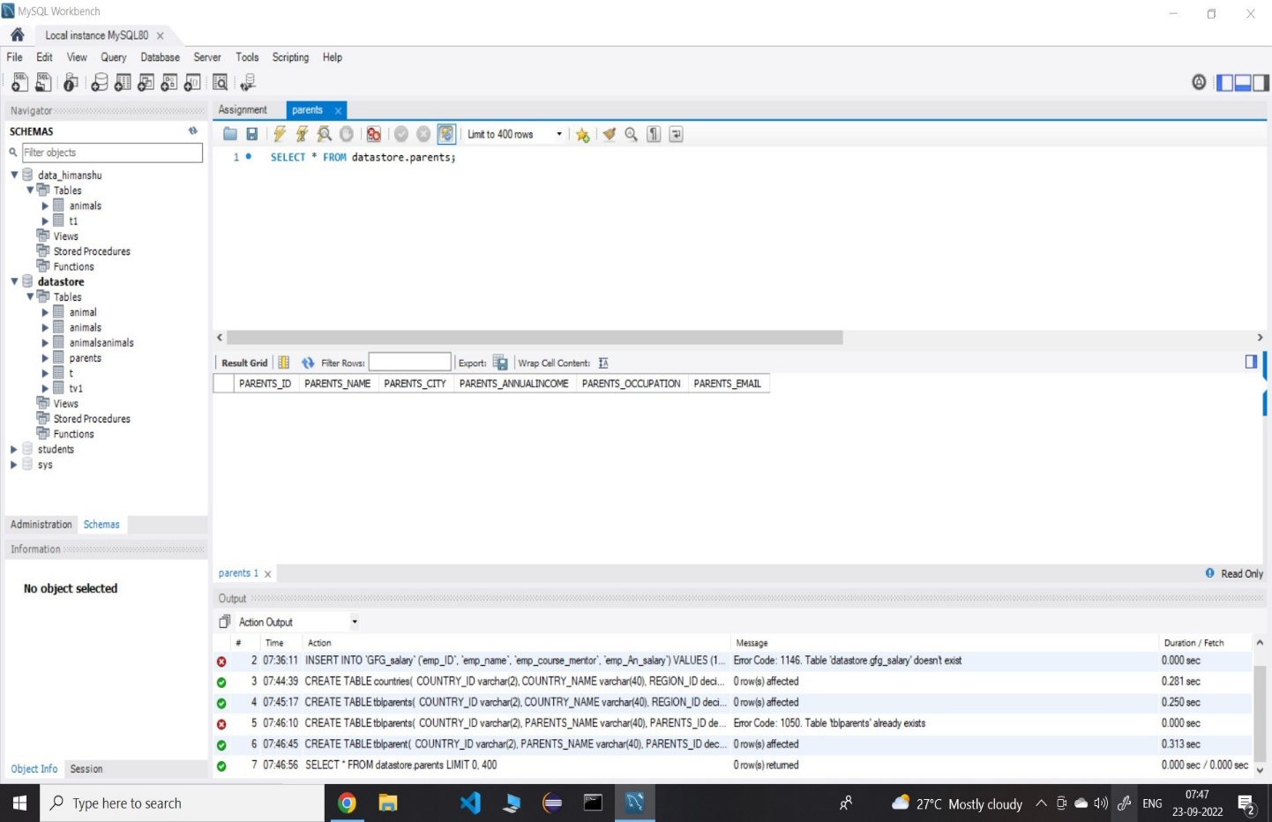

SELECT * FROM student.tblparent;

insert into student.tblparents values

(001,'Ravi','Lucknow',40,200000,'Tester','abc@'),

(002,'Rocky','Delhi',45,250000,'Tester','abc@gmail.com'),

(003,'Yash','NewDelhi',23,300000,'Tester','abc@gmail.com'),

(004,'Rohan','Mumbai',25,350000,'Tester','abc@gmail.com'),

(005,'Seema','Newyork',30,400000,'Tester','abc@gmail.com'),

(006,'Ragav','London',40,450000,'Tester','abc@gmail.com'),

(007,'Sumit','Lucknow',50,150000,'Tester','abc@gmail.com'),

(008,'Prakesh','Delhi',45,200000,'Tester','abc@gmail.com'),

(009,'Titu','Mumbai',56,250000,'Tester','abc@gmail.com'),

(010,'Pradeep','Lucknow',70,10000,'Tester','abc@gmail.com'),

(011,'ALOK','Lucknow',50,55000,'Tester','abc@gmail.com'),

(012,'Deepak','Newyork',51,50000,'Tester','abc@gmail.com'),

(013,'Karn','Lucknow',53,600000,'Tester','abc@gmail.com'),

(014,'Ravi','Banglore',40,650000,'Tester','abc@gmail.com'),

(015,'Vivek','London',54,700000,'Tester','abc@gmail.com'),

(016,'Vikash','Lucknow',52,76000,'Tester','abc@gmail.com'),

(017,'Ravi','Lucknow',40,250000,'Tester','abc@gmail.com'),

(018,'Ravi','Lucknow',21,900000,'Tester','abc@gmail.com'),

(019,'Ram','Lucknow',40,800000,'Tester','abc@gmail.com'),

(020,'Sita','NewDelhi',77,850000,'Tester','abc@gmail.com'),

(021,'Sagar','Ahmedabad',40,950000,'Tester','abc@gmail.com'),

(022,'Bibek','Chennai',60,150000,'Tester','abc@gmail.com'),

(023,'Rohan','Nagpur',65,350000,'Tester','abc@gmail.com'),

(024,'Ravi','Kanpur',55,450000,'Tester','abc@gmail.com'),

(025,'Rmash','Lucknow',45,300000,'Tester','abc@gmail.com'),

(026,'Ravi','Delhi',40,250000,'Tester','abc@gmail.com');

3. SELECT * FROM student.tblparents; select count(parent_id) from tblparents where annual_income>600000

4.SELECT * FROM student.tblparents; select* from tblparents where city in('Ahmedabad','Delhi','Mumbai','Chennai','Banglore');

5. SELECT * FROM student.tblparents; select * from tblparents where annual_income45;

6. create table student (

student_id int primary key,

student_name varchar(20),

maths_marks int not null,

science_marks int not null,

parent_id int not null,

foreign key(parent_id) REFERENCES tblparents(parent_id)

);

insert into student values

(1,"Himanshu", 90,89,101),

(2,"Divansh ",65,72,102),

(3,"Shiva ",69,55,101),

(4,"Shiv",45,52,117),

(5,"Dilip",69,75,119),

(6,"Chand",35,45,104),

(7,"Pakeeza",78,67,115),

(8,"Neha",75,49,113),

(9,"Vedhika",52,74,111),

(10,"Mansi",85,75,106);

commit;

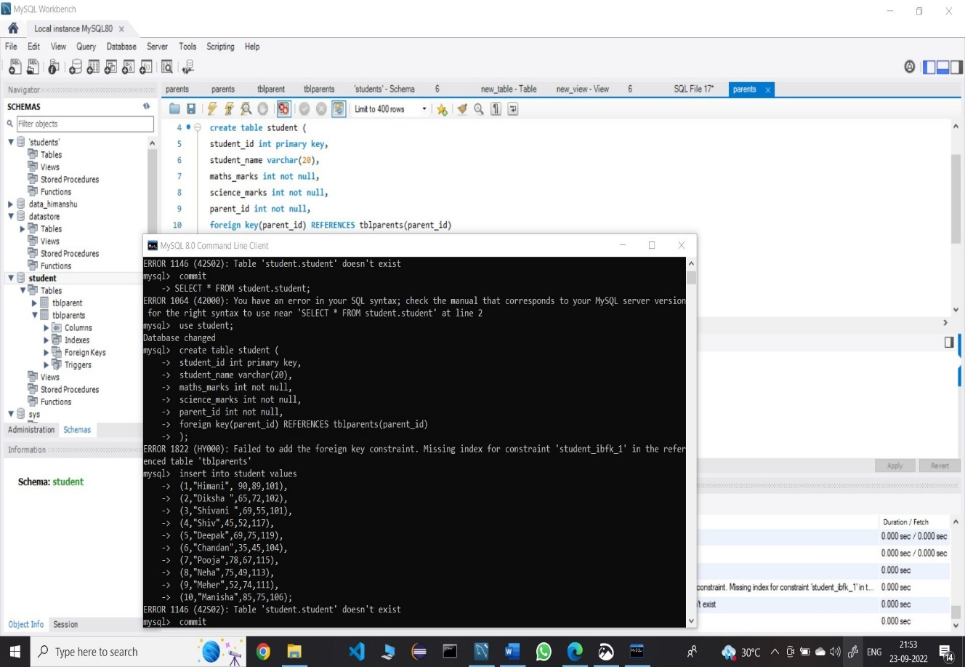

2. SELECT * FROM student. tblparents;

SET SQL_SAFE_UPDATES =0;

update tblparents set email_id= 'NA';

commit;

