ASSIGNMENT- 7

Answer-1

MAVEN HYBERNATE DEPENCIES

<project xmlns="http://maven.apache.org/POM/4.0.0" xmlns:xsi="http://www.w3.org/2001/XMLSchema-instance"

xsi:schemaLocation="http://maven.apache.org/POM/4.0.0 http://maven.apache.org/xsd/maven-4.0.0.xsd">

<modelVersion>4.0.0</modelVersion>

<groupId>com.example</groupId>

<artifactId>hybernate</artifactId>

<version>0.0.1-SNAPSHOT</version>

<packaging>jar</packaging>

<name>hybernate</name>

<url>http://maven.apache.org</url>

<properties>

<project.build.sourceEncoding>UTF-8</project.build.sourceEncoding>

</properties>

<dependencies>

<dependency>

<groupId>junit</groupId>

<artifactId>junit</artifactId>

<version>3.8.1</version>

<scope>test</scope>

</dependency>

</dependencies>

</project>

Session

//update query

/* Alien al = (Alien)session.get(Alien.class, 2005);

al.setName("Rishi");

System.out.println("Updated Successfully");

session.getTransaction().commit();

sf.close();*/

//delete query

Alien alt = (Alien)session.load(Alien.class,2005);

session.delete(alt);

System.out.println("Deleted Successfully");

session.getTransaction().commit();

sf.close();

Apps File of package

package com.example.hibernate;

import junit.framework.Test;

import junit.framework.TestCase;

import junit.framework.TestSuite;

/**

* Unit test for simple App.

*/

public class AppTest

extends TestCase

{

/**

* Create the test case

*

* @param testName name of the test case

*/

public AppTest( String testName )

{

super( testName );

}

/**

* @return the suite of tests being tested

*/

public static Test suite()

{

return new TestSuite( AppTest.class );

}

/**

* Rigourous Test :-*

public void testApp()

{

assertTrue( true );

}

}

EXAMPLE OF AGENT HYBERNATE

<?xml version="1.1" encoding="UTF-8"?>

<!DOCTYPE hibernate-configuration PUBLIC

"-//Hibernate/Hibernate Configuration DTD 3.0//EN"

"https://hibernate.org/dtd/hibernate-configuration-3.0.dtd">

<hibernate-configuration>

<session-factory>

<property name="hibernate.connection.driver_class">com.mysql.jdbc.Driver</property>

<property name="hibernate.connection.password">2202</property>

<property name="hibernate.connection.url">jdbc:mysql://localhost/3306</property>

<property name="hibernate.connection.username">root</property>

<property name="hibernate.dialect">org.hibernate.dialect.MySQLDialect</property>

<property name="hibernate.current_session_context_class">thread</property>

<property name="hibernate.show_sql">true</property>

<mapping class="com.journaldev.hibernate.model.Employee"/>

<mapping class="com.journaldev.hibernate.model.Address"/>

</session-factory>

</hibernate-configuration>package com.example.hibernateexmple;

import java.util.List;

import org.hibernate.Query;

import org.hibernate.Session;

import org.hibernate.SessionFactory;

import org.hibernate.Transaction;

import org.hibernate.cfg.Configuration;

/**

* Hello world!

*

*/

//

public class App

{

public static void main( String[] args )

{

Configuration con=new Configuration().configure().addAnnotatedClass(agent.class);

SessionFactory sf=con.buildSessionFactory();

Session session=sf.openSession();

Transaction tr=session.beginTransaction();

agent a1=new agent();

agent b1=new agent();

agent c1=new agent();

a1.setId(4);

a1.setName("Himanshu");

a1.setCity("lucknow");

a1.setcomm_amt(14);

session.save(a1);

b1.setId(5);

b1.setName("Aman");

b1.setCity("Kasairoad");

b1.setcomm_amt(64);

session.save(b1);

c1.setId(6);

c1.setName("Asish");

c1.setCity("Kunda");

c1.setcomm_amt(44);

session.save(c1);

tr.commit();

System.out.println("id: "+a1.getId()+" name: "+a1.getName()+" city "+a1.getCity()+" commision amount: "+a1.getcomm_amt());

System.out.println("id: "+b1.getId()+" name: "+b1.getName()+" city "+b1.getCity()+" commision amount: "+b1.getcomm_amt());

System.out.println("id: "+c1.getId()+" name: "+c1.getName()+" city "+c1.getCity()+" commision amount: "+c1.getcomm_amt());

session.close();

System.out.println( " Record inserted " );

}

}

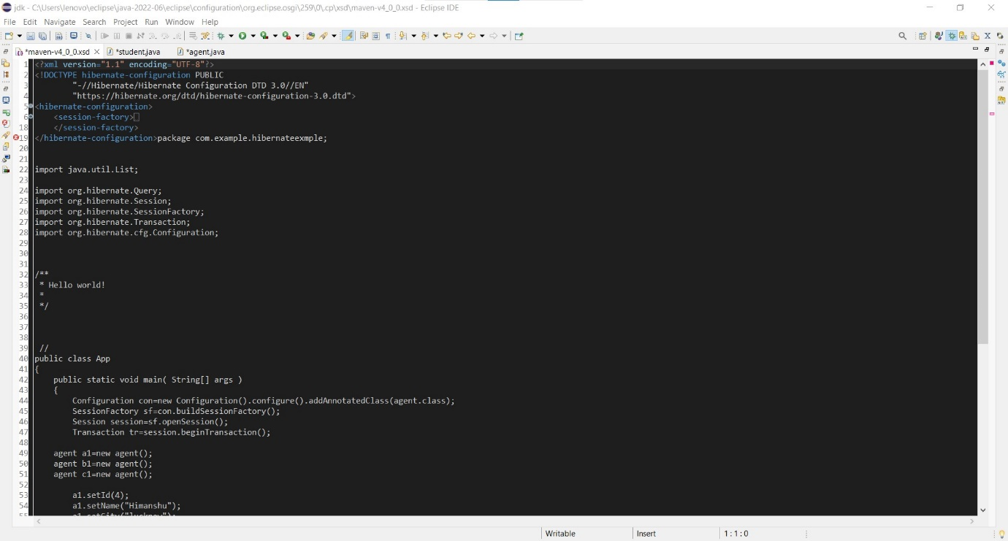

ANSWER-2

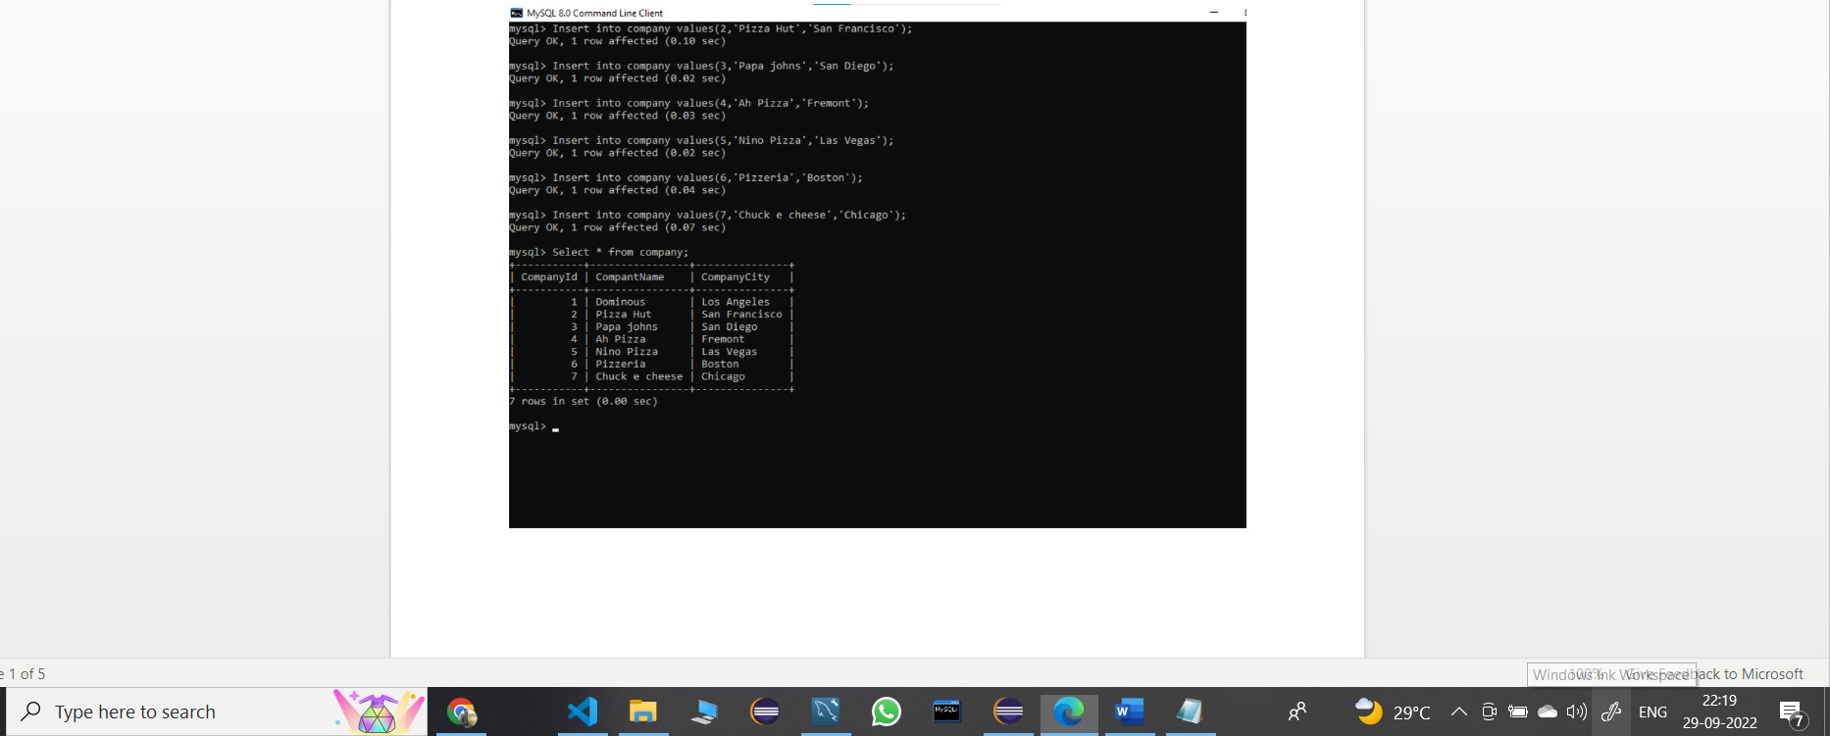

Connnection Establish mysql

<?xml version="1.0" encoding="UTF-8"?>

<!DOCTYPE hibernate-configuration PUBLIC"-//Hibernate/Hibernate Configuration DTD 3.0//EN"

"http://www.hibernate.org/dtd/hibernate-configuration-3.0.dtd">

<hibernate-configuration>

<session-factory>

<property name="hibernate.connection.driver_class">com.mysql.jdbc.Driver</property>

<property name="hibernate.connection.password">2202</property>

<property name="hibernate.connection.url">jdbc:mysql://localhost:3306/agent</property>

<property name="hibernate.connection.username">root</property>

<property name="hbm2ddl.auto">create</property>

<property name="hibernate.dialect">org.hibernate.dialect.MySQLDialect</property>

<mapping class="com.example.hibernateexmple.agent"/>

</session-factory>

</hibernate-configuration>