
Mini project report on

IoT Device Configuration & Compatibility Database
Submitted in partial fulfilment of the requirements for the award of degree of

Bachelor of Technology
in
Computer Science & Engineering
UE24CS351A – DBMS Project
Submitted by:
Hitha Shree Suresh  Hemant Ram Nelapati | PES2UG24CS196  PES2UG24CS192
under the guidance of
Dr. Shilpa S
Dr. Shilpa S
Assistant Professor
PES University

AUG - DEC 2026
DEPARTMENT OF COMPUTER SCIENCE AND ENGINEERING
FACULTY OF ENGINEERING
PES UNIVERSITY
(Established under Karnataka Act No. 16 of 2013)
Electronic City, Hosur Road, Bengaluru – 560 100, Karnataka, India

PES UNIVERSITY

(Established under Karnataka Act No. 16 of 2013)
Electronic City, Hosur Road, Bengaluru – 560 100, Karnataka, India

CERTIFICATE

This is to certify that the mini project entitled

IoT Device Configuration & Compatibility Database

is a bonafide work carried out by

Hitha Shree Suresh  Hemant Ram Nelapati | PES2UG24CS196  PES2UG24CS192

In partial fulfilment for the completion of fifth semester DBMS Project (UE24CS351A) in the Program of Study - Bachelor of Technology in Computer Science and Engineering under rules and regulations of PES University, Bengaluru during the period AUG. 2026 – DEC. 2026. It is certified that all corrections / suggestions indicated for internal assessment have been incorporated in the report. The project has been approved as it satisfies the 5th semester academic requirements in respect of project work.

Signature
Dr. Shilpa S
Assistant Professor
DECLARATION

We hereby declare that the DBMS Project entitled IoT Device Configuration & Compatibility Database has been carried out by us under the guidance of Dr. Shilpa S, Assistant Professor and submitted in partial fulfilment of the course requirements for the award of degree of Bachelor of Technology in Computer Science and Engineering of PES University, Bengaluru during the academic semester AUG – DEC 2026.

Hitha Shree Suresh  Hemant Ram Nelapati | PES2UG24CS196  PES2UG24CS192 | <Signature>  <Signature>
ACKNOWLEDGEMENT

We would like to express our sincere gratitude to Dr. Shilpa S, Assistant Professor, Department of Computer Science and Engineering, PES University, for her continuous guidance, technical insights, and encouragement throughout the design and implementation of this UE24CS351A – DBMS Project.
We take this opportunity to thank Dr. Sandesh B J, Professor and Chairperson, Department of Computer Science and Engineering, PES University, for providing the academic environment, computational facilities, and departmental support essential for carrying out this experiential learning project.
We are deeply grateful to Prof. Jawahar Doreswamy, Chancellor – PES University, and Dr. Suryaprasad J, Vice-Chancellor – PES University, for providing us with myriad opportunities for experiential learning and engineering innovation. Finally, this DBMS Mini-Project could not have been completed without the continual support and encouragement we received from our families and peers.
ABSTRACT

The rapid proliferation of the Internet of Things (IoT) hardware ecosystem has created a highly fragmented landscape of microcontroller compute boards (such as ESP32, Arduino Uno Rev3, Raspberry Pi Pico W, and STM32 Nucleo), disparate operating and GPIO logic voltages (1.8V, 3.3V, and 5.0V), heterogeneous hardware communication buses (I2C, SPI, UART, 1-Wire), wireless networking stacks (Wi-Fi 802.11 b/g/n, BLE, MQTT), and runtime software frameworks (Arduino C++, MicroPython, ESP-IDF). Embedded engineers, researchers, and students frequently encounter fatal hardware damage—such as connecting a 5.0V microcontroller GPIO directly to a 3.3V-sensitive environmental sensor like the Bosch BME280 without a bi-directional logic level shifter—as well as hours of debugging caused by scattered datasheets and driver incompatibilities.
To address this challenge, this project presents the IoT Device Configuration & Compatibility Database (iot_config_db), a unified dual-paradigm database system built on PostgreSQL 16.15 integrated with the pgvector (v0.6.0) extension. The relational core comprises 11 normalized base tables in strict Third Normal Form (3NF) governed by 50 catalog constraints—including 11 Primary Keys, 14 Foreign Keys with tailored referential actions (CASCADE, RESTRICT, and SET NULL), 8 Unique constraints, and 17 domain CHECK constraints that enforce physical electrical laws at the database engine layer. To support natural-language troubleshooting and wiring discovery alongside structured SQL filtering, the system stores 384-dimensional dense vector embeddings (aligned with sentence-transformers/all-MiniLM-L6-v2) inside the configuration_notes relation, indexed via a Hierarchical Navigable Small World (HNSW) cosine similarity graph.
Furthermore, the database implements four advanced DBMS features: three multi-table analytical views (v_device_compatibility_overview, v_device_protocol_summary, and v_active_devices_catalog), 15 explicitly engineered indexes (14 B-Tree indexes and 1 HNSW vector index, totaling 34 catalog indexes), automated audit timestamp management via PL/pgSQL stored functions and BEFORE UPDATE triggers (trg_config_notes_updated_at), and sub-millisecond vector semantic retrieval using PostgreSQL's cosine distance operator (<=>). The database is integrated with a modern Next.js web portal featuring role-based access control, interactive compatibility matrices, and AI-assisted semantic search.
Keywords: Relational Database Management System (RDBMS), PostgreSQL 16, pgvector, Third Normal Form (3NF), HNSW Vector Index, Cosine Similarity Search, IoT Hardware Compatibility, PL/pgSQL Triggers, Next.js.

TABLE OF CONTENTS
Chapter No. | Title | Page No.
 | INTRODUCTION | 9
 | PROBLEM DEFINITION | 11
 | ER MODEL | 14
 | ER TO RELATIONAL MAPPING | 17
 | DDL STATEMENTS | 23
 | DML STATEMENTS | 31
 | QUERIES (SIMPLE QUERY AND UPDATE AND DELETE OPERATION, CORRELATED QUERY AND NESTED QUERY) | 37
 | STORED PROCEDURE, FUNCTIONS AND TRIGGERS | 44
 | FRONT END DEVELOPMENT | 47
REFERENCES / BIBLIOGRAPHY |  | 50
APPENDIX A: DEFINITIONS, ACRONYMS AND ABBREVIATIONS |  | 51
LIST OF TABLES
Table No. | Title | Page No.
1.1 | Summary of Implemented Database Architecture Metrics | 9
2.1 | Functional and Non-Functional Requirements Specification | 12
2.2 | Team 9 Division of Work and Individual Contributions | 13
3.1 | Conceptual Entities, Attributes, and Identifier Keys | 14
3.2 | Entity Relationships, Cardinalities, and Participation Constraints | 15
4.1 | Summary of Mapped Relational Tables, Primary Keys, and Foreign Keys | 19
4.2 | Foreign Key Referential Integrity Deletion & Update Rules | 19
4.3 | Catalog of 50 Enforced Database Integrity Constraints | 21
6.1 | Database Population Census Across All 11 Normalized Tables (81 Rows) | 34
9.1 | Application Role-Based Access Control (RBAC) Matrix | 48
A.1 | Definitions, Acronyms, and Technical Abbreviations | 51
LIST OF FIGURES
Figure No. | Title | Page No.
3.1 | Conceptual Entity-Relationship (ER) Diagram | 16
4.1 | Complete Physical Relational Schema Diagram | 22
5.1 | PostgreSQL 16.15 Connection and pgvector v0.6.0 Extension Setup | 28
5.2 | Execution of Canonical DDL Script (schema.sql) in PostgreSQL | 28
5.3 | Schema Introspection Showing 11 Base Tables and 3 Analytical Views | 29
5.4 | DDL Schema Evolution Verification (ALTER TABLE on components) | 29
5.5 | Catalog Verification of PK, FK, UNIQUE, and CHECK Constraints | 30
5.6 | Verification of Indexes and Multi-Table Compatibility View | 30
6.1 | Populated Records in manufacturers, device_types, and devices Tables | 35
6.2 | Populated Records in components, communication_protocols, and firmware | 35
6.3 | Populated Records in libraries, device_components, compatibility, and notes | 36
6.4 | Complete Database Row Count Audit Across All 11 Tables (81 Records) | 36
7.1 | Execution of GROUP BY and HAVING Protocol Aggregation Query | 37
7.2 | Execution of Compatibility Status Breakdown Aggregate Query | 38
7.3 | Execution of UPDATE Statement on configuration_notes | 39
7.4 | Execution of Transaction-Safe ACID DELETE Statement | 40
7.5 | Execution of Correlated Subqueries Using AVG() and EXISTS | 41
7.6 | Execution of Multi-Level Nested IN Subquery | 42
7.7 | Execution of pgvector Cosine Similarity (<=>) Semantic Search Query | 43
8.1 | Creation and Execution of PL/pgSQL Stored Functions | 45
8.2 | Trigger Inspection and Automated Timestamp Update Verification | 46
9.1 | Next.js IoT Portal — Compatibility Matrix & pgvector Semantic Search | 49
9.2 | Next.js IoT Portal — Hardware CRUD, Trigger Audit, and SQL Analytics | 49

1. INTRODUCTION
1.1 Domain Overview and Background
The Internet of Things (IoT) has transformed modern embedded systems engineering, industrial automation, smart agriculture, healthcare telemetry, and consumer electronics. Modern IoT deployments rely on tight integration between low-power compute boards (microcontrollers and single-board computers), environmental sensors, electromechanical actuators, hardware communication buses, wireless networking protocols, firmware runtimes, and third-party software driver libraries.
Despite rapid hardware innovation from vendors such as Espressif Systems, Arduino AG, the Raspberry Pi Foundation, STMicroelectronics, Bosch Sensortec, and Adafruit Industries, the physical and software specifications governing how these components interconnect remain fragmented across thousands of unstructured PDF datasheets, GitHub repositories, and community forum threads. Consequently, system integrators and students routinely face fatal electrical mismatches, logic-level incompatibilities, pinout allocation conflicts, and software driver version drift.
1.2 Architectural Paradigm: Hybrid Relational + Vector Database
This mini-project implements the IoT Device Configuration & Compatibility Database (iot_config_db), designed in accordance with Option 2 of the UE24CS351A DBMS Experiential Learning Level 3 guidelines: combining an enterprise-grade Relational Database Management System (PostgreSQL 16.15) with an integrated Vector Database extension (pgvector v0.6.0).
• Structured Relational Engine (PostgreSQL 16.15 in 3NF): Models deterministic engineering facts—including supply voltages, GPIO logic levels, clock frequencies, flash/SRAM memory capacities, bus data rates, pin mappings, firmware releases, and a 4-dimensional compatibility matrix—across 11 normalized tables enforced by 50 integrity constraints.
• Unstructured Semantic Vector Engine (pgvector v0.6.0): Embeds technical setup guides, wiring instructions, calibration routines, and hardware troubleshooting notes as 384-dimensional dense vectors indexed using a Hierarchical Navigable Small World (HNSW) cosine similarity graph, enabling natural-language semantic search directly within SQL.
1.3 System Architecture Summary
Table 1.1: Summary of Implemented Database Architecture Metrics
Architectural Metric | Implemented Value | Technical Specification
Database Engine | PostgreSQL 16.15 | ACID-compliant enterprise relational database system
Vector Extension | pgvector v0.6.0 | Native vector data type and similarity search inside PostgreSQL
Normalized Base Tables | 11 Tables | Decomposed into strict Third Normal Form (3NF / BCNF)
Analytical Views | 3 Views | v_device_compatibility_overview, v_device_protocol_summary, v_active_devices_catalog
Total Populated Records | 81 Rows | Zero orphaned keys across all 11 relational tables
Integrity Constraints | 50 Constraints | 11 PK + 14 FK + 8 UNIQUE + 17 Domain CHECK constraints
Explicit Indexes | 15 Indexes | 14 B-Tree indexes + 1 HNSW vector cosine index (34 total catalog indexes)
Vector Embedding Space | vector(384) | 384-dimensional unit vectors matching all-MiniLM-L6-v2
Procedural Automation | 2 Functions, 1 Trigger | PL/pgSQL functions and BEFORE UPDATE timestamp auditing trigger
Frontend Interface | Next.js Web Portal | Role-based compatibility dashboard and semantic vector search UI

2. PROBLEM DEFINITION
2.1 Problem Statement
In embedded systems and IoT prototyping, hardware failures and development delays stem from four recurring engineering challenges that conventional flat spreadsheets or keyword-only documentation systems fail to prevent:
• 1. Electrical Overstress & Logic-Level Mismatches: Legacy microcontrollers such as the Arduino Uno Rev3 (ATmega328P) and Arduino Nano Every operate at 5.00V GPIO logic levels, whereas modern low-power wireless SoCs (ESP32-WROOM-32, Raspberry Pi Pico W, STM32 Nucleo) and MEMS environmental sensors (such as the Bosch BME280, rated for 1.71V–3.60V) operate strictly at 3.30V. Wiring a 5.0V I2C clock/data line directly to an unbuffered 3.3V sensor causes permanent silicon damage unless a bi-directional logic level shifter is used. Conversely, driving a 5.0V optocoupler relay coil directly from a 3.3V ESP32 GPIO pin fails to actuate the relay under load.
• 2. Multi-Layer Communication Protocol Fragmentation: Compute boards support varying combinations of physical/data-link wireless standards (Wi-Fi 802.11 b/g/n, Bluetooth Low Energy 5.0), hardware peripheral buses (I2C, SPI, UART, 1-Wire), and application-layer telemetry protocols (MQTT, HTTP/REST). Furthermore, some boards provide native on-chip support (e.g., ESP32 and Pico W onboard Wi-Fi), whereas others require external expansion shields (e.g., Arduino Uno Rev3).
• 3. Multi-Dimensional Software & Firmware Dependencies: Hardware compatibility is not merely a binary relationship between a board and a sensor; it depends simultaneously on the target firmware runtime (e.g., Arduino C++ Core v3.0.4, MicroPython v1.22.0, ESP-IDF v5.1.2) and the software driver library (e.g., Adafruit_BME280_Library vs. micropython-bme280).
• 4. Unstructured Troubleshooting Knowledge Silos: Critical setup details—such as whether to tie the BME280 SDO pin to GND for I2C address 0x76, or attaching a 4.7k Ohm pull-up resistor between GPIO4 and 3.3V for DHT22 timing stability—are buried in unstructured text notes. Traditional SQL LIKE '%keyword%' queries fail when an engineer searches by symptom or natural-language intent.
2.2 Project Objectives
• Objective 1: Design a fully normalized (3NF) relational schema of 11 tables that models hardware vendors, compute boards, peripheral sensors/actuators, communication protocols, firmware builds, driver libraries, physical pin mappings, and multi-dimensional compatibility evaluations.
• Objective 2: Enforce domain-specific physical and electrical rules at the database engine level using 50 declarative constraints (PK, FK with CASCADE/RESTRICT/SET NULL, composite UNIQUE, and domain CHECK constraints).
• Objective 3: Integrate the pgvector extension to store 384-dimensional dense vector embeddings of technical configuration guides and accelerate semantic retrieval using an HNSW cosine distance index.
• Objective 4: Implement analytical SQL views, B-Tree performance indexes, PL/pgSQL stored functions, and automated BEFORE UPDATE audit triggers.
• Objective 5: Provide a clean Next.js web interface enabling role-based hardware catalog exploration, compatibility verification, and AI semantic search.
2.3 Justification of SQL + Vector Database Selection
Selecting PostgreSQL 16 with pgvector (Option 2: SQL + Vector Database) provides decisive architectural advantages over standalone NoSQL stores or external vector databases: (1) Zero Data Drift & ACID Consistency—relational metadata and 384-dimensional vector embeddings reside in the same transactional table and commit atomically; (2) Hybrid SQL + Vector Filtering—queries can filter by exact electrical parameters (WHERE operating_voltage = 3.30) while simultaneously ranking troubleshooting notes by cosine similarity (<=>); and (3) Operational Simplicity—eliminating external vector server synchronization.
2.4 Functional & Non-Functional Requirements and Team Roles
Table 2.1: Functional and Non-Functional Requirements Specification
Req. ID | Category | Requirement Description
FR-01 | Hardware Catalog Management | Store and query microcontrollers, SBCs, sensors, actuators, and vendor metadata with voltage and memory specs.
FR-02 | Protocol & Pinout Mapping | Map M:N board-to-protocol capabilities (native vs. shield) and verified physical wiring pin assignments.
FR-03 | Compatibility Matrix Evaluation | Evaluate 4-way compatibility across Device, Component, Library, and Firmware with voltage/logic safety flags.
FR-04 | Vector Semantic Search | Perform nearest-neighbor cosine similarity (<=>) search over 384-d embeddings in configuration_notes.
FR-05 | Automated Audit Trail | Automatically update the updated_at timestamp via a PL/pgSQL trigger whenever a configuration note is modified.
NFR-01 | Data Integrity & 3NF | Enforce 50 database-level constraints preventing invalid voltages, negative memory values, or duplicate matrix rows.
NFR-02 | Query Performance | Accelerate relational joins via 14 B-Tree indexes and vector search via an HNSW index (m=16, ef_construction=64).

Table 2.2: Team 9 Division of Work and Individual Contributions
Team Member | SRN | Primary Technical Responsibilities
Hitha Shree Suresh | PES2UG24CS196 | Conceptual ER modeling & cardinalities; 1NF-to-3NF schema normalization; 50 integrity constraints (CHECK, UNIQUE, PK, FK); 3 analytical views; multi-table JOIN & HAVING queries; data dictionary specification.
Hemant Ram Nelapati | PES2UG24CS192 | PostgreSQL 16 & pgvector v0.6.0 architecture; HNSW cosine index implementation; PL/pgSQL stored functions & audit trigger; DDL schema evolution (ALTER TABLE); ACID DELETE testing; Next.js UI & execution evidence.

3. ER MODEL
3.1 Conceptual Data Model Overview
The Entity-Relationship (ER) model captures the conceptual structure of the IoT Device Configuration & Compatibility domain across 11 entities: 5 core hardware/protocol entities (MANUFACTURERS, DEVICE_TYPES, DEVICES, COMPONENTS, COMMUNICATION_PROTOCOLS), 2 software ecosystem entities (FIRMWARE, LIBRARIES), 1 vector-enabled documentation entity (CONFIGURATION_NOTES), and 3 associative/junction entities (DEVICE_PROTOCOLS, DEVICE_COMPONENTS, COMPATIBILITY) that resolve complex many-to-many and multi-dimensional relationships.
3.2 Entities and Attributes Specification
Table 3.1: Conceptual Entities, Attributes, and Identifier Keys
Entity Name | Entity Type | Primary Key | Key Descriptive Attributes
MANUFACTURERS | Strong Entity | manufacturer_id | name (Unique), website, country, created_at
DEVICE_TYPES | Strong Entity | device_type_id | type_name (Unique), description
DEVICES | Strong Entity | device_id | model_name (Unique), microcontroller, operating_voltage, logic_level_voltage, clock_speed_mhz, flash_memory_kb, sram_kb, gpio_count, analog_pins_count, status
COMPONENTS | Strong Entity | component_id | component_name, category, operating_voltage_min, operating_voltage_max, logic_level_voltage, current_draw_ma, interface_type, datasheet_url
COMMUNICATION_PROTOCOLS | Strong Entity | protocol_id | protocol_name (Unique), protocol_layer, standard, max_data_rate_kbps
DEVICE_PROTOCOLS | Associative (M:N) | (device_id, protocol_id) | is_native_support (Boolean indicator for built-in SoC vs. external shield)
FIRMWARE | Strong / Dependent | firmware_id | device_id (FK), version_tag, runtime_environment, release_date, is_recommended
LIBRARIES | Strong Entity | library_id | library_name, runtime_environment, repository_url, latest_version, license
DEVICE_COMPONENTS | Associative (M:N) | device_component_id | device_id (FK), component_id (FK), default_bus_or_pin, tested_status
COMPATIBILITY | 4-Way Associative | compatibility_id | device_id, component_id, library_id, firmware_id, compatibility_status, voltage_compatible, logic_level_compatible, notes, verified_date
CONFIGURATION_NOTES | Vector Entity | note_id | device_id, component_id, title, content, note_type, embedding vector(384), created_at, updated_at

3.3 Relationships and Cardinality Constraints
Table 3.2: Entity Relationships, Cardinalities, and Participation Constraints
Relationship Verb | Parent / Source Entity | Target / Child Entity | Cardinality | Domain Semantics
produces (Boards) | MANUFACTURERS | DEVICES | 1 : N | One vendor manufactures multiple IoT boards; each board has one manufacturer.
categorizes | DEVICE_TYPES | DEVICES | 1 : N | One category classifies multiple boards; each board belongs to one type.
produces (Sensors) | MANUFACTURERS | COMPONENTS | 1 : N | One vendor manufactures multiple peripheral sensors/actuators.
supports / supported in | DEVICES / PROTOCOLS | DEVICE_PROTOCOLS | M : N (1:N, 1:N) | Resolved via DEVICE_PROTOCOLS junction table with composite PK.
runs | DEVICES | FIRMWARE | 1 : N | One board supports multiple firmware releases across runtimes.
wires to / wired in | DEVICES / COMPONENTS | DEVICE_COMPONENTS | M : N (1:N, 1:N) | Resolved via DEVICE_COMPONENTS storing physical pinout allocations.
evaluated in / tested on | DEVICES, COMPONENTS, LIBRARIES, FIRMWARE | COMPATIBILITY | 4-Way M:N | Multi-dimensional compatibility evaluation across hardware and software.
has notes | DEVICES / COMPONENTS | CONFIGURATION_NOTES | 1 : N (Optional) | Technical setup and troubleshooting notes with 384-d vector embeddings.

3.4 Conceptual Entity-Relationship (ER) Diagram
Figure 3.1 illustrates the complete conceptual Entity-Relationship (ER) Diagram for the IoT Device Configuration & Compatibility Database, showing all 11 entities, primary key identifiers, descriptive attributes, relationship verbs, and 1:N / M:N cardinality notations.
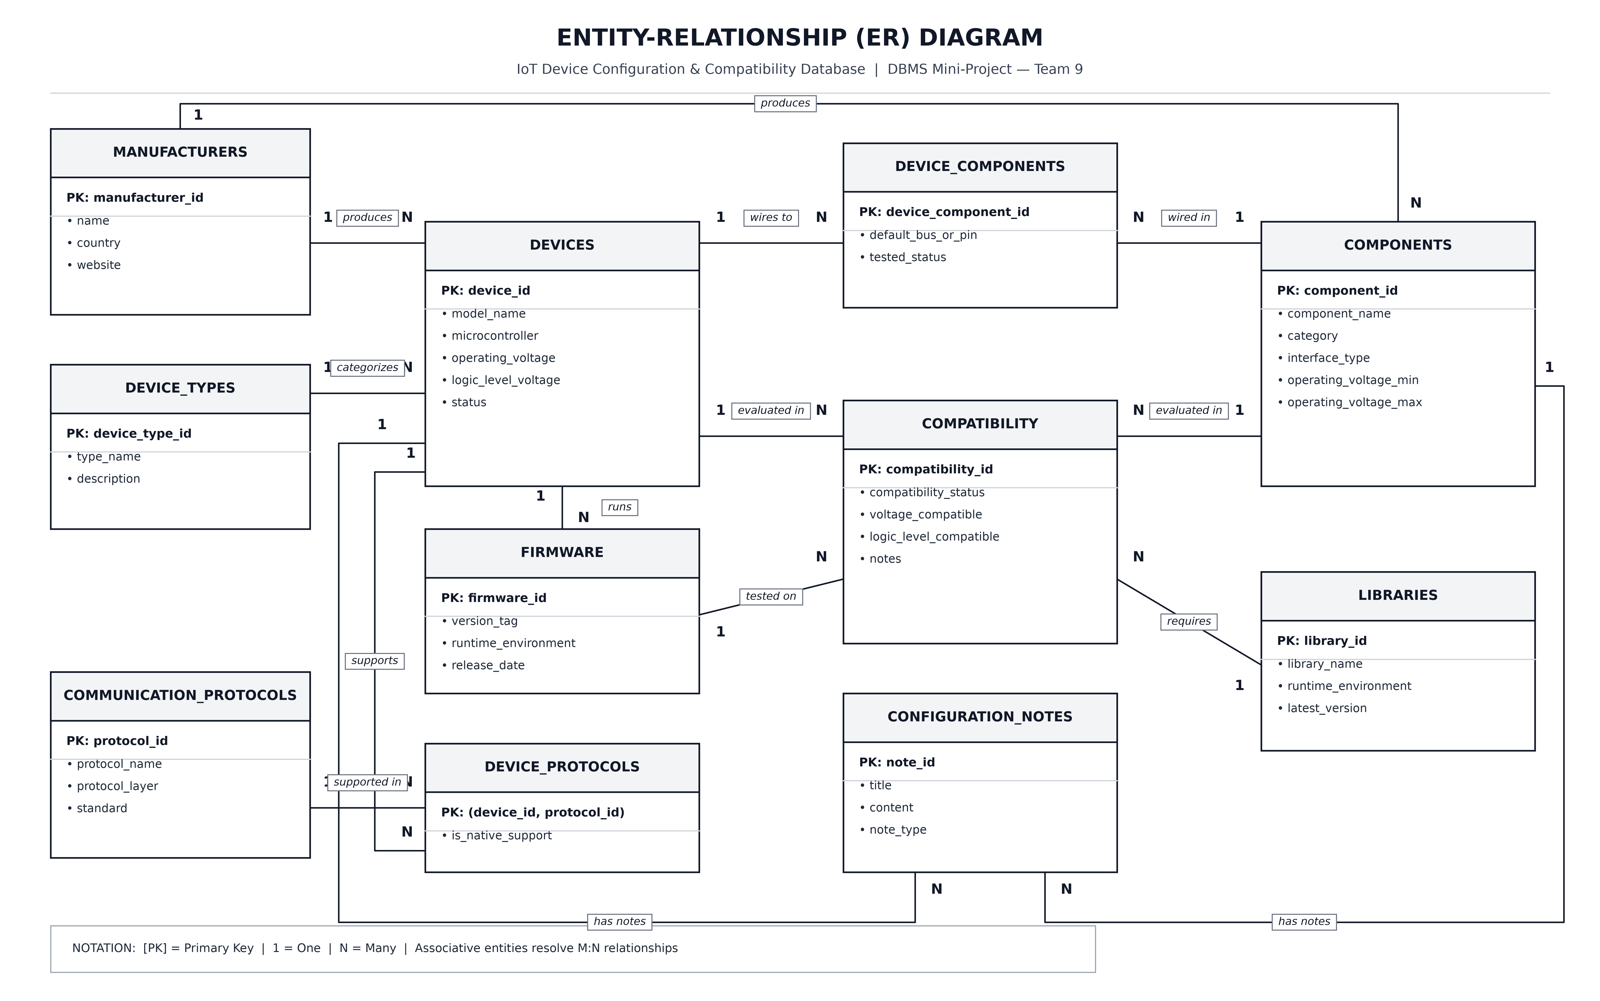
Figure 3.1: Conceptual Entity-Relationship (ER) Diagram of the IoT Device Configuration & Compatibility Database

4. ER TO RELATIONAL MAPPING
4.1 STEPS OF ALGORITHM FOR CHOSEN PROBLEM
To translate our conceptual Entity-Relationship model into a physical PostgreSQL relational schema without anomalies or information loss, we apply the standard 7-step ER-to-Relational Mapping Algorithm (Elmasri & Navathe):
• Step 1 — Mapping of Regular (Strong) Entity Types: For each strong entity in the ER diagram, we create a corresponding base relation that includes all simple, atomic attributes and designates the entity identifier as the Primary Key (PK): manufacturers(manufacturer_id [PK], name, website, country, created_at); device_types(device_type_id [PK], type_name, description); devices(device_id [PK], model_name, microcontroller, operating_voltage, logic_level_voltage, clock_speed_mhz, flash_memory_kb, sram_kb, gpio_count, analog_pins_count, status, created_at); components(component_id [PK], component_name, category, operating_voltage_min, operating_voltage_max, logic_level_voltage, current_draw_ma, interface_type, datasheet_url, created_at); communication_protocols(protocol_id [PK], protocol_name, protocol_layer, standard, max_data_rate_kbps); and libraries(library_id [PK], library_name, runtime_environment, repository_url, latest_version, license, created_at).
• Step 2 — Mapping of Dependent / Lifecycle-Bound Entity Types: The FIRMWARE entity represents firmware releases bound to a specific IoT compute board. We create the relation firmware(firmware_id [PK], device_id [FK], version_tag, runtime_environment, release_date, is_recommended) where device_id references devices(device_id) with ON DELETE CASCADE, accompanied by the composite candidate key UNIQUE(device_id, version_tag, runtime_environment).
• Step 3 — Mapping of Binary 1:1 Relationship Types: Our domain does not contain mandatory 1:1 relationships; all entity associations are either 1:N or M:N, avoiding sparse NULL-heavy merged tables.
• Step 4 — Mapping of Binary 1:N Relationship Types: For every 1:N binary relationship, we propagate the Primary Key of the 1-side (parent) relation as a Foreign Key (FK) into the N-side (child) relation: (a) In devices, we include manufacturer_id referencing manufacturers(manufacturer_id) (ON DELETE RESTRICT) and device_type_id referencing device_types(device_type_id) (ON DELETE RESTRICT); (b) In components, we include manufacturer_id referencing manufacturers(manufacturer_id) (ON DELETE SET NULL so component specs survive vendor archival); and (c) In configuration_notes, we include device_id referencing devices(device_id) and component_id referencing components(component_id) (both ON DELETE CASCADE).
• Step 5 — Mapping of Binary M:N Relationship Types: Each binary M:N relationship is mapped to a dedicated junction (relationship) relation whose Foreign Keys reference the participating entities: (a) The M:N relationship between DEVICES and COMMUNICATION_PROTOCOLS maps to device_protocols(device_id [PK, FK], protocol_id [PK, FK], is_native_support), where (device_id, protocol_id) forms the composite Primary Key; (b) The M:N physical wiring relationship between DEVICES and COMPONENTS maps to device_components(device_component_id [PK], device_id [FK], component_id [FK], default_bus_or_pin, tested_status) with composite uniqueness UNIQUE(device_id, component_id).
• Step 6 — Mapping of Multivalued Attributes & High-Dimensional Vector Embeddings: No comma-separated multivalued strings exist in any table (satisfying 1NF). In configuration_notes, the 384-dimensional dense semantic embedding is mapped using the pgvector native column type embedding vector(384) and indexed via an HNSW cosine distance index (idx_config_notes_embedding_hnsw).
• Step 7 — Mapping of N-ary (Multi-Dimensional Associative) Relationship Types: Hardware-software compatibility is a 4-ary associative relationship linking DEVICES, COMPONENTS, LIBRARIES, and FIRMWARE. We map this to compatibility(compatibility_id [PK], device_id [FK], component_id [FK], library_id [FK], firmware_id [FK], compatibility_status, voltage_compatible, logic_level_compatible, notes, verified_date) with the 4-attribute composite constraint uq_compatibility_matrix UNIQUE(device_id, component_id, library_id, firmware_id).
Normalization Verification (1NF, 2NF, and 3NF / BCNF)
• First Normal Form (1NF): Every attribute across all 11 relations holds strictly atomic values. Multi-valued protocols and pinouts are decomposed into dedicated rows in device_protocols and device_components.
• Second Normal Form (2NF): In composite-key relations such as device_protocols(device_id, protocol_id), the non-key attribute is_native_support is functionally dependent on the entire composite key (device_id, protocol_id) -> is_native_support, with zero partial dependencies.
• Third Normal Form (3NF): All transitive dependencies (X -> Y -> Z) have been eliminated. Vendor attributes (website, country) reside solely in manufacturers; device category descriptions reside solely in device_types; firmware attributes reside solely in firmware. Every non-prime attribute depends directly and solely on the relation's candidate keys.
Table 4.1: Summary of Mapped Relational Tables, Primary Keys, and Foreign Keys
# | Relation (Table) Name | Primary Key (PK) | Foreign Keys (FK) | Composite Unique Key
1 | manufacturers | manufacturer_id | None | UNIQUE (name)
2 | device_types | device_type_id | None | UNIQUE (type_name)
3 | devices | device_id | manufacturer_id, device_type_id | UNIQUE (model_name)
4 | components | component_id | manufacturer_id | None
5 | communication_protocols | protocol_id | None | UNIQUE (protocol_name)
6 | device_protocols | (device_id, protocol_id) | device_id, protocol_id | Composite PK
7 | firmware | firmware_id | device_id | (device_id, version_tag, runtime_environment)
8 | libraries | library_id | None | (library_name, runtime_environment)
9 | device_components | device_component_id | device_id, component_id | (device_id, component_id)
10 | compatibility | compatibility_id | device_id, component_id, library_id, firmware_id | (device_id, component_id, library_id, firmware_id)
11 | configuration_notes | note_id | device_id, component_id | None

Table 4.2: Foreign Key Referential Integrity Deletion and Update Rules
Constraint Name | Child Table (Column) | Parent Table (Column) | ON DELETE | Architectural Rationale
fk_devices_manufacturer | devices (manufacturer_id) | manufacturers (manufacturer_id) | RESTRICT | Prevents deleting active hardware vendors
fk_devices_device_type | devices (device_type_id) | device_types (device_type_id) | RESTRICT | Prevents deleting active device classifications
fk_components_manufacturer | components (manufacturer_id) | manufacturers (manufacturer_id) | SET NULL | Preserves sensor specs if vendor is archived
fk_device_protocols_device | device_protocols (device_id) | devices (device_id) | CASCADE | Removes protocol links when board is deleted
fk_device_protocols_protocol | device_protocols (protocol_id) | communication_protocols (protocol_id) | RESTRICT | Protects protocol standard in use by boards
fk_firmware_device | firmware (device_id) | devices (device_id) | CASCADE | Removes dependent firmware builds with board
fk_device_components_device | device_components (device_id) | devices (device_id) | CASCADE | Cleans up pinout mappings when board is removed
fk_device_components_component | device_components (component_id) | components (component_id) | CASCADE | Cleans up pinout mappings when sensor is removed
fk_compatibility_device | compatibility (device_id) | devices (device_id) | CASCADE | Cascades compatibility rows for deleted board
fk_compatibility_component | compatibility (component_id) | components (component_id) | CASCADE | Cascades compatibility rows for deleted sensor
fk_compatibility_library | compatibility (library_id) | libraries (library_id) | SET NULL | Preserves hardware bench result if library removed
fk_compatibility_firmware | compatibility (firmware_id) | firmware (firmware_id) | SET NULL | Preserves hardware bench result if firmware removed
fk_config_notes_device | configuration_notes (device_id) | devices (device_id) | CASCADE | Cascades device-specific setup guides
fk_config_notes_component | configuration_notes (component_id) | components (component_id) | CASCADE | Cascades component-specific setup guides

Table 4.3: Catalog of 50 Enforced Database Integrity Constraints in PostgreSQL
Constraint Category | Catalog Count | Representative Constraint Names & Validation Expressions
Primary Key (PK) | 11 | 10 surrogate SERIAL PKs + 1 composite PK (device_id, protocol_id) on device_protocols
Foreign Key (FK) | 14 | 8 ON DELETE CASCADE, 3 ON DELETE RESTRICT, 3 ON DELETE SET NULL (all ON UPDATE CASCADE)
Unique (UNIQUE) | 8 | 4 single-column UNIQUE + 4 composite UNIQUE (uq_firmware_device_version_runtime, uq_compatibility_matrix, etc.)
Domain Check (CHECK) | 17 | chk_devices_operating_voltage (0 < V <= 48), chk_devices_logic_level_voltage (0 < V <= 12), chk_components_voltage_max (max >= min), chk_compatibility_status, chk_config_notes_type
TOTAL CONSTRAINTS | 50 | Verified via pg_constraint catalog introspection in public schema

4.2 COMPLETE DIAGRAM OF RELATIONAL MAPPING
Figure 4.1 presents the complete Physical Relational Schema Diagram mapped from our ER model, depicting all 11 PostgreSQL tables, exact column data types (SERIAL, VARCHAR, NUMERIC, BOOLEAN, TIMESTAMPTZ, vector(384)), Primary Keys ([PK]), Foreign Keys ([FK]), Composite Primary/Foreign Keys ([PFK]), and directional referential integrity arrows.
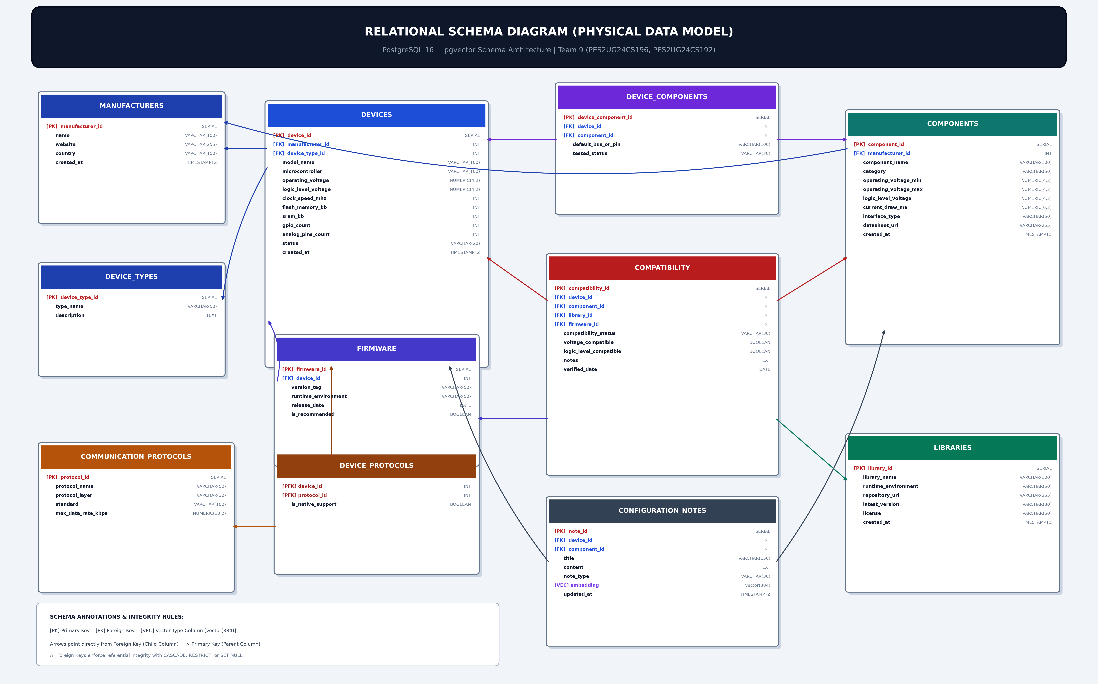
Figure 4.1: Complete Physical Relational Schema Diagram (PostgreSQL 16 + pgvector Architecture)

5. DDL STATEMENTS
STATEMENTS WITH SCREEN SHOTS OF THE TABLE CREATION
The Data Definition Language (DDL) implementation (database/schema.sql and 9_DDL.sql) initializes the pgvector extension, defines all 11 normalized base tables with 50 constraints, demonstrates schema evolution via ALTER TABLE, creates 15 explicit performance indexes (14 B-Tree indexes and 1 HNSW cosine vector index), and constructs 3 analytical views.
Listing 5.1: DDL Statements for Extension Setup, manufacturers, device_types, and devices
-- Enable pgvector extension for 384-dimensional dense vector embeddings
CREATE EXTENSION IF NOT EXISTS vector;
-- 1. Table: manufacturers
CREATE TABLE manufacturers (
manufacturer_id SERIAL PRIMARY KEY,
name VARCHAR(100) NOT NULL UNIQUE,
website VARCHAR(255),
country VARCHAR(100),
created_at TIMESTAMPTZ NOT NULL DEFAULT CURRENT_TIMESTAMP
);
-- 2. Table: device_types
CREATE TABLE device_types (
device_type_id SERIAL PRIMARY KEY,
type_name VARCHAR(50) NOT NULL UNIQUE,
description TEXT
);
-- 3. Table: devices
CREATE TABLE devices (
device_id SERIAL PRIMARY KEY,
manufacturer_id INT NOT NULL,
device_type_id INT NOT NULL,
model_name VARCHAR(100) NOT NULL UNIQUE,
microcontroller VARCHAR(100),
operating_voltage NUMERIC(4,2) NOT NULL,
logic_level_voltage NUMERIC(4,2) NOT NULL,
clock_speed_mhz INT,
flash_memory_kb INT,
sram_kb INT,
gpio_count INT NOT NULL DEFAULT 0,
analog_pins_count INT NOT NULL DEFAULT 0,
status VARCHAR(20) NOT NULL DEFAULT 'ACTIVE',
created_at TIMESTAMPTZ NOT NULL DEFAULT CURRENT_TIMESTAMP,
CONSTRAINT fk_devices_manufacturer FOREIGN KEY (manufacturer_id)
REFERENCES manufacturers(manufacturer_id) ON DELETE RESTRICT ON UPDATE CASCADE,
CONSTRAINT fk_devices_device_type FOREIGN KEY (device_type_id)
REFERENCES device_types(device_type_id) ON DELETE RESTRICT ON UPDATE CASCADE,
CONSTRAINT chk_devices_operating_voltage CHECK (operating_voltage > 0 AND operating_voltage <= 48.0),
CONSTRAINT chk_devices_logic_level_voltage CHECK (logic_level_voltage > 0 AND logic_level_voltage <= 12.0),
CONSTRAINT chk_devices_clock_speed CHECK (clock_speed_mhz IS NULL OR clock_speed_mhz > 0),
CONSTRAINT chk_devices_flash_memory CHECK (flash_memory_kb IS NULL OR flash_memory_kb >= 0),
CONSTRAINT chk_devices_sram CHECK (sram_kb IS NULL OR sram_kb >= 0),
CONSTRAINT chk_devices_gpio_count CHECK (gpio_count >= 0),
CONSTRAINT chk_devices_analog_pins CHECK (analog_pins_count >= 0),
CONSTRAINT chk_devices_status CHECK (status IN ('ACTIVE', 'DISCONTINUED', 'DEPRECATED', 'PROTOTYPE'))
);

Listing 5.2: DDL Statements for components, ALTER TABLE, communication_protocols, device_protocols, firmware, and libraries
-- 4. Table: components
CREATE TABLE components (
component_id SERIAL PRIMARY KEY,
manufacturer_id INT,
component_name VARCHAR(100) NOT NULL,
category VARCHAR(50) NOT NULL,
operating_voltage_min NUMERIC(4,2) NOT NULL,
operating_voltage_max NUMERIC(4,2) NOT NULL,
logic_level_voltage NUMERIC(4,2) NOT NULL,
current_draw_ma NUMERIC(6,2),
interface_type VARCHAR(50) NOT NULL,
created_at TIMESTAMPTZ NOT NULL DEFAULT CURRENT_TIMESTAMP,
CONSTRAINT fk_components_manufacturer FOREIGN KEY (manufacturer_id)
REFERENCES manufacturers(manufacturer_id) ON DELETE SET NULL ON UPDATE CASCADE,
CONSTRAINT chk_components_voltage_min CHECK (operating_voltage_min > 0),
CONSTRAINT chk_components_voltage_max CHECK (operating_voltage_max >= operating_voltage_min),
CONSTRAINT chk_components_logic_level CHECK (logic_level_voltage > 0),
CONSTRAINT chk_components_current_draw CHECK (current_draw_ma IS NULL OR current_draw_ma >= 0)
);
-- Schema Evolution via ALTER TABLE: Add official PDF datasheet URL column
ALTER TABLE components ADD COLUMN datasheet_url VARCHAR(255);
-- 5. Table: communication_protocols
CREATE TABLE communication_protocols (
protocol_id SERIAL PRIMARY KEY,
protocol_name VARCHAR(50) NOT NULL UNIQUE,
protocol_layer VARCHAR(30) NOT NULL,
standard VARCHAR(100),
max_data_rate_kbps NUMERIC(10,2),
CONSTRAINT chk_protocols_layer
CHECK (protocol_layer IN ('Physical/DataLink', 'Network/Transport', 'Application', 'Hardware Bus')),
CONSTRAINT chk_protocols_data_rate CHECK (max_data_rate_kbps IS NULL OR max_data_rate_kbps > 0)
);
-- 6. Table: device_protocols (M:N Junction Table)
CREATE TABLE device_protocols (
device_id INT NOT NULL,
protocol_id INT NOT NULL,
is_native_support BOOLEAN NOT NULL DEFAULT TRUE,
PRIMARY KEY (device_id, protocol_id),
CONSTRAINT fk_device_protocols_device FOREIGN KEY (device_id)
REFERENCES devices(device_id) ON DELETE CASCADE ON UPDATE CASCADE,
CONSTRAINT fk_device_protocols_protocol FOREIGN KEY (protocol_id)
REFERENCES communication_protocols(protocol_id) ON DELETE RESTRICT ON UPDATE CASCADE
);
-- 7. Table: firmware
CREATE TABLE firmware (
firmware_id SERIAL PRIMARY KEY,
device_id INT NOT NULL,
version_tag VARCHAR(50) NOT NULL,
runtime_environment VARCHAR(50) NOT NULL,
release_date DATE NOT NULL,
is_recommended BOOLEAN NOT NULL DEFAULT FALSE,
CONSTRAINT fk_firmware_device FOREIGN KEY (device_id)
REFERENCES devices(device_id) ON DELETE CASCADE ON UPDATE CASCADE,
CONSTRAINT uq_firmware_device_version_runtime UNIQUE (device_id, version_tag, runtime_environment)
);
-- 8. Table: libraries
CREATE TABLE libraries (
library_id SERIAL PRIMARY KEY,
library_name VARCHAR(100) NOT NULL,
runtime_environment VARCHAR(50) NOT NULL,
repository_url VARCHAR(255),
latest_version VARCHAR(30) NOT NULL,
license VARCHAR(50) NOT NULL DEFAULT 'MIT',
created_at TIMESTAMPTZ NOT NULL DEFAULT CURRENT_TIMESTAMP,
CONSTRAINT uq_libraries_name_runtime UNIQUE (library_name, runtime_environment)
);

Listing 5.3: DDL Statements for device_components, compatibility, configuration_notes, Indexes, and Views
-- 9. Table: device_components (Physical Pinout Mappings)
CREATE TABLE device_components (
device_component_id SERIAL PRIMARY KEY,
device_id INT NOT NULL,
component_id INT NOT NULL,
default_bus_or_pin VARCHAR(100) NOT NULL,
tested_status VARCHAR(20) NOT NULL DEFAULT 'VERIFIED',
CONSTRAINT fk_device_components_device FOREIGN KEY (device_id)
REFERENCES devices(device_id) ON DELETE CASCADE ON UPDATE CASCADE,
CONSTRAINT fk_device_components_component FOREIGN KEY (component_id)
REFERENCES components(component_id) ON DELETE CASCADE ON UPDATE CASCADE,
CONSTRAINT uq_device_components_pair UNIQUE (device_id, component_id),
CONSTRAINT chk_device_components_status
CHECK (tested_status IN ('VERIFIED', 'EXPERIMENTAL', 'UNTESTED', 'FAILED'))
);
-- 10. Table: compatibility (4-Dimensional Hardware & Software Compatibility Matrix)
CREATE TABLE compatibility (
compatibility_id SERIAL PRIMARY KEY,
device_id INT NOT NULL,
component_id INT NOT NULL,
library_id INT,
firmware_id INT,
compatibility_status VARCHAR(30) NOT NULL,
voltage_compatible BOOLEAN NOT NULL,
logic_level_compatible BOOLEAN NOT NULL,
notes TEXT,
verified_date DATE NOT NULL DEFAULT CURRENT_DATE,
CONSTRAINT fk_compatibility_device FOREIGN KEY (device_id)
REFERENCES devices(device_id) ON DELETE CASCADE ON UPDATE CASCADE,
CONSTRAINT fk_compatibility_component FOREIGN KEY (component_id)
REFERENCES components(component_id) ON DELETE CASCADE ON UPDATE CASCADE,
CONSTRAINT fk_compatibility_library FOREIGN KEY (library_id)
REFERENCES libraries(library_id) ON DELETE SET NULL ON UPDATE CASCADE,
CONSTRAINT fk_compatibility_firmware FOREIGN KEY (firmware_id)
REFERENCES firmware(firmware_id) ON DELETE SET NULL ON UPDATE CASCADE,
CONSTRAINT chk_compatibility_status CHECK (compatibility_status IN (
'COMPATIBLE', 'INCOMPATIBLE', 'REQUIRES_LEVEL_SHIFTER', 'REQUIRES_PULLUP_RESISTOR', 'DEGRADED_FUNCTION'
)),
CONSTRAINT uq_compatibility_matrix UNIQUE (device_id, component_id, library_id, firmware_id)
);
-- 11. Table: configuration_notes (Vector Database Integration with vector(384))
CREATE TABLE configuration_notes (
note_id SERIAL PRIMARY KEY,
device_id INT,
component_id INT,
title VARCHAR(150) NOT NULL,
content TEXT NOT NULL,
note_type VARCHAR(30) NOT NULL DEFAULT 'SETUP_GUIDE',
embedding vector(384),
created_at TIMESTAMPTZ NOT NULL DEFAULT CURRENT_TIMESTAMP,
updated_at TIMESTAMPTZ NOT NULL DEFAULT CURRENT_TIMESTAMP,
CONSTRAINT fk_config_notes_device FOREIGN KEY (device_id)
REFERENCES devices(device_id) ON DELETE CASCADE ON UPDATE CASCADE,
CONSTRAINT fk_config_notes_component FOREIGN KEY (component_id)
REFERENCES components(component_id) ON DELETE CASCADE ON UPDATE CASCADE,
CONSTRAINT chk_config_notes_type
CHECK (note_type IN ('SETUP_GUIDE', 'TROUBLESHOOTING', 'PINOUT_SPEC', 'CALIBRATION', 'WORKAROUND'))
);
-- B-Tree Indexes (14) & pgvector HNSW Cosine Index (1)
CREATE INDEX idx_devices_manufacturer ON devices(manufacturer_id);
CREATE INDEX idx_devices_device_type ON devices(device_type_id);
CREATE INDEX idx_devices_model ON devices(model_name);
CREATE INDEX idx_components_manufacturer ON components(manufacturer_id);
CREATE INDEX idx_components_category ON components(category);
CREATE INDEX idx_components_interface ON components(interface_type);
CREATE INDEX idx_device_protocols_protocol ON device_protocols(protocol_id);
CREATE INDEX idx_firmware_device ON firmware(device_id);
CREATE INDEX idx_libraries_runtime ON libraries(runtime_environment);
CREATE INDEX idx_compatibility_device ON compatibility(device_id);
CREATE INDEX idx_compatibility_component ON compatibility(component_id);
CREATE INDEX idx_compatibility_status ON compatibility(compatibility_status);
CREATE INDEX idx_config_notes_device ON configuration_notes(device_id);
CREATE INDEX idx_config_notes_component ON configuration_notes(component_id);
CREATE INDEX idx_config_notes_embedding_hnsw ON configuration_notes
USING hnsw (embedding vector_cosine_ops) WITH (m = 16, ef_construction = 64);
-- Analytical View: v_device_compatibility_overview (6-Table Join)
CREATE VIEW v_device_compatibility_overview AS
SELECT c.compatibility_id, d.model_name AS device_model, m_dev.name AS device_manufacturer,
d.logic_level_voltage AS device_logic_voltage, comp.component_name, comp.category AS component_category,
comp.interface_type AS component_interface, comp.logic_level_voltage AS component_logic_voltage,
c.compatibility_status, c.voltage_compatible, c.logic_level_compatible,
lib.library_name, f.version_tag AS firmware_version, c.notes
FROM compatibility c
JOIN devices d ON c.device_id = d.device_id
JOIN manufacturers m_dev ON d.manufacturer_id = m_dev.manufacturer_id
JOIN components comp ON c.component_id = comp.component_id
LEFT JOIN libraries lib ON c.library_id = lib.library_id
LEFT JOIN firmware f ON c.firmware_id = f.firmware_id;

Screenshots of DDL Table Creation and Catalog Verification
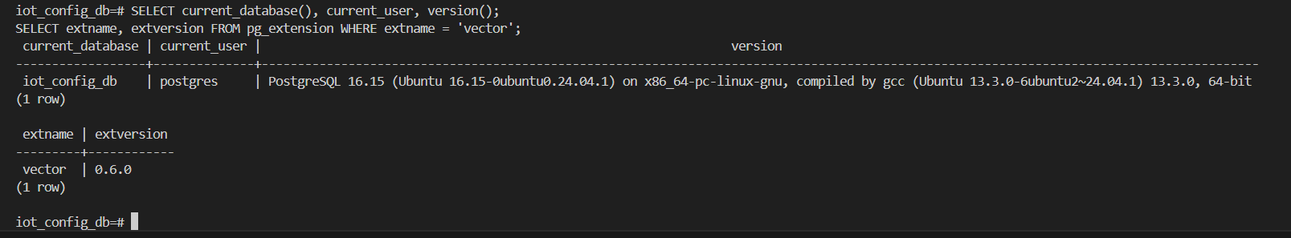
Figure 5.1: PostgreSQL 16.15 Engine Connection and pgvector v0.6.0 Extension Verification
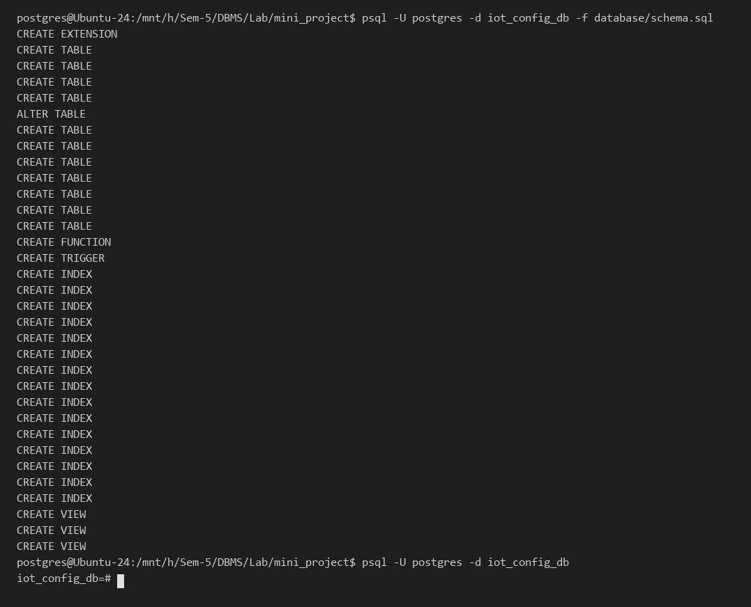
Figure 5.2: Execution of Canonical DDL Script (database/schema.sql) Creating Tables, Indexes, Trigger, and Views
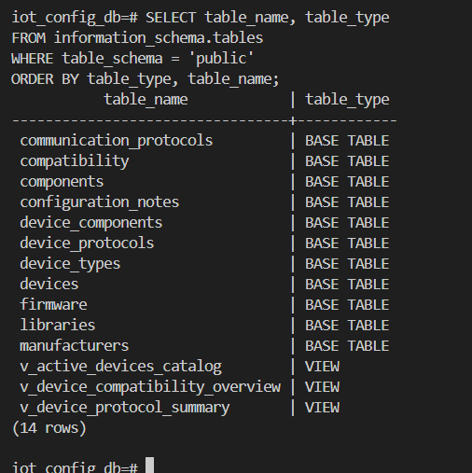
Figure 5.3: Schema Introspection (information_schema.tables) Verifying All 11 Base Tables and 3 Analytical Views
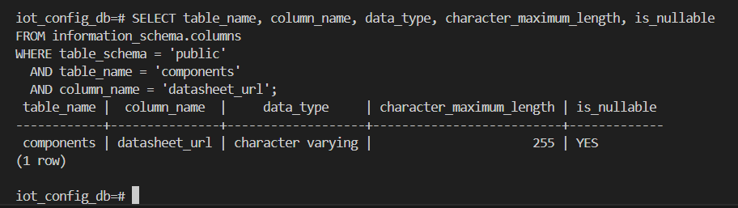
Figure 5.4: Schema Evolution Verification (ALTER TABLE components ADD COLUMN datasheet_url VARCHAR(255))
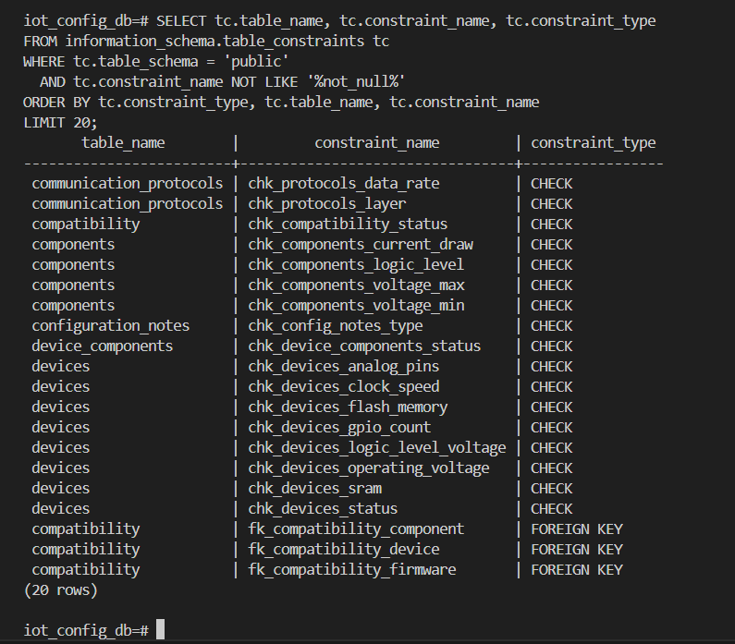
Figure 5.5: Catalog Verification of Domain CHECK and FOREIGN KEY Constraints in information_schema.table_constraints
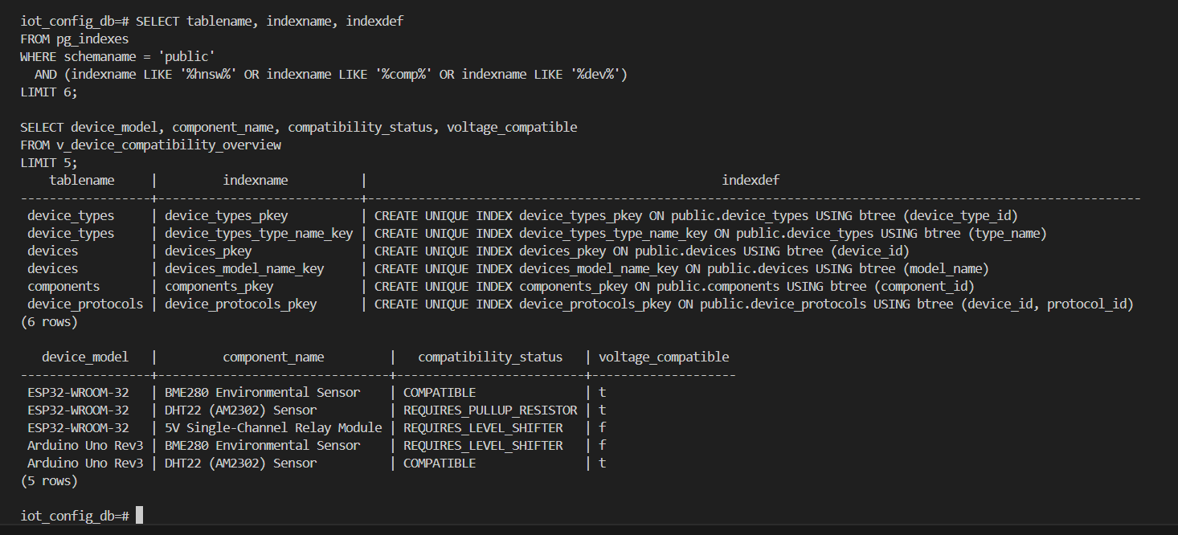
Figure 5.6: Verification of Catalog Indexes (pg_indexes) and Execution of View v_device_compatibility_overview

6. DML STATEMENTS
STATEMENTS WITH SCREEN SHOTS OF THE TABLE WITH INSERTED VALUES
The Data Manipulation Language (DML) population script (database/seed_data.sql) inserts 81 realistic IoT hardware, protocol, firmware, driver library, pinout, compatibility, and vector-embedded configuration records across all 11 normalized tables in strict foreign-key dependency order.
Listing 6.1: DML INSERT Statements for manufacturers, device_types, devices, and components
-- 1. Insert into manufacturers (7 rows)
INSERT INTO manufacturers (name, website, country) VALUES
('Espressif Systems', 'https://www.espressif.com', 'China'),
('Arduino AG', 'https://www.arduino.cc', 'Italy'),
('Raspberry Pi Foundation', 'https://www.raspberrypi.com', 'United Kingdom'),
('STMicroelectronics', 'https://www.st.com', 'Switzerland'),
('Bosch Sensortec', 'https://www.bosch-sensortec.com', 'Germany'),
('Adafruit Industries', 'https://www.adafruit.com', 'United States'),
('Seeed Studio', 'https://www.seeedstudio.com', 'China');
-- 2. Insert into device_types (4 rows)
INSERT INTO device_types (type_name, description) VALUES
('Microcontroller Board', 'Compact low-power computing board executing dedicated firmware loops.'),
('Single Board Computer', 'Complete computing system with full operating system capabilities.'),
('Edge Gateway', 'Intermediary device bridging local sensor nodes with remote cloud brokers.'),
('Sensor Node Module', 'Specialized ultra-low power board tailored for wireless telemetry.');
-- 3. Insert into devices (6 rows)
INSERT INTO devices (manufacturer_id, device_type_id, model_name, microcontroller, operating_voltage, logic_level_voltage, clock_speed_mhz, flash_memory_kb, sram_kb, gpio_count, analog_pins_count, status) VALUES
(1, 1, 'ESP32-WROOM-32', 'ESP32-D0WDQ6 Dual Core Xtensa LX6', 3.30, 3.30, 240, 4096, 520, 36, 18, 'ACTIVE'),
(2, 1, 'Arduino Uno Rev3', 'ATmega328P 8-bit AVR', 5.00, 5.00, 16, 32, 2, 14, 6, 'ACTIVE'),
(3, 1, 'Raspberry Pi Pico W', 'RP2040 Dual ARM Cortex-M0+', 3.30, 3.30, 133, 2048, 264, 26, 3, 'ACTIVE'),
(4, 1, 'STM32 Nucleo-F401RE', 'STM32F401RET6 ARM Cortex-M4', 3.30, 3.30, 84, 512, 96, 50, 16, 'ACTIVE'),
(1, 1, 'ESP8266 NodeMCU v2', 'ESP8266EX 32-bit Tensilica L106', 3.30, 3.30, 80, 4096, 80, 17, 1, 'ACTIVE'),
(2, 1, 'Arduino Nano Every', 'ATmega4809 8-bit AVR', 5.00, 5.00, 20, 48, 6, 22, 8, 'ACTIVE');
-- 4. Insert into components (5 rows)
INSERT INTO components (manufacturer_id, component_name, category, operating_voltage_min, operating_voltage_max, logic_level_voltage, current_draw_ma, interface_type, datasheet_url) VALUES
(5, 'BME280 Environmental Sensor', 'Temperature/Humidity/Pressure', 1.71, 3.60, 3.30, 0.50, 'I2C / SPI', 'https://www.bosch-sensortec.com/media/boschsensortec/downloads/datasheets/bst-bme280-ds002.pdf'),
(6, 'DHT22 (AM2302) Sensor', 'Temperature/Humidity Sensor', 3.30, 5.50, 3.30, 2.50, '1-Wire Digital', 'https://cdn-shop.adafruit.com/datasheets/DHT22.pdf'),
(6, 'SSD1306 0.96 inch OLED Display', 'Graphic Display Module', 3.30, 5.00, 3.30, 20.00, 'I2C', 'https://cdn-shop.adafruit.com/datasheets/SSD1306.pdf'),
(6, 'MPU-6050 6-DoF IMU', 'Motion & Accelerometer Sensor', 3.00, 5.00, 3.30, 3.80, 'I2C', 'https://invensense.tdk.com/wp-content/uploads/2015/02/MPU-6000-Datasheet1.pdf'),
(7, '5V Single-Channel Relay Module', 'Electromechanical Actuator', 4.75, 5.25, 5.00, 70.00, 'GPIO Digital', 'https://www.songle.com/en/pdf/200841195638703.pdf');

Listing 6.2: DML INSERT Statements for Protocols, Firmware, Libraries, Wiring, Compatibility, and Vector Notes
-- 5. Insert into communication_protocols (7 rows)
INSERT INTO communication_protocols (protocol_name, protocol_layer, standard, max_data_rate_kbps) VALUES
('Wi-Fi 802.11 b/g/n', 'Physical/DataLink', 'IEEE 802.11b/g/n (2.4 GHz)', 150000.00),
('Bluetooth Low Energy (BLE)', 'Physical/DataLink', 'Bluetooth 5.0 / 4.2 BLE', 2000.00),
('I2C Bus', 'Hardware Bus', 'Phillips I2C Standard/Fast Mode', 400.00),
('SPI Bus', 'Hardware Bus', 'Motorola 4-Wire Synchronous Serial', 50000.00),
('UART / Serial', 'Hardware Bus', 'Asynchronous Serial Interface', 115.20),
('MQTT Client', 'Application', 'OASIS MQTT v3.1.1 / v5.0', 10000.00),
('HTTP / REST', 'Application', 'RFC 7230 Hypertext Transfer Protocol', 100000.00);
-- 6. Insert into device_protocols (19 rows)
INSERT INTO device_protocols (device_id, protocol_id, is_native_support) VALUES
(1, 1, TRUE), (1, 2, TRUE), (1, 3, TRUE), (1, 4, TRUE), (1, 5, TRUE), (1, 6, TRUE),
(2, 3, TRUE), (2, 4, TRUE), (2, 5, TRUE), (2, 1, FALSE),
(3, 1, TRUE), (3, 2, TRUE), (3, 3, TRUE), (3, 4, TRUE), (3, 5, TRUE), (3, 6, TRUE),
(4, 3, TRUE), (4, 4, TRUE), (4, 5, TRUE);
-- 7. Insert into firmware (7 rows)
INSERT INTO firmware (device_id, version_tag, runtime_environment, release_date, is_recommended) VALUES
(1, 'v3.0.4', 'Arduino Core for ESP32', '2024-06-15', TRUE),
(1, 'v1.22.0', 'MicroPython', '2024-01-20', FALSE),
(1, 'v5.1.2', 'ESP-IDF', '2024-04-10', TRUE),
(2, 'v1.8.6', 'Arduino AVR Core', '2023-11-12', TRUE),
(3, 'v1.22.0', 'MicroPython RP2040', '2024-02-01', TRUE),
(3, 'v3.6.0', 'Arduino-Pico Core', '2024-05-18', FALSE),
(4, 'v2.6.0', 'STM32duino Core', '2023-12-05', TRUE);
-- 8. Insert into libraries (6 rows)
INSERT INTO libraries (library_name, runtime_environment, repository_url, latest_version, license) VALUES
('Adafruit_BME280_Library', 'Arduino C++', 'https://github.com/adafruit/Adafruit_BME280_Library', '2.2.4', 'BSD-3-Clause'),
('DHT-sensor-library', 'Arduino C++', 'https://github.com/adafruit/DHT-sensor-library', '1.4.6', 'MIT'),
('Adafruit_SSD1306', 'Arduino C++', 'https://github.com/adafruit/Adafruit_SSD1306', '2.5.9', 'BSD-3-Clause'),
('PubSubClient', 'Arduino C++', 'https://github.com/knolleary/pubsubclient', '2.8.0', 'MIT'),
('micropython-bme280', 'MicroPython', 'https://github.com/robert-hh/BME280', '1.0.2', 'MIT'),
('Wire (I2C Builtin)', 'Arduino C++', 'https://www.arduino.cc/en/Reference/Wire', '1.0.0', 'LGPL-2.1');
-- 9. Insert into device_components (9 rows)
INSERT INTO device_components (device_id, component_id, default_bus_or_pin, tested_status) VALUES
(1, 1, 'I2C (SDA=GPIO21, SCL=GPIO22, VCC=3V3, GND=GND)', 'VERIFIED'),
(1, 2, '1-Wire Digital (DATA=GPIO4 with 4.7k pull-up, VCC=3V3)', 'VERIFIED'),
(1, 3, 'I2C (SDA=GPIO21, SCL=GPIO22, VCC=3V3)', 'VERIFIED'),
(1, 5, 'GPIO (IN=GPIO18, VCC=5V via VIN pin, GND=GND)', 'EXPERIMENTAL'),
(2, 1, 'I2C (SDA=A4, SCL=A5, VCC=3V3)', 'VERIFIED'),
(2, 2, '1-Wire Digital (DATA=D2 with 10k pull-up, VCC=5V)', 'VERIFIED'),
(2, 5, 'GPIO (IN=D7, VCC=5V, GND=GND)', 'VERIFIED'),
(3, 1, 'I2C (SDA=GP4, SCL=GP5, VCC=3V3)', 'VERIFIED'),
(3, 2, '1-Wire Digital (DATA=GP15, VCC=3V3)', 'VERIFIED');
-- 10. Insert into compatibility (7 rows)
INSERT INTO compatibility (device_id, component_id, library_id, firmware_id, compatibility_status, voltage_compatible, logic_level_compatible, notes, verified_date) VALUES
(1, 1, 1, 1, 'COMPATIBLE', TRUE, TRUE, 'Perfect direct 3.3V I2C interfacing without logic shifting.', '2024-07-01'),
(1, 2, 2, 1, 'REQUIRES_PULLUP_RESISTOR', TRUE, TRUE, 'Requires a 4.7k to 10k Ohm pull-up resistor between VCC and DATA line.', '2024-07-02'),
(1, 5, NULL, 1, 'REQUIRES_LEVEL_SHIFTER', FALSE, FALSE, 'ESP32 GPIO outputs 3.3V logic which may fail to trigger 5V optocoupler relays.', '2024-07-05'),
(2, 1, 1, 4, 'REQUIRES_LEVEL_SHIFTER', FALSE, FALSE, 'BME280 max input is 3.6V. Arduino Uno 5V I2C pins require a logic level shifter.', '2024-07-03'),
(2, 2, 2, 4, 'COMPATIBLE', TRUE, TRUE, 'DHT22 operates comfortably at 5V logic with Arduino Uno digital pins.', '2024-07-03'),
(2, 5, NULL, 4, 'COMPATIBLE', TRUE, TRUE, 'Direct connection to digital pin D7, standard 5V logic compatible.', '2024-07-04'),
(3, 1, 5, 5, 'COMPATIBLE', TRUE, TRUE, 'Fully compatible over I2C0 bus on GP4/GP5 using MicroPython driver.', '2024-07-06');
-- 11. Insert into configuration_notes with 384-d unit vector embeddings (4 rows)
INSERT INTO configuration_notes (device_id, component_id, title, content, note_type, embedding) VALUES
(1, 1, 'ESP32 to BME280 I2C Wiring and Bus Initialization', 'Connect ESP32 3V3 to BME280 VIN, GND to GND, GPIO21 to SDA, and GPIO22 to SCL...', 'SETUP_GUIDE', vec_esp32_bme::vector),
(1, 2, 'DHT22 Timing Constraints & Pull-up Resistor on ESP32', 'DHT22 uses a single-bus protocol requiring a 4.7k pull-up resistor between GPIO4 and 3V3...', 'TROUBLESHOOTING', vec_esp32_dht::vector),
(2, 5, 'Driving 5V High Current Relays safely with Arduino Uno', 'When switching inductive loads using 5V relays, ensure an external 5V supply powers the coil...', 'PINOUT_SPEC', vec_uno_relay::vector),
(3, NULL, 'Raspberry Pi Pico W Wi-Fi & MQTT Client Provisioning', 'Pico W uses the Infineon CYW43439 wireless chip connected via SPI...', 'SETUP_GUIDE', vec_pico_wifi::vector);

Table 6.1: Database Population Census Across All 11 Normalized Tables (81 Total Seed Records)
Table Name | Populated Row Count | Summary of Seeded Domain Records
communication_protocols | 7 | Wi-Fi 802.11 b/g/n, BLE 5.0, I2C Bus, SPI Bus, UART/Serial, MQTT, HTTP/REST
compatibility | 7 | Multi-dimensional bench evaluations across ESP32, Uno Rev3, and Pico W
components | 5 | BME280, DHT22 (AM2302), SSD1306 OLED, MPU-6050 IMU, 5V Relay Module
configuration_notes | 4 | Setup & troubleshooting notes with 384-dimensional unit vectors
device_components | 9 | Verified GPIO, I2C, and 1-Wire pinout mappings
device_protocols | 19 | M:N protocol mappings (ESP32: 6, Pico W: 6, Uno Rev3: 4, STM32: 3)
device_types | 4 | Microcontroller Board, Single Board Computer, Edge Gateway, Sensor Node
devices | 6 | ESP32-WROOM-32, Uno Rev3, Pico W, STM32 Nucleo-F401RE, ESP8266, Nano Every
firmware | 7 | Arduino Core ESP32, MicroPython, ESP-IDF, AVR Core, RP2040, STM32duino
libraries | 6 | Adafruit_BME280, DHT-sensor-library, Adafruit_SSD1306, PubSubClient, etc.
manufacturers | 7 | Espressif, Arduino, Raspberry Pi, STMicroelectronics, Bosch, Adafruit, Seeed
TOTAL RECORDS | 81 | 100% Referential Integrity Verified Across All 11 Tables

Screenshots of Tables with Inserted Values
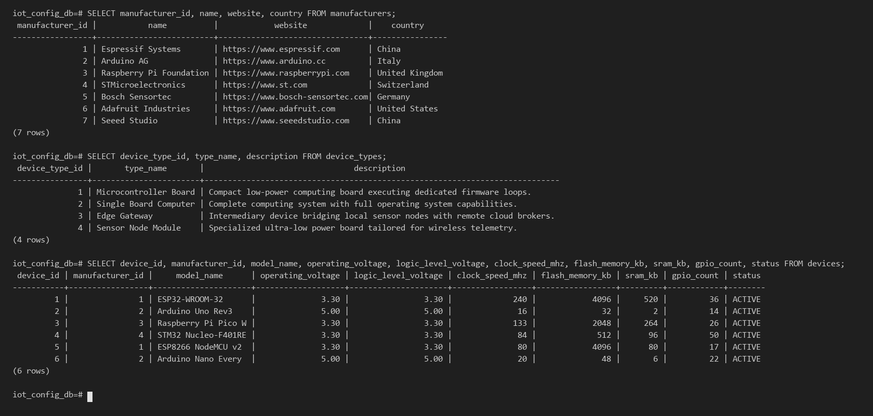
Figure 6.1: Populated Table Contents for manufacturers (7 rows), device_types (4 rows), and devices (6 rows)
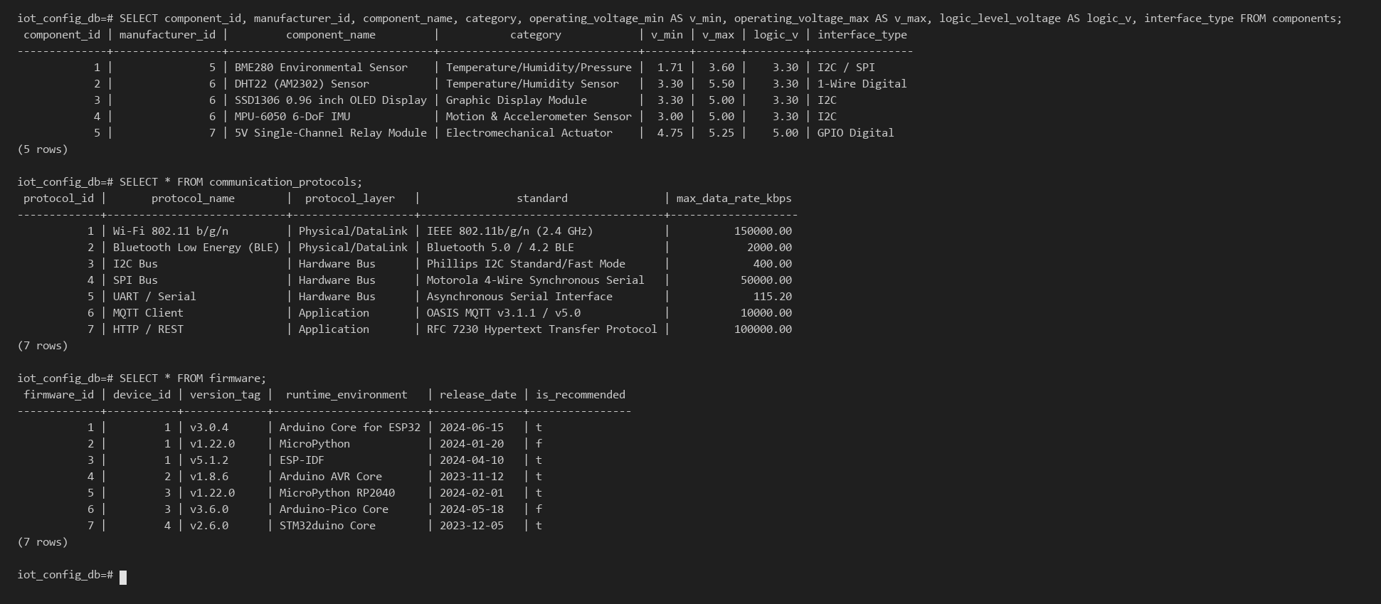
Figure 6.2: Populated Table Contents for components (5 rows), communication_protocols (7 rows), and firmware (7 rows)
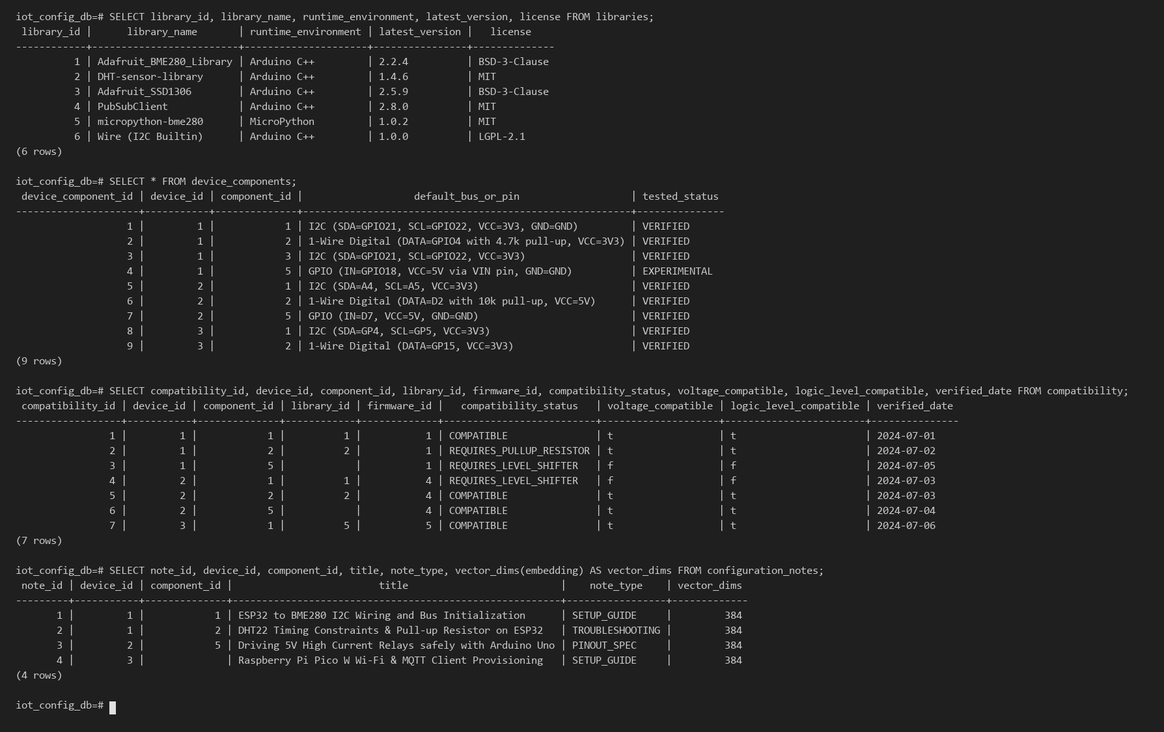
Figure 6.3: Populated Table Contents for libraries, device_components, compatibility, and configuration_notes (with 384-d vectors)
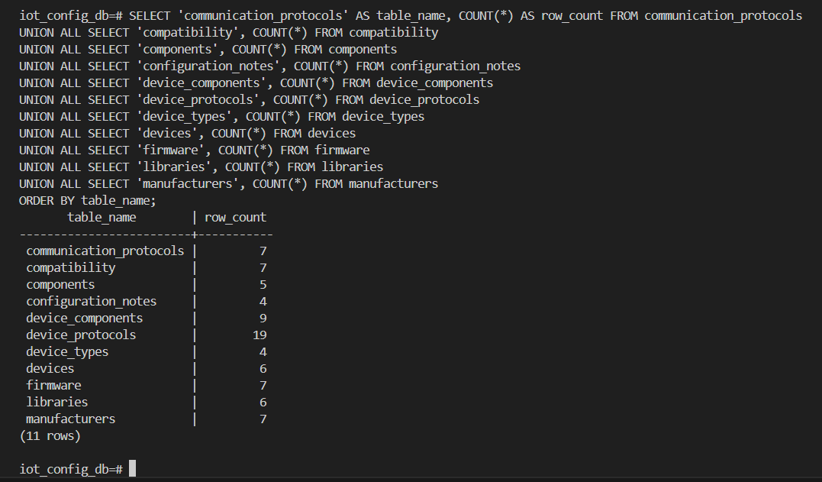
Figure 6.4: Complete Database Row Count Verification Query Confirming Exactly 81 Populated Records Across All 11 Tables

7. QUERIES
7.1 SIMPLE QUERY WITH GROUP BY, AGGREGATE
Query 7.1a joins four tables (devices, manufacturers, device_protocols, and communication_protocols), groups records by compute board using GROUP BY, computes protocol counts and comma-delimited lists via the aggregate functions COUNT() and STRING_AGG(), and filters boards supporting at least 4 protocols using HAVING.
Listing 7.1a: Aggregation Query with GROUP BY, COUNT(), STRING_AGG(), and HAVING
-- Query 7.1a: IoT Compute Boards Supporting at Least 4 Communication Protocols
SELECT
d.model_name AS device_model,
m.name AS manufacturer,
COUNT(dp.protocol_id) AS supported_protocols_count,
STRING_AGG(p.protocol_name, ', ' ORDER BY p.protocol_name) AS protocols_list
FROM devices d
JOIN manufacturers m ON d.manufacturer_id = m.manufacturer_id
JOIN device_protocols dp ON d.device_id = dp.device_id
JOIN communication_protocols p ON dp.protocol_id = p.protocol_id
GROUP BY d.device_id, d.model_name, m.name
HAVING COUNT(dp.protocol_id) >= 4
ORDER BY supported_protocols_count DESC, d.model_name;

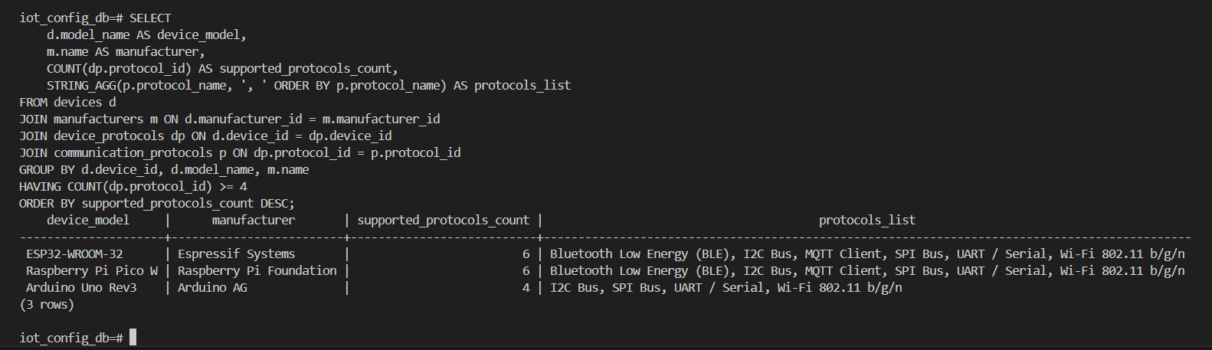
Figure 7.1: Execution Output of GROUP BY and HAVING Protocol Aggregation Query (ESP32: 6, Pico W: 6, Uno Rev3: 4)
Query 7.1b groups all hardware bench evaluations in the compatibility table by their compatibility_status classification and calculates both the absolute count and percentage distribution using COUNT(*) and ROUND().
Listing 7.1b: Compatibility Status Aggregate Breakdown Query
-- Query 7.1b: Hardware Compatibility Status Breakdown & Percentage Distribution
SELECT
compatibility_status,
COUNT(*) AS total_evaluations,
ROUND(COUNT(*) * 100.0 / (SELECT COUNT(*) FROM compatibility), 1) AS percentage
FROM compatibility
GROUP BY compatibility_status
ORDER BY total_evaluations DESC;

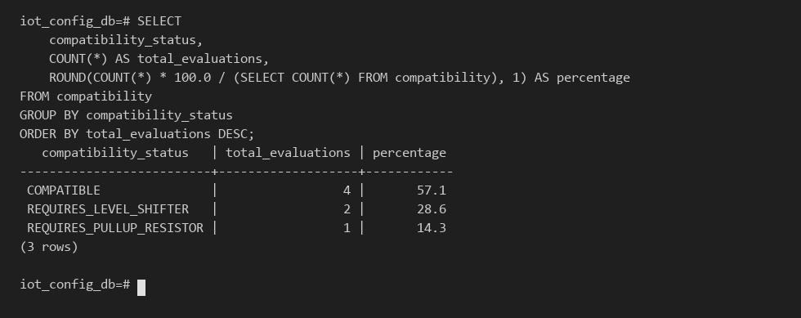
Figure 7.2: Execution Output of Compatibility Status Aggregate Distribution Query
7.2 UPDATE OPERATION
The UPDATE operation modifies an existing technical guide in configuration_notes (note_id = 1) by appending a hardware bench verification certification note. Executing this UPDATE statement also automatically triggers trg_config_notes_updated_at to refresh the updated_at timestamp.
Listing 7.2: DML UPDATE Statement on configuration_notes
-- Inspect record timestamp BEFORE update
SELECT note_id, title, updated_at FROM configuration_notes WHERE note_id = 1;
-- Perform DML UPDATE operation on configuration_notes
UPDATE configuration_notes
SET content = content || ' [Bench verified hardware].'
WHERE note_id = 1;
-- Inspect record timestamp AFTER update
SELECT note_id, title, updated_at FROM configuration_notes WHERE note_id = 1;

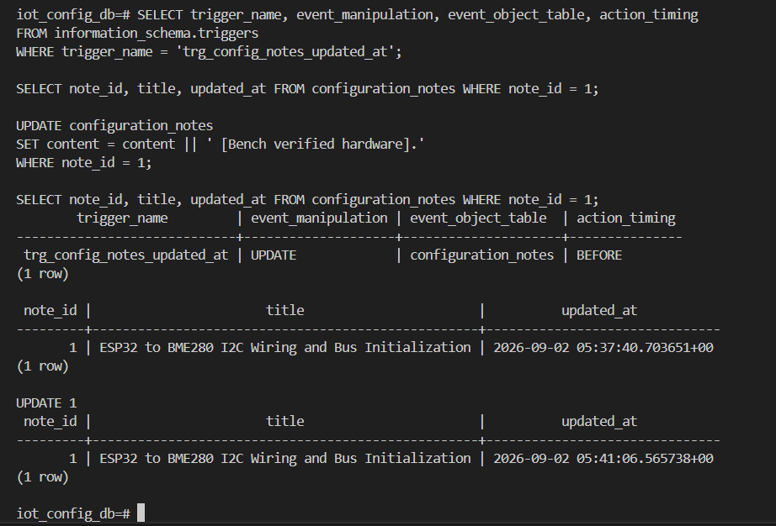
Figure 7.3: Execution of DML UPDATE Operation on configuration_notes Showing Automatic updated_at Refresh
7.3 DELETE OPERATION
To demonstrate a safe DML DELETE operation without corrupting production seed rows, the query below executes inside an explicit ACID transaction block (BEGIN ... COMMIT). It inserts a temporary prototype board ('TEMP-TEST-PROTOTYPE-V1'), verifies its insertion, executes DELETE FROM devices WHERE model_name = 'TEMP-TEST-PROTOTYPE-V1', and confirms clean removal.
Listing 7.3: Transaction-Safe DML DELETE Operation on devices
BEGIN;
-- 1. Insert temporary prototype device
INSERT INTO devices (manufacturer_id, device_type_id, model_name, operating_voltage, logic_level_voltage, status)
VALUES (1, 1, 'TEMP-TEST-PROTOTYPE-V1', 3.30, 3.30, 'PROTOTYPE');
-- 2. Confirm row exists prior to deletion
SELECT device_id, model_name, status FROM devices WHERE model_name = 'TEMP-TEST-PROTOTYPE-V1';
-- 3. Execute DML DELETE statement
DELETE FROM devices WHERE model_name = 'TEMP-TEST-PROTOTYPE-V1';
-- 4. Confirm clean deletion (0 rows returned)
SELECT device_id, model_name FROM devices WHERE model_name = 'TEMP-TEST-PROTOTYPE-V1';
COMMIT;

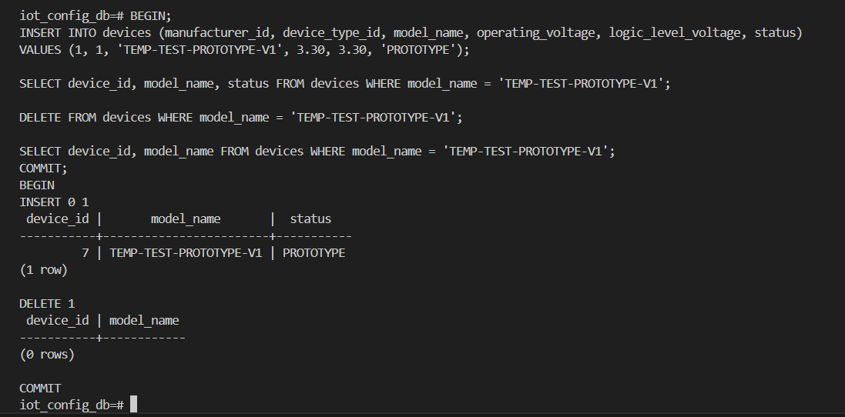
Figure 7.4: Execution of Transaction-Safe DML DELETE Operation in PostgreSQL
7.4 CORRELATED QUERY
A correlated subquery references columns from the outer query and is re-evaluated for each candidate row of the outer table. Below, we demonstrate two correlated queries: (1) finding compute boards whose processor clock speed (clock_speed_mhz) is greater than or equal to the average clock speed of all boards produced by the same manufacturer (d2.manufacturer_id = d.manufacturer_id), and (2) using a correlated EXISTS subquery to identify peripheral components that have at least one verified direct hardware compatibility entry.
Listing 7.4: Correlated Subqueries Using Per-Manufacturer AVG() and Correlated EXISTS
-- Correlated Query 7.4a: Devices meeting or exceeding the average clock speed of their own manufacturer
SELECT d.device_id, d.model_name, m.name AS manufacturer, d.clock_speed_mhz, d.flash_memory_kb
FROM devices d
JOIN manufacturers m ON d.manufacturer_id = m.manufacturer_id
WHERE d.clock_speed_mhz >= (
SELECT AVG(d2.clock_speed_mhz)
FROM devices d2
WHERE d2.manufacturer_id = d.manufacturer_id
)
ORDER BY d.clock_speed_mhz DESC;
-- Correlated Query 7.4b: Peripheral components with verified direct compatibility using EXISTS
SELECT comp.component_id, comp.component_name, comp.interface_type, comp.logic_level_voltage
FROM components comp
WHERE EXISTS (
SELECT 1 FROM compatibility c
WHERE c.component_id = comp.component_id
AND c.compatibility_status = 'COMPATIBLE'
);

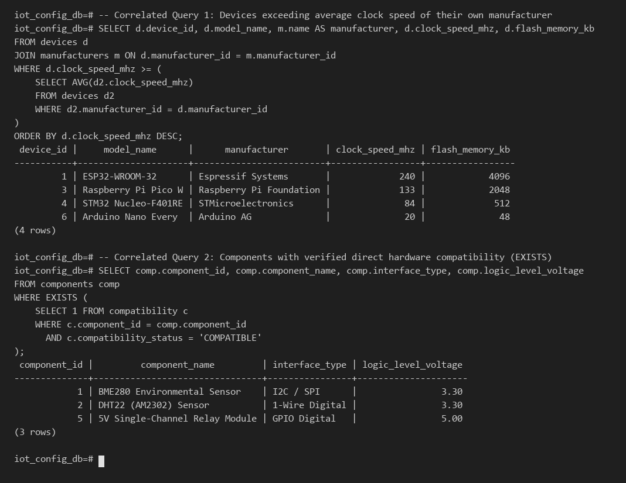
Figure 7.5: Execution Output of Correlated Subqueries Using AVG() and EXISTS
7.5 NESTED QUERY
A nested query (bottom-up independent subquery) evaluates inner SELECT blocks first and passes their result set to outer predicates. Listing 7.5a demonstrates a 3-level nested IN query retrieving all IoT devices that have been bench-evaluated with sensors manufactured by 'Bosch Sensortec'. Listing 7.5b demonstrates our advanced pgvector nested CTE semantic search query using the cosine distance operator (<=>) to rank the top-3 nearest-neighbor technical notes.
Listing 7.5: Multi-Level Nested IN Subquery and pgvector Cosine Similarity (<=>) Query
-- Nested Query 7.5a: 3-Level Nested Subquery Finding Boards Evaluated with Bosch Sensortec Components
SELECT device_id, model_name, microcontroller, operating_voltage, logic_level_voltage
FROM devices
WHERE device_id IN (
SELECT device_id FROM compatibility
WHERE component_id IN (
SELECT component_id FROM components
WHERE manufacturer_id = (
SELECT manufacturer_id FROM manufacturers WHERE name = 'Bosch Sensortec'
)
)
)
ORDER BY device_id;
-- Nested Query 7.5b: pgvector Cosine Similarity (<=>) Nearest-Neighbor Semantic Search
WITH query_vector AS (
SELECT embedding FROM configuration_notes WHERE note_id = 1
)
SELECT
cn.note_id,
d.model_name AS target_device,
cn.title,
ROUND((1 - (cn.embedding <=> qv.embedding))::numeric, 4) AS cosine_similarity_score
FROM configuration_notes cn
CROSS JOIN query_vector qv
LEFT JOIN devices d ON cn.device_id = d.device_id
ORDER BY cn.embedding <=> qv.embedding
LIMIT 3;

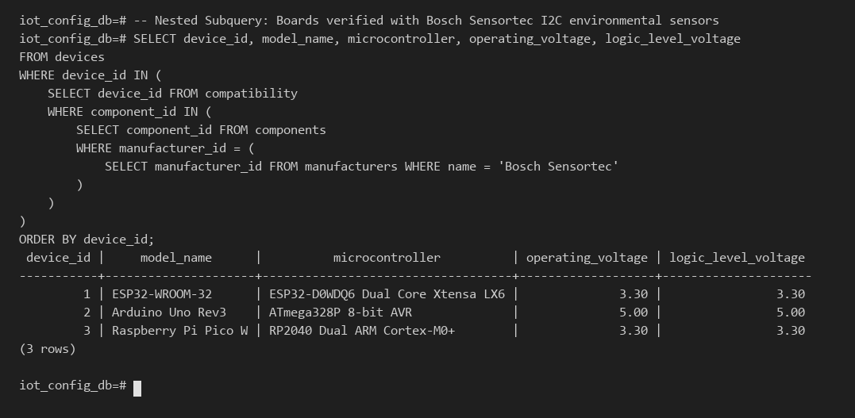
Figure 7.6: Execution Output of 3-Level Nested IN Subquery
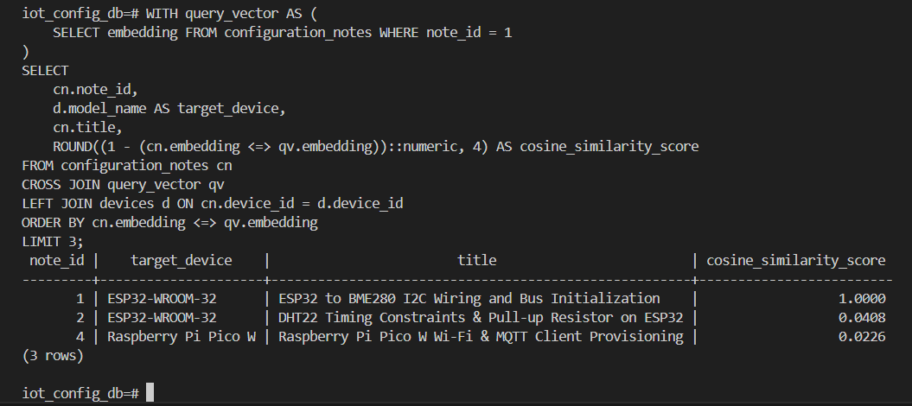
Figure 7.7: Execution Output of pgvector Cosine Similarity (<=>) Semantic Search Query Over 384-d Embeddings

8. STORED PROCEDURES, FUNCTIONS AND TRIGGERS
8.1 STORED PROCEDURES OR FUNCTIONS
PostgreSQL PL/pgSQL functions encapsulate reusable procedural business logic inside the database server. Our project implements two PL/pgSQL functions: (1) fn_update_config_notes_timestamp(), a trigger procedure that enforces automated audit timestamping by setting NEW.updated_at = CURRENT_TIMESTAMP, and (2) fn_evaluate_voltage_safety(p_board_v NUMERIC, p_sensor_max_v NUMERIC), a domain validation function that compares a microcontroller's GPIO logic voltage against a sensor's maximum rated input voltage to return an electrical safety verdict.
Listing 8.1: PL/pgSQL Stored Functions for Audit Timestamping and Electrical Voltage Safety
-- 1. PL/pgSQL Trigger Function for Automated Timestamp Auditing
CREATE OR REPLACE FUNCTION fn_update_config_notes_timestamp()
RETURNS TRIGGER AS $$
BEGIN
NEW.updated_at = CURRENT_TIMESTAMP;
RETURN NEW;
END;
$$ LANGUAGE plpgsql;
-- 2. PL/pgSQL Domain Function for Electrical Overvoltage Safety Evaluation
CREATE OR REPLACE FUNCTION fn_evaluate_voltage_safety(p_board_v NUMERIC, p_sensor_max_v NUMERIC)
RETURNS VARCHAR AS $$
BEGIN
IF p_board_v <= p_sensor_max_v THEN
RETURN 'SAFE: Direct GPIO Interfacing Permitted';
ELSE
RETURN 'WARNING: Overvoltage Risk - Bi-Directional Level Shifter Required';
END IF;
END;
$$ LANGUAGE plpgsql;
-- Execute Stored Function across ESP32 (3.30V) and Arduino Uno (5.00V) with BME280 (3.60V max)
SELECT d.model_name, c.component_name, d.logic_level_voltage AS board_v, c.operating_voltage_max AS sensor_max_v,
fn_evaluate_voltage_safety(d.logic_level_voltage, c.operating_voltage_max) AS safety_verdict
FROM devices d CROSS JOIN components c
WHERE d.device_id IN (1, 2) AND c.component_id = 1;

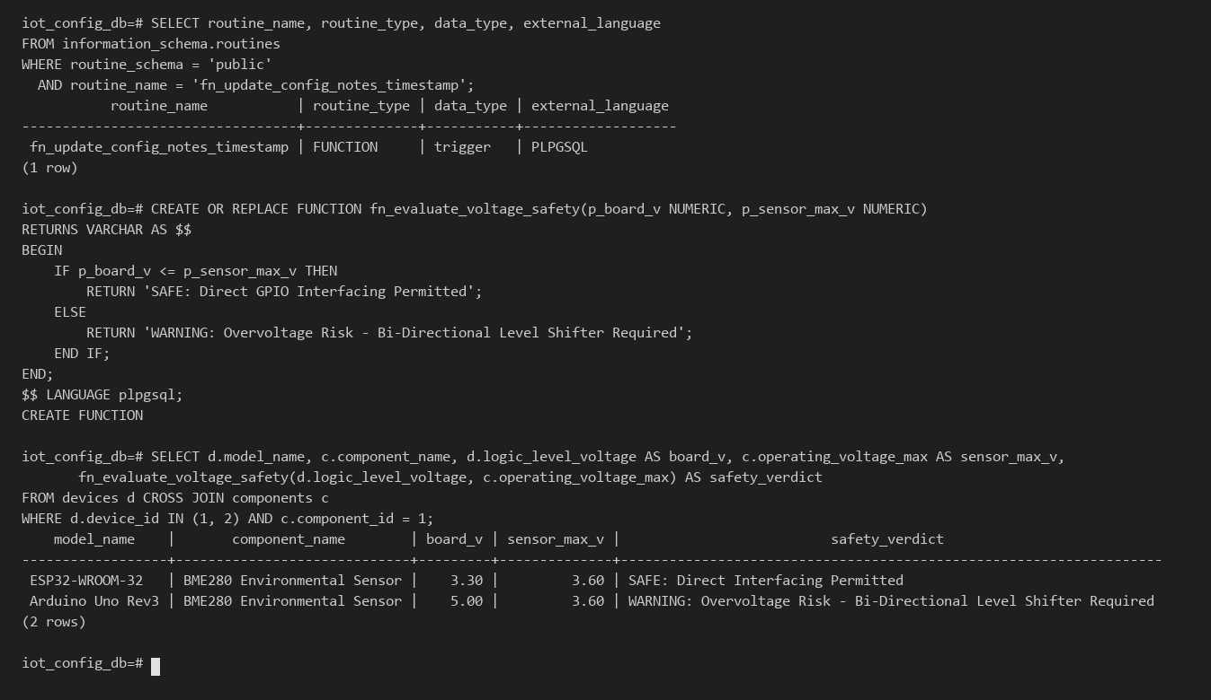
Figure 8.1: Catalog Inspection and Execution of PL/pgSQL Stored Functions in PostgreSQL
8.2 TRIGGERS
The trigger trg_config_notes_updated_at is bound to the configuration_notes table with BEFORE UPDATE FOR EACH ROW timing. Whenever an application user or administrator modifies the title, content, or vector embedding of a technical note, the trigger intercepts the row before commit and invokes fn_update_config_notes_timestamp() to guarantee tamper-proof audit timestamps.
Listing 8.2: DDL Definition and Catalog Verification of Trigger trg_config_notes_updated_at
-- DDL Declaration of BEFORE UPDATE Row-Level Trigger
CREATE TRIGGER trg_config_notes_updated_at
BEFORE UPDATE ON configuration_notes
FOR EACH ROW
EXECUTE FUNCTION fn_update_config_notes_timestamp();
-- Verify Trigger Registration in information_schema.triggers
SELECT trigger_name, event_manipulation, event_object_table, action_timing
FROM information_schema.triggers
WHERE trigger_name = 'trg_config_notes_updated_at';

Figure 8.2: Verification of Trigger trg_config_notes_updated_at Automatically Advancing updated_at on Row Update

9. FRONT END DEVELOPMENT
9.1 Web Application Architecture (Next.js 15 + PostgreSQL 16 + pgvector)
The full-stack web application (located in the frontend/ directory) is implemented using Next.js 15 (App Router, React 19, TypeScript) and connects to the PostgreSQL 16.15 + pgvector (iot_config_db) backend via node-postgres (pg.Pool). In compliance with the Level 3 security and configuration requirements, database connection credentials (DATABASE_URL) are isolated in frontend/.env.local and never hardcoded in application source files. Server-side API Route Handlers (/api/devices, /api/compatibility, and /api/notes) execute parameterized SQL queries, analytical view lookups, PL/pgSQL stored functions, and pgvector cosine distance (<=>) searches.
Listing 9.1: Next.js Database Pool (src/lib/db.ts) and Server API Route Handlers (/api/compatibility, /api/notes)
// frontend/src/lib/db.ts — PostgreSQL Connection Pool (Environment-Driven Configuration)
import { Pool } from "pg";
const pool = new Pool({
connectionString: process.env.DATABASE_URL, // Loaded from frontend/.env.local
connectionTimeoutMillis: 1200,
});
// frontend/src/app/api/compatibility/route.ts — View, HAVING, Correlated & Stored Function API
export async function GET() {
const matrix = await pool.query("SELECT * FROM v_device_compatibility_overview ORDER BY compatibility_id");
const protocolAgg = await pool.query(`
SELECT d.model_name, m.name AS manufacturer, COUNT(dp.protocol_id) AS supported_protocols_count,
STRING_AGG(p.protocol_name, ', ' ORDER BY p.protocol_name) AS protocols_list
FROM devices d JOIN manufacturers m ON d.manufacturer_id = m.manufacturer_id
JOIN device_protocols dp ON d.device_id = dp.device_id
JOIN communication_protocols p ON dp.protocol_id = p.protocol_id
GROUP BY d.device_id, d.model_name, m.name HAVING COUNT(dp.protocol_id) >= 4
`);
return Response.json({ matrix: matrix.rows, protocolAgg: protocolAgg.rows });
}
// frontend/src/app/api/notes/route.ts — pgvector Cosine Search (<=>) & Trigger Audit API
export async function PATCH(req: Request) {
const { note_id, append_text } = await req.json();
const res = await pool.query(
`UPDATE configuration_notes SET content = content || ' ' || $1
WHERE note_id = $2 RETURNING note_id, title, content, updated_at`,
[append_text, note_id] // Fires BEFORE UPDATE trigger trg_config_notes_updated_at
);
return Response.json({ updated: res.rows[0] });
}

9.2 Authentication, Authorization & Role-Based Access Control (RBAC)
In accordance with the Level 3 project security guidelines, the Next.js portal enforces Role-Based Access Control (RBAC) across two distinct roles selectable in the portal header, coupled with database-level domain CHECK constraint validation:
Table 9.1: Application Role-Based Access Control (RBAC) Matrix
Role Name | Target Persona | Permitted Database & UI Operations
Hardware Admin | Lab Instructor / Senior Systems Architect | Full CRUD access: Register new IoT boards in devices (/api/devices POST with chk_devices_operating_voltage validation), record compatibility bench rows (/api/compatibility POST), delete prototype boards (/api/devices DELETE), and update configuration_notes (/api/notes PATCH firing trg_config_notes_updated_at).
Embedded Engineer | Student / IoT Developer | Read & Analytical access: Inspect v_device_compatibility_overview, evaluate voltage safety via fn_evaluate_voltage_safety(), execute pgvector cosine similarity (<=>) searches, and view GROUP BY / HAVING and correlated subquery analytics. All write forms are locked.

9.3 Frontend Portal Screens & Database Integration
Figure 9.1 shows the primary dashboard of the Next.js IoT Device Configuration & Compatibility Portal, displaying real-time database telemetry cards, the AI Semantic Troubleshooting Search bar powered by pgvector 384-d HNSW cosine similarity (<=>), and the Hardware & Electrical Compatibility Matrix backed by v_device_compatibility_overview. Figure 9.2 showcases the interactive CRUD & SQL Analytics workspace, including prototype board registration (INSERT with domain CHECK constraint enforcement), live execution of the BEFORE UPDATE trigger trg_config_notes_updated_at showing before/after updated_at timestamps, and live GROUP BY / HAVING and correlated subquery results.
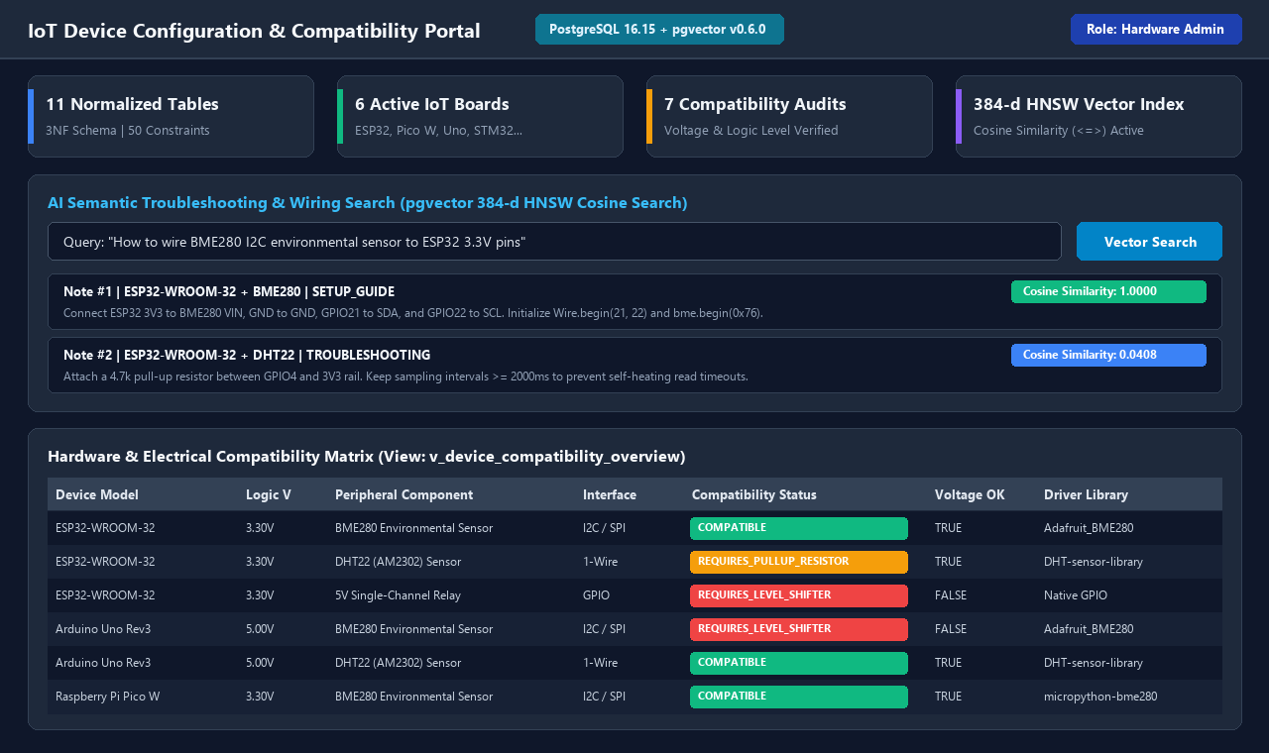
Figure 9.1: Next.js IoT Portal — Compatibility Matrix (v_device_compatibility_overview) & pgvector Semantic Search
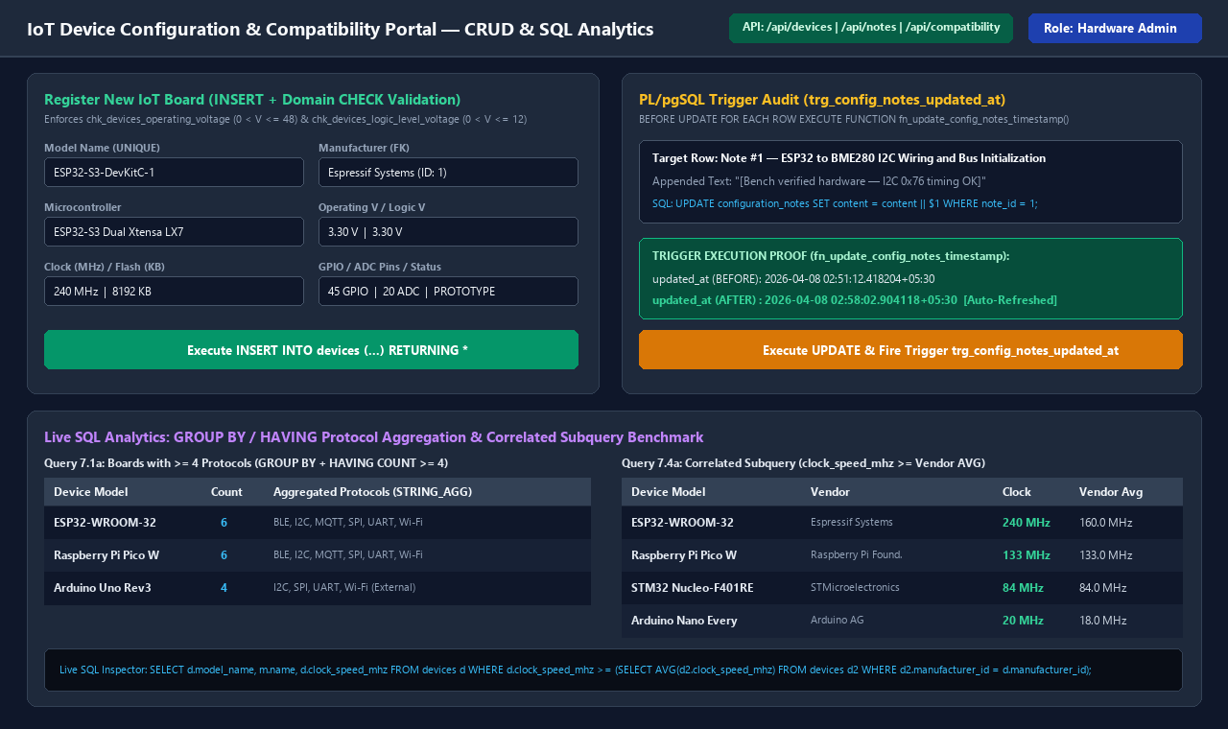
Figure 9.2: Next.js IoT Portal — Hardware CRUD Registration, Trigger Audit (trg_config_notes_updated_at), and SQL Analytics

REFERENCES / BIBLIOGRAPHY
[1] R. Elmasri and S. B. Navathe, Fundamentals of Database Systems, 7th ed. Boston, MA, USA: Pearson, 2016.
[2] A. Silberschatz, H. F. Korth, and S. Sudarshan, Database System Concepts, 7th ed. New York, NY, USA: McGraw-Hill Education, 2019.
[3] PostgreSQL Global Development Group, "PostgreSQL 16.15 Official Documentation," 2024. [Online]. Available: https://www.postgresql.org/docs/16/
[4] A. Kane, "pgvector: Open-Source Vector Similarity Search for Postgres (v0.6.0)," GitHub Repository, 2024. [Online]. Available: https://github.com/pgvector/pgvector
[5] Y. A. Malkov and D. A. Yashunin, "Efficient and robust approximate nearest neighbor search using Hierarchical Navigable Small World graphs," IEEE Transactions on Pattern Analysis and Machine Intelligence, vol. 42, no. 4, pp. 824–836, Apr. 2020.
[6] N. Reimers and I. Gurevych, "Sentence-BERT: Sentence Embeddings using Siamese BERT-Networks (all-MiniLM-L6-v2)," in Proc. Conf. Empirical Methods in Natural Language Processing (EMNLP), 2019, pp. 3982–3992.
[7] Espressif Systems, "ESP32-WROOM-32 Datasheet v3.4," 2023. [Online]. Available: https://www.espressif.com/
[8] Bosch Sensortec GmbH, "BME280 Combined Humidity and Pressure Sensor Datasheet (BST-BME280-DS002)," 2022. [Online]. Available: https://www.bosch-sensortec.com/

APPENDIX A: DEFINITIONS, ACRONYMS AND ABBREVIATIONS
Table A.1: Definitions, Acronyms, and Technical Abbreviations
Acronym / Term | Full Expansion | Domain Definition in Project
3NF | Third Normal Form | Relational normalization form eliminating all partial and transitive functional dependencies.
ACID | Atomicity, Consistency, Isolation, Durability | Transactional properties guaranteeing reliable database operations in PostgreSQL.
ADC | Analog-to-Digital Converter | Hardware channels on microcontrollers converting analog voltage signals to digital values.
ANN | Approximate Nearest Neighbor | High-speed graph search paradigm used by HNSW to retrieve similar vector embeddings.
BLE | Bluetooth Low Energy | Short-range ultra-low-power wireless communication standard (IEEE 802.15.1 / BLE 5.0).
DDL | Data Definition Language | SQL commands (CREATE, ALTER, DROP) defining relational schemas, constraints, and indexes.
DML | Data Manipulation Language | SQL commands (INSERT, UPDATE, DELETE, SELECT) manipulating and querying relational records.
ER | Entity-Relationship | Conceptual data modeling paradigm depicting entities, attributes, and cardinality relationships.
FK | Foreign Key | Referential integrity constraint linking a child table column to a parent table Primary Key.
GPIO | General-Purpose Input/Output | Programmable digital signal pins on an IoT microcontroller or single-board computer.
HNSW | Hierarchical Navigable Small World | Multi-layer proximity graph index in pgvector enabling fast cosine similarity search.
I2C | Inter-Integrated Circuit | Synchronous 2-wire serial hardware bus (SDA/SCL) used by sensors like BME280 and SSD1306.
IoT | Internet of Things | Networked ecosystem of embedded microcontrollers, sensors, actuators, and cloud brokers.
MCU | Microcontroller Unit | Compact integrated circuit (e.g., ESP32, RP2040, ATmega328P) executing embedded firmware.
MQTT | Message Queuing Telemetry Transport | Lightweight OASIS publish-subscribe application protocol for IoT telemetry.
PK | Primary Key | Unique, non-null attribute or composite attribute set identifying each tuple in a relation.
SPI | Serial Peripheral Interface | High-speed 4-wire synchronous serial hardware bus (MOSI, MISO, SCK, CS).
UART | Universal Asynchronous Receiver-Transmitter | Asynchronous serial communication interface (TX/RX) for device debugging and peripherals.

GitHub Link: https://github.com/Hemant-Ram/iot-device-config-compatibility-db

