Lab 3 – Architectural Pattern Selection
Alumni Mentorship & Mock Interview Platform
Student: HEMANT RAM NELAPATI | SRN: PES2UG24CS192

1. Architecture Selection
We chose the Layered (Three-Tier) Architecture for the Alumni Mentorship & Mock Interview Platform. The system is decoupled into three cohesive tiers — Presentation, Business Logic, and Data Persistence — where each tier communicates strictly with adjacent layers through well-defined interfaces.
2. Reason 1: Shared Domain Logic Across Distinct Role Portals
The platform serves two primary actor classes — Student Mentees and Alumni Mentors — each requiring dedicated user interfaces with divergent workflows (mentee discovery vs. mentor availability management). However, both portals operate over unified business rules: authentication, RBAC, matching workflows, session tracking, and interview scheduling. Layered architecture cleanly isolates role-specific presentation concerns while consolidating shared domain logic into reusable business components, eliminating duplicate code and preventing logic drift.
3. Reason 2: Transactional Integrity Across Coupled Operations
A mock interview workflow is inherently transactional: booking a slot requires simultaneously verifying mentor availability, reserving the calendar interval, generating a session record, and queuing notifications. A centralized data access layer backed by ACID-compliant relational transactions guarantees consistency and prevents concurrency hazards such as double-booking. In contrast, distributed microservice data stores would necessitate complex two-phase commits or eventual-consistency saga orchestrations disproportionate to this application.
4. Security Advantage: Centralized Role-Based Access Control (RBAC)
The Business Logic Layer functions as a single, authoritative security boundary. All incoming requests from both portals must traverse the Authentication & User Management component before reaching mentorship or scheduling services. This choke point centralizes token validation and RBAC enforcement, ensuring students cannot alter alumni schedules and alumni cannot view unauthorized mentee records. This eliminates the sprawling attack surface and inter-service token propagation vulnerabilities inherent in microservice architectures.
5. Performance Advantage: Zero-Latency In-Process Communication
All inter-component collaborations within the business tier execute as direct in-process method invocations rather than serialized HTTP/REST or gRPC network calls. A student search and booking request traverses authentication, matching, scheduling, and database access within a unified runtime context, delivering sub-second response times. For campus-scale traffic (hundreds to low thousands of concurrent users), in-process communication avoids API gateway latencies, network serialization overhead, and the operational complexity of distributed service meshes.
Architectural Pattern Comparison Summary
Evaluation Criterion | Layered (Selected) | Microservices | Client-Server
Separation of Concerns | High (Clean 3-Tier Separation) | High (Per-Service Boundaries) | Low (Monolithic Server)
Deployment & Ops Complexity | Low (Single Unified Package) | Very High (Mesh & Orchestration) | Low (Single Monolith)
Security & RBAC Enforcement | Centralized Enforcement Point | Distributed / Multi-Gateway | Centralized but Monolithic
Data Consistency (ACID) | High (Central Relational ACID) | Low (Eventual Consistency / Sagas) | High (Central Relational ACID)
Performance (Campus Scale) | Optimal (In-Process Execution) | Moderate (Network Latency) | High (Direct Server Invocations)

UML Component Diagram
Alumni Mentorship & Mock Interview Platform | Layered (Three-Tier) Architecture
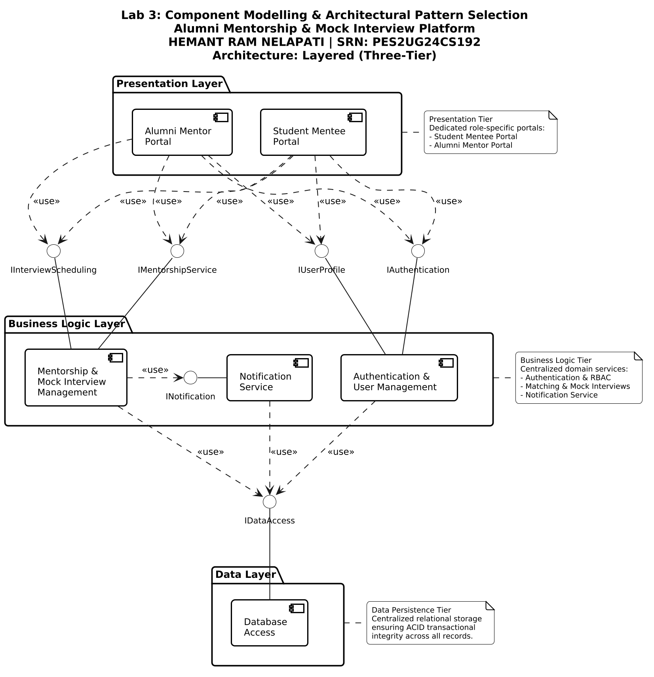
Component & Interface Traceability Matrix
Layer / Tier | Components (6 Total) | Provided Interfaces | Required Interfaces
Presentation Tier | Student Mentee Portal  Alumni Mentor Portal | None (Client Portals) | IAuthentication, IUserProfile,  IMentorshipService, IInterviewScheduling
Business Logic Tier | Authentication & User Management  Mentorship & Mock Interview Mgmt  Notification Service | IAuthentication, IUserProfile,  IMentorshipService, IInterviewScheduling,  INotification | INotification (MIM -> NOTIF),  IDataAccess (AUTH, MIM, NOTIF -> DB)
Data Persistence Tier | Database Access | IDataAccess | None (Relational Storage Engine)

