# **DAYANANDA SAGAR UNIVERSITY**

Devarakaggalahalli, Harohalli

Kanakapura Road, Ramanagara - 562112, Karnataka, India

**BACHEOR OF COMPUTER SCIENCE AND TECHNOLOGY**

**IN**

**(Artificial Intelligence & Machine Learning)**

**ESD – MINI PROJECT**

**(22AM2404)**

**Soil Moisture Sensor with Arduino.**

**By**

**YOGESH N (ENG22AM0070)**

**HEMANG SINGH SENGAR (ENG22AM0097)**

**HENA BASHEER (ENG22AM0098)**

**RITVIK VASUNDH (ENG22AM0125)**

**Under the supervision of**

Prof. PRADEEP KUMAR **Assistant Professor, CSE (AI &ML)**

Prof. ABHINAV KARAN **Assistant Professor, CSE**

Dr**.** MUDE NAGARJUNA NAIK **Assistant Professor, CSE (AI & ML)**

**DEPARTMENT OF COMPUTER SCIENCE & ENGINEERING(AI&ML)**

#### SCHOOL OF ENGINEERING

#### DAYANANDA SAGAR UNIVERSITY, BANGALORE

**(2023-2024)**

**Day****ananda Sagar University**

**School of Engineering**

**Department of Computer Science & Engineering**

**(Artificial Intelligence & Machine Learning)**

**Devarakaggalahalli, Harohalli, Kanakapura Road, Ramanagara - 562112, Karnataka, India**

# CERTIFICATE

This is to certify that the ESD-Mini Project (22AM2404) work titled **“Soil Moisture Sensor with Arduino.”** is carried out by **Yogesh N** bearing **USN :ENG22AM0070,Hemang Singh Sengar bearing USN:ENG22AM0097 , Hena Basheer bearing USN:ENG22AM0098,Ritvik Vasundh (ENG22AM0125)** Bonafede students of Bachelor of Technology in Computer Science and Engineering (AI&ML) at the School of Engineering, Dayananda Sagar University, Bangalore in partial fulfillment for the award of degree in Bachelor of Technology in Computer Science and Engineering, during the year **2023-2024**.

Prof. Abhinav Karan

Assistant Professor

Dept. of CSE,

School of Engineering

Dayananda Sagar University

Date: 27-05-2024

Prof. Pradeep Kumar K

Assistant Professor

Dept. of CSE (AI&ML),

School of Engineering

Dayananda Sagar University

Date: 27-05-2024

Dr. Jayavrinda Vrindavanam V

Chairman CSE (AI&ML)

School of Engineering

Dayananda Sagar University

Date: 27-05-2024

Dr. Mude Nagarjuna Naik

Assistant Professor

Dept. of CSE (AI&ML),

School of Engineering

Dayananda Sagar University

Date: 27-05-2024

**DECLARATION**

We, Yogesh N, Hemang Singh Sengar, Hena Basheer and Ritvik Vasundh, students of fourth semester B. Tech in Computer Science and Engineering with specialization in Artificial intelligence and machine learning , at School of Engineering, Dayananda Sagar University, hereby declare that the ESD-Mini project titled “**Soil Moisture Sensor with Arduino**” has been carried out by us and submitted to Prof. Pradeep Kumar during the academic year 2023-2024.

Student 1: Signature:   
Name: Yogesh N  
USN: ENG22AM0070

Student 2: Signature:   
Name: Hemang Singh Sengar  
USN: ENG22AM0097

Student 3: Signature:   
Name: Hena Basheer  
USN: ENG22AM0098

Student 4: Signature:   
Name: Ritvik Vasundh  
USN: ENG22AM0125

**ACKNOWLEDGEMENT**

*It is a great pleasure for me to acknowledge the assistance and support of many individuals who have been responsible for the successful completion of this project work.*

*First, I take this opportunity to express my sincere gratitude to School of Engineering & Technology, Dayananda Sagar University for providing us with a great opportunity to pursue our Bachelor’s degree in this institution.*

*I would like to thank* ***Dr. Udaya Kumar Reddy K R, Dean, School of Engineering & Technology, Dayananda Sagar University*** *for his constant encouragement and expert advice.*

*It is a matter of immense pleasure to express our sincere thanks to* ***Dr. Jayvrinda Vrindavanam v, Department Chairman****,* ***Computer Science and Engineering(AI&ML)****,* ***Dayananda Sagar University,*** *for providing right academic guidance that made the task possible.*

*I would like to thank our guides* ***Prof. Pradeep Kumar K, Prof. Abhinav Karan, Dr. Mude Nagarjuna Naik,******Assistant Professors****,* ***Dept. of Computer Science and Engineering (AI&ML)****,* ***Dayananda Sagar University****, for sparing his valuable time to extend help in every step of the project work, which paved the way for smooth progress and fruitful culmination of the project.*

*I am also grateful to my family and friends who provided me with every requirement throughout the course.*

*I would like to thank one and all who directly or indirectly helped me in the Project work.*

**INDEX**

ABSTRACT --------------------------------------------------- 06

LIST OF FIGURES------------------------------------------- 07

INTRODUCTION -------------------------------------------- 08

COMPONENTS OVERVIEW ------------------------------ 09  
DEVICE OPERATION -------------------------------------- 12

CIRCUIT DIAGRAM ---------------------------------------- 14

CODE IMPLEMENTATION & RESULT ---------------- 16

CONCLUSION ------------------------------------------------- 17

REFERENCES -------------------------------------------------- 18

**LIST OF FIGURES**

|  |  |
| --- | --- |
| Fig.1 | Soil Moisture Sensor Set-up |
| Fig.2 | Soil Moisture Sensor Pinout Diagram |
| Fig.3 | Soil Moisture Sensor Module Component Diagram |
| Fig.4 | Circuit Diagram |
| Fig.5 | Result |

**ABSTRACT**

This project explores the integration of a soil moisture sensor with an Arduino microcontroller to monitorand assess soil moisture levels. The system consists of a sensor probe with two conductive pads and an electronic module that processes the data. The sensor features four pins: VCC for power, GND for grounding, Aout for analog output, and Dout for digital output. By embedding the probe in the soil, the sensor measures the electrical conductivity, which varies with moisture content. The analog and digital signals from the sensor are fed to the Arduino, which processes the data and outputs it for monitoring. An Arduino code is implemented to read analog values from the sensor, map the data for better visualization, and control an LED to indicate moisture levels. This project demonstrates a practical application of soil moisture sensing in agriculture, enabling efficient water usage and

**INTRODUCTION**

Efficient water management is essential in modern agriculture and gardening to ensure optimal plant growth and conserve resources. Traditional methods for assessing soil moisture can be both time-consuming and inaccurate, often resulting in overwatering or underwatering. To overcome these challenges, integrating technology into soil moisture monitoring provides a precise and automated solution.

This project centers on developing a soil moisture monitoring system using an Arduino microcontroller and a soil moisture sensor. The sensor comprises two main components: a probe with conductive pads that measure soil moisture by detecting changes in electrical conductivity, and an electronic module that processes this data into analog and digital signals.

By connecting the soil moisture sensor to the Arduino, we can continuously monitor soil moisture levels and make informed irrigation decisions. The Arduino code reads analog values from the sensor, maps the data to a more user-friendly format, and controls an LED indicator to visually represent the soil moisture status. This automated system enhances water usage efficiency and ensures plants receive the right amount of water, promoting sustainable agricultural practices.

This project demonstrates the practical application of soil moisture sensors and Arduino technology in creating an effective soil moisture monitoring system, highlighting its potential benefits for agriculture and gardening.

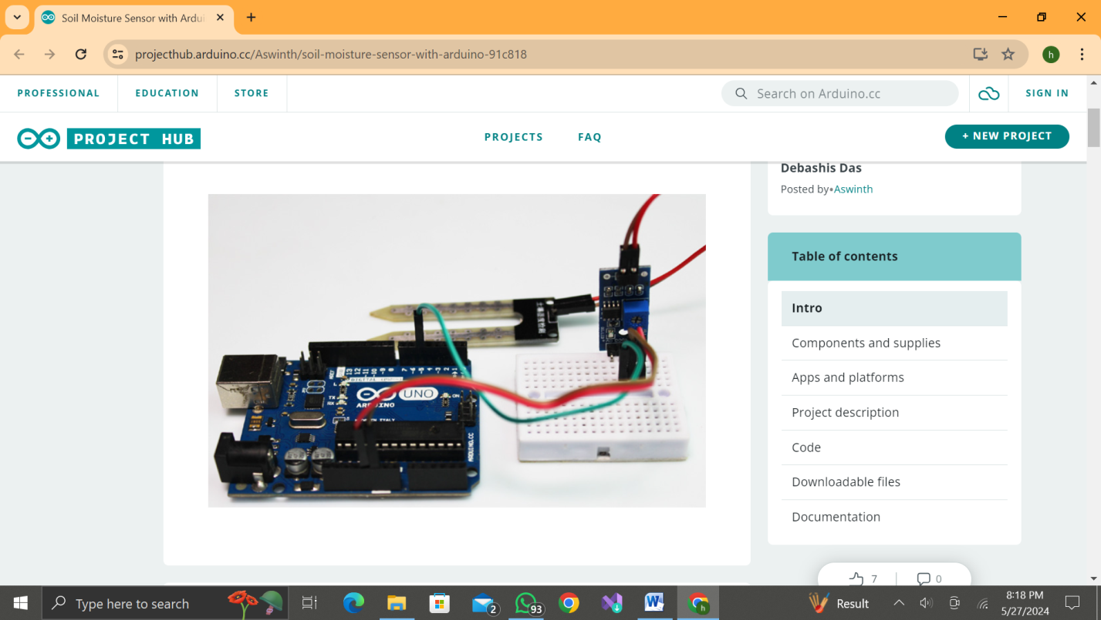

**Fig.1. Soil Moisture Sensor Set-up**

**COMPONENTS OVERVIEW**

**1. Arduino Board**

The Arduino board is a key component in this project, serving as the central microcontroller that reads data from the sensor and processes it for output. We use the Arduino Uno, a popular choice due to its ease of use and versatility. The Arduino Uno features 14 digital input/output pins, 6 analog inputs, a 16 MHz ceramic resonator, a USB connection, a power jack, an ICSP header, and a reset button. It operates at 5V and is capable of interfacing with a wide range of sensors and actuators, making it ideal for prototyping and educational purposes.

2.**Sensor Probe**

The sensor probe used in this project is designed to measure the soil's moisture content. It consists of two large conductive pads made typically from corrosion-resistant metals such as copper, which are plated with a protective coating to prevent degradation over time. These pads act as electrodes that detect the soil's electrical conductivity, which varies with moisture levels. When inserted into the soil, the probe measures how easily electricity can pass between the two pads; higher moisture levels result in higher conductivity, and lower moisture levels result in lower conductivity.

**3.Electronic Module**

The electronic module is the brain of the sensor system, converting the raw data from the sensor probe into a form that the Arduino can interpret. This module typically includes an operational amplifier (op-amp) to process the analog signals from the probe and a comparator to convert the analog signal into a digital output. The module has four pins: VCC (power), GND (ground), Aout (analog output), and Dout (digital output). The analog output provides a continuous voltage that varies with soil moisture levels, while the digital output provides a binary indication (wet or dry) based on a predefined threshold.

**4.Connecting Wires**

The connecting wires play a crucial role in linking all components together, ensuring the transmission of power and data. In this project, we use standard male-to-female jumper wires, which are flexible and easy to use with the Arduino's pin headers. These wires connect the VCC and GND pins of the sensor to the 5V and GND pins on the Arduino, respectively. The Aout pin of the sensor is connected to one of the Arduino's analog input pins (A0), while the Dout pin is connected to a digital input pin, allowing the Arduino to read both the analog and digital signals from the sensor.

Together, these components form a cohesive system that effectively monitors soil moisture levels, providing valuable data for efficient water management in agricultural and gardening applications.

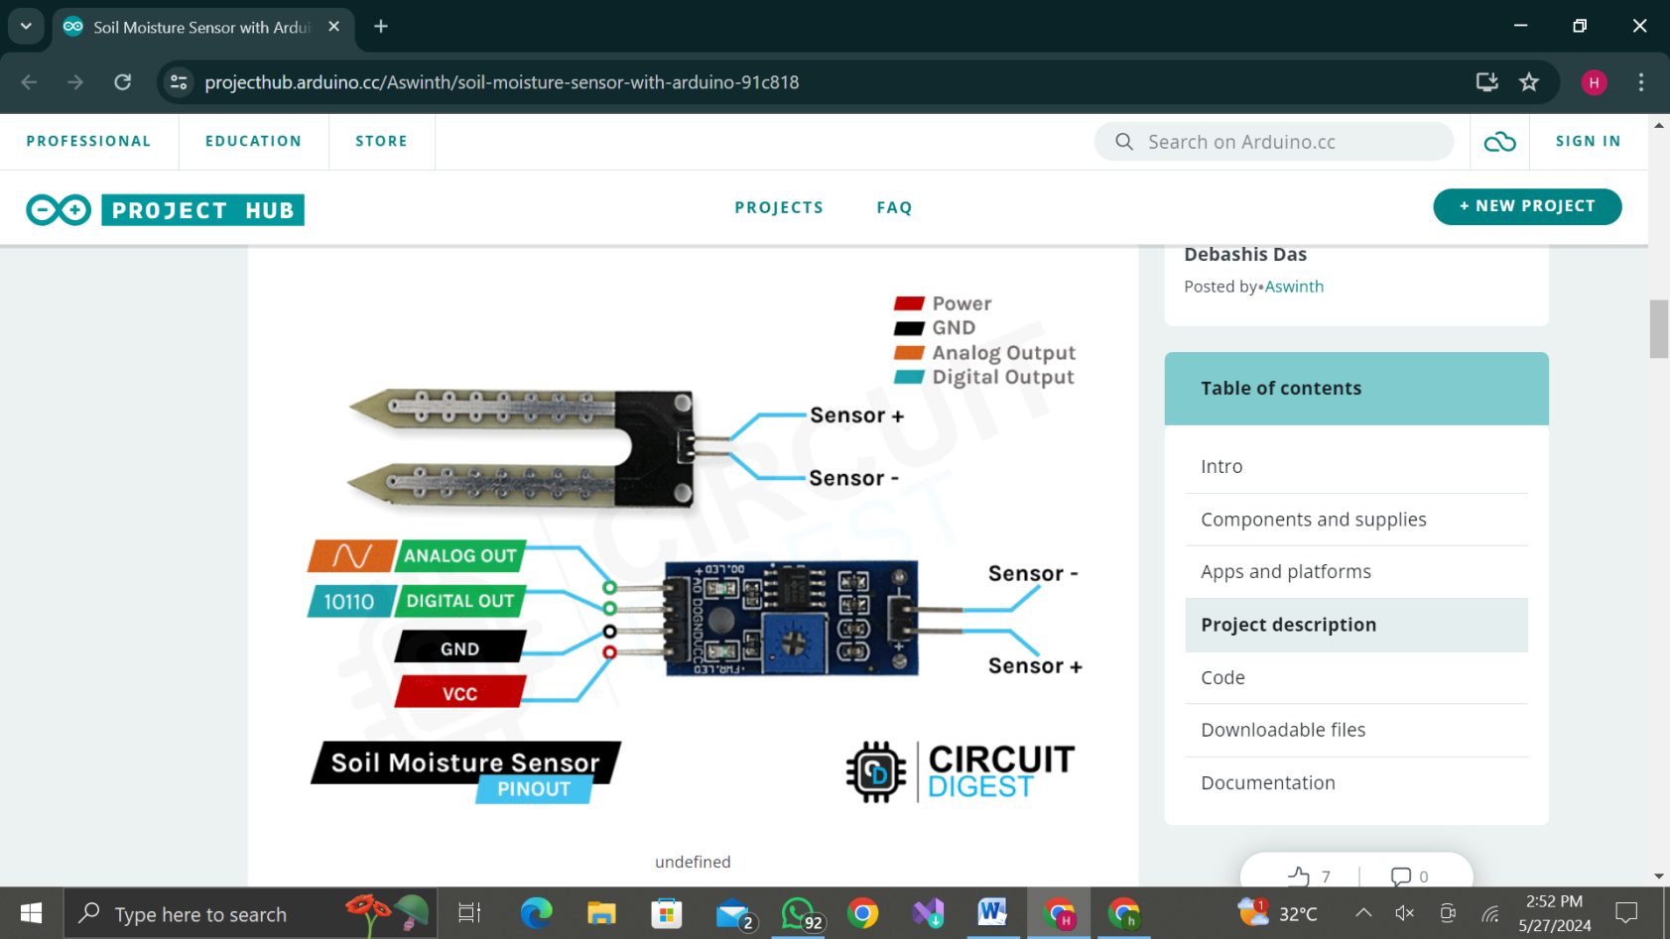

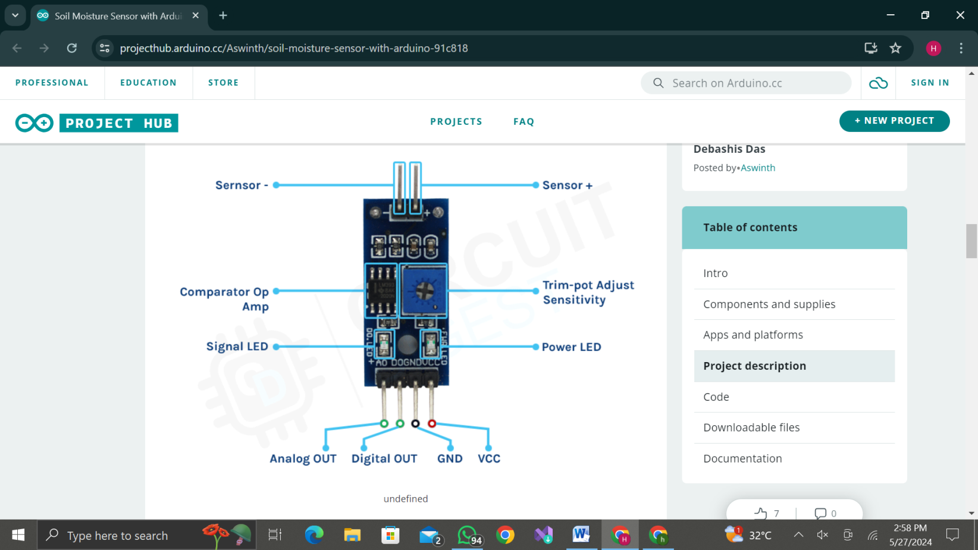 **Fig.2. Soil moisture Sensor Pinout Diagram**

**Fig.3. Soil Moisture Sensor Module Component Diagram**

**Device Operation**

The Soil Moisture Sensor with Arduino project operates by continuously monitoring soil moisture levels and providing real-time data to inform irrigation decisions. Here’s a detailed explanation of how the device works, including how to connect the components.

**Sensor Probe Operation**

The sensor probe, equipped with two conductive pads made of corrosion-resistant materials, is inserted into the soil. These conductive pads measure the soil's electrical conductivity, which varies with the moisture content. Wet soil conducts electricity more effectively, resulting in higher conductivity readings, while dry soil exhibits lower conductivity.

**Signal Processing by Electronic Module**

The sensor probe is connected to an electronic module that processes the signals from the probe. This module includes an operational amplifier (op-amp) to amplify the weak signals from the sensor probe and a comparator to convert the analog signal to a digital output. The module also features an adjustable trim-pot to set the threshold for the digital output.

**Component Connections**

To set up the device, follow these steps to connect the sensor and Arduino:

**1. Power and Ground Connections**:

- Connect the VCC pin on the sensor module to the 5V pin on the Arduino.

- Connect the GND pin on the sensor module to the GND pin on the Arduino.

**2. Analog Output Connection:**

- Connect the Aout (Analog Output) pin on the sensor module to one of the Arduino's analog input pins (e.g., A0).

**3. Digital Output Connection:**

- Connect the Dout (Digital Output) pin on the sensor module to one of the Arduino's digital input pins (e.g., D2).

**Arduino Data Processing**

The Arduino Uno reads the analog signal from the Aout pin using its analog input (A0). The `analogRead()` function captures this signal, providing a value between 0 and 1023. This value is then mapped to a range of 0 to 255 using the `map()` function, making it easier to interpret and use for controlling outputs.

The digital signal from the Dout pin is read using a digital input pin (e.g., D2). This provides a binary wet/dry status, which can be used for simple condition checks.

**Output and Indication**

The Arduino sends the moisture data to the Serial Monitor for real-time monitoring and analysis. The `Serial.print()` function is used to display the moisture readings, making it easy to track the soil moisture levels over time.

This project showcases a practical and efficient method for monitoring soil moisture levels using a soil moisture sensor and Arduino. It enhances water management in agricultural and gardening applications, ensuring that plants receive the right amount of water, promoting healthy growth, and conserving water resources.

**CIRCUIT DIAGRAM**

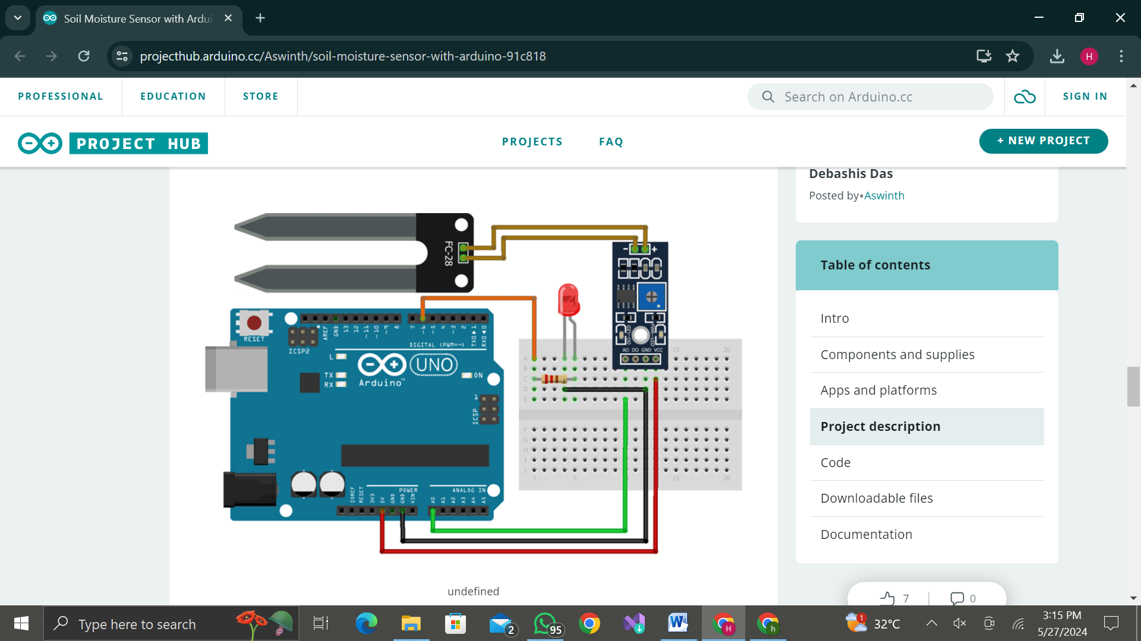

**Fig.4. Circuit Diagram**

The above circuit diagram illustrates the connections for a soil moisture sensor interfaced with an Arduino Uno. Here is a description of the various components and their connections:

**Components:**

1. **Arduino Uno:** The main microcontroller board used for this project.

2. **Soil Moisture Sensor:** Detects the moisture level in the soil.

3**. Connecting Wires:** Used to connect different components.

**Connections:**

1. Soil Moisture Sensor to Arduino:

- The sensor has three pins: VCC, GND, and OUT.

- **VCC (Power):** Connects to the 5V pin on the Arduino.

- **GND (Ground):** Connects to the GND pin on the Arduino.

- **OUT (Signal):** Connects to an analog input pin on the Arduino (e.g., A0).

**Working:**

- The soil moisture sensor measures the moisture level in the soil and outputs an analog signal proportional to the moisture level.

- The Arduino reads the sensor's output from the analog pin (A0).

- Based on the moisture level read by the Arduino, it can process the data and take necessary actions (e.g., triggering a relay, sending data to a cloud service, etc.).

**Extra Components (which can be used for advancement):**

- **LED:** An optional component that can be used to indicate the status of soil moisture.

- **Breadboard:** Used to make connections between components without soldering for prototyping.

- **Resistor:** Used in conjunction with the LED to limit current.

This basic setup allows the Arduino to monitor soil moisture levels and perform actions based on the sensor readings. The project can be expanded by integrating additional components like relays, Wi-Fi modules, or data logging systems to enhance functionality.

**CODE IMPLEMENTATION**

#define sensorPin A0

void setup() {

Serial.begin(9600);

}

void loop() {

Serial.print("Analog output: ");

Serial.println(readSensor());

delay(500);

}

// This function returns the analog data to calling function

int readSensor() {

int sensorValue = analogRead(sensorPin); // Read the analog value from sensor

int outputValue = map(sensorValue, 0, 1023, 255, 0); // map the 10-bit data to 8-bit data

return outputValue; // Return analog moisture value

}

**RESULT:**

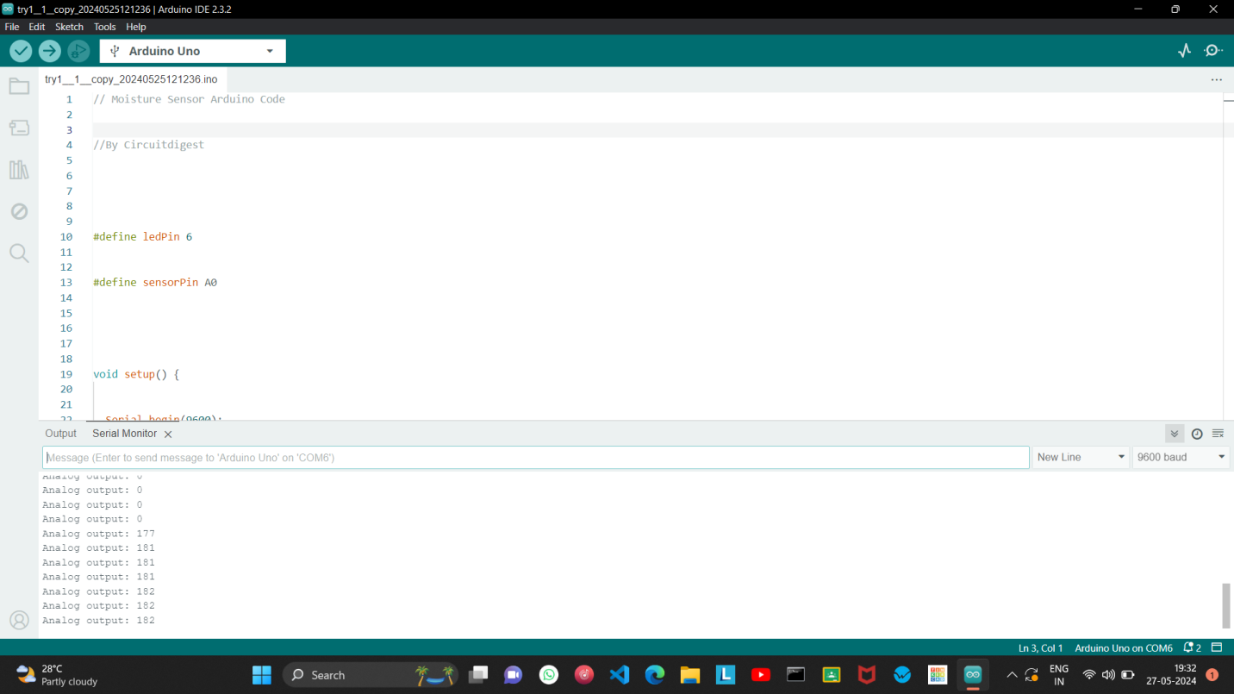

**Fig.5.Result**

**CONCLUSION**

Through the integration of the soil moisture sensor with Arduino, this project provides a comprehensive solution for assessing and managing soil moisture levels. By delving into the technical aspects of the sensor and its connection to Arduino, we have established a robust framework for real-time soil moisture monitoring. The simplicity of the Arduino code allows for easy implementation and customization, catering to a wide range of applications in agriculture, gardening, and environmental research.

Furthermore, the practical demonstration of this project highlights its utility in ensuring optimal plant growth and water conservation. By accurately gauging soil moisture content, users can tailor irrigation schedules to the specific needs of their crops, thereby promoting resource efficiency and yield optimization. Additionally, the project lays the groundwork for future enhancements, such as wireless connectivity and data logging, to facilitate remote monitoring and analysis.

In essence, the successful execution of this project underscores the potential of combining sensor technology with microcontrollers to address pressing challenges in agriculture and environmental sustainability. By empowering individuals and communities with actionable insights into soil moisture dynamics, this project contributes to the advancement of precision agriculture practices and the promotion of eco-conscious stewardship of natural resources.

**REFERENCES**

1. <https://projecthub.arduino.cc/nikolaiapalis/simple-soil-moisture-sensor-ec23c7>

2. <https://www.instructables.com/Arduino-Soil-Moisture-Sensor/>

3. <https://lastminuteengineers.com/soil-moisture-sensor-arduino-tutorial/>

4. <https://circuitdigest.com/microcontroller-projects/interfacing-soil-moisture-sensor-with-arduino-uno>

5. <https://circuitdigest.com/microcontroller-projects/interfacing-soil-moisture-sensor-with-arduino-uno>