Martin Buss, 2nd of July 2019

IsoAddConnectionInfo.dll for Plant 3D

Note: This tool is example code to show you how you could work more efficiently. It is not supported by Autodesk and you use it at own risk:

// AUTODESK PROVIDES THIS PROGRAM "AS IS" AND WITH ALL FAULTS.

// AUTODESK SPECIFICALLY DISCLAIMS ANY IMPLIED WARRANTY OF

// MERCHANTABILITY OR FITNESS FOR A PARTICULAR USE. AUTODESK, INC.

// DOES NOT WARRANT THAT THE OPERATION OF THE PROGRAM WILL BE

// UNINTERRUPTED OR ERROR FREE.

**Problem to solve this the tool:**

Continuation labels of pipes on Plant 3D isos are just pointing to the pipe group and not to the actual DWG. This information will be completed by this tool:

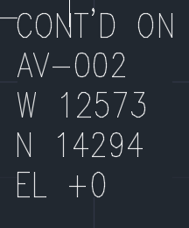 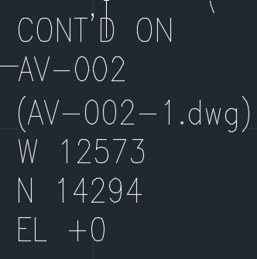

**How to use*:**

Open Plant 3D, open an empty drawing (drawing1.dwg), load with “_netload”, apply with command:

IsoAddConnectionInfo

Followed by a space and the following configuration string (in quotes):

IsoAddConnectionInfo "path=C:/Users/bussm/OneDrive - autodesk/Documents/EUmetric2021/Isometric/Check_A2/ProdIsos/Drawings,findlabelwith=CONT,linegroupshorterthan=6"

(You can store the full command with the CUI command and pull it on a new tool palette for easy access)

The path is pointing to a folder where all of your isos of a project sit in (flat structure). After executing the script, there will be another folder in this folder with the name “changedfiles”. This folder contains all files that were modified.

“Findlabelwith” and “linegroupshorterthan” are parameters to identify the labels that we want to work with. Put in “findlabelwith” a substring of the first line of the label that uniquely identifies it. If the continuation to other linegroups has the same text as inner piping labels, then you can use “linegroupshorterthan”, to make the difference between these two continuation label types. If you don’t need this parameter, set it to a high value like 100.

The rest has to be kept exactly like this in regards of commas and =. Also avoid spaces.

**How it works:**

All isos will be opened twice. In the first run an internal list will get created containing coordinates in connection with the filename. If coordinates fit, then the drawing name will get inserted in the second run. Note that both runs are contained in a single command execution. Also note that the label has to have exactly 5 lines. The first line needs to contain the continuation text and the last 3 the coordinates. Labels with more lines will not get touched.

|  |
| --- |
| *Dll doesn’t load, commands are not available? |
| •             Add the following line (in Red) to acad.exe.config:     <runtime>                 <generatePublisherEvidence enabled="false"/>                 <loadFromRemoteSources enabled="true"/>     </runtime>  •             If the still doesn’t work, maybe dll is blocked? please unblock the dll, by rightclicking on it -> properties -> unblock |