Temporal difference learning has been used to estimate the value function. We now want to obtain an estimation of the optimal policy itself. To do this, a TD learning style update is used which is non stationary and non-episodic. However, there are 2 types of policy approaches that can be used for this, SARSA and Q-learning and they are explained below:

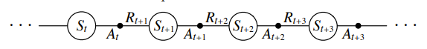Fully written out as state, action, reward, state, action, SARSA is an on policy algorithm which means the policy $π$ it uses to select an action A’ is the same policy used to update the Q-function $Q(S,A)$. The name SARSA comes from the sequence taken every episode when learning the action value function as shown in figure 1.0.

Figure 1.0 – episode of alternating sequence of states and state-action pairs

The algorithm for SARSA itself to update the state action-pair is shown in equation (1). Where $Q\left(S_{t},A_{t}\right)$ is the expected return for taking an action $A$ in state $S$ at time $t$. $α$ is the constant weighting that denotes learning rate and $R_{t+1}+γQ\left(S_{t+1},A_{t+1}\right)-Q\left(S_{t},A_{t}\right)$ is the correction signal. The update for the Q-function is done for every $S_{t}$ part from the terminal state in which $Q\left(S_{t+1},A_{t+1}\right)$ is equal zero instead.

$Q\left(S_{t},A_{t}\right)←Q\left(S_{t},A_{t}\right)+α[R_{t+1}+γQ\left(S_{t+1},A_{t+1}\right)-Q\left(S_{t},A_{t}\right)]$ (1)

Figure 1.1 shows the pseudo code for SARSA algorithm. The state action values are initially defined for all states along with the algorithm parameters $α$ for the learning rate and $ε$ which is used to define the probability of exploration depending on the policy one wishes to use such as $ε$-greedy or $ε$-soft policies.

A loop is then generated for every episode, that starts by taking an action $A$ depending on the chosen policy (usually $ε$-greedy). A nested loop for each step in this episode is then created where because SARSA is on policy, the policy $π$, is used to take the action $A$. The state $S'$ and reward $R$ is then recorded. Using the chosen policy again, an action $A'$ is selected before all obtained values are finally input into equation (1). This repeats until the final state is terminal.

The result of this is SARSA will converge with a probability of 1 to an absolute optimal policy and action-value function if all state-action pairs are visited an infinite number of times. In addition to this, since the system uses a greedy policy, it will also converge if exploration is decreased over time for example, $ε=\frac{1}{t}$.

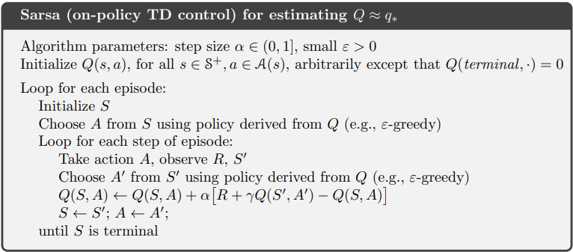

Figure 1.1 – SARSA pseudo code

Q-learning on the other hand is an off policy algorithm. The algorithm for it is shown in equation (2). The use of the $max$ function is what makes the algorithm off policy because instead of updating the action function Q using the action taken $A$’, it uses the greedy action $a$, i.e. the value from the best possible action.

$Q\left(S_{t},A_{t}\right)←Q\left(S_{t},A_{t}\right)+α[R_{t+1}+γ\max_{a}{Q\left(S_{t+1},a\right)}-Q\left(S_{t},A_{t}\right)]$ (2)

Figure 1.2 shows the pseudo code for Q-learning. The initialising of parameters, the looping of episodes and steps within each episode and choosing/taking actions based off greedy policy is all similar to SARSA. However with the $max$ function, it changes the way the Q-function is updated so this makes it seem as if the greedy policy is followed completely or $ε=0$ and there is no exploration.

As a result, given an infinite amount of time and episodes to experience and learn, Q-learning will directly converge with probability of 1 to an optimal policy.

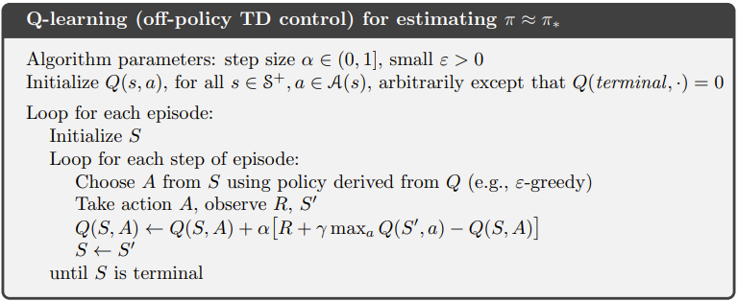

Figure 1.2– Q-learning pseudo code