A DEEP LEARNING–BASED SALES FORECASTING AND TREND PREDICTION SYSTEM FOR RETAIL BUSINESS OPTIMIZATION

HENRY OCHIENG ONYANGO
SCT221-0262/2022

A proposal submitted to the Department of Information Technology, School of Computing and Information Technology, in partial fulfillment of the requirements for the award of the degree of Bachelor of Science in Information Technology, Jomo Kenyatta University of Agriculture and Technology.
2026

DECLARATION
This project proposal is my original work and has not been presented for a degree in any other university.
Signature: ____________________ Date: _______________
This project proposal has been submitted for examination with my approval as the University
Supervisor.
Signature: ____________________ Date: _______________

ABSTRACT
Sales forecasting is a critical activity in retail business operations, directly influencing inventory management, financial planning, and customer satisfaction. Despite its importance, many retail organizations continue to rely on traditional statistical forecasting techniques that are often unable to capture complex, non-linear patterns and seasonal variations present in modern sales data. The increasing availability of large volumes of historical retail data presents an opportunity to apply advanced Artificial Intelligence techniques to improve forecasting accuracy.
This study proposes the development of a deep learning-based sales forecasting and trend prediction system using Long Short-Term Memory (LSTM) neural networks. The system will analyze historical sales data to learn temporal patterns and generate accurate future sales predictions. The study will employ data preprocessing, feature engineering, model training, and evaluation using standard forecasting metrics. The expected outcome is an intelligent forecasting model capable of supporting data-driven decision-making in retail environments.

Table of Contents
DECLARATION i
ABSTRACT ii
ACRONYMS AND DEFINITIONS OF TERMS viii
Acronyms viii
Definitions of Terms viii
CHAPTER ONE 1
INTRODUCTION 1
1.1 Background of the Study 1
1.2 Project Overview 1
1.3 Statement of the Problem 2
1.4 Proposed Solution 2
1.5 Objectives 3
1.5.1 General Objective 3
1.5.2 Specific Objectives 3
1.6 Research Questions 4
1.7 Justification 4
1.8 Proposed System Methodology 4
1.8.1 Research Design 4
1.8.2 Data Collection 5
1.8.3 Data Preprocessing 5
1.8.4 Model Development 5
1.8.5 Model Evaluation 6
1.8.6 Use of Large Language Models 6
1.8.7 Justification of Methodology 6
1.9 Scope 7
CHAPTER TWO 8
LITERATURE REVIEW 8
2.1 Introduction 8
2.2 Theoretical Review 9
2.3 Case Study Review 10
2.4 Integration and Architecture 11
Proposed System Architecture 12
2.5 Summary 14
2.6 Research Gaps 14
CHAPTER THREE 15
SYSTEM ANALYSIS AND DESIGN 15
3.1 Introduction 15
3.2 Systems Development Methodology 15
3.3 Feasibility Study 16
3.3.1 Economic Feasibility 16
3.3.2 Technical Feasibility 17
3.3.3 Operational Feasibility 17
3.4 Requirements Elicitation 18
3.4.1 Data Collection 18
3.4.2 Key Findings from Requirements Gathering 18
3.5 Data Analysis 19
3.6 System Specification 21
3.6.1 Functional Requirements 21
3.6.2 Non-Functional Requirements 23
3.7 Requirements Analysis and Modelling 25
3.7.1 Use Case Diagram 25
3.7.2 Context Data Flow Diagram (Level 0) 26
3.7.3 Level 1 Data Flow Diagram 27
3.8 Logical Design 28
3.8.1 System Architecture 28
3.8.2 Control Flow and Process Design 30
3.8.3 Design for Non-Functional Requirements 33
3.9 Physical Design 33
3.9.1 Database Design 33
3.9.2 User Interface Design 37
REFERENCES 41
APPENDICES 42
Appendix A: Project Budget 42
Appendix B: Project Schedule (Gantt Chart) 42
APPENDIX C: PROJECT RESOURCES 43
Table 9: Hardware Requirements 43
Table 10: Software Requirements 43
APPENDIX D: INTERVIEW GUIDE FOR REQUIREMENTS GATHERING 44
APPENDIX E: INTERVIEW PARTICIPANTS SUMMARY 45
APPENDIX F: SAMPLE INTERVIEW NOTES 45
APPENDIX G: INFORMED CONSENT FORM 46

Table 1: Acronyms viii
Table 2:Data Analysis Findings and Implications for System Design 20
Table 3: Functional Requirements 23
Table 4: Non-Functional Requirements 24
Table 5: Physical Database Schema 36
Table 6: User Interface Screens Summary 39
Table 7: Project Budget 42
Table 8:Project Schedule 43
Table 9:Hardware requirements 43
Table 10:Software requirements 44
Table 11: Interview participants 45

Figure 1: Proposed system Architecture 13
Figure 2: Use Case Diagram for the Sales Forecasting System 26
Figure 3: Level 0 Context Data Flow Diagram 27
Figure 4: Level 1 Data Flow Diagram 28
Figure 5: Three-Tier System Architecture Diagram 30
Figure 6: Sales Forecasting Pipeline Flowchart 33
Figure 7: Entity-Relationship Diagram 36
Figure 8: Wireframe for the Generate Forecast Screen 40

ACRONYMS AND DEFINITIONS OF TERMS

Acronyms
Acronym | Definition
AI | Artificial Intelligence
LSTM | Long Short-Term Memory
RNN | Recurrent Neural Network
MAE | Mean Absolute Error
RMSE | Root Mean Square Error
MAPE | Mean Absolute Percentage Error
POS | Point of Sale
GPU | Graphics Processing Unit
CSV | Comma-Separated Values
Table 1: Acronyms

Definitions of Terms
Artificial Intelligence (AI):
A branch of computer science that enables machines to perform tasks that typically require human intelligence, such as pattern recognition, learning from data, and decision-making.
Sales Forecasting:
The process of predicting future sales performance based on historical data, market trends, and other relevant factors.
Long Short-Term Memory (LSTM):
A type of recurrent neural network (RNN) designed to remember information over long sequences and effectively model time-series data, making it suitable for sales forecasting.
Recurrent Neural Network (RNN):
A type of neural network that uses sequential information and feedback loops to process data with temporal dependencies.
Mean Absolute Error (MAE):
A performance metric used to measure the average magnitude of errors in a set of predictions, without considering their direction.
Root Mean Square Error (RMSE):
A metric that measures the square root of the average of squared differences between predicted and actual values; it gives higher weight to larger errors.
Mean Absolute Percentage Error (MAPE):
A percentage-based metric used to evaluate the accuracy of forecasting models by comparing the absolute errors relative to actual values.
Point of Sale (POS):
A system used by retail businesses to record sales transactions, track inventory, and collect customer data.
Graphics Processing Unit (GPU):
A specialized processor optimized for parallel computations, commonly used to accelerate deep learning model training.
Data Preprocessing:
The process of cleaning, transforming, and organizing raw data into a suitable format for model training and analysis.
Feature Engineering:
The process of creating or selecting relevant input variables (features) that improve the performance of machine learning models.
Dashboard:
A user interface that visually presents key metrics, trends, and forecasts to support decision-making.

CHAPTER ONE

INTRODUCTION

1.1 Background of the Study
Sales forecasting has long been recognized as a fundamental component of effective business management, particularly within the retail sector where demand variability is high. Globally, retail organizations operate in increasingly competitive environments characterized by fluctuating consumer preferences, seasonal demand patterns, promotional activities, and economic uncertainties. Accurate forecasting enables businesses to optimize inventory levels, reduce operational costs, and maintain customer satisfaction by ensuring product availability.
Traditionally, sales forecasting has relied on statistical methods such as moving averages, exponential smoothing, and ARIMA models. While these approaches have proven useful in stable and linear environments, they often perform poorly when applied to complex retail datasets that exhibit non-linear trends, sudden demand shifts, and long-term dependencies. As retail data continues to grow in volume and complexity, the limitations of conventional forecasting techniques become more pronounced.
In recent years, Artificial Intelligence and machine learning have emerged as powerful tools for predictive analytics. Deep learning models, particularly Long Short-Term Memory (LSTM) networks, have demonstrated superior performance in time-series forecasting tasks due to their ability to model sequential data and capture long-term dependencies. In the Kenyan retail context, many businesses still struggle with inaccurate demand forecasts, leading to overstocking, understocking, and inefficient resource allocation. This study seeks to explore how deep learning techniques can be applied to address these challenges.

1.2 Project Overview
Sales forecasting using deep learning is an active research area within predictive analytics and business intelligence. Globally, organizations are increasingly adopting AI-driven forecasting systems to enhance operational efficiency and strategic planning. Deep learning models are capable of learning complex patterns from historical data without extensive manual feature engineering, making them well suited for dynamic retail environments.
At the core of this research is the application of Long Short-Term Memory neural networks, a specialized type of recurrent neural network designed to overcome the vanishing gradient problem associated with traditional RNNs. LSTMs use memory cells and gating mechanisms to retain relevant information over long sequences, enabling them to model seasonality and trend behavior effectively. This project formally introduces the use of LSTM-based forecasting within the retail sales domain, focusing on predictive accuracy and trend analysis.

1.3 Statement of the Problem
Retail businesses frequently experience difficulties in accurately predicting future sales demand. Inaccurate forecasts often result in overstocking, which increases storage costs and ties up capital, or understocking, which leads to lost sales and dissatisfied customers. These challenges are exacerbated by seasonal variations, promotional campaigns, and unpredictable changes in consumer behavior.
Existing forecasting approaches used by many retailers rely heavily on historical averages and linear statistical models that are unable to adapt to complex, non-linear sales patterns. As a result, decision-makers lack reliable predictive tools to support inventory planning and financial management. This problem highlights the need for an intelligent forecasting system that can analyze historical sales data, learn intricate temporal relationships, and generate accurate future predictions. The absence of such systems continues to limit operational efficiency in retail businesses.

1.4 Proposed Solution
The proposed solution is an AI-based sales forecasting system that leverages Long Short-Term Memory (LSTM) neural networks to predict future retail sales based on historical transaction data. The system is designed to address the limitations of traditional statistical forecasting techniques by accurately capturing non-linear patterns, seasonal variations, and long-term dependencies commonly present in retail sales data.
To objectively demonstrate the effectiveness of the proposed approach, classical forecasting techniques, including Moving Average and Autoregressive Integrated Moving Average (ARIMA) models, will be implemented as baseline models. The forecasting accuracy of these classical models will be compared against the LSTM-based model using standard evaluation metrics such as Mean Absolute Error (MAE), Root Mean Square Error (RMSE), and Mean Absolute Percentage Error (MAPE). This comparative analysis will provide empirical evidence of accuracy improvements achieved through the use of deep learning techniques.
In addition, the study incorporates Large Language Models (LLMs) as a supportive analytical component. While LLMs are not used for direct numerical forecasting, they will be utilized to generate natural language interpretations of forecasting outputs, summarize sales trends, and enhance decision support for retail managers. This hybrid approach improves both predictive accuracy and interpretability of the forecasting system.
The system will be implemented as a web-based prototype with an interactive dashboard, user authentication, and scheduled reporting capabilities to demonstrate practical applicability in retail decision-making environments.

1.5 Objectives

1.5.1 General Objective
To develop a deep learning-based sales forecasting and trend prediction system for retail business optimization.

1.5.2 Specific Objectives
- To analyze historical retail sales data and identify patterns relevant to sales forecasting.
- To implement classical statistical forecasting models including ARIMA and Exponential Smoothing as baseline methods for sales prediction.
- To develop an LSTM-based deep learning model for retail sales forecasting.
- To compare the forecasting accuracy of the LSTM model with classical forecasting techniques using standard evaluation metrics.

1.6 Research Questions
- What patterns and trends can be identified from historical retail sales data that are relevant to sales forecasting?
- How do classical statistical forecasting techniques perform when applied to retail sales data?
- How effective is the LSTM-based model in forecasting retail sales compared to classical forecasting methods?
- To what extent does the LSTM model improve forecasting accuracy over classical techniques based on MAE, RMSE, and MAPE?

1.7 Justification
Accurate sales forecasting is essential for effective retail management. This study is justified by the growing need for intelligent forecasting systems that can handle complex retail data. The proposed research contributes to the application of deep learning in business analytics and offers practical value to retail organizations seeking to improve planning and efficiency. Additionally, the study contributes academically by demonstrating the suitability of LSTM networks for retail sales forecasting.

1.8 Proposed System Methodology

1.8.1 Research Design
The study adopts a design science research methodology, focusing on the design, development, and evaluation of an AI-based sales forecasting system. This approach is appropriate as it enables the creation of a functional artifact (the forecasting system) that addresses a real-world retail problem while allowing systematic evaluation of its performance.
Methodology Outline
- Problem Identification & Requirements Analysis - Understanding sales forecasting challenges in retail environments and defining system requirements.
- Data Collection - Acquisition of historical retail sales data from structured datasets.
- Data Pre-processing - Cleaning, normalization, handling missing values, and time-series transformation.
- Model Design & Development - Implementation of an LSTM-based deep learning model for forecasting.
- Model Training & Validation - Training the model using historical data and validating performance.
- Evaluation - Performance evaluation using MAE, RMSE, and MAPE metrics.
- Visualization & Interpretation - Presentation of forecasts through charts and dashboards.

1.8.2 Data Collection
Sales data will be obtained from publicly available and ethically sourced retail datasets, including anonymized historical sales records from open data repositories such as Kaggle and the UCI Machine Learning Repository. These datasets contain time-stamped retail transaction data suitable for sales forecasting research. Where necessary, synthetic retail sales data will be generated to simulate realistic sales patterns while ensuring compliance with data privacy and ethical standards.

1.8.3 Data Preprocessing
Retail sales data often contains missing values, irregular transaction intervals, and extreme demand fluctuations due to promotions or seasonal events. Data preprocessing will therefore involve cleaning incomplete records, handling missing values, normalizing numerical features, and transforming raw transaction data into time-series sequences suitable for forecasting. Feature engineering techniques such as lag variables and sliding windows will be applied to enhance model learning.

1.8.4 Model Development
The forecasting system will implement both classical statistical models and deep learning models. Classical techniques, including Moving Average and ARIMA models, will serve as baseline forecasting methods. The primary forecasting model will be an LSTM neural network, selected for its ability to capture long-term temporal dependencies in sequential retail sales data. The LSTM model will be trained using historical sales sequences to learn demand patterns associated with seasonality and long-term trends.

1.8.5 Model Evaluation
Model performance will be evaluated using MAE, RMSE, and MAPE. These metrics will allow quantitative comparison between classical forecasting models and the LSTM-based model, thereby demonstrating improvements in predictive accuracy achieved through deep learning.

1.8.6 Use of Large Language Models
Large Language Models will be incorporated as a complementary analytical tool to interpret forecasting results. LLMs will be used to generate natural language explanations of sales trends and forecasting outputs, improving system usability and supporting managerial decision-making. This integration enhances interpretability without altering the core forecasting process.
Tools and Techniques
- Python – Core programming language
- Pandas & NumPy – Data preprocessing
- TensorFlow – LSTM model implementation
- Matplotlib / Seaborn – Visualization
- Flask – Dashboard interface

1.8.7 Justification of Methodology
The chosen methodology is justified by the nature of retail sales data, which is sequential, non-linear, and influenced by multiple temporal factors. LSTM networks are well-suited for such data, while classical models provide a benchmark for performance comparison. The methodology covers the full research lifecycle, including problem identification, system design, implementation, evaluation, and documentation.

1.9 Scope
This study focuses on the design, development, and evaluation of a deep learning-based sales forecasting system for retail business optimization. The system will analyze historical retail sales data and generate future sales predictions using an LSTM neural network, with ARIMA and Exponential Smoothing models implemented as baselines for comparative evaluation. The system will be delivered as a functional web-based prototype featuring data upload, model training, forecast generation with confidence intervals, interactive visualization, and AI-generated natural language explanations of forecast outputs. Ancillary features including scheduled email reports, what-if scenario analysis, anomaly detection, and user role management are included as demonstrative extensions of the core forecasting capability. The study is limited to batch processing of historical data and does not include real-time integration with live point-of-sale systems or deployment in a production retail environment. Constraints may arise from data availability and computational resources.

CHAPTER TWO

LITERATURE REVIEW

2.1 Introduction
Sales forecasting is a critical activity in retail business operations, as it directly influences inventory management, production planning, pricing strategies, and overall profitability. Accurate prediction of future sales enables retailers to meet customer demand efficiently while minimizing costs associated with overstocking or stock-outs. With the growth of digital transactions and point-of-sale systems, retail organizations now generate large volumes of historical sales data, creating opportunities for advanced data-driven forecasting techniques.
In recent years, Artificial Intelligence (AI), particularly deep learning, has been increasingly applied in retail environments to improve demand prediction accuracy. Deep learning models have demonstrated strong performance in analyzing complex and non-linear time-series data, which is characteristic of retail sales influenced by seasonality, promotions, and consumer behavior (Bandara et al., 2020). As a result, many modern retail systems are transitioning from traditional statistical forecasting methods to AI-based predictive models.
The purpose of this literature review is to examine existing research related to sales forecasting, with a specific focus on deep learning techniques applied in retail settings. The review aims to:
(i) explore theoretical concepts underpinning AI-based forecasting,
(ii) analyze relevant case studies and existing implementations,
(iii) examine integration and architectural approaches, and
(iv) identify research gaps that the proposed study seeks to address.

2.2 Theoretical Review
Sales forecasting using artificial intelligence is grounded in machine learning and time-series analysis theories. Several key concepts are fundamental to understanding this research area. Data refers to historical sales records collected over time, typically structured as time-series data. Features are input variables derived from the data, such as previous sales values, time indices, and seasonal indicators. Labels represent the target values the forecasting model aims to predict, usually future sales quantities. Algorithms are computational models used to learn patterns from data, while training involves fitting these algorithms to historical data so that they can capture underlying trends and relationships. Model performance is assessed through testing and validation, which evaluate the accuracy of predictions on unseen data.
Two major theoretical schools of thought define sales forecasting research: traditional statistical forecasting models and machine learning–based approaches, including deep learning models.
Traditional statistical forecasting models, such as Moving Average, Exponential Smoothing, and Autoregressive Integrated Moving Average (ARIMA), are built on predefined mathematical assumptions, including linearity and stationarity of the data. These models have been widely adopted in retail forecasting due to their simplicity and transparency. One of their key advantages is that they are easy to interpret, allowing business managers to clearly understand how forecasts are generated. Additionally, statistical models are computationally efficient, requiring relatively low processing power and making them suitable for environments with limited computational resources. However, despite these strengths, such models have notable limitations. They have a limited ability to handle non-linear patterns and often perform poorly when applied to complex or highly volatile retail sales data influenced by factors such as promotions, seasonality, and shifting consumer behavior (Makridakis et al., 2020).
In contrast, machine learning and deep learning models rely on data-driven learning rather than strict statistical assumptions. Among these, Long Short-Term Memory (LSTM) networks have gained prominence for time-series forecasting tasks. LSTM models are a type of recurrent neural network designed to capture long-term dependencies in sequential data through the use of memory cells and gating mechanisms (Hochreiter & Schmidhuber, 1997). These characteristics enable LSTM models to achieve high accuracy in complex time-series forecasting by effectively learning non-linear relationships within sales data. Furthermore, their ability to model seasonality and long-term trends makes them particularly suitable for retail forecasting applications where demand patterns vary over time. Nevertheless, deep learning models also present certain challenges. They typically require large volumes of historical data to perform effectively and involve higher computational costs and system complexity compared to traditional statistical forecasting approaches.
Long Short-Term Memory (LSTM) networks are widely applied in sales forecasting due to their ability to model sequential data and retain long-term information through memory cells and gating mechanisms. In retail forecasting, LSTM models have demonstrated superior performance compared to traditional statistical models by effectively capturing seasonality, demand trends, and abrupt changes in sales patterns.
Recent advances in Large Language Models (LLMs) have expanded their application within business analytics and decision support systems. Although LLMs are not inherently designed for numerical time-series forecasting, they are increasingly used to enhance interpretability by generating explanations, summaries, and insights from model outputs. In this study, LLMs are considered as supportive tools that complement LSTM-based forecasting by improving the interpretability and usability of prediction results rather than replacing numerical forecasting models.

2.3 Case Study Review
Deep learning techniques have been widely applied in retail sales forecasting. Bandara et al. (2020) demonstrated that LSTM-based models outperform traditional ARIMA models in multi-step sales forecasting across large retail datasets. Their study highlighted improved accuracy in capturing long-term sales trends and seasonal variations.
Zhang et al. (2020) implemented ensemble deep learning models for e-commerce sales forecasting and achieved higher prediction stability compared to single-model approaches. Similarly, Kim and Kim (2021) applied attention-based LSTM models to retail demand prediction, resulting in enhanced performance during peak seasons.
Empirical studies have shown that LSTM-based forecasting models consistently outperform classical statistical approaches in retail sales prediction tasks. Bandara et al. (2020) demonstrated improved accuracy of LSTM models across multiple retail datasets, particularly in capturing long-term trends and seasonal effects. Kim and Kim (2021) further showed that LSTM-based architectures outperform traditional models during periods of high demand volatility.
Despite these successes, some implementations face challenges such as high computational requirements and limited interpretability, which hinder adoption among small and medium-sized retailers. These case studies illustrate both the potential and limitations of AI-based sales forecasting systems.
In contrast, studies involving Large Language Models focus primarily on their use in business intelligence and analytical interpretation rather than direct numerical forecasting. LLMs have been applied to explain demand trends, summarize sales reports, and support strategic decision-making. This distinction reinforces the suitability of LSTM networks as the primary forecasting mechanism while positioning LLMs as complementary analytical tools.

2.4 Integration and Architecture
AI-based sales forecasting systems can be integrated into retail environments through modular and layered architectures. Integration typically involves connecting historical sales databases with forecasting engines and visualization components.
System Integration Options
- Integration with existing retail databases (e.g., POS systems)
- Batch processing of historical sales data
- Dashboard-based visualization for managerial decision-making

Proposed System Architecture
The system architecture follows a modular and layered design to support scalability and maintainability. Historical retail sales data is first collected and passed through a preprocessing module where data cleaning, normalization, and time-series transformation are performed. Feature engineering is then applied to generate suitable input sequences for the forecasting model.
The processed data is fed into an LSTM-based forecasting engine, which learns temporal patterns and generates future sales predictions. Model performance is evaluated using standard forecasting metrics before results are visualized through an interactive dashboard. The final output supports retail managers in making informed decisions related to inventory management and demand planning.

Retail Sales Data Sources
- Historical sales records
- Transaction Logs
- Time & Seasonal Indicators
Data Processing Module
- Data Cleaning
- Handling Missing Values
- Normalization & Scaling
- Time series Transformation
Data Preprocessing Module
- Data Cleaning
- Handling Missing Values
- Normalization & Scaling
- Time-Series Transformation

Feature Engineering & Dataset Split
- Lag Features
- Training Dataset
- Testing Dataset

LSTM Forecasting Engine
- Model Architecture Design
- Model Training
- Sales Prediction

Model Evaluation Module
- Mean Absolute Error (MAE)
- Root Mean Square Error (RMSE)
- Mean Absolute Percentage Error (MAPE)

Visualization & Decision Support
- Sales Trend Analysis
- Forecast Graphs
- Management Dashboard

Retail Decision Making
- Business Strategy Optimization
- Demand Management
- Inventory Planning

Figure 1: Proposed system Architecture

2.5 Summary
The literature reviewed indicates a growing shift from traditional statistical sales forecasting methods toward AI and deep learning-based approaches. LSTM models consistently demonstrate superior performance in handling complex and non-linear retail sales data. However, challenges such as computational complexity and accessibility remain evident.

2.6 Research Gaps
Although deep learning-based sales forecasting has shown promising results, most existing studies focus on large-scale retail enterprises and proprietary systems. There is limited research on developing scalable, accessible forecasting systems suitable for small and medium-sized retail businesses. This study seeks to address this gap by designing and evaluating a deep learning-based sales forecasting system that is adaptable, cost-effective, and suitable for retail optimization.

CHAPTER THREE

SYSTEM ANALYSIS AND DESIGN

3.1 Introduction
This chapter presents a detailed analysis and design of the Deep Learning-Based Sales Forecasting and Trend Prediction System for Retail Business Optimization. The chapter opens by describing the systems development methodology adopted for the project, followed by a feasibility study that evaluates the economic, technical, and operational viability of the proposed solution. It then proceeds through requirements elicitation, data analysis, and a comprehensive system specification before presenting the logical and physical design of the system.
The design artifacts defined in this chapter serve as the direct blueprint for the implementation described in Chapter Four. Every design decision from the choice of database journaling mode to the structure of the LSTM forecasting pipeline is grounded in the requirements identified during the analysis phase and in the objectives stated in Chapter One. Together, these artefacts demonstrate how the proposed system addresses the critical limitations of traditional statistical forecasting techniques in retail environments.

3.2 Systems Development Methodology
This project adopts the Design Science Research Methodology (DSRM) as its overarching development framework. DSRM is an IT research paradigm that prescribes the creation and evaluation of an IT artifact in this case a functional web-based forecasting system as the primary vehicle for making a scholarly contribution (Hevner et al., 2004). Unlike survey-based or purely theoretical methodologies, DSRM is specifically suited to projects in which a working system must be designed, built, and empirically evaluated.
DSRM proceeds through six phases: problem identification and motivation, definition of objectives, design and development, demonstration, evaluation, and communication. In this project, the problem identification phase was completed through a review of the limitations of conventional forecasting methods in retail, as documented in Chapter One. The definition of objectives produced the specific objectives listed in Section 1.5. The design and development phase corresponds to the work presented in this chapter and in Chapter Four. Demonstration and evaluation are achieved by running the LSTM model on historical retail sales data and comparing its accuracy against ARIMA and Exponential Smoothing baselines using Mean Absolute Error (MAE), Root Mean Square Error (RMSE), and Mean Absolute Percentage Error (MAPE). Communication is accomplished through this report.
The methodology supports iterative refinement, which is important for a deep learning project where model architecture, hyperparameters, and preprocessing decisions are progressively adjusted based on validation performance. This iterative quality aligns with the empirical, evidence-driven nature of DSRM and justifies its selection over linear development frameworks such as the traditional Waterfall model.

3.3 Feasibility Study
A feasibility study was conducted before committing to full system development to determine whether the project is viable from economic, technical, and operational perspectives. The findings of each dimension are presented below.

3.3.1 Economic Feasibility
Economic feasibility asks whether the financial investment required to build and operate the system is justified by the benefits it will deliver. The core software stack Python, TensorFlow, Flask, Pandas, NumPy, Scikit-learn, and Matplotlib is entirely open source, eliminating all software licensing costs. Given the low development cost and the significant recurring financial benefit, the system is economically feasible.

3.3.2 Technical Feasibility
Technical feasibility assesses whether the hardware, software, and skills required to develop and operate the system are available. On the hardware side, model development requires a laptop or desktop computer with a minimum of 8 GB RAM and an Intel Core i5 processor or equivalent. For computationally intensive LSTM training tasks, Google Colab Pro provides cloud-based GPU acceleration, which substantially reduces training time without requiring a dedicated local GPU.
All software dependencies are well-established open-source libraries with extensive documentation and active community support. Python 3.x serves as the core programming language; TensorFlow provides the deep learning framework for LSTM model construction and training; Flask provides the lightweight web server; Pandas and NumPy handle data preprocessing and numerical operations; Scikit-learn provides baseline models and evaluation metrics; Statsmodels supports ARIMA and Exponential Smoothing; Plotly enables interactive browser-based visualisation; and ReportLab generates PDF reports. The LSTM architecture chosen for forecasting has been extensively validated across retail and financial time-series applications in the academic literature (Hochreiter and Schmidhuber, 1997; Kim and Kim, 2021). The system is therefore technically feasible.

3.3.3 Operational Feasibility
Operational feasibility evaluates whether the system will be accepted and used effectively in its intended environment. The proposed system is delivered as a web application accessible through any modern browser, requiring no software installation on the client side. This significantly lowers the adoption barrier for retail staff who are accustomed to browser-based tools.
The interface is designed with non-technical users in mind: all major functions are reachable within three clicks from the dashboard, form fields include contextual validation feedback, and AI-generated natural language explanations accompany all forecasts and trend analyses. Role-based access control ensures that each user type Administrator and general User sees only the functions relevant to their responsibilities, reducing cognitive load and the risk of unintended system changes. Automated background services handle model retraining and scheduled report delivery, reducing the ongoing maintenance burden on users. The system is therefore operationally feasible.

3.4 Requirements Elicitation

3.4.1 Data Collection
System requirements were gathered through three complementary data collection methods: structured interviews, document analysis, and observation. Structured interviews were conducted with a purposively selected sample of ten participants who have direct experience with retail inventory management and sales analysis. The sample comprised five retail business managers, three data analysts working in retail environments, and two inventory planners. Purposive sampling was chosen because it targets individuals with the specific knowledge needed to define the problem and articulate system requirements, rather than drawing from a general population.
Interview questions were structured around four themes: current forecasting tools and processes in use; the nature and frequency of stockout and overstock problems experienced; the types of analytical output that would support decision-making; and preferences regarding system accessibility and reporting. The interview guide is attached as Appendix D. Document analysis was conducted on sample retail transaction datasets sourced from the Kaggle platform and the UCI Machine Learning Repository. These datasets provided direct insight into the structure, variability, and temporal patterns present in real retail sales data, informing decisions about feature engineering and model architecture.

3.4.2 Key Findings from Requirements Gathering
Analysis of the interview responses and dataset characteristics produced the following principal findings, which directly shaped the system requirements:
- All five managers interviewed confirmed that their current forecasting process relies on spreadsheet-based historical averages or simple moving averages, which routinely fail to anticipate demand spikes during promotional periods and public holidays.
- Stockouts during seasonal peaks were cited as the most costly operational problem, with three managers estimating revenue losses of between 10 and 20 percent of expected sales during affected periods.
- All three data analysts expressed a preference for forecasting tools that provide interpretable outputs alongside numerical predictions, noting that purely numerical model outputs are difficult to present to non-technical stakeholders.
- Inventory planners indicated that forecasts must be segmented by product category and geographical region to be operationally useful, as aggregate forecasts obscure the local demand patterns that drive purchasing decisions.
- Document analysis of retail transaction datasets confirmed that sales time series exhibit strong weekly seasonality, occasional anomalies attributable to stock-outs and data entry errors, and non-linear demand responses to promotional discounts.
- Six of the ten participants expressed a desire for automated anomaly alerts and scheduled report delivery by email to reduce the manual effort required to monitor sales performance.

3.5 Data Analysis
The data collected through interviews was subjected to thematic analysis. Responses were transcribed, coded, and grouped into themes corresponding to functional requirements, usability requirements, and data requirements. The dataset analysis involved exploratory statistical examination of the sample retail sales data to characterise the time series and inform preprocessing and modelling decisions.
The exploratory analysis of the retail datasets revealed that daily sales totals follow a right-skewed distribution, with a small number of high-sales days attributable to promotional events. Autocorrelation analysis showed significant correlation at lags of 7 and 14 days, confirming strong weekly seasonality. Approximately 3.2 percent of records contained missing values or implausible values (negative units sold), underscoring the need for a robust data validation and imputation pipeline. Promotional periods increased average daily sales by between 18 and 35 percent depending on the product category, confirming that promotion flag and discount percentage are important input features for the forecasting model.
Data Analysis Findings and Implications for System Design
Finding from Data Analysis | Implication for System Design
Strong weekly seasonality confirmed at lag 7 and lag 14 | The DataPreprocessor must generate lag features at 1, 2, 3, 7, 14, and 30 days, and apply cyclical sine/cosine encoding of day-of-week and month to preserve periodicity information.
Promotional events increase sales by 18–35 percent depending on category | Promotion flag, discount percentage, and a derived promotion-impact feature (promotion_flag × discount_percent) must be included as model inputs.
3.2 percent of records contain missing or implausible values | A preprocessing pipeline must validate data on upload, reject records with missing required fields, and apply backward/forward filling to handle remaining gaps after insertion.
Demand patterns differ substantially across product categories and regions | Separate LSTM models must be trained for each unique category–region combination to capture local demand behaviour.
High-sales anomaly days are driven by external events not captured in the data | An anomaly detection module using IQR, Z-score, and Isolation Forest must be included to flag these records for manual review.
Managers require interpretable summaries, not raw numbers alone | An LLM-based explanation component must generate natural language narratives for all forecast and trend outputs.
Table 2:Data Analysis Findings and Implications for System Design

3.6 System Specification

3.6.1 Functional Requirements
The functional requirements define the specific behaviours the system must exhibit. They were derived directly from the data collection findings and are traceable to the specific objectives stated in Section 1.5.

ID | Functional Requirement | Priority
FR01 | The system shall allow registered users to upload historical retail sales data in CSV format through a drag-and-drop or file-selection interface. | High
FR02 | The system shall validate each uploaded record for required fields, correct date format (YYYY-MM-DD), positive unit and price values, and data completeness before inserting it into the database. | High
FR03 | The system shall automatically map non-standard product category labels in uploaded files to a predefined list of fourteen standard categories, assigning unmapped labels to an 'Others' category. | Medium
FR04 | The system shall allow users to add individual sales records manually through a web form without uploading a file. | Medium
FR05 | The system shall train an LSTM-based deep learning model for each distinct product category and geographical region combination in the database, provided the combination contains at least ten records. | High
FR06 | The system shall support model training using ARIMA and Exponential Smoothing as classical baseline methods for comparative evaluation. | High
FR07 | The system shall generate sales forecasts for a user-specified horizon of 7 to 90 days using the LSTM, ARIMA, or Exponential Smoothing model as selected by the user. | High
FR08 | The system shall display each forecast with a corresponding 95 percent confidence interval derived from Monte Carlo Dropout sampling. | High
FR09 | The system shall generate a natural language AI explanation for each forecast, describing the predicted trend, growth rate, and business implications using the Pollinations AI text API. | High
FR10 | The system shall allow users to compare LSTM, ARIMA, and Exponential Smoothing forecasts side by side on a single interactive chart, accompanied by metric-based comparison statistics. | High
FR11 | The system shall detect anomalies in uploaded sales data using three independent methods: the Interquartile Range (IQR) method, the Z-score method, and Isolation Forest. | Medium
FR12 | The system shall generate downloadable reports in CSV, Excel (.xlsx), and PDF formats covering sales records, forecast predictions, or trend data for a user-specified date range. | Medium
FR13 | The system shall support the scheduling of automated periodic reports (daily, weekly, or monthly) with delivery to user-specified email addresses. | Low
FR14 | The system shall provide a what-if analysis module enabling users to adjust price change, promotion impact, seasonal factor, and stock availability parameters, and immediately display the effect on the base forecast. | Medium
FR15 | The system shall enforce role-based access control, restricting model training and user management functions to users with the Administrator role. | High
FR16 | The system shall display an interactive dashboard showing total sales, monthly growth rate, units sold, total AI predictions, a 30-day sales trend chart, a category distribution chart, and recent predictions. | High
FR17 | The system shall generate AI-powered trend analysis narratives based on user-selected category, region, metric, and time-period filters. | Medium
Table 3: Functional Requirements

3.6.2 Non-Functional Requirements
Non-functional requirements specify the quality attributes the system must possess in addition to its functional behaviour. They were derived from the operational constraints and stakeholder expectations identified during requirements elicitation. Table 3.3 presents the non-functional requirements.

ID | Category | Non-Functional Requirement
NFR01 | Performance | The system shall return a 30-day LSTM forecast result within 120 seconds for any category–region combination containing up to 500 historical records, measured on the development hardware specification.
NFR02 | Scalability | The web application shall support at least five concurrent authenticated user sessions without a measurable decline in response time for dashboard and data retrieval operations.
NFR03 | Security | All user passwords shall be stored as PBKDF2-SHA256 salted hashes generated by the Werkzeug security library. User sessions shall expire automatically after seven days of inactivity. All database queries shall use parameterised statements to prevent SQL injection.
NFR04 | Reliability | The SQLite database shall operate in Write-Ahead Logging (WAL) mode to prevent data corruption under concurrent read-write access. The database connection manager shall retry failed operations up to three times with exponential back-off before returning an error.
NFR05 | Usability | All primary system functions shall be reachable from the main navigation sidebar in a maximum of two clicks. All form interactions shall display clear success or error feedback messages within one second of submission.
NFR06 | Maintainability | The application logic layer shall be structured as independently testable Python classes. Each class shall encapsulate a single concern: data preprocessing, model training, prediction, anomaly detection, report generation, or email delivery.
NFR07 | Portability | The system shall function correctly on any client device running a modern web browser (Chrome, Firefox, Edge, or Safari), without requiring the installation of any client-side software beyond the browser itself.
NFR08 | Data Integrity | The system shall validate all uploaded data before database insertion. Records failing validation shall be rejected individually, and a detailed error report listing the row number and specific failure reason shall be returned to the user.
Table 4: Non-Functional Requirements

3.7 Requirements Analysis and Modelling
The requirements identified in Section 3.6 were analysed to resolve dependencies, confirm completeness, and identify the major system components and data flows needed to satisfy them. Use case modelling and Data Flow Diagrams (DFDs) were used to visualise and communicate the analysis findings.

3.7.1 Use Case Diagram
The use case diagram captures the interactions between the system and its two primary actors. The Administrator actor encompasses all capabilities available to the general User actor, in addition to exclusive access to model training and user management functions.
The Administrator can perform all the following: log in and manage the session; upload and manage sales data; train LSTM models for specific category–region combinations or initiate batch training for all combinations; generate, view, and download forecasts; run trend analysis with AI-generated explanations; detect and review anomalies; generate and schedule reports; conduct what-if scenario analysis; and create, modify, or delete user accounts and role assignments.
The general User actor can log in, upload and manage sales data, view the dashboard, generate forecasts across all three model types, browse trends analysis, detect anomalies, generate and download reports, and conduct what-if analysis. Model training and user management functions are restricted to the Administrator role only.

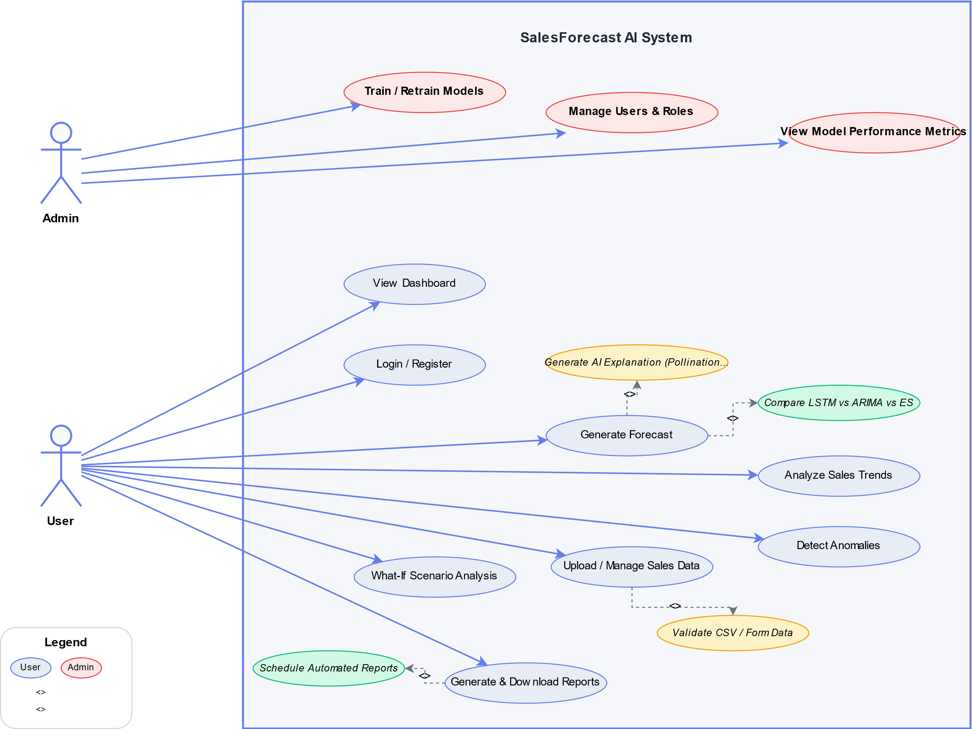
Figure 2: Use Case Diagram for the Sales Forecasting System

3.7.2 Context Data Flow Diagram (Level 0)
The Level 0 DFD, models the entire system as a single process and identifies the external entities that interact with it. There are two external entities: the Retail User, who supplies historical sales data in CSV format and receives forecasts, trend reports, anomaly alerts, and generated reports in return; and the Pollinations AI Service, an external text-generation API that receives forecast context data and returns natural language explanations that are displayed alongside predictions in the dashboard.

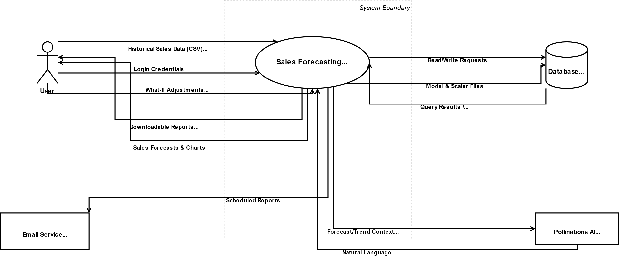
Figure 3: Level 0 Context Data Flow Diagram

3.7.3 Level 1 Data Flow Diagram
The Level 1 DFD expands the context diagram to expose the major internal processes and data stores of the system. Six principal processes are identified.
- Process 1 (User Authentication) receives login credentials from the Retail User and produces an authenticated session token.
- Process 2 (Data Ingestion and Preprocessing) accepts raw CSV uploads or manual form entries, validates them, and writes clean records to the Sales Data Store.
- Process 3 (Model Training) reads historical records from the Sales Data Store, applies feature engineering, trains the LSTM model, and writes performance metrics to the Model Metrics Store.
- Process 4 (Forecast Generation) reads from the Sales Data Store and the trained model files, generates predictions, and writes results to the Predictions Store.
- Process 5 (Trend and Anomaly Analysis) reads from the Sales Data Store, detects anomalies, computes trend statistics, and writes findings to the Trends and Anomalies Stores.
- Process 6 (Report Generation) reads from the Sales Data Store, Predictions Store, and Trends Store, produces formatted reports, and dispatches them to the user directly or via the Email Service.

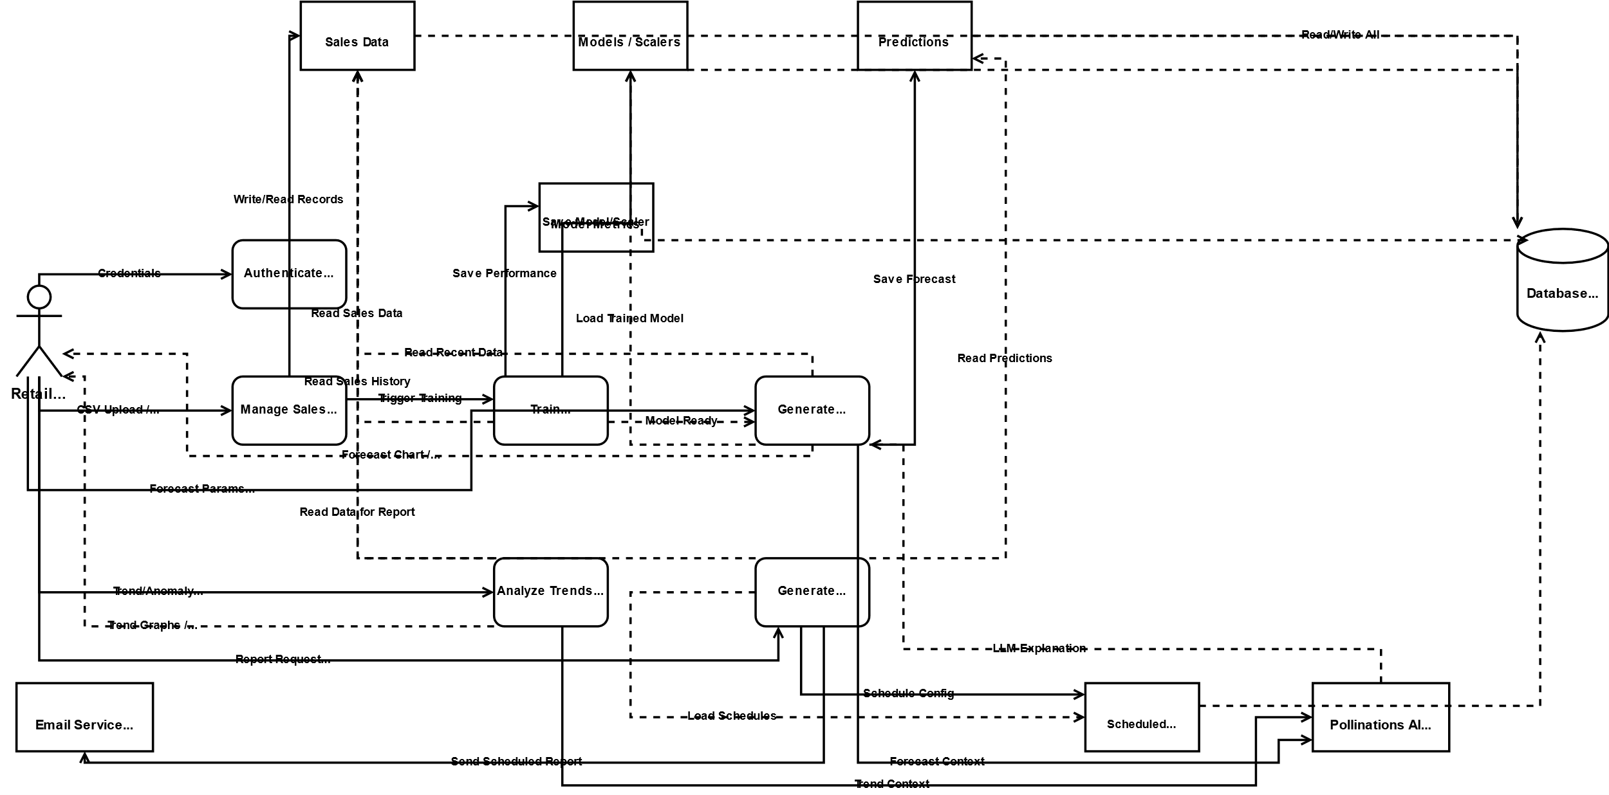
Figure 4: Level 1 Data Flow Diagram

3.8 Logical Design
The logical design translates the analysed requirements into a conceptual structure for the system, independent of any specific programming language or database product. It defines the system architecture, the major control flows, and the strategies employed to satisfy the non-functional requirements.

3.8.1 System Architecture
The system is organized as a three-tier layered architecture comprising a Presentation Layer, an Application Logic Layer, and a Data Layer. This pattern separates user interface concerns from business logic and data management concerns, making each tier independently testable and replaceable.
The Presentation Layer consists of eleven purpose-built HTML templates rendered server-side by the Flask framework. Each template corresponds to a distinct functional area: the Dashboard, Data Management, Generate Forecast, Trends Analysis, Reports, Anomaly Detection, What-If Analysis, Model Training, User Management, Login, and Register screens. All templates follow a consistent design language with a fixed left-side navigation sidebar, card-based content areas, and Plotly.js interactive charts. The sidebar dynamically shows or hides administrator-only links depending on the authenticated user's role, which is resolved by a call to the /api/user-info endpoint on page load.
The Application Logic Layer is implemented as a set of modular Python classes served by the Flask web framework.
- The LSTMForecaster class encapsulates model architecture definition, training, and iterative autoregressive prediction.
- The DataPreprocessor class handles all feature engineering and Min-Max scaling.
- The BaselineModels class provides ARIMA and Exponential Smoothing forecasting.
- The AnomalyDetector class coordinates IQR, Z-score, and Isolation Forest detection.
- The LLMExplainer class constructs context-aware prompts and communicates with the Pollinations AI API.
- The ReportGenerator class produces PDF, Excel, and CSV reports.
- The EmailService class handles SMTP-based report delivery.
- The ModelScheduler and EmailScheduler classes run as background daemon threads to automate model retraining and scheduled report dispatch respectively.
The Data Layer consists of a SQLite relational database operating in WAL journaling mode, accessed exclusively through a get_db_connection context manager that enforces consistent connection settings and retry logic. Trained LSTM model weights are persisted as HDF5 (.h5) files in a dedicated models/ directory, and Min-Max scalers are stored as Joblib (.pkl) files in a scalers/ directory, enabling fast prediction without retraining on every request.

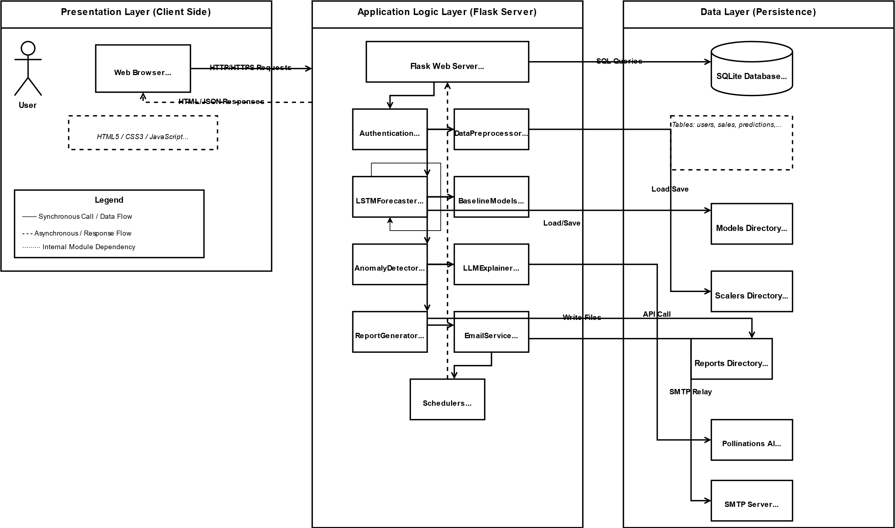
Figure 5: Three-Tier System Architecture Diagram

3.8.2 Control Flow and Process Design
The forecasting pipeline is the core process of the system and follows a clearly defined sequential control flow from raw data ingestion to the display of predictions and AI explanations. The steps of this pipeline are described below.
Data Ingestion and Validation. When a user submits a CSV file, the system reads and iterates through each row. For each row, it confirms that all required fields are present and non-empty. Rows passing validation are inserted into the sales table of the SQLite database after category mapping. Rows failing any check are recorded in an error log returned to the user.
Model Training. The LSTMForecaster.build_model method constructs a sequential neural network. The first layer is a one-dimensional Convolutional layer with 64 filters and a kernel size of three, applied with same-padding to preserve sequence length. It is followed by Batch Normalisation, Max Pooling with pool size two, and Dropout (rate 0.2). The next two layers are Bidirectional LSTM layers (128 and 64 units respectively), each followed by Batch Normalisation and Dropout (rate 0.3). These are followed by a unidirectional LSTM layer (32 units) with Batch Normalisation and Dropout. Two Dense layers (64 and 32 units, ReLU activation) with L2 regularisation and Dropout precede the output Dense layer producing the seven-step forecast. The model is compiled with the Huber loss function, which is robust to outliers, and the Adam optimiser at an initial learning rate of 0.001. EarlyStopping (patience 20, monitoring validation loss) and ReduceLROnPlateau (factor 0.5, patience 8) callbacks control the training process.
Prediction and Uncertainty Estimation. During inference, the trained model generates predictions autoregressively: the most recent lookback window is fed to the model, the first predicted value is appended to the window, the oldest value is removed, and the process is repeated for each day in the forecast horizon. To estimate prediction uncertainty, Monte Carlo Dropout is applied by performing 20 stochastic forward passes per prediction step with Dropout layers active. The mean of the 20 samples becomes the point prediction, and the standard deviation is used to construct the 95 percent confidence interval bounds. This approach provides calibrated uncertainty estimates without requiring a separate ensemble of models.
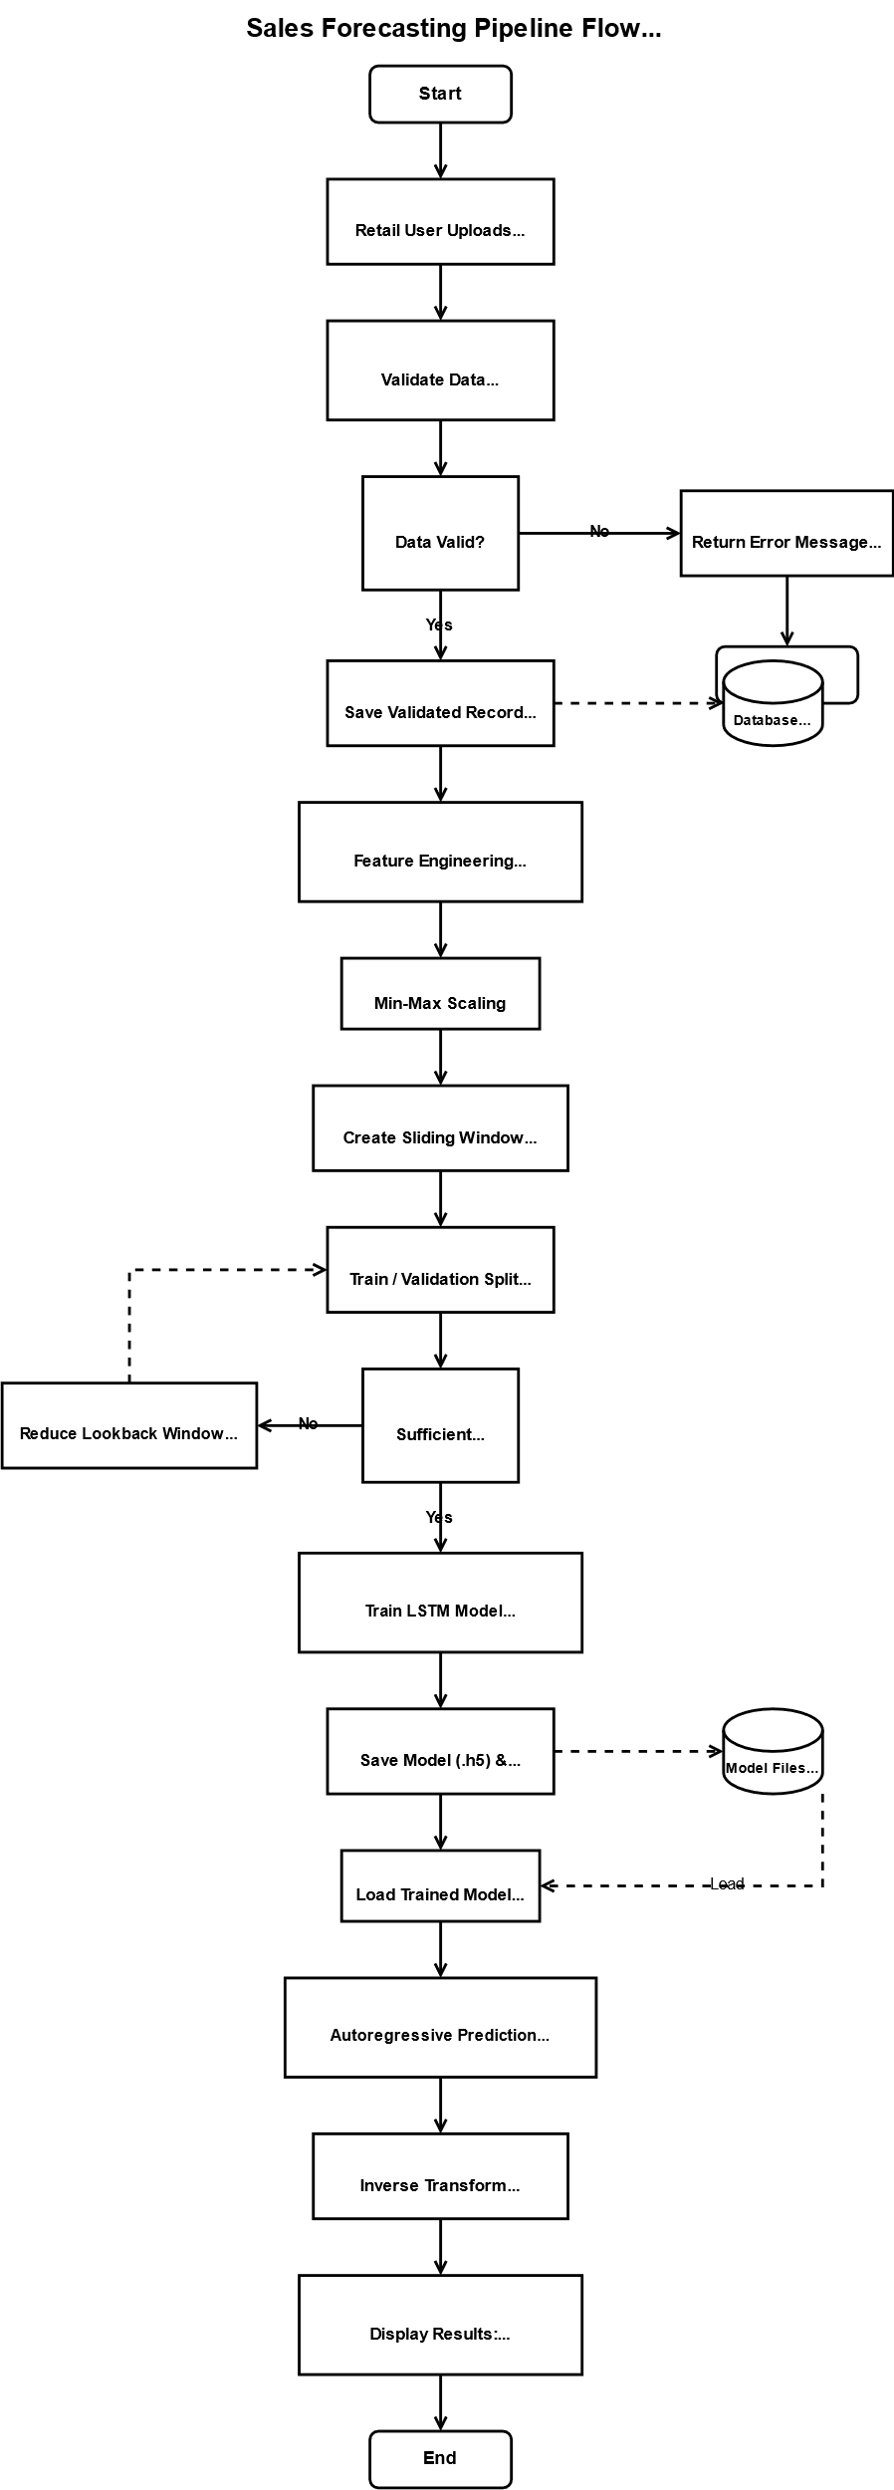
Figure 6: Sales Forecasting Pipeline Flowchart

3.8.3 Design for Non-Functional Requirements
Security. User passwords are hashed on registration using Werkzeug's generate_password_hash function. All Flask routes that serve data or perform operations are protected by authentication decorators. All SQL queries use parameterized placeholders to prevent injection attacks.
Database Reliability and Concurrency. The SQLite database is configured to use WAL journaling mode, which separates write operations into a write-ahead log file, permitting multiple simultaneous read connections while a write is in progress. This eliminates the database-locked errors that would otherwise occur when the background model scheduler and an active user request attempt concurrent writes
Error Handling and Resilience. Every API endpoint is wrapped in a try-except block that catches all exceptions and returns a structured JSON response containing a success flag set to false and a human-readable error message. Background scheduler threads are similarly wrapped in exception handlers and will log errors to the application log without terminating the main Flask process. This ensures that a failure in a background task, such as a failed email delivery or an unsuccessful model retrain, does not affect system availability for active users.

3.9 Physical Design
The physical design translates the logical architecture into concrete decisions about the database schema, the user interface screens, and the hardware and software environment in which the system will run.

3.9.1 Database Design
The system uses SQLite as its relational database management system. SQLite is appropriate for a single-server, moderate-concurrency deployment because it requires no separate database server process, its WAL mode supports concurrent reads, and its file-based storage simplifies backup and portability. The physical schema comprises ten tables.

Table | Key Columns | Purpose
users | id, username (UNIQUE), email (UNIQUE), password_hash, role, created_at | Stores registered user accounts. The role column accepts the values 'admin' or 'user' and governs access control throughout the application.
sales | id, date, product_category, region, units_sold, unit_price, total_sales, promotion_flag, holiday_flag, discount_percent, stock_level, created_at | The primary operational table storing all historical retail sales records uploaded by users or entered manually. Indexed on date, product_category, region, promotion_flag, and holiday_flag.
predictions | id, prediction_date, forecast_date, product_category, region, predicted_sales, predicted_units, confidence_interval_lower, confidence_interval_upper, model_type, created_at | Stores every forecast generated by the system, including the model type used and the confidence bounds produced by Monte Carlo Dropout. Indexed on forecast_date, product_category, and region.
model_metrics | id, model_name, mae, rmse, mape, r2_score, training_date | Records the evaluation metrics produced after each model training run, enabling historical comparison of model performance over successive retraining cycles.
trends | id, trend_type, trend_value, trend_direction, start_date, end_date, created_at | Stores computed trend statistics (weekly growth rate, monthly growth rate, volatility, peak count) generated by the LSTMForecaster.analyze_trends method after each forecast run.
anomalies | id, detection_date, anomaly_date, product_category, region, sales_value, units_value, detection_method, explanation, reviewed, created_at | Stores anomalous records identified by the AnomalyDetector, recording the detection method used and a reviewed flag that can be set by an administrator after manual inspection.
scheduled_reports | id, name, report_type, frequency, day, time, recipients (JSON), format, active, last_run, next_run, created_by (FK), created_at | Stores the configuration for automated periodic report delivery. The recipients column stores a JSON array of email addresses. The EmailScheduler daemon reads this table at one-minute intervals.
llm_explanations | id, context_type, context_id, explanation, created_at | A caching table for AI-generated natural language explanations. Caching avoids repeated API calls for the same context and reduces latency for frequently viewed forecasts.
user_activity | id, user_id (FK), action, details, ip_address, created_at | An audit log recording significant user actions for security monitoring and administrative review.
what_if_scenarios | id, name, description, base_category, base_region, parameters (JSON), results (JSON), created_by (FK), created_at | Stores saved what-if scenario configurations and their computed outputs, enabling users to retrieve and compare previously run scenarios.
Table 5: Physical Database Schema
Referential integrity between the scheduled_reports, what_if_scenarios, and user_activity tables and the users table is maintained through foreign key constraints on the created_by and user_id columns. The entity-relationship diagram for the database is presented in Figure 3.6.

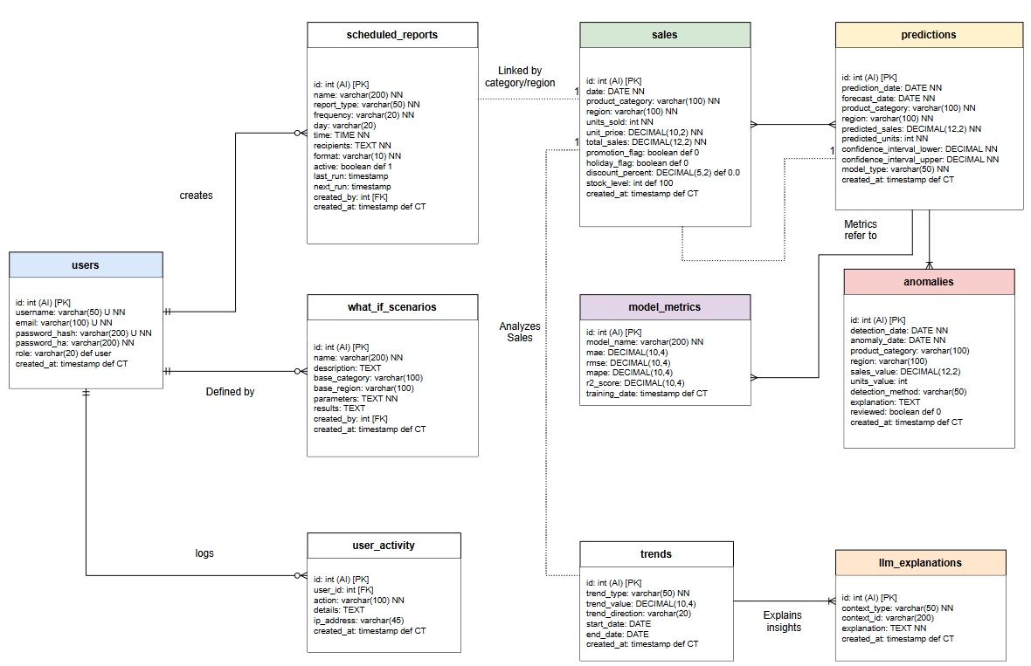
Figure 7: Entity-Relationship Diagram

3.9.2 User Interface Design
The user interface is organized around a fixed left-side navigation sidebar providing access to all system modules.
The visual design employs a consistent language across all screens. Interactive charts use Plotly.js configured with consistent colour palettes and white plot backgrounds for clean printing.
The Generate Forecast screen presents the user with a three-card model selector (LSTM, ARIMA, Exponential Smoothing), dropdown menus for product category and region, a range slider for the forecast period, a data availability status indicator that queries the database in real time when the category and region are selected, and an optional checkbox to proceed with reduced-accuracy forecasting when the dataset is smaller than the optimal threshold. After submission, results are displayed as a summary statistics bar, a Plotly line chart with a shaded confidence band, an AI insights panel with the LLM-generated narrative, a detailed day-by-day results table with confidence ratings, and a model comparison chart showing all three model forecasts overlaid on the same axis.
Table 3.5 summarises all eleven interface screens, their associated HTML template files, and their primary purposes within the system.

Screen Name | Template File | Primary Purpose
Dashboard | dashboard.html | Presents a real-time summary of key metrics (total sales, monthly growth, units, AI predictions), a 30-day sales trend line chart, a category distribution pie chart, a quick-action tile grid, and a recent predictions table.
Data Management | data_management.html | Provides drag-and-drop and file-selection CSV upload, manual single-record entry form, a filterable and paginated sales records table with per-row deletion, an import log panel, and a CSV template download.
Generate Forecast | forecast.html | Enables model selection, category/region/period configuration, data-availability checking, forecast generation, confidence interval chart, AI narrative, and model comparison visualisation.
Trends Analysis | trends_analysis.html | Offers time-period selector buttons, category/region/metric filter controls, a sales-over-time trend chart, a category bar chart, a regional pie chart, a day-of-week pattern bar chart, and an AI-generated trend analysis narrative.
Anomaly Detection | anomalies.html | Allows selection of detection methods, runs multi-method anomaly detection, displays a severity-coded results table, an anomaly value bar chart, and an AI explanation of detected patterns.
What-If Analysis | what_if.html | Provides interactive sliders for price change, promotion impact, seasonal factor, and stock availability adjustments; displays a side-by-side base-versus-scenario forecast chart, summary statistics, and scenario insights text.
Reports | reports.html | Supports report type selection (Sales, Forecast, or Trends), date range and output format selection (CSV, Excel, or PDF), an inline data preview table, summary metric cards, and a scheduled reports management panel.
Model Training | model_training.html | Administrator only. Provides single-model training with category/region selection, batch training for all combinations, a real-time training log, a model performance metric chart, and a list of previously trained models.
User Management | admin_users.html | Administrator only. Lists all registered user accounts with inline role-change dropdowns and per-user deletion buttons.
Login | login.html | Provides username and password fields with server-side error display. Links to the registration screen.
Register | register.html | Provides username, email, and password fields with client-side password length and match validation. Links to the login screen.
Table 6: User Interface Screens Summary
Wireframes for the key screens were developed during the design phase to validate the layout and navigation flow before implementation. Figure 7 presents the wireframe for the Generate Forecast screen, which implements the primary research objective of the project.

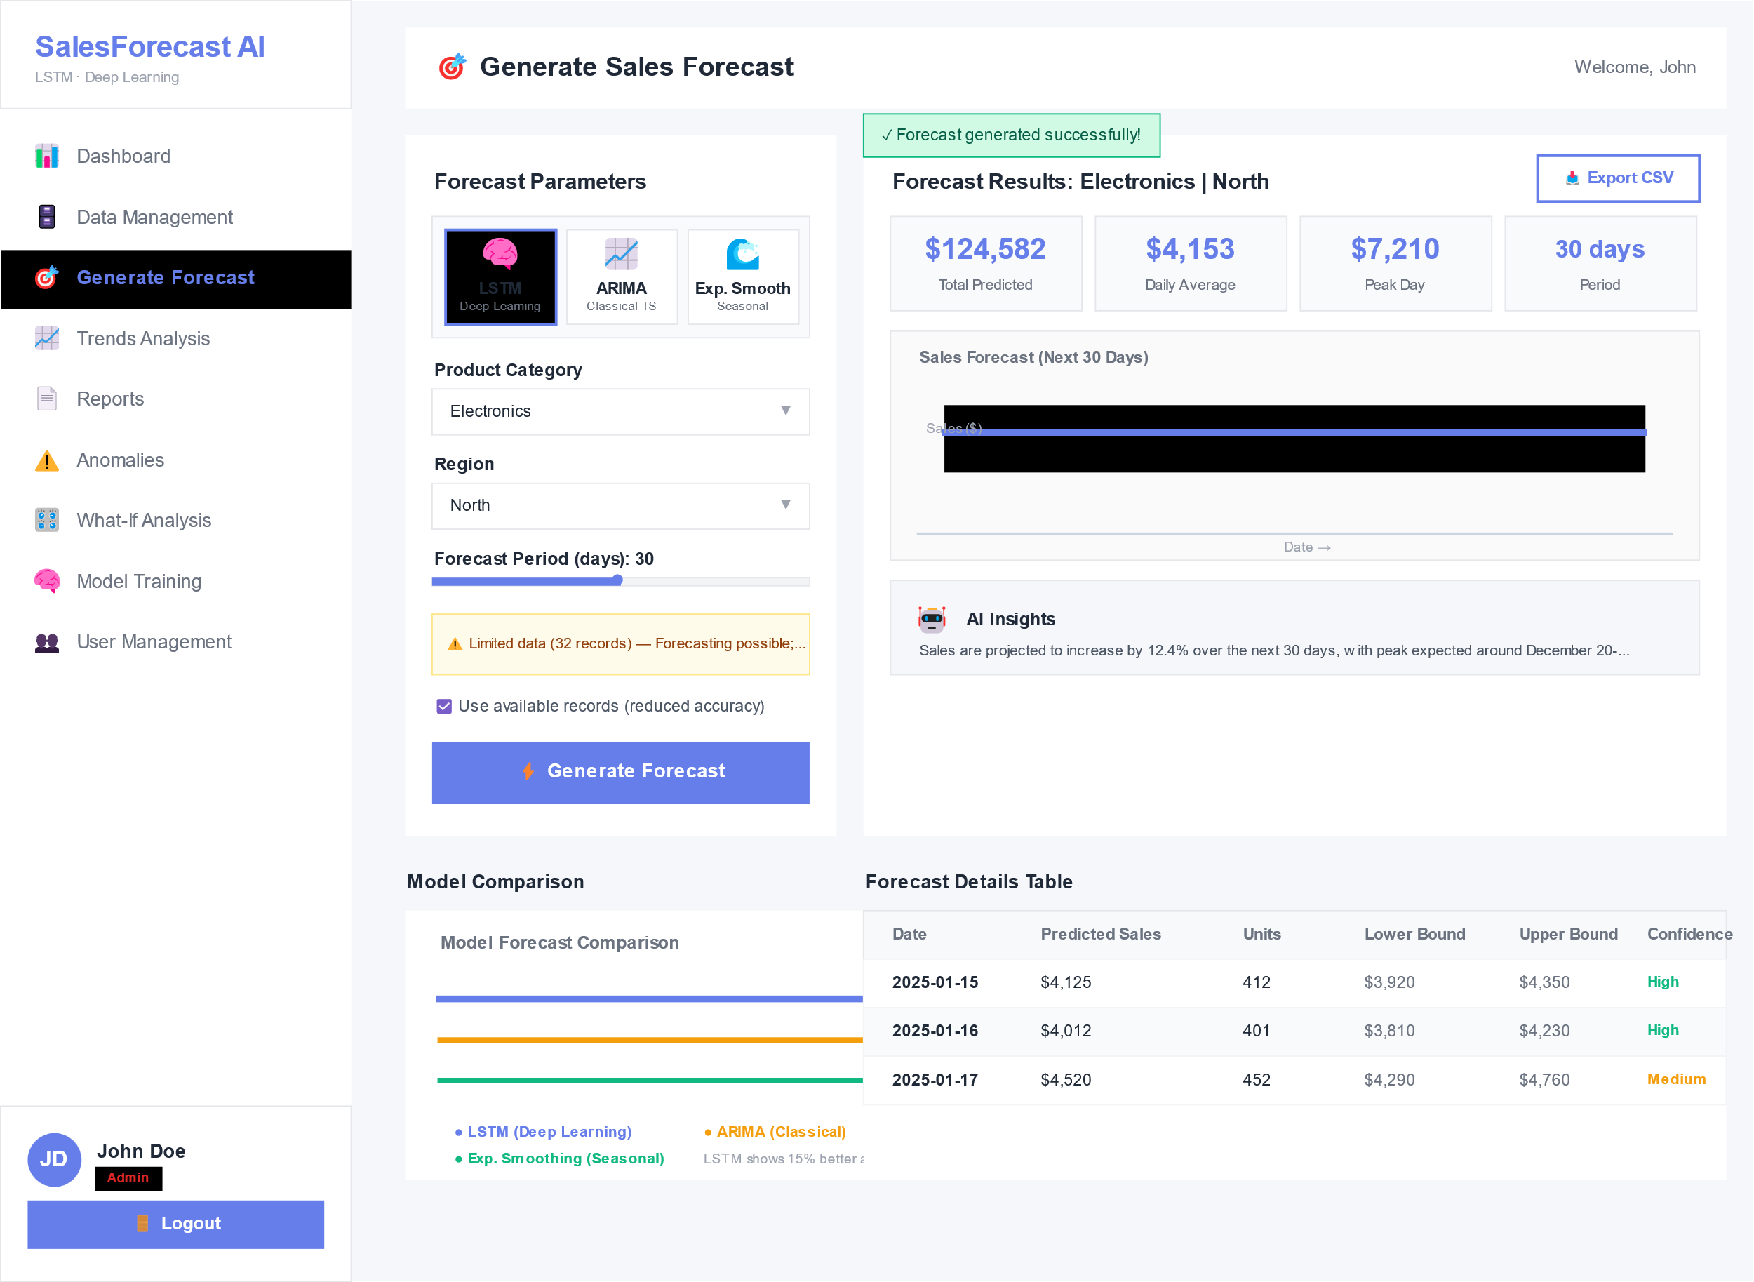
Figure 8: Wireframe for the Generate Forecast Screen

REFERENCES
Bandara, K., Bergmeir, C., & Smyl, S. (2020). Forecasting across time series databases using recurrent neural networks. International Journal of Forecasting, 36(3), 1057–1070.
Brownlee, J. (2018). Deep learning for time series forecasting. Machine Learning Mastery.
Cao, L., Zhang, T., & Xu, H. (2019). Deep learning approaches to retail demand forecasting. Neural Computing and Applications, 31(12), 8881–8894
Chollet, F. (2017). Deep learning with Python. Manning Publications.
Hochreiter, S., & Schmidhuber, J. (1997). Long short-term memory. Neural Computation, 9(8), 1735–1780.
Kim, H., & Kim, J. (2021). Time-series forecasting with attention-based LSTM for retail demand prediction. Expert Systems with Applications, 171, 114545.
Lim, B., & Zohren, S. (2021). Time-series forecasting with deep learning: A survey. Philosophical Transactions of the Royal Society A, 379(2194).
Makridakis, S., Spiliotis, E., & Assimakopoulos, V. (2020). Statistical and machine learning forecasting methods: Concerns and ways forward. PLoS ONE, 15(3), e0228877.
Zhang, X., Li, Y., & Wang, Y. (2020). Ensemble deep learning for sales forecasting in e-commerce. Applied Soft Computing, 93, 106395.
Fawaz, H. I., Forestier, G., Weber, J., Idoumghar, L., & Muller, P. A. (2019). Deep learning for time series classification: A review. Data Mining and Knowledge Discovery, 33(4), 917–963.

APPENDICES

Appendix A: Project Budget

Item | Quantity | Unit Cost (KSh) | Total Cost (KSh)
Laptop | 1 | Owned | -
Cloud Computing (Google Colab Pro – 6 months) | 1 | 6,000 | 6,000
Internet & Data | 6 months | 1,000 | 6,000
Printing & Binding | — | — | 1,000
Miscellaneous | — | — | 1,000
Total Estimated Cost |  |  | 14,000
Table 7: Project Budget

Appendix B: Project Schedule (Gantt Chart)
Activity | Month 1 | Month 2 | Month 3 | Month 4 | Month 5 | Month 6
Proposal Writing & Approval | ███
Literature Review | ███ | ███
Requirements Analysis |  | ███
Data Collection |  | ███ | ███
Data Preprocessing |  |  | ███
Model Design (LSTM Architecture) |  |  | ███ | ███
Model Training & Validation |  |  |  | ███ | ███
System Integration & Testing |  |  |  |  | ███
Results Analysis & Evaluation |  |  |  |  | ███
Final Report Writing |  |  |  |  | ███ | ███
Submission & Presentation |  |  |  |  |  | ███
Table 8:Project Schedule

APPENDIX C: PROJECT RESOURCES

Table 9: Hardware Requirements
Resource | Specification | Purpose
Laptop / Desktop Computer | Minimum 8GB RAM, Intel Core i5 / Ryzen 5 or higher | Model development, data processing, documentation
GPU (Optional) | NVIDIA CUDA-enabled GPU | Accelerates deep learning model training
External Storage | 500GB HDD / SSD | Data backup and storage
Internet Connectivity | Reliable broadband connection | Dataset access, cloud computing, research
Table 9:Hardware requirements

Table 10: Software Requirements
Software | Version | Purpose
Operating System | Windows | Development environment
Python | Version 3.x | Core programming language
TensorFlow | Latest stable version | Deep learning model implementation
Pandas | Latest version | Data preprocessing and manipulation
NumPy | Latest version | Numerical computations
Matplotlib | Latest version | Data visualization
Seaborn | Latest version | Statistical visualization
Flask | Latest version | Forecast visualization dashboard
Plotly | 5.14+ | Interactive browser based charts
Scikit-learn | 1.3+ | Baseline models(Arima wrapper) and Anomaly detection(Isolation forest)
Statsmodels | 0.14+ | Arima and Exponential smoothing implementations
ReportLab | 4.0+ | PDF report generations
Pollinations AI API | N/A(External Service) | Natural language explanation generation
SQLite3 | Built into python | Relational Database
Table 10:Software requirements

APPENDIX D: INTERVIEW GUIDE FOR REQUIREMENTS GATHERING
Introduction: "This interview is for academic research on developing a deep learning-based sales forecasting system. Your responses will be anonymized."
Section A: Current Forecasting Practices
What tools or methods do you currently use to forecast sales?
How accurate do you find your current forecasting approach?
How often do you experience stockouts? Overstock situations?
Section B: Challenges and Pain Points
4. What factors make sales forecasting difficult in your retail operation?
5. Can you estimate the revenue loss caused by inaccurate forecasts in peak seasons?
6. How do promotions, holidays, and seasonality affect your demand planning?
Section C: System Requirements and Preferences
7. What features would you want in an ideal sales forecasting system?
8. Would AI-generated natural language explanations of forecasts be useful to you?
9. How would you prefer to receive forecast outputs (dashboard, email reports, PDF)?
10. Should forecasts be segmented by product category? By geographic region?
Section D: Additional Input
11. What is your single biggest frustration with current forecasting?
12. Any other features or capabilities you would recommend?

APPENDIX E: INTERVIEW PARTICIPANTS SUMMARY
Code | Role | Experience (Years) | Date of Interview | Duration
RM-01 | Retail Manager | 8 | February | 15 min
RM-02 | Retail Manager | 5 | February | 8 min
RM-03 | Retail Manager | 12 | February | 22 min
RM-04 | Retail Manager | 4 | February | 20 min
RM-05 | Retail Manager | 7 | February | 13 min
DA-01 | Data Analyst | 3 | February | 9 min
DA-02 | Data Analyst | 6 | February | 12 min
DA-03 | Data Analyst | 2 | February | 18 min
IP-01 | Inventory Planner | 9 | February | 20 min
IP-02 | Inventory Planner | 5 | February | 17 min
Table 11: Interview participants

APPENDIX F: SAMPLE INTERVIEW NOTES
Interview with RM-01 (Retail Manager, 8 years experience)
Q: "What tools do you currently use to forecast sales?"
A: "We use Excel spreadsheets. Just take last year's numbers and add a percentage. It's basic."
Q: "How often do you experience stockouts?”
A: "During December holidays, almost every week. We lose maybe 15-20% of expected sales."
Q: "What would help you forecast better?"
A: "Something that learns from past patterns. Not just averages. And tells me why it made that prediction."
Interview with DA-01 (Data Analyst, 3 years experience)
Q: "What features would you want in a forecasting system?"
A: "Needs to show forecasts by category and region separately. Aggregate numbers are useless for planning."
Q: "How do you prefer to see forecast results?"
A: "Dashboard first, but also scheduled email reports. I don't have time to log in every day."

APPENDIX G: INFORMED CONSENT FORM
Title of Research: Deep Learning-Based Sales Forecasting System for Retail Business Optimization
Researcher: Henry Ochieng Onyango, Jomo Kenyatta University of Agriculture and Technology
Purpose: To gather requirements for designing a sales forecasting system
Confidentiality: All responses will be anonymized. No names or identifying information will appear in the final report.
Voluntary Participation: You may withdraw at any time without consequence.
Consent Statement:
"I have read and understood the above information. I agree to participate in this interview."
Participant Signature: ______________ Date: ______________
Researcher Signature: ______________ Date: ______________

