  Patriotism • Leadership • Service • Professionalism | City Government of San Pablo  PAMANTASAN NG LUNGSOD NG SAN PABLO  STUDENT LIFE SUCCESS  GUIDANCE AND COUNSELING OFFICE  San Jose, San Pablo City | Tel No.: (049) 536-7830 | Email Address: plspofficial@plsp.edu.ph | 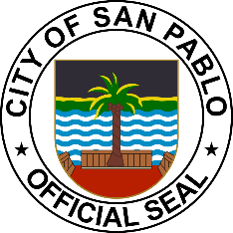

Request for Certificate of Good Moral Character and Electronic Documentary Stamp Tax

Date Requested:
GOR No.: _________________________
EDST: ____________________________
Name:
Address:
Course:
Purpose:
Last Attendance(S.Y):
Cellphone No.:

(Kindly Check):

Undergraduate: Graduate:

_________________________________________
Student Signature

