  Patriotism • Leadership • Service • Professionalism | City Government of San Pablo  PAMANTASAN NG LUNGSOD NG SAN PABLO  STUDENT LIFE SUCCESS  GUIDANCE AND COUNSELING OFFICE  San Jose, San Pablo City | Tel No.: (049) 536-7830 | Email Address: plspofficial@plsp.edu.ph | 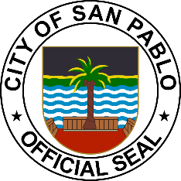

CERTIFICATE OF GOOD MORAL CHARACTER

To Whom it May Concern:

This is to certify that {{name}}, is a student of this institution taking up {{course}}, A.Y. {{school_year}}.
This further certifies that as per records on file in this office he was found to be of good moral character.
Given this {{day}} day of {{month_year}} for {{purpose}} only.

MRS. EILEEN ARCE – OPEÑA, RPm, LPT
Guidance Counselor III

not valid without dry seal
"DOCUMENTARY STAMP TAX PAID”
{{gor}} {{date_of_payment}}
(GOR SERIAL NUMBER) (DATE OF PAYMENT)

