
Alexandria University
Faculty of Engineering
Computer and Communication Program
CC484 Pattern Recognition
Assignment One: Face Recognition

Project Link: Colab Notebook

Name | ID
Omar Walied Mohamed | 7058
Hend Khaled AbdelHamid M. Aly | 6986
Habiba Mohamed Hefny | 6939

Table of Contents
Introduction to the problem statement 2
Problem Description 2
Code Explaination and Screenshots 3
Uploading dataset (step 1) 3
Steps 2 & 3 3
PCA Classification and its Classifier Tuning 4
Alpha vs Accuracy Plots 8
LDA Classification and its Classifier Tuning 10
Alpha vs Accuracy Plots 10
Face Images vs Non-Face Images 11
Bonus 25
Part One : 70 30 split 25
Part Two: PCA 31
Part Two: LDA .37
Comparisons 39
Alpha vs accuracy in PCA 39
LDA vs PCA 40
Bonus: 70 30 split vs 50 50 split 40
Bonus: PCA variation vs Original 41
Bonus: LDA variation vs Original 43

- What is Face Recognition Problem?
Face recognition means that for a given image, we can tell the subject id. In the given dataset, we have 40 subjects, each of 10 images, each image of size 92*112.

- Problem Description:
- downloaded the dataset from kaggle website.
- converted every image into a vector of 10304 values (image size).
- Generate the date matrix D and the label vector Y.
- Apply PCA Classification.
- Apply LDA Classification.
- Set the number of neighbors in the K-NN classifier to 1,3,5,7. To apply classifier tunning.
- Get another dataset containing non-face images to compare it with the face images dataset.
- Changed the number of instances per subject to 7 and keep 3 instances per subject for testing, then compared the results with the results of 50% split.
- Used Incremental PCA (IPCA) as a variation of PCA other than the one used in the fourth step.
- Used Regularized LDA (RDA) as a variation of LDA other than the one used in the fifth step.

Step 1: upload dataset to colaboratory

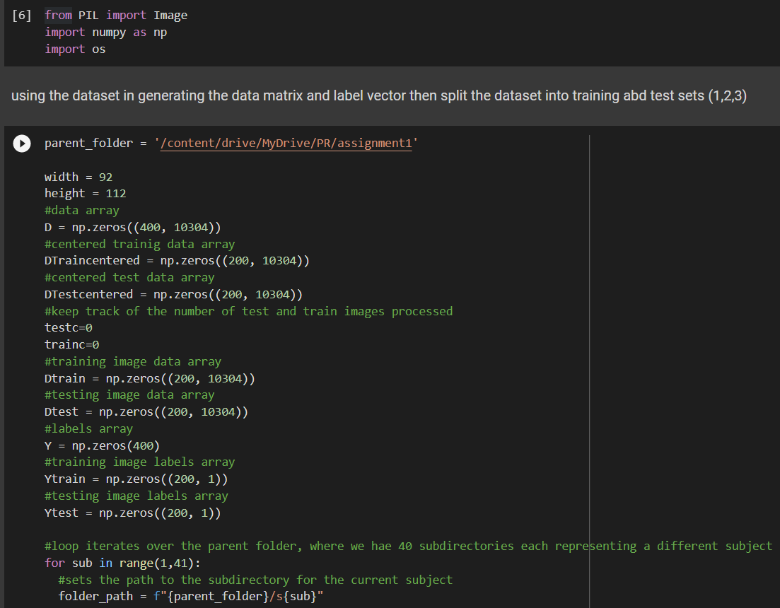
Step 2,3:

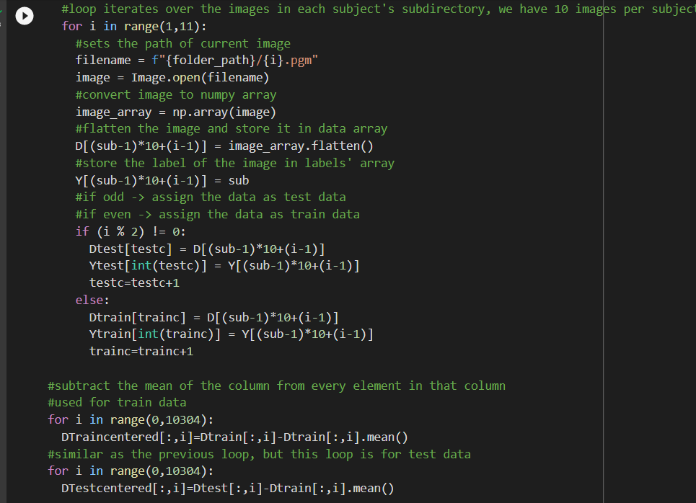
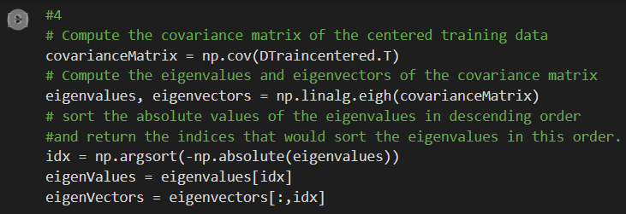
Step 4,6:

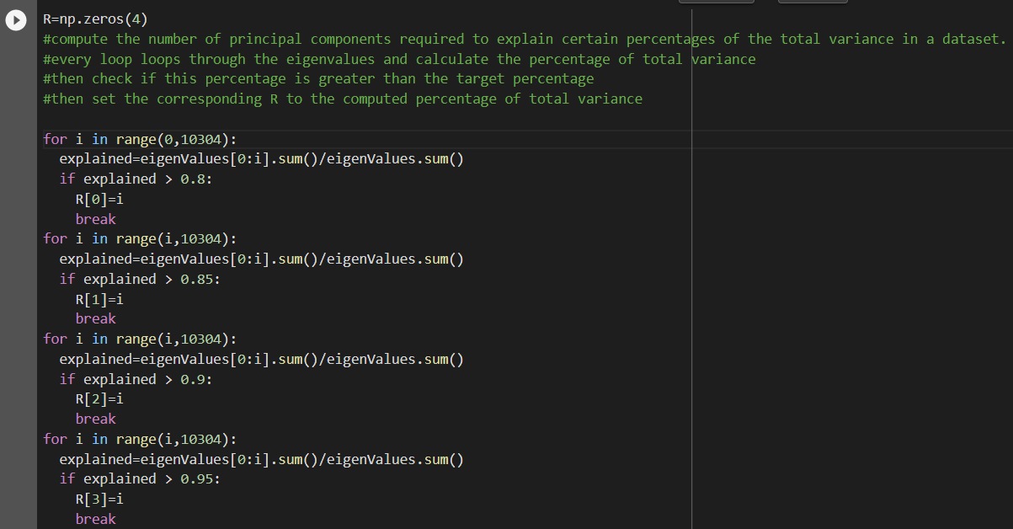
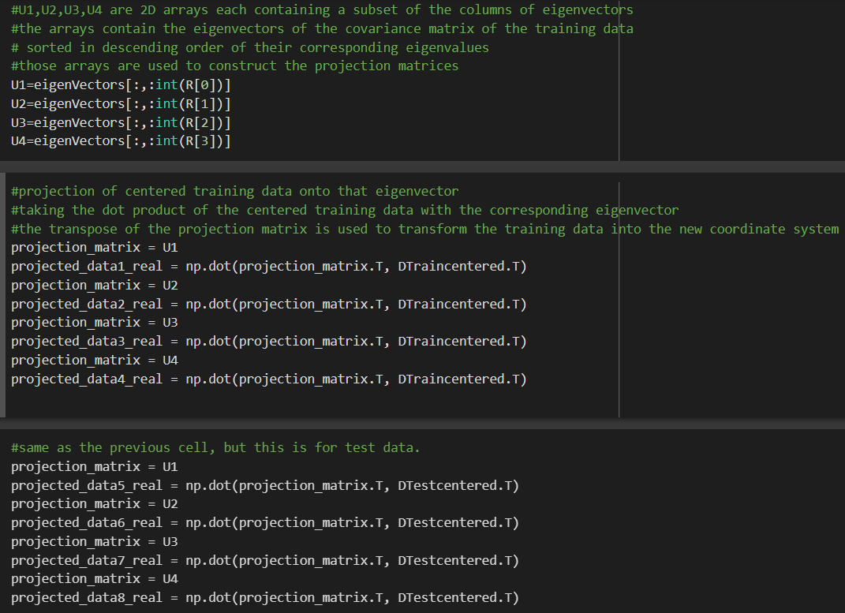

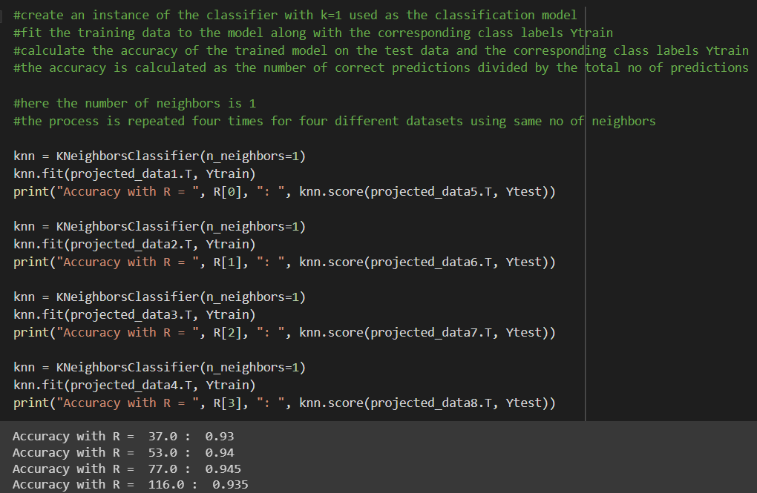

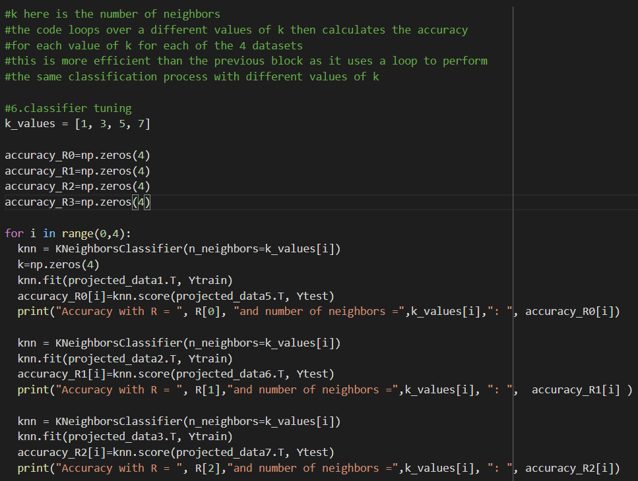

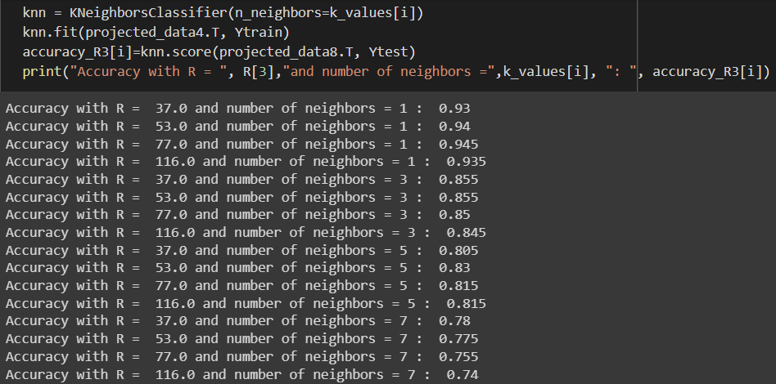

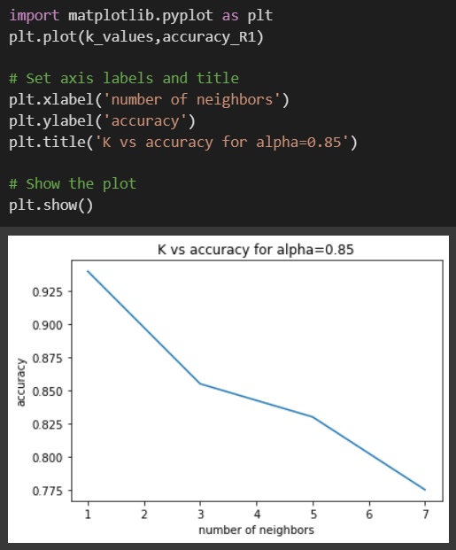
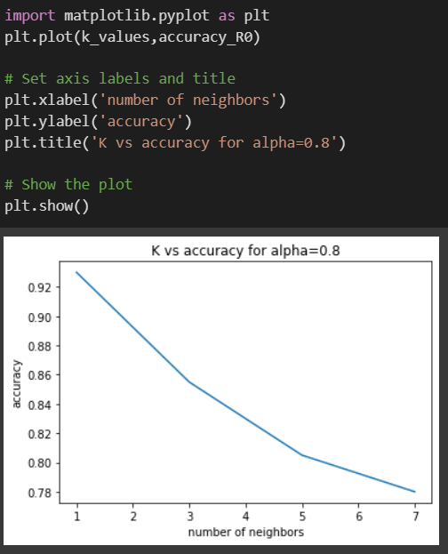
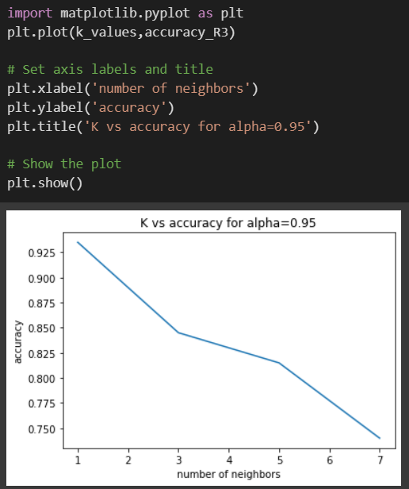
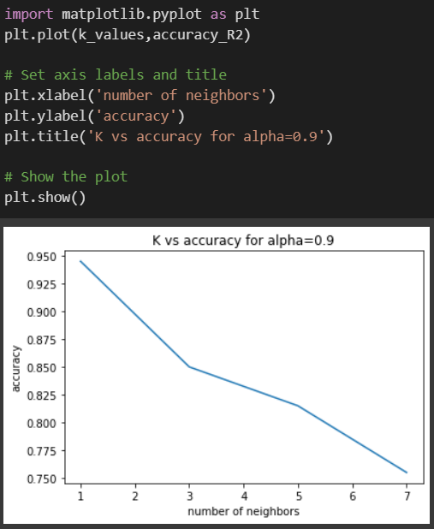
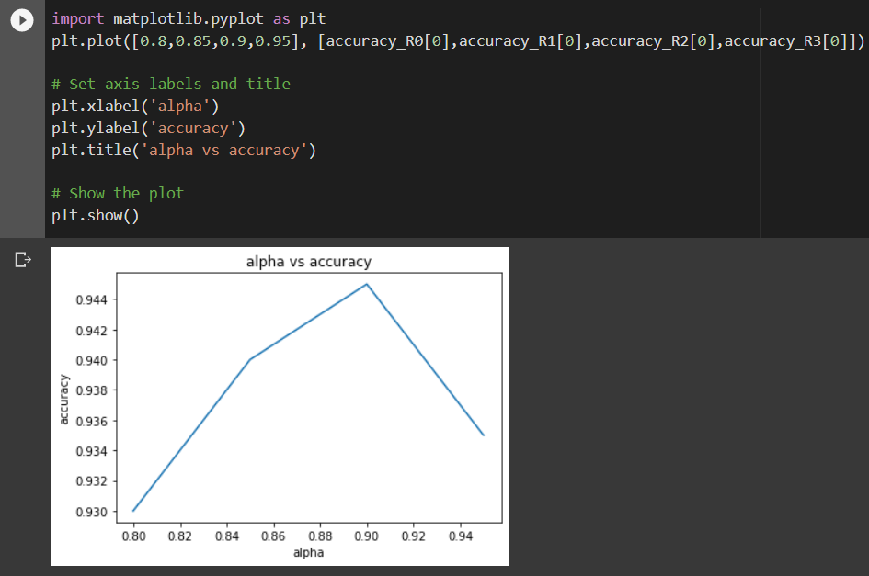
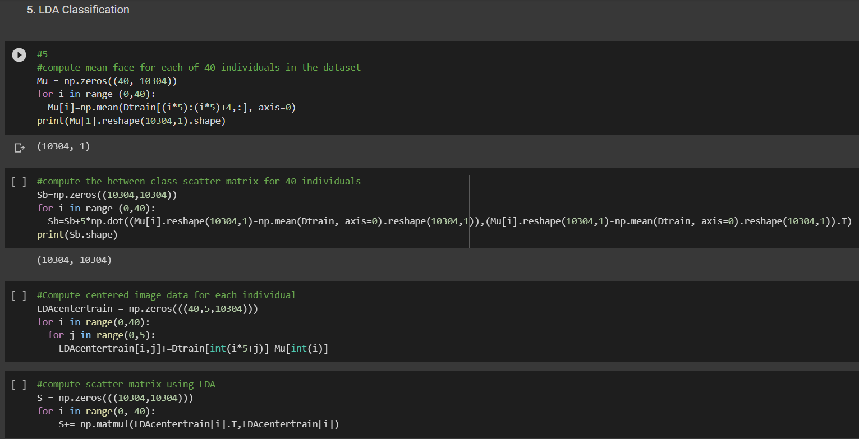
Step 5,6:

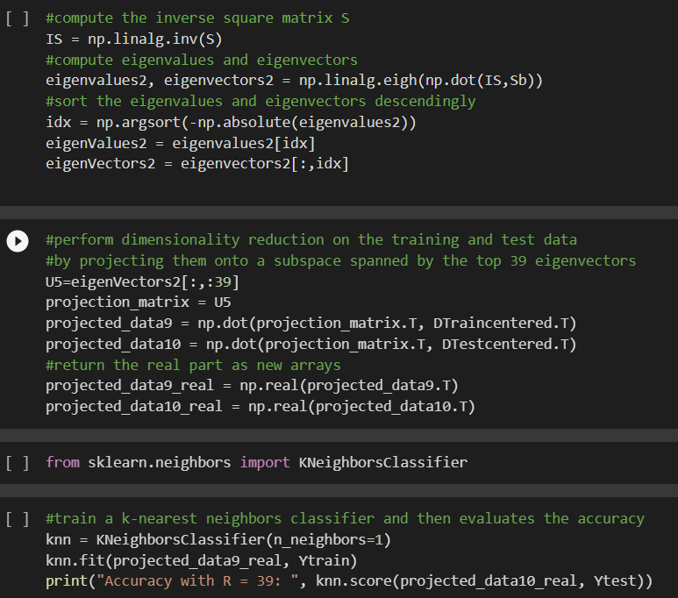

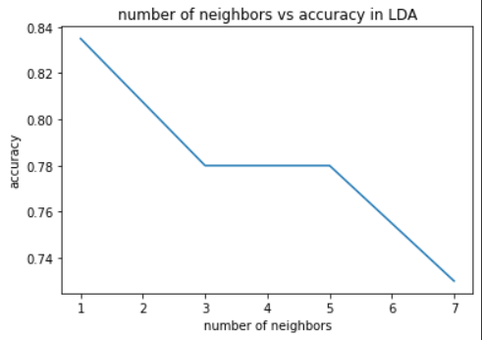
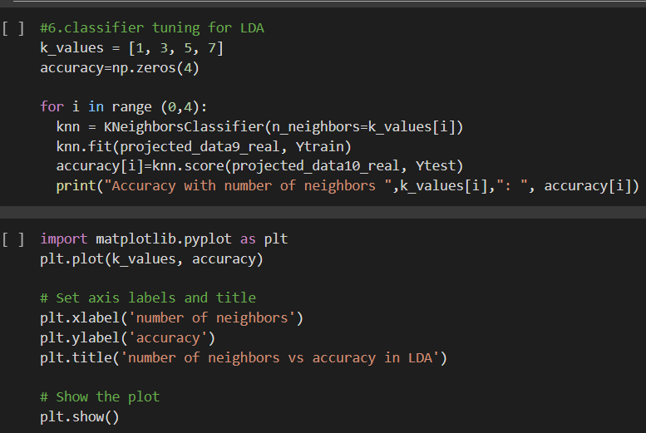
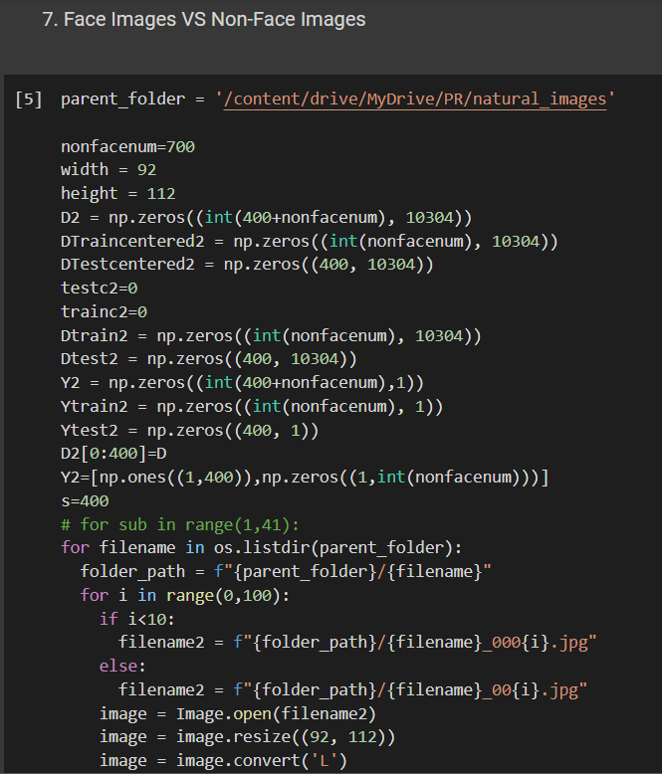
Step 7:

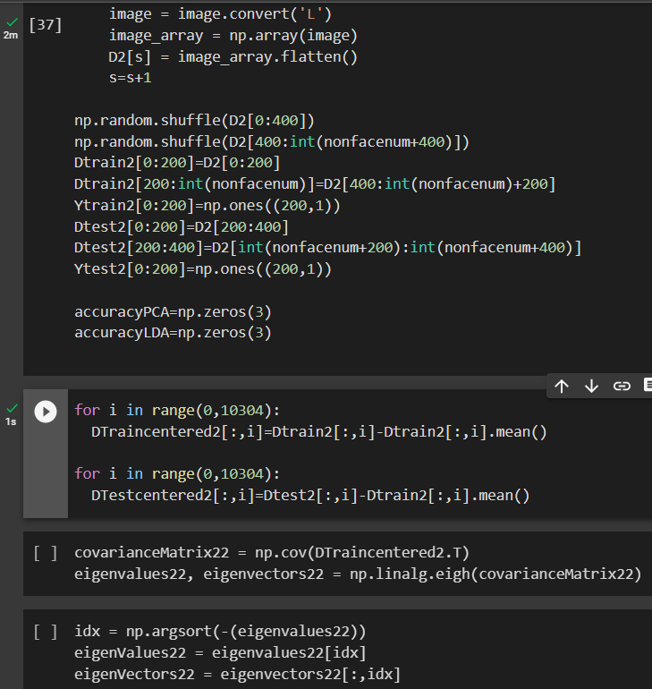

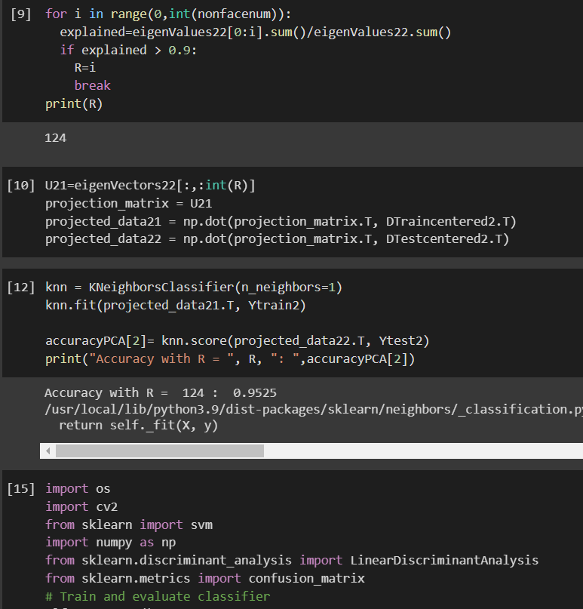
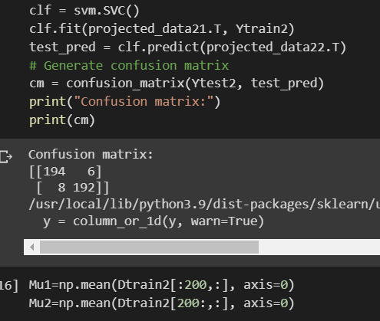
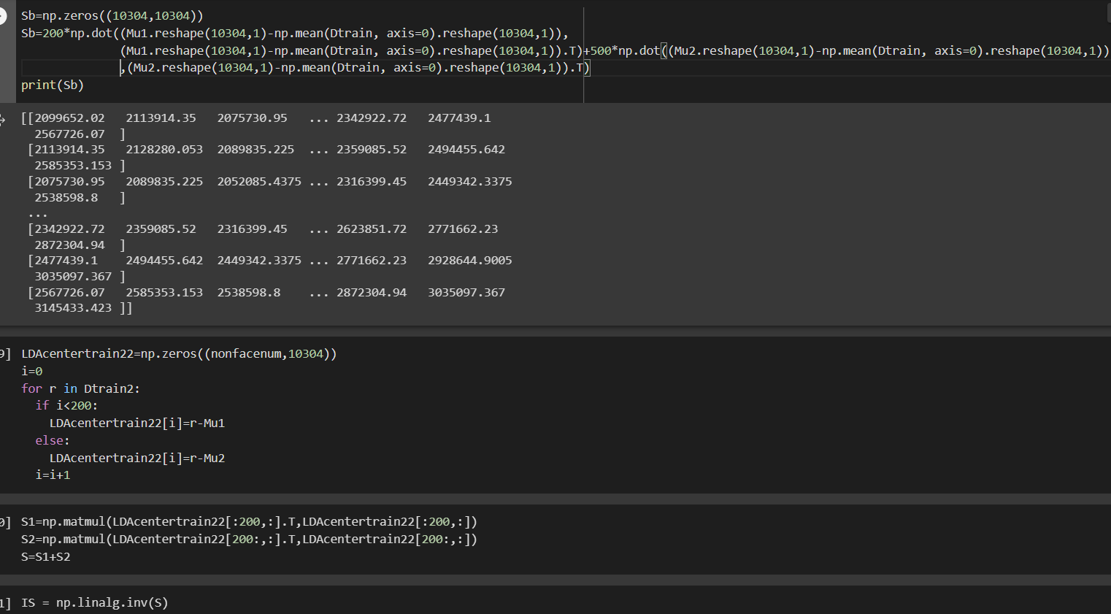

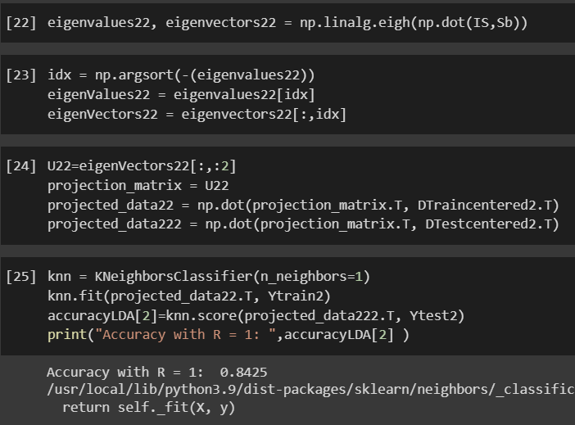

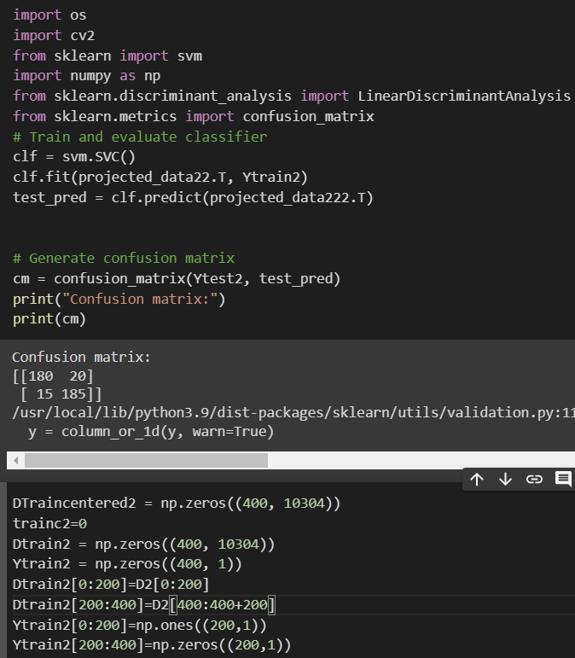

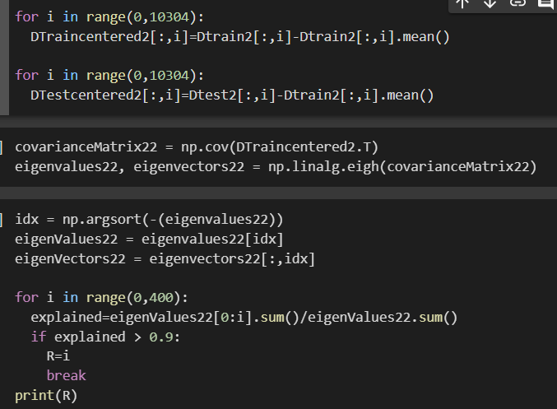

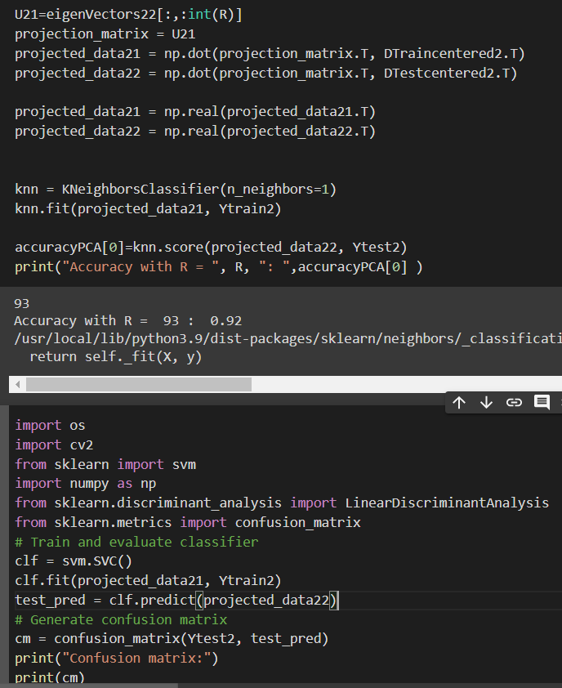

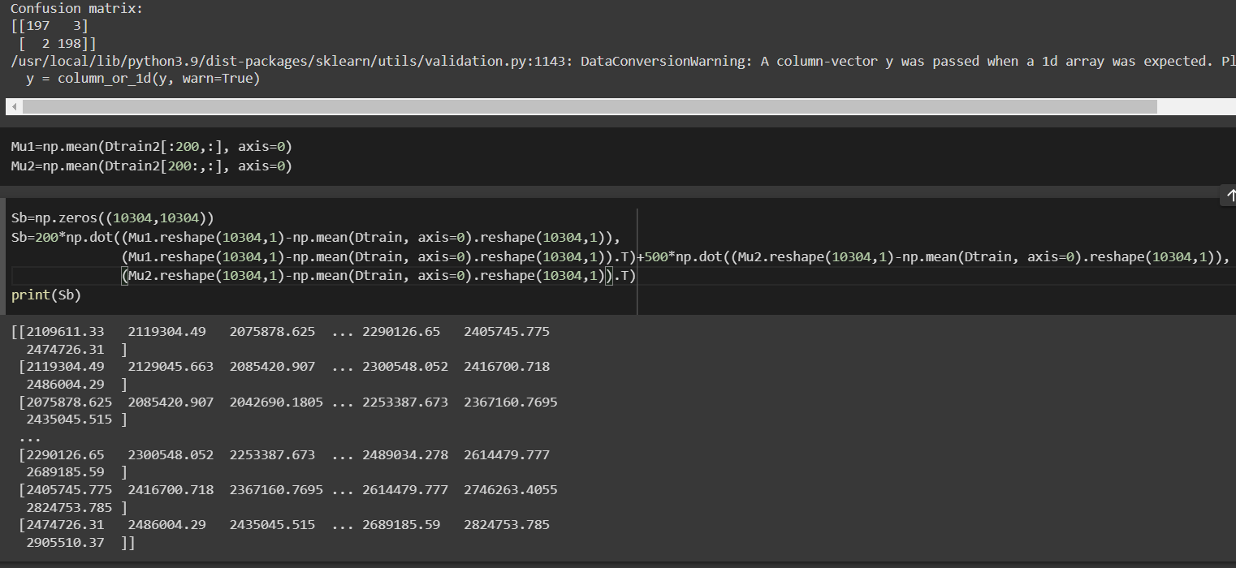

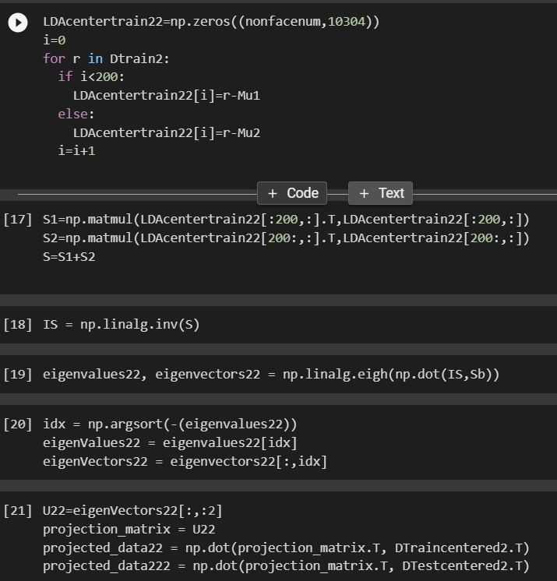

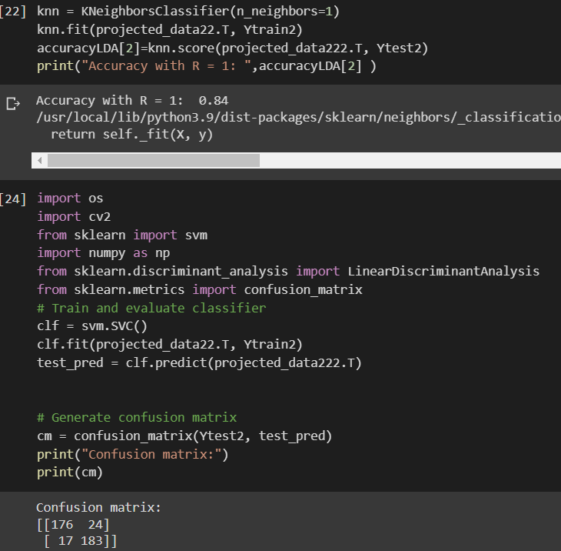

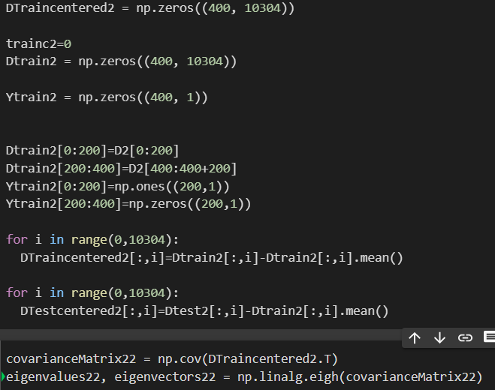

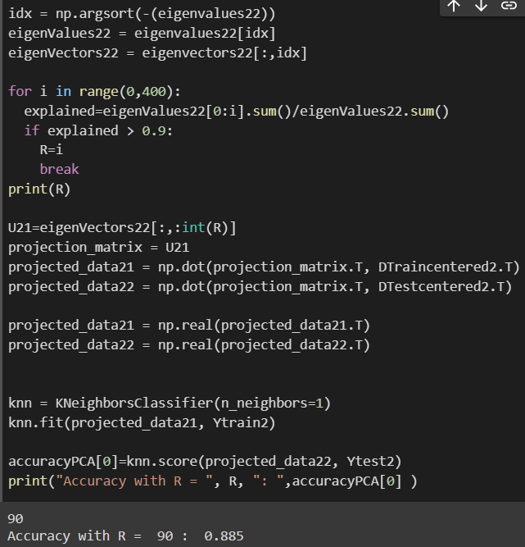

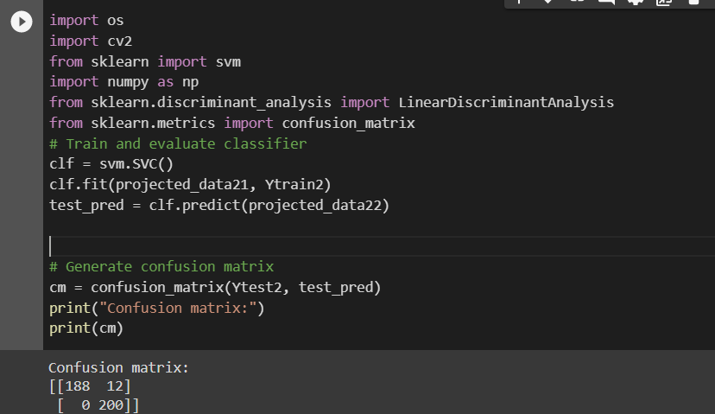

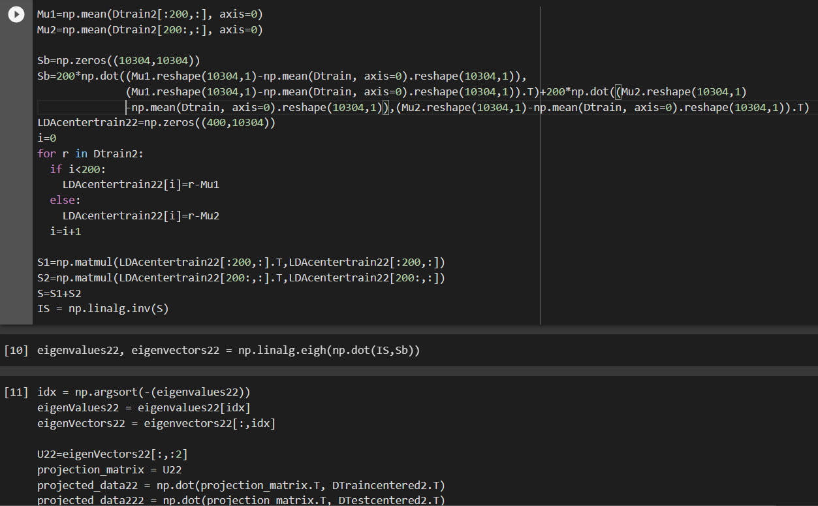

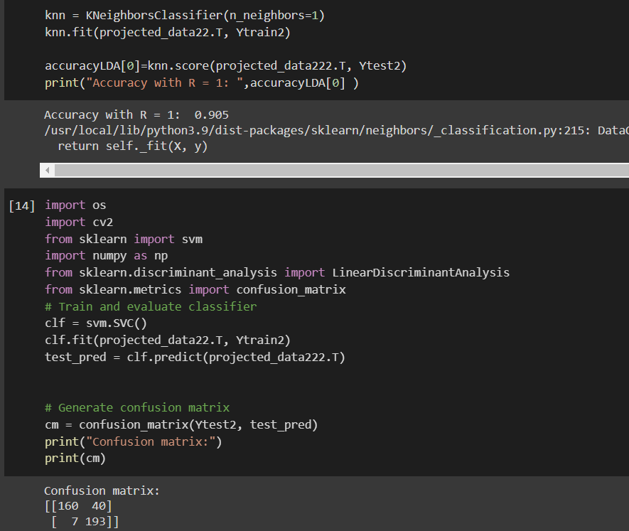

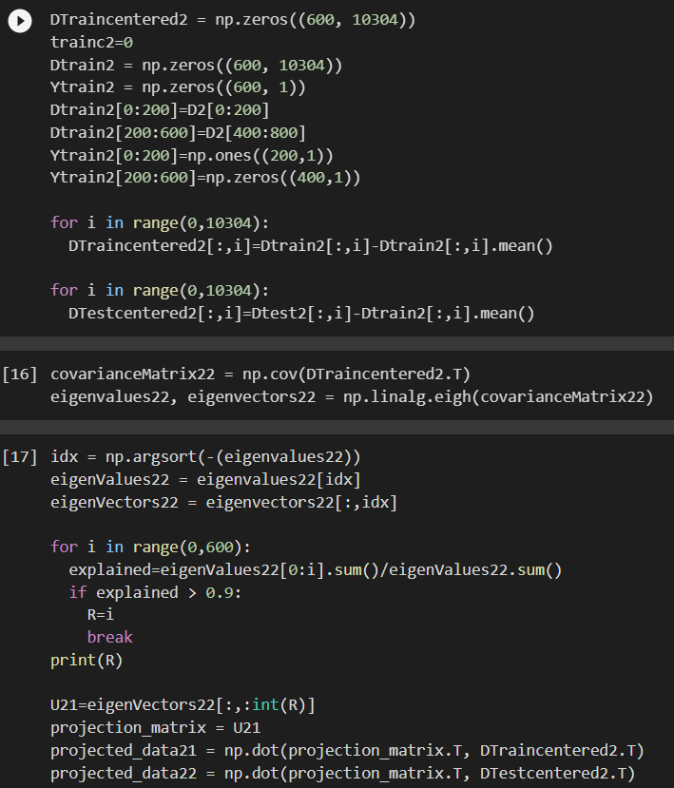

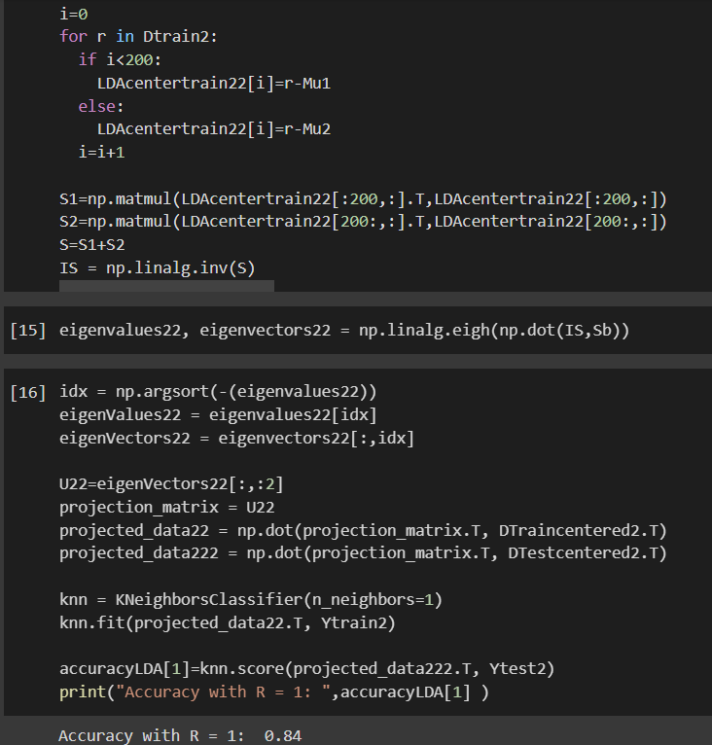
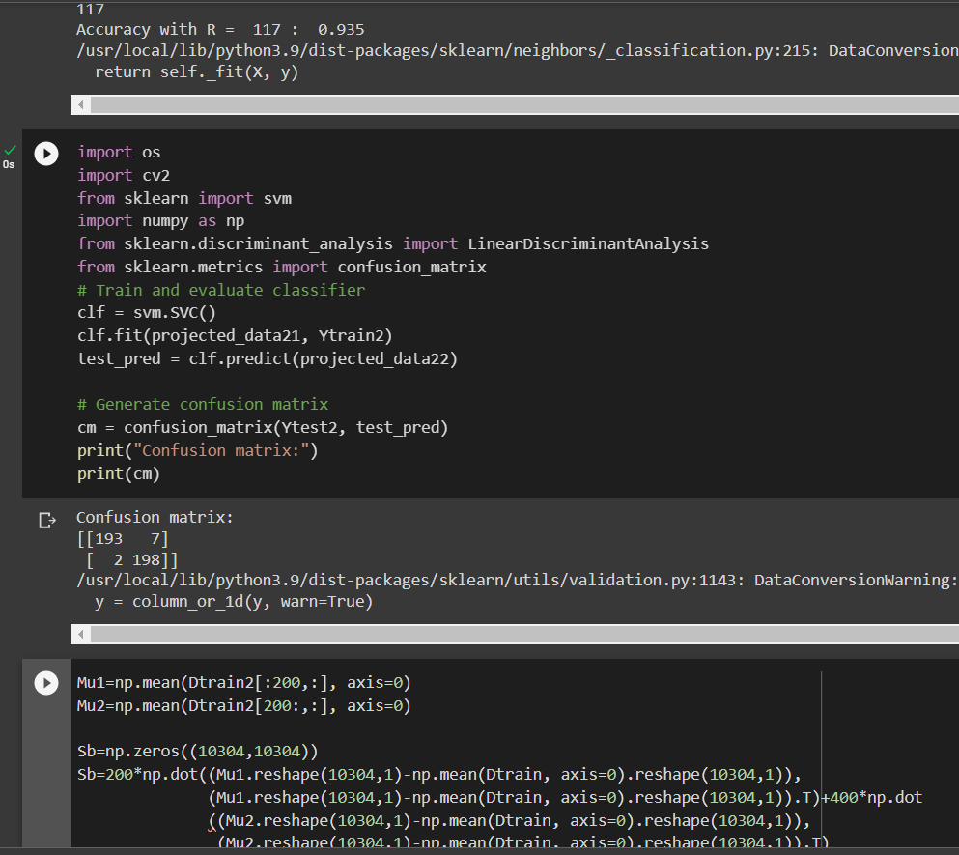

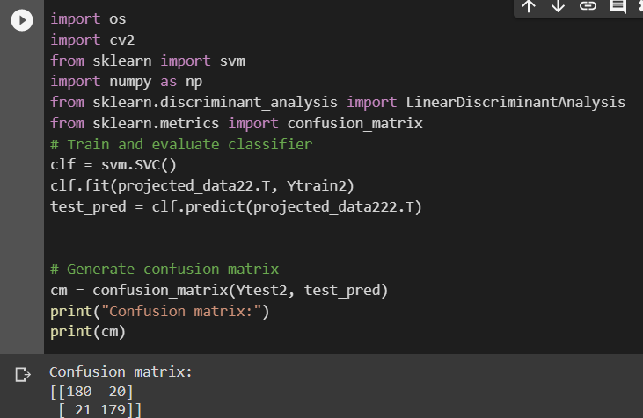

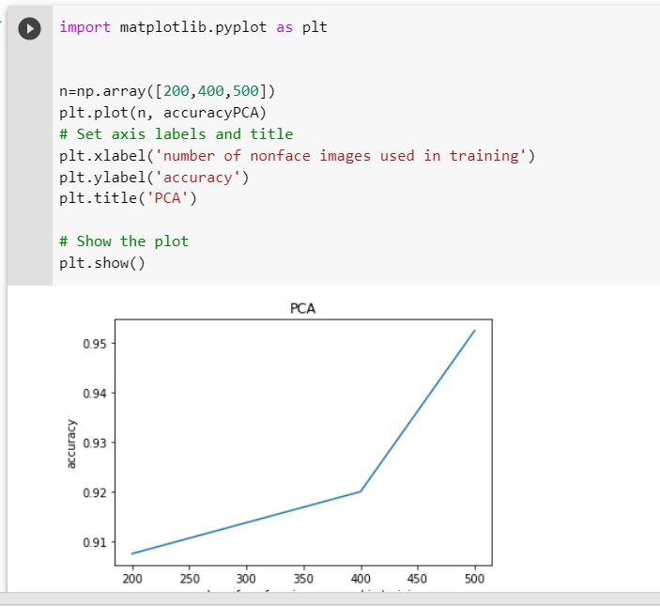

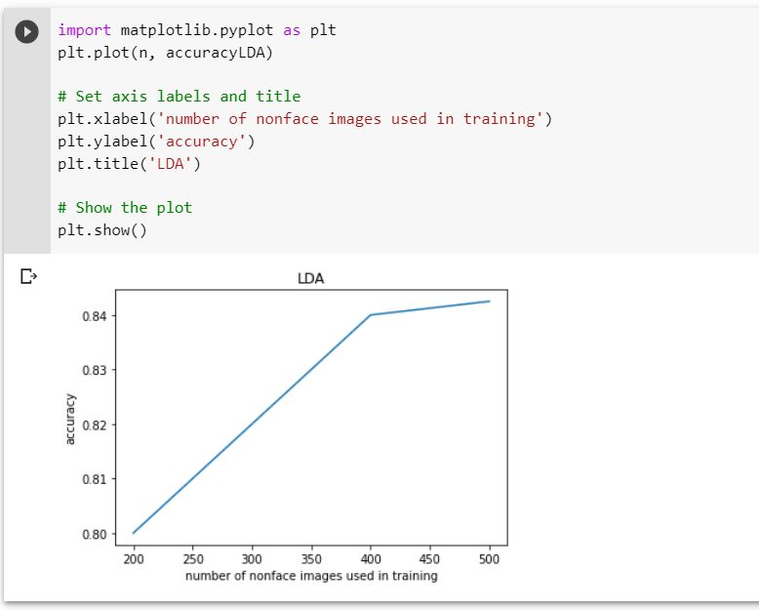

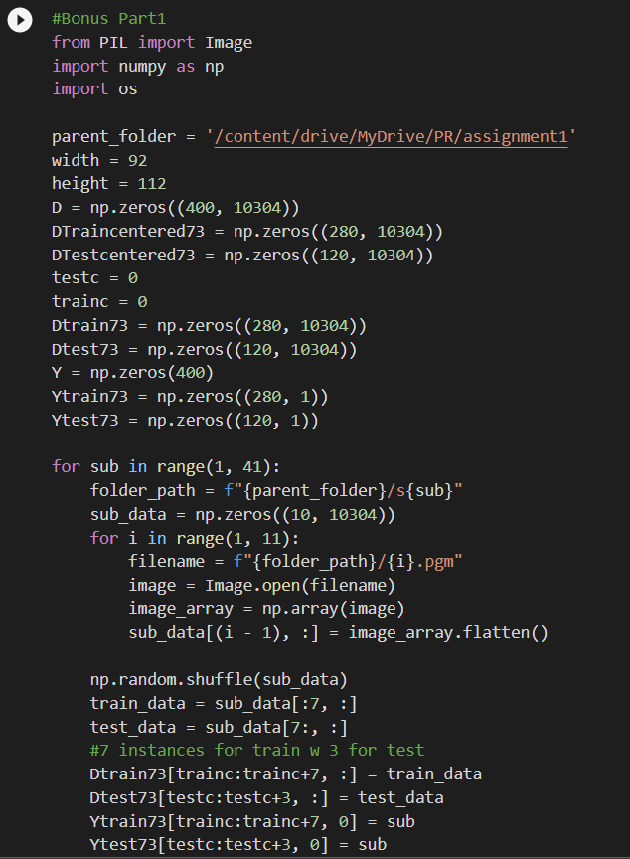
Step 8 (Bonus):

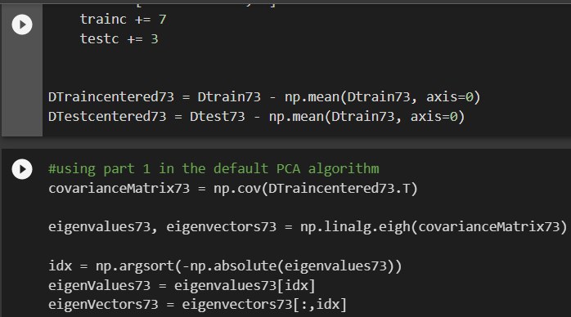

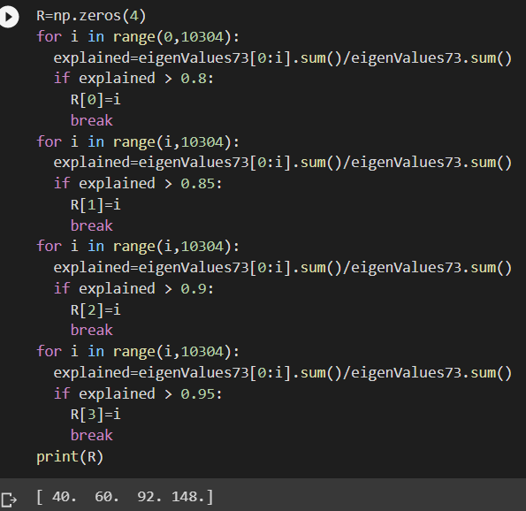

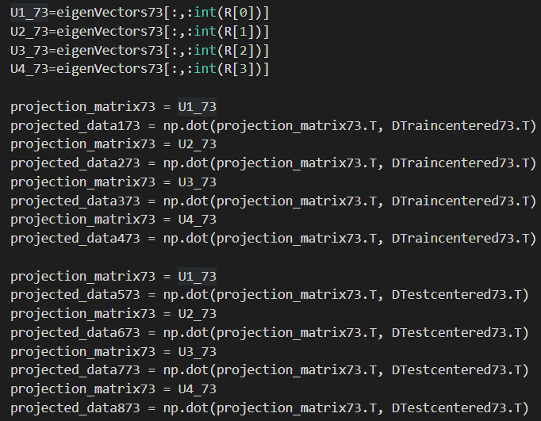

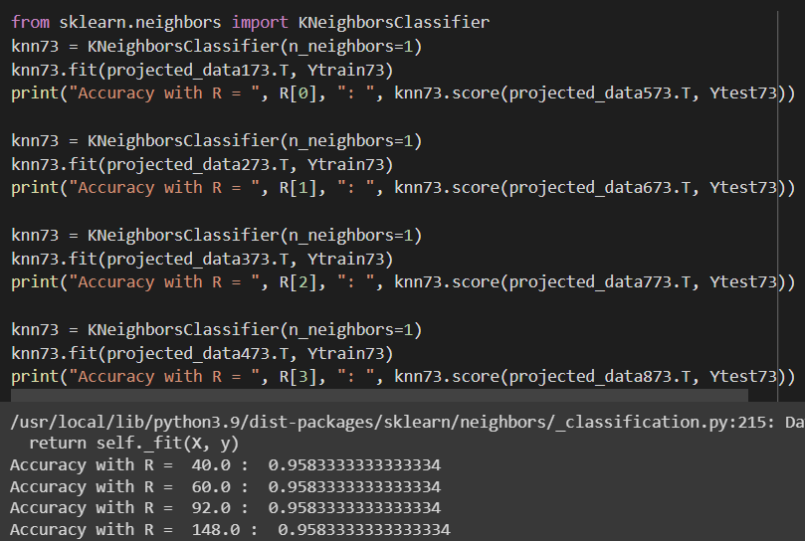

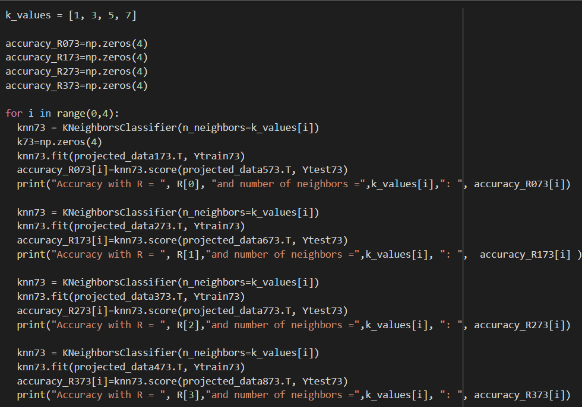

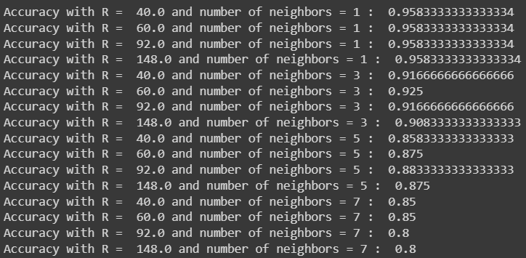

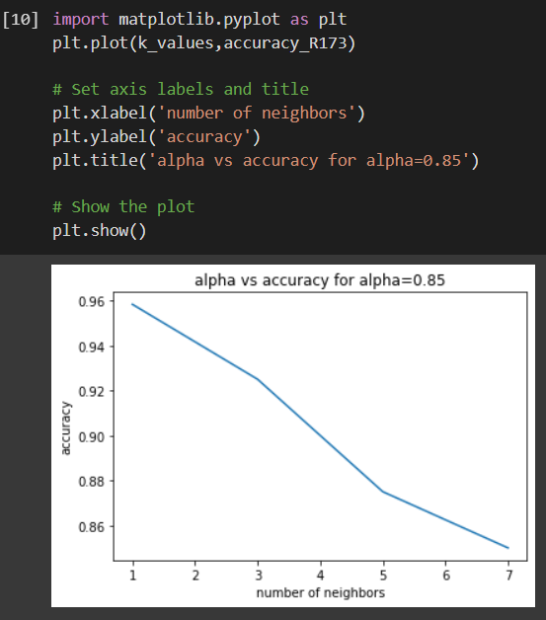
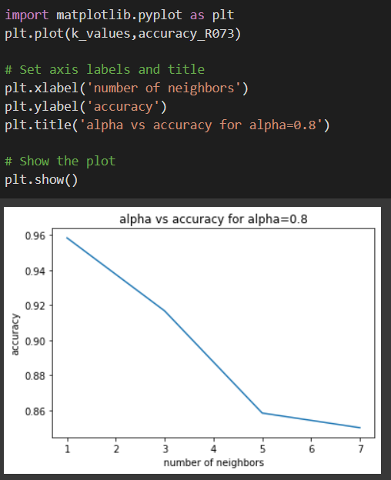
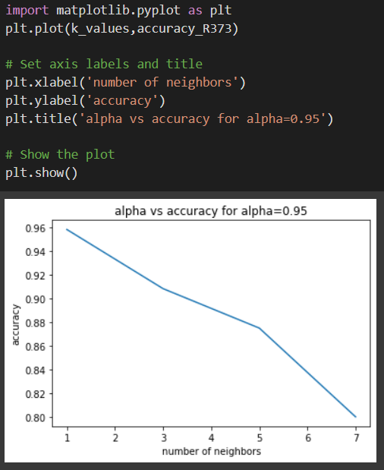
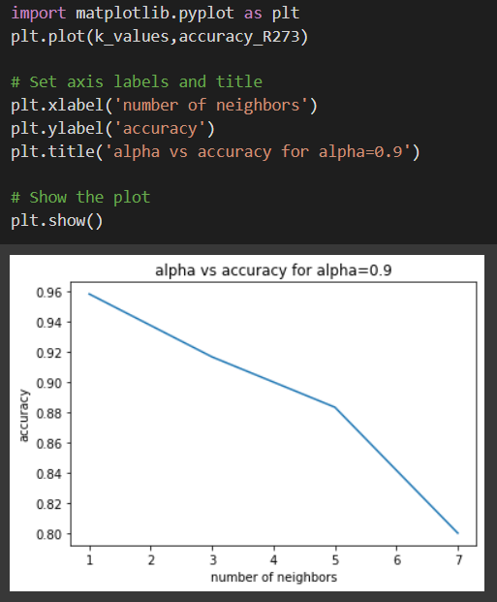
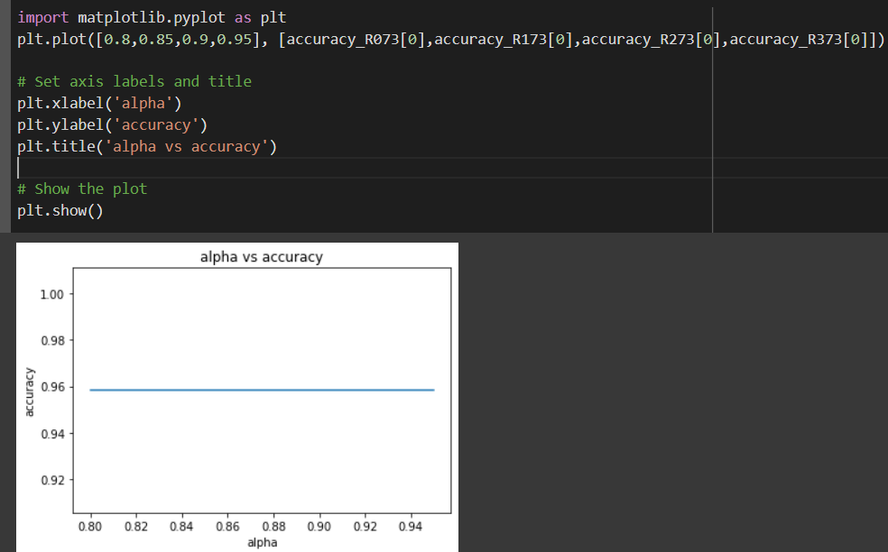

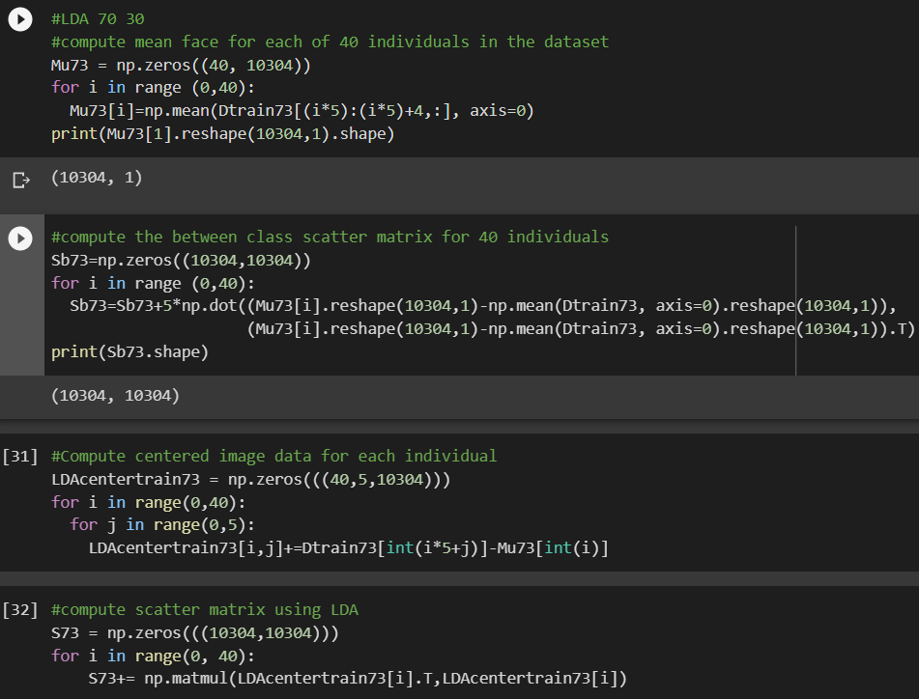

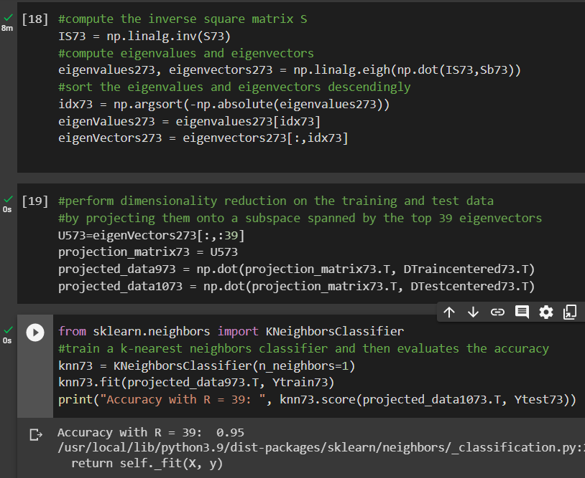

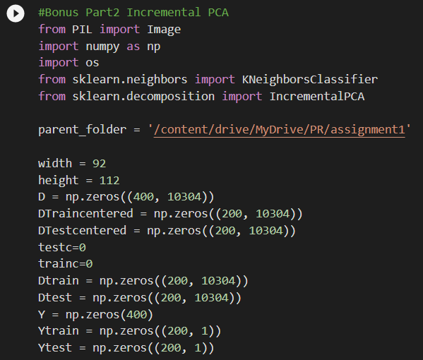
Part Two PCA:

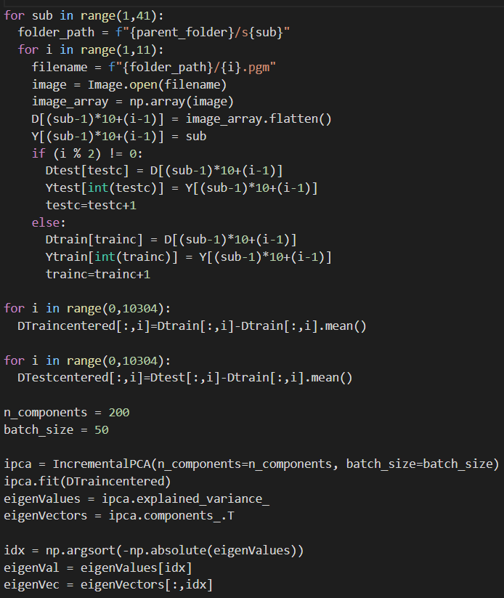

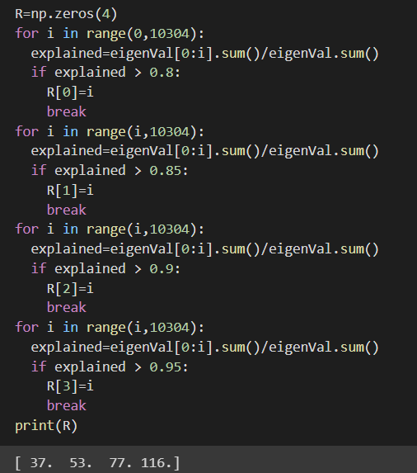

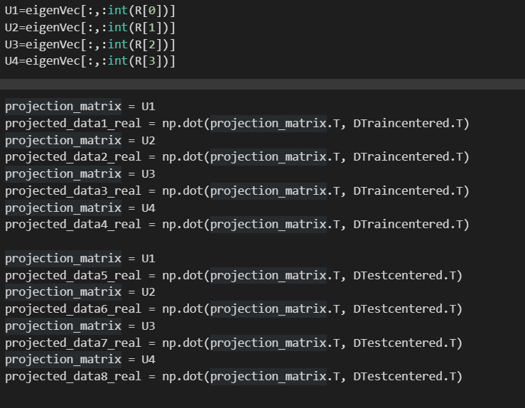

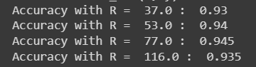
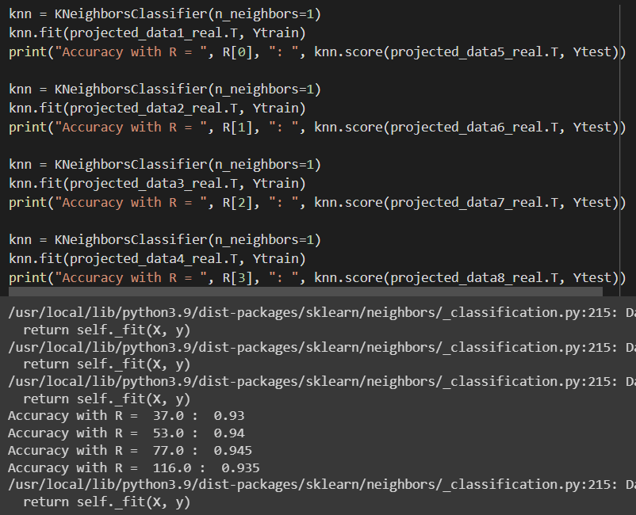
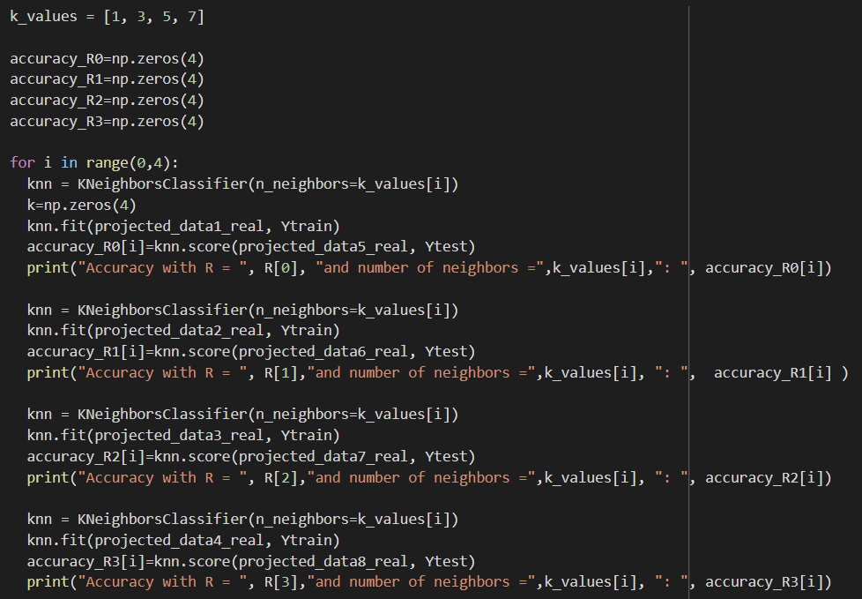
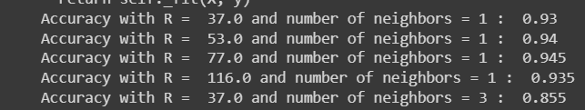
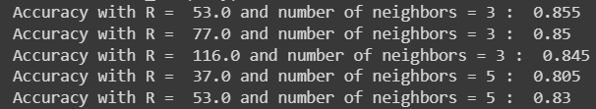

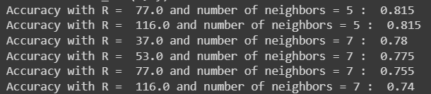

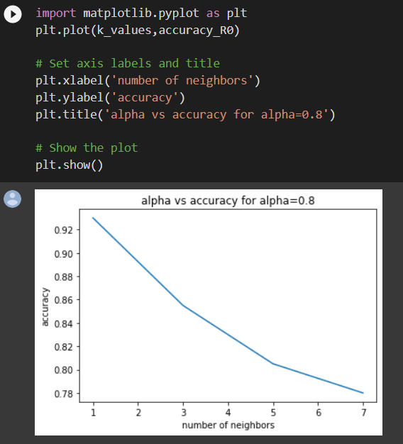
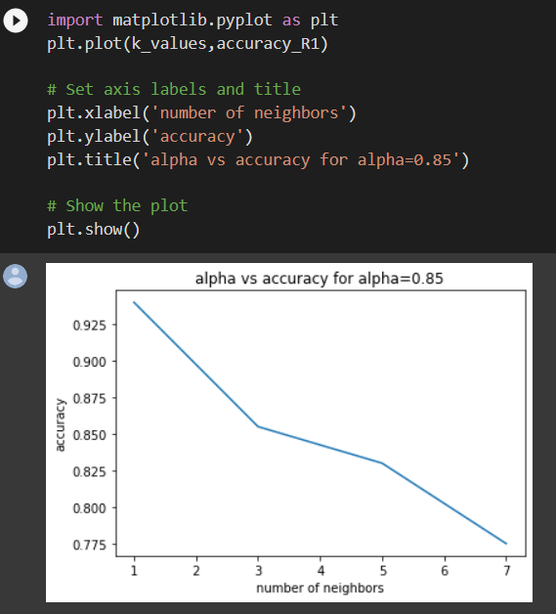
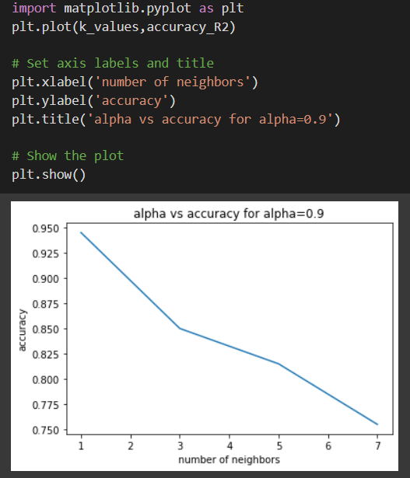
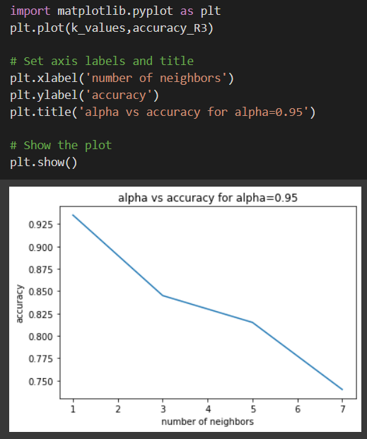
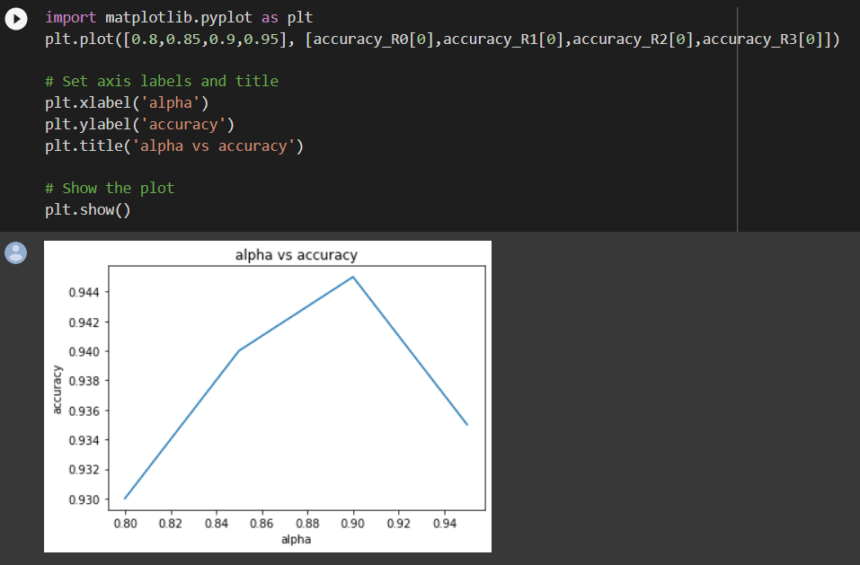
Part Two LDA:

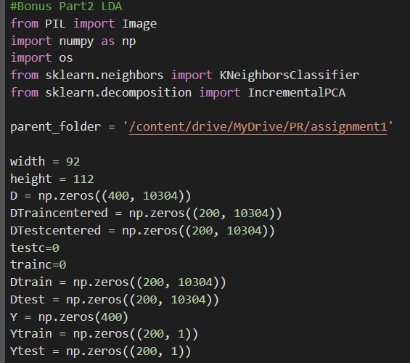

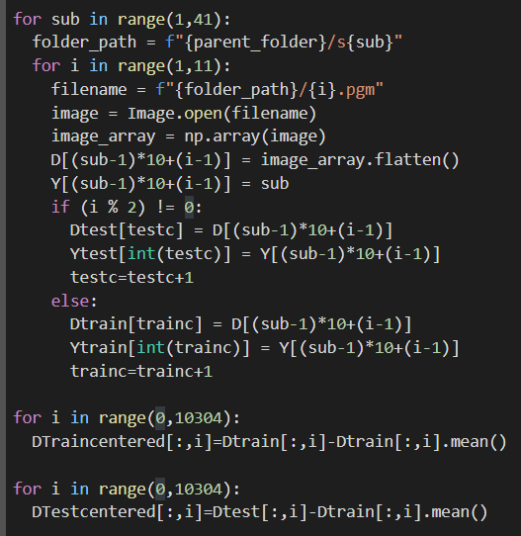

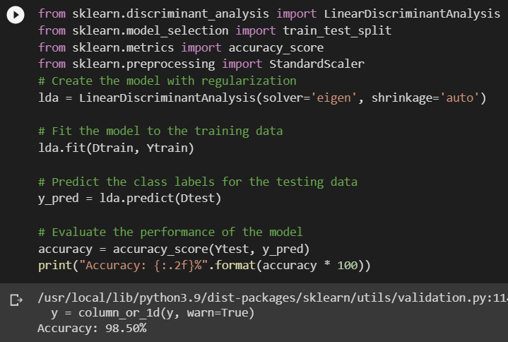

Comparisons:
- Part 4 – e) Can you find a relation between alpha and classification accuracy? (PCA Classification)
Answer:
- In the Simple Classifier: accuracy changes with the change of alpha. Where in alpha = 0.8, R = 37.0 so the accuracy = 93%
In case of alpha = 0.85 -> R = 53.0 -> accuracy = 94%
Alpha = 0.9 -> R = 77.0 -> accuracy = 94.5%
Alpha = 0.95 -> R = 116.0 -> accuracy = 93.5%
- In the Classifier Tuning: accuracy is inversly proportional to the number of neighbours, where the accuracy decreases by increasing the number of neighbours with the same 4 alpha values.
N = 1 , alpha = 0.8 -> R = 37 -> accuracy = 93%
N = 1 , alpha = 0.85 -> R = 53 -> accuracy = 94%
N = 1 , alpha = 0.9 -> R = 77 -> accuracy = 94.5%
N = 1 , alpha = 0.95 -> R = 116 -> accuracy = 93.5%
N = 3 , alpha = 0.8 -> R = 37 -> accuracy = 85.5%
N = 3 , alpha = 0.85 -> R = 53 -> accuracy = 85.5%
N = 3 , alpha = 0.9 -> R = 77 -> accuracy = 85%
N = 3 , alpha = 0.95 -> R = 116 -> accuracy = 84.5%
N = 5 , alpha = 0.8 -> R = 37 -> accuracy = 80.5%
N = 5 , alpha = 0.85 -> R = 53 -> accuracy = 83%
N = 5 , alpha = 0.9 -> R = 77 -> accuracy = 81.5%
N = 5 , alpha = 0.95 -> R = 116 -> accuracy = 81.5%
N = 7 , alpha = 0.8 -> R = 37 -> accuracy = 78%
N = 7 , alpha = 0.85 -> R = 53 -> accuracy = 77.5%
N = 7 , alpha = 0.9 -> R = 77 -> accuracy = 75.5%
N = 7 , alpha = 0.95 -> R = 116 -> accuracy = 74%

- Part 5 – e) Compare the LDA results to the PCA results.
Answer:
P.O.C | PCA | LDA
Simple Classifier | α=0.8 -> accuracy=93%  α=0.85 -> accuracy=94%  α=0.9 -> accuracy=94.5%  α=0.95 -> accuracy=93.5% | Accuracy = 93.5%
Classifier Tuning | With respect to alpha  N=1 -> accuracy= 93% - 94.5%  N=3 ->accuracy= 84.5% - 85.5%  N=5 -> accuracy= 80.5% - 83%  N=7 -> accuracy= 74% - 78% | N=1 -> accuracy=93.5%  N=3 -> accuracy=86%  N=5 -> accuracy=79.5%  N=7 -> accuracy=77.5%

Therefore, the accuracy doesn’t only depend on the type of analysis. It also depends on the dataset itself, the number of neighbours, and the alpha in the pca. So in some cases, the accuracy of PCA is better and in other cases the accuracy of LDA is better.

- Part 8 – a) Compare the results of 70% Training 30% Test split with the 50% split.
Answer: this comparison is done in the PCA Classification and the LDA Classification also.
The following table shows the comparison in all the cases:

P.O.C | 50% split | 30%-70% split
Simple Classifier  PCA | α=0.8 -> accuracy=93%  α=0.85 -> accuracy=94%  α=0.9 -> accuracy=94.5%  α=0.95 -> accuracy=93.5% | α=0.8 -> accuracy=95.8%  α=0.85 -> accuracy=95.8%  α=0.9 -> accuracy=95.8%  α=0.95 -> accuracy=95.8%
Simple Classifier  LDA | Accuracy = 93.5% | Accuracy = 95%
Classifier Tuning  PCA | With respect to alpha  N=1 -> accuracy= 93% - 94.5%  N=3 ->accuracy= 84.5% - 85.5%  N=5 -> accuracy= 80.5% - 83%  N=7 -> accuracy= 74% - 78% | With respect to alpha  N=1 -> accuracy= 95.8%  N=3 ->accuracy= 90.8% - 92.5%  N=5 -> accuracy= 85.8% - 88.3%  N=7 -> accuracy= 80% - 87.5%

In conclusion, the 30% 70% split is better than the 50% split. Where its accuracy is higher than the 50% split.

- Part 8 – b) Compare PCA variation with the original algorithm.
Answer:
The PCA variation used is Incremental PCA, The difference between normal PCA and Incremental PCA is the way they handle large datasets.
Where incremental PCA is designed to handle large datasets that cannot fit into memory. IPCA processes the data in small batches and updates the covariance matrix incrementally. This approach reduces memory usage and computational complexity, making it more efficient for handling large datasets.
While in normal PCA the entire dataset is loaded into memory and the covariance matrix is computed for all the data points at once. This approach can be computationally expensive and memory-intensive, making it impractical for very large datasets.
P.O.C | Normal PCA | Incremental PCA
Simple Classifier | α=0.8 -> accuracy=93%  α=0.85 -> accuracy=94%  α=0.9 -> accuracy=94.5%  α=0.95 -> accuracy=93.5% | α=0.8 -> accuracy=93%  α=0.85 -> accuracy=94%  α=0.9 -> accuracy=94.5%  α=0.95 -> accuracy=93.5%
Classifier Tuning | With respect to alpha  N=1 -> accuracy= 93% - 94.5%  N=3 ->accuracy=  84.5% - 85.5%  N=5 -> accuracy= 80.5% - 83%  N=7 -> accuracy= 74% - 78% | With respect to alpha  N=1 -> accuracy=  93% - 94.5%  N=3 ->accuracy=  84.5% - 85.5%  N=5 -> accuracy=  80.5% - 83%  N=7 -> accuracy= 74% - 78%
Time Complexity | O(n³) | O(m*n²)

In conclusion, the results are close to each other because both PCA and IPCA use eigenvalue decomposition to identify these important features and compute a set of principal components that capture most of the variability in the data.
In both cases, the accuracy of PCA and IPCA will depend on several factors such as the number of principal components retained, the amount of variance explained, and the choice of parameters. If these factors are optimized appropriately, it is possible for the accuracies in PCA and IPCA to be the same.
- Part 8 – b) Compare LDA variation with the original algorithm.
Answer: The LDA variation used is Regularized LDA, the main difference between normal LDA and regularized LDA is that regularized LDA uses a regularization parameter to shrink the covariance matrix estimates, while normal LDA assumes that the covariance matrices are equal across classes and estimates them using the pooled within-class covariance matrix. Regularized LDA can be beneficial when the assumptions of LDA are not met or when the number of features is large compared to the number of samples.
LDA aims to identify a linear combination of features that maximizes the separation between classes. It assumes that the data is normally distributed and that the classes have equal covariance matrices. However, in some cases, the assumptions of LDA may not hold, leading to overfitting or poor performance.
Regularized LDA, also known as Shrinkage LDA, is a variant of LDA that uses a regularization parameter to overcome some of the limitations of LDA. The regularization parameter allows for some shrinkage of the covariance matrix estimates, which can improve the stability of the estimates and reduce overfitting.
P.O.C | LDA | Regularized LDA
Accuracy | Accuracy = 93.5%  For N neighbours  N=3 -> accuracy = 86%  N=5 -> accuracy = 79.5%  N=7 -> accuracy = 77.5% | Accuracy = 98.5%

Therefore, Regularized LDA is more effiecient than normal LDA.

