
Alexandria University
Faculty of Engineering
Computer and Communication Program
CC484 Pattern Recognition

Assignment Two: Network Anomaly Detection
Project Link: Colab Notebook

Name | ID
Omar Walied Mohamed | 7058
Hend Khaled AbdelHamid M. Aly | 6986
Habiba Mohamed Hefny | 6939

Table of Contents
Introduction to the problem statement 2
Problem Description 2
Code Explaination and Screenshots 4
- Analyzing and Preprocessing Dataset 4
- Kmeans Clustering 6
Algorithm 6
K = 7 8
K = 15 9
K = 23 10
K = 31 11
K = 45 12
- Normalized Cut Clustering 13
- Evaluation 14
Kmeans 14
Normalized Cut 21
- New Clustering (DBSCAN) 22
Algorithm 22
Evaluation 25

- What is Network Anomaly Detection?
Network anomaly detection in machine learning refers to the process of identifying unusual or unexpected patterns or behavior in network traffic that may indicate the presence of security threats such as malware infections, cyber attacks, or other malicious activities.
Anomaly detection algorithms analyze network traffic data to identify deviations from normal patterns and flag suspicious activities that could indicate potential security threats. This is done by training a machine learning model on a large dataset of network traffic, identifying patterns and behaviors that are considered normal, and then using this model to detect deviations from the norm.
There are various techniques used for network anomaly detection, including statistical analysis, clustering, and classification algorithms. These techniques help to identify anomalies in different types of network traffic, such as packets, flows, or sessions.
Network anomaly detection is an important tool for enhancing the security of networks, allowing organizations to quickly detect and respond to potential threats before they can cause significant damage.
- Problem Description:
- downloaded the KDD cup 1999 dataset from kaggle website.
- Imported the needed libraries.
- Import the 10 percent data and assign it to ‘train’, then provide some basic statistical information about the data in the DataFrame, such as the count, mean, standard deviation, and quartiles of each column.
- Assign the ‘corrected.gz’ data to ‘test’, then provide basic statistical information about the data in the DataFrame, such as the count, mean, standard deviation, and quartiles of each column. This information can be used to compare the test dataset with the training dataset and check for any significant differences between the two.
- Preprocess the data for training and testing datasets where we create lists of the service, flag, label columns from both trainging and testing datasets then assign a unique integer value to each item in these lists using numpy's zero’s function.
- Replace the string values in the "protocol_type", "service", "flag", and "label" columns of both the training and testing datasets with their corresponding integer values.
- Shuffle the rows of train DataFrame randomly by calling the sample function with frac=1, avoid any order or bias in the training data, remove first column of the shuffled train dataframe (old index column).
- Perform our implementation of Kmeans algorithm several times, each time with a different number of clusters. Where we’ll change the k of the Kmeans algorithm between {7, 15, 23, 31, 45} to produce different clusters.
- Perform Normalized Cut Clustering that we implemented where we used 42 as the random seed across all experiments, Split the training dataset used, apply the normalized cut algorithm to the preprocessed data to cluster it into 23 clusters, rerun the experiments on kmeans when k=23.
- Evaluated the models after using kmeans clustering using precision, recall, f1 score, and conditional entropy. We did the same process after performing the normalized cut clustering.
- Implemented a new clustering algorithm which is DBSCAN and evaluated it using precision, recall, f1 score, and conditional entropy.

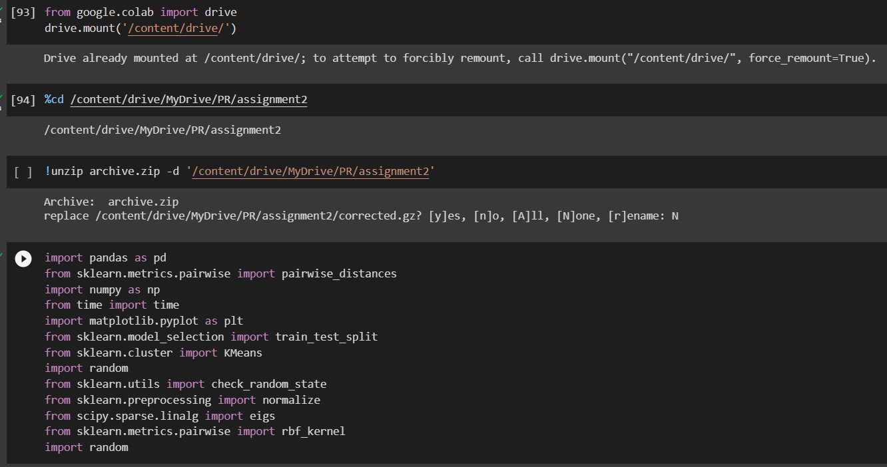

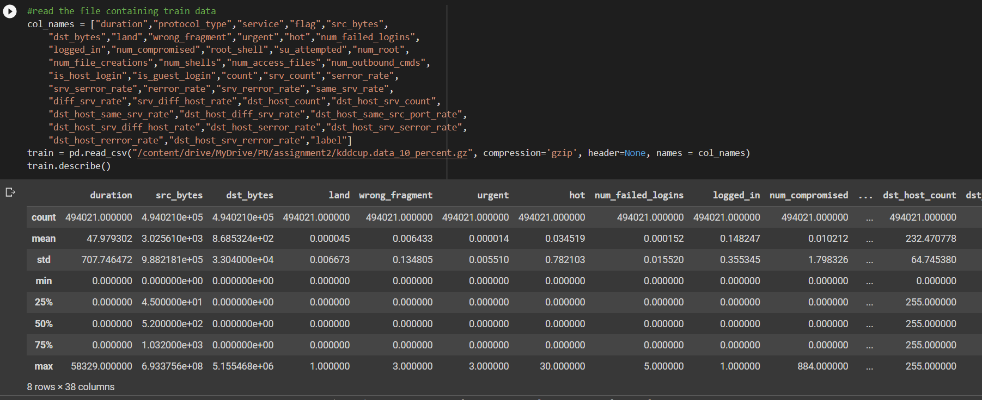
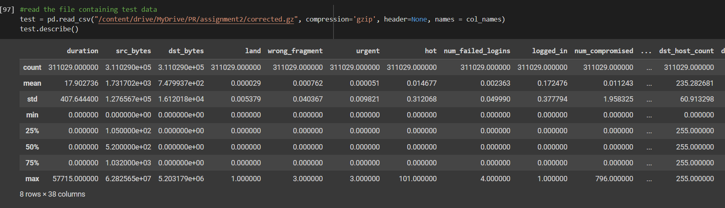

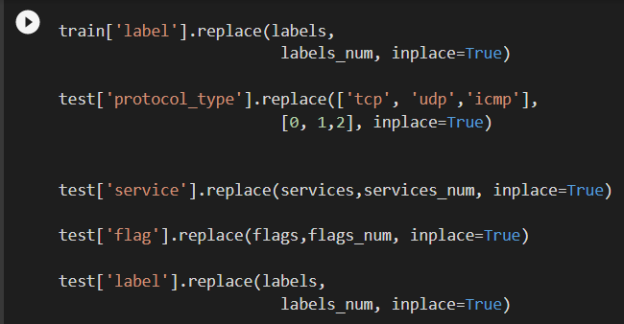
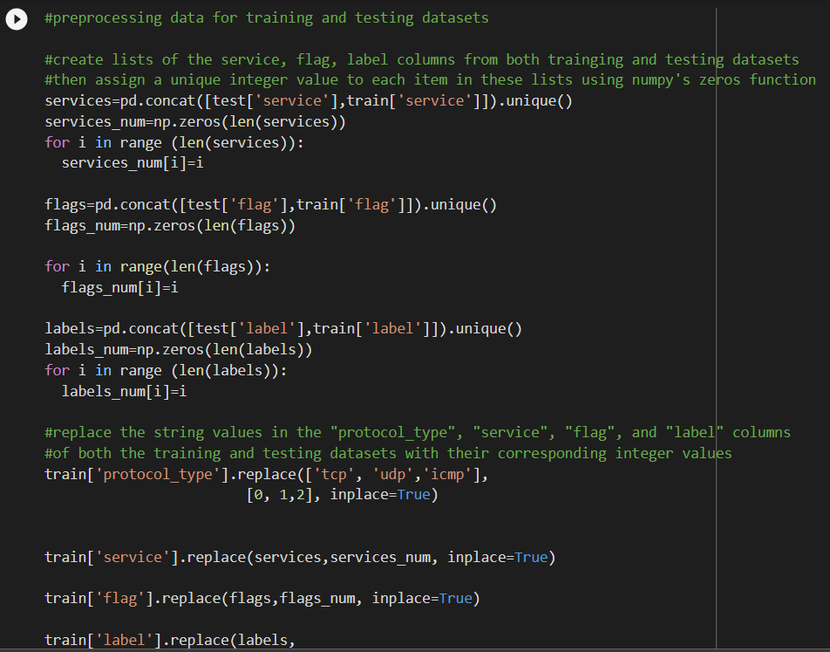
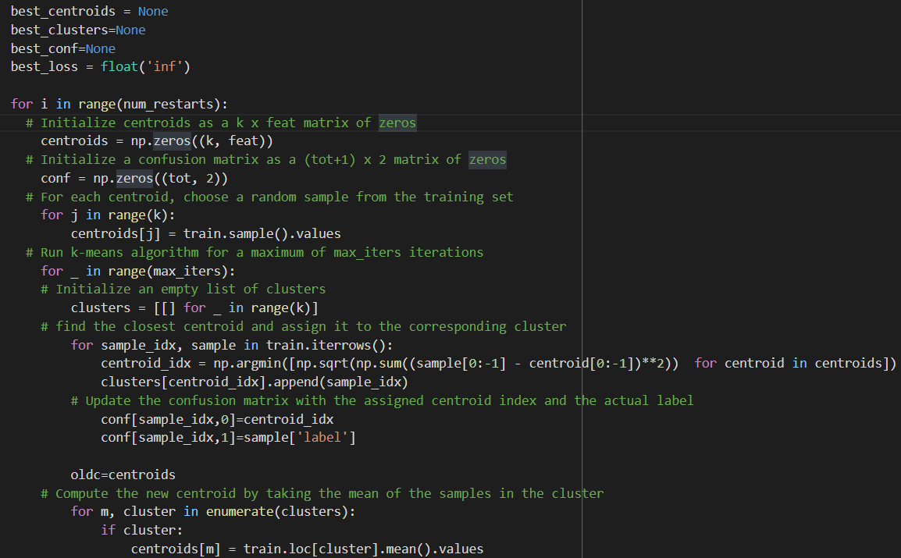
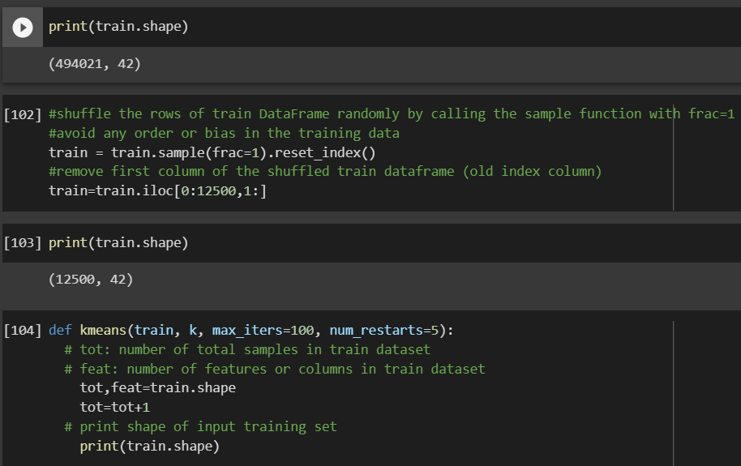

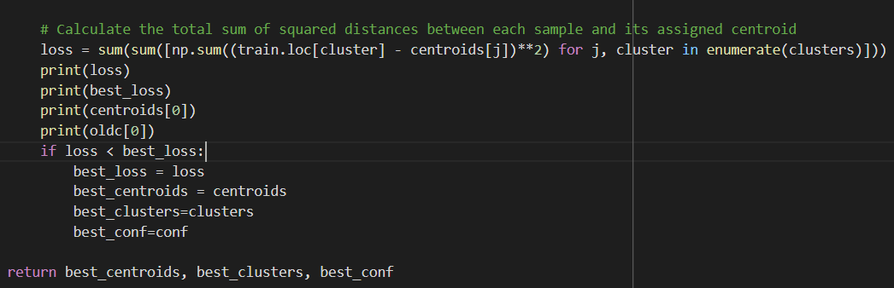

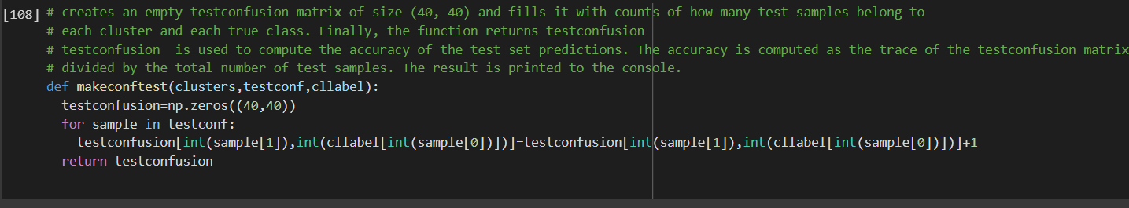
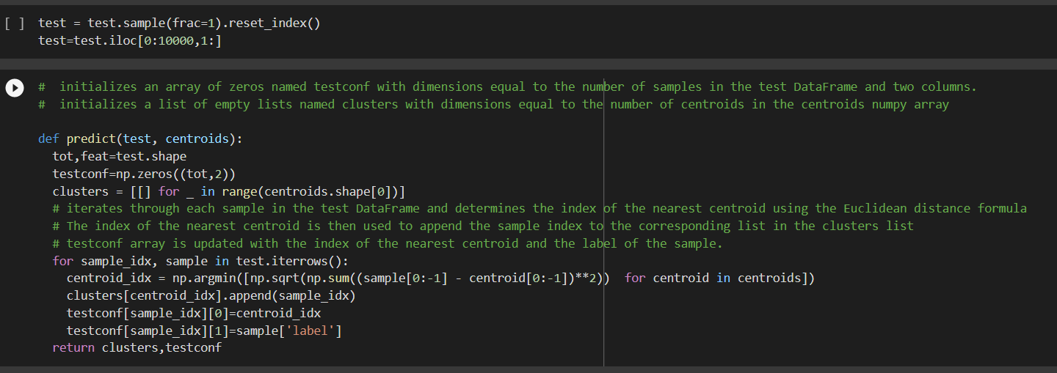
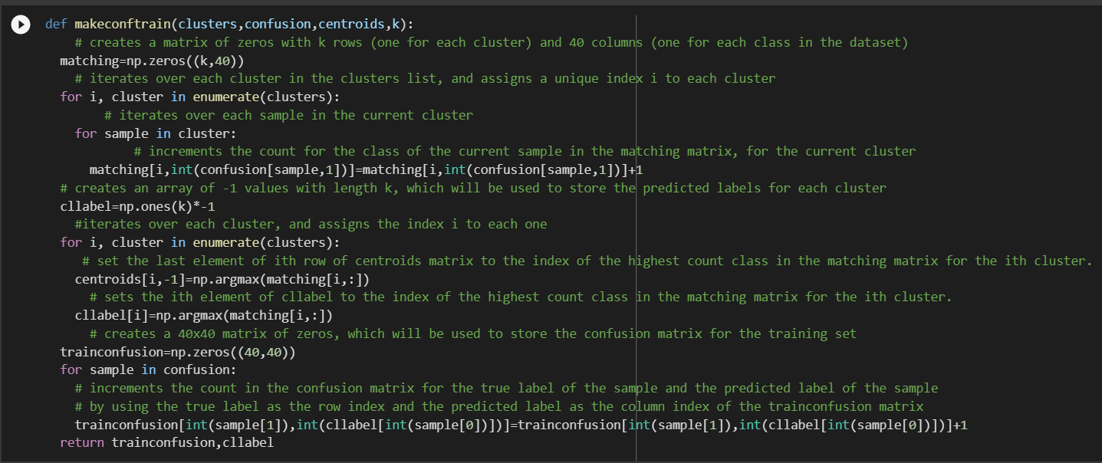
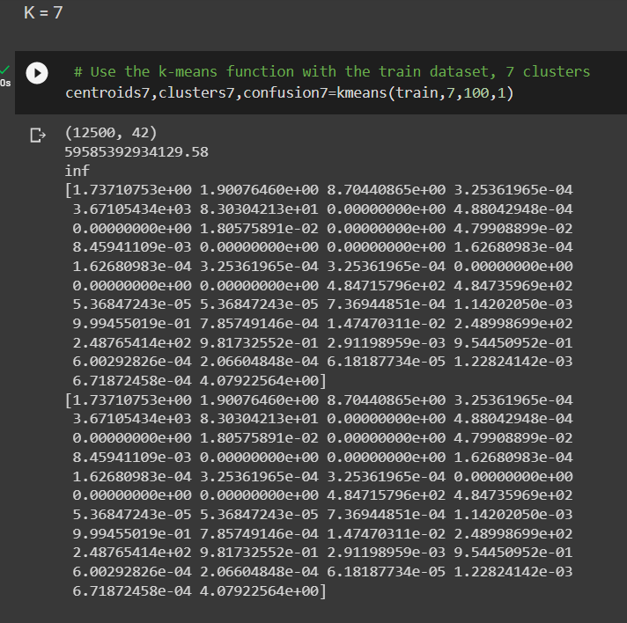

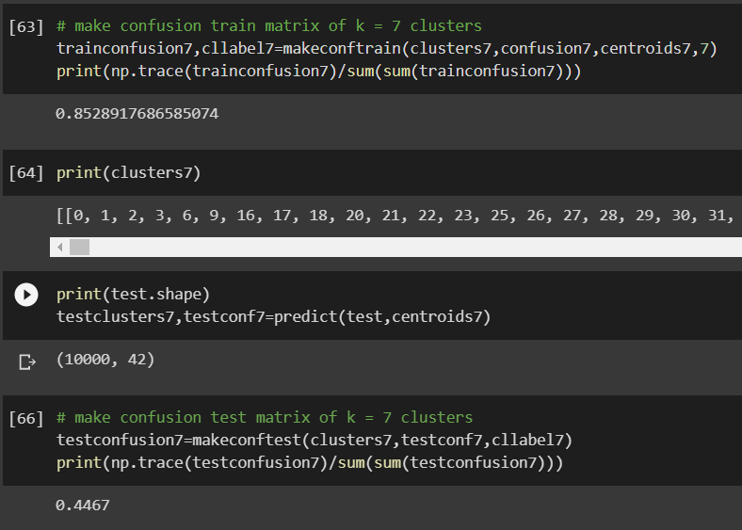
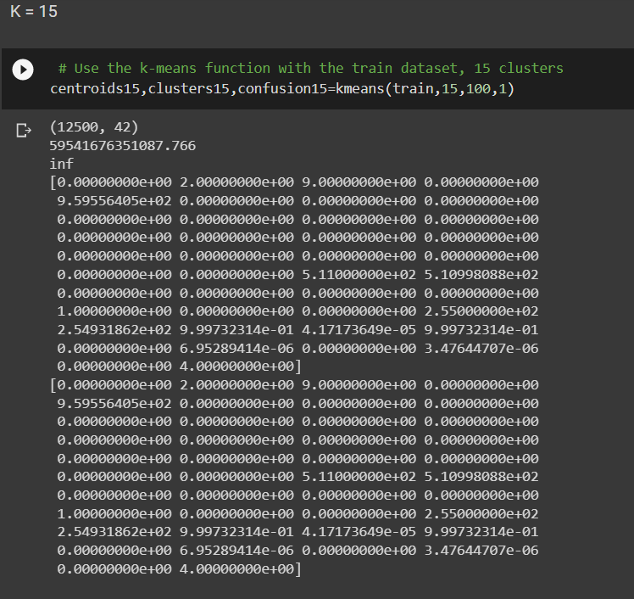

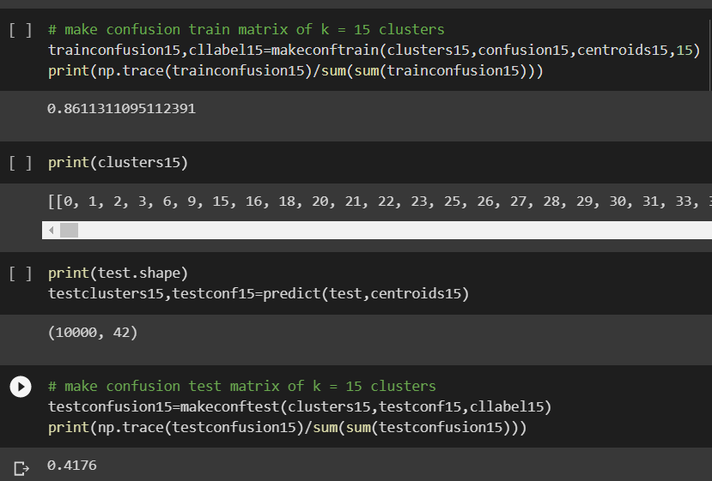

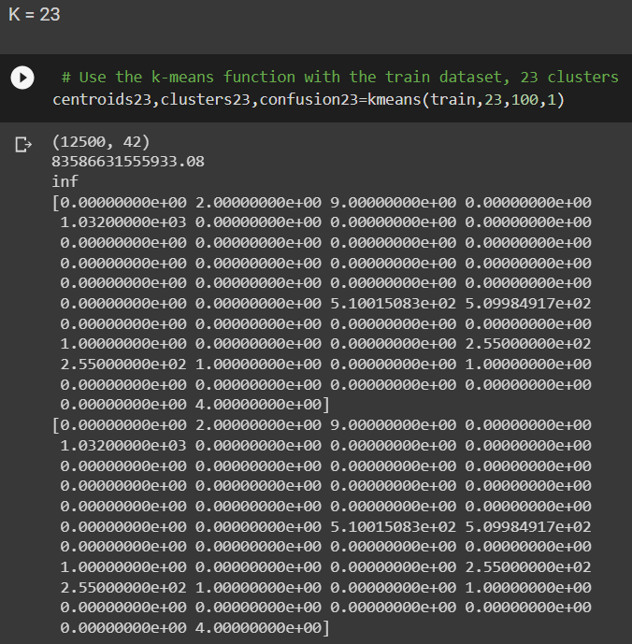

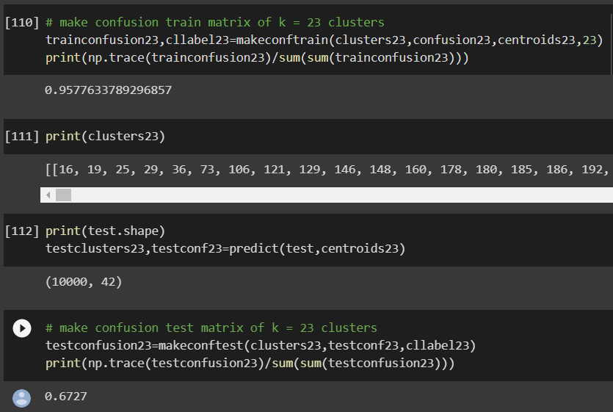

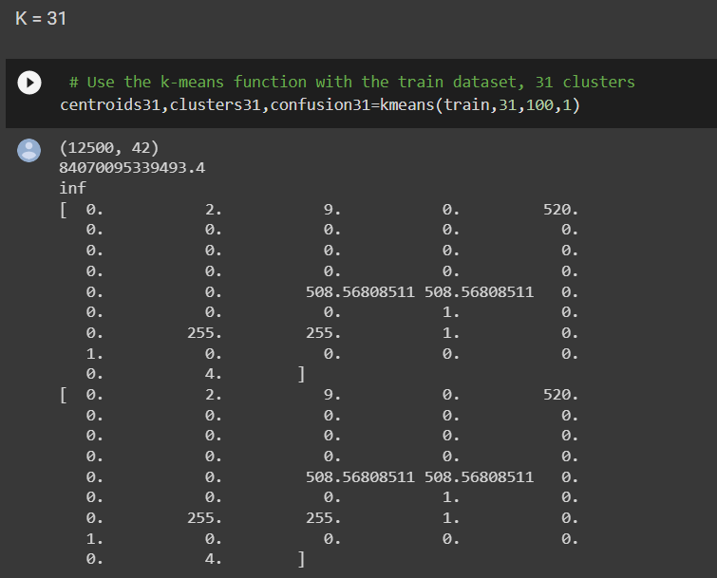

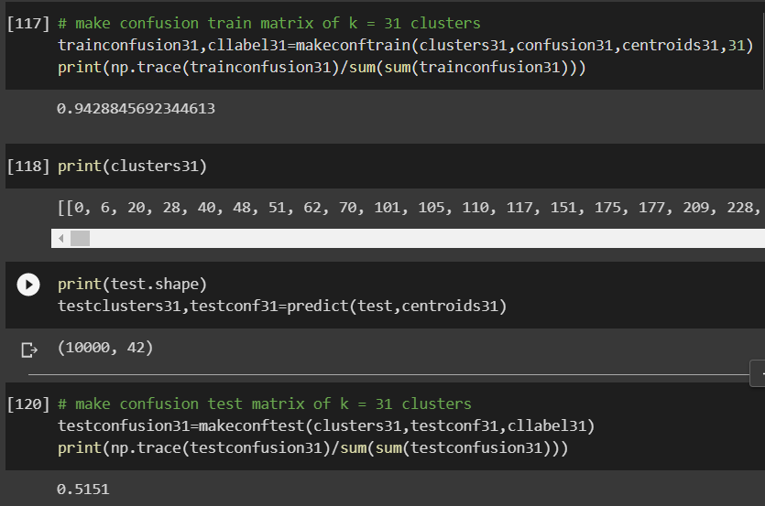
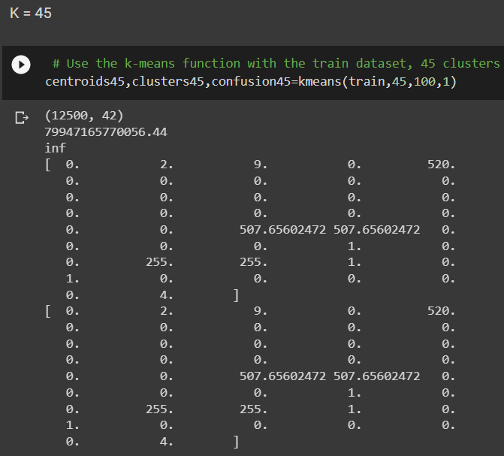

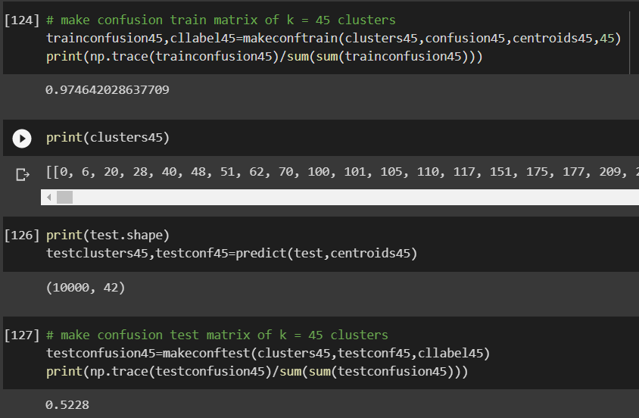
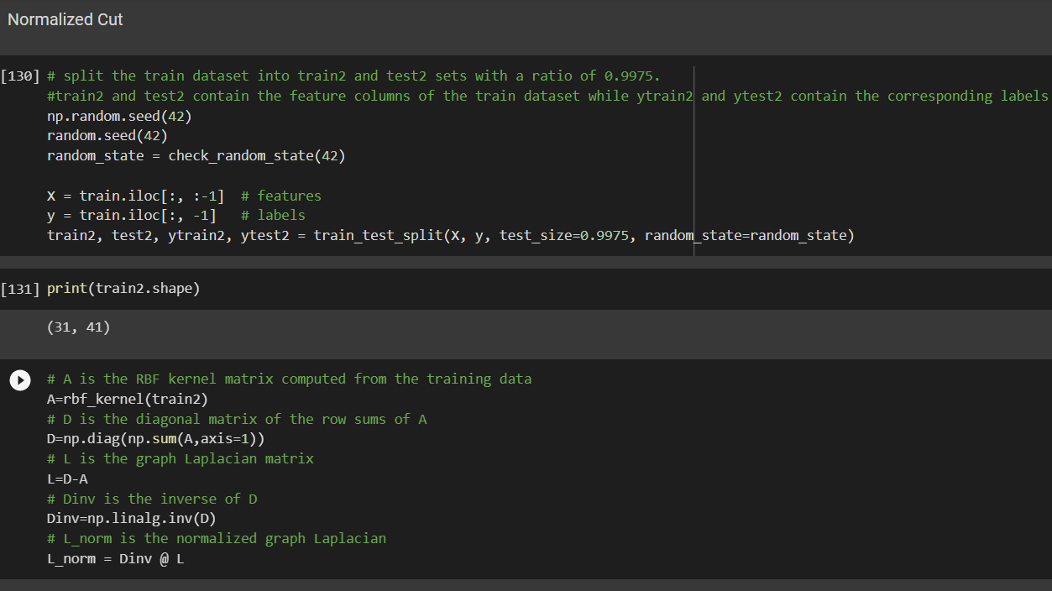
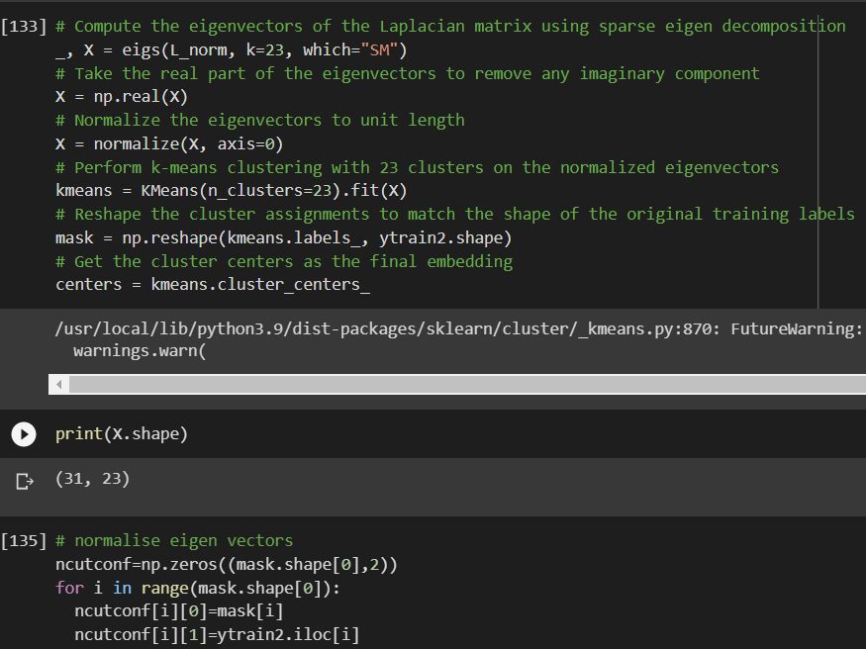

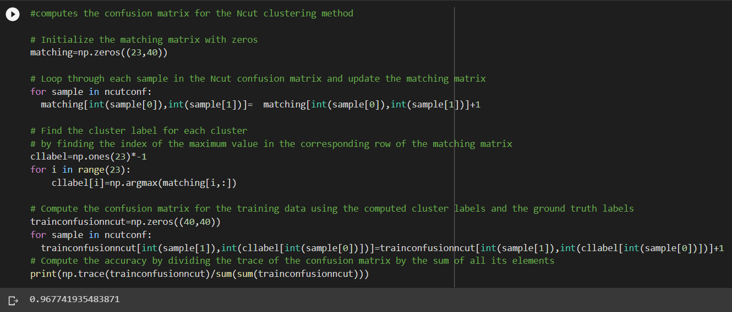
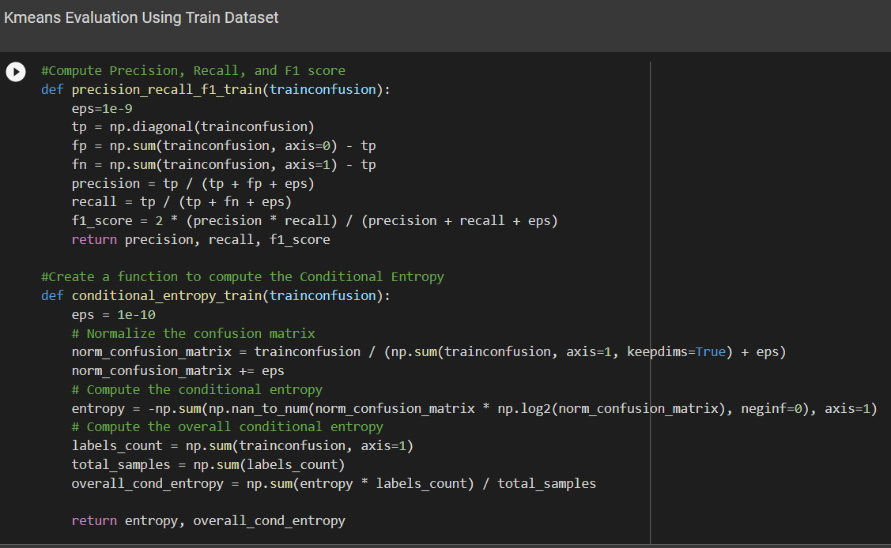

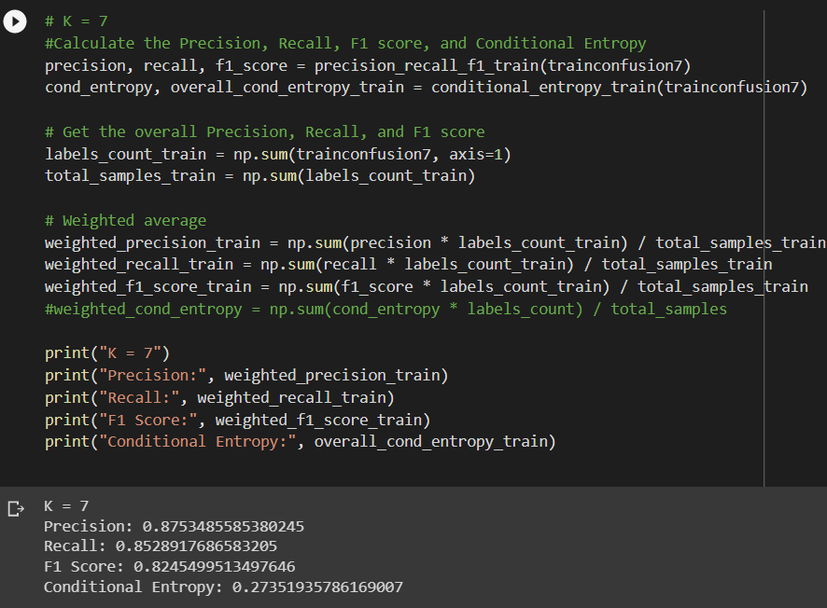

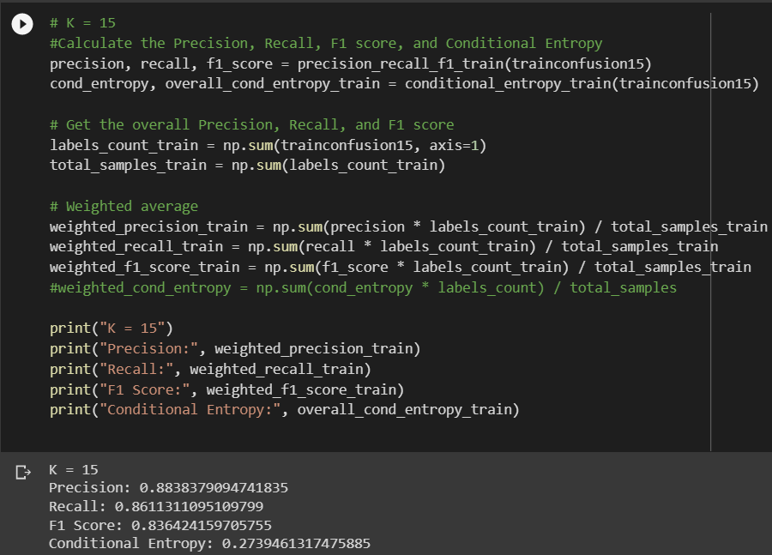

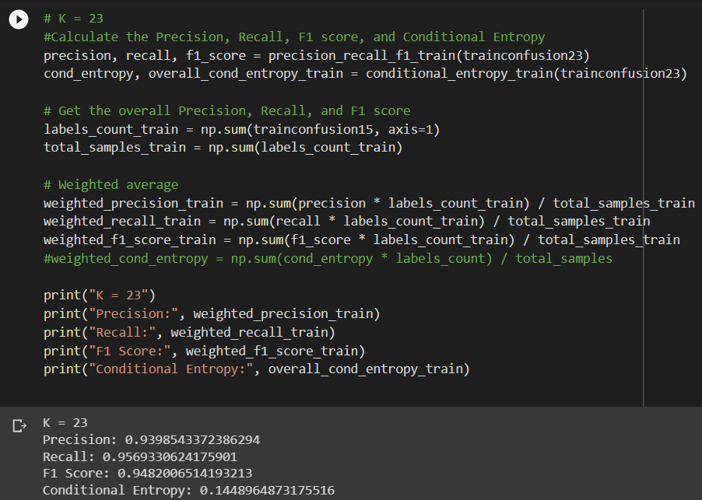
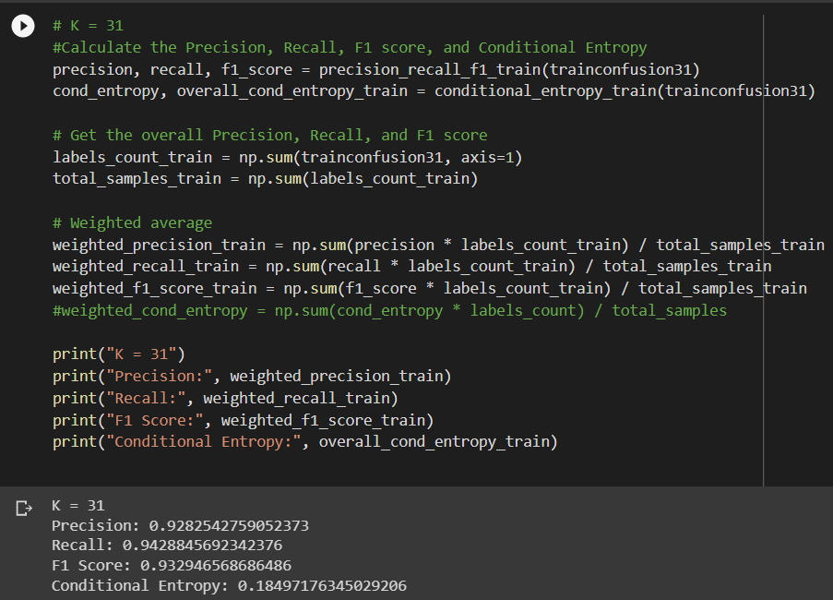
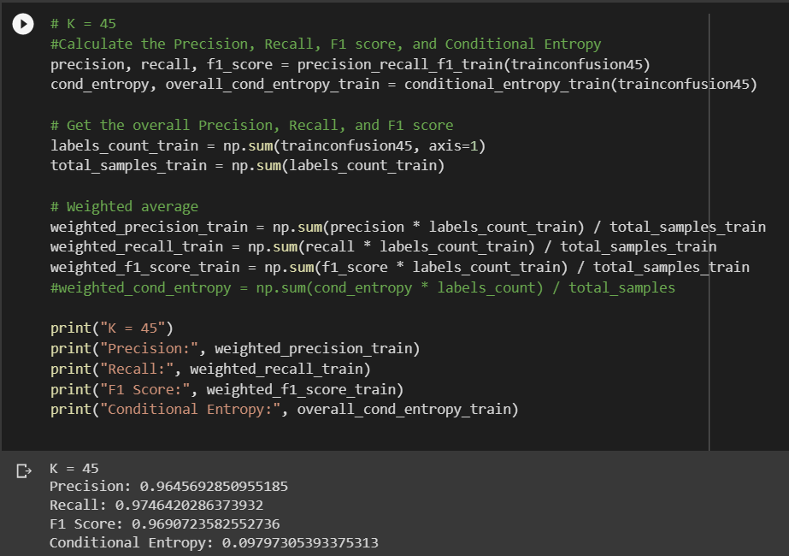
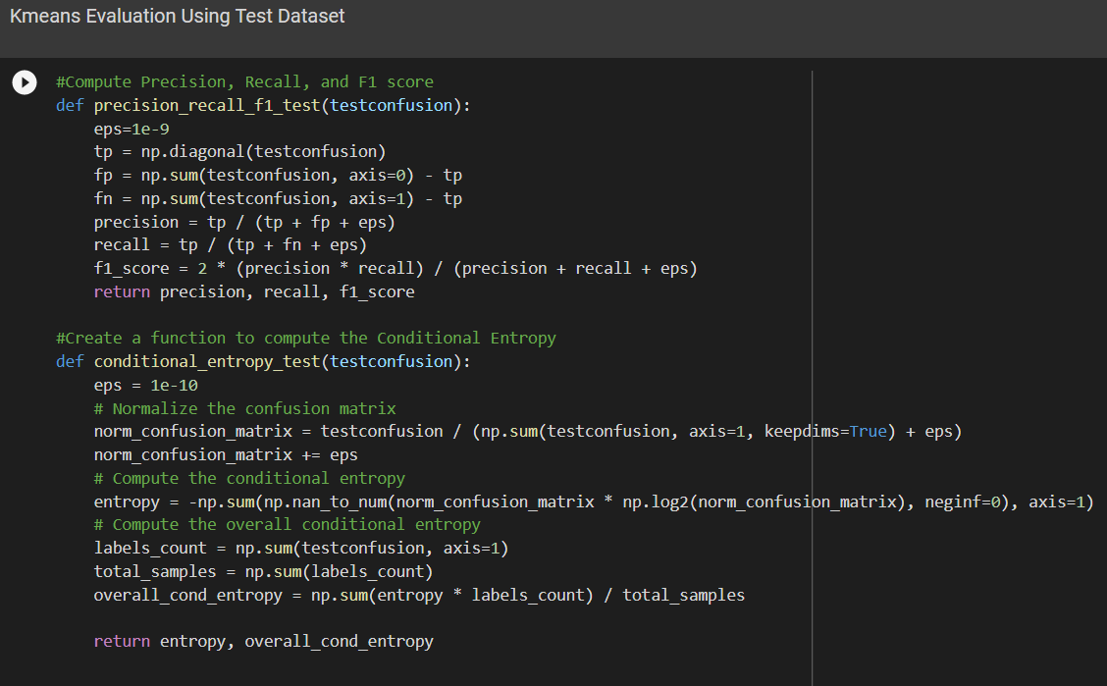
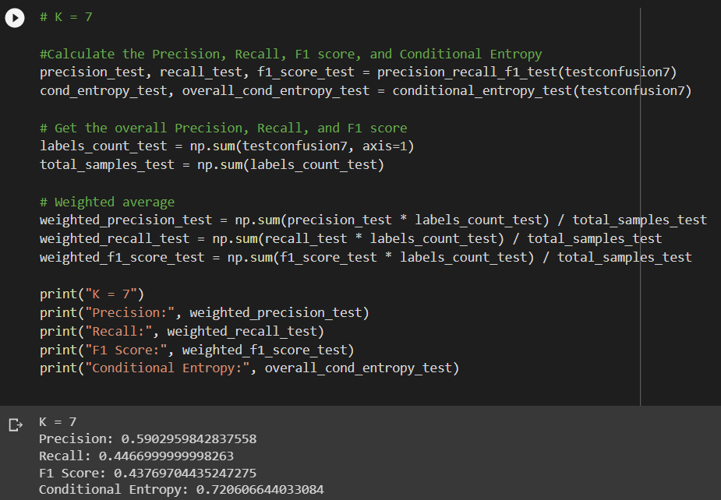
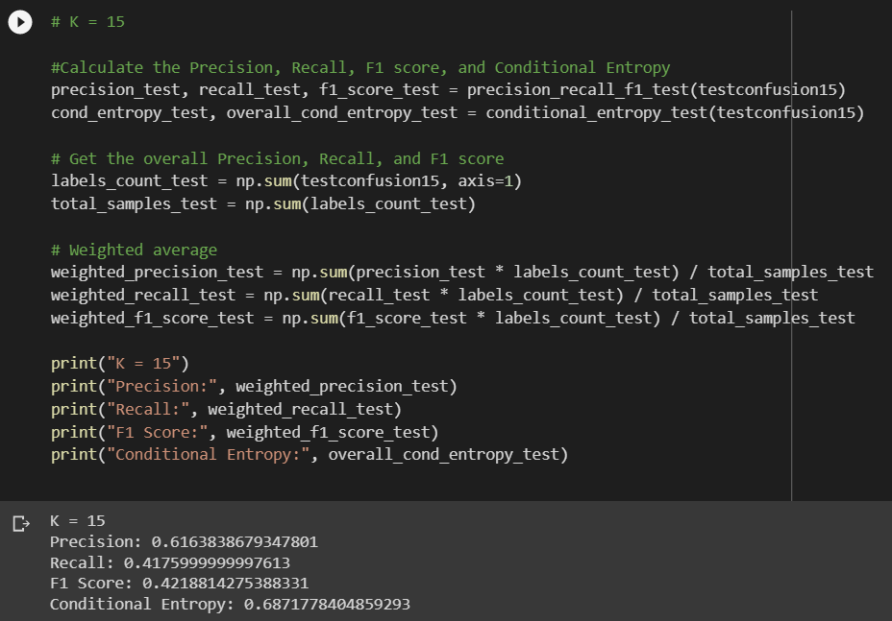
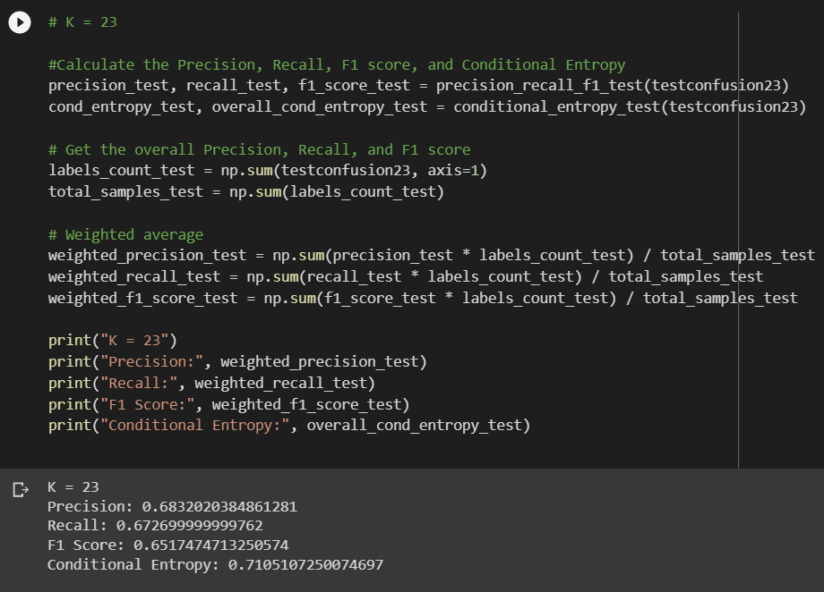
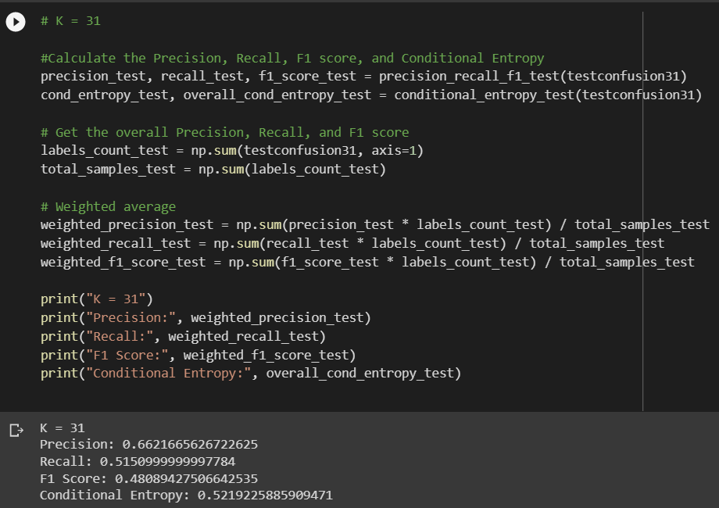
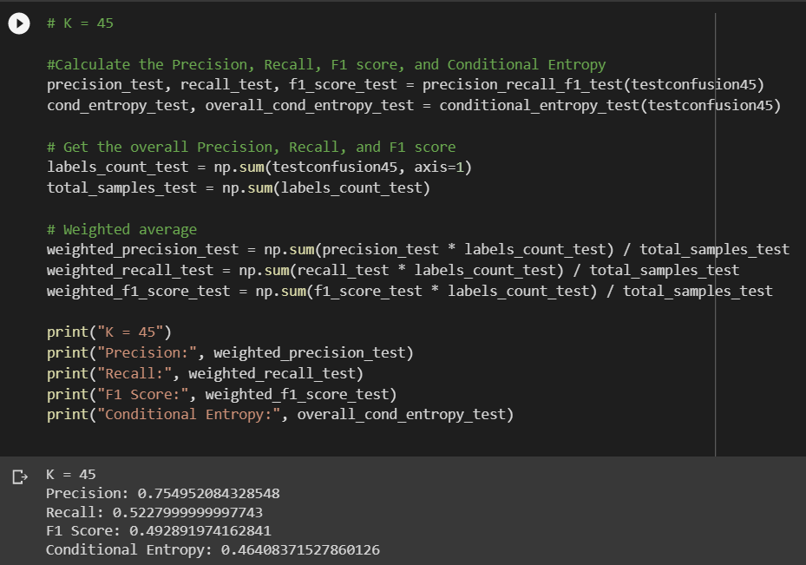
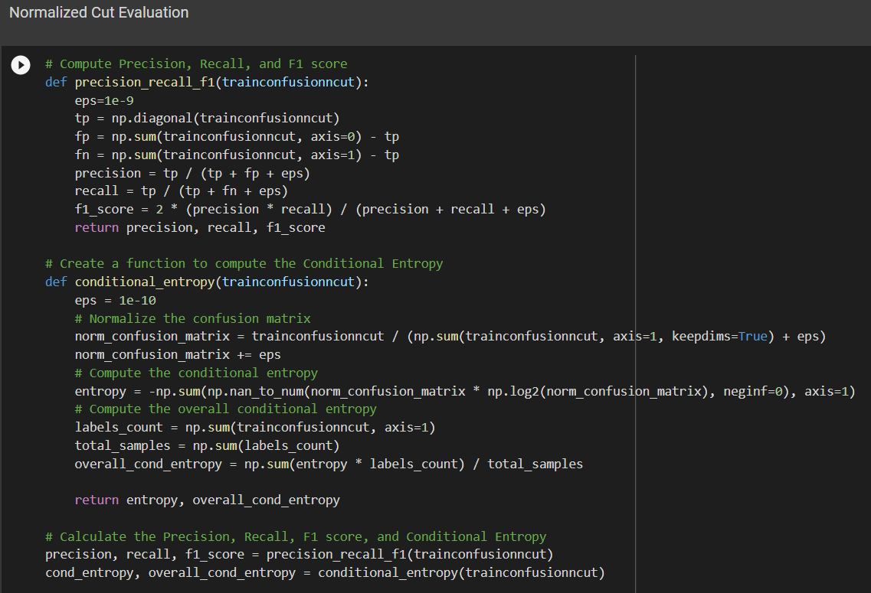
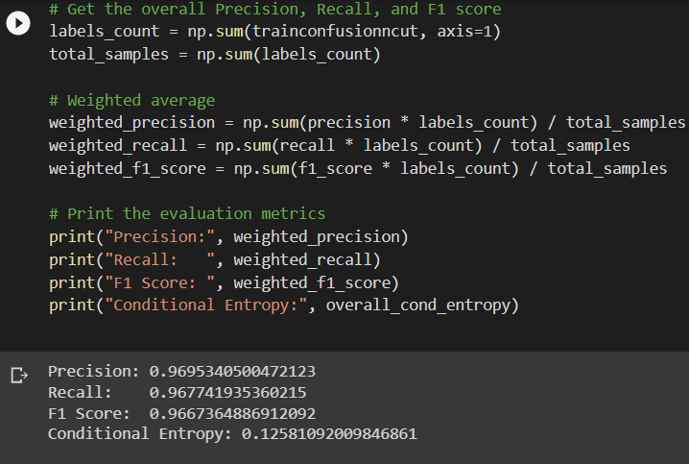
New Clustering Algorithm:
DBSCAN is a density-based clustering method, which means it works by detecting areas where points are concentrated and where they are separated by areas that are empty or sparse. Points that are not part of a cluster are labeled as noise (labeled by -1).
The algorithm takes as input a dataset X, a radius parameter eps, and a minimum number of samples required to form a cluster (min_samples).
First, it starts by initializing all data points to the "unvisited" state (labeled 0). Next, it iterates over each point and checks if it has been visited or not. If not, the function retrieves its neighboring points within a distance of eps using get_neighbors(X, i, eps). If the number of neighbors is less than min_samples, the point is labeled as noise (-1), and the algorithm moves on to the next unvisited point.
If the number of neighbors is greater than or equal to min_samples, a new cluster is formed, and the point is labeled with a new cluster label (C). The algorithm then expands the cluster by recursively adding new points that are within a distance of eps from the current cluster using expand_cluster(X, labels, i, neighbors, C, eps, min_samples).

