
Alexandria University
Faculty of Engineering
Computer and Communication Program
CC484 Pattern Recognition
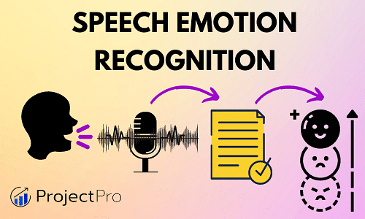
Assignment Three: Speech Emotion Recognition
Project Link: Colab Notebook
Name | ID
Omar Walied Mohamed | 7058
Hend Khaled Aly | 6986
Habiba Mohamed Hefny | 6939

Table of Contents
Introduction to the problem statement 2
Problem Description 3
Code Explaination and Screenshots 6
Reference Paper 25

- What is Speech Emotion Recognition?
Speech emotion recognition (SER) refers to the process of automatically identifying and classifying emotions from speech signals. It involves using computational techniques to analyze acoustic features extracted from the speech signal and determining the emotional state of the speaker.
Speech carries various cues that can indicate the emotional state of a person. These cues include prosodic features such as pitch, rhythm, and intonation, as well as spectral features related to the frequency content of the speech signal. By analyzing these features, SER systems aim to recognize and classify emotions such as happiness, sadness, anger, fear, and more.
The process of speech emotion recognition typically involves the following steps:
Preprocessing: The speech signal is processed to remove noise, normalize the volume, and segment it into smaller units, such as frames or phonemes.
Feature Extraction: Acoustic features are extracted from the preprocessed speech signal. These features can include pitch contour, energy, spectral characteristics, and prosodic features.
Feature Selection: Relevant features are selected to reduce dimensionality and remove irrelevant or redundant information. This step helps improve the accuracy and efficiency of emotion classification.
Emotion Classification: Machine learning or pattern recognition techniques are applied to classify the extracted features into different emotion categories. Common classification algorithms include support vector machines (SVMs), hidden Markov models (HMMs), artificial neural networks (ANNs), and decision trees.
Evaluation: The performance of the SER system is assessed using evaluation metrics such as accuracy, precision, recall, and F1 score. This step helps gauge the effectiveness of the system and identify areas for improvement.
Speech emotion recognition has various applications, including human-computer interaction, affective computing, psychological research, and social robotics. It can be used in systems that aim to understand and respond to users' emotions, improve human-robot interaction, or analyze emotional states in clinical or therapeutic settings.

- Problem Description:
- We imported the libraries necessary for the project
- Categorize the audio files in the specified directory based on their emotions, where we define a list of different emotions such as anger, disgust, fear, happiness, neutral, and sadness. The emotion is extracted from the file name by accessing the third element in the file name, and after the extraction, the code checks if the extracted emotion is valid or not.
- Define a function called calculate_energy to calculate the energy of an audio frame by squaring the audio samples, summing the squared values, and then dividing by the frame length to obtain the normalized energy per frame.
- Create an empty dataframe, specify data types for data frame columns, loop over each emotion list, get the file paths for each emotion, load and process each audio file using librosa, extract spectrogram, convert spectogram to PIL image, compute various audio features such as MFCC, STFT, ZCR, F0 and spectral centroid, then normalize each of those features.

- Concatenate features vectors, map the emotion label, append data to data frame, plot the waveform of each audio signal.
- Retrieve spectrogram images from a data frame, resize them to a consistent shape, converts them to NumPy arrays, reshapes them if necessary, and stores them along with their corresponding emotion labels in separate NumPy arrays.
- Create a label encoder to convert the categorical labels into numeric values that can be processed. Each unique emotion is assigned a unique numeric value.
- Split data into training, validation, and testing sets, then ensure that the data is divided in a startified manner, preserving the distribution of emotion classes in each split, and allows further separation of specific columns if needed.
- Define a convolutional neural network (CNN) model for spectrogram data using keras API from TensorFlow, the model is defined with convolutional, pooling, dropout, and dense layers for processing spectrogram data . The model is designed to learn and classify the input spectrograms into one of six possible classes.
- Set up a callback function called ModelCheckpoint in Keras, which is used to save the best model during training. the model will continuously monitor the validation accuracy during training and save the model weights to the specified file path whenever the validation accuracy improves. This ensures that you have access to the best-performing model at the end of training.
- Compile and trains the model using the training and validation data. The training process will iterate over the specified number of epochs, updating the model's weights based on the optimization algorithm and minimizing the loss function. The training progress and evaluation metrics will be stored in the history object, which can be used for further analysis and visualization.
- Evaluate the performance of the trained model on the test data and calculates various classification metrics: precision, recall, and F1 score.
- Evaluate the performance of the trained CNN model on the test data and visualizes the confusion matrix to gain insights into the model's predictions.
- Identify the most confusing classes based on the confusion matrix computed earlier. Then perform data splitting into training/validation and testing sets.
- Set up a CNN model with multiple convolutional and dense layers for a specific input shape and number of output classes. By compiling the model and displaying a summary of its architecture for further training and evaluation. Then convert the training and validation data from their original formats to NumPy arrays, perform string operations and type conversion to process the data elements, and reshape the target variables for compatibility with further processing and modeling.
- Compare the predicted labels generated by a model with the true labels from the test set.
- Evaluates the performance of the predicted labels by computing the accuracy, F1 score, and confusion matrix and display the results.
- Generate a heatmap visualization of the confusion matrix and identify the most confusing classes based on the confusion matrix.

- Code Explaination and Screenshots:
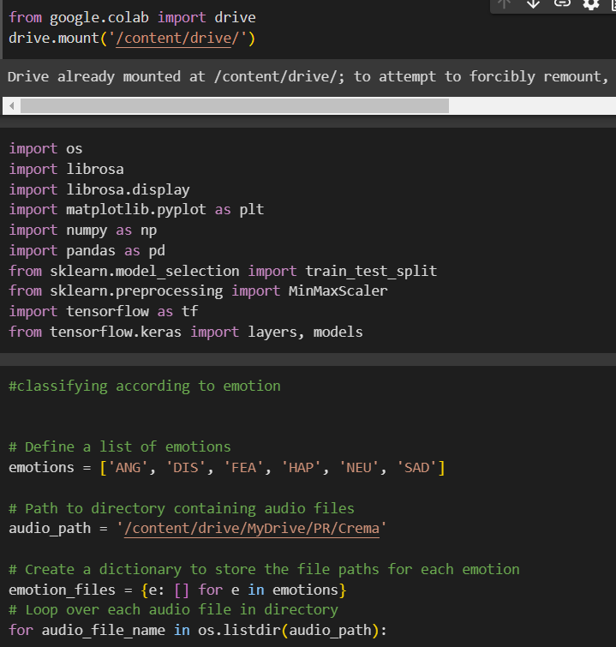

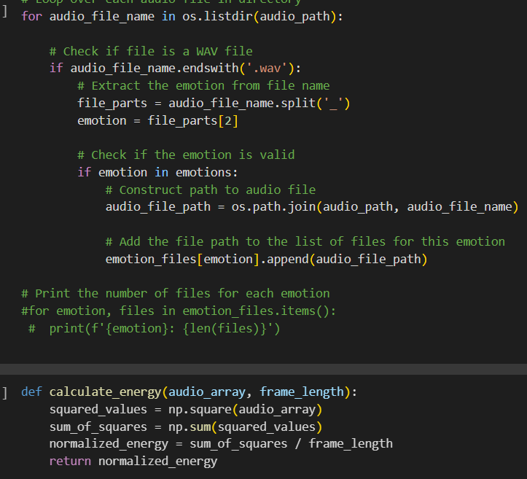

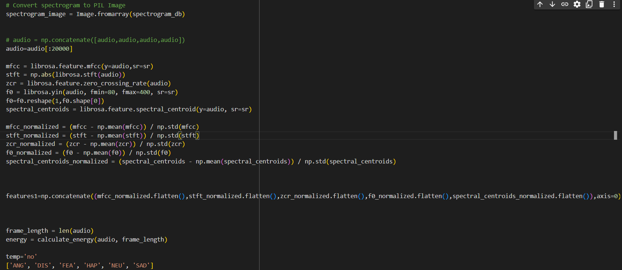
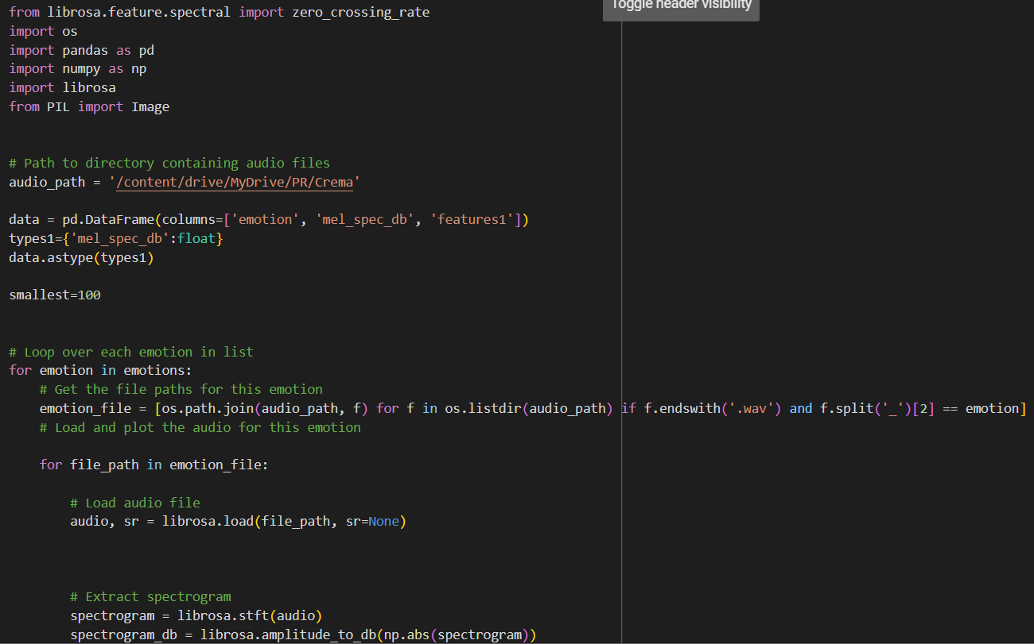
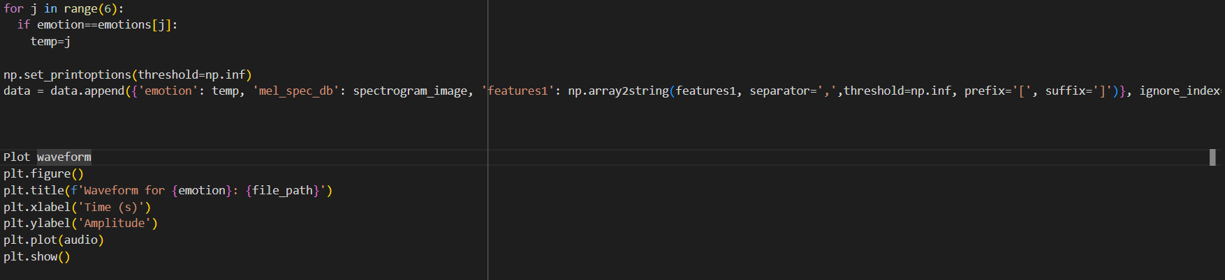
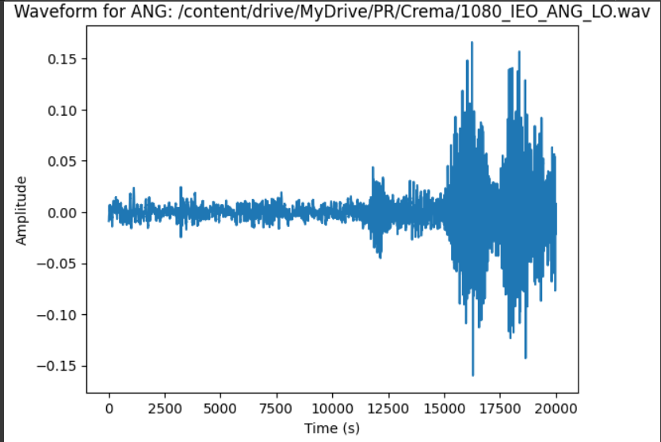
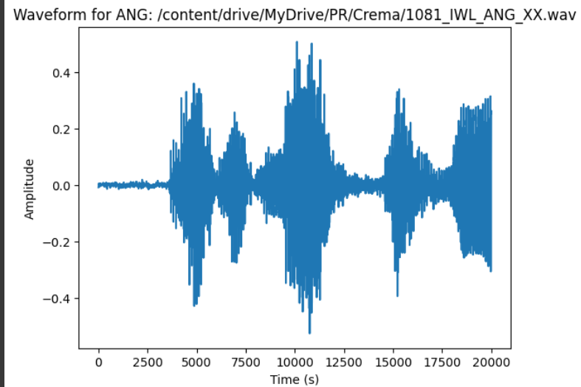
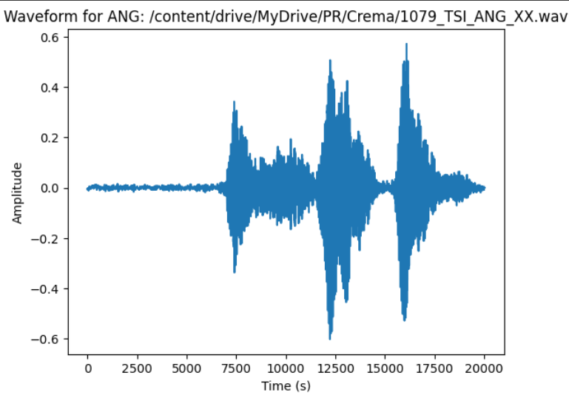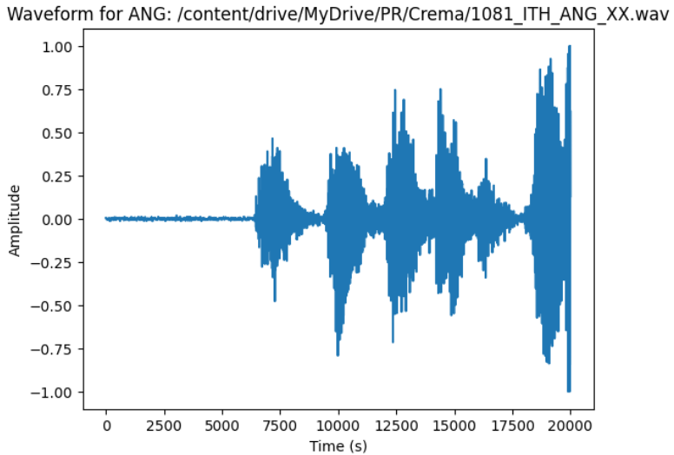
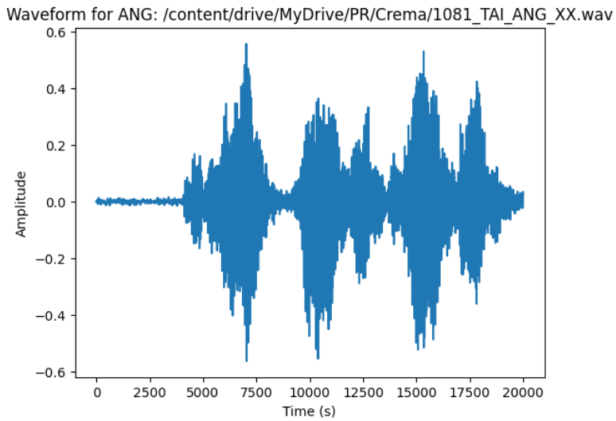
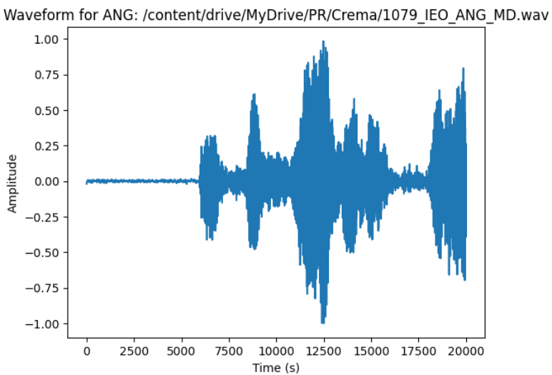
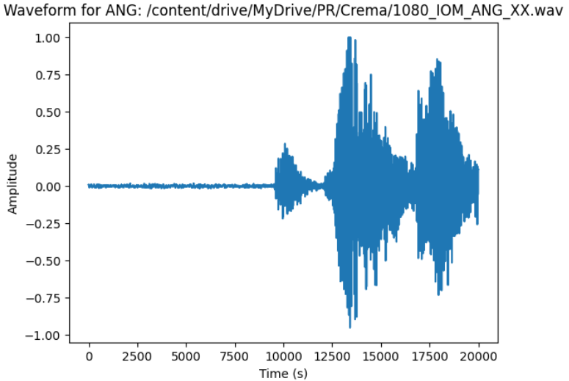
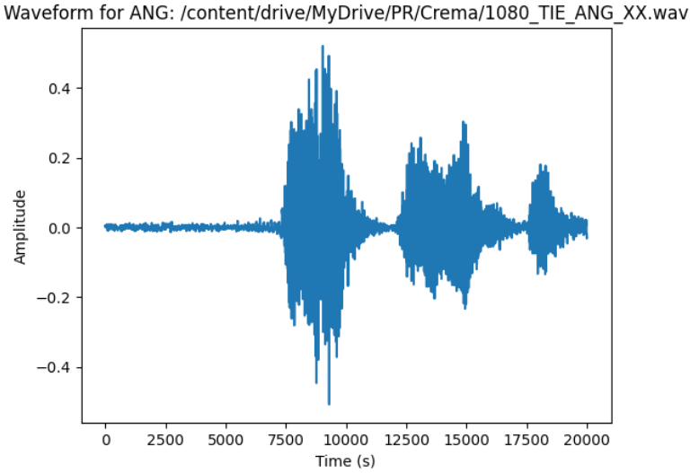
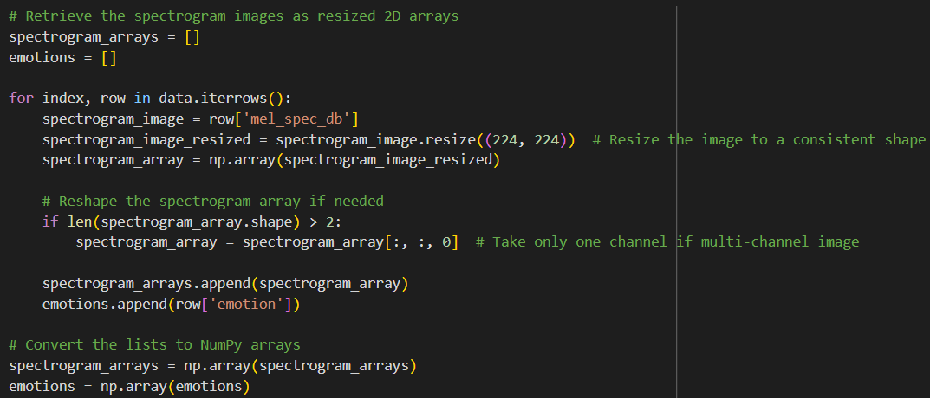

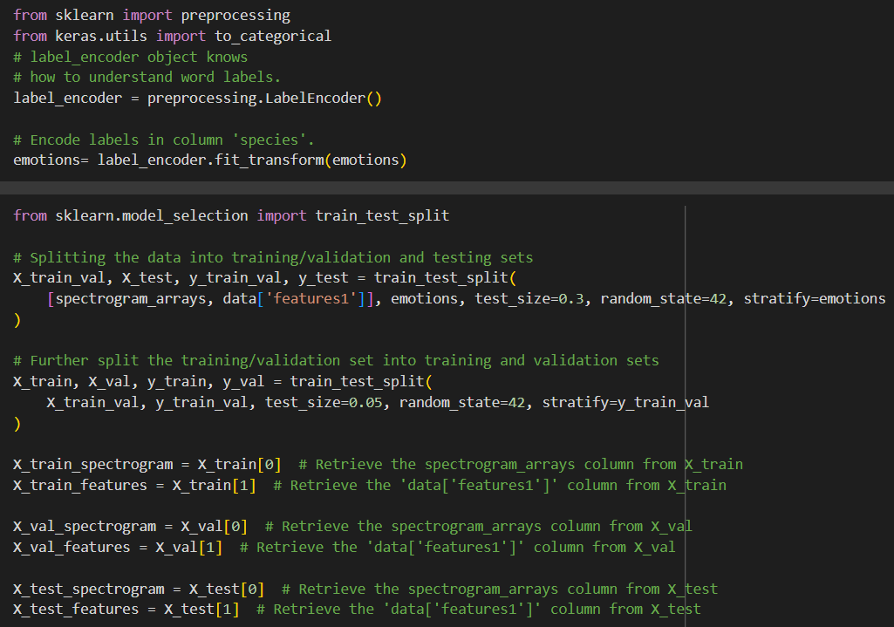

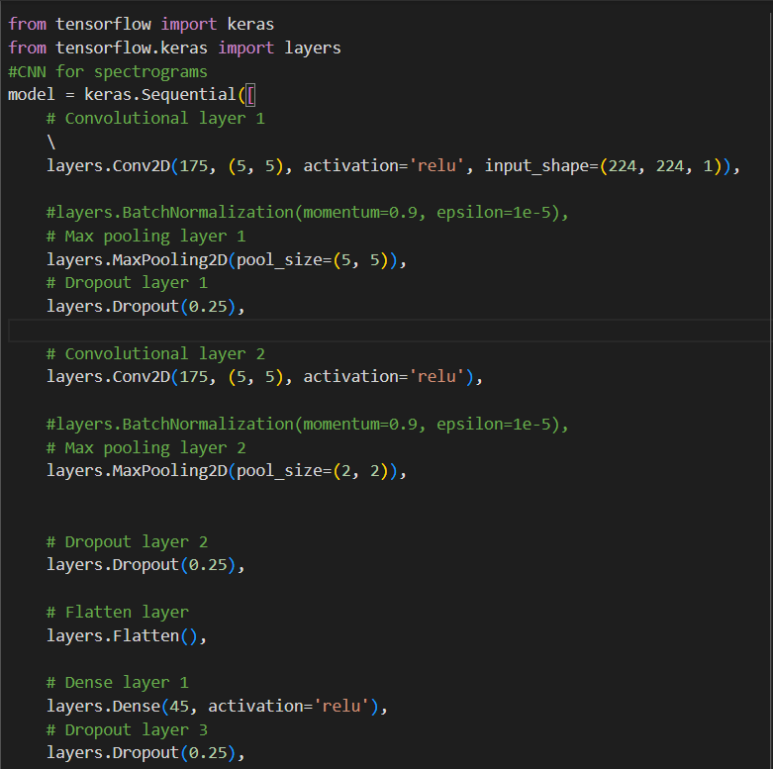

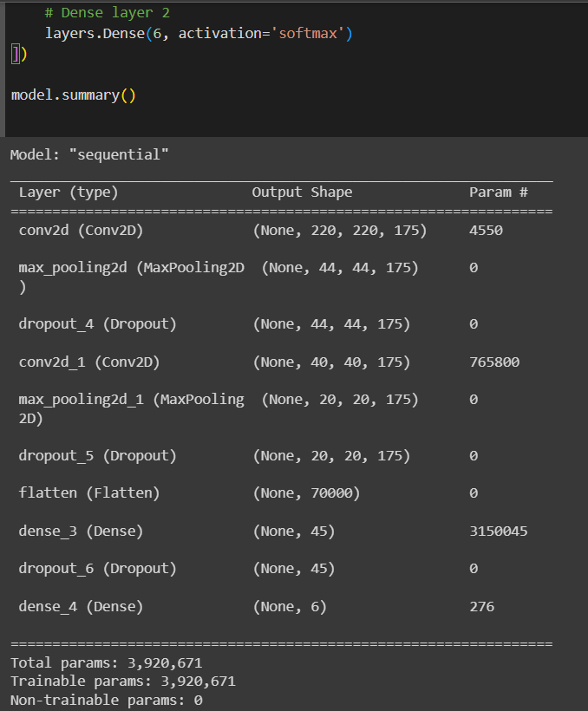

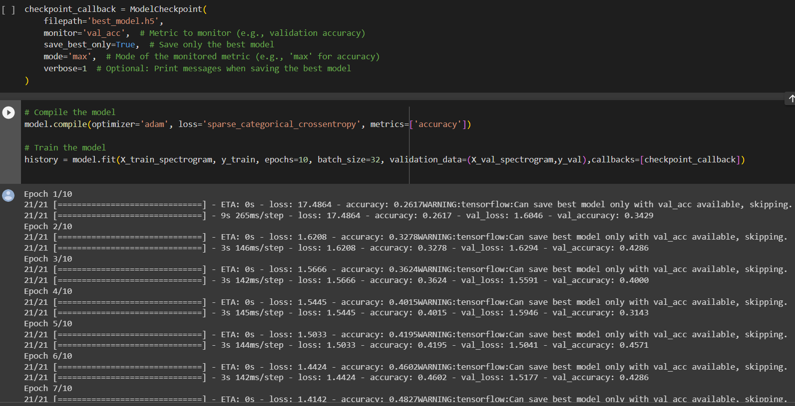

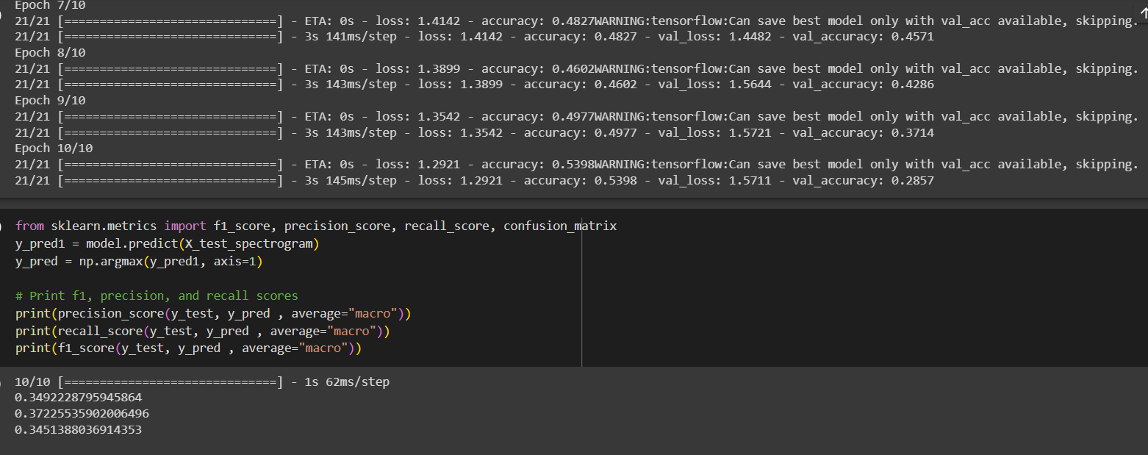

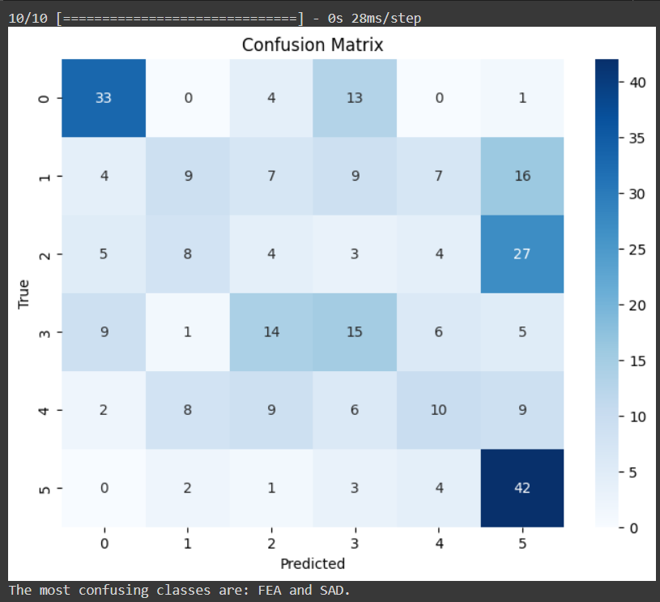
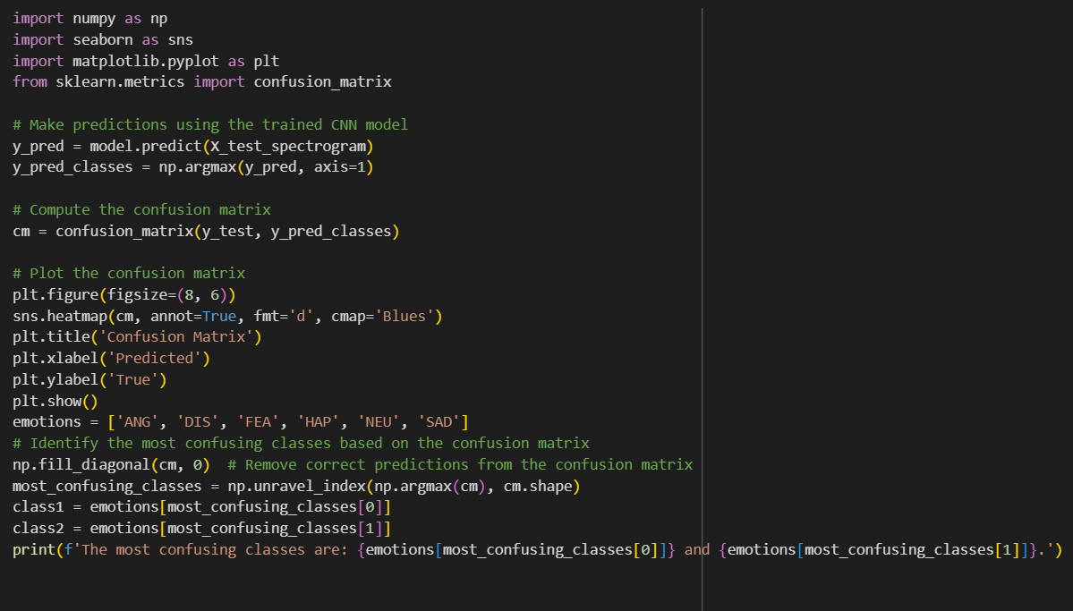

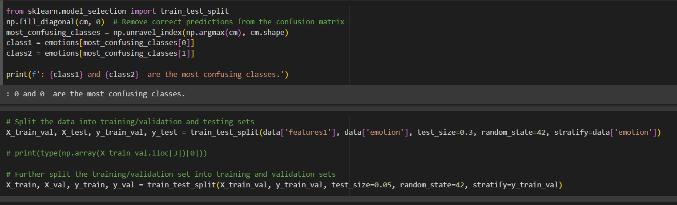
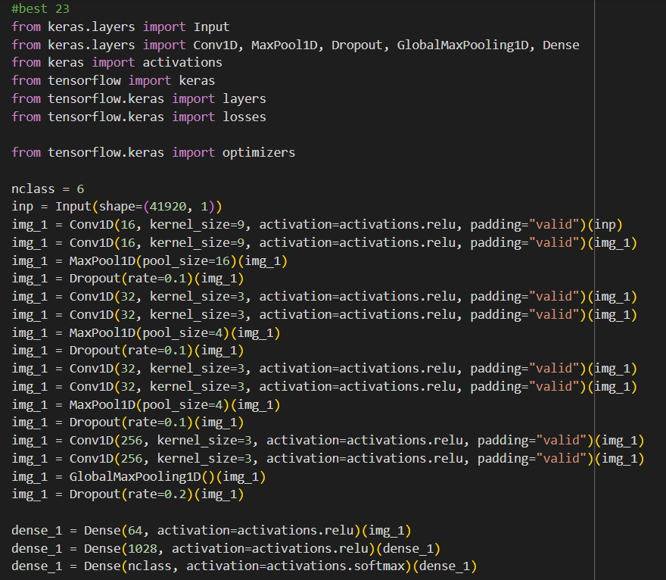

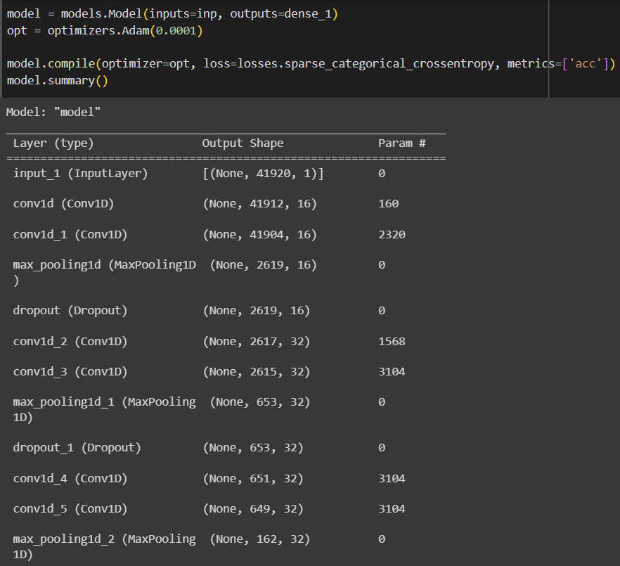
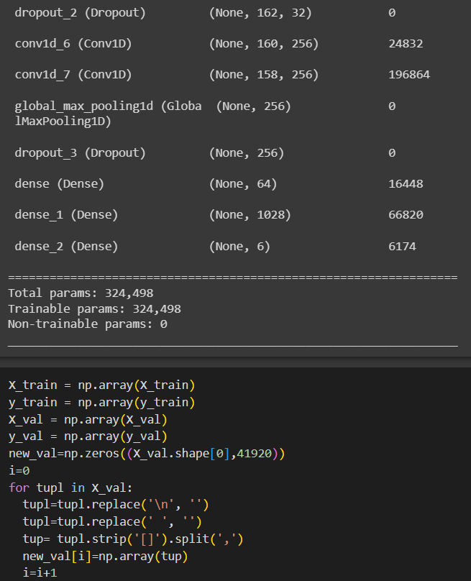

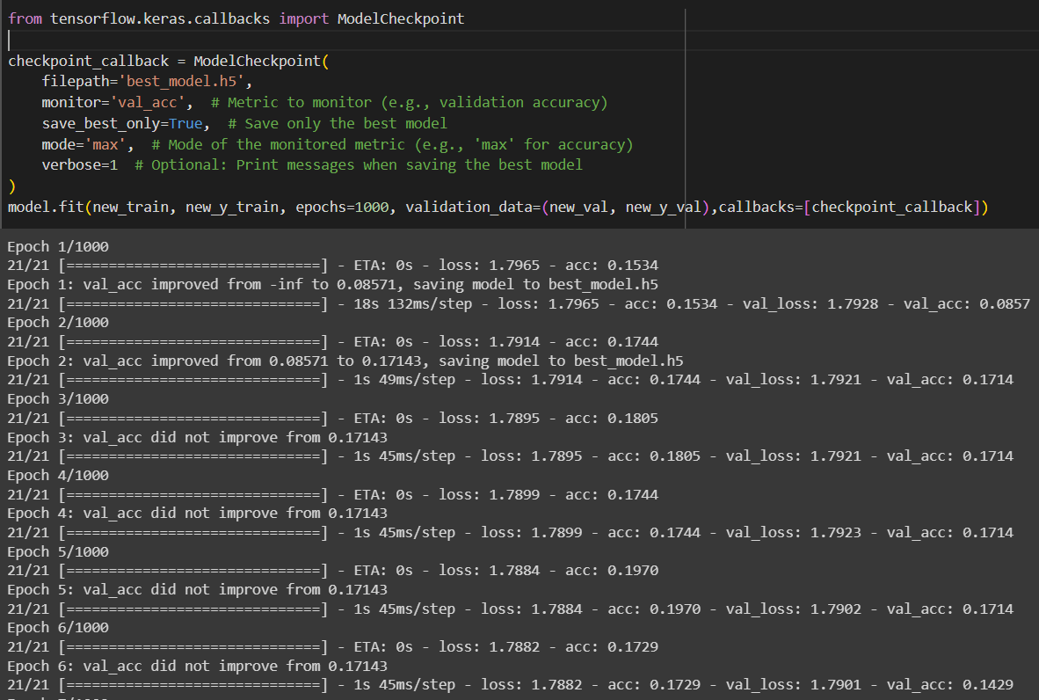
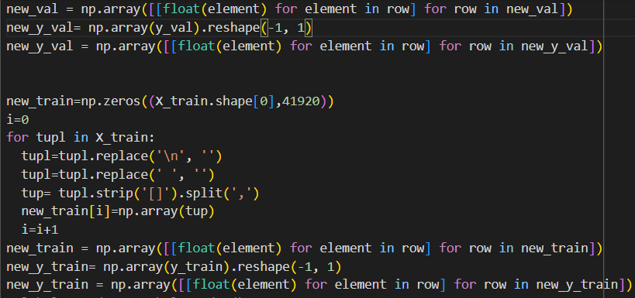
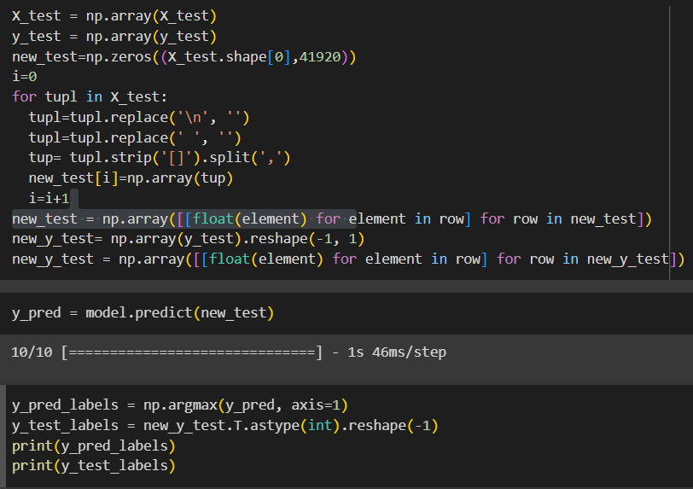
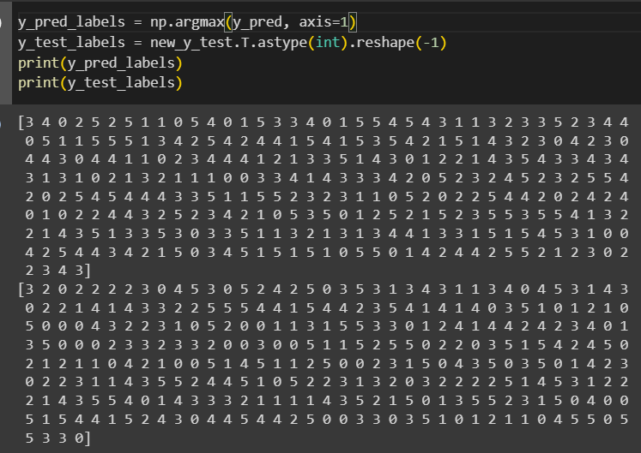

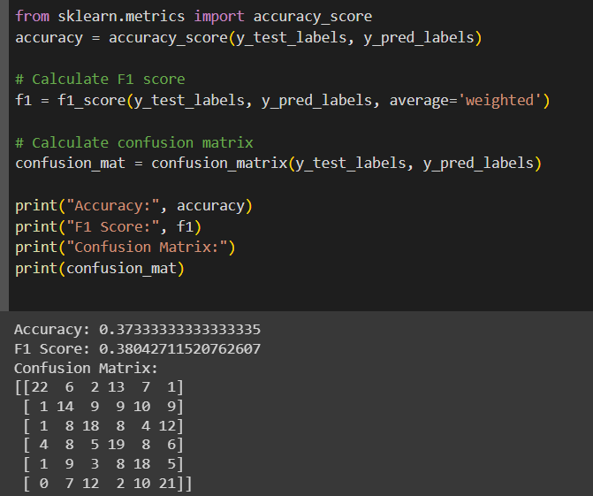

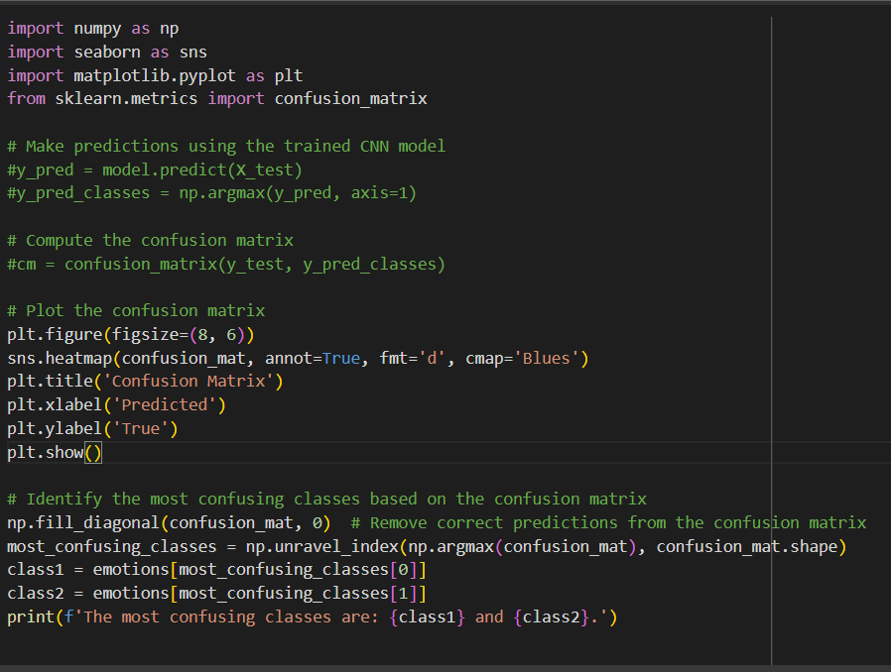

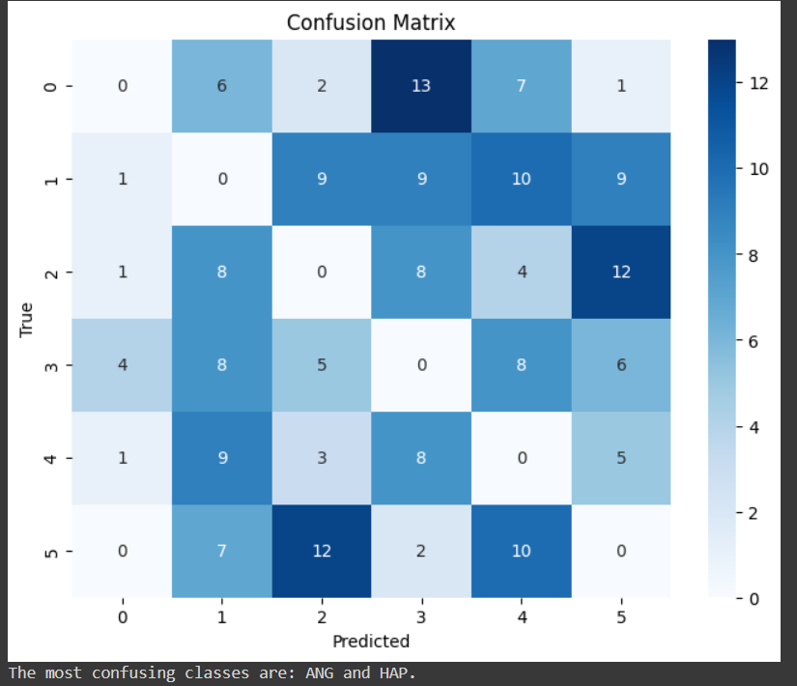

- Reference Paper:
We used an article as our reference for building the architecture of the model which is called “Recognition of Emotions in Speech Using Convolutional
Neural Networks on Different Datasets”
by Marta Zielonka, Artur Piastowski, Andrzej Czyzewski, Paweł Nadachowski, Maksymilian Operlejn and Kamil Kaczor
The study focuses on applying Convolutional Neural Networks (CNN) to extract emotions from spectrograms and mel-spectrograms. The research compares the efficiency of these two feature extraction methods in representing emotions. The study uses five popular datasets: CREMA-D, RAVDESS, SAVEE, TESS, and IEMOCAP, and considers six emotion classes: happiness, anger, sadness, fear, disgust, and neutral.
The results show that mel-spectrograms are better suited for training CNN-based Speech Emotion Recognition (SER) models. An accuracy of 55.89% is achieved when recognizing four emotions, and the most accurate model for six emotion recognition achieves 57.42% accuracy using a combination of four datasets.
The article also addresses the issue of inappropriate data division between training and test sets, which can significantly impact the test accuracy of CNNs. The popular ResNet18 architecture is employed to validate the research results and demonstrate that the data division problem is not specific to custom CNN architectures.
Additionally, the article includes a study on the label correctness of the CREMA-D dataset, which involves the use of a questionnaire.

