Assignment3
Computational Intelligence
Genetic Algorithm
Hend Waheed Farouk

1. Introduction
In this project, a Genetic Algorithm (GA) is implemented to solve an optimization problem. The objective is to maximize the following function:
$$F(x_{1},x_{2})=8-(x_{1}+0.0317)^{2}+(x_{2})^{2}$$
subject to the range:
$$-2≤x_{1},x_{2}≤2$$
Genetic Algorithms are optimization techniques inspired by natural selection and genetics. They evolve a population of candidate solutions over multiple generations using operators such as selection, crossover, and mutation. Over time, the population converges toward better solutions that maximize the objective function.

2. Solution Representation
Each solution is represented as a pair of real numbers $x_{1}$and $x_{2}$within the interval [-2, 2]. Unlike binary encoding, the variables are stored directly as double values in the algorithm.

3. Fitness Function
The fitness function evaluates how good each individual solution is:
$$\text{Fitness}=F(x_{1},x_{2})=8-(x_{1}+0.0317)^{2}+(x_{2})^{2}$$
Higher fitness values indicate better solutions. The GA uses this value to guide selection and reproduction.

4. Initial Population
The algorithm starts by generating a random population of individuals. Each individual is initialized with two real numbers $x_{1}$and $x_{2}$uniformly sampled from the interval [-2, 2].
The population size used in this experiment is 100.

5. Selection
Parent selection is performed using Tournament Selection:
- A number $k$of individuals is randomly chosen from the population.
- The individual with the highest fitness among them is selected as a parent.
- This process is repeated to select the second parent.
Two different tournament sizes are tested:
- $k=2$(small tournament)
- $k=\text{population size}$(large tournament)

6. Crossover
The algorithm uses Arithmetic Crossover:
- Two parents are combined to produce two offspring by taking a weighted average of their variables:
$${\text{child}}_{1}=α⋅{\text{parent}}_{1}+(1-α)⋅{\text{parent}}_{2} \\ {\text{child}}_{2}=α⋅{\text{parent}}_{2}+(1-α)⋅{\text{parent}}_{1}$$
- $α$is a random number between 0 and 1.
- Crossover occurs with a probability pcross = 0.6.

7. Mutation
The algorithm applies Gaussian Mutation:
- Each variable $x_{1}$and $x_{2}$may be perturbed by a Gaussian random value with standard deviation $σ=0.5$, with probability pmut = 0.05.
- After mutation, the variable is clipped to remain within [-2, 2].
Mutation maintains diversity in the population and prevents premature convergence.

8. Replacement
After selection, crossover, and mutation, a new population is formed for the next generation. This process repeats for 100 generations.

9. Elitism
In the elitism version, the best 2 individuals from the current generation are directly copied to the next generation. This ensures that the best solutions are preserved and accelerates convergence.

10. Experimental Setup
The Genetic Algorithm was executed with the following parameters:
- Population Size = 100
- Number of Generations = 100
- Crossover Probability (pcross) = 0.6
- Mutation Probability (pmut) = 0.05
- Gaussian Mutation Standard Deviation (sigma) = 0.5
- Tournament Sizes: $k=2$and $k=100$
- Elitism: Enabled or Disabled
Each experiment tracks the best fitness and average fitness of the population over generations.

11. Results Without and With Elitism
The GA was executed for four scenarios:
- Without Elitism, $k=2$
- Without Elitism, $k=\text{population size}$
- With Elitism, $k=2$
- With Elitism, $k=\text{population size}$
For each run, the best fitness and average fitness were recorded per generation. The data were saved in CSV files for plotting and analysis.
Observations:
- Elitism preserves the best solutions and generally leads to higher final best fitness.
- Tournament size influences selection pressure: larger $k$increases selection pressure and accelerates convergence but may reduce diversity.
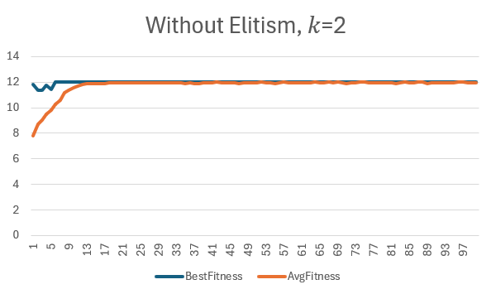
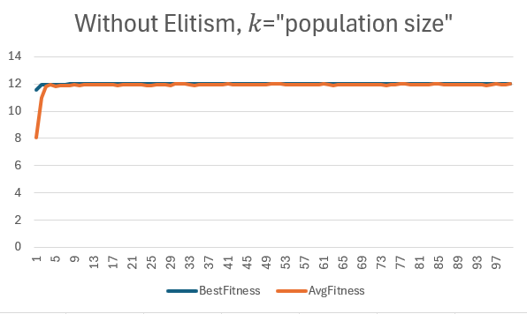

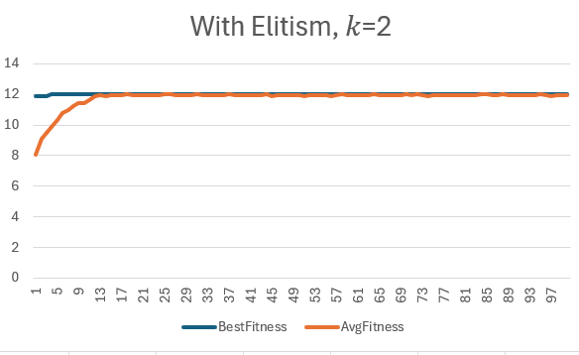
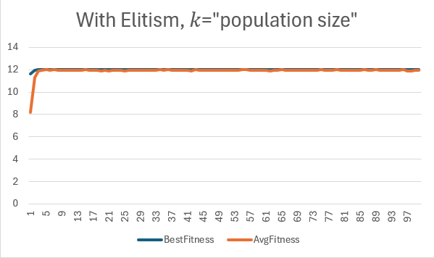

12. Discussion
- The GA successfully improved the population fitness over generations using selection, crossover, and mutation.
- Elitism helped to maintain the best solutions and improve convergence speed.
- Tournament selection size $k$affects the balance between exploration and exploitation:
  - Small $k$→ slower convergence but higher diversity
  - Large $k$→ faster convergence but risk of premature convergence
- Using real-valued representation with arithmetic crossover and Gaussian mutation ensures smooth exploration of the search space.

13. Conclusion
In this project, a Genetic Algorithm was implemented to optimize the function:
$$F(x_{1},x_{2})=8-(x_{1}+0.0317)^{2}+(x_{2})^{2}$$
within the bounded search space [-2, 2] for both variables.
Key findings:
- Real-valued representation is effective for continuous optimization.
- Tournament selection, arithmetic crossover, and Gaussian mutation efficiently improve population fitness.
- Elitism helps preserve top solutions and accelerates convergence.
- The choice of tournament size $k$influences the trade-off between convergence speed and population diversity.
Overall, the GA demonstrates effective optimization performance for this nonlinear problem using the specified operators and parameters.

