Assignment4
Computational Intelligence
PSO
Hend Waheed Farouk

1. Objective
The objective of this assignment is to implement the Particle Swarm Optimization (PSO) algorithm to maximize the following fitness function:
$$f(x_{1},x_{2})=sin⁡(2x_{1}-0.5π)+3cos⁡(x_{2})+0.5x_{1}$$
The algorithm is executed in two cases:
- Without elitism
- With elitism
The results are then compared in terms of convergence behavior.

2. Problem Constraints
The search space is defined as:
- $x_{1}∈[-2,3]$
- $x_{2}∈[-2,1]$
Velocity limits:
- $v∈[-0.1,1]$

3. PSO Algorithm Steps
The following steps were applied:
- Initialize a swarm of particles with random positions and velocities within the defined bounds.
- Evaluate the fitness value for each particle.
- Set the initial personal best (pbest) for each particle.
- Determine the global best (gbest) among all particles.
- Update velocity using:
$$v=v+c_{1}r_{1}(pbest-x)+c_{2}r_{2}(gbest-x)$$
- Update position:
$$x=x+v$$
- Apply boundary constraints to positions and velocities.
- Update pbest if a better fitness is found.
- Repeat the process for a fixed number of generations.

4. Elitism Strategy
Elitism is applied by forcing one particle in the swarm to always take the global best position found so far.
This helps:
- Preserve the best solution
- Improve convergence speed

5. Results and Analysis
The algorithm was executed for a fixed number of generations, and the following values were recorded:
- Best fitness value per generation
- Average fitness value per generation

Case 1: Without Elitism
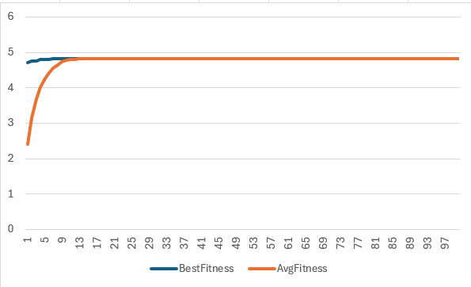

Observation:
- Slower convergence
- Higher diversity in early generations

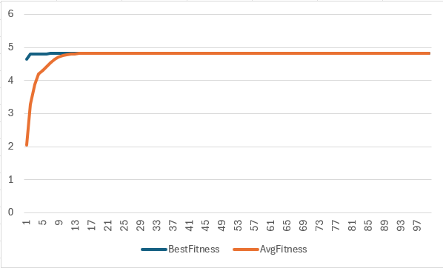
Case 2: With Elitism

Observation:
- Faster convergence
- More stable improvement in fitness values

6. Comparison
Aspect | Without Elitism | With Elitism
Convergence Speed | Slower | Faster
Stability | Less stable | More stable
Diversity | Higher | Lower

7. Conclusion
The PSO algorithm successfully optimized the given function.
- The version with elitism showed faster convergence and better stability.
- The version without elitism maintained higher diversity but required more time to converge.
Overall, elitism improves performance but may reduce exploration.

