Assignment6
Computational Intelligence
Simplex_search_algorithm
Hend Waheed Farouk

Simplex Search (Nelder-Mead) Optimization Report

1. Introduction
In this assignment, the Simplex Search method (Nelder-Mead algorithm) is implemented to solve an optimization problem. The objective is to minimize the following function:
$$f(x,y)=(x-2)^{2}+(y-2)^{2}$$
This function has a global minimum at the point (2, 2), where the function value equals zero.

2. Algorithm Overview
The Nelder-Mead algorithm is a derivative-free optimization technique that operates on a simplex of points. In a 2D problem, the simplex consists of three vertices.
At each iteration, the algorithm performs the following steps:
- Sorting:
The points are sorted based on their fitness values into:
  - Best point (Xb)
  - Second best point (Xg)
  - Worst point (Xw)
- Centroid Calculation:
The centroid of the best and second-best points is calculated as:
$$X_{c}=\frac{X_{b}+X_{g}}{2}$$
- Reflection:
The worst point is reflected across the centroid:
$$X_{r}=X_{c}+α(X_{c}-X_{w})$$
- Expansion:
If the reflected point is better than the best point:
$$X_{e}=X_{c}+γ(X_{r}-X_{c})$$
- Contraction:
If reflection does not improve the solution, contraction is applied:
  - Outside contraction:
$$X_{out}=X_{c}+β(X_{r}-X_{c})$$
  - Inside contraction:
$$X_{in}=X_{c}+β(X_{w}-X_{c})$$

3. Parameters Used
The algorithm uses three main parameters:
- Reflection coefficient (α)
- Expansion coefficient (γ)
- Contraction coefficient (β)
In this implementation, these parameters are randomly generated within the following ranges:
- $α∈[0.5,1.5]$
- $γ∈[1.5,2.5]$
- $β∈[0.1,0.5]$

4. Implementation Details
- The algorithm starts with three initial points:
(0,0), (1,0), and (0,1)
- The simplex is updated iteratively over a fixed number of iterations.
- In each iteration:
  - The best fitness value is recorded.
  - The average fitness value of all simplex points is calculated.

5. Results and Observations

Best Fitness
The best fitness value decreases over iterations, showing that the algorithm is successfully converging toward the optimal solution.

Average Fitness
The average fitness also decreases, indicating that all points in the simplex are moving toward the optimum.

Convergence Behavior
- The algorithm gradually approaches the optimal point (2,2).
- The convergence is smooth and stable.
- Random parameter selection still leads to effective optimization.

6. Graphical Analysis
The following graph illustrates:
- Best fitness over iterations
- Average fitness over iterations
The graph clearly shows a decreasing trend, confirming convergence toward the global minimum.
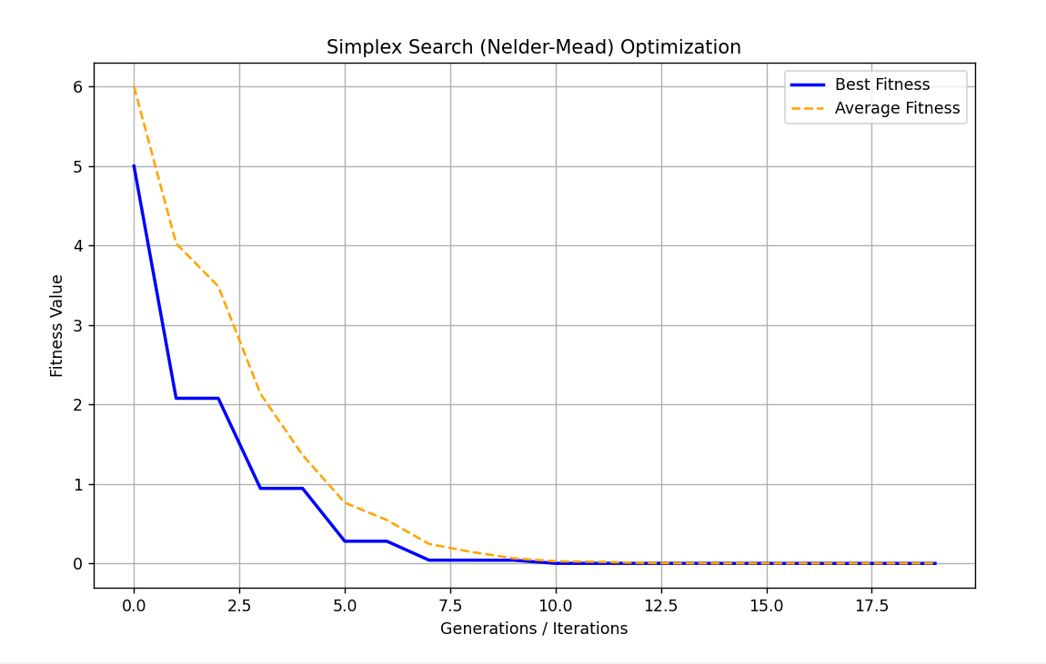

7. Elitism Discussion
Although elitism is commonly used in evolutionary algorithms, it is not explicitly required in the Nelder-Mead method.
However:
- The algorithm inherently preserves the best solution by always keeping it in the simplex.
- This behavior is similar to elitism since the best point is never discarded.

8. Conclusion
The Nelder-Mead Simplex algorithm was successfully implemented to minimize the given function.
Key conclusions:
- The algorithm efficiently converges to the optimal solution (2,2).
- The best and average fitness values consistently decrease over iterations.
- Random parameter selection does not significantly affect convergence quality.
- The method is simple, effective, and does not require derivatives.

