Assignment7
Computational Intelligence
CSA
Hend Waheed Farouk

Cuckoo Search Algorithm:

Introduction
This report presents the implementation of the Cuckoo Search Algorithm (CSA) to minimize the function f(x,y) = (x−2)² + (y−2)², which has a global minimum of zero at the point (2, 2).

Algorithm Parameters
The following parameters were used in the implementation:
- Number of nests: n = 20
- Discovery probability: pₐ = 0.25
- Step size: α = 1
- Number of iterations: 100
- Variables range: [−5, 5]

Solution Steps
Step 1 — Initialize Nests 20 random solutions were generated uniformly within the range [−5, 5] for both x and y. The fitness of each nest was evaluated using the objective function.
Step 2 — Generate New Solutions via Lévy Flights At each iteration, each nest moves to a new position using the Lévy flight equation:
x_new = x + α · L · cos(θ)
y_new = y + α · L · sin(θ)
Where L is computed using the Mantegna approximation with β = 1.5:
L = |u| / |v|^(1/β)
Where u ~ Normal(0, σᵤ²) and v ~ Normal(0, 1), and σᵤ is computed as:
σᵤ = [ Γ(1+β) · sin(πβ/2) / (Γ((1+β)/2) · β · 2^((β−1)/2)) ]^(1/β)
The direction θ is chosen uniformly from [0, 2π]. The new solution is clipped to remain within the variable range.
Step 3 — Evaluate Fitness The fitness of each new solution was evaluated using the objective function f(x,y) = (x−2)² + (y−2)².
Step 4 — Replace Worse Nests (Greedy Selection) If the new solution has a better (lower) fitness than the current nest, it replaces it. Otherwise, the current nest is kept.
Step 5 — Abandon Some Nests For each nest, a random number r is drawn from Uniform(0,1). If r < pₐ = 0.25, the nest is discarded and replaced with a completely new random solution within the variable range.
Step 6 — Elitism At the end of each iteration, the global best solution found so far is tracked. If no improvement is found in the current iteration, the worst nest in the population is replaced by the global best solution to ensure it is never lost.

Results
 | With Elitism | Without Elitism
Best Fitness | 3.86 × 10⁻⁵ | 0.0801
Average Fitness | 11.99 | 21.73
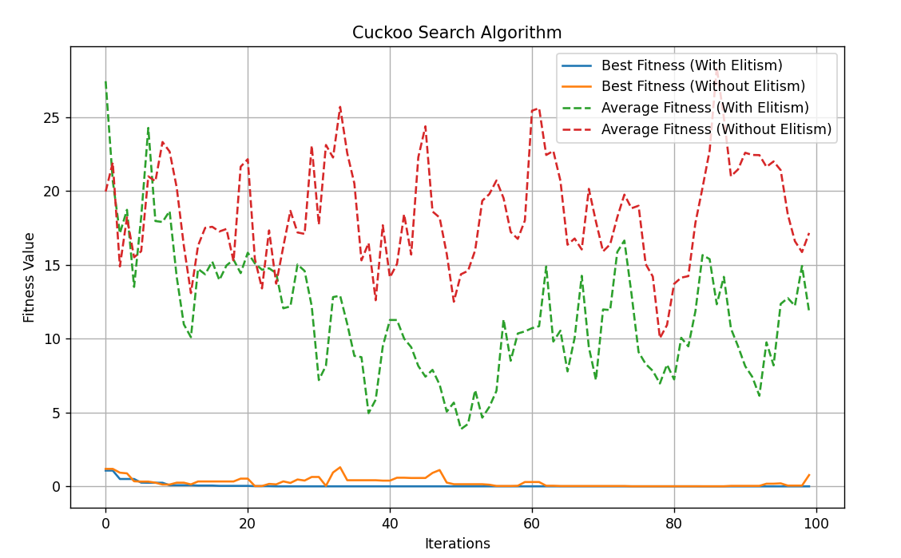
With Elitism: The best fitness reached approximately zero, very close to the global optimum at (2, 2). The elitism mechanism ensured the best solution was preserved across iterations even if the abandonment phase discarded it.
Without Elitism: The best fitness was higher since good solutions could be lost during the abandonment phase with no mechanism to recover them. The average fitness was also significantly higher, indicating more scattered population.

Conclusion
The Cuckoo Search Algorithm successfully minimized the objective function. The Lévy flight mechanism balanced exploration and exploitation by producing mostly small steps for local refinement and occasionally large steps to escape local optima. The abandonment phase maintained population diversity. Elitism proved effective in preserving the best solution and accelerating convergence.

