

Project
Project Proposal

 | Student Number | Surname | First Name
1 | 202402708 | Mokoena | Karabo
2 | 202306895 | Molomo | Karabo
3 | 202420029 | Thabethe | Kamohelo
4 | 202207325 | Thuto | Henderson

TITLE: School Feeding Program Distribution & Tracking System

INTRODUCTION

Everyday millions of African schoolchildren get meals from the National School Nutrition Program. The National School Nutrition Program is really helping these kids. Staff members at the National School Nutrition Program make meals for the students. They also distribute food packs to the schools. The National School Nutrition Program is doing a job of giving food to the students. These food packages are currently tracked manually through phone calls and written records. Schools are required to physically count their inventory and call the feeding plan office to report issues such as short deliveries or missing products. We do not have a system to keep track of who gets food, where the food goes. If the kids get the food. The food distribution process needs to be more accountable and transparent. This idea is about using a system to track the food from when it is delivered to when the kids eat it. The digital system will help us keep track of food distribution.

PROBLEM
South Africa already struggles with food insecurity. According to Statistics South Africa, millions of households experience moderate to severe food insecurity. That means inconsistent access to enough safe and nutritious food. For many learners, the school meal is not a “top-up.” It is the most reliable meal of the day.
The Department of Basic Education has repeatedly stated that the National School Nutrition Program feeds over nine million learners daily. That number alone tells you something important: the program is not supplementary — it is structural. It holds up part of the country’s food access system.
So, when meals are stolen, delayed, poorly distributed, or expire due to weak tracking, it doesn’t just create an admin problem. It increases food vulnerability for children who may already come from households struggling with poverty or unemployment.
Food insecurity is not just hunger, it includes:
- Not having consistent access.
- Not having nutritious food.
- Skipping meals because food runs out.
- Anxiety about where the next meal will come from.
If the school system fails to deliver meals properly, learners who depend on those meals may skip eating for the day. That affects concentration, cognitive performance, attendance, and long-term development. Nutrition directly impacts brain function. Iron deficiency alone can impair learning capacity. This is not dramatic — it is biological.
Food parcels meant for schoolchildren are not properly tracked. This creates several serious problems:
- Manual stock tracking: Food deliveries are noted by school personnel in paper notebooks. Manual stock counts are sometimes imprecise or out-of-date.
- Delayed reporting: Schools are required to contact the nutrition program office when food is either short-delivered or missing. It takes time, and occasionally no calls are placed at all.
- Food theft: Food theft is a problem. Staff members and teachers sometimes take food that is meant for the kids. Nobody says anything, about it. The people who do this do not get into trouble because there is no way to keep track of who took what and when they took it. The food packages that are supposed to go to the kids are just. Nobody knows who did it. Food theft is still a problem because of this.
- No expiration monitoring: Because use-by dates are not routinely tracked food goes bad while it sits in storage.
- Lack of usage data: The nutrition program is unaware of the precise amount of food that each school consumes each day in comparison to what is supplied. It is difficult to spot discrepancies.
- Ineffective deliveries: Because timetables are not monitored, delivery vans may show up at random. While waiting, schools run out of food.
- Food insecurity: Many learners depend on school meals as their most consistent source of nutritious food. When deliveries are delayed, missing, stolen, or spoiled, learners risk going hungry. This not only affects their health and nutrition but also their ability to focus, learn, and attend school consistently.

Affected Users:
- Schoolchildren: When food is taken, expires, or runs out, they go hungry.
- School principals: Without accurate records, they are unable to demonstrate that food is missing.
- Nutrition scheme managers: They are unable to identify troublesome schools or follow the path of delivery.
- Government: Food that never reaches children is a waste of taxpayer money.
Policies linked to the Problem
The National School Nutrition Program operates under the South African Schools Act (Act 84 of 1996), which permits the state to create an environment that supports access to basic education. Adequate nutrition forms part of this responsibility, as learners cannot effectively participate in education to their best potential when they are hungry.
Section 27 and Section 29 of the Constitution of the Republic of South Africa (1996) also guarantee the right to sufficient food and the right to basic education. When food parcels are stolen, mismanaged, or expired due to poor monitoring, these constitutional rights are undermined.
To add on, the Public Finance Management Act (Act 1 of 1999) requires transparent use of public funds, proper record keeping, and prevention of wasteful expenditure. The current manual tracking system within the NSNP creates gaps in accountability, increasing the risk of financial mismanagement and loss of taxpayer money.
The identified operational problems not only does it represent logistical weaknesses, but also compliance risks in relation to national legislation and governance standards.

SOLUTIONS
Existing solutions
Before proposing a new digital system, we looked at how the National School Nutrition Program (NSNP), managed by the Department of Basic Education, currently handles food distribution and monitoring.
At school level, food deliveries are recorded manually. Staff write down the quantity of items received in notebooks or printed registers. Stock is counted by hand and compared against what was delivered. This method depends completely on human accuracy. If someone forgets to record information, makes an error, or intentionally changes data, there is no automatic way to detect it.
When deliveries are short or missing, schools report the issue by phone or email to district offices. This process is slow and inconsistent. There is no structured digital reporting format, which means complaints are handled differently from school to school.
Monitoring is also done through district visits and audits. Officials may inspect records during scheduled visits. However, these inspections do not happen daily. If food goes missing between visits, the issue may only be discovered much later.
Procurement and supplier management are handled at a provincial level through formal tender processes. While this controls who supplies food, it does not track what happens after the food arrives at schools. Once delivery is completed, monitoring returns to manual record-keeping.
Some provinces require periodic summary reports from schools. These reports are usually compiled after the fact and do not provide real-time visibility into stock levels, expiry dates, or daily usage.
From this review, the NSNP already has administrative controls in place. The program is structured and funded. However, tracking remains manual, fragmented, and reactive. There is no centralized live system that shows where food is at any given time, how much stock remains, or whether deliveries match actual usage.
This gap in real-time digital monitoring creates opportunities for delays, waste, and loss that are difficult to detect early.

Proposed solutions
To track the distribution, storage, and consumption of food parcels in real time, this project suggests creating a Digital School Feeding Program Distribution & Tracking System. Schools, vendors, and government officials will be able to use a secure digital solution that will replace laborious paper-based monitoring.
The Brazilian National School Feeding Program digital school feeding monitoring system, which tracks food delivery and ensures accountability using digital technologies, is one of the successful foreign models that served as inspiration for the proposed system. The method in Brazil has increased openness, decreased food waste, and made sure that meals are effectively delivered to millions of kids.
The following elements will be part of the suggested system:
1. Digital Delivery Logging System
When the delivery workers get to a school, they will use a tablet or a mobile application to write down the food deliveries. They will write down the date and the time of each delivery and how food they brought and what kind of food it is. The delivery workers will use this information to keep track of the food deliveries. Digital confirmation of receipt will be provided by the school personnel. By doing this, the need for paper logs is eliminated and a permanent digital record is created.
This method is comparable to logistics tracking systems employed by businesses such as DHL, which use electronic delivery scanning and confirmation to guarantee precise tracking.

2. Real-Time Centralized Monitoring Dashboard
Nutrition plan managers will be able to track delivery in real time across all schools via a web-based dashboard. Which schools got food, when delivery took place, and whether there are any inconsistencies will all be displayed on the dashboard.
Centralized dashboards are used by the Estonian government's digital government services to effectively and openly monitor the provision of public services.
3. Inventory Management System with Expiry Tracking
The technology will be used by school personnel to track daily food consumption. The system will keep track of when things expire and figure out how much stock is left. When food is about to go the system will send alerts to employees, so they know. This helps cut down on throwing away food that's still good and makes sure people do not eat bad food.
Healthcare systems, like the National Health Service in the UK use systems, like this to keep track of medicine and other supplies. They do this to avoid throwing away things that have expired. The National Health Service uses these systems a lot to manage their supplies and avoid waste from things expiring.
4. Automated Reporting and Alert System
The system will immediately alert administrators if food delivery are missing, delayed, or incomplete. Schools won't have to rely on phone calls to report problems. This guarantees that issues are resolved promptly and enhances response time.
Automated alerts are used by the Government of Singapore's public service monitoring systems to track service performance and boost operational effectiveness.
5. User Authentication and Accountability Tracking
There will be secure logins for every user. The user who tracks deliveries, modifies inventory, or reports problems will be noted by the system. This lowers theft and unauthorized access while establishing accountability.
Estonia's national digital identification system employs secure identity-based access control to guarantee accountability and transparency in the administration of public services.

Contrast Between Current System and Proposed System
Manual record keeping, delayed reporting, and recurring audits are the major components of the present National School Nutrition Program monitoring procedure. These approaches do not enable real-time surveillance of food deliveries, stock levels, or usage across schools, even though they offer some administrative supervision. Food theft, delayed delivery, erroneous stock records, and expired food are examples of issues that frequently go unreported until much later.
Under the existing system, school employees manually record food deliveries in notebooks or paper registers. This approach is totally reliant on human integrity and correctness. There is no automated system to identify inconsistencies if data is reported inaccurately, changed, or not at all. On the other hand, the suggested digital approach will be a tablet or mobile application to electronically record deliveries. The school staff will digitally verify receipt of each delivery, which will be recorded with the date, time, type, and quantity of food supplied. This produces a digital record that is both permanent and verifiable.
The lack of real-time monitoring is another significant drawback of the current system. Typically, district administrators are only made aware of issues when schools notify them via phone, email, or planned audits. Problem solving is delayed by this reactive strategy. Government representatives and managers of feeding programs can keep an eye on delivery and stock levels in real time thanks to the proposed system's centralized monitoring dashboard. This increases openness and enables problems to be found and fixed right away.
The existing manual method has limitations regarding inventory management. Schools rarely keep a systematic track of expiration dates, and they count stock by hand. When food expires without being discovered, this can result in food deterioration or shortages. To address this, the suggested system includes an automatic inventory management module that keeps track of expiration dates and daily food consumption. When food items are about to expire, the system will immediately notify school personnel.
Another area where the existing method is ineffective is reporting. Shortages, missing delivery, and other issues must be manually reported by schools via phone calls or emails. This procedure is irregular and occasionally not carried out at all. On the other hand, when deliveries are missing, partial, or delayed, the suggested system will automatically provide warnings. This guarantees that problems are reported right away and dealt with more quickly.
Lastly, because it doesn’t track who makes deliveries or changes stock data, the existing system lacks accountability. This makes it possible for data to be stolen or altered. Activity logging and secure user authentication are new features of the suggested system. Every user will have a distinct login, and every action taken within the system will be tracked. This lowers the possibility of abuse and establishes accountability.
Overall, by substituting a centralized digital monitoring platform for manual procedures, the proposed digital School Feeding Program Distribution and Tracking System increases accountability, efficiency, and transparency. This contrast shows how technology may guarantee that food supplies reach the intended beneficiaries while addressing the shortcomings of the current system.

Current System | Proposed System
Paper-based delivery records | Digital delivery logging
Phone reporting of issues | Automated alerts
No real-time monitoring | Live monitoring dashboard
Manual stock counting | Automated inventory tracking
No expiry tracking | Expiry alerts
No accountability | User authentication and activity logs

Expected Impact
Significant improvements will arise from the deployment of this technology, including:
  - Increased openness in the delivery of food
  - A decrease in food loss and theft
  - Precise monitoring of food supply and consumption
  - Quicker reporting and fixing delivery issues
  - Less food waste because of checking expiration dates
  - Enhanced effectiveness in the administration of government nutrition programs
Above all, by ensuring that food reaches the right people, the system will boost schoolchildren's health and wellbeing.

Architecture

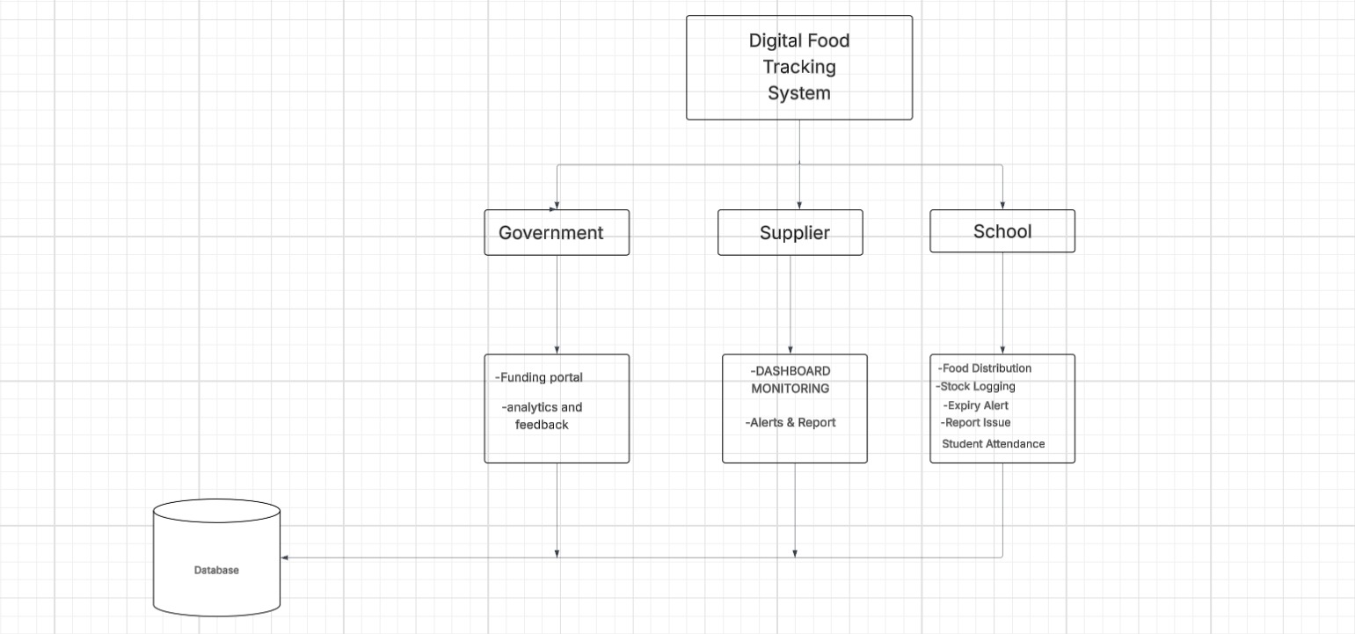

ERD
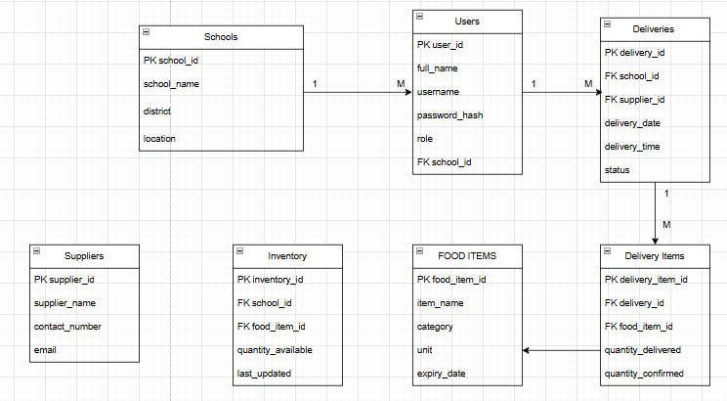

REFERENCES
Department of Basic Education (2024) Internal government documents on National School Nutrition Programme supply chain inefficiencies. Pretoria: Department of Basic Education. (August).
Qila, V.E. and Tyilo, N. (2014) ‘Implementing National School Nutrition Programme (NSNP): how involved are the stakeholders’, Mediterranean Journal of Social Sciences, 5(27), pp. 381–390.
World Food Programme Centre of Excellence against Hunger Brazil (2022) Using digital tools to strengthen South-South cooperation in school feeding. Brasília: WFP Centre of Excellence against Hunger.

