- Ctrl + C
- Break exits out of a loop, while continue goes back to the start of the loop
- They are all the same, only (unnecessarily) more specified
- 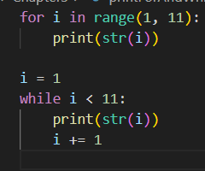
- spam.bacon()

