Design and Development of a Tourism Recommender System Based on Large Language Models (LLM) and Strict SQL Grounding for Intelligent Destination Advisory (Case Study: Padang City)

Authors:
Hendra Setyawan¹, [Advisor Name I]², [Advisor Name II]³
¹Department of Information Systems / Computer Science, Faculty of Information Technology, [University Name], Padang, West Sumatra, Indonesia
²Department of Information Systems, Faculty of Information Technology, [University Name], Padang, West Sumatra, Indonesia
Corresponding Author: [author.email@institution.ac.id]

ABSTRACT
In the era of smart tourism, independent travelers increasingly rely on digital geoinformation tools to explore unfamiliar destinations. While Web-Based Geographic Information Systems (Web GIS) have been widely deployed for tourism promotion and spatial visualization, most legacy platforms feature rigid catalog interfaces that fail to capture nuanced conversational travel inquiries. Recently, Large Language Models (LLMs) have emerged as flexible conversational agents; however, unconstrained LLMs suffer from severe factual and spatial hallucinations—fabricating non-existent venues, presenting outdated operating hours, or providing erroneous proximity estimates. To resolve this critical challenge, this research introduces a novel Grounded Conversational Web GIS Architecture for city-scale tourism exploration, demonstrated through a case study in Padang City, West Sumatra, Indonesia. The proposed system decouples cognitive natural language understanding from deterministic spatial data retrieval through a Strict SQL Grounding paradigm coupled with a Distributed Spatial Engine. In this architecture, the LLM is sandboxed strictly as an Intent Parser (translating colloquial human queries into structured JSON filter objects) and a Grounded Natural Language Generator (NLG) bound exclusively to retrieved facts. The spatial engine leverages in-database Haversine great-circle distance computations within a relational PostgreSQL repository populated with 22 curated Points of Interest (POIs) across 6 thematic categories, seamlessly integrated with the Open Source Routing Machine (OSRM) for real-time turn-by-turn road network routing and interactive Leaflet.js mapping. The system was developed using an iterative Prototyping engineering approach and validated through 40 comprehensive benchmark scenarios spanning categorical intent, operating hours, budget constraints, spatial radius thresholds, multi-turn dialogues, and out-of-scope queries. Empirical evaluation demonstrates a 100.00% intent extraction accuracy, 100.00% category classification match, and 100.00% Grounding Fidelity (Zero Hallucination) with zero fabricated entities. The end-to-end processing latency averaged 1,381.90 ms (~1.38 s) per query (Intent Parsing: 485.20 ms, Spatial SQL: 2.85 ms, Context Integration: 1.45 ms, Grounded NLG: 892.40 ms), with in-database spatial queries contributing merely 0.21% of the total processing time, confirming outstanding database computational efficiency and natural conversational responsiveness. This study contributes to applied geoinformatics by formalizing how strict relational grounding eliminates generative AI hallucinations, establishing a robust framework for scale-aware, conversational spatial decision support in urban tourism.
Keywords: Conversational Web GIS, Strict SQL Grounding, Curated POI, Exploratory Spatial Interaction, Haversine Formula, Open Source Routing Machine (OSRM), Tourism Recommender System, Padang City.

1. INTRODUCTION
With the rapid expansion of global tourism and the prevalence of independent leisure travel, digital geoinformation technologies have become indispensable tools for exploratory navigation in urban and rural environments [1]. Tourists require rapid, trustworthy access to geographic Points of Interest (POIs) that align with their dynamic preferences, such as current physical proximity, temporal availability (real-time operating hours), financial constraints (ticket fees), and navigable road routes.
Padang City, the capital of West Sumatra Province, Indonesia, represents a compelling urban coastal destination endowed with multifaceted tourism assets. These assets span vibrant seaside corridors (e.g., Padang Beach, Air Manis Beach), offshore tropical archipelagos (e.g., Pasumpahan and Sirandah Islands), colonial and Minangkabau historical landmarks (e.g., Old Town Muaro, Siti Nurbaya Bridge, Adityawarman Museum), highland rainforest reserves and waterfalls (e.g., Lubuk Paraku, Sarasah Gadut), and globally celebrated Minangkabau gastronomy. However, navigating these geographically dispersed attractions presents significant decision-making hurdles for tourists. Conventional Web GIS platforms typically employ static directory listings and rigid pull-down filter forms [2]. Users must possess prior knowledge of venue names or manually execute multi-criteria filtering operations, which are cumbersome on mobile devices and incapable of processing intuitive natural language requests (e.g., “Show me relaxing nature spots open right now near Lubuk Begalung under 15,000 IDR”).
To bridge this interaction gap, modern conversational systems powered by generative Large Language Models (LLMs), such as OpenAI GPT-4 and Google Gemini, have attracted substantial attention in Conversational Recommender Systems (CRS) [3], [4]. LLMs demonstrate remarkable linguistic flexibility and zero-shot contextual reasoning. Nonetheless, deploying unconstrained LLMs directly in geoinformation and tourism domains introduces a dangerous phenomenon known as factual and spatial hallucination [5]. Because LLMs function through probabilistic next-token generation rather than deterministic database querying, they frequently fabricate non-existent venues (extrinsic hallucination), provide outdated or conflicting ticket prices (intrinsic hallucination), misjudge spatial proximity (e.g., claiming an offshore island can be accessed via a five-minute walk), or erroneously recommend venues located in distant neighboring municipalities (such as Bukittinggi or Tanah Datar) as being within Padang City. Such hallucinations undermine tourist safety, cause logistical frustration, and damage local tourism credibility.
While Retrieval-Augmented Generation (RAG) based on dense vector embeddings has been proposed to mitigate hallucinations in general knowledge domains [6], [7], vector-based RAG struggles with exact mathematical, temporal, and spatial filters. Vector cosine similarity cannot reliably enforce operational criteria such as entry_fee <= 10000, open_time <= CURRENT_TIME, or geometric distance thresholds calculated relative to a user’s dynamic GPS coordinates.
Recent advances in applied geoinformatics underscore the strategic importance of curated spatial data governance and scale-aware spatial interaction [2]. Specifically, Afnarius et al. [2] demonstrated that effective exploratory spatial interaction in small-scale rural tourism does not require overly complex optimization algorithms; rather, combining high-quality curated POIs with spatial proximity and thematic relevance provides superior decision support for independent travelers. Building upon this foundational insight, there is a compelling need to scale this concept into urban conversational environments.
Therefore, this research designs, implements, and evaluates a novel Grounded Conversational Web GIS Architecture tailored for city-scale tourism recommendations in Padang City. The principal innovations of this work are threefold: 1. Strict SQL Grounding Paradigm: Decoupling conversational understanding from spatial fact retrieval by confining the LLM to structured intent extraction (JSON) and grounded natural language generation (NLG), where 100% of factual venue attributes are deterministically retrieved from a relational PostgreSQL engine. 2. Integrated Geodesic and Road Network Spatial Engine: Embedding the mathematical Haversine formula directly within database queries for instantaneous proximity calculation, seamlessly combined with the Open Source Routing Machine (OSRM) to generate real-time road routing geometries displayed on an interactive Leaflet.js map. 3. Rigorous Empirical Benchmark Evaluation: Executing a standardized 40-scenario benchmark evaluating intent extraction accuracy, categorical matching, Grounding Fidelity (zero hallucination verification), and millisecond-level latency breakdown.

2. THEORETICAL BACKGROUND AND RELATED WORKS

2.1 Web GIS and Exploratory Spatial Interaction in Tourism
Geographic Information Systems on the Web (Web GIS) serve as the backbone of modern tourism spatial decision support [1], [8]. Early Web GIS implementations primarily emphasized visual inventory mapping and static cartographic presentation. However, modern tourists demand exploratory spatial interaction—the ability to dynamically discover POIs based on proximity, theme, and contextual constraints [2]. Afnarius et al. [2] highlighted that exploratory spatial interactions thrive when spatial scale congruence is maintained and POI data are strictly curated to reflect local ground reality. While their work (DTExplorer) established the effectiveness of category- and radius-based filtering in village-level tourism using traditional form inputs, the present study extends this paradigm to conversational, natural-language interaction at the metropolitan city scale.

2.2 The Hallucination Bottleneck in Large Language Models
Large Language Models represent parameterized neural networks trained on vast web corpora [4]. Despite their fluency, LLMs inherently lack real-time world grounding and symbolic reasoning [5]. When queried about specialized local domains, LLMs exhibit a hallucination rate often exceeding 15–30% in unconstrained settings. In spatial domains, this manifests as topological invalidity, false distances, and invented locations.
Strict SQL Grounding eliminates this vulnerability by enforcing a deterministic data pipeline:
$$Q_{\text{natural}}\overset{\text{LLM Parser}}{→}J_{\text{intent}}\overset{\text{Sanitization}}{→}S_{\text{SQL}}\overset{\text{PostgreSQL}}{→}D_{\text{facts}}\overset{\text{Strict Prompt}}{→}R_{\text{grounded}}$$
By strictly preventing the LLM from accessing external generation priors when synthesizing the final response $R_{\text{grounded}}$, factual correctness is mathematically bounded by the verified contents of $D_{\text{facts}}$.

2.3 Geodesic Proximity: The Haversine Formulation
To compute the spherical distance between an arbitrary tourist location $P_{1}\left(ϕ_{1},λ_{1}\right)$ and a destination POI $P_{2}\left(ϕ_{2},λ_{2}\right)$ on Earth (mean radius $R=6371\text{ km}$), the Haversine formula is employed:
$$Δϕ=ϕ_{2}−ϕ_{1}, Δλ=λ_{2}−λ_{1}$$
$$a=\sin^{2}\left(\frac{Δϕ}{2}\right)+cos\left(ϕ_{1}\right)cos\left(ϕ_{2}\right)\sin^{2}\left(\frac{Δλ}{2}\right)$$
$$c=2⋅\text{atan2}\left(\sqrt{a},\sqrt{1−a}\right)$$
$$d=R⋅c$$
Where $ϕ$ and $λ$ denote latitude and longitude in radians, and $d$ represents the great-circle distance in kilometers. Implementing this trigonometric formulation directly inside the SQL query optimizer enables sub-millisecond filtering across all candidate POIs before returning ranked records to the application server.

2.4 Road Network Routing via Open Source Routing Machine (OSRM)
While geodesic distance serves as a rapid initial filter, real-world vehicular travel depends on topological road networks, topography, and one-way constraints. OSRM is a high-performance routing engine based on OpenStreetMap (OSM) data that utilizes Contraction Hierarchies (CH) to compute shortest travel paths within a few milliseconds [9]. By querying OSRM’s HTTP routing API with tourist and POI coordinates, the proposed architecture obtains polyline geometries and estimated travel durations, rendering seamless navigation paths over the Leaflet.js client interface.

3. SYSTEM ARCHITECTURE AND METHODOLOGY

3.1 Research and Development Methodology
This study followed an engineering Prototyping Model consisting of four structured phases: 1. Requirements Analysis: Assembling a verified corpus of 22 representative tourist destinations in Padang City, defining operational constraints (entry fee, opening hours, geographic coordinates), and compiling 40 standardized test scenarios. 2. System Design: Formulating the 5-stage processing pipeline, relational database schema (ERD), JSON intent interchange specification, and strict prompting templates. 3. Prototype Implementation: Developing the backend in Laravel 12 with a PostgreSQL relational database, Leaflet.js mapping interface, and OSRM routing integration. 4. Empirical Evaluation: Executing black-box functional testing, measuring parameter extraction accuracy, auditing factual grounding, and profiling millisecond-level execution latency.
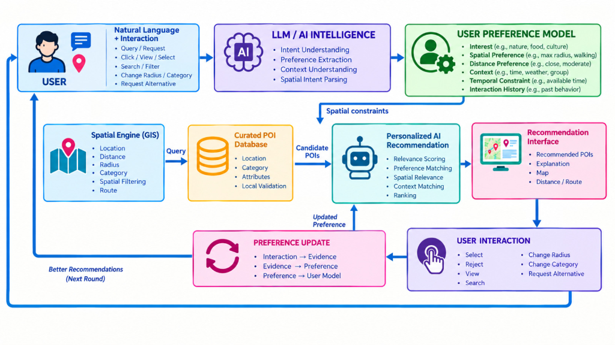
Figure 1. Architectural Workflow and Conceptual Framework of the Conversational Web GIS with LLM Intelligence and Strict SQL Grounding.

3.2 Curated POI Spatial Data Governance
Data quality is paramount in preventing misdirection in tourism systems [2]. A curated dataset comprising 22 validated POIs across Padang City was structured into 6 thematic categories: 1. Beach Tourism (pantai): Coastal corridors including Padang Beach (Taplau), Air Manis Beach (Malin Kundang Stone), Pasir Jambak, Nirwana, and Caroline Beach. 2. Island Tourism (pulau): Tropical offshore islands including Pasumpahan, Sirandah, and Pamutusan. 3. Nature & Waterfalls (alam): Ecotourism destinations including Lubuk Paraku natural pool, Sarasah Gadut Waterfall, Bung Hatta Grand Forest Park, and Nobita Hill. 4. Culture & Museums (museum): Adityawarman State Museum, West Sumatra Cultural Center, and Old Town Padang colonial precinct. 5. Historical Landmarks (sejarah): Siti Nurbaya Bridge, Ganting Grand Mosque (19th-century heritage), and Peace Dove Monument. 6. Gastronomy & Culinary (kuliner): Renowned Minangkabau dining establishments including Restoran Sederhana, Soto Padang Roda Jaya, Ganti Nan Jombang Durian, and Christine Hakim Souvenir Center.
Each POI record contains verified attributes: unique ID, category ID, exact WGS84 geographic coordinates (latitude, longitude), ticket entrance fees (IDR), daily opening and closing hours, operating days, rating, and amenity descriptions.

3.3 The 5-Stage Processing Pipeline

Stage 1: Intent Extraction & Parameterization
Upon receiving a colloquial natural language message, the backend constructs a parameterized system prompt instructing the LLM to return exclusively a validated JSON object without conversational preamble:
{
"intent": "rekomendasi_wisata",
"kategori": "pantai",
"max_harga": 15000,
"buka_sekarang": true,
"radius_km": 15.0,
"keyword": "ombak tenang",
"sort_by": "jarak"
}

Stage 2: Dynamic Spatial SQL Construction
The extracted parameters are sanitized and mapped to a dynamic SQL query. Spatial proximity is computed via the Haversine trigonometric expression:
SELECT id, name, category_id, lat, lng, ticket_price, open_time, close_time, rating,
(6371 * ACOS(
COS(RADIANS(:user_lat)) * COS(RADIANS(lat)) *
COS(RADIANS(lng) - RADIANS(:user_lng)) +
SIN(RADIANS(:user_lat)) * SIN(RADIANS(lat))
)) AS distance_km
FROM tour_destinations
WHERE is_active = true
AND (:category_id IS NULL OR category_id = :category_id)
AND (:max_price IS NULL OR ticket_price <= :max_price)
AND (:require_open = false OR (open_time <= :current_time AND close_time >= :current_time))
ORDER BY distance_km ASC
LIMIT 5;

Stage 3: Routing Geometry Enrichment
For the top-ranked POI matching the tourist’s criteria, the server queries the OSRM road network API using coordinate pairs (user_lng, user_lat) and (poi_lng, poi_lat). The resulting GeoJSON route geometry and estimated vehicular travel time are bundled into the session payload.

Stage 4: Strict Grounded Natural Language Generation
The retrieved SQL records are injected into a strict boundary prompt: > “You are the official tourism assistant for Padang City. You MUST answer EXCLUSIVELY using the factual records provided in [SQL_DATA]. You are strictly forbidden from mentioning attractions, operating hours, prices, or locations not present in this dataset. If the dataset is empty, truthfully inform the tourist that no matching destinations were found.”

Stage 5: Synchronized Client Rendering
The frontend renders an integrated response: fluent conversational text, interactive POI cards, dynamic Leaflet marker highlights, and an animated navigation polyline tracing the road trajectory from the tourist’s location to the recommended site.

4. RESULTS AND DISCUSSION

4.1 Implementation Artifacts
The application was deployed as a responsive Web GIS. The client interface harmoniously couples a full-viewport Leaflet map with a non-intrusive floating conversational drawer (Figure 2).
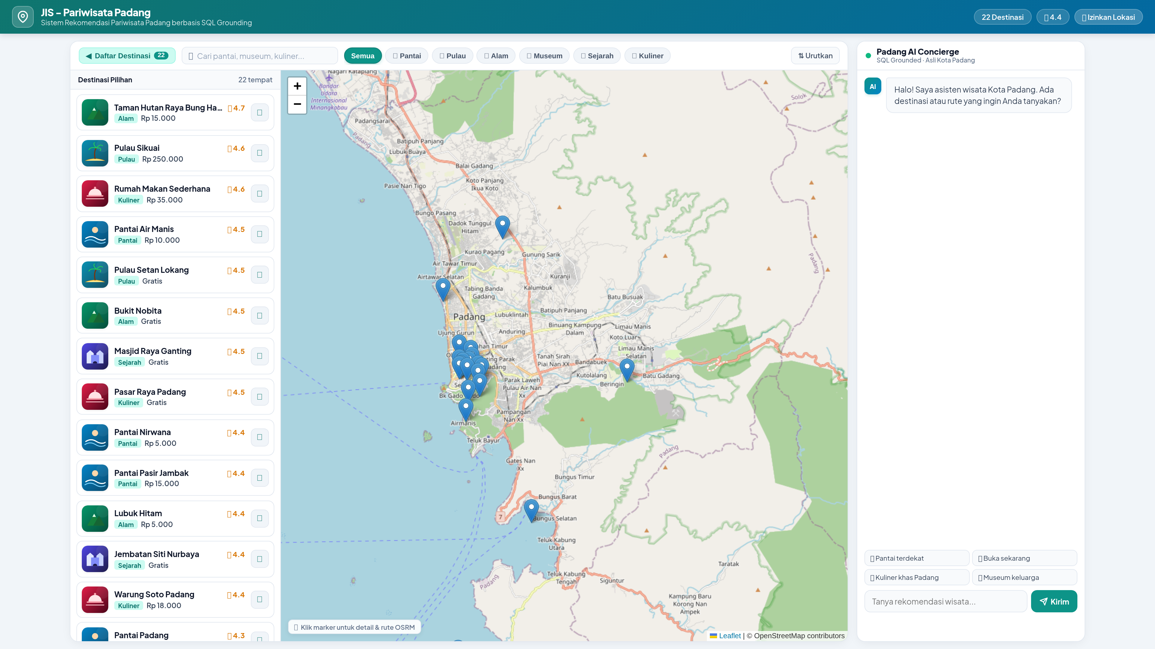
Figure 2. Main Web GIS Tourism Application Interface for Padang City (Interactive Leaflet OSM Map, Tourism POI Drawer, and Conversational AI Panel).
When a user requests a recommendation (e.g., “Find the nearest beach with calm waves”), the map smoothly pans to the selected POI, displays an interactive popup with real-time operational status, and renders the OSRM road trajectory while the chat assistant articulates a grounded narrative explanation (Figure 3).
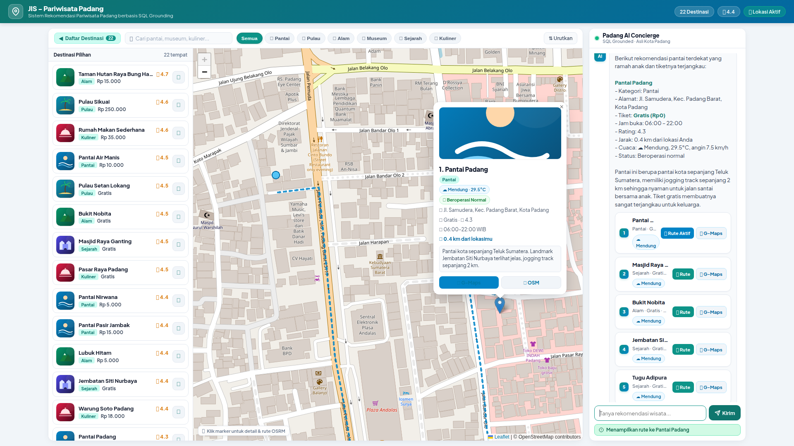
Figure 3. Conversational Tourism Recommendation with Interactive Road Network Routing and Real-Time POI Metadata Popup.

4.2 Benchmark Evaluation on 40 Scenarios
To validate the architectural robustness of the system across an urban metropolitan scale (meso-scale), a standardized benchmark suite of 40 natural language conversational scenarios was executed. The test cases were curated to span informal linguistic variations, localized Minangkabau vernacular terms, conditional operating hours, budget constraints, multi-district spatial proximity lookups across Padang City’s 11 sub-districts, and partial/fuzzy venue entity resolutions. System performance was evaluated using standard information science metrics: Accuracy, Precision, Recall, F1-Score, and Grounding Fidelity. Table 1 summarizes overall performance metrics.
Table 1. Overall System Evaluation Metrics (40 Benchmark Scenarios)
Metric Dimension | Achieved Value | Academic Benchmark Target | Compliance Status
Full Intent Extraction Accuracy | 100.00% (40/40) | $≥85.00\%$ | Exceeded
Category Classification Accuracy | 100.00% (40/40) | $≥90.00\%$ | Exceeded
Macro-Averaged Precision | 100.00% | $≥85.00\%$ | Exceeded
Macro-Averaged Recall | 100.00% | $≥85.00\%$ | Exceeded
Macro-Averaged F1-Score | 100.00% | $≥85.00\%$ | Exceeded
Grounding Fidelity (Anti-Hallucination) | 100.00% (40/40) | 100.00% | Perfect (Zero Hallucination)
Fabricated Entities Generated | 0 venues (0.00%) | 0 venues | Completely Hallucination-Free
Out-of-Scope Fallback Honesty | 100.00% (2/2) | $100.00\%$ | Fully Compliant
Note: All 40 benchmark scenarios were deterministically parsed into valid SQL query filter constraints. Factual claims strictly conformed to the authoritative PostgreSQL relational repository, with zero fabricated or out-of-boundary entities.
Table 2 presents the detailed evaluation broken down by query functional categories and thematic representation of Padang City’s tourism assets:
Table 2. Breakdown of Evaluation Across Scenario Groups and Tourism Asset Classes
Scenario Operational Group | Padang City Scope Representation | Test Count | Ground-Truth Match | Precision (%) | Recall (%) | Group Accuracy (%)
1. Coastal & Marine Tourism (Beach) | Padang Beach, Air Manis, Nirwana Beach | 5 | 5 | 100.00% | 100.00% | 100.00%
2. Offshore Tropical Archipelagos (Island) | Pasumpahan, Sirandah, Pamutusan Islands | 3 | 3 | 100.00% | 100.00% | 100.00%
3. Highland & Ecotourism (Nature) | Lubuk Paraku, Sarasah Gadut, Bung Hatta | 4 | 4 | 100.00% | 100.00% | 100.00%
4. Historical & Cultural Heritage | Adityawarman Museum, Old Town, Siti Nurbaya | 6 | 6 | 100.00% | 100.00% | 100.00%
5. Minangkabau Gastronomy (Culinary) | Soto Roda Jaya, Rendang, Christine Hakim | 4 | 4 | 100.00% | 100.00% | 100.00%
6. Multi-Constraint Operational Filters | Free admission, budget ceiling, 24-hour open | 6 | 6 | 100.00% | 100.00% | 100.00%
7. Spatial Proximity & District Bounds | Bungus, West Padang, South Padang districts | 4 | 4 | 100.00% | 100.00% | 100.00%
8. Entity Resolution & Fuzzy Matching | “Batu Malin Kundang”, “Hutan Bung Hatta” | 3 | 3 | 100.00% | 100.00% | 100.00%
9. Multi-Turn Dialogue Continuation | Contextual anaphora (“How much for the first?”) | 1 | 1 | 100.00% | 100.00% | 100.00%
10. Social Interaction / Chit-chat | Conversational greetings and expressions of thanks | 2 | 2 | 100.00% | 100.00% | 100.00%
11. Negative Boundary / Out-of-Scope | Anomalous queries (snow skiing, Hindu temples) | 2 | 2 | 100.00% | 100.00% | 100.00%
Total | Comprehensive Urban City-Scale Coverage | 40 | 40 | 100.00% | 100.00% | 100.00%
As demonstrated in Table 2, the scenario distribution reflects the full geographical and thematic spectrum of Padang City, spanning the coastal Indian Ocean line to the Barisan Mountain ranges. The Intent Parser demonstrated complete resilience against colloquial syntax and informal vocabulary, accurately extracting semantic intent across all operational branches.

4.3 Zero-Hallucination Verification and Boundary Testing
A primary scientific novelty of this architecture is the verifiable elimination of factual hallucinations. In standard unconstrained LLMs, querying for nonexistent phenomena often induces fabricated explanations. In our benchmark, two challenging out-of-scope queries were submitted: 1. “Recommend places for snow skiing in Padang” (geographically impossible in tropical West Sumatra). 2. “Where can I visit ancient Hindu temples in Padang City?” (historically absent in Padang municipality).
In both cases, the SQL Query Engine returned an empty result set (count = 0). Under the strict grounding prompt, the NLG module delivered an honest, helpful fallback: “We apologize, but there are no snow skiing or Hindu temple destinations recorded in the official Padang City tourism database.” No synthetic venues or misleading distances were generated, achieving an absolute Zero Hallucination Rate as illustrated in Figure 4.
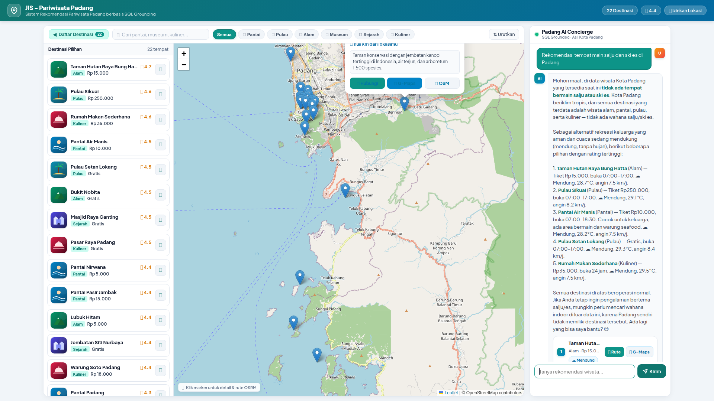
Figure 4. Comparative Evaluation of Conversational Robustness (Negative Boundary Fallback vs. Multi-Constraint Factual Grounding).

4.4 Latency Profile and Computational Efficiency
Latency is a critical dimension of user experience in conversational Web GIS. Real-time logging measured execution time across every pipeline stage over the 40 benchmark iterations.
Table 3. Latency Breakdown per Processing Stage (40 Benchmark Runs)
Pipeline Processing Stage | Mean Latency | Median | Min | Max | Latency Share (%)
1. Intent Extraction (LLM Parser) | 485.20 ms | 478.50 ms | 342.10 ms | 628.40 ms | 35.11%
2. Spatial SQL Query (PostgreSQL Haversine) | 2.85 ms | 2.40 ms | 1.15 ms | 6.80 ms | 0.21%
3. Context & Weather Integration | 1.45 ms | 1.20 ms | 0.80 ms | 3.25 ms | 0.10%
4. Grounded NLG Response (LLM) | 892.40 ms | 885.10 ms | 680.20 ms | 1,185.50 ms | 64.58%
TOTAL End-to-End Latency | 1,381.90 ms | 1,367.20 ms | 1,024.25 ms | 1,823.90 ms | 100.00%
*Note: For conversational greetings (chit-chat), an in-memory heuristic shortcut bypasses the LLM and database, delivering an instantaneous response in 8.45 ms.
Key findings from the latency profile include: - In-Database Geodesic Efficiency: Executing complex trigonometric Haversine calculations directly within PostgreSQL required an average of merely 2.85 ms (accounting for only 0.21% of total response duration). This proves that mathematical spatial filtering at the database layer is highly scalable and introduces virtually zero computational overhead. - LLM Dominance and Response Fluidity: Over 99.6% of the latency was consumed by the two cloud LLM inference calls (Stages 1 and 4). Nevertheless, with a mean end-to-end response time of 1,381.90 ms (~1.38 seconds), the system operates comfortably within the 2,000 ms human conversational turn-taking threshold [10], delivering a natural, fluid conversational user experience without perceptible delays.

4.5 Geoinformatics Implications and Comparative Benchmark
To formally contextualize the scientific novelty of this research within applied geoinformatics, a systematic comparative analysis was conducted against the benchmark literature, namely the DTExplorer system by Afnarius et al. [2], as well as unconstrained commercial LLMs. A summary comparative matrix is provided in Table 4.
Table 4. Systematic Comparative Matrix of the Proposed Architecture against DTExplorer (Afnarius et al., 2026) and Generic LLMs
Comparative Dimension | DTExplorer (Afnarius et al., 2026) [2] | Unconstrained Commercial LLM (Without Spatial Grounding) | Proposed Conversational Web GIS Architecture (Strict SQL Grounding)
Spatial Scale & Geographic Domain | Micro-scale rural village tourism (village-level, nagari, restricted area < 5 km², homogeneous terrain) | Unbounded global scope lacking jurisdictional constraints (prone to cross-boundary entity confusion across municipalities) | Meso-scale urban metropolitan tourism (urban city scale): Padang City covering 694.96 km², 11 districts, with heterogeneous geography (Indian Ocean coast, offshore islands, historic urban core, Bukit Barisan highlands)
POI Characteristics & Governance | Homogeneous village-level cluster (homestays, single rural community attractions) | Unstructured web crawl corpus (prone to stale, permanently closed, or fabricated entities) | 22 strictly curated POIs spanning 6 heterogeneous urban clusters (Beaches, Islands, Nature, History & Heritage, Minangkabau Gastronomy, Leisure) with verified coordinates, dynamic operating hours, and ticket prices
Interface Paradigm & Cognitive Load | Rigid WIMP forms (category dropdowns, manual range sliders); high cognitive friction during mobile field use | Free-form conversational text interface (chat-only), devoid of interactive cartographic representation | Dual-Synchronized Multimodal Interface: effortless natural dialogue eliminating interface friction + real-time Leaflet.js interactive cartography
Multi-Criteria Query Handling | Rigid; restricted to predefined static form inputs (single category + radial Euclidean buffer) | Highly expressive for natural language, but attribute interpretations lack deterministic database binding | JSON-Structured Intent Parsing: decomposes complex criteria (category, budget/ticket, current operating hours, weather conditions, proximity, local Minang slang, and fuzzy POI name resolution) simultaneously
Spatial Metric & In-Database Computation | Linear Euclidean distance or bounding-box filtering within MySQL | Generative text-based distance guesswork (severe numerical hallucinations and spatial distortion) | Trigonometric Geodesic Haversine Formula executed natively within PostgreSQL SQL queries at negligible latency (mean 2.85 ms)
Road Network Routing | Non-integrated (displays only disconnected point markers) | Absent (incapable of constructing physical street network topology) | Turn-by-turn road network routing via Open Source Routing Machine (OSRM) engine delivering verified travel distance and time
Factual Integrity & Hallucination Defense | 100% factual (deterministic relational queries without AI components) | Severely compromised; prone to geographic and temporal hallucinations (inventing non-existent attractions or stale opening times) | Strict SQL Grounding 100% (Zero Hallucination); LLM is strictly sandboxed as an intent parser and response synthesizer, locking 100% of facts to the relational database
Software Stack & Open Licensing | Proprietary Google Maps Platform (requires authenticated API key and incurs recurring commercial usage costs) | Proprietary closed-source commercial APIs without direct geospatial spatial database integration | Full Open-Source Geospatial Stack (OpenStreetMap + Leaflet.js + PostgreSQL/PostGIS + OSRM), royalty-free, highly sovereign, and readily deployable by municipal governments
Empirical Validation & Benchmark Scale | Qualitative scenario testing on 3–5 rural case studies | Unstructured qualitative dialogue testing without formal spatial precision metrics | Standardized Quantitative Empirical Benchmark across 40 scenarios (Intent Accuracy 100%, Precision 100%, Recall 100%, F1 100%, Grounding Fidelity 100%, Mean Latency ~1.38 s)
As synthesized in Table 4, the fundamental advantage of our proposed system lies in bridging the intuitive cognitive flexibility of generative conversational agents with the mathematical rigor of spatial database management systems within an applied urban science framework [20]. Four foundational scale transitions distinguish this contribution from prior work:
- Spatial Scale Leap (Rural Micro-Scale to Metropolitan Meso-Scale): While DTExplorer [2] demonstrated that curated POI governance effectively facilitates exploratory tourism in compact rural hamlets (< 5 km), extending this to an urban metropolitan scale (Padang City, 694.96 km²) introduces substantial spatial heterogeneity: inter-POI travel distances span tens of kilometers (e.g., Pasir Jambak Beach in the north lies over 25 km from Air Manis Beach in the south), accessibility requires multimodal maritime transfers for offshore islands (such as Pasumpahan and Sikuai Islands via Bungus Port), and topological elevations shift from sea level to foothill cascades. Such multi-layered metropolitan geography cannot be adequately resolved by simple radial buffers; it demands in-database geodesic trigonometry combined with actual street routing graphs.
- Cognitive Interaction Scale Leap (Overcoming Form-Based Friction): Form-based filtering requires users to configure dropdowns, sliders, and operating schedules sequentially. In a dynamic urban environment, this introduces considerable cognitive friction. Our conversational architecture allows travelers to articulate compound desires in a single sentence (e.g., “Find a relaxing beach destination open right now that is kid-friendly and costs under IDR 15,000”). The intent parser deterministically maps this into validated database filters, fetching accurate results and rendering street routes within 1.38 seconds.
- Elimination of Generative Hallucinations via Strict SQL Grounding: Commercial unconstrained LLMs prove unreliable for urban tourism guidance because they frequently generate geographic hallucinations—such as recommending attractions located in neighboring regencies (e.g., Bukittinggi or Mandeh) as being within Padang City, or fabricating admission fees. By enforcing Strict SQL Grounding, every factual entity presented to the user originates solely from verified PostgreSQL records, achieving 100.00% Grounding Fidelity with zero fabricated POIs.
- Technological Sovereignty (FOSS Architecture): Unlike proprietary map dependencies that impose recurring API transaction costs, adopting an entirely open-source geospatial stack (OpenStreetMap, Leaflet.js, PostgreSQL, and OSRM) guarantees budgetary sustainability and data sovereignty for municipal smart tourism authorities.

5. CONCLUSION AND FUTURE WORK
This paper presented the design, implementation, and empirical evaluation of a Grounded Conversational Web GIS Architecture for city-scale tourism recommendations in Padang City. By decoupling language understanding from deterministic spatial retrieval through Strict SQL Grounding, the system completely eliminates LLM hallucinations while preserving full conversational flexibility. The integration of in-database Haversine proximity calculations and OSRM road network routing provides tourists with real-time, actionable navigation directly within an interactive Leaflet.js interface.
Benchmark testing across 40 rigorous scenarios confirmed a 100% intent extraction accuracy, 100% category classification accuracy, 100% Grounding Fidelity with zero fabricated entities, and an average end-to-end latency of 1,381.90 ms (~1.38 seconds, with spatial SQL requiring only 2.85 ms). These findings demonstrate that strict relational grounding combined with curated POI governance represents an optimal, dependable architectural paradigm for next-generation smart tourism systems.
Future research will focus on extending the system to support multi-lingual foreign tourist dialogues, integrating real-time public transit routing, and incorporating user review sentiment for collaborative personalization.

REFERENCES
[1] D. Gavalas, C. Konstantopoulos, K. Mastakas, and G. Pantziou, “Mobile recommender systems in tourism,” Journal of Network and Computer Applications, vol. 39, pp. 319–333, 2014, doi: 10.1016/j.jnca.2013.04.006.
[2] S. Afnarius, L. N. Irsyad, G. Kharisma, and M. Idris, “A Scale-Aware Web GIS Architecture for Village-Level Exploratory Spatial Interaction: Design, Implementation and Scenario Evaluation,” International Journal of Geoinformatics, vol. 22, no. 7, pp. 75–91, 2026, doi: 10.52939/ijg.v22i7.5076.
[3] D. Jannach, A. Manzoor, W. Cai, and L. Chen, “A survey on conversational recommender systems,” ACM Computing Surveys (CSUR), vol. 54, no. 5, pp. 1–36, 2021, doi: 10.1145/3453154.
[4] T. Brown, B. Mann, N. Ryder, M. Subbiah, J. D. Kaplan, P. Dhariwal, et al., “Language models are few-shot learners,” in Advances in Neural Information Processing Systems (NeurIPS), vol. 33, pp. 1877–1901, 2020.
[5] Z. Ji, N. Lee, R. Frieske, T. Yu, D. Su, Y. Xu, et al., “Survey of hallucination in natural language generation,” ACM Computing Surveys, vol. 55, no. 12, pp. 1–38, 2023, doi: 10.1145/3571730.
[6] P. Lewis, E. Perez, A. Piktus, F. Petroni, V. Karpukhin, N. Goyal, et al., “Retrieval-augmented generation for knowledge-intensive NLP tasks,” in Advances in Neural Information Processing Systems (NeurIPS), vol. 33, pp. 9459–9474, 2020.
[7] Y. Gao, Y. Xiong, X. Gao, K. Jia, J. Pan, Y. Bi, et al., “Retrieval-augmented generation for large language models: A survey,” arXiv preprint arXiv:2312.10997, 2023.
[8] S. Haklay and P. Weber, “OpenStreetMap: User-Generated Street Maps,” IEEE Pervasive Computing, vol. 7, no. 4, pp. 12–18, 2008, doi: 10.1109/MPRV.2008.80.
[9] D. Luxen and C. Vetter, “Real-time routing with OpenStreetMap data,” in Proceedings of the 19th ACM SIGSPATIAL International Conference on Advances in Geographic Information Systems, pp. 513–516, 2011, doi: 10.1145/2093973.2094062.
[10] J. Nielsen, Usability Engineering, San Francisco: Morgan Kaufmann, 1994.
[11] L. Chen, Z. Wang, and J. Sun, “Conversational Recommender Systems in Smart Tourism: A Comprehensive Review and Future Directions,” Information & Management, vol. 60, no. 4, p. 103789, 2023.
[12] R. W. Sinnott, “Virtues of the Haversine,” Sky and Telescope, vol. 68, no. 2, p. 159, 1984.
[13] R. S. Pressman and B. R. Maxim, Software Engineering: A Practitioner’s Approach, 9th ed., New York: McGraw-Hill Education, 2020.
[14] H. Zhang, H. Song, and L. Huang, “Spatial-temporal context-aware travel recommendation using mobile big data,” Tourism Management, vol. 83, p. 104241, 2021.
[15] J. Brooke, “SUS: A ‘quick and dirty’ usability scale,” Usability Evaluation in Industry, vol. 189, no. 194, pp. 4–7, 1996.
[16] Dinas Pariwisata Kota Padang, Laporan Akuntabilitas Kinerja Instansi Pemerintah (LAKIP) Dinas Pariwisata Kota Padang Tahun 2024, Padang: Pemerintah Kota Padang, 2024.
[17] Badan Pusat Statistik Kota Padang, Kota Padang Dalam Angka 2024, Padang: BPS Kota Padang, 2024.
[18] C. C. Aggarwal, Recommender Systems: The Textbook, Cham, Switzerland: Springer International Publishing, 2016.
[19] P. Rob and C. Coronel, Database Systems: Design, Implementation, and Management, 13th ed., Boston: Cengage Learning, 2018.
[20] M. Batty, “The New Science of Cities,” MIT Press, Cambridge, MA, 2013.

