

PRT661
DATA SCIENCE PRACTICE

ASSESSMENT 04
FINAL PROFESSIONAL REPORT

FORECASTING ASSAULT RATES ACROSS NT REGIONS TO SUPPORT PUBLIC SAFETY RESOURCE PLANNING

Submitted by: Group DAN2 - THEME2
Lecturer: Dr Thuseethan Selvarajah

Student:
Thi Xuan Thanh Tran (Emma) - S389244
Ngoc Anh Nguyen (Will) - S386805
Van Hoi Dang (Hendrick) - S395598
Le Nhat Minh Tran (Thomas) - S390789

￼
Table of Contents
SECTION 1 – Complete Assessment 2 Submission 5
I. Assessment 1 report 5
1. Project overview and objectives 5
2. Theme justification 5
3. Problem statement 6
4. Initial architecture diagram 6
5. Workflow plan 9
6. Task allocation and team structure 11
7. Initial risk analysis 11
8. Ethics, privacy and security considerations 12
9. References 13
II. Project Update Summary 14
III. Assessment 2 Technical Development 15
1. Data acquisition and storage 15
2. Data cleaning and preprocessing 16
3. Data engineering 18
4. Analytics and machine learning 20
5. Implementation progress 28
6. Updated Workflow 29
7. Project governance 30
8. Risk analysis 31
9. Ethics, privacy and security considerations 32
10. Evaluation of progress 32
11. Any other relevant technical developments 32
12. References 33
IV. Individual Work and Contribution Summary 35
SECTION 2 – Final Project Update Summary 39
SECTION 3 - Final Technical Development 40
1. Final system architecture 40
2. Complete implementation 40
3. Deployment 42
4. Data engineering 43
5. Analytics and machine learning 44
6. System evaluation 46
7. Performance analysis 47
8. Discussion of results 48
9. Deployment readiness 50
10. Governance 52
11. Ethics, privacy and security 53
12. Limitations 54
13. Future improvements 54
References 55
Section 4 – Individual Work and Contribution Summary 56

LIST OF TABLES
Table 1: Data sources 6
Table 2: Pipeline stages, tools and purpose 8
Table 3. Twelve-week workflow plan 9
Table 4. Task allocation and team structure 11
Table 5: 5Vs characterisation 15
Table 6: Category translations 16
Table 7: Output file after merging 18
Table 8: Per-Capita Metrics 19
Table 9: PCA explained variance - age structure 21
Table 10: Feature variant comparison - Linear Regression, train 2015-2022 21
Table 11: Model performance comparison - Model A (no alcohol supply) 23
Table 12: Per-region prediction accuracy (XGBoost, test 2023-2025) 23
Table 13: Forecast accuracy by horizon, assault rate per 100,000 (rolling-origin backtest) 25
Table 14. Twelve-week workflow plan 29
Table 15: Implemented components and status 41
Table 16: Deployment artefacts 43
Table 17: Row lineage from source files to the model panel (audit/A3_data_lineage.csv) 43
Table 18: Feature variant cross-validation (log-scale RMSE, training period) 44
Table 19: Alcohol supply comparison on identical rows 45
Table 20: Forecasts from December 2025, assault rate per 100,000 with 80% interval 45
Table 21: Rolling-origin backtest, RMSE per 100,000 by horizon 46
Table 22: Model A, test 2023-2025, RMSE per 100,000 47
Table 23: Frozen models on January-April 2026 (provisional actuals), RMSE per 100,000 48
Table 24: Planning error against current practice 49
Table 25: Deployment readiness assessment 50
Table 26: Release checks and their first run on 18 October 2026 51
Table 27: Operational risks and mitigations 52
Table 28: Weeks 8-12 workflow, final status 53

LIST OF FIGURES
Figure 1: Project Architecture 8
Figure 2: Offence-weighted encoding of Alcohol and DV involvement flags 17
Figure 3: Population Data Cleaning 18
Figure 4: Merging the Three Source Tables 18
Figure 5: Train/Test Split 20
Figure 6: EDA plots 20
Figure 7: Feature Variant RMSE Comparison 21
Figure 8: VIF scores for selected features 22
Figure 9: Ridge and Lasso CV RMSE across alpha values (TimeSeriesSplit) 22
Figure 10: Model Results and Evaluation 24
Figure 11: Final system architecture 40
Figure 12: Forecasts & Planning Ranges tab of the Administrator Portal 42
Figure 13: Forecasts from December 2025 with 80% intervals 46
Figure 14: Backtest RMSE by forecast horizon 47

SECTION 1 – Complete Assessment 2 Submission
- Assessment 1 report
- Project overview and objectives
This project develops an end-to-end forecasting system for monthly, region level assault rates in the Northern Territory (NT), designed to strengthen operational planning within NT Police, Fire and Emergency Services (PFES). The work involves three core components:
- Building a secure and automated data pipeline covering acquisition, storage, and processing of NT crime datasets along with relevant datasets;
- Developing a robust forecasting model capable of producing interpretable, region-specific monthly predictions; and
- Delivering an interactive dashboard that presents historical trends, forecasts, and risk indicators for PFES operational use. The system ultimately supports PFES by improving resource allocation, enabling early identification of emerging hotspots, and enhancing evidence-based decision-making across the Territory.
The system supports PFES through better resource allocation, early hotspot identification, and evidence-based decision-making.
- Primary users: PFES operational planners and duty officers - shift commanders (patrol scheduling), regional operations managers (cross-station coordination), and strategic planning staff (quarterly staffing levels).
- Secondary users: PFES analysts needing historical trend data for budget/policy submissions.
The dashboard targets non-technical operational staff, prioritising clear visual summaries over raw statistical output.
- Theme justification
The project's core theme is forecasting monthly assault rates across NT regions, within the crime analysis domain. Forecasting suits this data because it is genuinely time-series: assault counts show month-to-month dependence, seasonal patterns (dry vs wet seasons), and temporal autocorrelation - requiring models that capture temporal structure rather than static methods.
This theme aligns with the five mandatory data-science capabilities:
- Acquisition: pulling data from the NTG open data portal (Northern Territory Government, 2026)
- Storage: secure, structured retention of historical records.
- Processing: cleaning, aggregation, and feature engineering into monthly, region-level series.
- Analytics: the forecasting model itself, capturing trends, seasonality, and uncertainty.
- Visualisation: an operational dashboard showing patterns, predictions, and regional risk signals.
Together, these form a complete end-to-end system supporting PFES's operational planning and decision-making.
This project goes beyond training a single model - it spans the full data science lifecycle:
- Data sourcing & reconciliation: integrating 3 heterogeneous public datasets with differing formats and update cycles
- Storage & cataloguing: designing a secure, structured layer for historical and incoming data
- Data engineering: handling structural breaks in crime-recording and inconsistent regional boundaries
- Domain & ethical judgement: addressing Indigenous data governance and predictive-policing misuse risks to shape model outputs
- End-to-end delivery: a user-facing dashboard, not just a model artifact
The forecasting model is just one component of this pipeline. This system-level scope is what distinguishes the project as data science rather than applied ML.
- Problem statement
PFES faces sustained resource pressure from high, volatile crime volumes across the NT. Monthly assault counts typically range 750 -1,100 incidents Territory-wide, with notable regional fluctuation (Northern Territory Government, 2026); demographic and alcohol-consumption factors may also contribute. These unpredictable surges strain PFES's finite staffing and patrol capacity (Northern Territory Police Association, 2025).
This volatility directly affects PFES's resource planning. Darwin, Alice Springs, Katherine, and Tennant Creek show distinct, shifting assault patterns, requiring frontline teams to adjust without advance warning. High domestic-violence involvement (often 60 - 70% of total assaults) and significant alcohol involvement further intensify demand on policing, investigations, and interagency coordination (Northern Territory Government, 2026). Without a mechanism to anticipate escalation, PFES remains reactive - reallocating resources only after spikes occur.
This project addresses that challenge with a forecasting system producing monthly, region-level assault predictions, backed by a secure data pipeline and dashboard. This gives PFES anticipatory visibility into hotspots and workload, enabling proactive staffing, patrol scheduling, and earlier interventions.
This aligns with PFES's intelligence-led approach, as seen in Operation Ventura (NTPFES, 2026), and extends it by helping PFES anticipate pressure points before they escalate - supporting more efficient resource use and sustained crime-reduction outcomes.
- Initial architecture diagram
Table 1: Data sources
Datasets | Publisher | Date published | URL | File format | Rows | Columns
Population estimates for NTG Service Regions (1986 to 2025) | Northern Territory Government | 07 March 2024 | https://data.nt.gov.au/dataset/nt-government-regions-1986-2025 | XLSX | 17,280 | 7
NT Crime Statistics 2020- 2023 | Northern Territory Government | 16 January 2024 | NT Crime Statistics November 2023 - Dataset - NTG Open Data Portal | CSV | 46037 | 10
NT Crime Statistics Latest | Northern Territory Government | 11 June 2026 | https://data.nt.gov.au/dataset/current-nt-crime-statistics-april-2026 | CSV | 9111 | 10
Wholesale Alcohol Supply by Quarter, 2023 | Department of Tourism and Hospitality | 13 November 2025 | https://data.nt.gov.au/dataset/wholesale-alcohol-supply-by-quarter-2023 | XLSX | 29 | 12
Wholesale Alcohol Supply by Quarter, 2024 | Department of Tourism and Hospitality | 13 November 2025 | https://data.nt.gov.au/dataset/wholesale-alcohol-supply-by-quarter-2024 | XLSX | 29 | 12
Wholesale Alcohol Supply by Quarter, 2025 | Department of Tourism and Hospitality | 13 November 2025 | https://data.nt.gov.au/dataset/wholesale-alcohol-supply-by-quarter-2025 | XLSX | 29 | 12
The NT Crime Statistics dataset was selected because it provides monthly time-series crime data by region and offence type, making it suitable for temporal and spatial trend analysis. NTG population data were used to standardise crime rates per 100,000 population, enabling fair comparisons across regions with different population sizes.
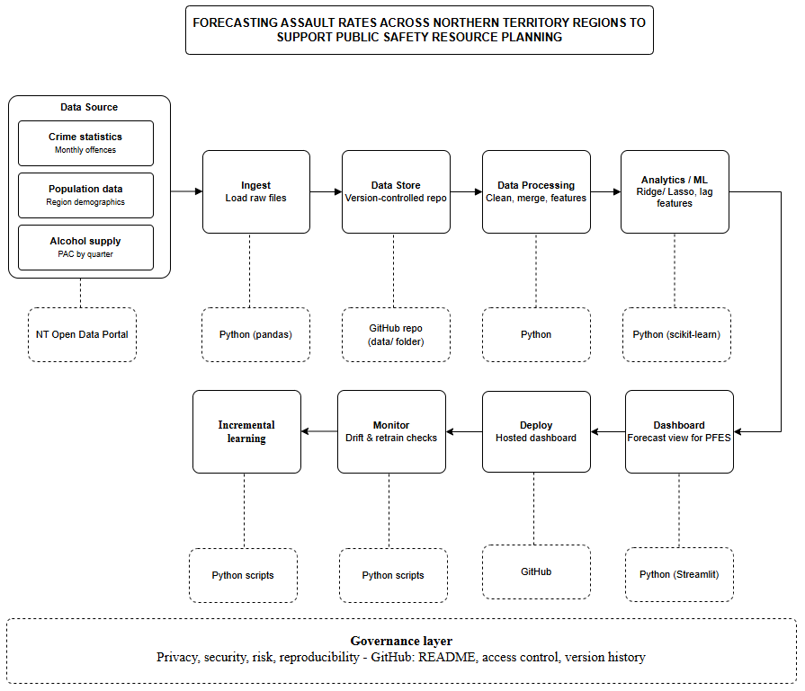
Figure 1: Project Architecture
Table 2: Pipeline stages, tools and purpose
Stage | Tool/ Technology | Purpose
Data Source | NT Open Data Portal | Three public datasets: crime statistics, population demographics, wholesale alcohol supply.
Ingest | Python (pandas) | Loads raw CSV/XLSX files from each source.
Data Store | GitHub repository | Version-controlled storage of raw and processed data, giving change history and access control in place of a cloud data lake.
Data Processing | Python (pandas) | Cleans, merges and engineers features (lagged indicators, cyclical month encoding, per-capita normalisation) across the three sources.
Analytics / ML | Python (scikit-learn) | Trains and validates Ridge and Lasso regression models to forecast monthly, region-level assault rates.
Dashboard | Python (Streamlit) | Presents forecasts and regional trends in an interactive view for PFES.
Deploy | Streamlit Community Cloud (via GitHub) | Automatically redeploys the live dashboard whenever changes are pushed to the GitHub repository.
Monitor | Python scripts | Checks forecast performance for drift and flags when the model should be retrained.
Incremental learning | Python scripts | Continuously adjusting the model parameters by training based on incoming data
Governance considerations spanning the full pipeline (privacy, security and reproducibility) are addressed through GitHub's built-in access controls, commit history and README documentation, and are detailed further in Section 8.
Although the architecture conceptually mirrors AWS's managed data pipeline pattern (S3 à Glue Data Catalog à Glue ETL à SageMaker à QuickSight, with SageMaker Model Monitor for post-deployment monitoring and SageMaker’s built-in incremental training capability for scheduled retraining), the group project implements each stage using open-source, non-AWS tools, consistent with the module's guidance to rely on open-source tools for the group deliverable.
Technology roadmap. The current implementation uses open-source tools (pandas, scikit-learn, and Streamlit with GitHub providing version-controlled storage) to deliver a working proof of concept within the semester timeframe. Should PFES adopt the system operationally, the architecture is designed to migrate directly onto AWS-equivalent managed services with minimal redesign: the GitHub-based data storage to Amazon S3, pandas-based data processing to AWS Glue ETL, the Analytics/ML stage to Amazon SageMaker for managed training and scheduled deployment, the Streamlit dashboard to Amazon QuickSight, the Monitor stage to Amazon SageMaker Model Monitor, and the Incremental learning stage to SageMaker's built-in incremental (continuous) training capability. Future enhancements under consideration include real-time or near-real-time data ingestion (replacing manual/batch downloads) and integration with additional predictors such as weather or event-calendar data to improve forecast accuracy.
- Workflow plan
The workflow plan spans the full 12-week semester and is aligned to the four assessment milestones (Table 3). Weeks immediately preceding each submission are used for consolidation and reporting, other weeks are allocated to the team members responsible for the relevant pipeline stage, as shown in Table 4.

Table 3. Twelve-week workflow plan
Week | Focus | Deliverable | Owner
1 | Team formation, theme confirmation, environment setup. | GitHub repository with README; Streamlit account set up; draft problem statement | All
2 | Data collection and validation, architecture design | Architecture diagram; project management board populated; confirmed data sources | All
3 | Proposal writing and initial risk analysis | Assessment 1 submitted: Project proposal and design | All
4 | Load raw data into the repository; begin cleaning and harmonising six years of multi-source data; resolve region-mapping and data-regime discontinuities | Raw data in GitHub; cleaned, merged dataset in progress | Will (Ingest)  Emma (Data processing)
5 | Finalise ingest and storage structure in GitHub; complete data processing scripts; preliminary exploratory analysis | Working ingest/ store/ processing stages; EDA notebook | Will (Ingest, Data store)  Emma (Data processing)
6 | Consolidate pipeline evidence and baseline model into progress report | Assessment 2 submitted: Progress report and development | All
7 | Feature engineering: lagged indicators, cyclical encoding, per-capita normalisation | Feature set finalised for modelling | Hendrick (Analytics/ML)
8 | Model training and validation; begin dashboard build | Validated candidate model; dashboard prototype | Hendrick (Analytics/ML)  Thomas (Dashboard)
9 | Rehearse and deliver technical demonstration | Assessment 3 submitted: Group Technical demonstration and presentation | All
10 | Incorporate feedback; finalise dashboard; deploy to Streamlit Community Cloud; implement monitoring and retraining logic | Deployed dashboard; monitoring stage implemented | Thomas (Dashboard, Deploy)  Emma (Monitor)
11 | End-to-end pipeline testing; draft final report sections | Full pipeline validated; report draft | All
12 | Final review and submission | Assessment 4 submitted: Final Professional Report | All
- Task allocation and team structure
Each team member owns one or two pipeline stages for the duration of the semester (Table 4), ensuring individually attributable contributions are visible in the GitHub commit history across all four assessments.
Table 4. Task allocation and team structure
Member | Primary role | Responsibilities
Will Nguyen | Ingest & Data Store | Loads the three raw datasets and maintains the version-controlled GitHub repository structure (raw and processed data folders)
Emma Tran | Data processing & Monitor | Cleans, merges and engineers features across the three data sources; implements post-deployment drift-checking scripts
Hendrick Dang | Analytics / ML | Develops, tunes and validates the Ridge/Lasso forecasting model
Thomas Tran | Dashboard & Deploy | Builds the Streamlit dashboard and manages its deployment and redeployment via Streamlit Community Cloud.
- Initial risk analysis
The project has six main risks. These risks will be reviewed during each assessment milestone and updated when needed.
The first risk is changes in the crime data. The transition from PROMIS to SerPro in November 2023 and the ANZSOC classification transition in April 2025 may pose challenges in comparing old and new crime data. To minimise this risk, both transitions will be incorporated into the model.
The second one is that recent crime data may be incomplete because some offences are recorded later. To prevent incorrect results, the latest six months of data will not be included in the model’s training and testing.
The third risk is limited data on alcohol supply. This data is only available quarterly and may not cover enough years. The team will collect older data where possible. However, the main forecasting model will still work without alcohol data.
The fourth risk is the same region may be named or bounded differently in different datasets. This can lead to wrong data matching. The team will work with one shared set of regions and validate the data after each merge.
The fifth is a delay in dashboard deployment. To reduce this risk, the team will create and deploy a simple version of the dashboard early on, then improve it throughout the project.
And the final risk is misuse or misinterpretation of the forecasts. If predictions are read as statements about particular communities, the system could cause harm rather than support safety. Small counts in low-population regions could also make incidents identifiable. Forecasts will therefore be shown only at region and month level, with uncertainty ranges, and small values will be suppressed.
- Ethics, privacy and security considerations
Data privacy
The project only uses public and aggregated data from the Northern Territory Government and the Australian Bureau of Statistics. It does not use personal information or individual records. However, very small crime counts may still make some incidents easier to identify. Small values will therefore be hidden or grouped before being shown on the dashboard.
Indigenous data governance
Aboriginal people are strongly represented in NT crime statistics (Northern Territory Police Force, 2025), so the data must be used carefully and respectfully. The project follows the CARE Principles (Carroll et al., 2020) and the AIATSIS Code of Ethics (AIATSIS, 2020). The model will only make predictions at the regional and monthly level and will not make predictions based on Indigenous status.
Responsible use
The system is designed to help PFES plan staff and resources. It is not designed to predict whether an individual will commit a crime or to target specific addresses or communities.
Forecasts may not always be correct, so the dashboard will show uncertainty and explain the limitations of the data and model. This helps users avoid treating the predictions as exact results.
Security and reproducibility
Only public data and project code will be stored in the GitHub repository. Passwords, API keys and private information will not be uploaded.
The project will also keep its data-processing and analysis steps in version-controlled code. This allows others to understand, replicate, and verify the results.
GitHub repository:
https://github.com/HendrickDang/PRT661-DATA-SCIENCE-PRACTICE
Project management board (JIRA): https://hendrickdang.atlassian.net/jira/software/projects/SCRUM/boards/1
- References
Australian Bureau of Statistics. (2025, June). National, state and territory population. https://www.abs.gov.au/statistics/people/population/national-state-and-territory-population/latest-release.
Australian Bureau of Statistics. (2025). Prisoners in Australia. ABS. https://www.abs.gov.au/statistics/people/crime-and-justice/prisoners-australia/latest-release.
Australian Institute of Aboriginal and Torres Strait Islander Studies. (2020). AIATSIS Code of Ethics for Aboriginal and Torres Strait Islander Research. AIATSIS. https://aiatsis.gov.au/research/ethical-research/code-ethics
Carroll, S. R., Garba, I., Figueroa-Rodríguez, O. L., Holbrook, J., Lovett, R., Materechera, S., Parsons, M., Raseroka, K., Rodriguez-Lonebear, D., Rowe, R., Sara, R., Walker, J. D., Anderson, J., & Hudson, M. (2020). The CARE Principles for Indigenous Data Governance. Data Science Journal, 19(1), 1–12. https://doi.org/10.5334/dsj-2020-043
Hathaway-Wilson, J. (2025, September 21). NT police data shows violent crime increasing, property crime decreasing. Abc.net.au; ABC News. https://www.abc.net.au/news/2025-09-22/is-nt-crime-decreasing-since-clp-government-elected-police-data/105797920
Northern Territory Government. (2026). NT crime statistics march 2026 - NTG open data portal. Nt.Gov.Au. https://data.nt.gov.au/dataset/current-nt-crime-statistics-march-2026
Northern Territory Police Association. (2025). Northern Territory Police Association demands better pay and conditions to prevent officer exodus. In Ntpa.com.au. https://www.ntpa.com.au/knowledgebase/article/KA-01198/
NTPFES. (2026). Operation ventura | NT police, fire & emergency services. NT Police, Fire & Emergency Services. https://pfes.nt.gov.au/newsroom/2026/operation-ventura
Northern Territory Police Force. (2025). Annual Report 2024-25. https://hdl.handle.net/10070/1016397.

Project Update Summary
• Changes Since Previous Assessment
Area | Previous State | Current State | Justification
Modelling approach | Ridge and Laso only | Added XGBoost | Captures potential non-linear patterns in lag features
Modelling validation | Single train/test split comparison. | Added evaluation.py: naive baselines, leakage-free CV, rolling-origin backtest | Responds directly to A1 feedback on validation rigour
Pipeline structure | Separate ingest.py and data_processing.py scripts | Merged into single End to End pipeline.py | Simplifies execution to one entry point; easier to maintain a single dependency / environment setup
Ethics | General statements | Specific design constraints and working agreements documented | Responds to A1 feedback on over-policing risk and governance rigour
• Contribution Summary
Team Member | Contribution
Thi Xuan Thanh Tran (Emma) | Data processing stage: cleaning, standardising, and merging the three source datasets.
Ngoc Anh Nguyen (Will) | Ingest and Data Store stage: built the data pipeline, then verified it end-to-end and fixed several runtime and code-quality defects before handoff.
Van Hoi Dang (Hendrick) | Analytics and Machine Learning: forecast task specification, validation design and leakage controls; built evaluation.py with naive baselines, rolling-origin backtesting and prediction intervals; set drift thresholds and retraining rules.
Le Nhat Minh Tran (Thomas) | Review the pipeline, making suggestions (feature engineering) and implement changes when necessary. Added XGBoost model to capture non-linear patterns.
• Evidence Locations
Evidence | Repository Location
GitHub | https://github.com/HendrickDang/PRT661-DATA-SCIENCE-PRACTICE
Jira | https://hendrickdang.atlassian.net/jira/software/projects/SCRUM/boards/1/timeline?rangeMode=WEEKS
Final code to run | https://github.com/HendrickDang/PRT661-DATA-SCIENCE-PRACTICE/blob/main/Updated_End_to_End_pipeline.py
Evaluation code | https://github.com/HendrickDang/PRT661-DATA-SCIENCE-PRACTICE/blob/main/evaluation.py
Ingest and processing code | https://github.com/HendrickDang/PRT661-DATA-SCIENCE-PRACTICE/commits/main/End%20to%20End%20pipeline.py

Assessment 2 Technical Development
- Data acquisition and storage
Three datasets were acquired (Table 1): NT Crime Statistics (2020-2023 and current), Population estimates (1986-2025), and Wholesale Alcohol Supply (2023-2025). Raw files are stored untouched in dataset/source/; any correction happens in code, never by hand-editing the source.
Acquisition and processing are both handled by End to End pipeline.py. The two stages were originally developed as separate scripts (ingest.py and data_processing.py) but have since been merged into a single pipeline file for easier maintenance and a single point of execution; the ingest logic now runs as Stage 1 of that script:
- Fuzzy filename matching: handles naming differences between teammates' downloads (punctuation, Windows "(2)" duplicate suffixes).
- Validation checks: empty dataframes, duplicated columns, fully-null columns flagged before proceeding.
- Provenance tracking: each run writes to dataset/raw/ plus a manifest.json recording row/column counts and warnings.
Storage follows a three-stage convention: dataset/source/ dataset/raw/ dataset/processed/, all produced by the corresponding stages within End to End pipeline.py. GitHub was chosen for version-controlled history and individually-attributable commits at no cost.
The Assessment 1 feedback correctly flagged GitHub as a weak primary data store for production use. A SQL layer (SQLite/PostgreSQL) was considered but not adopted this milestone, for three reasons:
- Scale doesn't warrant it: current volume (~72,000 rows across all sources) doesn't need the concurrent-access or indexing capabilities a relational database provides.
- Functionality already exists: the joins and aggregations a SQL layer would offer are already handled by the existing pipeline; adding one would duplicate rather than extend capability.
- Timing risk: refactoring the already-tested Ingest, Processing, and Engineering stages mid-semester could destabilise working code during the weeks reserved for modelling and dashboard delivery.
A structured store remains scoped in the technology roadmap (Table 2) and will be revisited if the dashboard (Weeks 7–10) requires concurrent read access beyond what flat files support.
5 Vs characterisation:
Table 5: 5Vs characterisation
5Vs | Characterisation
Volume | 55,148 raw crime records; 17,280 population rows; 87 alcohol rows 66 region-year population rows and one merged region-month panel after cleaning
Velocity | Crime: irregular, multi-month cycle. Population: annual. Alcohol: quarterly. No source supports real-time ingestion, batch refresh only
Variety | Two CSV transaction logs, one wide Excel demographic table, three quarterly Excel extracts, merged into one long-format panel
Veracity | PROMISSerPro recording change (Nov 2023), category-label mismatch between crime files, missing Nov 2023, alcohol data from 2023 only, mismatched region boundaries (7 police vs 6 NTG regions)
Value | Crime = forecasting target; population = per-capita normalisation; alcohol = candidate predictor (alcohol–violence link)
- Data cleaning and preprocessing
Before any analysis can begin, the datasets need to be cleaned and standardised so they can be combined reliably. Three main problems had to be solved:
- The crime data switched to a new classification system mid-way through the study period.
- The geographic regions used in the crime files do not match those in the population files, and
- Certain flags in the crime records needed to be encoded correctly to remain consistent across both file formats.
Step 1: Crime Data Cleaning
The two crime files use different offence category labels. The table below lists all translations:
Table 6: Category translations
Old category (nt_crime_statistics_2020-2023.csv) | à | New category (nt_crime_statistics_latest.csv)
Acts intended to cause Injury | à | 02 Assault
Homicide and related Offences | à | 01 Homicide
Abduction - harassment and other offences against the person | à | 04 Harm or endanger persons
Other dangerous or negligent acts endangering persons | à | 04 Harm or endanger persons
Sexual assault and related offences | à | 03 Sexual offences
Robbery, extortion and related offences | à | 05 Robbery, blackmail, and extortion
House break-ins | à | 061 Burglary – dwelling
Motor vehicle theft and related offences | à | 07 Theft
Theft and related offences (other than MV) | à | 07 Theft
Property Damage Offences | à | 11 Property damage offences
November 2023 gap. November 2023 is absent from both crime files. It is retained as NaN and never imputed.
Binary encoding. ‘Alcohol involvement’ and ‘DV involvement’ flags are encoded as 0/1. The dash (-) is treated as 0. Critically, the flags are multiplied by ‘Number of offences’ rather than counting source rows:
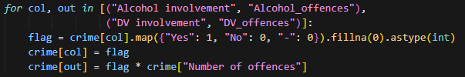
Figure 2: Offence-weighted encoding of Alcohol and DV involvement flags
Step 2: Region Remapping
Crime data uses 7 NT Police reporting regions; population and alcohol data use the 6 NT Government (NTG) statistics regions. Using mismatched boundaries without correction would assign the entire Greater Darwin population to both Darwin and Palmerston separately, doubling the denominator and producing per-capita rates roughly half their true value. All crime rows are remapped in two stages.
- Stage 1 – Direct mapping:
- Darwin + Palmerston à Greater Darwin
- Alice Springs à Central Australia
- Katherine à Big Rivers
- Nhulunbuy à East Arnhem
- Tennant Creek à Barkly
- Unknown à Top End
- Stage 2 – SA2-level mapping for NT Balance rows.
NT Balance records carry no town identifier. Each row also has a Statistical Area 2 (SA2) field indicating the sub-region of the offence. A secondary lookup table (SA2_TO_REGION) maps 16 SA2 values to their parent NTG region, such as:
- SA2 = ‘Barkly’ à Barkly
- SA2 = ‘East Arnhem’ à East Arnhem
- SA2 = ‘Howard Springs’ à Greater Darwin
- Any unrecognised SA2 à Top End
Step 3: Population Data Cleaning
The population file has a 'Status' column ('Preliminary' / 'Final'). If a year had both statuses, summing across demographic breakdowns would double-count residents. The pipeline validates this before aggregation:
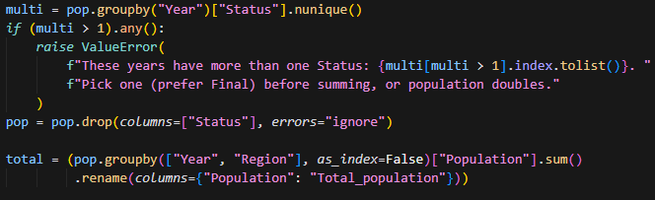
Figure 3: Population Data Cleaning
Population summed across all demographic breakdowns for each Region x Year combination. Status column dropped after validation.
Data trimmed to the 2015-2025 analysis window à 66 rows (6 regions x 11 years).
- Data engineering
Data engineering transforms the three cleaned source tables into a single analysis-ready panel. Five steps handle dataset merging, per-capita normalisation, lag feature construction, age-structure dimensionality reduction, and train/test partitioning.
  - Merging the Three Source Tables
Two left joins produce the merged panel. Crime rows carry Year, Quarter, and Region keys; alcohol joins on Year × Quarter × Region; population joins on Year × Region.
Figure 4: Merging the Three Source Tables
PAC quarterly attachment. Each quarterly PAC value is attached to all three months in that quarter, not divided by three. PAC measures total supply available during the quarter; dividing would understate the supply signal and create artificial within-quarter variation.
PAC imputation (2023-2025 only). Years 2015-2022 remain NaN by design; backward extrapolation would introduce unsupported assumptions.
Table 7: Output file after merging
Property | Value
Output file | Nt_crime_merged_2015_2025.csv
Coverage | 2015-2025, 6 regions
PAC null values | 0 within 2023-2025 after imputation; 2015-2022 PAC NaN
  - Per-Capita Metrics
Raw offence counts and PAC volumes are heavily confounded with population size. Greater Darwin has the largest number of the NT population and will always dominate absolute counts. Two per-capita are derived to enable fair cross-region comparison.
Table 8: Per-Capita Metrics
Derived Feature | Formula | Unit | Purpose
Assault_rate_100k | Assault_offences / Total_population x 100,000 | Offences per 100k people | Comparable assault intensity across regions
Alcohol_per_capita | Total_PAC / Total_population | Litres PAC per person | Comparable alcohol supply across regions
  - Features Engineering
A series of new features have been constructed from existing features to capture a holistic view of the crime situation in the Northern Territory. The features and reasons behind them are demonstrated below
Log_assault_rate:
Since the crime rate is not normally distributed but rather follows a log-normal distribution (heavily right-skewed) due to seasonality characteristics. By transforming the assault rate logarithmically, we aim to stabilise the distribution, making it symmetrical which is essential for good performance of linear regression models (Limpert et al., 2001)
Sin_month and cos_month:
To preserve the cyclic behaviours of months, sine and cosine functions are applied to represent time since these trigonometric functions pursue cycles between “top” and “bottom” and have a settled cycle length which is perfect for modelling regular cycles such as months (Lindsey and Pavur, 2005)
Season:
This feature serves as an indicator for wet and dry seasons, which according to research by Blakeslee et al. (2018), have a statistically significant relationship with crime incidence.
Assault_rate_lag1, lag3, lag12:
Three lagged versions of the assault rate are constructed for each region — the value one, three, and twelve months prior - computed separately per region (groupby("Region")) so a lag never crosses into another region's history. The three horizons capture distinct temporal patterns: lag1 captures short-term momentum (recent months tend to predict the next), lag3 captures a quarterly trend that smooths month-to-month noise, and lag12 captures the seasonal/yearly cycle, allowing the model to compare a month against the same month one year earlier rather than assuming a fixed sine/cosine seasonal shape alone. These lags form the temporal core of every feature variant tested in Section 4.3.
  - Train/Test Split
Because of the nature of time-series data, results are susceptible to previous information. The dataset needs to be split into train and test using a temporal cut-off, ensuring that training data only contains observations prior to the test period to avoid any leakage of future information (Hasanov et al., 2022).
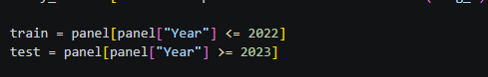
Figure 5: Train/Test Split
- Analytics and machine learning
  - Exploratory Data Analysis (EDA)
EDA serves as a critical stage following data ingestion and pre-processing, as it enables systematic inspection of the dataset for distributional characteristics, outliers, inconsistencies, and anomalous patterns that may affect downstream modelling (Komorowski et al., 2016). This diagnostic step ensures that data quality issues are identified early and addressed appropriately. Beyond quality assurance, EDA also plays a strategic role in shaping the feature engineering process. By revealing underlying relationships, trends, and variable interactions, EDA provides the empirical insight needed to design features that capture meaningful structure in the data and enhance model performance. As Mao (2015) emphasises, effective feature engineering is grounded in a thorough understanding of the data, making EDA an indispensable component of the modelling pipeline.
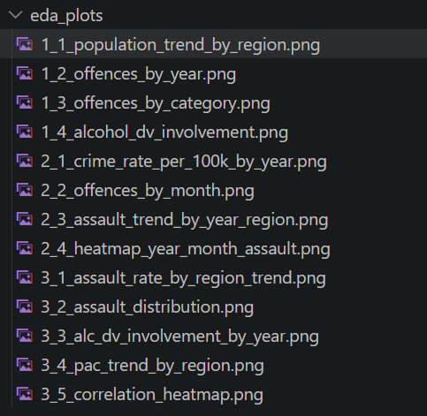
Figure 6: EDA plots
  - PCA of regional Age Structure
PCA was applied to 18 age-group population shares across 66 region-year observations as a diagnostic step, ahead of deciding whether age structure warrants inclusion as a model feature. PC1 explains 53.0% of variance; 5 components are needed for 90% (Table 9) - indicating the 18 age groups are highly correlated rather than independent signals.
Shares, not raw counts, were used deliberately: counts scale with region size and would leave PC1 at ~99%, merely re-measuring region size rather than age composition (Mishra et al., 2017).
This step is diagnostic only, components are not yet merged into the regression panel or included in FEATURES. Incorporating PC1-PC2 remains a candidate for future model iterations.
Table 9: PCA explained variance - age structure
PC | Explained (%) | Cumulative (%)
PC1 | 53 | 53
PC2 | 17.3 | 70.3
PC3 | 9.5 | 79.9
PC4 | 8.2 | 88.1
PC5 | 3.1 | 91.2
PC6 | 2.3 | 93.5
  - Feature Variant Selection
Four feature variants were compared using a baseline Linear Regression model with TimeSeriesSplit cross-validation over the training period (2015-2022, 504 rows after lag warm-up), leaving the 2023-2025 test period untouched. Each feature combination was standardised inside the cross-validation folds and trained under identical conditions, allowing a controlled comparison of predictive performance. RMSE was used as the primary selection criterion, supported by MAE, due to its sensitivity to larger errors and its suitability for the log-transformed assault-rate target.
Table 10: Feature variant comparison - Linear Regression, train 2015-2022
Variant | Features added | RMSE
V1: Temporal | sin/cos month, Season, lag1/3/12 | 0.2353
V2: + Region | V1 + region dummies | 0.2146
V3: + Crime ctx | V1 + Alcohol_offences, DV_offences | 0.2246
V4: Full (no PAC) | V1 + Alcohol_offences, DV_offences + region dummies | 0.1794

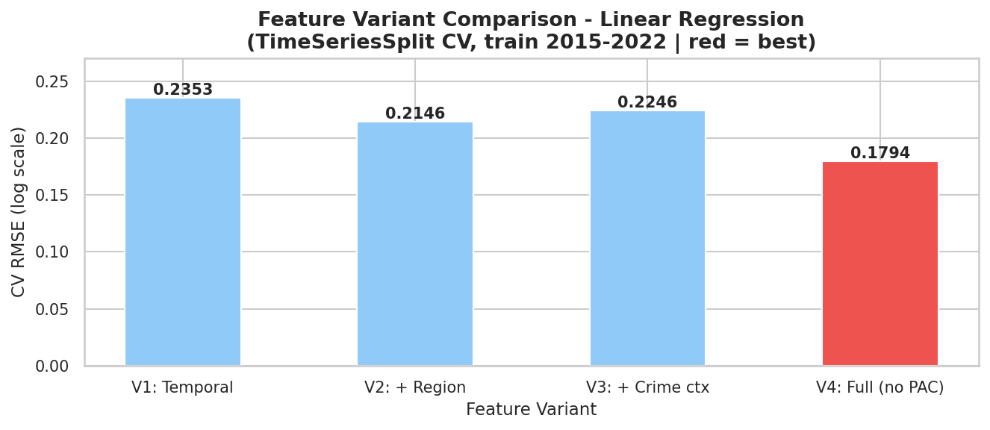
Figure 7: Feature Variant RMSE Comparison
V4 was selected as it achieved the lowest RMSE. Notably, V3 alone yielded a smaller gain than V2 - adding crime-context features without controlling for region-level baseline differences provides less independent signal, since regions differ systematically in both alcohol/DV offence volumes and assault rates. Only once region dummies are added alongside the crime-context features (V4) does the model benefit: the region terms absorb the between-region baseline differences, allowing the crime-context features to capture genuine within-region variation instead of confounding it with region identity. This is why V4 outperforms both V2 (region only) and V3 (crime context only) individually - the two feature groups are complementary rather than independently additive. Wholesale alcohol supply (PAC) was excluded from this comparison as it is only available from 2023 onward and would truncate the training window.
  - Multicollinearity Check and Hyperparameter Tuning
With an aim to maximise the model performance, a multicollinearity check was carried out by calculating the Variance Inflation Factor (VIF) of each feature and removing the ones with VIF > 30. High multicollinear features are known to have a negative effect on the regression model by hampering the interpretability of model predictors and resulting in highly volatile coefficient estimates (Dertli et al., 2024). In this study, while Alcohol_offences (VIF = 24.1), Reg_Barkly (17.2), DV_offences (16.6), and Reg_Top End (10.6) were flagged as elevated, all features remained below the removal threshold of 30, and no features were dropped.
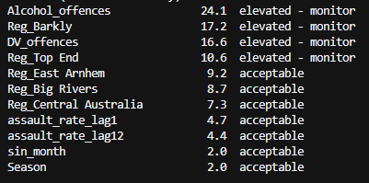
Figure 8: VIF scores for selected features
Another approach to optimising model performance is hyperparameter tuning. In this pipeline, tuning for linear models (Ridge and Lasso) is performed using alpha tuning with is to choose the most favourable alpha parameter that minimises the models' error in cross-validation (Deb, 2025).
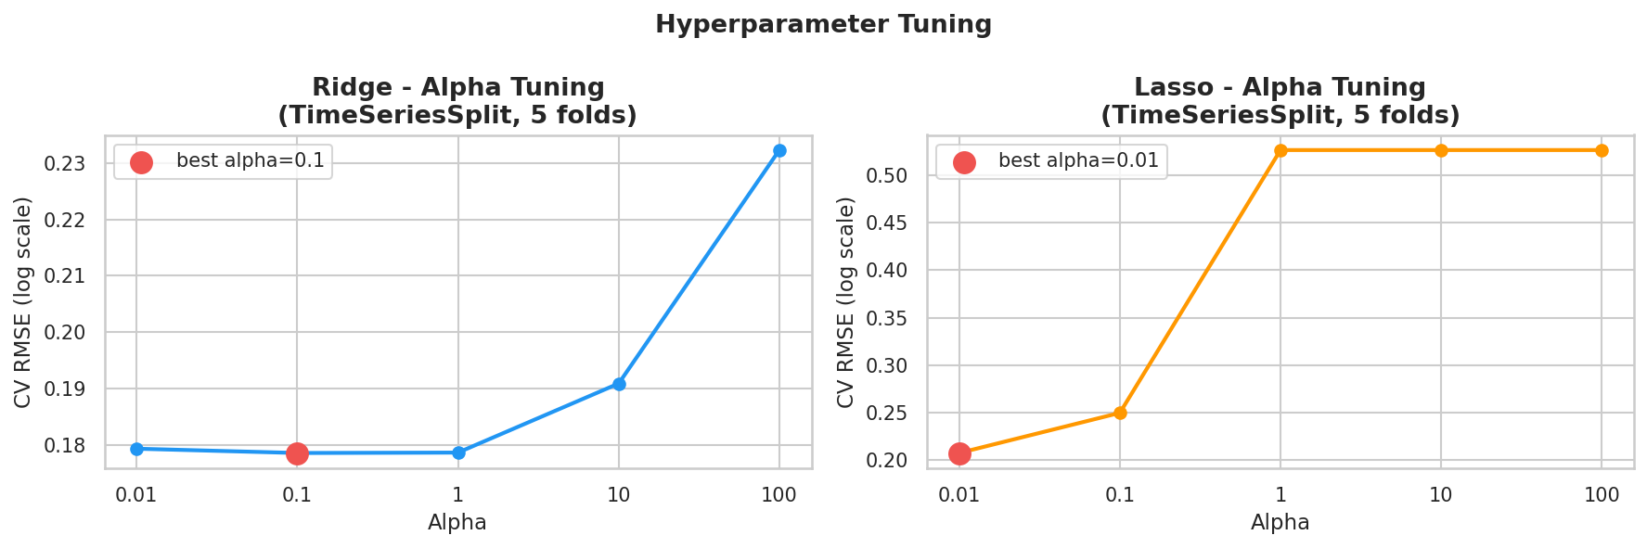
Figure 9: Ridge and Lasso CV RMSE across alpha values (TimeSeriesSplit)
  - Model Results and Evaluation
Table below compares four candidate models trained on Model A's feature set (Section 4.3-4.4), evaluated on the held-out 2023-2025 test period.
Table 11: Model performance comparison - Model A (no alcohol supply)
Model | RMSE(log) | MAE(log) | RMSE(/100k) | CV RMSE
Linear Regression | 0.2010 | 0.1686 | 106.0 | 0.1795
Ridge (α=0.1) | 0.2004 | 0.1681 | 105.6 | 0.1786
Lasso (α=0.01) | 0.2153 | 0.1693 | 140.0 | 0.2071
XGBoost | 0.1517 | 0.1227 | 84.5 | 0.1703

XGBoost performed best across every metric (RMSE 0.1517 log / 84.5 per 100k, lowest MAE and CV RMSE), indicating the predictors - particularly the lag features (Section 3.3) - contain non-linear structure a tree-based model captures better than a linear one. Residual normality check (Shapiro-Wilk W=0.9755, p=0.0019) rejected the normality assumption for the Linear Regression model, further supporting the selection of XGBoost as the final model. Paired t-tests on absolute error confirmed XGBoost significantly outperformed all three linear models (p<0.001), while differences between Linear Regression and Lasso were not statistically significant (p=0.94).
Among linear models, Ridge (α=0.1) modestly beat plain Linear Regression, consistent with the correlated lag/region features flagged in the VIF check (Section 4.4). Lasso (α=0.01) performed worst, likely discarding useful signal through coefficient shrinkage.
Per-region accuracy (Table 12) is best in Greater Darwin (RMSE 26.7, 7.5% error) and worst in Barkly and Top End (RMSE 131.3 and 114.6), with Top End under-predicted by 16.9% - suggesting the pooled model misses region-specific dynamics, a candidate improvement for future iterations.
Table 12: Per-region prediction accuracy (XGBoost, test 2023-2025)
Region | Actual (avg) | Predicted (avg) | RMSE | Error %
Greater Darwin | 212.1 | 227.1 | 26.7 | 7.5
Central Australia | 551.1 | 583.5 | 56.2 | 7.0
Big Rivers | 624.0 | 603.4 | 83.9 | -2.2
East Arnhem | 275.1 | 256.9 | 39.7 | -3.9
Barkly | 852.5 | 770.6 | 131.3 | -8.1
Top End | 571.9 | 472.4 | 114.6 | -16.9

As a secondary specification, Model B adds alcohol_per_capita (Section 3.2), trained on a much shorter window (2023-2024, test 2025 - 120 train rows vs Model A's 504) since alcohol data only starts in 2023.
Results are not directly comparable to Model A, the smaller sample and different test period mean RMSE differences reflect the data window as much as the model itself.
Figure 10 shows Model B's results. Unlike Model A, Linear Regression performs best here, with a small, consistent positive alcohol_per_capita coefficient (+0.0409) that shrinks toward zero under Lasso, suggesting alcohol supply is a weak, uncertain predictor once other variables are controlled for.
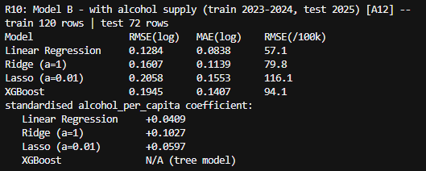
Figure 10: Model Results and Evaluation
  - Forecast Evaluation and Benchmarking
This subsection documents the forecasting and evaluation work completed since Assessment 1. It responds directly to the Assessment 1 feedback, which asked the team to justify the choice of Ridge and Lasso, compare them against suitable baselines, and define the forecast horizon, validation approach, evaluation metrics, uncertainty calculation, leakage-control strategy, drift thresholds and retraining rules. Each is addressed below. The work is implemented in evaluation.py in the repository root, which runs independently of the main pipeline and writes its results to Outputs/.
Forecast task definition
Assessment 1 described the objective as monthly, region-level assault forecasting over a three-to-twelve month horizon but did not specify the prediction task precisely. It is now defined as follows.
- Target: assault offences per 100,000 residents, by NT Government service region, by calendar month. The model is fitted on the log1p transform of this rate and predictions are back-transformed before evaluation, so all reported errors are on the interpretable rate scale.
- Granularity: six regions (Barkly, Big Rivers, Central Australia, East Arnhem, Greater Darwin, Top End) across 116 months, giving 696 usable region-month observations after lag warm-up.
- Horizons: forecasts are produced and evaluated at 1, 3, 6 and 12 months ahead, spanning the operational range stated in Assessment 1.
- Evaluation window: the six most recent months are excluded because offences are still being recorded against them. This aligns the implementation with the commitment made in the Assessment 1 risk analysis.
Model selection and justification
Regularised linear regression is appropriate here for three reasons. First, the predictor set is dominated by lagged values of the target at one, three and twelve months, which are strongly correlated with one another; L2 regularisation is designed for exactly this collinearity, and Lasso additionally performs variable selection among competing lags. Second, the panel contains 696 observations across six regions, which is small for high-variance learners and creates a substantial overfitting risk. Third, the end user is an operational planner rather than a data scientist, and linear coefficients can be read directly as the effect of a change in each predictor, supporting the interpretability requirement identified in Assessment 1.
Validation design and leakage control
Two sources of information leakage were identified in the existing pipeline and corrected. First, the feature-variant comparison selected the best variant using error measured on the 2023 to 2025 test set, and the final models were then scored on that same set. Reported performance was therefore optimistic, because the test data had already influenced a modelling decision. Variant selection now takes place on cross-validation folds drawn only from the training period. Second, the cross-validation routine fitted the feature scaler on the entire frame before splitting, so each fold was standardised using statistics that included later folds. Scaling is now performed inside a scikit-learn Pipeline, which refits the scaler on each fold's training rows alone.
Validation uses rolling-origin backtesting with an expanding window. At each origin the model is refitted on every month strictly earlier than that origin and then asked to predict the month h steps ahead. All predictors are lagged values or deterministic calendar terms, so no information from the target month or later enters the prediction. This measures forecasting performance rather than in-sample fit, and produces a distribution of errors across many origins rather than a single train-test split.
Baseline comparison
Assessment 1 compared candidate models only against one another, which cannot establish whether any of them add value. Two naive benchmarks were introduced: a seasonal naive forecast, which predicts the same month in the previous year, and a twelve-month moving average of the most recent complete year. Skill is reported as the percentage reduction in RMSE relative to the seasonal naive benchmark, so a negative value indicates a model performing worse than assuming last year repeats.
Table 13: Forecast accuracy by horizon, assault rate per 100,000 (rolling-origin backtest)
Model | Horizon (months) | MAE | RMSE | MAPE (%) | Skill (%)
XGBoost | 1 | 66.4 | 90.7 | 14.4 | 29.7
Moving average (12m) | 1 | 70.7 | 96.6 | 14.5 | 25.2
Ridge (a=0.1) | 1 | 75.1 | 99.4 | 16.2 | 23.0
Linear | 1 | 75.1 | 99.4 | 16.2 | 23.0
Lasso (a=0.01) | 1 | 78.8 | 120.6 | 15.7 | 6.6
Seasonal naive (t-12) | 1 | 91.7 | 129.1 | 19.2 | 0.0
Moving average (12m) | 3 | 74.7 | 104.5 | 15.0 | 24.4
XGBoost | 3 | 74.9 | 115.1 | 14.4 | 16.8
Ridge (a=0.1) | 3 | 88.5 | 123.1 | 18.2 | 11.0
Linear | 3 | 88.6 | 123.2 | 18.2 | 10.9
Lasso (a=0.01) | 3 | 84.6 | 131.3 | 17.0 | 5.0
Seasonal naive (t-12) | 3 | 95.6 | 138.3 | 19.5 | 0.0
Moving average (12m) | 6 | 76.1 | 105.7 | 15.2 | 25.0
XGBoost | 6 | 77.5 | 115.4 | 15.2 | 18.1
Ridge (a=0.1) | 6 | 88.4 | 123.8 | 18.1 | 12.2
Linear | 6 | 88.5 | 123.9 | 18.1 | 12.1
Lasso (a=0.01) | 6 | 88.0 | 137.3 | 17.4 | 2.6
Seasonal naive (t-12) | 6 | 97.4 | 141.0 | 19.7 | 0.0
Moving average (12m) | 12 | 79.7 | 110.5 | 15.2 | 21.0
XGBoost | 12 | 83.1 | 121.2 | 15.3 | 13.3
Ridge (a=0.1) | 12 | 98.1 | 133.2 | 19.4 | 4.8
Linear | 12 | 98.2 | 133.2 | 19.4 | 4.7
Seasonal naive (t-12) | 12 | 96.2 | 139.8 | 19.2 | 0.0
Lasso (a=0.01) | 12 | 97.8 | 153.2 | 18.8 | -9.6
All six models evaluated on feature variant V2, selected on training-period cross-validation. Skill (%) is the RMSE reduction relative to the seasonal naive benchmark. Best model at each horizon shown in bold.

Interpretation of results

No single model dominates across the forecast range. XGBoost is the most accurate at a one-month horizon, achieving an RMSE of 90.7 against 96.6 for the twelve-month moving average, a skill score of 29.7 per cent against the seasonal naive benchmark. From three months onward the ranking reverses: the moving average leads at every remaining horizon, with an RMSE of 104.5 at three months against 115.1 for XGBoost, and the gap persists at six and twelve months.
The pattern is consistent across metrics and is not an artefact of the error measure chosen. XGBoost retains the lowest MAPE at one and three months while the moving average has the lower RMSE from three months on, which indicates that XGBoost makes smaller errors on typical months but larger errors on the extreme months that RMSE penalises more heavily. For a resource-planning application where large under-predictions are the costly failure mode, RMSE is the more relevant criterion and the moving average is the safer choice beyond the immediate month.
Both regularised linear models perform worse than the moving average at every horizon. Ridge reaches 23.0 per cent skill at one month but falls to 4.8 per cent at twelve, and Lasso performs worse than the seasonal naive benchmark at the twelve-month horizon, with a skill score of -9.6 per cent. This does not support the Assessment 1 plan, which proposed Ridge and Lasso as the primary models without benchmark comparison.
These figures are not directly comparable with the single-split comparison reported in Section 4.5. That comparison selects features and ranks models on one held-out period, whereas the results here come from repeated out-of-sample forecasts at a fixed horizon with leakage controls applied and provisional months excluded. Where the two disagree, the backtest is the more conservative estimate of operational performance and is the basis for the recommendation below.
The two stages also select different feature variants, and the reason is methodological rather than an inconsistency. The pipeline selects variant V4 on cross-validated RMSE computed on the log scale, which is the objective the models are fitted against. The evaluation module back-transforms predictions and computes the same statistic on the assault rate per 100,000, and on that scale V2 is preferred by a clear margin (85.1 against 107.6). The ranking is stable in both cases: V4 leads on the log scale and V2 leads on the rate scale, whether cross-validation is restricted to the training period or run over the full panel, so the divergence is driven by the choice of scale alone.
The two scales answer different questions. Log-scale error measures proportional accuracy, so Barkly at roughly 850 assaults per 100,000 and Greater Darwin at roughly 210 carry equal weight. Rate-scale error measures absolute accuracy, so the high-rate regions dominate. Both are legitimate, and the project retains both: V4 for the model comparison in Section 4.5, where log-scale fit is the relevant criterion, and V2 for the forecast evaluation reported here, on the principle that a model should be selected on the same metric the deliverable is reported in. The forecasts supplied to PFES are rates per 100,000, so rate-scale cross-validation is the appropriate basis for the operational recommendation.
The practical reading is that the short horizon and the planning horizon are different problems. At one month ahead there is enough recent signal for a non-linear model to exploit, and XGBoost does so. Beyond that, regional assault rates are dominated by a slow-moving local level, and additional model complexity contributes little. Three factors plausibly contribute to the weak medium-term signal: the panel is short relative to the number of parameters; the series contains two documented administrative breaks inside the last two years; and aggregating to six large regions smooths much of the local variation a richer model could exploit.
The recommendation for the operational system is therefore a split specification: XGBoost for one-month-ahead forecasts, and the twelve-month moving average as the reference forecast at three months and beyond. Any model proposed for the final system must demonstrate skill against the moving average at its intended horizon, not against the seasonal naive benchmark alone. This is a stricter standard than the one applied in Assessment 1.
Uncertainty quantification
Prediction intervals are constructed empirically from the distribution of backtest residuals rather than from a parametric assumption, since the residuals are not normally distributed. For each horizon the tenth and ninetieth percentiles of the residual distribution are added to the point forecast. Empirical coverage of the resulting intervals is between 78 and 80 per cent against a nominal 80 per cent, indicating the intervals are well calibrated. The intervals are wide, spanning roughly 230 to 246 assaults per 100,000, which is itself an important operational message: forecasts at this granularity carry substantial uncertainty and should be presented to PFES as planning ranges rather than point predictions.
Structural breaks
Binary indicators were added for the two documented changes in crime recording: the transition from PROMIS to SerPro from December 2023, and the ANZSOC reclassification from April 2025. Including these indicators did not change cross-validation error, because the cross-validation period ends in 2022 and both indicators are therefore constant across every fold. They are retained because they are active in the evaluation period and because omitting a known level shift would bias the coefficients on the lag terms. This null result in cross-validation is reported explicitly rather than left implicit.
Drift monitoring and retraining
Forecast error is tracked as a rolling three-month MAE on the rate scale. A drift alert is raised when this rolling error exceeds the backtest MAE for the corresponding horizon by more than 50 per cent, which for the three-month horizon corresponds to a threshold of approximately 112 assaults per 100,000. Models are refitted monthly on the full available history when new crime data is published, rather than on a fixed schedule, so that each refit incorporates the most recent complete month.
Assessment 1 described an incremental learning stage, and the feedback correctly questioned whether the selected approach supports it. It does not: neither Ridge nor Lasso in scikit-learn implements partial_fit, so parameters cannot be updated online from streaming data. The stage is therefore clarified as scheduled full retraining on an expanded training window, not online parameter updating.
Limitations and next steps
Three limitations should be noted. The alcohol supply data covers only 2023 onward, so any specification including per-capita alcohol consumption is fitted on a much shorter window than the main models and its results are not directly comparable. The six-region aggregation was necessary to join the crime, population and alcohol sources onto a common geography, but it removes the sub-regional variation that would be most useful operationally. Finally, the evaluation covers 78 to 102 region-month predictions per horizon, sufficient to rank models but not to detect small differences between them with confidence.
Work planned for Assessment 3 includes testing whether a damped local-level model improves on the plain moving average, evaluating whether per-region models outperform the pooled specification, and integrating the prediction intervals into the dashboard so that forecast uncertainty is visible to end users.
- Implementation progress
Since Assessment 1, progress has been made across five of the eight pipeline stages in Table 2:
- Ingest & Data Store (Will) - Complete. Six raw datasets ingested with validation and provenance tracking (Section 3.1).
- Data Processing (Emma) - Complete. Datasets cleaned, region-matched, and merged into a single analysis-ready panel (Section 3.2).
- Data Engineering (Hendrick/Thomas) - Complete. Per-capita normalisation, cyclical/lagged features, temporal train/test split (Section 3.3).
- Analytics/ML (Hendrick/Thomas) - Complete. Baseline pipeline covers EDA, PCA, feature-variant selection, multicollinearity screening, and four candidate models. A second, independent module (evaluation.py) adds naive baselines, leakage-free feature selection, rolling-origin backtesting, and empirical prediction intervals, responding directly to the Assessment 1 feedback on validation rigour (Section 4.6, Hendrick).
- Dashboard, Deploy, Monitor, Incremental-learning - Not yet started. Scheduled for Weeks 7–8 (dashboard) and Week 10 (deployment/monitoring) per the workflow plan (Table 3).
The updated workflow table below records progress against each week's planned deliverable at the time of this submission.
- Updated Workflow
The workflow plan spans the full 12-week semester and is aligned to the four assessment milestones. Weeks immediately preceding each submission are used for consolidation and reporting, other weeks are allocated to the team members responsible for the relevant pipeline stage, as shown in table below:
Table 14. Twelve-week workflow plan
Week | Focus | Deliverable | Owner | Progress
1 | Team formation, theme confirmation, environment setup. | GitHub repository with README; Streamlit account set up; draft problem statement | All | Done
2 | Data collection and validation, architecture design | Architecture diagram; project management board populated; confirmed data sources | All | Done
3 | Proposal writing and initial risk analysis | Assessment 1 submitted: Project proposal and design | All | Done
4 | Load raw data into the repository; begin cleaning and harmonising six years of multi-source data; resolve region-mapping and data-regime discontinuities | Raw data in GitHub; cleaned, merged dataset in progress | Will (Ingest)  Emma (Data processing) | Done
5 | Finalise ingest and storage structure in GitHub; complete data processing scripts; preliminary exploratory analysis | Working ingest/ store/ processing stages; EDA notebook | Will (Ingest, Data store)  Emma (Data processing) | Done
6 | Feature engineering: lagged indicators, cyclical encoding, per-capita normalisation | Feature set finalised for modelling | Hendrick (Analytics/ML) | Done
7 | Consolidate pipeline evidence and baseline model into progress report | Assessment 2 submitted: Progress report and development | All | Done
8 | Model training and validation; begin dashboard build | Validated candidate model; dashboard prototype | Hendrick (Analytics/ML)  Thomas (Dashboard) | Progressing
9 | Rehearse and deliver technical demonstration | Assessment 3 submitted: Group Technical demonstration and presentation | All
10 | Incorporate feedback; finalise dashboard; deploy to Streamlit Community Cloud; implement monitoring and retraining logic | Deployed dashboard; monitoring stage implemented | Thomas (Dashboard, Deploy)  Emma (Monitor)
11 | End-to-end pipeline testing; draft final report sections | Full pipeline validated; report draft | All
12 | Final review and submission | Assessment 4 submitted: Final Professional Report | All
- Project governance
Risk Management
Potential risks, including data quality issues, ethical concerns, and technical challenges, will be continuously monitored throughout the project. Mitigation strategies such as data validation procedures, adherence to ethical guidelines, and regular system testing will be implemented to minimise their impact. Risks will be reviewed periodically, and corrective actions will be taken promptly to ensure project objectives are achieved successfully.
Compliance
As this project involves the analysis and forecasting of crime-related data, strong governance and compliance measures are essential to ensure responsible data use and maintain public trust. The project will adhere to Northern Territory Government data-handling policies (Northern Territory Government,2024) to ensure that data is collected, stored, accessed, and managed securely throughout the project lifecycle.
The project continues to respect Indigenous Data Sovereignty principles by recognising the rights of Indigenous communities to govern the collection, ownership, and use of data relating to their people and communities.
In addition, all predictive analytics activities seek to comply with ethical standards to minimise bias, promote transparency, and support fair decision-making. Forecasting models will be regularly evaluated for accuracy, reliability, and potential unintended consequences.
To strengthen day-to-day governance, the team applies a set of working agreements throughout the project. All code changes go through a pull request reviewed by at least one other member before merging. Jira tickets move to "Done" only when the associated code has been merged and the relevant pipeline stage runs without errors. Blockers unresolved within two working days are escalated at the next team check-in. Any scope or dataset change is logged in the repository change log with a brief justification before work begins.
- Risk analysis
The project has six main risks. These risks will be reviewed during each assessment milestone and updated when needed.
The first risk is changes in the crime data. The transition from PROMIS to SerPro in November 2023 and the ANZSOC classification transition in April 2025 may pose challenges in comparing old and new crime data. To minimise this risk, both transitions will be incorporated into the model.
The second one is that recent crime data may be incomplete because some offences are recorded later. To prevent incorrect results, the latest six months of data will not be included in the model’s training and testing.
The third risk is limited data on alcohol supply. This data is only available quarterly and may not cover enough years. The team will collect older data where possible. However, the main forecasting model will still work without alcohol data.
The fourth risk is the same region may be named or bounded differently in different datasets. This can lead to wrong data matching. The team will work with one shared set of regions and validate the data after each merge.
The fifth is a delay in dashboard deployment. To reduce this risk, the team will create and deploy a simple version of the dashboard early on, then improve it throughout the project.
And the final risk is misuse or misinterpretation of the forecasts. If predictions are read as statements about particular communities, the system could cause harm rather than support safety. Small counts in low-population regions could also make incidents identifiable. Forecasts will therefore be shown only at region and month level, with uncertainty ranges, and small values will be suppressed.
Since Assessment 1, two additional risks have materialised during implementation. The November 2023 data gap, absent from both crime files due to the PROMIS-to-SerPro transition, was identified and retained as NaN rather than imputed, to avoid introducing artificial values into the time series. The ANZSOC category-label mismatch between the two crime files also required a manual translation table to ensure consistent offence classification across the full study period. Both issues are now resolved in the pipeline and documented in the repository change log.
- Ethics, privacy and security considerations
Data privacy
The project only uses public and aggregated data from the Northern Territory Government and the Australian Bureau of Statistics. It does not use personal information or individual records. However, very small crime counts may still make some incidents easier to identify. Small values will therefore be hidden or grouped before being shown on the dashboard.
Indigenous data governance
Aboriginal people are strongly represented in NT crime statistics (Northern Territory Police Force, 2025), so the data must be used carefully and respectfully. The project follows the CARE Principles (Carroll et al., 2020) and the AIATSIS Code of Ethics (AIATSIS, 2020). The model will only make predictions at the regional and monthly level and will not make predictions based on Indigenous status.
Responsible use
The system is designed to help PFES plan staff and resources. It is not designed to predict whether an individual will commit a crime or to target specific addresses or communities.
Forecasts may not always be correct, so the dashboard will show uncertainty and explain the limitations of the data and model. This helps users avoid treating the predictions as exact results.
To guard against over-policing and unfair targeting, forecasts are produced at region and month level only, no suburb or address-level predictions are generated. Outputs are displayed with uncertainty ranges to make clear they are planning signals, not guaranteed outcomes. Counts below a suppression threshold are masked in the dashboard to protect individuals in low-population areas. Any operational response remains the judgment of PFES commanders rather than a direct output of the model.
Security and reproducibility
Only public data and project code will be stored in the GitHub repository. Passwords, API keys and private information will not be uploaded.
The project will also keep its data-processing and analysis steps in version-controlled code. This allows others to understand, replicate, and verify the results.
- Evaluation of progress
All major Assessment 1 feedback points have now been addressed. The 5Vs characterisation, and leakage-free validation directly respond to the modelling feedback. The storage-architecture concern has been acknowledged with a documented justification for retaining GitHub at this milestone and a plan to revisit if concurrent access becomes necessary. Governance has been strengthened with formal working agreements covering pull request reviews, Jira completion criteria, and change logging. The ethics section has been expanded to address over-policing risks explicitly. The main items still in progress are the dashboard, deployment, and monitoring stages, which are scheduled for Weeks 8 and 10 per the workflow plan.
- Any other relevant technical developments
Three cross-cutting developments are worth recording.
Pipeline verification. Before relying on the pipeline for modelling, it was tested end-to-end in a clean environment, surfacing several defects now fixed and recorded in the commit history:
- Two undeclared dependencies (xgboost, openpyxl) that broke the pipeline on any machine but the original developer's.
- A Windows-only Unicode crash inside a print() statement.
- A duplicated function definition from a Git merge, with a missing argument in the abandoned copy.
- A biased VIF calculation (missing its constant term) and an unsafe eval() call.
Architecture correction. The AWS-equivalent mapping (Table 2) was corrected: Athena is a query/cataloguing tool, not a transformation engine, so AWS Glue ETL replaces it as the conceptual equivalent for the cleaning/feature-engineering stage.
Output-artefact policy. The team commits pipeline outputs (eda_plots/, regression_plots/, dataset/raw/, dataset/processed/) to GitHub rather than .gitignore-excluding them, so markers can inspect results without re-running the pipeline, trading occasional merge conflicts on regenerated images for the reproducibility the module's GitHub expectations call for.
- References
Australian Bureau of Statistics. (2025, June). National, state and territory population. https://www.abs.gov.au/statistics/people/population/national-state-and-territory-population/latest-release.
Australian Bureau of Statistics. (2025). Prisoners in Australia. ABS. https://www.abs.gov.au/statistics/people/crime-and-justice/prisoners-australia/latest-release.
Australian Institute of Aboriginal and Torres Strait Islander Studies. (2020). AIATSIS Code of Ethics for Aboriginal and Torres Strait Islander Research. AIATSIS. https://aiatsis.gov.au/research/ethical-research/code-ethics
Carroll, S. R., Garba, I., Figueroa-Rodríguez, O. L., Holbrook, J., Lovett, R., Materechera, S., Parsons, M., Raseroka, K., Rodriguez-Lonebear, D., Rowe, R., Sara, R., Walker, J. D., Anderson, J., & Hudson, M. (2020). The CARE Principles for Indigenous Data Governance. Data Science Journal, 19(1), 1–12. https://doi.org/10.5334/dsj-2020-043
Hathaway-Wilson, J. (2025, September 21). NT police data shows violent crime increasing, property crime decreasing. Abc.net.au; ABC News. https://www.abc.net.au/news/2025-09-22/is-nt-crime-decreasing-since-clp-government-elected-police-data/105797920
Northern Territory Government. (2026). NT crime statistics march 2026 - NTG open data portal. https://data.nt.gov.au/dataset/current-nt-crime-statistics-march-2026
Northern Territory Police Association. (2025). Northern Territory Police Association demands better pay and conditions to prevent officer exodus. In Ntpa.com.au. https://www.ntpa.com.au/knowledgebase/article/KA-01198/
NTPFES. (2026). Operation ventura | NT police, fire & emergency services. NT Police, Fire & Emergency Services. https://pfes.nt.gov.au/newsroom/2026/operation-ventura
Northern Territory Police Force. (2025). Annual Report 2024-25. https://hdl.handle.net/10070/1016397.
Baird, A., While, D., Flynn, S., Ibrahim, S., Kapur, N., Appleby, L., & Shaw, J. (2019). Do homicide rates increase during weekends and national holidays? The Journal of Forensic Psychiatry & Psychology, 30(3), 367–380.
Blakeslee, D. S., & Fishman, R. (2018). Weather shocks, agriculture, and crime: Evidence from India. Journal of Human Resources, 53(3), 750–782.
Chakraborty, J., Majumder, S., & Menzies, T. (2021). Bias in machine learning software: Why? How? What to do? Proceedings of the 29th ACM Joint Meeting on European Software Engineering Conference and Symposium on the Foundations of Software Engineering, 429–440.
D., D. (2025). Performance of LASSO and ridge regression for variable selection in genome-wide association studies of maize flowering time.
Dertli, H. I., Hayes, D. B., & Zorn, T. G. (2024). Effects of multicollinearity and data granularity on regression models of stream temperature. Journal of Hydrology, 639, 131572.
Hasanov, M., Wolter, M., & Glende, E. (2022). Time series data splitting for short-term load forecasting. In Pess+ pelss 2022; power and energy student summit (pp. 1–6). VDE.
Komorowski, M., Marshall, D. C., Salciccioli, J. D., & Crutain, Y. (2016). Exploratory data analysis. In Secondary analysis of electronic health records (pp. 185–203).
Limpert, E., Stahel, W. A., & Abbt, M. (2001). Log-normal distributions across the sciences: Keys and clues: On the charms of statistics, and how mechanical models resembling gambling machines offer a link to a handy way to characterize log-normal distributions, which can provide deeper insight into variability and probability—Normal or log-normal: That is the question. BioScience, 51(5), 341–352.
Lindsey, M. D., & Pavur, R. J. (2005). As the PMI turns: A tool for supply chain managers. Journal of Supply Chain Management, 41(1), 30–39.
Mao, Y. (2015). Data visualization in exploratory data analysis: An overview of methods and technologies.
Mishra, S. P., Sarkar, U., Taraphder, S., Datta, S., Swain, D., Saikhom, R., & Laishram, M. (2017). Multivariate statistical data analysis-principal component analysis (PCA). International Journal of Livestock Research, 7(5), 60–78.
Northern Territory Government. (2024, May 16). Records and information management standards. Department of Corporate and Digital Development. https://dcdd.nt.gov.au/government-records/records-information-management-standards

Individual Work and Contribution Summary
      - Student Information
Name: Thi Xuan Thanh Tran (Emma)
Student ID: S389244
      - Laboratory Completion Evidence of:
Laboratory 1 – Lab: Querying Data by Using Athena (Module 4)
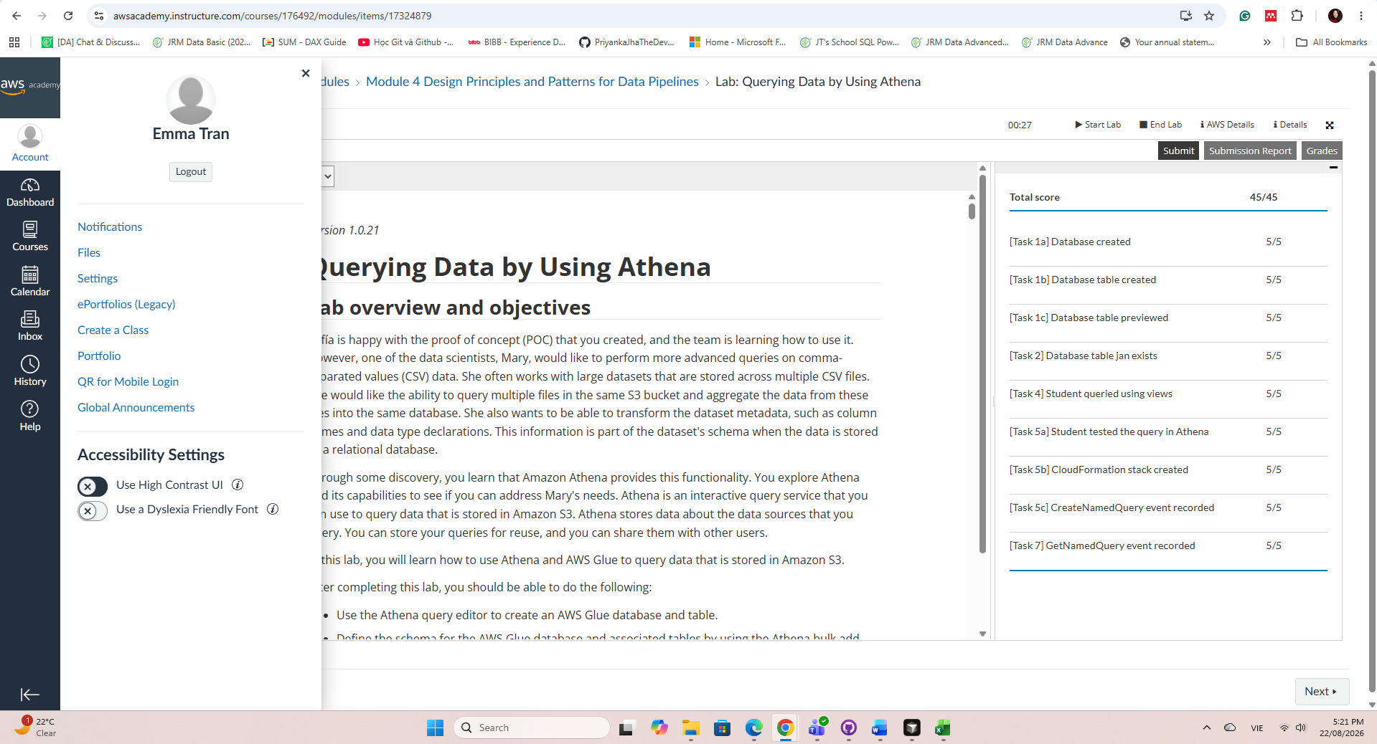
      - Individual Project Contribution
Since Assessment 1, I was responsible for the data processing stage: cleaning, standardising, and merging the three source datasets (crime, population, alcohol supply) into a single analysis-ready panel. This included category translation, a two-stage region crosswalk to align police boundaries with NTG statistical regions, offence-weighted encoding of alcohol and DV flags, and population validation before aggregation. Alongside this, I contributed to team coordination through Jira task management, GitHub maintenance, report writing, and reviewing teammates' work against assignment requirements.
https://github.com/HendrickDang/PRT661-DATA-SCIENCE-PRACTICE/commits?author=EmmaTran56
Visualisation:https://github.com/HendrickDang/PRT661-DATA-SCIENCE-PRACTICE/commits/main/eda_plots
Documentation:https://github.com/HendrickDang/PRT661-DATA-SCIENCE-PRACTICE/commits/main/documents
Code:https://github.com/HendrickDang/PRT661-DATA-SCIENCE-PRACTICE/commits/main/End%20to%20End%20pipeline.py
      - Brief Professional Reflection
This project highlighted how much of real-world data science happens before any modelling begins. Decisions of how to handle a missing month, which geographic boundary to use, how to encode a categorical flag had direct consequences on downstream model validity. Working across both a technical role and team coordination responsibilities also developed my ability to balance execution with communication: keeping work on track through Jira, reviewing others' outputs critically, and ensuring the team's collective work met the standard the assessment required. These are skills I expect to rely on throughout my professional practice.
            - Student Information
Name: Ngoc Anh Nguyen (Will)
Student ID: S386805
            - Laboratory Completion Evidence of:
Laboratory 1 – Lab: Querying Data by Using Athena (Module 4)

            - Individual Project Contribution
Since Assessment 1, I was responsible for the Ingest and Data Store stage, and for verifying that the pipeline the team built actually runs correctly end-to-end. This included implementing ingest.py to load and validate the six raw datasets with filename fuzzy-matching and manifest-based provenance tracking, compiling the project's missing dependency list after finding the pipeline would not run in a clean environment, and identifying and removing a Windows-specific Unicode crash and a duplicated function definition left over from a merge. I also corrected two silent code-quality defects - a statistically biased VIF calculation and an unsafe eval() call - before re-running the full pipeline to confirm it completes without errors ahead of the technical write-up.
Github:https://github.com/HendrickDang/PRT661-DATA-SCIENCE-PRACTICE/commits?author=ngocanh8585
Documentation:https://github.com/HendrickDang/PRT661-DATA-SCIENCE-PRACTICE/commits/main/documents
            - Brief Professional Reflection
Owning the ingest stage taught me that "does it run?" must be checked deliberately, not assumed. Defects like missing dependencies, a Windows-only Unicode crash, and a duplicated function definition were invisible on individual machines but would have surfaced during the demonstration or on the marker's machine - catching them early freed up time for modelling and reporting. It also showed me that verification means checking correctness, not just absence of errors: the VIF calculation and an unsafe eval() call ran without crashing, yet one was statistically biased and the other insecure.
- Student Information
Name: Van Hoi Dang (Hendrick) - Student ID: S395598
Role: Analytics and Machine Learning
- Laboratory Completion Evidence of:
Laboratory 1 – Lab: Querying Data by Using Athena (Module 4)

- Individual Project Contribution
Since Assessment 1 I covered the analytics and evaluation stage, addressing the modelling feedback. I built evaluation.py, a standalone module providing naive baselines, leakage-free feature selection, rolling-origin backtesting at four horizons, prediction intervals and structural-break indicators. It exposed two leakage sources I then fixed: variant selection on the test set, and scaling fitted before the CV split. Seasonal naive and 12-month moving average benchmarks produced Table 13 (Section 4.6). I also defined the forecast specification, drift thresholds and retraining rules, and wrote the Forecast Evaluation and Benchmarking subsection (Section 4.6).
Github:https://github.com/HendrickDang/PRT661-DATA-SCIENCE-PRACTICE/commits?author=HendrickDang
Documentation:https://github.com/HendrickDang/PRT661-DATA-SCIENCE-PRACTICE/commits/main/documents
Evaluation:https://github.com/HendrickDang/PRT661-DATA-SCIENCE-PRACTICE/commits/main/evaluation.py
Backtest:https://github.com/HendrickDang/PRT661-DATA-SCIENCE-PRACTICE/commits/main/Outputs
- Brief Professional Reflection
A model comparison only means something against a benchmark. Assessment 1 compared regression models against each other; once naive baselines were added, a 12-month moving average beat every model from three months out, and XGBoost only won at one month. Reporting a split result was less comfortable than reporting a single winner, but more defensible. The second lesson was leakage: every case I found produced plausible output, which is why they were easy to miss.
            - Student Information
Name: Le Nhat Minh Tran (Thomas)
Student ID: S390789
            - Laboratory Completion Evidence of:
Laboratory 1 – Lab: Querying Data by Using Athena (Module 4)

            - Individual Project Contribution
In this assessment, I maintain multiple roles, mostly with the technical side of the project. My contribution includes: Review the output from the ingesting and preprocessing steps, doing basic testing to see if anomalies exist and also seeking clarification when necessary, making sure that the processed data are ready for the next steps; Researching and choosing appropriate machine learning models and techniques from wide range of options and implementing them in the pipeline; Documenting and writing up reports based on my findings.
GitHub commits: Commits · HendrickDang/PRT661-DATA-SCIENCE-PRACTICE
Documentation: PRT661-DATA-SCIENCE-PRACTICE/documents at main · HendrickDang/PRT661-DATA-SCIENCE-PRACTICE
            - Brief Professional Reflection
Throughout this assessment, I focused mainly on the technical components of the project, which strengthened my analytical, research, and problem-solving skills. Working with different machine learning models improved my understanding of model selection, evaluation, and optimisation, giving me practical experience applying theory to a real-world problem. Conducting research to support our findings also exposed me to important concepts and current developments in machine learning. This broadened my technical knowledge and deepened my appreciation for the academic foundations that guide data science and predictive analytics. A major lesson from the project was the importance of collaboration and communication. Regular discussions with teammates and tutors helped me understand how professional IT projects are coordinated. Sharing updates, seeking feedback, and resolving issues highlighted the value of teamwork, stakeholder engagement, and clear communication. Overall, the project strengthened both my technical capabilities and professional skills. It reinforced the importance of data quality, evidence-based decision-making, continuous learning, and effective collaboration when developing reliable and impactful data-driven solutions.

SECTION 2 – Final Project Update Summary
Changes since Assessment 2
Area | Previous State | Current State | Justification
Architecture | Pipeline and evaluation scripts only | Adds forecast stage, monitoring script, dashboard and audit (Figure 11) | A complete batch plus dashboard system
Feature timing | Alcohol and DV offences from the target month | Lagged to the forecast origin [A18] | They are 49% and 64% of the target
Ingest validation | Warnings only (empty file, duplicate or empty columns) | Schema check stops a bad source file before anything is written; 17 tests | A renamed column or new flag value would otherwise corrupt the panel silently
Release gate | Promotion decision recorded only | Failed or incomplete forecasts cannot reach the dashboard; 23 tests | The control is enforced in code, not advisory
Backtest | Features built at the target month | Direct multi-horizon backtest, every month scored | A forecast may only use data known on its date
Alcohol model | Different period from Model A | Identical rows, previous-quarter supply [A19] | Fair comparison; supply is published late
Forecast output | Evaluation metrics only | 1 to 12 month forecasts with 80% intervals | Planners need forecasts, not only scores
New data test | None | Frozen models scored on Jan to Apr 2026 | First data no model has seen
Models | Retrained at every run | Saved with joblib [A21] | Report and dashboard use one artefact
Dashboard | Not started | Dual-role Streamlit portal with forecast and monitoring views, hosted online | User-facing delivery for PFES
Deployment | Not addressed | Reference environment, hosted app, rollback | Results reproduce exactly
Monitoring | One drift rule in the text | monitoring.py: 25 PASS / WARN / FAIL checks per release | Decides promotion and retraining
Team contribution summary
Team Member | Contribution
Thi Xuan Thanh Tran (Emma) | Deployment and monitoring design documents (now implemented in monitoring.py); coordinated the Assessment 3 and 4 reports; dashboard section of the Assessment 3 slides.
Ngoc Anh Nguyen (Will) | Read-only data lineage, reproducibility and leakage audit (pull request #8), which found the same-month feature issue; schema check in the ingest stage with 17 tests (pull request #9); drafted the Assessment 3 deck.
Van Hoi Dang (Hendrick) | Feature-timing and backtest corrections; forecast stage, saved models and 2026 check; monitoring script, dashboard forecast view and hosting; documentation, GitHub and Jira.
Le Nhat Minh Tran (Thomas) | Streamlit dual-role dashboard (app.py, core_data.py, two portal pages, Windows launcher); Assessment 3 system demonstration.
Evidence locations
Evidence | Repository Location
GitHub | github.com/HendrickDang/PRT661-DATA-SCIENCE-PRACTICE
Live dashboard | nt-safety-forecast.streamlit.app
Jira | hendrickdang.atlassian.net/jira/software/projects/SCRUM/boards/1/timeline
Code to run | repo: Execution Instructions/execution_instructions.md
Results and models | repo: Outputs
Change log | repo: CHANGELOG.md
Data audit | repo: audit/README.md
Design documents | repo: documents
Ingest tests | github.com/HendrickDang/PRT661-DATA-SCIENCE-PRACTICE/blob/main/tests/test_ingest_schema.py

SECTION 3 - Final Technical Development
  - Final system architecture
Since Assessment 2 the project has moved from two analysis scripts to a complete batch plus dashboard decision-support system. Figure 11 shows the final architecture. Storage keeps the source, raw and processed layout described in the Assessment 2 report (Data acquisition and storage). On top of it sit five executable components: the pipeline (ingest, panel build, EDA, PCA and regression), the evaluation module (benchmarks and the rolling-origin backtest), the new forecast stage, the new monitoring script, which checks every data release before its forecasts reach users, and the Streamlit dashboard. A read-only data audit supports them as a release check.
Three design decisions shaped the final architecture. First, it is batch rather than streaming, because the NT Government publishes crime figures monthly and alcohol supply quarterly. Second, storage stays file based: the processed panel has 13,629 rows, so a database would add complexity without adding capability. The cloud path is still clear, because the AWS Data Engineering capstone completed for this unit used the same pattern at larger scale (Parquet files in Amazon S3, an AWS Glue crawler and Amazon Athena views). Third, every stage writes its results to files (Outputs/ and Models/), so the report, the dashboard and any reviewer read the same artefacts instead of console output. The dashboard is served from the main branch of the GitHub repository by Streamlit Community Cloud, so a reviewed change to main is also a deployment.
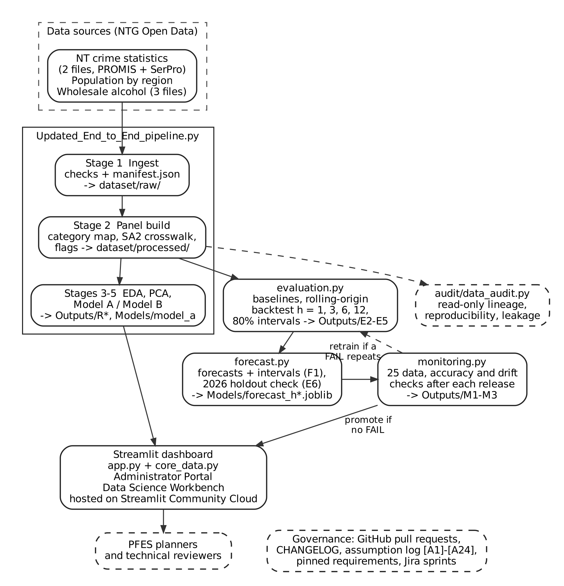
Figure 11: Final system architecture (solid: implemented; dashed: supporting or designed)
  - Complete implementation
Table 15 lists every component of the final system, the file that implements it and its status. All code is in the GitHub repository and runs in four commands: python Updated_End_to_End_pipeline.py, python evaluation.py, python forecast.py and python monitoring.py, followed by streamlit run app.py for the dashboard.
Table 15: Implemented components and status
Component | Implementation | What it does | Status
Ingest and panel build | Updated_End_to_End_pipeline.py, Stages 1-2 | Checks the six source files against a schema and writes nothing if one fails, logs each run in manifest.json, harmonises categories and regions, builds the 13,629-row panel | Complete
EDA, PCA, regression | Pipeline, Stages 3-5 | 13 EDA figures, PCA, Model A and B, result tables R1-R10, saves Model A | Complete
Evaluation | evaluation.py | Benchmarks, rolling-origin backtest at 1, 3, 6, 12 months, 80% intervals, bootstrap | Complete
Forecast stage | forecast.py (new) | Forecasts with intervals, one saved model per horizon, 2026 out-of-sample check | Complete
Dashboard | app.py, core_data.py, pages/ | Administrator Portal with a forecast and release-check tab; Data Science Workbench with a backtest and monitoring tab | Complete; hosted
Data audit | audit/data_audit.py | Row lineage, reproducibility, feature availability | Complete
Monitoring | monitoring.py (new), from the monitoring design | 25 data, accuracy and drift checks after each release; decides promotion and retraining | Complete; first run 18 Oct 2026
Documentation | README, CHANGELOG, Execution and Environment instructions, Models/README | How to install, run, verify and roll back | Complete

Testing was built into the implementation rather than left to the end. Seven checks were run on the final code:
- Reproducibility: re-running the pipeline and the evaluation module reproduced every Assessment 3 output file byte for byte, and the evaluation, forecast and monitoring stages give identical files on Python 3.8 and 3.11.
- Leakage: for all 16 forecast origin and horizon combinations, the features and benchmarks were rebuilt with every value after the origin removed; none changed. The model set-up, chosen once on 2016-2022 cross-validation, is re-checked after the selection window under System evaluation.
- Data rebuild: before using the 2026 months, forecast.py rebuilds 2025 from the raw file and confirms it matches the processed panel exactly (72 region-months, no differences).
- Unit tests: 40 tests (tests/) confirm that the six current source files pass, that eleven kinds of broken file are rejected and leave dataset/raw/ unchanged, that a forced release-check FAIL or a forecast file missing a region or horizon leaves the file the dashboard reads unchanged, and that the dashboard never shows a rejected forecast as cleared. On the current files, ingest reproduces the committed raw files exactly.
- Dashboard: all three Streamlit pages, including the new forecast and monitoring tabs, load headless in Streamlit's AppTest with no exceptions, in under 5 seconds and about 300 MB of memory, and the leaderboard matches the pipeline.
- Audit: the read-only audit script still runs against the final code and writes only to audit/.
- Monitoring: the first release check (Table 26) rebuilt 2025 from the raw crime file and matched the panel exactly, and compared the latest backtest months (January to June 2025) and the provisional 2026 months with the backtest.
The dashboard (Figure 12) gives two audiences their own view of the same results. The Administrator Portal now opens a Forecasts & Planning Ranges tab with the latest release check, then shows each region's forecast at 1, 3, 6 and 12 months with an 80% planning range, both as a rate and as an expected number of assaults, a chart against the observed series and a plain-language note on how reliable each horizon has been. Its other tabs show territory indicators, a regional map, a staffing priority matrix, a seasonal calendar, a policy scenario simulator and a briefing export. The Data Science Workbench adds a backtest, forecast and monitoring tab to the assumption log, EDA, PCA, feature selection and VIF, tuning curves, the Model A and B leaderboard and residual diagnostics. The forecast views read the saved output files and refit nothing, so they always show the numbers in this report. Since Assessment 3 the simulator is labelled as illustrative and the priority labels use neutral wording (item 11).
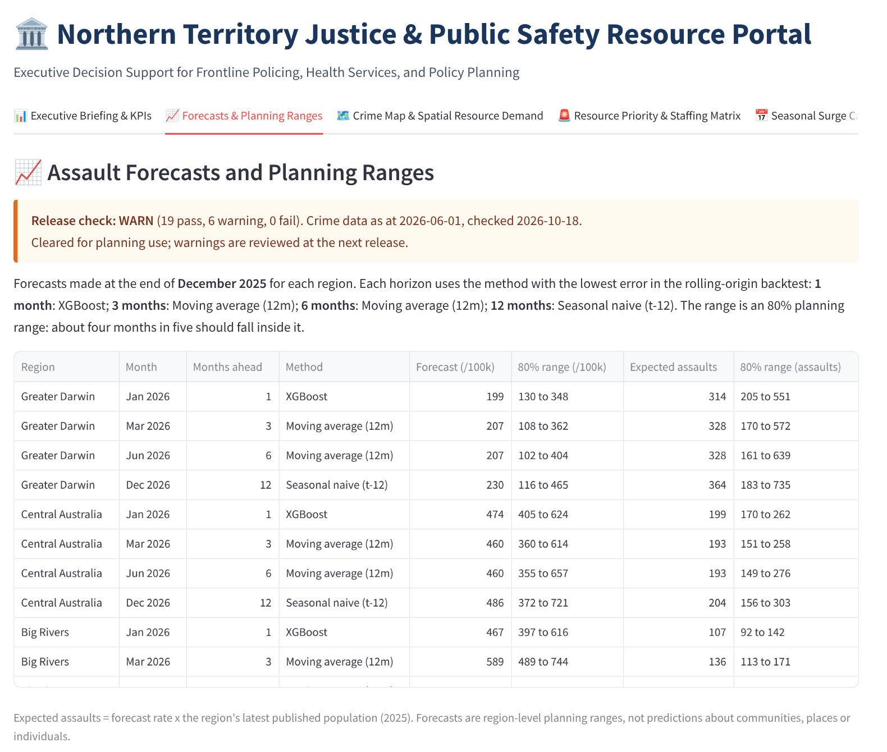
Figure 12: Forecasts & Planning Ranges tab of the Administrator Portal, with the latest release check
  - Deployment
The system is deployed in two ways that follow the team's deployment design (documents/Deployment_Design_DAN2_Theme2.docx). The dashboard is hosted on Streamlit Community Cloud at nt-safety-forecast.streamlit.app, built directly from the main branch, so PFES staff and markers can use it in a browser without installing anything. The same code also runs as a local, reproducible demonstrator. Both suit the project: all inputs are public open data and there are no credentials to protect. A containerised service and a REST API were considered and deferred, because every current user is a person reading the dashboard. Table 16 lists the deployment artefacts.
Table 16: Deployment artefacts
Artefact | Implementation
Environment contract | requirements.txt with pinned versions (pandas 2.0.3, scikit-learn 1.3.2, xgboost 2.1.4, joblib 1.4.2, streamlit 1.45.1); Python 3.8+ for the scripts, 3.9+ for the dashboard; a root copy of requirements.txt for the hosted app
Reference environment | Linux x86_64, Python 3.11. Every reported figure comes from this environment, which is recorded in Outputs/pipeline_run_summary.json and forecast_run_summary.json
Saved models | Models/model_a.joblib and Models/forecast_h1/3/6/12.joblib, each with its feature order and package versions
Launch | Hosted: nt-safety-forecast.streamlit.app (Python 3.11; redeploys on each push to main). Local: streamlit run app.py or run_dashboard.bat (Windows), at localhost:8501
Release and rollback | Changes reach main through commits or pull requests; monitoring.py decides whether new forecasts are promoted; a bad release is reverted in GitHub, which also redeploys the hosted app. Committed outputs let a reviewer inspect the last good results without re-running anything

The reference environment was a deliberate decision. Will's audit showed that XGBoost produces slightly different trees on Windows and Linux even with identical package versions (80.7 against 84.5 RMSE at Assessment 3). Linux was chosen because it matches the audit and Streamlit Community Cloud, the hosting platform. The audit also found that evaluation.py wrote to outputs/ while the repository used Outputs/, which are different folders on Linux; this was corrected, so the scripts write, and the dashboard reads, the same committed results. The hosted app runs on Linux with Python 3.11, the reference environment, and reads the committed Outputs/ files, so it shows exactly the forecasts and release check in this report.
  - Data engineering
Data engineering since Assessment 2 focused on proving that the pipeline is correct rather than adding sources. Will built a read-only audit (pull request #8, audit/) that traces every row count from the source files to the model panel, fingerprints each source file with a SHA-256 hash, re-runs the project from a clean clone and checks whether each feature would be known at forecast time. Table 17 summarises the lineage it established.
Table 17: Row lineage from source files to the model panel (audit/A3_data_lineage.csv)
Stage | Rows | Explanation
Raw crime rows, both files | 55,146 | 46,036 (2008 to 2023) plus 9,110 (Dec 2023 to Apr 2026)
Inside the 2015 to 2025 window | 34,306 | Rows outside the analysis window are not used
Processed offence-level panel | 13,629 | Aggregated by region, month, offence type and flags
Complete region-month grid | 792 | 132 months x 6 regions
Usable model panel | 696 | After the lag-12 warm-up, the Nov 2023 gap and lags that fall on it
Train / test | 504 / 192 | Jan 2016 to Dec 2022 / Jan 2023 to Dec 2025

The audit produced five findings, and all were acted on. The same-month feature overlap is corrected in 5.1 below. The platform dependence of XGBoost led to the reference environment described under Deployment (item 3). The output-folder case mismatch was fixed. The audit also corrected the wording "train 2015 to 2022": 2015 serves only as lag history, so training starts in January 2016. Finally, it detected header drift between crime releases (a trailing space in "Offence type " and a different capitalisation of "Reporting Region"). The pipeline still accepts both, but ingest now checks every source file before writing anything (pull request #9). A missing or renamed column, a month outside 1 to 12, a negative or non-numeric count, or an alcohol or DV flag other than "Yes", "No" or "-" stops the run with a clear message, and dataset/raw/ keeps the last good copies. Before this change, an unexpected flag value was silently counted as "No". The check changes no reported figure: on the current files, ingest reproduces the committed raw data exactly. monitoring.py still reports drift after each run (check D2).
The latest crime file (As At 1 June 2026) already contains January to April 2026. The processed panel stops at December 2025 because population estimates end in 2025 [A1]. Rather than wait, forecast.py builds the 2026 months with the pipeline's own region crosswalk and flag rules, after first rebuilding 2025 the same way and confirming it matches the panel exactly. Rates for 2026 use each region's 2025 population [A22]. All four months are within six months of the As At date, so they are provisional and will be revised upward [A23].
  - Analytics and machine learning

5.1. Feature timing correction [A18]
The audit showed that the alcohol- and DV-flagged assault counts in feature variants V3 and V4 were counted from the same region-month as the target. They make up 49% and 64% of the number being predicted and are not known when a forecast is made, a form of leakage that is a well-known cause of over-optimistic results (Kaufman et al., 2012). Both features now use the previous month's value. Table 18 compares the feature variants before and after the correction.
Table 18: Feature variant cross-validation (log-scale RMSE, training period), Assessment 2 and Assessment 4
Variant | Features | Assessment 2 | Assessment 4
V1: Temporal | sin/cos month, season, lags 1/3/12 | 0.2353 | 0.2353
V2: + Region | V1 + region dummies | 0.2146 | 0.2146
V3: + Crime context | V1 + alcohol and DV offences | 0.2246 | 0.2323
V4: Full (selected) | V1 + crime context + region dummies | 0.1794 | 0.2088

V4 is still selected, but by a far smaller margin over V2, which confirms that most of its Assessment 2 advantage came from the leaked information. A useful side effect is that the pipeline (log scale) and the evaluation module (rate scale, 81.6 against 85.1 for V2) now select the same variant; in Assessment 2 they disagreed.

5.2. Genuine forecast horizons
The Assessment 2 backtest refitted the models at each origin but built the features at the target month, so a "3-month-ahead" forecast still used the assault rate from one month before the target. The backtest now forecasts directly: for horizon h the lags are h, h + 2 and 12 months, the moving-average benchmark ends h months before the target, and a separate model is fitted for each horizon. Training windows expand from a 60-month minimum and are refitted every three months, and every month from June 2021 to June 2025 is scored at every horizon. This rolling-origin design follows standard practice for out-of-sample forecast evaluation (Tashman, 2000; Hyndman & Athanasopoulos, 2021).

5.3. Alcohol supply comparison redesigned [A19]
Model B previously used the supply of the quarter being forecast, which is published about three months later, and was compared with a Model A trained on a different period. It is now fitted three ways on the same 102 training and 72 test rows (Table 19).
Table 19: Alcohol supply comparison on identical rows (train 2023-2024, test 2025, RMSE per 100,000)
Model | No alcohol | Same quarter (association) | Previous quarter (forecast test) | Coefficient (prev. quarter)
Linear Regression | 98.9 | 98.7 | 98.2 | +0.138
Ridge (a = 0.01) | 99.1 | 98.9 | 98.2 | +0.137
Lasso (a = 0.01) | 126.1 | 125.9 | 122.7 | +0.062
XGBoost | 95.6 | 105.7 | 95.0 | n/a

Adding the previous quarter's supply changes the error by less than one point for the strongest models, while the coefficient is positive in every linear model. Alcohol supply is associated with higher assault rates, but it does not improve the forecast on the data available.

5.4. Final models, saved models and forecasts
The final model set is Linear Regression, Ridge and Lasso (alpha 0.01 for both, tuned on training-period cross-validation) and XGBoost (Chen & Guestrin, 2016; depth 3, learning rate 0.05, 800 trees), with the seasonal naive and 12-month moving-average benchmarks. The fitted models are now saved with joblib [A21]: Model A by the pipeline, and one bundle per horizon by forecast.py, trained on every month to December 2025 with the backtested set-up.
forecast.py turns the evaluation into forecasts PFES can use. For each horizon it applies the method chosen by a two-window rule (System evaluation) with its empirical 80% interval: XGBoost at one month, the 12-month moving average at three and six months, and the seasonal naive value at twelve months. Table 20 and Figure 13 show the forecasts from December 2025.
Table 20: Forecasts from December 2025, assault rate per 100,000 with 80% interval (Outputs/F1_forecasts.csv)
Region | Jan 2026 (XGBoost) | Mar 2026 (moving avg.) | Jun 2026 (moving avg.) | Dec 2026 (seasonal naive)
Greater Darwin | 199 (130-348) | 207 (108-362) | 207 (102-404) | 230 (116-465)
Central Australia | 474 (405-624) | 460 (360-614) | 460 (355-657) | 486 (372-721)
Big Rivers | 467 (397-616) | 589 (489-744) | 589 (484-786) | 478 (363-712)
East Arnhem | 265 (195-414) | 295 (196-450) | 295 (190-492) | 332 (218-567)
Barkly | 632 (563-782) | 866 (766-1021) | 866 (761-1063) | 636 (521-870)
Top End | 595 (526-745) | 572 (473-727) | 572 (467-770) | 634 (519-869)
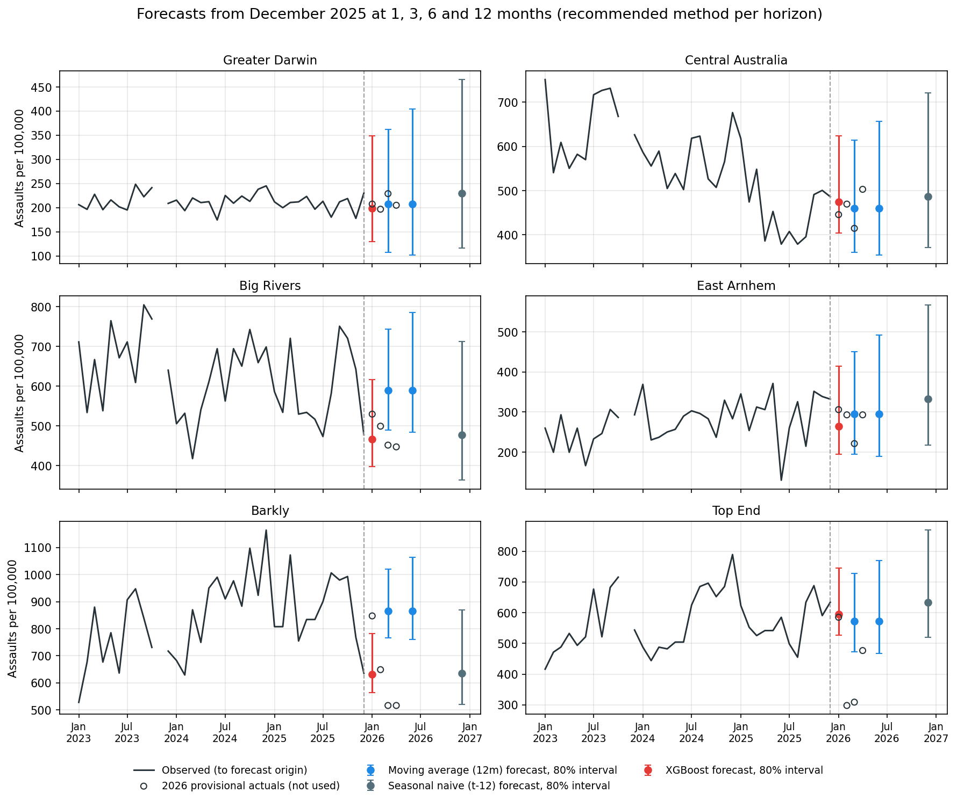
Figure 13: Forecasts from December 2025 with 80% intervals, against the 2026 provisional actuals
  - System evaluation
The system is evaluated against two simple benchmarks rather than only against other models, because a forecast PFES pays for must beat what a planner could compute in a spreadsheet. Skill is reported as the percentage reduction in error against the seasonal naive forecast, a scale-free comparison with a benchmark (Hyndman & Koehler, 2006). Table 21 gives the rolling-origin results after the corrections in Section 5.
Table 21: Rolling-origin backtest, RMSE per 100,000 by horizon (targets June 2021 to June 2025; best in bold)
Model | h = 1 | h = 3 | h = 6 | h = 12
XGBoost | 99.8 | 124.5 | 139.3 | 172.0
Linear Regression | 112.3 | 131.4 | 140.6 | 178.2
Ridge (a = 0.01) | 112.3 | 131.4 | 140.6 | 178.1
Lasso (a = 0.01) | 129.2 | 134.6 | 151.0 | 153.6
12-month moving average | 107.3 | 116.3 | 130.4 | 150.8
Seasonal naive (t-12) | 137.4 | 139.1 | 141.2 | 145.5
Forecasts scored | 270 | 258 | 240 | 210

XGBoost is the most accurate method one month ahead, 27.4% better than the seasonal naive benchmark. From three months onward the 12-month moving average is best, and at twelve months the seasonal naive value is best: every fitted model is worse than both benchmarks there. The ranking is unchanged when all horizons are scored on the same target months (Outputs/E4_backtest_metrics_common_window.csv).
Two further checks measure how far these results can be trusted. A paired bootstrap that resamples whole months puts XGBoost ahead of the moving average at one month in 93% of resamples, but its 95% interval for the difference (-17.7 to +2.3) includes zero, so the lead is likely rather than established. The 80% prediction intervals, built from the distribution of past forecast errors (Hyndman & Athanasopoulos, 2021), were checked out of sample, each month against an interval built only from earlier months, giving coverage of 79.3%, 74.7%, 77.4% and 76.8% at the four horizons. Intervals are therefore slightly narrower than they should be, most of all at three months.
Selection window and deployment rule. The feature set, alphas and XGBoost settings were chosen once on 2016-2022 cross-validation, but the backtest scores forecasts from June 2021, so its early forecasts use a set-up chosen with later data. Re-scoring only origins from December 2022 (E11) gives XGBoost 97.0 against 99.2 for the moving average at one month, then the moving average at three and six months (108.0 and 117.6), and Lasso at twelve (119.4 against 126.1 for last year's figure). A method is therefore deployed only if it leads the full backtest and also beats last year's figure on these origins (E12). The methods deployed at one, three and six months do (bootstrap: ahead in 100%, 100% and 97% of resamples), and their intervals still cover 80.1%, 75.7% and 75.4% of outcomes. Lasso does not: its twelve-month lead is ahead in only 71% of resamples, the 95% interval (-28.6 to +9.7) includes zero, and it is 8.1 points worse over the full backtest, so last year's figure stays the twelve-month method. XGBoost's one-month lead over the moving average is small (ahead in 67%) and not established.
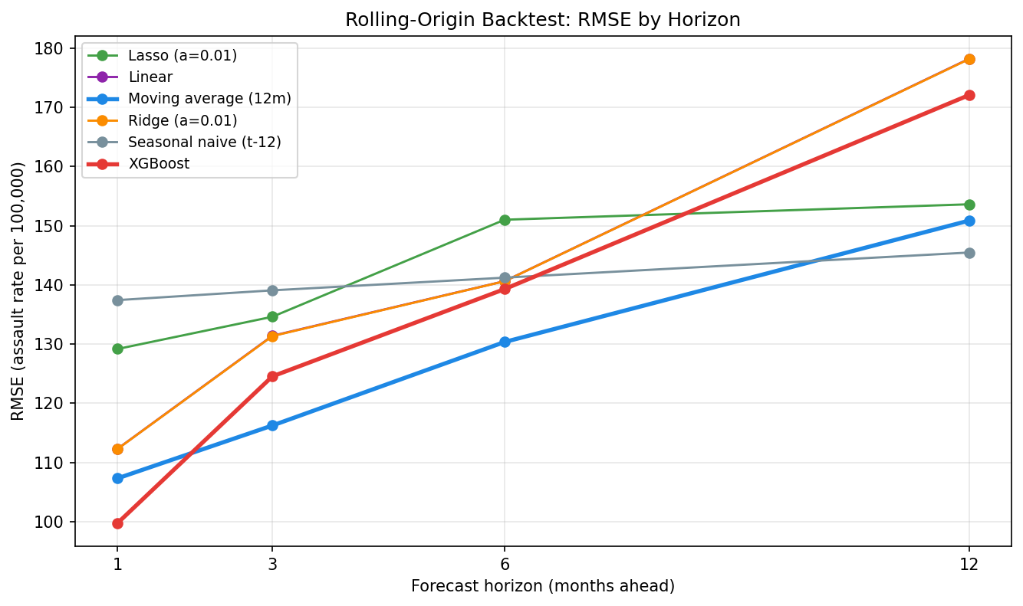
Figure 14: Backtest RMSE by forecast horizon

6.1. Qualitative evaluation against the Assessment 1 objectives
The team also reviewed the system against each Assessment 1 objective. This is a structured team review, not a user study: the system has not yet been tested with PFES staff.
- Data pipeline: largely met. Ingest, evaluation, forecasting and release checks run as four scripted commands, and ingest rejects malformed files; new releases are still downloaded by hand.
- Interpretable regional forecasts: met. Every region has 1, 3, 6 and 12 month forecasts with an 80% range; beyond one month the methods are ones planners can check by hand.
- Dashboard for non-technical staff: met. Forecasts are shown as expected numbers of assaults with a plain-language reliability note; technical detail stays in the Workbench.
- Early identification of emerging hotspots: partly met. The release check flags sharp regional shifts, as for Central Australia (8.1), but six regions cannot show hotspots within a region.
- Responsible use: met within the prototype. Only region-level figures are shown and prescriptive advice was removed (item 11); community consultation is still outstanding.
  - Performance analysis

7.1. Effect of the corrections on the single train/test split
Table 22 compares the single-split results reported in Assessment 2 (Table 11) with the corrected results. Errors rose by 19 to 44 points, as expected once the leaked information was removed, but XGBoost still has the lowest test error. On training-period cross-validation the linear models score slightly better (Outputs/R4_model_a_metrics.csv), so the single split alone does not establish XGBoost as the better model; the backtest (Table 21) is the basis for the recommendation.
Table 22: Model A, test 2023-2025, RMSE per 100,000: Assessment 2 against Assessment 4
Model | Assessment 2 | Assessment 4 | Assessment 4, excluding provisional months
Linear Regression | 106.0 | 125.2 | 129.6
Ridge | 105.6 (a = 0.1) | 125.2 (a = 0.01) | 129.5
Lasso (a = 0.01) | 140.0 | 184.0 | 162.4
XGBoost | 84.5 | 117.7 | 120.2

Accuracy differs strongly by region. XGBoost's error is lowest in Greater Darwin (21.5) and highest in Barkly (210.9) and Top End (127.5), where it also under-forecasts the 2023 to 2025 level by 17% and 19%. Regions with small populations have volatile rates, and both of these regions rose sharply after 2023, so a model trained to 2022 lags behind them.

7.2. First test on unseen data: January to April 2026
Table 23 scores the saved models, kept frozen, on the 2026 months that no part of the project had seen.
Table 23: Frozen models on January-April 2026 (provisional actuals), RMSE per 100,000
Model | h = 1 (24 forecasts) | Bias, h = 1 | h = 3 (12 forecasts) | Backtest RMSE, h = 1
Linear / Ridge | 80.5 | +11.4 | 123.6 | 112.3
Lasso | 99.6 | +26.9 | 157.5 | 129.2
XGBoost | 103.8 | +12.1 | 171.0 | 99.8
12-month moving average | 135.0 | +75.4 | 176.6 | 107.3
Seasonal naive | 166.7 | +92.7 | 211.5 | 137.4

All fitted models beat both benchmarks on these months, and XGBoost's one-month error (103.8) is close to its backtest error (99.8). The linear models did better still, and every method forecast above the outcome on average. Part of that bias is expected, because provisional counts rise as late reports arrive. XGBoost's 80% interval contained 15 of the 24 outcomes (62.5%).

7.3. Robustness and scalability
Robustness was tested in four ways: the ranking holds when every horizon is scored on the same months, the bootstrap resamples whole months, the frozen models were scored on unseen 2026 months, and the release checks compare the latest backtest months (January to June 2025) and the newest 2026 months with the backtest at every release (Table 26). The system is light: on a laptop each script runs in under a minute and the release checks in seconds. A tenfold larger panel would still fit in files, the backtest refits can run in parallel, and beyond that the stages would move to Parquet in Amazon S3 with AWS Glue and Athena, as practised in the AWS capstone.
  - Discussion of results
The most important result of this final stage is that the project's conclusions survived a correction that made every number worse. Removing same-month information raised the single-split XGBoost error from 84.5 to 117.7 and the one-month backtest error from 90.7 to 99.8, yet the recommended specification is the same in substance: XGBoost for one month ahead and simple benchmarks beyond. The one change is at twelve months, where the seasonal naive value, not the moving average, is the better reference.
Simple benchmarks win at longer horizons because monthly assault rates follow a slow-moving regional level with seasonal swings. One month ahead there is enough recent signal for XGBoost to exploit; further out, any model mainly re-estimates that level, and the extra flexibility adds variance without adding information. This agrees with large forecasting comparisons, in which simple statistical methods often match or beat machine learning (Makridakis et al., 2018). For PFES this is a practical message: the 3 to 12 month planning view can rest on transparent methods that staff can verify by hand.
The 2026 check should be read with care. Four months are too few to overturn a four-year backtest, and the counts are provisional. They also come from the June 2026 release rather than the data a planner held at each origin, so the check approximates live use rather than replaying it. It does raise two points for monitoring: the linear models did better than XGBoost on the most recent data, and XGBoost's interval covered only 62.5% of outcomes. The intervals are pooled across regions, so they are too wide for Greater Darwin and too narrow for volatile regions such as Barkly and Top End. These months should be re-scored when the counts are final, before any change to the recommendation.
Finally, alcohol supply shows a consistent positive association with assault rates but no forecast gain. With only twelve quarters of supply data, the project cannot separate a weak effect from no effect, so supply is reported as context in the dashboard rather than used as a forecasting input. The association is consistent with the documented burden of alcohol-related harm in the NT (Smith et al., 2019); the result means that supply data add no forecast information beyond recent assault rates, not that alcohol is unimportant.

8.1. Planning impact against current practice
Without the system, a planner's simplest forecast is the same month last year, which is the seasonal naive benchmark. Table 24 converts the backtest errors into numbers of assaults, using each region's population, and adds the absolute errors across the six regions. One month ahead, the recommended forecasts miss by a combined 104 assaults a month, against 143 for last year's figure: about 40 fewer assaults a month planned for in the wrong region, on an NT average of about 875 assaults a month. The gain falls with the horizon, to about 22 assaults at three months and 10 at six, and is zero at twelve months, where the recommended method is last year's figure itself. This is a retrospective estimate from the backtest, not a measured result of PFES using the system.
Table 24: Planning error against current practice: absolute forecast error in assaults a month, summed over the six regions (backtest, June 2021 to June 2025)
Horizon | Recommended method | Error: recommended | Error: last year | Reduction
1 month | XGBoost | 103.6 | 143.1 | 39.5 (28%)
3 months | 12-month moving average | 126.0 | 147.8 | 21.8 (15%)
6 months | 12-month moving average | 136.2 | 145.9 | 9.7 (7%)
12 months | Seasonal naive (same month last year) | 151.5 | 151.5 | 0.0

The difference matters most when a region's level changes. Central Australia's assault rate fell from an average of 926 per 100,000 a month in October to December 2022 to 493 in the same quarter of 2025, a period that began with new alcohol restrictions in and around Alice Springs in February 2023 (Cross, 2023). Last year's figure kept planning for the old level: in 2024 and 2025 it over-forecast the region by 70 to 86 per 100,000 a month on average, and its one-month error there was 145 per 100,000 against 96 for XGBoost, which reads the most recent months. The release check flagged the same shift on its first run (check R1: the October to December 2025 rate was 32% below the same quarter of 2022 to 2024), so a planner is alerted before the change shows in the error statistics.
The planning range also supports scenario analysis. Planning every region to the top of its 80% range would have covered the actual number of assaults in 89% of region-months one month ahead, checked out of sample, but would have meant planning for about 390 more assaults a month than occurred across the NT, 42% above actual demand. The central forecast is therefore the planning baseline, and the upper end is a surge scenario for regions where under-provision is most costly.

8.2. Recommendations for PFES
The findings support five recommendations for a PFES pilot:
- Match the method to the horizon: XGBoost for the next month, the 12-month moving average at three and six months and last year's figure at twelve, the methods that lead the full backtest and beat last year's figure after the selection window (Table 21).
- Plan to the central forecast: use the top of the 80% range only as a surge scenario, since planning every region to it would have meant 42% more assaults planned for than occurred.
- Act on drift warnings: review a region when the release check reports a shift, as for Central Australia, rather than relying on last year's figure after a policy change.
- Treat the newest six months as provisional: re-score the 2026 check when counts are final before changing any method.
- Keep alcohol supply as context: it is associated with assault rates but adds no forecast accuracy; use the forecasts only for region-level planning, after consultation with PFES and Aboriginal community organisations.
  - Deployment readiness
Table 25 assesses the system against the criteria a PFES pilot would need.
Table 25: Deployment readiness assessment
Criterion | Status | Evidence or remaining gap
Reproducible build | Ready | Pinned environment; outputs reproduce byte for byte
Leakage-safe evaluation | Ready | Fixes [A15]-[A18]; leakage test on all 16 origin-horizon pairs; set-up re-checked after the selection window (E11)
Saved models and forecast file | Ready | Models/*.joblib; Outputs/F1_forecasts.csv, published only after the release checks
Dashboard | Ready | Forecast and release-check views read the saved outputs; the Workbench recomputes its diagnostics once at start-up (cached)
Hosted access | Ready | Streamlit Community Cloud (nt-safety-forecast.streamlit.app), redeployed from main; public, aggregated data only
Monitoring | Ready | monitoring.py: 25 checks, first run 18 Oct 2026 (Table 26); a FAIL blocks publication (release_gate.py); started by hand after each release
Retraining strategy | Ready | Rule-based: retrain on a repeated FAIL or lasting drift, and when new population estimates extend the panel
Data refresh | Partial | 2026 crime months available; panel waits for 2026 population estimates; frozen at the 1 June 2026 release, so forecasts are a reproducible vintage, not current
Access control | Partial | Public aggregated data only; PFES use would need sign-in

The system is ready as a decision-support prototype: its results are reproducible, leakage-safe, monitored and documented, and it is available online. It is not operational PFES software and should not be presented as such until the release checks run on a schedule, access is controlled and the system has been reviewed with PFES and the communities the data describe.

9.1. Monitoring and retraining strategy
monitoring.py implements the team's monitoring design and is run after every NT crime statistics release. It answers three questions, whether the data are complete, whether the forecasts are still accurate and whether the pattern of assaults has shifted, in 25 checks that each return PASS, WARN or FAIL (Table 26). A FAIL on the data or on settled months stops the new forecasts from being promoted to the dashboard and opens an investigation; a WARN is logged and reviewed at the next release. Checks on the newest months never FAIL, because their counts are still provisional [A23]. Following the concept-drift literature, detection is kept separate from adaptation (Gama et al., 2014): a shift is flagged for human review and never triggers retraining by itself [A24]. The promotion rule is enforced in code: forecast.py writes new forecasts to Outputs/staging/, and monitoring.py publishes them to the file the dashboard reads only when no check fails and the file passes integrity checks against a fixed expected set (all six regions and four horizons, target months matching the origin, a range that contains each forecast). Otherwise the dashboard keeps the last approved forecast, and its banner follows what was actually published; tests force each failure to confirm this.
Table 26: Release checks and their first run on 18 October 2026 (Outputs/M1_monitoring_checks.csv)
Area | What is checked | Rule | First run
Data (D1-D10) | Files, schema, category and region mapping, gaps, panel rebuild, provisional window, release age, population coverage | FAIL blocks the release | 8 PASS, 2 WARN: crime file 139 days old; 2026 uses 2025 population
Accuracy, settled months (P, C) | Skill against last year's figure, error against the backtest, 80% interval coverage | FAIL if skill below 0%; WARN below 10% (h = 1), above 1.25 x backtest RMSE or coverage outside 70-90% | 8 PASS: skill 28.4% at h = 1; coverage 74-81%
Accuracy, newest months (N, NC) | The same checks on the provisional 2026 months | Never FAIL [A23] | 1 PASS, 3 WARN: low coverage, over-forecast at h = 3
Drift (R1-R3) | Regional rate against the same quarter of the past three years; alcohol and DV shares | WARN above 25% or 5 points [A24] | 2 PASS, 1 WARN: Central Australia 32% lower
Overall | Promotion and retraining decision | Promote if no FAIL | WARN (19 PASS, 6 WARN, 0 FAIL): promoted; no retraining needed

Retraining is rule-based. The models are refitted when a performance FAIL on settled months repeats at the next release or is explained by lasting drift, and when new population estimates allow the panel to be extended [A1]. The refit re-runs the backtest and forecast.py re-selects the best method at each horizon, so a fitted model is used only where it still beats both benchmarks. Models are versioned through Git and joblib, so a rollback restores the previous bundle. The first run returned WARN with no FAIL: the forecasts were promoted and no retraining was needed, and its drift warning is the Central Australia case in 8.1.

9.2. Operational risks
Table 27 lists the main operational risks and the controls in place.
Table 27: Operational risks and mitigations
Risk | Effect | Mitigation in place
Late or revised crime data | Newest months understated, so forecasts look too high | Provisional months flagged and never FAIL; re-scored when final [A9], [A23]
Source format changes | Pipeline breaks or silently drops rows | Schema check at ingest stops a bad file before it is written; category and crosswalk checks (D2-D4); raw-to-panel rebuild (D6)
Population estimates late | 2026 rates rest on 2025 population | Flagged (D10) [A22]; panel extended when published
Level shift after a policy change | Models and last year's figure lag the new level | Drift check (R1), human review, retraining rule
Forecasts read as targets for communities | Stigma and over-policing | Region-level ranges only, neutral wording, consultation before use (Perry et al., 2013)
Hosting outage or idle sleep | Dashboard unavailable | Free hosting restarts on the first visit; local launch documented
Knowledge held by one person | Maintenance stalls | README, CHANGELOG, assumption log and execution instructions

  - Governance
Governance became more formal after Assessment 2, largely because the team found and corrected its own errors and needed to show how. Changes reached the main branch through commits and pull requests (#5 to #9), and every change since Assessment 1 is recorded in CHANGELOG.md with its justification, including a table of superseded Assessment 2 figures. The assumption log grew from [A1]-[A17] to [A1]-[A24], each tag referenced at the line of code where it applies. Every run writes a summary of its settings, platform and package versions next to its result tables.
Response to Assessment 3 feedback. Each point raised by the marker was acted on: the same-month features were lagged and feature selection, tuning and evaluation repeated (5.1, Table 18); the backtest was rebuilt with one model per horizon using only data available at the origin (5.2, Table 21); the simulator is labelled as an illustrative sensitivity scenario with its assumed factors explained, and prescriptive deployment advice was removed from the dashboard (item 11); the dashboard now reads the saved model bundles and the multi-horizon forecasts with 80% ranges (item 2, Figure 12); and training dates (January 2016 to December 2022), provisional-month treatment and reported figures were reconciled across Sections 2 to 4, the audit, the dashboard and CHANGELOG.md; Section 1 reproduces the Assessment 2 report as submitted.
When results changed after the Assessment 3 presentation, the team told the unit coordinator and shared the repository exactly as it stood at that deadline (commit 64bc7ef), so the presentation could still be checked against its own code. Project tracking was disrupted when the Jira site was locked after an automatic trial upgrade in late September; the team kept working from the read-only task list, Atlassian restored the site on the Free plan on 8 October, and the unit coordinator, the group lecturer and Khaled Eabne Delowar were given viewer access. Meeting minutes are kept in documents/. Work since Assessment 2 is tracked in Jira issues SCRUM-14 to SCRUM-20, covering model training, the dashboard, the demonstration, hosting, monitoring, testing and the final submission, and every release check is kept in Outputs/M1-M3.
Table 28 updates the Assessment 2 workflow plan (Table 14) with the final status of weeks 8 to 12.
Table 28: Weeks 8-12 workflow, final status
Week | Planned deliverable | Delivered | Status
8 | Validated candidate model; dashboard prototype | Models validated; first dashboard committed 15 September | Done
9 | Assessment 3 technical demonstration | Presentation delivered; video link committed 4 October | Done
10 | Deployed dashboard; monitoring stage implemented | Dashboard complete 29 September; deployment and monitoring designs 4 October; monitoring.py and the forecast view 18 October; hosted on Streamlit Community Cloud 19 October | Done
11 | Full pipeline validated; report draft | Data audit (pull request #8, 3 October); feature-timing fix and forecast stage (15 October); ingest schema check with 17 tests (pull request #9, 18 October) | Done
12 | Assessment 4 final report | This report | Done on submission

The main slippage was in week 10. Monitoring and the forecast view were finished later than planned, because the feature-timing problem found by the data audit in early October changed every result, and the team chose to correct and re-verify the results before building on them.
  - Ethics, privacy and security
Privacy. The system uses only public, aggregated NT Government statistics at the level of six regions. No personal or identifiable information is collected, stored or inferred, and the smallest unit reported is a region-month.
Indigenous data governance. The CARE principles (Carroll et al., 2020) applied in Assessment 2 remain the frame. The data describe communities with a large Aboriginal population, yet no community consultation took place, so the project cannot claim "authority to control". This is stated as a limitation rather than solved, and it is a precondition for any real deployment.
Responsible use. Forecasts support resource planning, not the targeting of communities or individuals; crime forecasts can reinforce existing patterns of enforcement when they are treated as targets (Perry et al., 2013). The dashboard was changed for this reason: alert labels use neutral wording (High need, Elevated, Baseline); the staffing matrix and seasonal tab describe recorded demand instead of prescribing deployments; and the policy simulator, which now uses the saved Model A, is presented as an illustrative sensitivity scenario whose 0.4 and 0.2 pass-through factors are stated as assumptions, not causal effects. The forecast tab states that its ranges are region-level planning figures, not predictions about communities, places or individuals.
Transparency. Correcting and disclosing the feature-timing error, rather than keeping the better Assessment 2 numbers, is itself an ethical choice: decision makers must not be given a false sense of accuracy. Forecasts are always shown with intervals, and provisional months are flagged.
Security. The repository holds no secrets, and the dashboard reads local files only. The AWS labs completed for this unit showed the controls a cloud version would need: least-privilege IAM roles (the capstone IDE role could not write to S3 until the correct role was used), separate buckets for source data and query results, and access restricted by security groups. The hosted app serves only public aggregated data and holds no secrets; a PFES deployment would add sign-in and run inside the agency's network.
  - Limitations
- Six-region aggregation was needed to join the three sources, but it hides sub-regional hot spots that matter operationally.
- Short alcohol series: twelve quarters of supply data cannot separate a weak effect from no effect.
- Provisional and revised data: the latest six months, including all 2026 months, are understated; structural breaks in 2023 and 2025 change how offences are recorded. The prototype is frozen at the 1 June 2026 release for reproducibility; a newer release must pass the release checks before its forecasts are used.
- Pooled intervals: one interval per horizon for all regions is too wide for Greater Darwin and too narrow for Barkly and Top End.
- Platform dependence: XGBoost results differ slightly between Windows and Linux; figures are reproducible only in the reference environment.
- Small evaluation samples: about 45 scored months at one month ahead, which is why the XGBoost lead is not statistically established. The model set-up was chosen once on 2016-2022 rather than at every origin (E11).
- Operational gaps: the release checks are started by hand rather than on a schedule, the hosted app has no sign-in, and the Workbench recomputes its diagnostic models at start-up instead of loading the saved ones, which briefly uses more CPU than the free hosting tier allows.
- Initial thresholds: the monitoring thresholds were set before much new data existed [A24] and need review after several releases.
- No community consultation with the people and organisations the data describe.
  - Future improvements
- Schedule the release checks: run monitoring.py automatically, for example with GitHub Actions, when a new crime file is published, and tune the initial thresholds after several releases.
- Harden the dashboard for PFES use: add sign-in, and load the saved models in the Workbench instead of recomputing them.
- Region-specific intervals: build intervals on the log scale or per region so that their width matches each region's volatility.
- Nested selection: choose the feature set and tuning again at each backtest origin, so no forecast uses a set-up chosen with later data.
- One shared feature module: the panel-building code exists in three files, and each correction had to be made three times, a form of the technical debt described by Sculley et al. (2015).
- Monthly data refresh: download each new crime release into a staging folder, run the ingest schema check on it, and extend the panel once 2026 population estimates are published.
- Cloud migration path: Parquet in Amazon S3 with AWS Glue and Athena, as practised in the AWS Data Engineering capstone, if PFES needed a larger, shared store.
- Consultation with PFES and Aboriginal community organisations before any operational use.

References
Carroll, S. R., Garba, I., Figueroa-Rodríguez, O. L., Holbrook, J., Lovett, R., Materechera, S., Parsons, M., Raseroka, K., Rodriguez-Lonebear, D., Rowe, R., Sara, R., Walker, J. D., Anderson, J., & Hudson, M. (2020). The CARE principles for Indigenous data governance. Data Science Journal, 19(1), 43. https://doi.org/10.5334/dsj-2020-043
Chen, T., & Guestrin, C. (2016). XGBoost: A scalable tree boosting system. In Proceedings of the 22nd ACM SIGKDD International Conference on Knowledge Discovery and Data Mining (pp. 785-794). https://doi.org/10.1145/2939672.2939785
Cross, J. (2023, February 16). New "community-led" alcohol measures come into effect in and around Alice Springs. National Indigenous Times. https://nit.com.au/16-02-2023/4984/New-community-led-alcohol-measures-come-into-effect-in-and-around-Alice-Springs
Gama, J., Žliobaitė, I., Bifet, A., Pechenizkiy, M., & Bouchachia, A. (2014). A survey on concept drift adaptation. ACM Computing Surveys, 46(4), Article 44. https://doi.org/10.1145/2523813
Hyndman, R. J., & Athanasopoulos, G. (2021). Forecasting: Principles and practice (3rd ed.). OTexts. https://otexts.com/fpp3/
Hyndman, R. J., & Koehler, A. B. (2006). Another look at measures of forecast accuracy. International Journal of Forecasting, 22(4), 679-688. https://doi.org/10.1016/j.ijforecast.2006.03.001
Kaufman, S., Rosset, S., Perlich, C., & Stitelman, O. (2012). Leakage in data mining: Formulation, detection, and avoidance. ACM Transactions on Knowledge Discovery from Data, 6(4), Article 15. https://doi.org/10.1145/2382577.2382579
Makridakis, S., Spiliotis, E., & Assimakopoulos, V. (2018). Statistical and machine learning forecasting methods: Concerns and ways forward. PLoS ONE, 13(3), Article e0194889. https://doi.org/10.1371/journal.pone.0194889
Perry, W. L., McInnis, B., Price, C. C., Smith, S. C., & Hollywood, J. S. (2013). Predictive policing: The role of crime forecasting in law enforcement operations. RAND Corporation. https://doi.org/10.7249/RR233
Sculley, D., Holt, G., Golovin, D., Davydov, E., Phillips, T., Ebner, D., Chaudhary, V., Young, M., Crespo, J.-F., & Dennison, D. (2015). Hidden technical debt in machine learning systems. In Advances in Neural Information Processing Systems 28 (pp. 2503-2511). https://proceedings.neurips.cc/paper/2015/file/86df7dcfd896fcaf2674f757a2463eba-Paper.pdf
Smith, J., Whetton, S., & d'Abbs, P. (2019). The social and economic costs and harms of alcohol consumption in the NT. Menzies School of Health Research. https://www.menzies.edu.au/icms_docs/302326_Final_Report_-_Social_and_Economic_Costs_and_Harms_of_Alcohol_Consumption_in_the_Northern_Territory.pdf
Tashman, L. J. (2000). Out-of-sample tests of forecasting accuracy: An analysis and review. International Journal of Forecasting, 16(4), 437-450. https://doi.org/10.1016/S0169-2070(00)00065-0

Section 4 – Individual Work and Contribution Summary
1. Student Information
Name: Van Hoi Dang (Hendrick) - Student ID: S395598
Role: Analytics and Machine Learning
2. Individual Capstone Project Completion Evidence
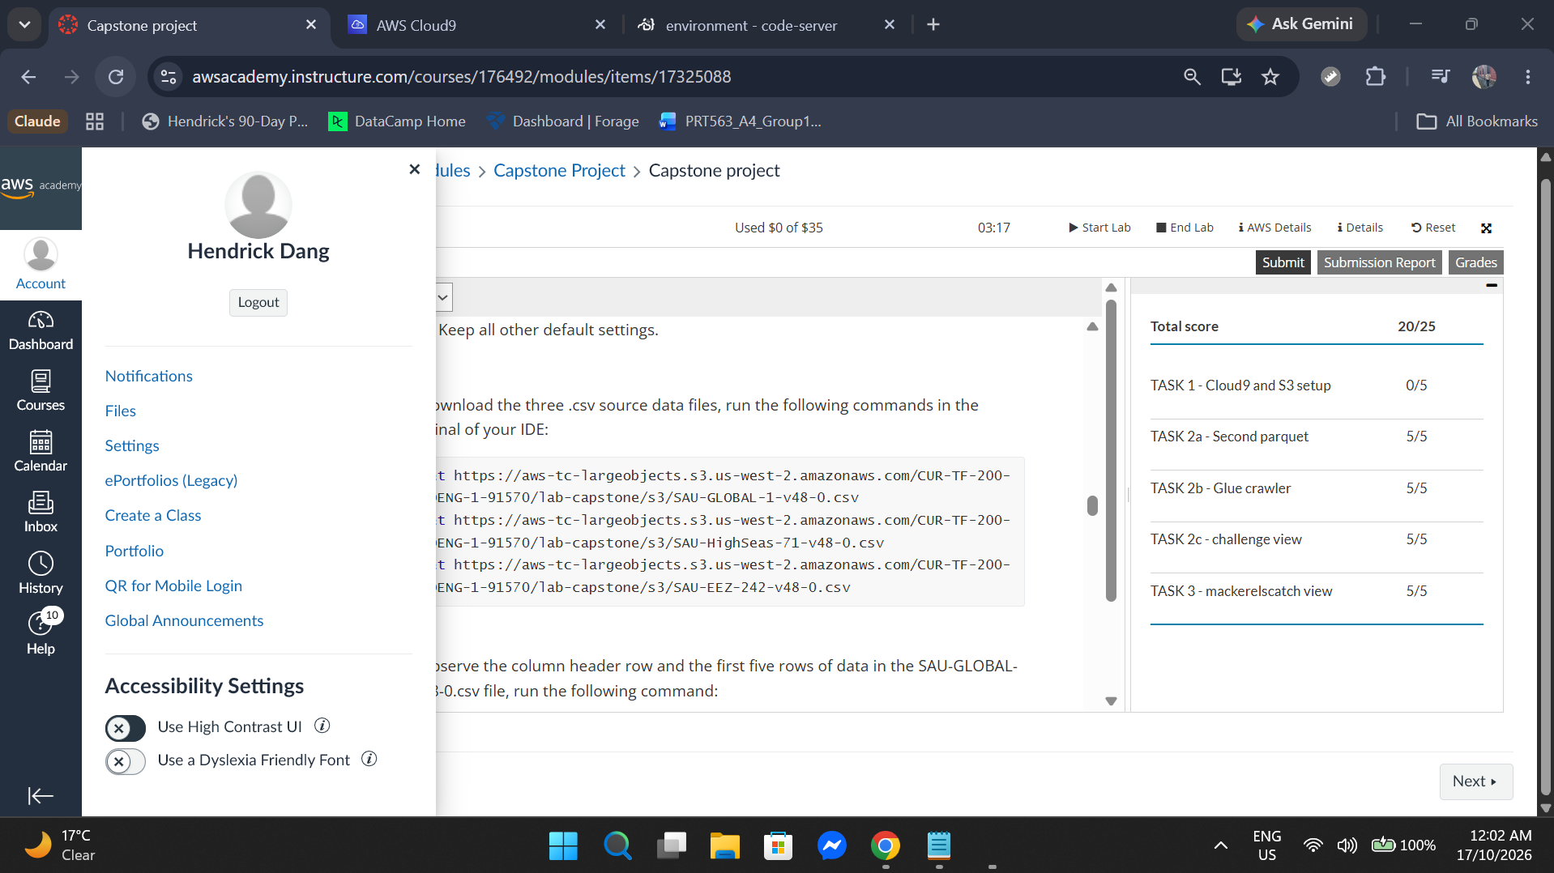
AWS Academy Data Engineering, Capstone project: submitted, score 20/25, 17 October 2026, 12:02 am.
3. Individual Project Contribution
Since Assessment 2 I owned the analytics, evaluation and forecasting work. After Will's audit found that two features came from the target month, I lagged them, rebuilt the backtest so every forecast uses only data known on its forecast date, and redesigned the alcohol comparison on identical rows. I then wrote forecast.py (1 to 12 month forecasts with 80% intervals, saved models and the 2026 check) and monitoring.py, which implements Emma's monitoring design and blocks failed forecasts from the dashboard, and added the forecast and monitoring views to the dashboard and hosted it. I documented every change in the README, CHANGELOG and assumption log, fixed a reference environment so results reproduce exactly, presented slides 12 to 16 in Assessment 3, and administered GitHub and Jira, including restoring Jira access.
Commits: commits by HendrickDang
Feature-timing fix: commit 9fa44d8
Forecast stage: commit 1bc597f
Monitoring script: monitoring.py on GitHub
Change log: CHANGELOG.md
Jira issues: SCRUM-14 (model training and validation), SCRUM-19 (pipeline testing and report)
4. Brief Professional Reflection
The most significant work since Assessment 2 was correcting the feature timing and then turning the evaluation into forecasts that PFES could use. The main challenge was that the correction made every result worse, and XGBoost gave different numbers on Windows and Linux. I addressed this by reporting the corrected figures openly, fixing one reference environment and checking that every output reproduces byte for byte, and by testing whether the conclusions still held, which they did. The 2026 check was a further lesson, because the simplest models did best on the newest data. My contribution supported the project by giving the dashboard and the report one trusted set of forecasts, saved models and documented results.
AWS Capstone issue (Task 1, Cloud9). Task 1 asks for an AWS Cloud9 environment, but creating one failed with an access-denied error "with an explicit deny in an identity-based policy". Restarting the lab and retrying gave the same error, so I completed the other tasks (all passed) and reported the block to the coordinator, since a student cannot remove an AWS Academy deny. As when my first Streamlit build of the dashboard failed on the Python version, I learned to trace an error to its source before changing my own work.
- Student Information
Name: Thi Xuan Thanh Tran (Emma)
Student ID: S389244
- Individual Capstone Project Completion Evidence

AWS Academy Data Engineering, Capstone project: submitted, score 20/25, 17 October 2026, 12:26 am. Task 1 lost 5 marks only because the grader looks for an AWS Cloud9 environment that the lab account is not permitted to create (explicit deny); all other checks passed.
- Individual Project Contribution
Since Assessment 2, I wrote the deployment and monitoring design documents, which define how the system is run, released and rolled back, and the PASS, WARN and FAIL checks applied after each data release; monitoring.py now implements them. I then checked the code against the design and the Assessment 3 feedback. In monitoring.py I added a clear stop when the evaluation outputs are missing and documented which months the release checks score. In the dashboard I removed the model refit on page load, so the Administrator Portal no longer waits for training, and replaced causal and prescriptive wording with descriptive text. I also coordinated the Assessment 3 and 4 reports and presented slides 7 to 11.
Commits: commits by EmmaTran56
Monitoring design: commit d15b5c0 and commit 8981221
Documents commit: my changes to documents/
Dashboard (A3 feedback): commit 5993395
Jira issue: SCRUM-18 (monitoring and retraining logic)

- Brief Professional Reflection
The most significant work since Assessment 2 was turning our deployment and monitoring plans into designs the system now follows, and then checking that the code and dashboard matched them. The main challenge was setting thresholds before much new data existed; I based them on the backtest and planned to review them after each release, and the 2026 check became their first test. Reviewing the dashboard against the Assessment 3 feedback taught me that wording is part of a model’s validity: a sentence that implies a causal effect claims more than the evidence supports. My contribution supported the project by making the system runnable, checkable by someone other than its author, and honest about its limits.
            - Student Information
Name: Ngoc Anh Nguyen (Will)
Student ID: S386805
            - Individual Capstone Project Completion Evidence
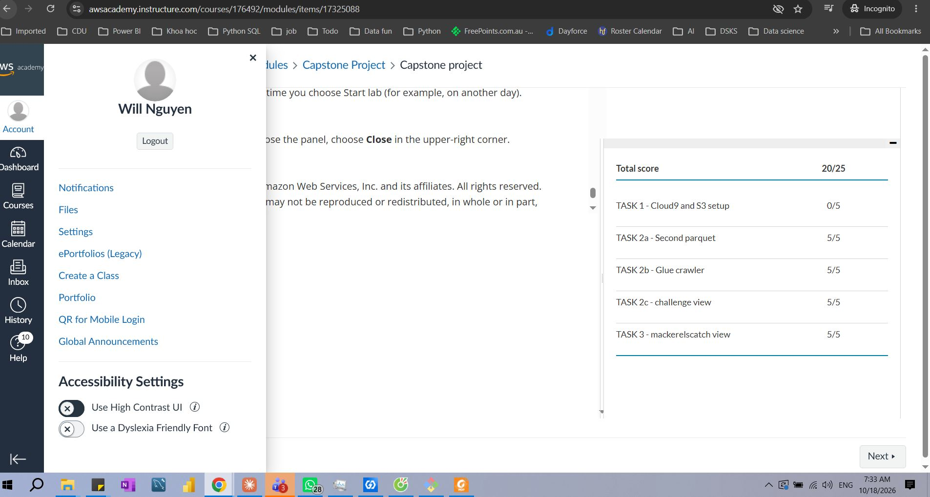
AWS Academy Data Engineering, Capstone project: submitted, score 20/25, 18 October 2026, 07:33 am. Task 1 lost 5 marks only because the grader looks for an AWS Cloud9 environment that the lab account is not permitted to create (explicit deny); all other checks passed.
            - Individual Project Contribution
Since Assessment 2 I built a read-only data lineage, reproducibility and leakage audit (pull request #8). It traces every row from 55,146 raw crime rows to the 696-row model panel, fingerprints each source file and checks whether each feature is known at forecast time. Its findings led to the feature-timing corrections in Section 3 (5.1) and the reference environment. I then turned its header-drift finding into an ingest schema check with 17 tests (pull request #9). I also drafted the Assessment 3 deck and presented slides 1 to 6.

Commits: commits by ngocanh8585
Pull request #8: merged audit-a3 branch
Audit commit: a35c1e5 (read-only audit)
Audit report: audit/README.md
Jira: SCRUM board (timeline)
schema check to ingest

            - Brief Professional Reflection
The most significant work since Assessment 2 was the data audit and the ingest schema check that grew out of it. The hardest part of the audit was keeping it read-only while re-running the whole project, which I solved by checksumming every file outside the audit folder before and after each run. Finding that two features overlapped with the target was uncomfortable, because our presented results were too optimistic, but documenting it with evidence let the modelling owner correct it quickly. For the schema check, the challenge was to reject broken files without changing any reported number. My contribution made every reported number traceable to its source and protected from malformed data.
- Student Information
Name: Le Nhat Minh Tran (Thomas)
Student ID: S390789
- Individual Capstone Project Completion Evidence

AWS Academy Data Engineering, Capstone project: submitted, score 20/25, 17 October 2026, 2:35 pm. Task 1 lost 5 marks only because the grader looks for an AWS Cloud9 environment that the lab account is not permitted to create (explicit deny); all other checks passed.
- Individual Project Contribution
Since Assessment 2, I built the Streamlit decision-support dashboard. It has a landing page and two role-based portals: an Administrator Portal for planners (indicators, regional map, staffing priority matrix, seasonal calendar, scenario simulator and briefing export) and a Data Science Workbench for reviewers (assumption log, EDA, PCA, feature selection, tuning curves, Model A and B leaderboard and residual diagnostics). I wrote the shared core_data.py module that loads data and trains the models with caching, a Windows launcher, and presented the system demonstration in Assessment 3.
Commits: commits by thomastran2k2
Dashboard commit: e1c8ec7 (dashboards for two audiences)
Dashboard app: app.py
Portal pages: pages/
Jira issues: SCRUM-15 (dashboard prototype), SCRUM-17 (finalise and deploy the dashboard)

- Brief Professional Reflection
The most important task I worked on after Assessment 2 was creating the dashboard for PFES users. A key challenge was supporting two different audiences while maintaining a single source of data. I solved this by building two separate portals that both connect to the same data and model module, so the information shown remains consistent across both views. This setup meant a fix to the dashboard’s data or models only had to be made once for both portals, although the feature-timing correction still had to be repeated in core_data.py, because it builds the features separately from the pipeline. Through this contribution, I helped make the project's outputs more accessible for non-technical users and ensured there was a clear way for reviewers to understand where the results came from.

