Charles Darwin University
PRT565 Machine Learning, Artificial Intelligence and Algorithms

Assessment 4: Group Report

Fault Detection for Industrial Water Pumps
Using Machine Learning and Deep Learning

DRW Group 2 (Darwin campus)
Group member | Student ID
Van Hoi (Hendrick) Dang | S395598
Avery Doan | S395841
Jane Tran | S395830

Lecturer: Dr Yan Zhang
Due date: 15 October 2026, 22:00 (Sydney time)
Date submitted:
Word count (Sections 2 to 7, excluding tables, captions and references):

We declare that this report is our own work, that all sources are acknowledged in APA 7 format, and that each member completed the sections listed against their name on the next page.

1. Group Information and Project Title
Project title: Fault Detection for Industrial Water Pumps Using Machine Learning and Deep Learning. This report gives the detailed account of the project we presented in Assessment 3. The work was divided as shown in Table A, and each member reviewed the sections written by the others.
Table A. Division of work
Member | Sections | Words
Member 1: Van Hoi (Hendrick) Dang, S395598 | Problem Description and Motivation; Dataset Description; Dataset Analysis, Feature Selection, Preprocessing and Engineering (Sections 2 to 4) | 1,587
Member 2: Avery Doan, S395841 | Choice and Description of the Algorithms: Decision Tree, Random Forest, Naive Bayes, ANN; Hyperparameter Tuning (Sections 5.1 to 5.5 and 5.7)
Member 3: Jane Tran, S395830 | LSTM; Overview of Model Evaluation Measures; Results and Overall Understanding (Sections 5.6, 6 and 7)

The code, the notebook with all outputs, and the data file are included in the submission archive. Every figure and number in this report is produced by that notebook.

2. Problem Description and Motivation
Industrial pumps fail without notice, and when they do the plant stops. Unplanned downtime is expensive because repairs cannot be scheduled, spare parts may not be on hand, and every process downstream of the pump has to wait. Maintenance practice has therefore moved away from fixed service intervals towards condition monitoring, in which sensor data is used to recognise an abnormal machine state as it happens (Carvalho et al., 2019).
Our project asks whether machine learning and deep learning models can recognise an abnormal operating state of an industrial water pump from its sensor readings alone. We frame this as supervised binary classification: each minute of data is labelled either normal or anomalous, and a model learns to tell the two apart. A model that does this reliably would alert a maintenance team the moment a fault appears instead of leaving it to be noticed by hand.
Two properties of the problem shaped every decision in this report. First, failures are rare, so the classes are heavily imbalanced and accuracy is a misleading measure of success (He & Garcia, 2009). Second, the data is a time series, so a model has to be evaluated on a period later than the one it was trained on, or the result says nothing about how it would behave once deployed (Bergmeir & Benítez, 2012). We are also direct, in Section 4.4, about what the models achieve: they detect a pump that has already failed, and they do not predict a failure before it happens.

3. Dataset Description
We used the Pump Sensor Data set published on Kaggle (Nphantawee, 2018). It holds readings from 52 sensors on a single water pump, taken once a minute for five months. The sensors are anonymised, so the dataset gives no physical meaning for any column, and every conclusion below is drawn from the behaviour of the data itself. Table 1 summarises the dataset.
Table 1. Summary of the pump sensor dataset
Property | Value
Rows | 220,320 (one per minute)
Period | 1 April 2018 to 31 August 2018
Features | 52 numeric sensors (sensor_00 to sensor_51), plus a timestamp
Label (machine_status) | NORMAL 205,836 rows (93.43%); RECOVERING 14,477 rows (6.57%); BROKEN 7 rows (0.003%)
Missing values | sensor_15 is 100% missing; sensor_50 35%; sensor_51 7%; all others below 5%

Figure 1 plots the three label counts on a logarithmic axis. A log axis is the only way to show all three bars at once: on a linear axis the BROKEN bar would be too small to see. What we take from the chart is that BROKEN, the event we would most like to model, occurs only seven times in 220,320 rows. Seven examples are far too few for a classifier to learn from, so we merged RECOVERING and BROKEN into a single ANOMALY class. This gives a binary target that is 93.43% normal and 6.57% anomalous.
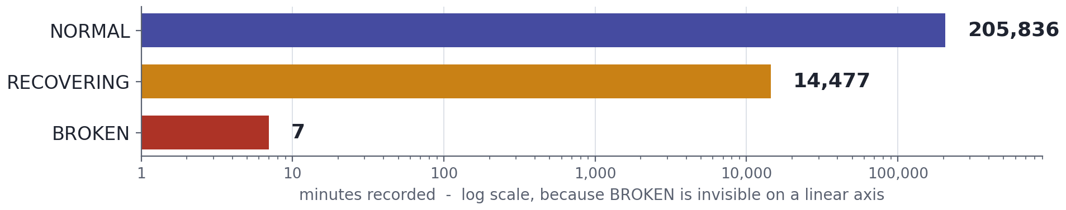
Figure 1. Label counts on a logarithmic axis. BROKEN appears 7 times in 220,320 rows.
The same chart explains our choice of evaluation measures. A model that predicted NORMAL for every row would score 93.43% accuracy and detect nothing. We therefore judge every model on precision, recall, F1-score, ROC-AUC and PR-AUC for the anomaly class, with PR-AUC as the main ranking measure because it is the most informative under class imbalance (Saito & Rehmsmeier, 2015).
Figure 2 shows two of the 52 sensors across the full five months, with anomalous periods shaded. The chart shows that anomalies are not isolated spikes. They form seven continuous episodes, lasting from 42 minutes to 8,391 minutes (almost six days), and in each one the sensor level collapses and stays low until the pump is restored. Two later decisions rest on this observation: light outlier clipping cannot erase an anomaly, because an anomaly is a sustained shift and not a single extreme value, and neighbouring minutes are so similar that short gaps can be filled by interpolation.
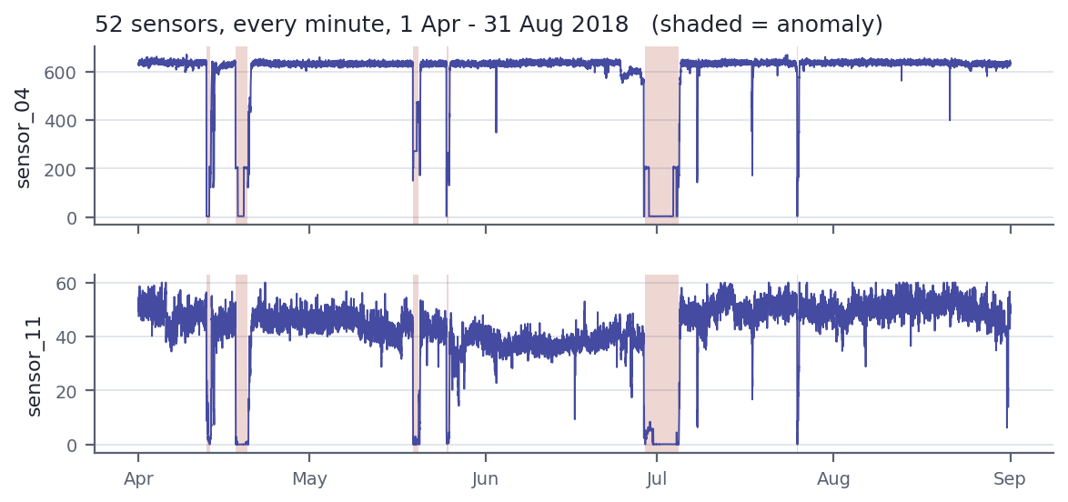
Figure 2. sensor_04 and sensor_11 from April to August 2018. Shaded bands mark the seven anomaly episodes.

4. Dataset Analysis, Feature Selection, Preprocessing and Engineering

4.1 Missing data and feature selection
The left panel of Figure 3 ranks the sensors by missing values. sensor_15 never recorded a value, so it carries no information and was removed. sensor_50 is the more instructive case. At 35% missing overall it looks like a column that could be repaired, but the right panel shows where the gap falls: the sensor is complete throughout the training months and then absent from 9 July to the end of the data, which is 86.2% of the test period.
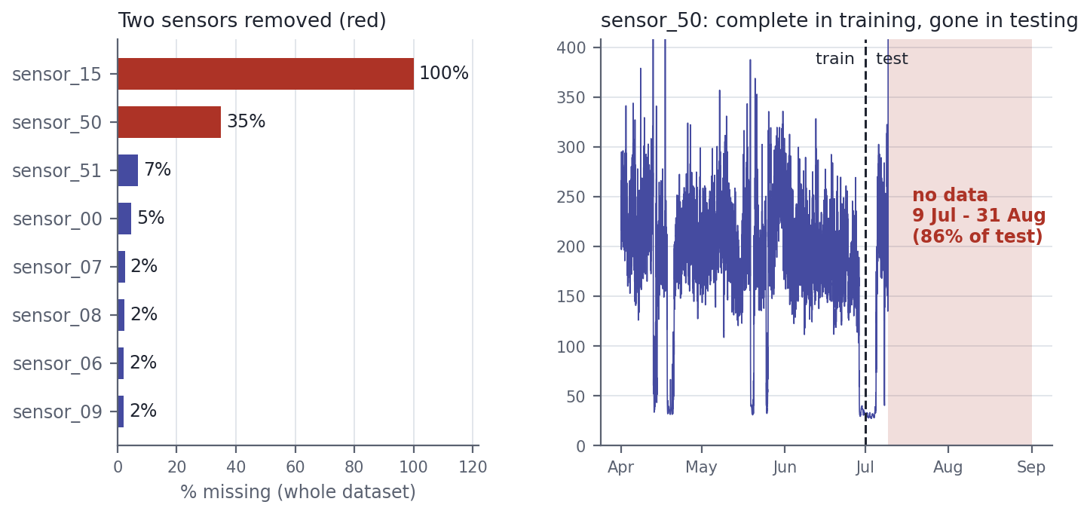
Figure 3. Left: share of missing values for the eight most affected sensors. Right: sensor_50 over time, with the train and test boundary and the 53-day gap.
This is what the chart taught us: the amount of missing data matters less than where it sits relative to the split. Interpolating across a 53-day gap simply extends the last recorded value, which leaves sensor_50 12.1 standard deviations away from its training distribution, against 2.0 for the next worst sensor. A model could learn a rule on that column during training that cannot hold at test time, which is a leakage-type failure in the sense of Kaufman et al. (2012). We removed it. The cost is small, because six other sensors correlate with sensor_50 at between 0.72 and 0.80 and all six are fully recorded in the test period. This left 50 sensors. The remaining gaps are short dropouts, and we filled them by time-ordered linear interpolation in preference to a global mean.

4.2 The train and test split
Because the data is a time series, we split it chronologically, training on earlier months and testing on later ones. Figure 4 shows why the usual 80/20 split cannot be used here. Every anomaly falls between 12 April and 25 July, and August is entirely normal. The last 20% of the rows begins on 1 August and contains 44,064 rows with no anomalies at all, so precision, recall and F1 would be undefined and no model could be evaluated.
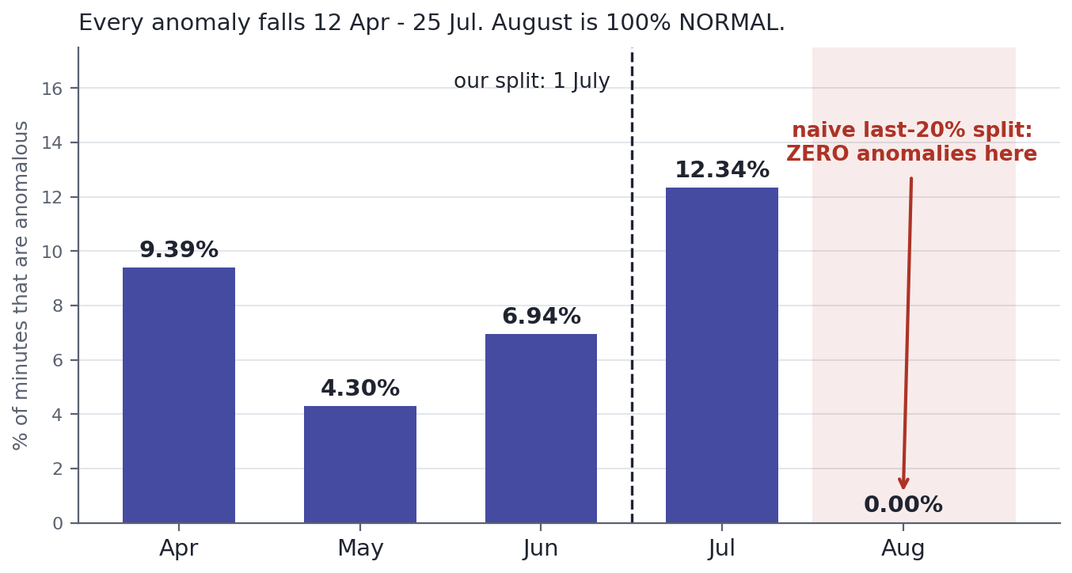
Figure 4. Share of anomalous minutes per month. A naive last-20% test window falls entirely in August.
We split on a fixed date instead, 1 July 2018. This gives 131,040 training rows and 89,280 test rows with anomaly rates of 6.85% and 6.17%, and both sides contain real failures (five BROKEN events in training, two in testing). The understanding we gained from this chart is that a split has to be checked for what it contains and not only for its size, because events in this dataset are clustered in time.

4.3 Transformation and feature engineering
Every transformation was fitted on the training split only and then applied to the test split, so that no information from the test period reaches the models. Extreme values were clipped to the 0.1 and 99.9 percentiles of the training data, and the features were standardised with a scaler fitted on the training data (Pedregosa et al., 2011). Listing 1 shows the relevant code. To counter the imbalance we used class weights of 0.54 for NORMAL and 7.30 for ANOMALY in place of synthetic oversampling, which keeps every training example real.
Listing 1. Outlier bounds and scaling are learned from the training split only
# Outlier clipping: bounds learned from TRAIN only, applied to both splits
lower = train_feat[feature_cols].quantile(0.001)
upper = train_feat[feature_cols].quantile(0.999)
train_feat[feature_cols] = train_feat[feature_cols].clip(
lower=lower, upper=upper, axis=1)
test_feat[feature_cols] = test_feat[feature_cols].clip(
lower=lower, upper=upper, axis=1)

scaler = StandardScaler()
X_train_scaled = scaler.fit_transform(X_train) # fit on train
X_test_scaled = scaler.transform(X_test) # apply to test

For features we kept the 50 raw sensors and added, for each one, a mean and a standard deviation over a backward-looking five-minute window, giving 150 features. The windows only look backwards, so they cannot leak future values. We tested whether these engineered features carry signal instead of assuming it. Figure 5 compares, for each sensor, how far its raw level and its rolling standard deviation move in the 60 minutes before a failure. (This analysis and Section 4.4 use the 51 sensors that remain after removing sensor_15.)
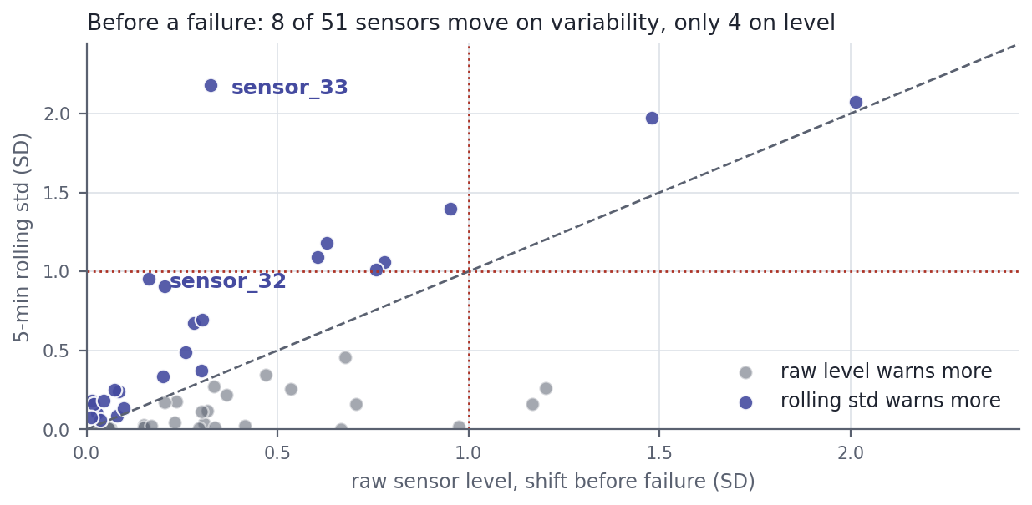
Figure 5. Shift before failure on raw level (x) and on five-minute rolling standard deviation (y). Points above the diagonal warn earlier on variability.
Before a failure, 8 of 51 sensors shift by more than one standard deviation on rolling variability, against 4 on raw level. During the anomaly the pattern reverses: 20 sensors move on level and only 4 on variability. sensor_33 is the clearest example, moving 0.32 standard deviations on level and 2.18 on variability. The chart shows that the two feature families do different jobs. A failed pump settles at a new but stable level, so raw readings make detection easy, while instability before the failure is what carries the limited early warning. That is our justification for keeping both.

4.4 What the label represents
All seven failures follow the same sequence: NORMAL, then BROKEN for exactly one minute, then a long RECOVERING period while the pump is repaired. RECOVERING therefore always comes after the failure, and 14,477 of the 14,484 anomalous rows (99.95%) describe a pump that has already failed. Table 2 compares four sensors before and during an anomaly.
Table 2. Distance from normal operation, in standard deviations, before and during an anomaly
Sensor | 60 minutes before | During anomaly | Ratio
sensor_04 | 2.01 | 10.48 | 5x
sensor_00 | 1.48 | 9.75 | 7x
sensor_06 | 0.78 | 9.34 | 12x
sensor_07 | 0.63 | 12.77 | 20x

The table shows that the sensors which separate a failed pump most clearly are the ones that move least beforehand. During an anomaly 20 of 51 sensors sit more than one standard deviation from normal; in the hour before, only 4 do. The classes are close to separable, so the very high scores reported in Section 7 reflect how distinctive a failed pump looks and should be read as fault detection, not failure prediction.

4.5 Structure in the data without labels
Two further analyses describe the structure of the sensor space. The sensors are not independent: the mean absolute correlation between pairs is 0.27 and only 5.1% of pairs exceed 0.9, but grouping sensors that move together reduces 51 sensors to about 28 distinct groups. This matters for Naive Bayes in Section 5, which assumes independent features.
We also clustered the 50 cleaned sensors with K-means, using no labels, and scored each solution with the silhouette coefficient (Rousseeuw, 1987) and the Davies-Bouldin index (Davies & Bouldin, 1979). Figure 6 shows the result. With two clusters the partition does not match the label at all (best F1 of 0.13). The silhouette peaks at three clusters (0.57), and at that point one cluster is 90.2% anomalous against a base rate of 6.4%, which corresponds to an F1 of 0.93 against labels the algorithm never saw. The supervised Random Forest reaches 0.98.
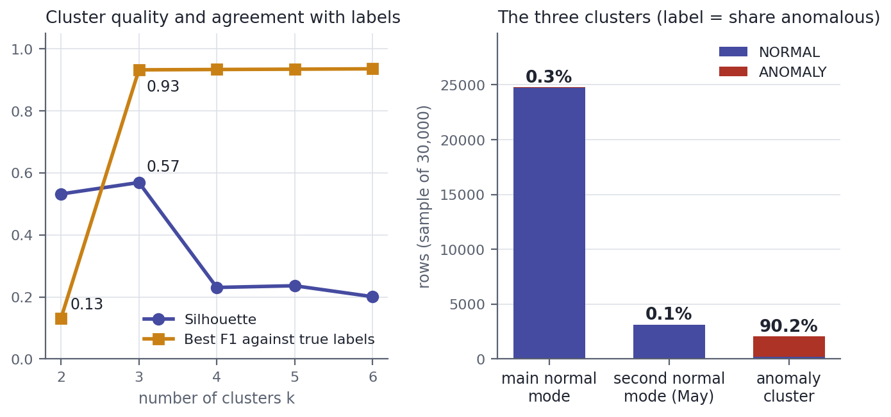
Figure 6. Left: silhouette and agreement with the true labels for k = 2 to 6. Right: composition of the three clusters.
We learned two things from this chart. First, the anomaly state is a real structure in the data and not something created by our labelling, and supervision adds roughly five points of F1 on top of a purely geometric partition. Second, normal operation is not one state. The extra cluster is a second normal operating mode, concentrated in May and driven by a block of sensors between sensor_14 and sensor_25, the same tightly correlated group found above. A pump that changes its normal behaviour over time is a strong argument for retraining a deployed model regularly.

5. Choice and Description of the Algorithms

5.1 Why these models

5.2 Decision Tree
[How a tree splits (Gini impurity). Our settings: max_depth 10, min_samples_leaf 20, class_weight balanced, and why depth is limited. Include its confusion matrix as a figure and state what it shows: how many false alarms and how many missed anomaly minutes.]

5.3 Random Forest

5.4 Naive Bayes

5.5 Artificial Neural Network

5.6 Long Short-Term Memory network

5.7 Hyperparameter tuning with GridSearchCV

6. Overview of Model Evaluation Measures

6.1 The confusion matrix

6.2 Accuracy, precision, recall and F1

6.3 ROC-AUC and PR-AUC

6.4 Decision thresholds

7. Results and Overall Understanding

7.1 Results at the default threshold

7.2 Results at validation-selected thresholds

7.3 Diagnostics

7.4 Limitations and future work

7.5 Overall understanding

References
Bergmeir, C., & Benítez, J. M. (2012). On the use of cross-validation for time series predictor evaluation. Information Sciences, 191, 192-213. https://doi.org/10.1016/j.ins.2011.12.028
Carvalho, T. P., Soares, F. A. A. M. N., Vita, R., Francisco, R. da P., Basto, J. P., & Alcalá, S. G. S. (2019). A systematic literature review of machine learning methods applied to predictive maintenance. Computers & Industrial Engineering, 137, Article 106024. https://doi.org/10.1016/j.cie.2019.106024
Davies, D. L., & Bouldin, D. W. (1979). A cluster separation measure. IEEE Transactions on Pattern Analysis and Machine Intelligence, PAMI-1(2), 224-227. https://doi.org/10.1109/TPAMI.1979.4766909
He, H., & Garcia, E. A. (2009). Learning from imbalanced data. IEEE Transactions on Knowledge and Data Engineering, 21(9), 1263-1284. https://doi.org/10.1109/TKDE.2008.239
Hochreiter, S., & Schmidhuber, J. (1997). Long short-term memory. Neural Computation, 9(8), 1735-1780. https://doi.org/10.1162/neco.1997.9.8.1735
Kaufman, S., Rosset, S., Perlich, C., & Stitelman, O. (2012). Leakage in data mining: Formulation, detection, and avoidance. ACM Transactions on Knowledge Discovery from Data, 6(4), Article 15. https://doi.org/10.1145/2382577.2382579
Nphantawee. (2018). Pump sensor data [Data set]. Kaggle. https://www.kaggle.com/datasets/nphantawee/pump-sensor-data
Pedregosa, F., Varoquaux, G., Gramfort, A., Michel, V., Thirion, B., Grisel, O., Blondel, M., Prettenhofer, P., Weiss, R., Dubourg, V., Vanderplas, J., Passos, A., Cournapeau, D., Brucher, M., Perrot, M., & Duchesnay, E. (2011). Scikit-learn: Machine learning in Python. Journal of Machine Learning Research, 12, 2825-2830.
Rousseeuw, P. J. (1987). Silhouettes: A graphical aid to the interpretation and validation of cluster analysis. Journal of Computational and Applied Mathematics, 20, 53-65. https://doi.org/10.1016/0377-0427(87)90125-7
Saito, T., & Rehmsmeier, M. (2015). The precision-recall plot is more informative than the ROC plot when evaluating binary classifiers on imbalanced datasets. PLoS ONE, 10(3), Article e0118432. https://doi.org/10.1371/journal.pone.0118432
[The highlighted Hochreiter reference is cited only in Section 5.6. Keep it once that section is written. Add any other source Avery or Jane cite, in APA 7 and in alphabetical order, and remove any reference that ends up uncited.]

