Exploring and preparing data with Data Refinery

Log in to your CPDaaS account: <https://eu-de.dataplatform.cloud.ibm.com/>

Navigate to your My AutoAI Experiment project you created as part of the pre-work – you can do that from the home page tile, or, alternatively – by going through the main menu (top left of the screen).

A Project is a collaborative workspace where you work with data and other assets to achieve a particular goal. Your project resources can include data, collaborators, tools, and operational assets that run code, like notebooks and models. Projects allow you to work with different analytical tools and IDEs built into the platform, and will spin up and run various runtimes, environments and jobs as/where needed.

Download the .zip file from the following folder: <https://github.ibm.com/Hendrik-Loeffel/End-to-End-Data-Science-for-Business-Users/tree/main/DataRefinery>

And extract it on your local machine. You should see two .csv files, namely customer_sat-churn-21.11.21.cvs and customer_profile-spend-21.11.21.csv.

Drag and drop both csv files into the “Drop files here” box under Data – Load

Once the upload finishes, navigate to the customer_profile-spend-21.11.21.csv by clicking the corresponding link in the Data Assets section

Cloud Pak for Data allows you to preview the data in your data asset. This applies to both files that you physically load to projects and catalogues, and to “Connected assets” – files and tables residing in remote data sources (that you can connect to Cloud Pak for Data using a wide range of standard connectors through “Connections”). In this lab, we will be working with uploaded project files only.

Let’s explore the data further and do some data wrangling. Click the Refine button

The platform will fire up a Data Refinery instance (sandbox) for your file.

[Data Refinery](https://www.ibm.com/docs/en/cloud-paks/cp-data/4.0?topic=data-refining) is a built-in data wrangling and data preparation tool available in Watson Studio. It helps reduce the amount of time it takes to prepare data for analysis and data science and allows you to cleanse and shape tabular data with a graphical flow editor. You can also use interactive templates to code operations, functions, and logical operators (R code is used). With Data Refinery, you can:

* Interactively discover, cleanse, and transform your data with over 100 built-in operations. No coding is required.
* Understand the quality and distribution of your data using dozens of built-in charts, graphs, and statistics.
* Automatically detect data types and business classifications.
* Schedule data flow executions for repeatable outcomes.

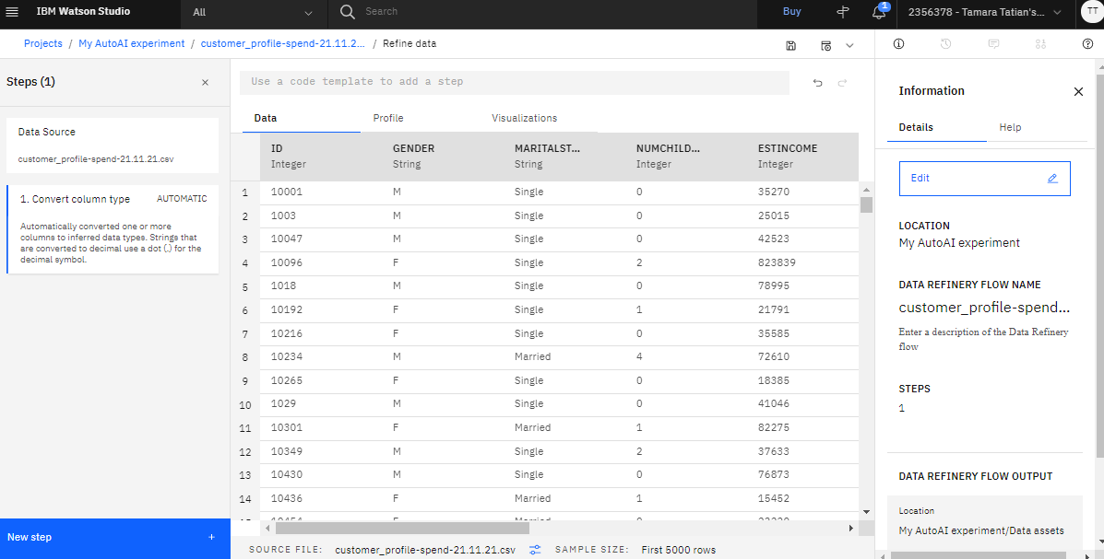

In your Data Refinery sandbox you can explore your data, design data wrangling and cleansing ‘recipes’ (flows) that you can further save and execute as jobs. While you are building your data wrangling recipes, all the transformations and changes are effectively performed in-memory and actual data is not touched at that point. It is only once you choose to execute your flow by running a Data Refinery job that the actual data will be transformed and changed.

On first load, the system may offer you to take a Tour – please feel free to explore or skip it.

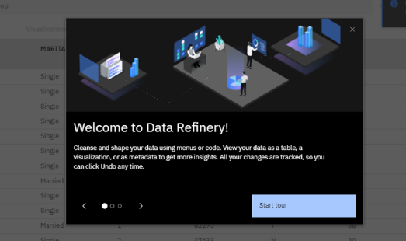

First, let’s explore our data. Minimise the Information and Steps panes on the screen (click X in those sections). Click on the Profile tab above the Gender column title.

The Profile tab shows you statistics and frequency analysis for each of the columns in your data set.

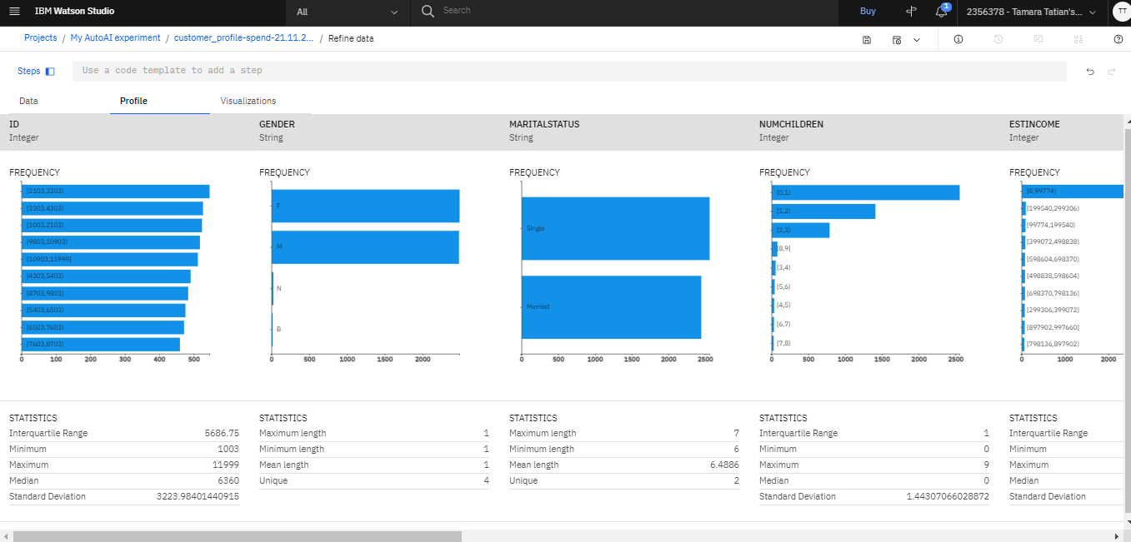

Next, let’s visualize the data to try to explore and understand it a bit more. Navigate to the Visualizations tab above the Gender column title. Select GENDER as your first column, and add AVGMONTHLYSPEND as your second one, then click the Visualize Data button.

Refinery will automatically suggest the best fit type of visualization based on the data and number of columns that you choose.

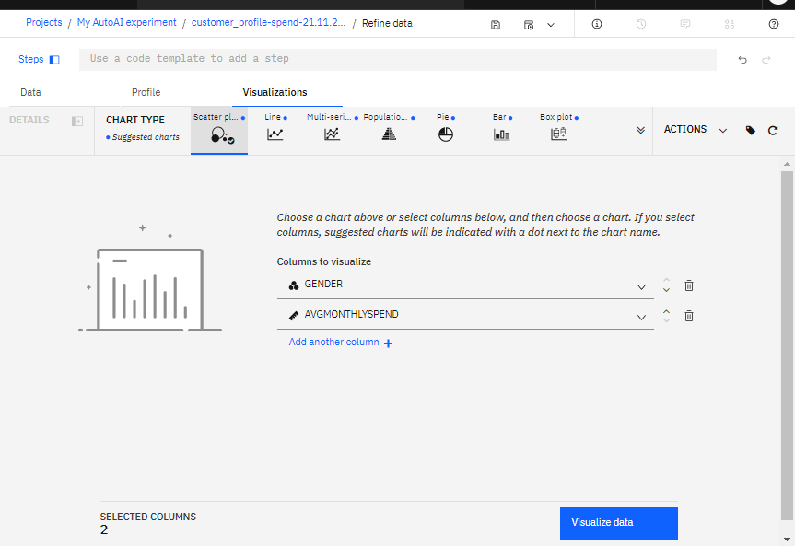

In our case, it picked Scatter plot.

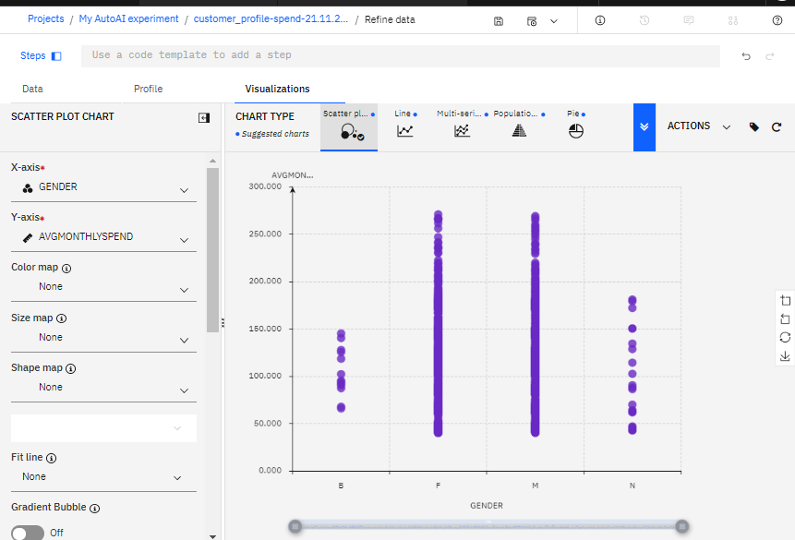

Note that the visualization highlighted to us that in our data set, our customers’ gender data contains not only the more typical F and M values, but also B and N. This may warrant further investigation – there may be issue with data quality, or those could be legitimately valid values, depending on our company’s data governance and capture policies and rules.

Expand the Chart Type menu by clicking on the chevron button. Note that the most suitable chart types are marked with a blue dot next to them. Feel free to switch between them and explore.

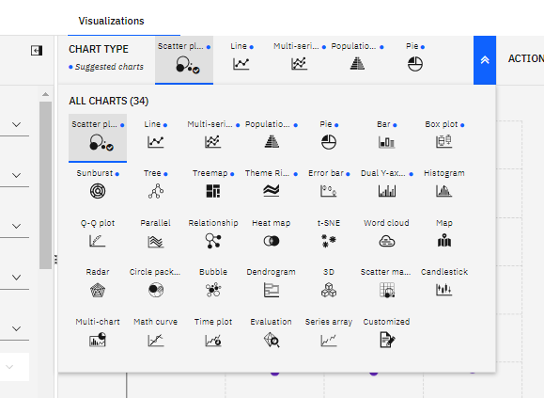

If you wanted to reset the visualization and start over, reset the chart by clicking the Start Over button. Note that you can also save your visualizations as an image.

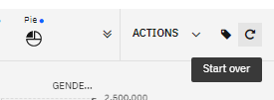

Some more examples of visualizations built using our data set:

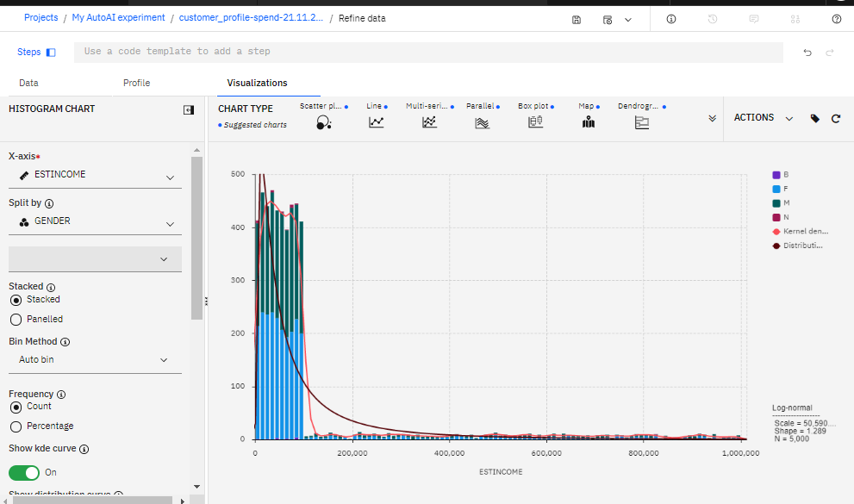

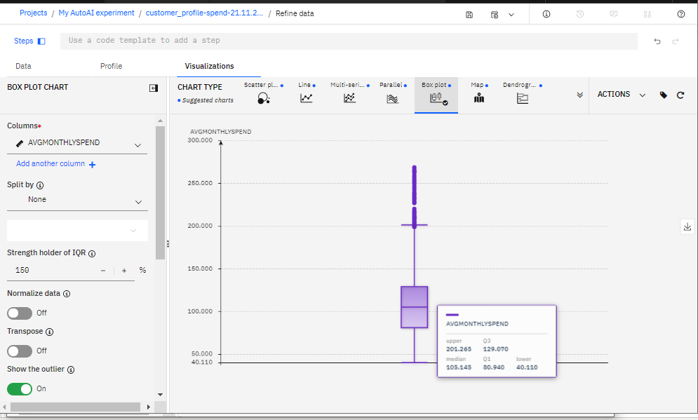

Switch back to the Data tab. We are going to address the GENDER data quality issue, data type/quality issues with some of the columns, create a new feature in our data called TOTALSPEND, and join our data set to the other csv from our project.

Expand the Steps pane.

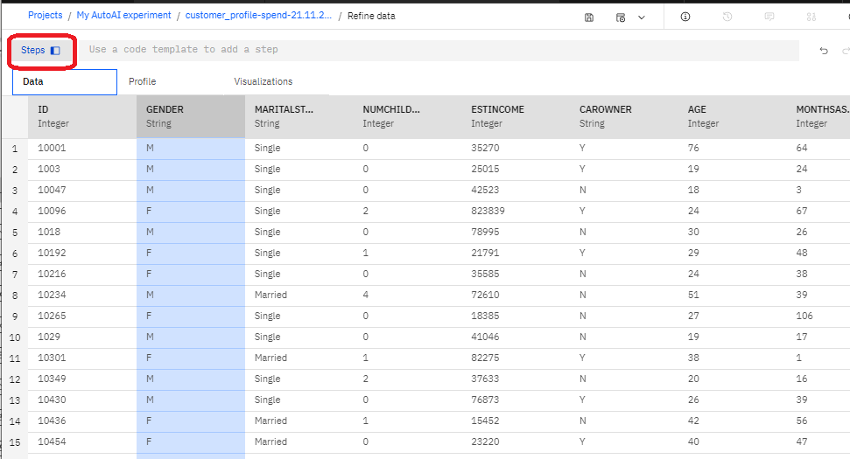

First, let’s get rid of the automated transformation step the tool did for us – Data Refinery can autoconvert column types to the best fit/most suitable ones based on the data they contain. It can prove useful, but because in our case we wanted to join the data set to another one by the ID feature later on, we need to make sure the data types of the ID column match in both of our CSVs – so the original type String would work best for us. Click on the Bin icon next to step – this will remove it. Please note that you can remove any steps we build later on the same way – e.g. if you make a mistake or decide you no longer need them.

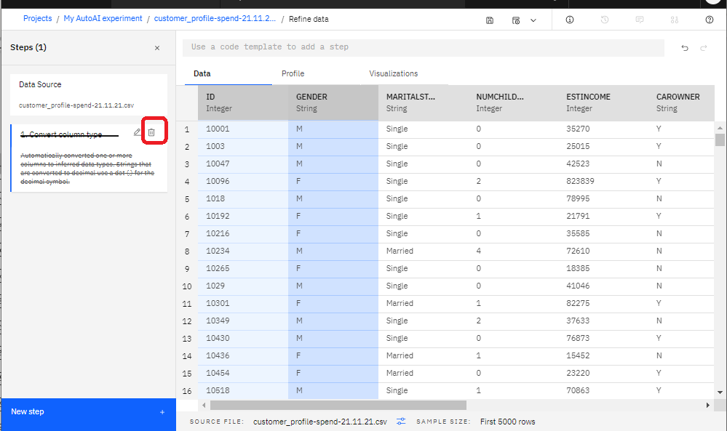

Select Replace Substring from the menu – we are going to replace our B and N entries in the GENDER column with a single new gender type of O, as we happen to know that our company’s data capture rules allow for “Other/Prefer Not to Say” option in addition to F (female) and M (male).

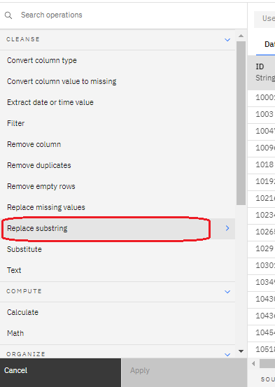

Select GENDER, click Next, switch to Pattern recognition on the next screen and enter the following values:

**Regular expression: [B,N]{1}**

**Replacement string: O**

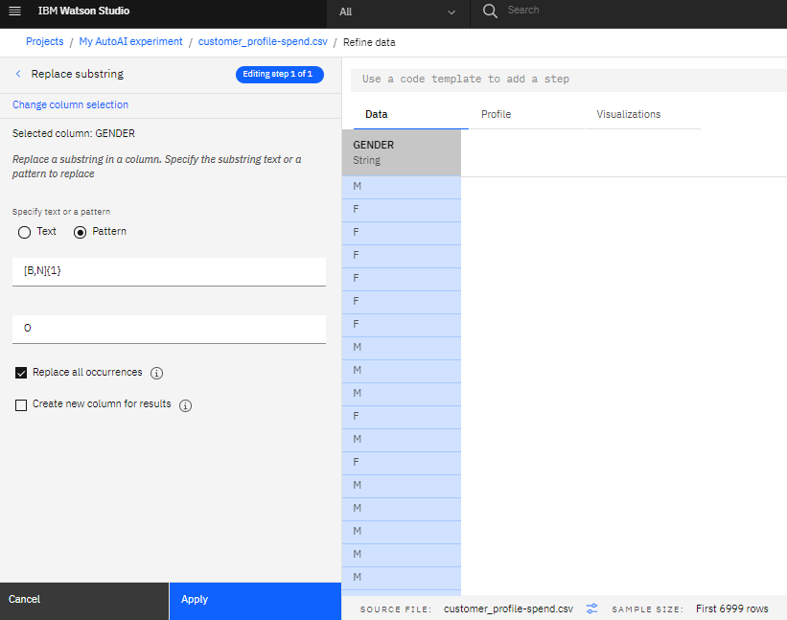

Click Apply – you now have a new step in your data preparation flow.

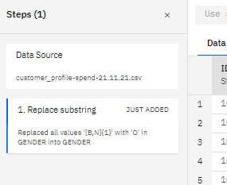

Next, we are going to convert several columns with numerical data to more appropriate data formats. Click on the three dots icon next to NUMCHILDREN column’s title, select Convert Column Type > Integer.

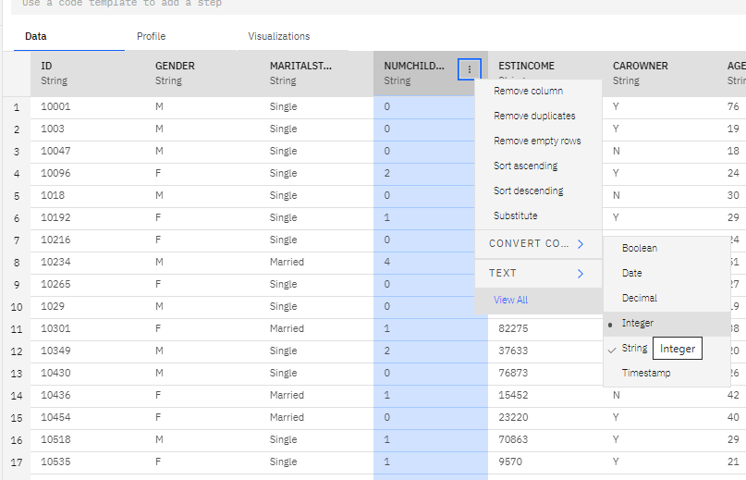

Add more columns on the next screen - click Select Column and add the following conversions:

ESTINCOME – Integer

AGE – Integer

MONTHSASCUSTOMER – Integer

LASTBILLAMOUNT – Decimal

AVGMONTHLYSPEND - Decimal

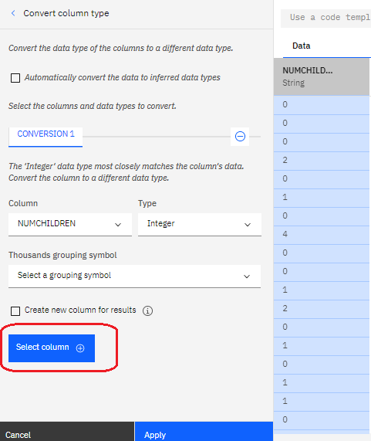

Click Apply. Note how you can immediately see the changes in the preview, based on the transformation steps you are performing.

Next, we are going to create a new feature. Select the AVGMONTHLYSPEND column by clicking on it, then select Next Step – Calculate

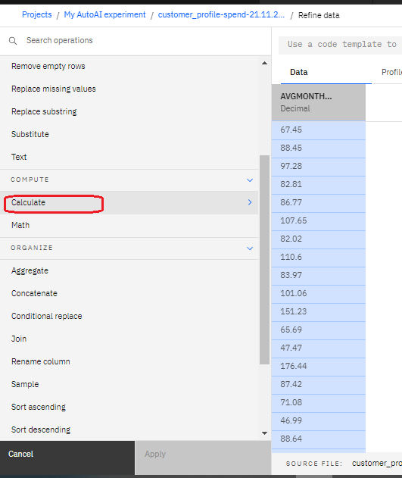

Enter the following on the next screen:

Calculation type: Multiplication

By: Column – MONTHSASCUSTOMER

Create new column for results checkbox ticked (yes)

Column name: TOTALSPEND

Click Apply.

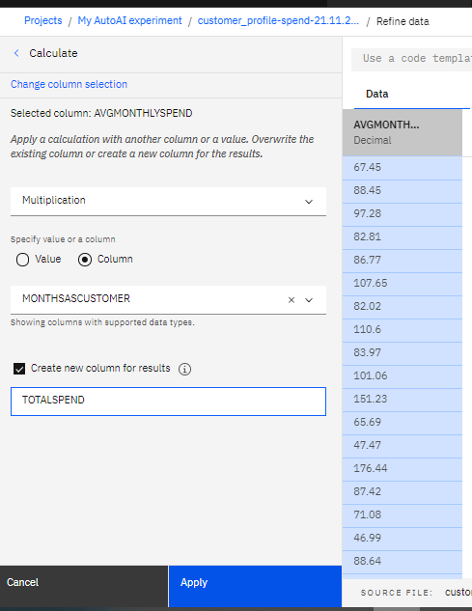Preview now shows: 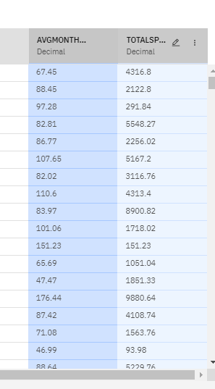

Finally, let’s join our two csvs. We are going to be predicting customer CHURN and building a model for it later on – at the moment, our current data set does not include CHURN data. However, the other csv file we loaded does have it – so let’s join them together.

Click Next Step – select Join from the menu.

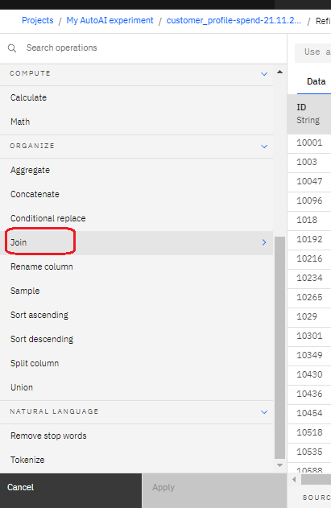

On the next screen, click the Add Data Set link

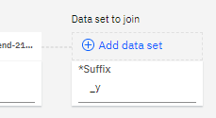

Select customer_sat-churn-21.11.21.csv (Data asset > customer_sat-churn-21.11.21.csv), then Apply.

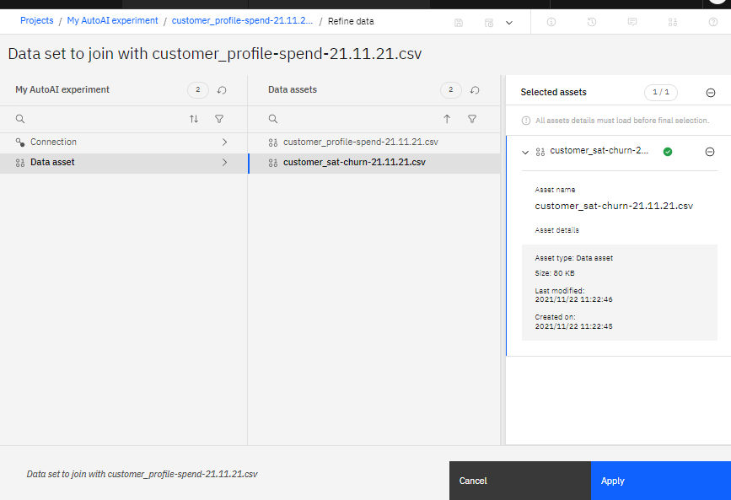

Select ID as join keys for both the files (note that for the join to work both the columns you are using as join keys need to be of the same type – e.g. String and String, or Integer and Integer etc. – the tool will only let you pick columns of the same type once you specify your join key for the first data set). Click Next. On the next screen exclude CAROWNER and SUPPORTCALLSMONTH columns, then click Apply.

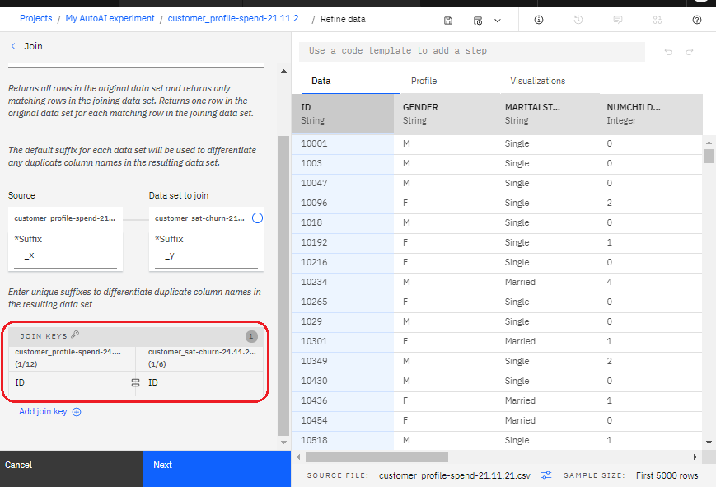

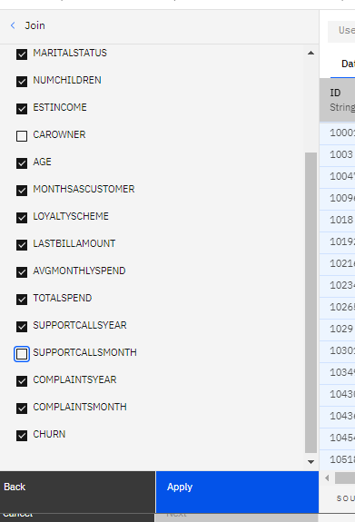

We finished building the data preparation and cleansing flow – let’s now save it and run our shaping job.

First, let’s give it a name and decide how and where we would want to save the output of our shaping flow. Click the i icon to expand the Information pane, then click on the pencil icon next to the data refinery flow name to edit it. Name your flow my_refinery_flow_25.11.21, then click Apply.

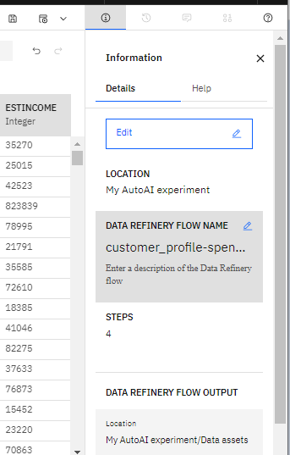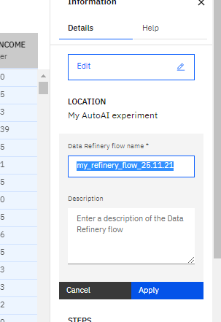

Next, let’s check where and how Refinery is going to output the results of our data cleansing and shaping flow. Click the Edit button, then Edit Output on the next screen

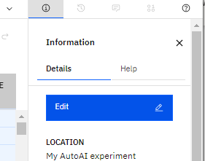

Name your data set customer-profile-churn-joined.csv

By default, Refinery will create a new csv file within your project (a new local data asset in the project). Please note that you can choose other file and format types if/where relevant, and choose to write the results to a connection (remote data source) as well – if you have any defined in the project. We are going to go with defaults - click the tickbox icon once you finish renaming the file, then click the Done button (bottom right of the screen)

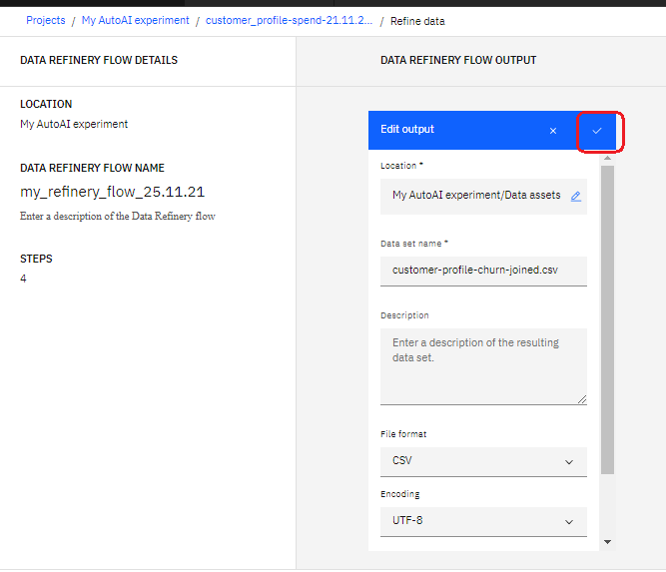

Now, let’s create and run a job that will execute our flow. From the menu on the top right hand side, select Save and create a job.

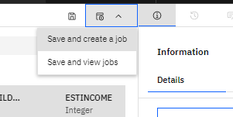

Give your job a name – e.g. “my first Refinery job”, click Next. Review and go with the defaults on the next screen. Note that if you have the Analytics Engine for Spark service deployed as part of your CPDaaS, you can select different environment / runtime configurations and sizes for your Refinery jobs (e.g. create and use larger specs for more complex and data/compute intensive jobs).

Next screen allows you to specify a schedule for your job. We are going to run it as a one-off, but feel free to explore the scheduling options. Disable the schedule before you move to the next screen. On the Notifications screen click next, and then Create and Run on the last screen.  
  
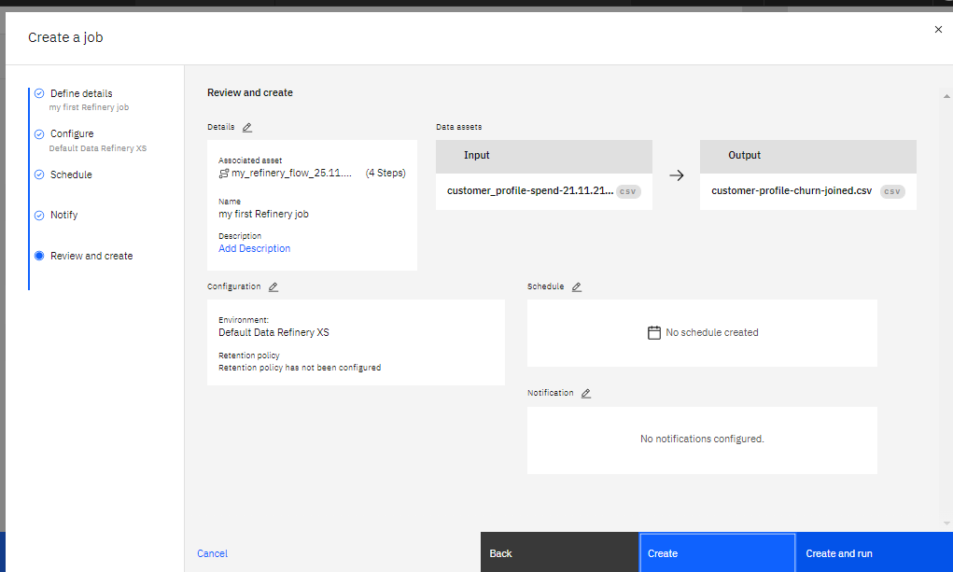

Select save and view jobs – then navigate to your newly created job

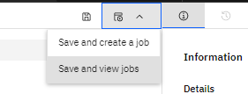

You can monitor its progress, as well as see the logs and execution details.

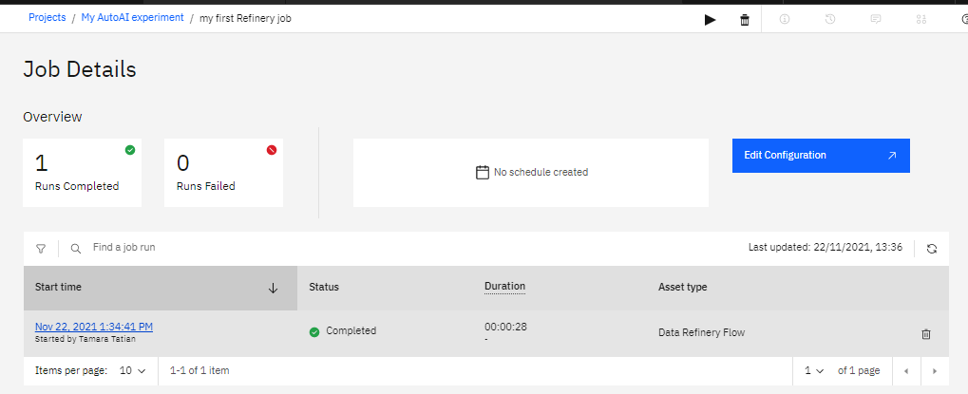

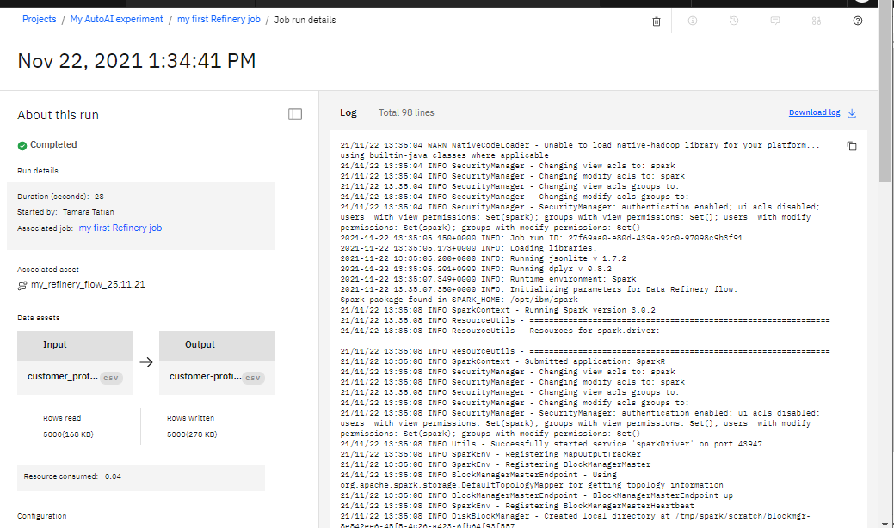

Navigate back to your project Assets view by clicking on the project name

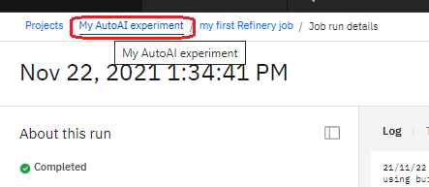

You new data set and flow are now available – please feel free to preview the joined data set.



