Overview

TODO: Short Introduction, Prerequisites etc.

Use-Case

You are a data scientist employed by ABCOnlineRetailXYZ Ltd. The online retailer has not been doing that great lately and has been losing customers to competition. While it is clear that its customer churn rates have been growing, figuring out which customers are more likely to churn is proving hard.

Your manager came by your desk today, gave you a couple of files containing some customer-related data and asked you to build a model helping the business understand which of its customers may churn in the near future, so that Marketing could proactively target them with personalized incentives and discount vouchers.

You have a lot of other work to do and are a short on time, and are in need of inspiration – your Python skills are a bit rusty.  
You are aware that IBM provides market-leading data science tooling and decide to use IBM’s Watson Studio running on CPDaaS to build and test your model.

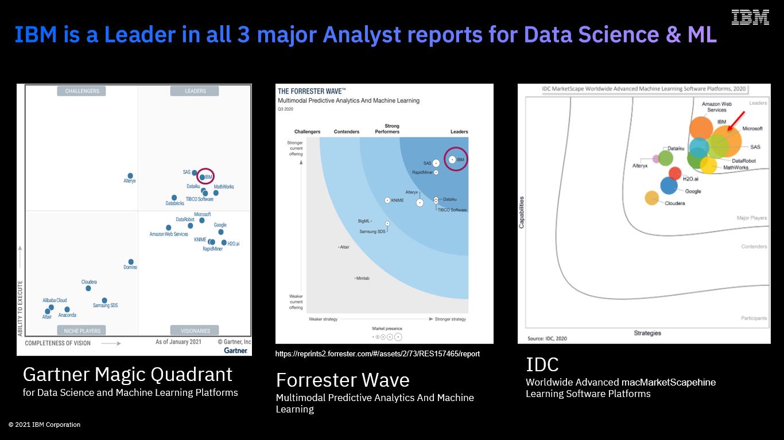

IBM’s position in the market

IBM’s Cloud Pak for Data provides a range of capabilities catering for the whole data science life cycle – from data preparation, to model build, deployment, training and monitoring.

The platform’s Data Science and ML component(s) sit under the Watson Studio branding umbrella. Cloud Pak for Data’s Watson Studio services (Watson Studio / Watson Studio Build, Watson Machine Learning / Watson Studio Deploy, Watson Openscale / Watson Studio Trust) enable the Build, Run and Manage capabilities of the MLOps lifecycle.

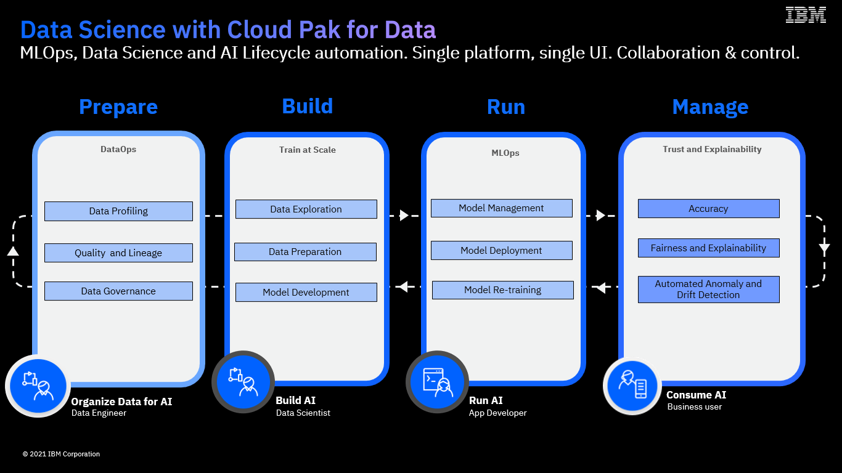

IBMs’ Cloud Pak for Data

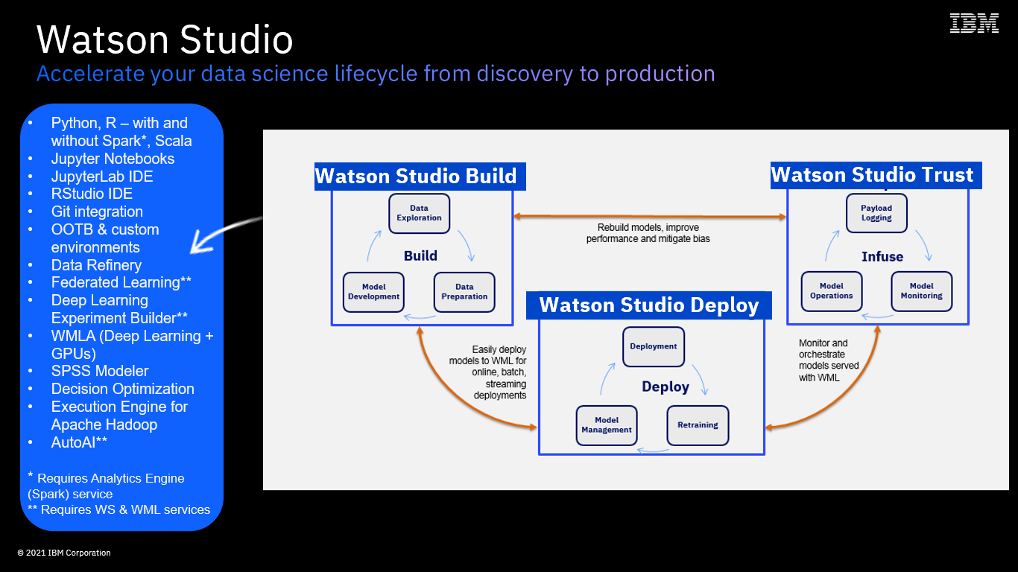

Components of Watson Studio at a Glance

In this Lab, you will:

* Use AutoAI to automatically build the most optimal customer churn prediction model based on your data sets
* And, finally, deploy and test that model with Watson Machine Learning (Watson Studio Deploy capabilities).

… and, your model will be built (for you!) and deployed in minutes - not hours or days!