**PSG COLLEGE OF ARTS AND SCIENCE**

**COIMBATORE 641014.**

**REPORT ON SOCIAL IMMERSION**

**DOMESTIC COMPOSTING AWARNESS**

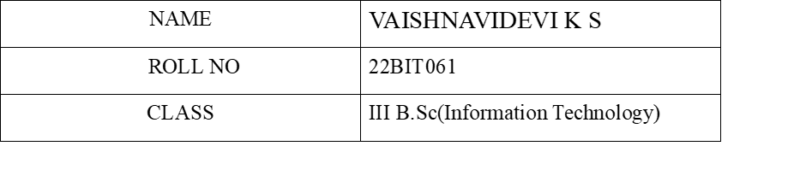

**Brief Summary of the Activity Done:**

1. The questions of whether wastes are segregated before disposal was raised, and then proper awareness was given.
2. Domestic Composting is a natural way of recycling and returning nutrients to the end soil. Awareness was given about the need and instruction on making it on their own is also given.

1. Gave insight on how it is necessary for the general public to take initiative on the proper separation and disposal of waste for the betterment of the world.

1. Visited some of the homes again and enquired about the usefulness of the decomposition technique we had recommended and if it is being used on a regular basis.

**NAME**: VELUMANI S

ADDRESS: Peelamedu,

Gandhi managar, Coimbatore,

Tamil Nadu 641004,

India.

**GEO TAGGED PHOTOS:**

