## DEPARTMENT OF INFORMATION TECHNOLOGY PSG COLLEGE OF ARTS & SCIENCE

An Autonomous College-Affiliated to Bharathiar University

Accredited with 'A++ ' Grade by NAAC (4th cycle)

College with Potential for Excellence

(Status Awarded by the UGC)

Star College Status Awarded by DBT-MST

An ISO 9001 : 2015 Certified Institution.

Coimbatore-641 014

**CERTIFICATE**

This is to certify that this internship work entitled "**APPLICATIONS OF SOIL MOIST SENSOR IN IoT**" is a bonafide record of work done by **Vaishnavidevi K S (22BIT061)** in partial fulfillment of the requirement for the award of Degree of **Bachelor of Science in Information Technology** of Bharathiar University.

**Faculty Guide Head of the Department**

Submitted for Viva-Voce Examination held on_______________________

**Internal Examiner External Examiner**

**i**

**DECLARATION**

I **Vaishnavidevi K S (22BIT061)** hereby declare that this internship work entitled **"APPLICATIONS OF SOIL MOIST SENSOR IN IoT"** is submitted to PSG College of Arts & Science (Autonomous), Coimbatore in partial fulfilment for the award of Bachelor of Science in Information Technology, is a record of original work done by me under the supervision and guidance of **Dr P.Prabhakaran MSc(CT), MCA, M.Phil., MBA, MA(Yoga), PFDCE ,Ph.D.,** Assistant Professor, Department of Information Technology, PSG College of Arts & Science, Coimbatore.

This internship work has not been submitted by me for the award of any other Degree/ Diploma/ Associate ship/Fellowship or any other similar degree to any other university.

PLACE : Coimbatore **Vaishnavidevi K S**

DATE : **22BIT061**

**ii**

**ACKNOWLEDGEMENT**

My venture stands imperfect without dedicating my gratitude to a few people who have contributed a lot towards the victorious completion for my internship work.

I extend my sincere gratitude to **Shri. Gopalakrishnan L. Managing Trustee of PSG & Sons Charities** for providing me with the opportunity and conducive environment that enabled the successful execution of my internship work.

I take this opportunity to express my deep sense of gratitude to **Dr. Kannaian T.** **Secretary of PSG College of Arts & Science**, Coimbatore, for granting permission and facilitating the necessary steps that contributed to the successful culmination of this internship.

I deeply offer my sincere thanks to our **Dr. Brindha D. Principal, MSc MPhil PhD MA (Yoga),** for her valuable advice and genuine concern for our students.

I would like to express my sincere thanks to **Dr. Umarani M MCom MPhil PhD Vice Principal** for her unwavering support.

I kindly and sincerely thank **Dr B. Rajdeepa MCA MPhil PhD Head & Associate Professor of the Department of Information Technology** for her whole hearted help to complete this internship successfully by giving valuable suggestions.

I convey my heartiest and passionate sense of thankfulness to my internship Work guide**, Dr P. Prabhakaran MSc (CT), MCA, M.Phil., MBA, MA(Yoga), PFDCE, Ph.D., Assistant Professor,** **Department of Information Technology** for his timely suggestion which has enabled me to complete the internship successfully.

This note of acknowledgment would be lacking its true essence if I didn't extend my deepest gratitude to my parents, friends, and the various individuals who have stood by me. Their steadfast blessings, constant encouragement, generous financial support, and infinite patience have been the cornerstones of my success, making the completion of this endeavour possible.

**iii**

## PSG COLLEGE OF ARTS & SCIENCE

An Autonomous College-Affiliated to Bharathiar University

Accredited with 'A++ ' Grade by NAAC (4th cycle)

College with Potential for Excellence

(Status Awarded by the UGC)

Star College Status Awarded by DBT-MST

An ISO 9001 : 2015 Certified Institution.

Coimbatore-641 014

**CERTIFICATE**

This is to certify that this internship work entitled "**APPLICATIONS OF SOIL MOIST SENSOR IN IoT**" is submitted to PSG College of Arts & Science (Autonomous), Coimbatore, Affiliated to Bharathiar University in partial fulfilment for the award of Bachelor of Science in Information Technology, is a record of original work done by **Vaishnavidevi K S (22BIT061)** during June 2024 to October 2024 of her study in the Department of Information Technology, PSG College of Arts & Science affiliated to Bharathiar University under my supervision and guidance. This internship work has not formed the basis for the award of any other Degree / Diploma/ Associate ship/Fellowship or any other similar degree to any other University,

**Signature of the Guide Signature of the HOD**

Dr. P.Prabhakaran Dr. B. Rajdeepa

Assistant Professor Associate Professor and Head

Department of Information Technology Department of Information Technology

PSG College of Arts & Science PSG College of Arts & Science

Coimbatore -14 Coimbatore -14

**iv**

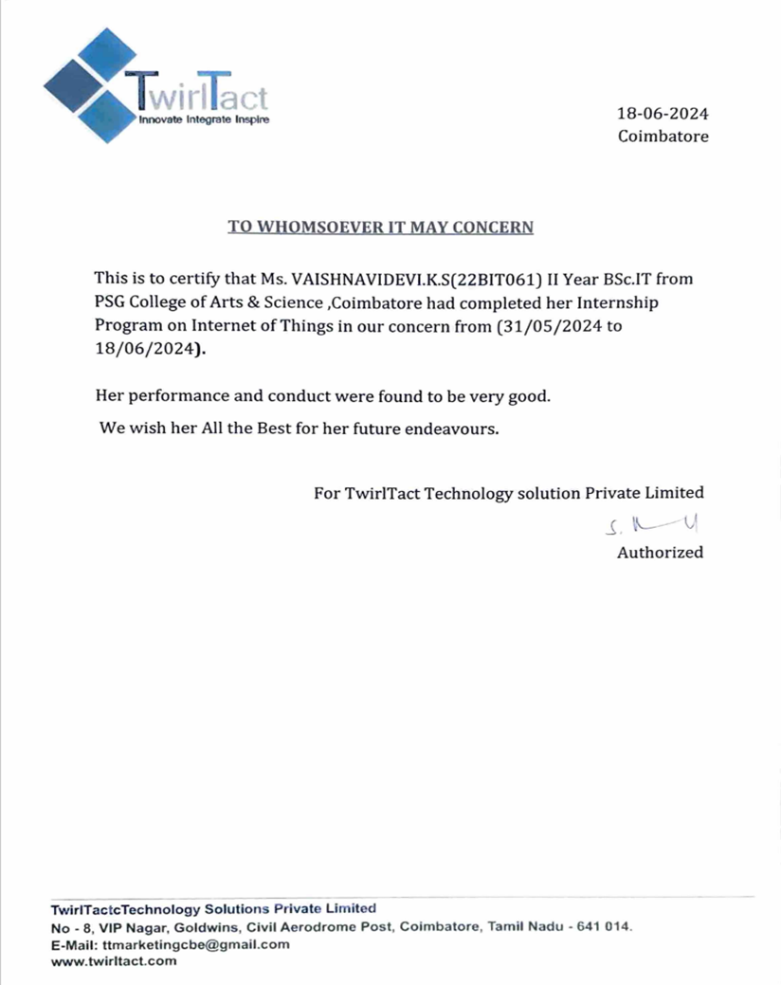

**SYNOPSIS**

During the internship in TwirlTact Technology solutions, acquired both theoretical and practical concepts of IoT. The Internet of Things (IoT) involves a vast network of interconnected sensors that collect, transmit, and analyze data to enable smart systems and processes. Connectivity is a fundamental aspect of IoT, enabling these sensors to communicate effectively across diverse environments.

The aim of project is to develop the “APPLICATIONS OF SOIL MOIST SENSORS IN IoT” by using python programming as an interface and sensor as an input devices and display devices for output. The purpose of this application is to monitor soil condition and crop health for optimizing irrigation.

This abstract discusses the various connectivity technologies employed in IoT. Each technology offers distinct advantages in terms of range, power consumption, and data throughput, tailored to specific use cases such as smart homes, industrial automation, and environmental monitoring.

**v**

**TABLE OF CONTENTS**

**CONTENTS PAGE NO.**

1. **INTRODUCTION** 
   1. **Overview 1**
   2. **Organizational profile 2**
   3. **Contribution to Organization 4**
   4. **Objective 5**
   5. **Module Description 6**
2. **SYSTEM ANALYSIS** 
   1. **Existing system 7**
   2. **Drawbacks of Existing system 7**
   3. **Proposed System 9**
   4. **Advantages of Proposed System 9**
3. **SYSTEM SPECIFICATION**
   1. **Hardware Specification 11**
   2. **Software Specification 13**
4. **SYSTEM DESIGN** 
   1. **Functionalities 14**
   2. **System flow Diagram 18**
5. **SYSTEM IMPLEMENTATION 19**
6. **SYSTEM TESTING 21**

**vi**

1. **CONCLUSION 24**
2. **SCOPE FOR FUTURE ENHANCEMENT 25**
3. **BIBLIOGRAPHY 26**
4. **APPENDICES 27**

**vii**