MATRIMONIAL SITE

Submitted by
HENEL PJ
MCA LE S3
ROLLNO:23

ABSTRACT
This online matrimonial site is mainly developed to let individual find their potential matches for marriage according to their priorities set. This project allows the phrase ‘Marriages are made in heaven’ to be rephrased as ‘Marriages are now made online’. This application allows browsing profiles of those who have registered themselves on this site. This allows individual to give their information such as Name, Gender, Religion, Caste, Marital status, Current salary, Occupation etc. Thus this application allows individual to let others view its profile and also allows it to view others profile depending on the priority set.

MODULES
- Registration-This module helps individual who are looking for marriage to register themselves in order to use the services of this application.

- Create profile-This application allows individual to create profile which includes all the details that he/she wishes to let other registered users to know.
- Prioritize profile-This application allows individual to set priorities according to which the profiles will be displayed to the user.

- Search profile-The individual can search profiles on this site which matches their requirement.

- Chatting-This allows an interested individual to send chats by both of their permission.

USERS:
Premium Account User:
- Registration
- Create profile
- Prioritize profile
- Search profile
- Chatting

Normal User:
- Registration

ADMIN:
- Approve profile: check the genuine of the user.
- View profile

GOOGLE API: The project uses Google Map as API. It is used to locate the groom and bride.

TABLES
Tbl_login
L_id :pk
F_Name | Data Type | Constrains | Description
L_id | Int | Not null | Identify login users
E_mail | Varchar (50) | Not null | Refers from tbl_reg
Password | Varchar (20) | Not null | Check password for success/failure

Tbl_cast
C_id : pk
F_Name | Data Type | Constrains | Description
C_id | Int | Not null | Identify cast
Religion | Varchar (20) | Not null | Add new religion
cast | Varchar (20) | Not null | Add new cast

Tbl_registration
R_id :pk , p_id:ck
F_Name | Data Type | Constrains | Description
R_id | Int | Not null | Identify normal users
Name | Varchar (50) | Not null | Identify users name
Age | Int | Not null | Identify age
Cast | Varchar (20) | Not null | Identify cast
Gender | Varchar (20) | Not null | Identify male or female
P_id | Int | Null | Identify premium users
Address | Varchar (50) | Null | Identify address
occupation | Varchar (20) | Null | Identify job
Education | Varchar (20) | Null | Identify graduation details
Phone no | Int | Null | Contact number

Tbl_payment
B_id :pk , p_id : fk
F_Name | Data Type | Constrains | Description
B_id | Int | Not null | Identify bank id
B_Name | Varchar (50) | Not null | Identify bank name
Account no | Int | Not null | Confirm account
Cvv | Int | Not null | Card verification value
Card no | Int | Not null | Verify card holder
P_id | Int | Null | Refers from tbl_reg

Tbl_chat
P_ide :pk , p_id :fk
F_Name | Data Type | Constrains | Description
P_ide | Int | Not null | Identify sender
Date | Date | Null | Identify chat date
Time | Time | Null | Identify chat time
Description | Varchar(200) | Not null | Message
P_id | Int | Null | Refers from tbl_reg and identify receiver

DATA FLOW DIAGRAM
LEVEL 0

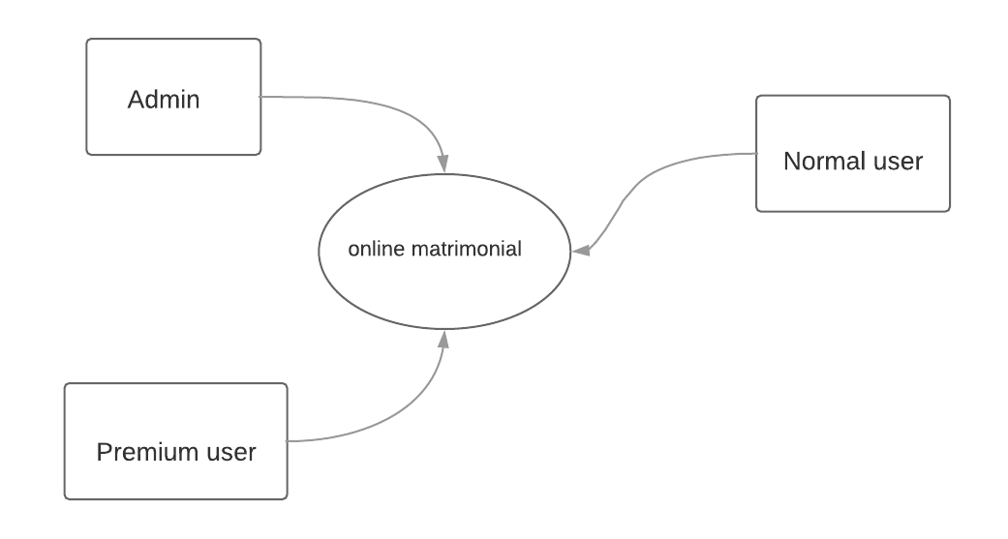

LEVEL 1
NORMAL USER
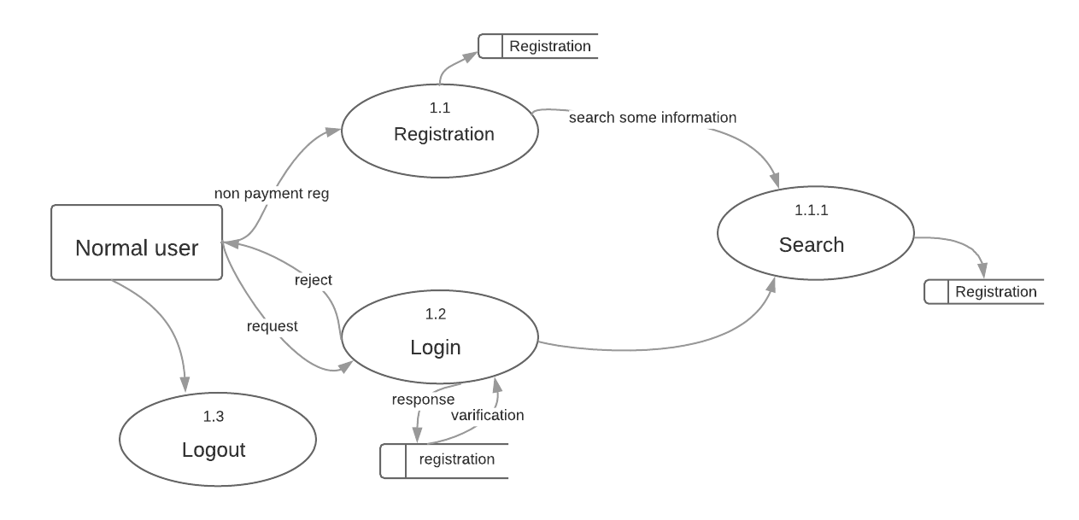

PREMIUM USER
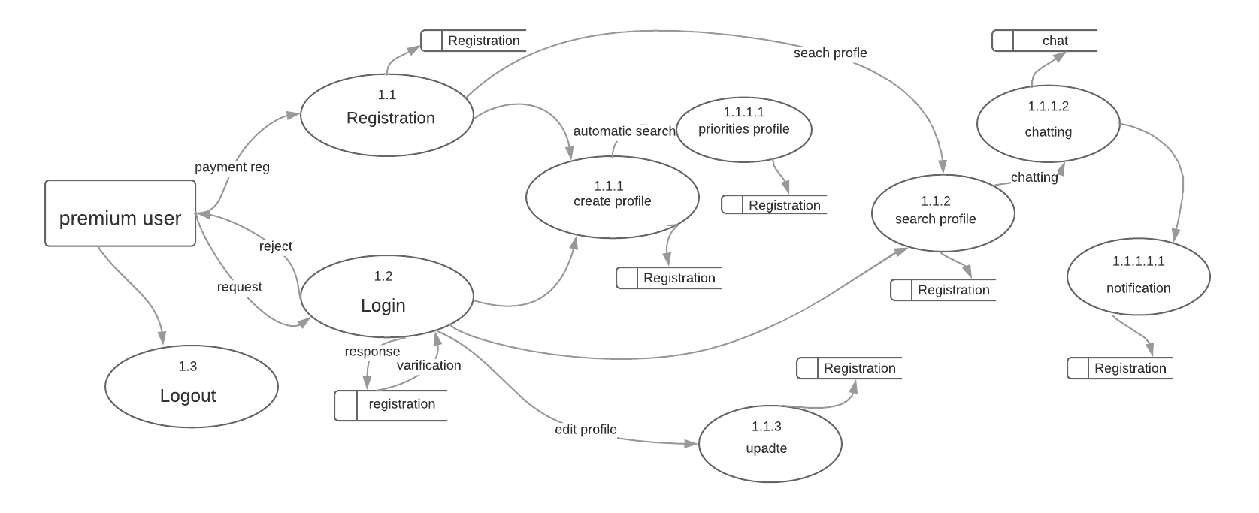

ADMIN
