110700022 陳沂亨 hw1_report

TaskA part1

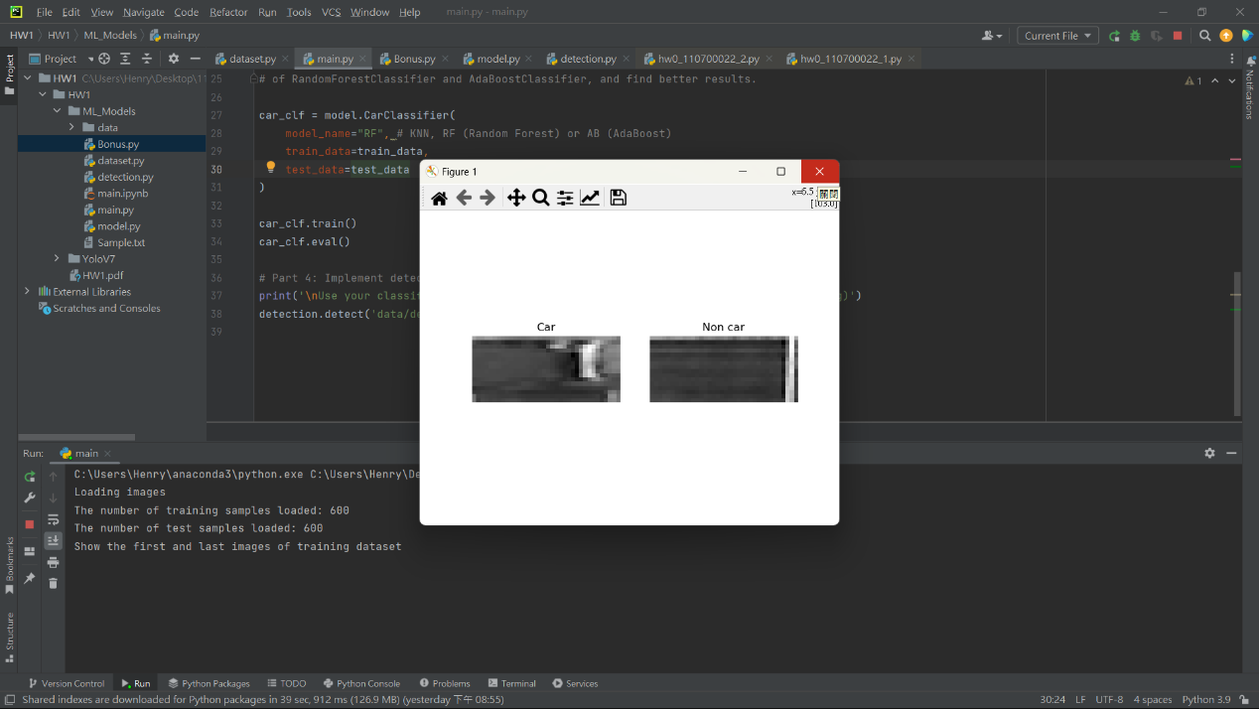

在part1時,先從datapath中讀檔,用cv2將圖片讀入,將其resize成36x16再轉成灰階

然後標記上label後把兩個List轉成tuple,之後將他們zip在一起,這樣dataset就設定好了

TaskA part2

在part2時,init中將傳進來的dataset assign給test和train x和y,

然後在build_model中return 正確的model回去

Q1:

parametric models require we specify some of the parameters before we make predictions.

while non-parametric models don't rely on any parameter setting.

Non-parametric ways of Machine Learning often produce a more accurate results.

Q2:

The basic concept of emsemble learning is combining multiple models to solve the problem and make the performance better than a single model.

bagging: bagging is also called boosstrap aggregating,in bagging,multiple models are trained on different random subsets of the training data,and their predictions are averaged to make the final predictions.This technique can reduce the variance in the predictions and prevent overfitting.

boosting: in boosting,multiple models are trained sequentiallly,with each model trying to correct the errors of the previous model.Boosting can improve the accuracy of the predictions and reduce the bias.

stacking: stacking is a way that use the predictions of multiple models as input features for a higher-level model.The higher-level model learns to combine the predictions of the base models to make the final prediction.

Q3:

n_neighbors in KNN helps we find the numbers of point that are nearest the point we want to predict.

The k values in knn defines how many neighbors will be checked to determine the classification of a

specific query point.

n_estimators in RF specifiy the number of decision trees being built in the forest.

n_estimators in AB specifiy the number of weak learners to train iteratively.

Q4:

The four numbers in the confusion matrix are True Positive(TP),False Positive(FP),False Negative(FN),and True Negative(FN).

TP means that you predict the result as positive and it's true.

TN means that you predict the result as negative and it's true.

FP also called Type 1 error,it means that you predict the result as positive and it's false.

FN also called as Type 2 error,it means that you predict the result as negative and it's false.

Positive or negative is what we predict, and True or False is the actual value of what we want to predict.

Q5:

Precision is calculated:

TruePositives / (TruePositives + FalsePositives)

Recall is calculated:

TruePositives / (TruePositives + FalseNegatives)

Precision is a good measure to determine,when the costs of False Positive is high.

Recall is a good measure to determine,when the costs of False Negative is high.

TaskA part3 find the optimizer

RF(random_state=42, n_jobs=-1, max_depth=7,n_estimators=100,oob_score=True)

With Accuracy 98%.

TaskA part4

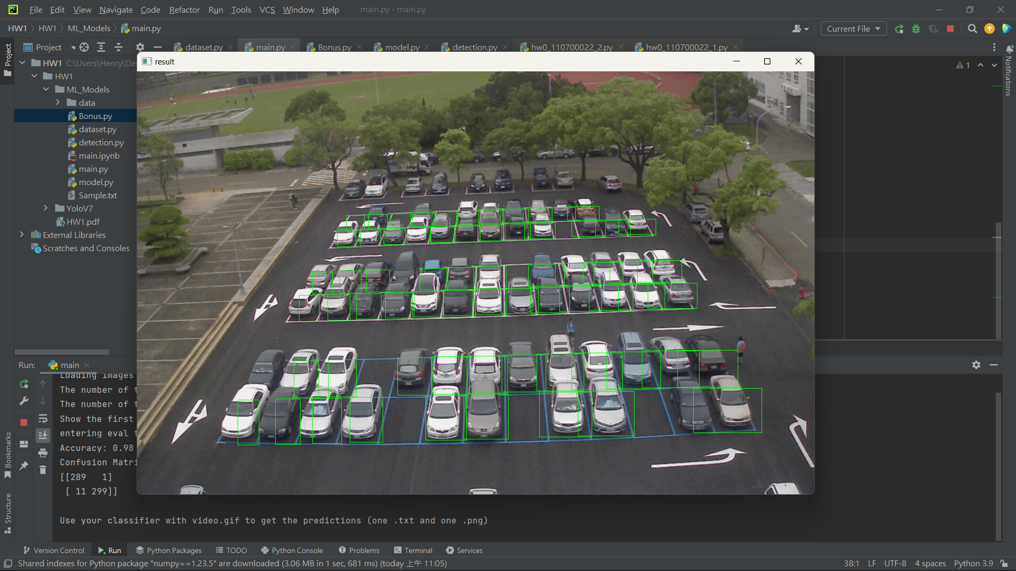

在part4時,先將停車格的座標從detectData.txt中讀進來,並將這些座標存成76組資料在一個List中方便

等一下使用,讀入video.gif,在每一個frame都crop原本的frame,並resize成36x16和轉成灰階,

之後轉成nparray並reshape,之後執行classify執行預測結果,並根據辨識結果用cv2.rectangle畫上綠色長方形

Task B part 1

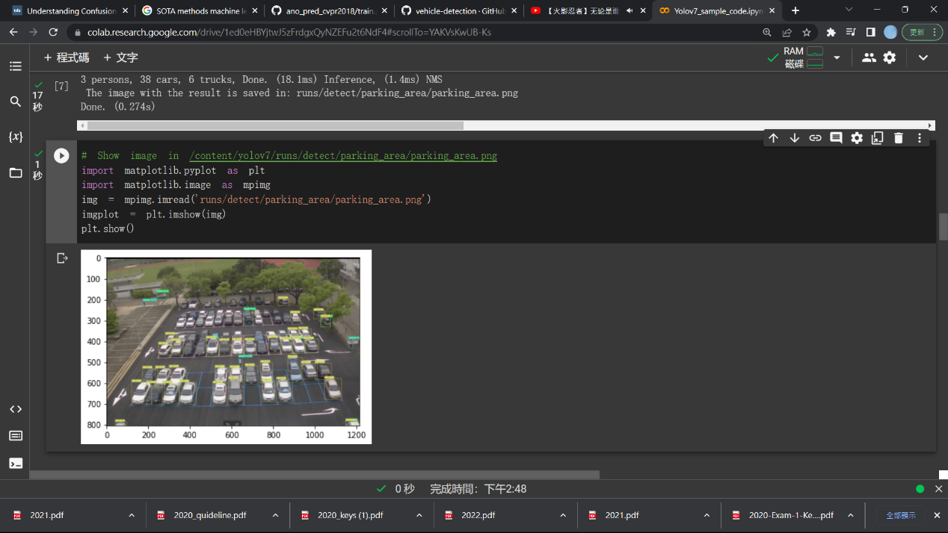

TaskB part2

我在截止日當天的大概9點多時,有用epoch = 100和其他的一些參數調出accuracy大概有91.多%的model,可是後來路徑有點怪怪的重新設定後就跑不出來了,因為時間關係用epochs=100會來不及所以將epochs調低試試看,結果因為太低也沒有辦法跑到預期的結果,只好上傳了,但train跟detect和其他區塊的程式都有完成,希望下次可以把握好時間交出最好的東西

3. Discuss what you observed with accuracy, F1-score and parking slots occupation plot of different methods in the report.

Accuracy:

We have a tradeoff between speed and accuracy,faster achieve lower the accuracy.

F1-score combines the score of precision and recall.

4. Describe problems you meet and how you solve them.

在寫Task A的part 1時,對機器學習所需要的資料格式不夠熟,想了並嘗試了幾次後找到對的資料格式並成功將car non-car顯示出來

part2 時要將傳過去的資料assign給 self.x_test self.y_test...等, 要怎麼將剛剛從dataset丟過來的資料正確assign給訓練和測試集讓我卡了好一段時間,後來上網查到一種寫法剛好實現了我要的寫法,

在寫YOLOV7的時候在設定檔案路徑時卡了一段時間,因為對google colab的操作不是很熟,多碰多失敗了幾次之後就知道檔案路徑要怎麼寫和一些terminal的指令操作