Neural network structure

Input: 5yr-mean 3D-matrix: 64*32*2, \delta TS (64*32)

+ \delta PminusE + wind ? cloud ? TOA energy imbalance try this later

Output: 1*7 vector Aerosol mass at 90, 60, 30, 0, -30, -60, -90 degree

1*7 to higher resolution? Done. 1*14 also works

CAM task1: start from preindustrial, start geoengineering & double CO2 together at yr0, try to keep climate (TS & PminusE) stable at preindustrial. Run model for 30yrs.

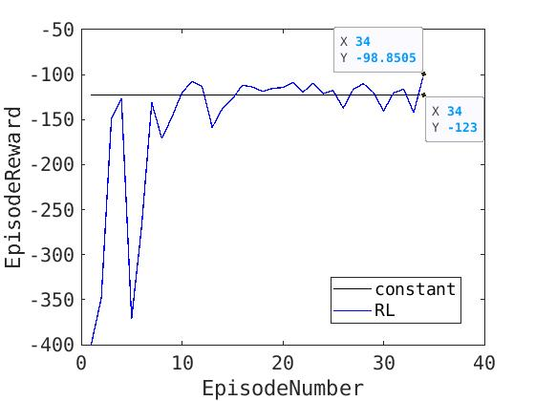

Episode reward: Trained for 34 episodes, RL converges and outperforms reference (constant and uniform SRM) by 20%. Converge around -100 after episode 34

Perturb IC to evaluate the variance of ‘constant reference’ try this later

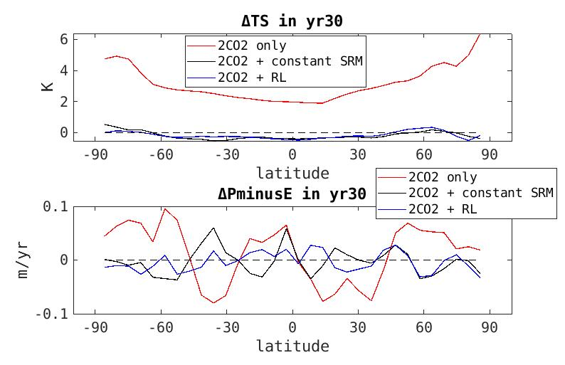

Final climate at the end of a 30yr simulation:

1. Surface temperature: The trained neural network performs as good as reference
2. PminusE: The trained neural network outperforms reference (blue line closer to 0, RL keeps PminusE more stable than reference)

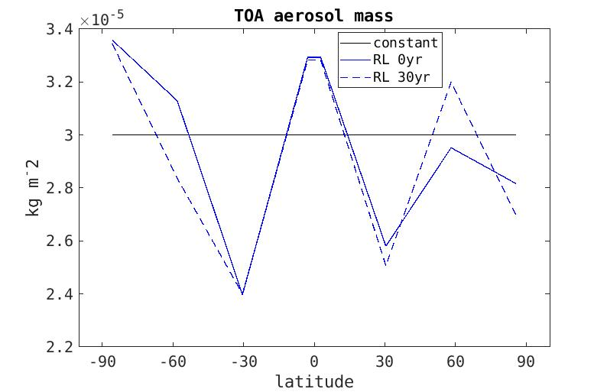

SRM profile:

1. The trained neural network produces similar SRM strategy at beginning and end in a 30yr simulation (because the input climate is always close to initial preindustrial state)
2. The trained neural network thinks **more aerosol in high lat (60, 90) and tropics (0), less at low lat (30)** is better.

Next step:

1. Continue training RL, see whether it becomes better … done
2. CAM task 2: start geoengineering at a warmed climate, cool climate (TS & PminusE) back to preindustrial … done

CAM task2: start from warmed climate (start geoengineering 5 yrs after doubling CO2), try to drive climate (TS & PminusE) back to preindustrial. Run model for 30yrs.

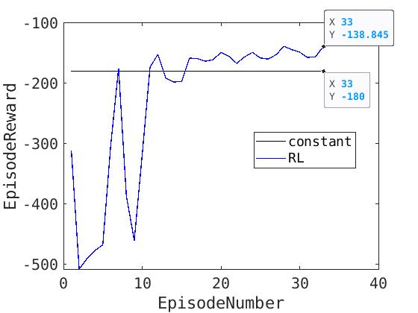

Episode reward: Trained for 33 episodes, RL converges and outperforms reference (constant and uniform SRM) by 20%. Converge around -140 after episode 33

Perturb IC to evaluate the variance of ‘constant reference’ try this later

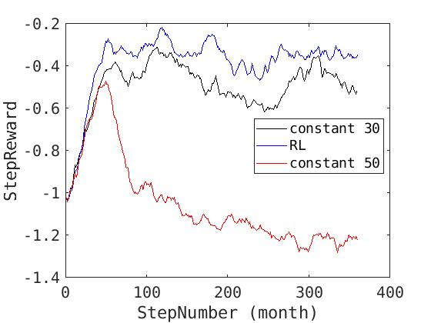

Step reward: see how the trained neural network behaves in a 30yr simulation.

1. Different from the temperature-only geoengineering task, in CAM task 2 (T & PminusE) **different uniform geoengineering strategies (30,40,50μgm*-2) have similar results in the beginning**. 50μgm*-2 can cool T back to preindustrial better than 30μgm*-2, but for T & PminusE combined reward they behave similarly.
2. RL is better than uniform & constant reference policies starting from the 3rd year (StepNumber 25).

Perturb IC to evaluate the variance of ‘constant reference’ try this later

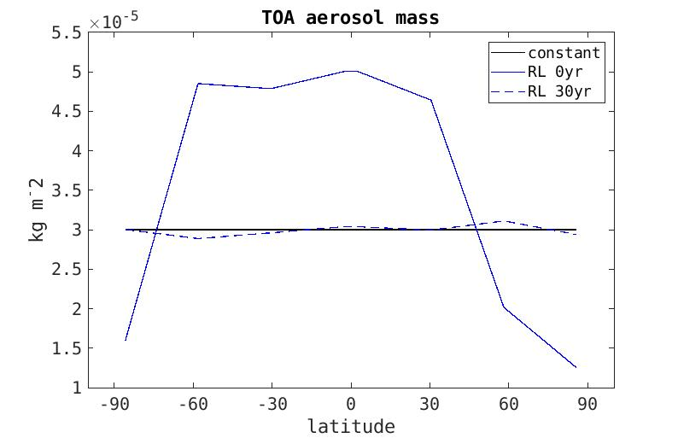

SRM profile: geoengineering actions given by the trained neural network in the beginning and end of a 30yr simulation … **time-varying geoengineering**

1. Beginning: intense geoengineering in low-mid latitudes, less geoengineering near poles
2. End: actually the shape is similar to CAM task 1 (page 2)

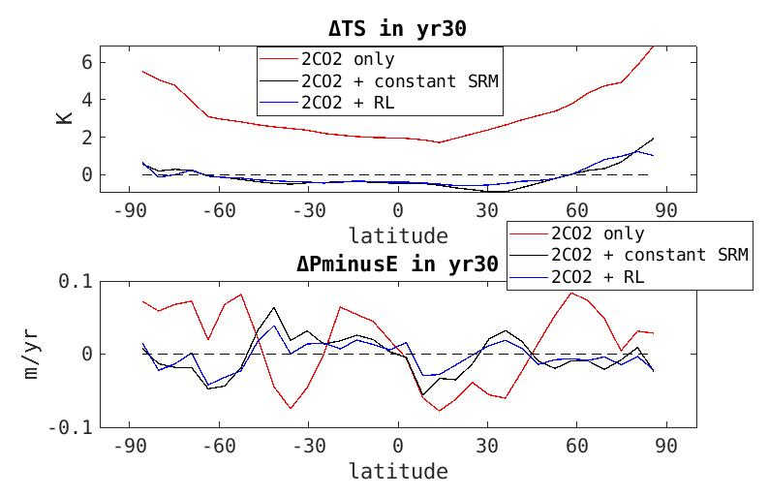

Final climate at the end of a 30yr simulation:

1. Surface temperature: The trained neural network performs as good as reference
2. PminusE: The trained neural network outperforms reference (blue line closer to 0)

Regional geoengineering:

Task 1: Try arctic only…

Arctic: lat > 66 … index 29~32

South Asia: lat index 18~23, lon index 12~18

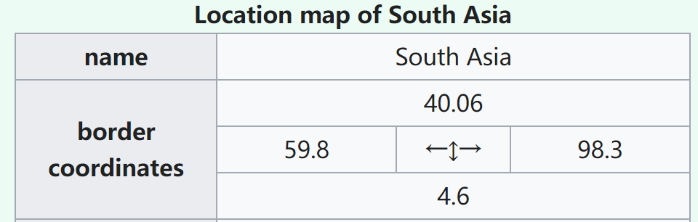

Wet bulb temperature equation:

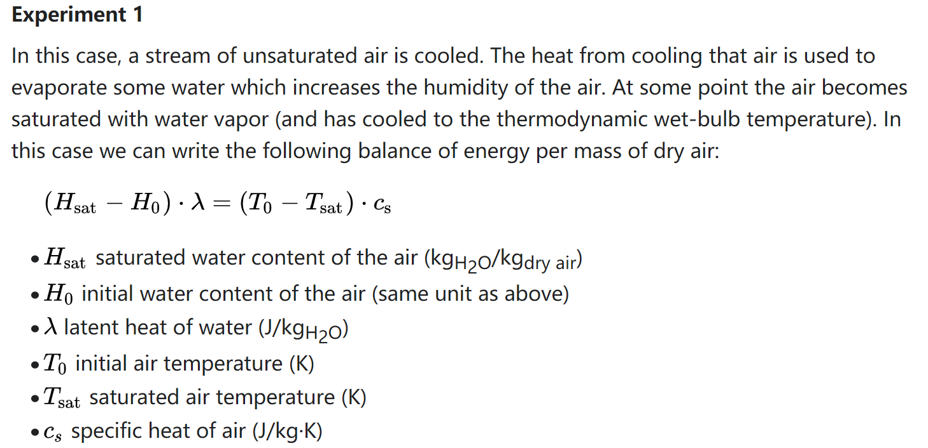

Each region has its own reward (weighted average with a ‘mask’) in unit K

Use them to calculate another final reward (use equal weight)

Regional Geoengineering:

Tropics, -30°~+30°

Similar to task 1, keep T & P-E stable together

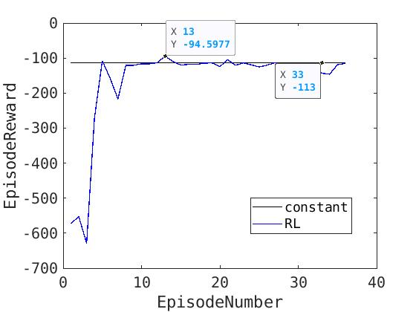

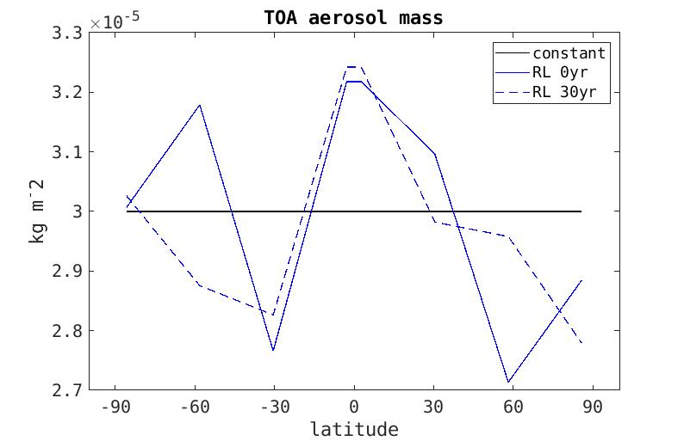

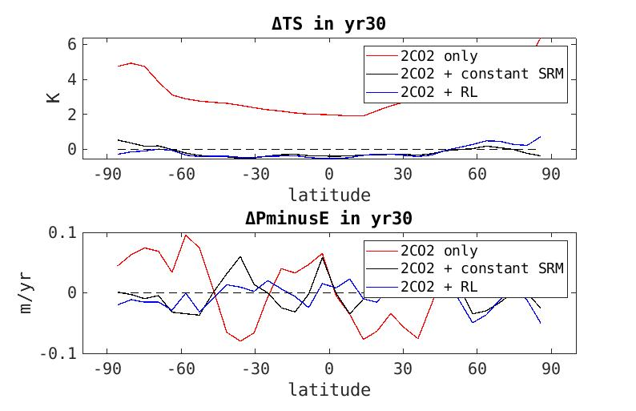

1. Different IC / seed … train again
2. figures