In CAM task 1, actually different SRM profile can have the same effect:

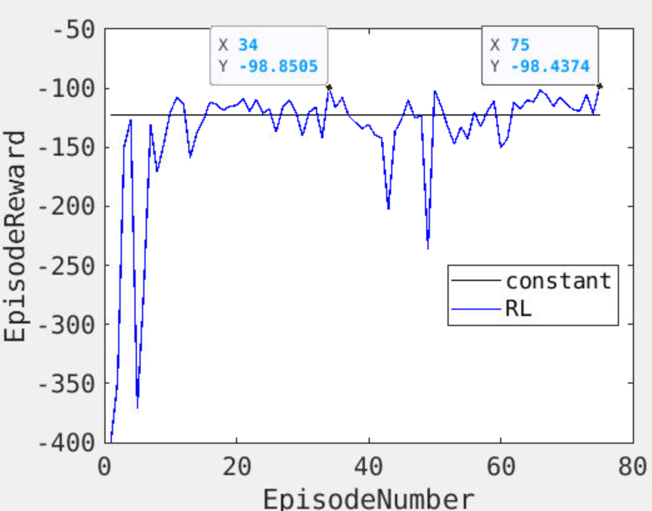

Look at Episode 34 and 75, they have the same episode reward. But their SRM profile are different:

Compare other outputs beside T & PminusE!

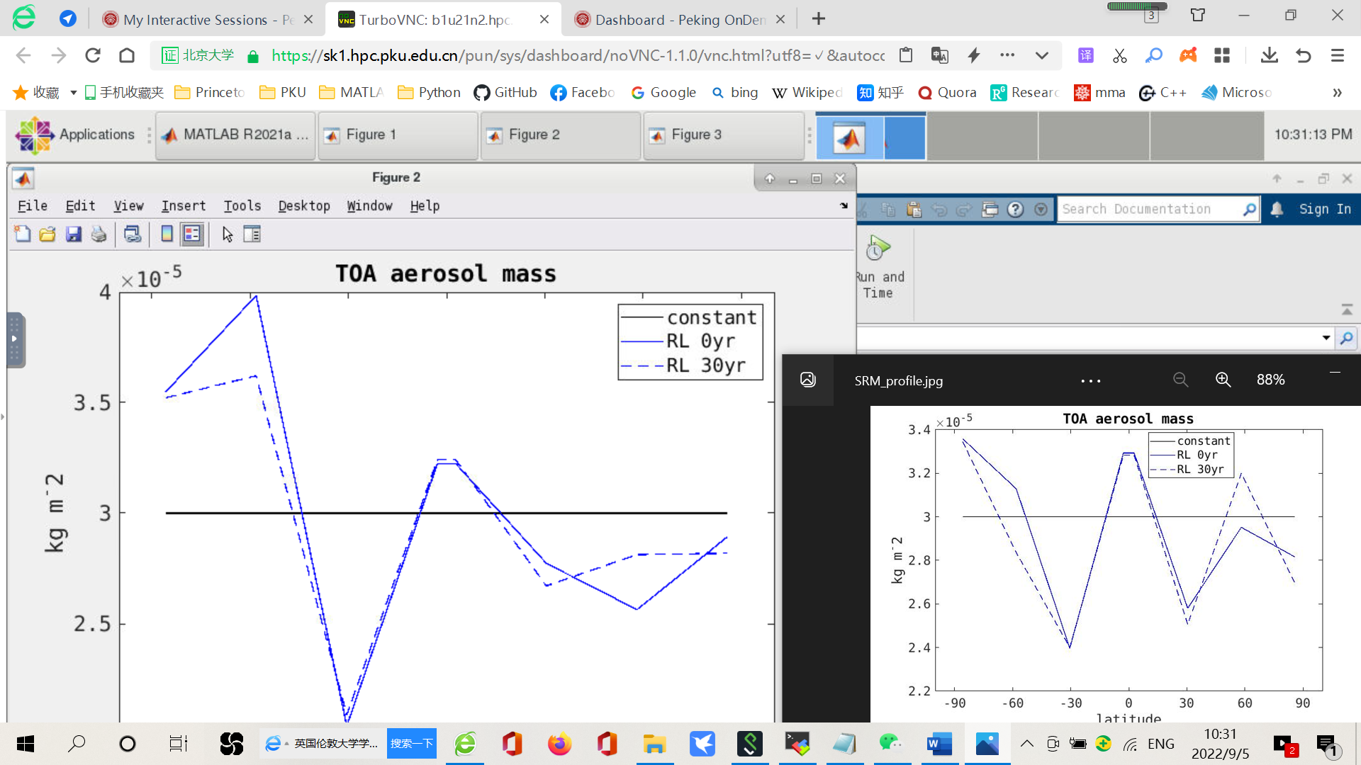

Left: SRM profile in episode 75; Right: SRM profile in episode 34

**The same episode reward can correspond to multiple SRM profiles. Or, there might be more than one ‘optimal SRM profile’. Therefore, I think the optimal SRM profile in CAM task 2 when climate is cooled back to preindustrial (figure below, yr 30) doesn’t need to be the same as the SRM profile in CAM task 1 (figure above).**

