Engineering-Prior-Guided NSGA-II for Elastic Capacity-Load Ratio Planning under High Distributed Photovoltaic Penetration
Heng Xu
School of Electrical Engineering
China University of Mining and Technology
Xuzhou, Jiangsu, China
ts24230188p31@cumt.edu.cn

Abstract—High-penetration distributed PV challenges fixed capacity-load ratio planning in county 110 kV grids by introducing reverse power and changing N-1 supply risk. This paper formulates an elastic per-station planning model that couples capacity-load ratio, storage power, reverse-power constraints, and supply risk. Engineering-Prior-Guided NSGA-II (EPG-NSGA-II) combines feasibility-aware initialization with repair projection to improve constrained search efficiency. In a synthetic county case with K=20, the selected elastic configuration reduces the annualized cost index by 13.1% relative to the uniform R=2.0 baseline under equal EENS. At K=40, EPG-NSGA-II reaches a comparable hypervolume with fewer evaluations than plain NSGA-II.
Index Terms—Distributed photovoltaics, capacity-load ratio, NSGA-II, multi-objective optimization, storage planning.
I. INTRODUCTION
High-penetration distributed PV is making county 110 kV grids increasingly bidirectional. Midday PV output may exceed local demand, causing reverse power and changing the N-1 supply margin [3]. A uniform county-wide capacity-load ratio may over-invest at moderate-PV stations while failing to reflect reverse-power pressure at PV-dense stations [1], [2]. Existing planning often relies on rigid ratio rules, while evolutionary optimization can search the cost-risk trade-off directly [1], [2], [5], [6]. Under strong engineering constraints, random initialization and variation can generate many infeasible individuals.
This paper proposes EPG-NSGA-II to address this feasibility bottleneck. It keeps nondominated sorting unchanged and adds two engineering-prior operators: warm-start sampling within engineering bounds and repair projection after variation. The contributions are threefold: an elastic capacity-load ratio model with reverse-power and N-1 constraints, an EPG-NSGA-II strategy with warm-start sampling and repair projection, and a synthetic county case with ablation analysis.
II. ENGINEERING-PRIOR-GUIDED NSGA-II
A. Planning Model
The model considers a set of 110 kV substations. Each station is assigned two planning variables: a capacity-load ratio and a storage power rating for absorbing reverse power. Current peak loads are projected to the planning year with a 5% annual growth rate over a five-year horizon. The projected load of station $\text{j}$, denoted by ${\text{L}}_{\text{j}}^{\text{p}}$, is used consistently in the capacity, reverse-power, and N-1 risk terms.
The pre-storage midday reverse injection at station $\text{j}$ is denoted by $r_{\text{j}}^{\text{0}}$. After storage absorption, the residual reverse power is given by
 | $${\tilde{r}}_{j}(P_{j})=max\{0,r_{j}^{0}−P_{j}\} .$$ | (1)
Here, ${\text{P}}_{\text{j}}$ denotes the storage power rating assigned to station $\text{j}$ . ${\tilde{r}}_{j}(P_{j})$ is the residual reverse power after storage absorption. The capacity-load ratio R_{j} is bounded within [1.2, 3.0], and the storage power rating P_{j} is bounded within [0, 6] MW. The regional capacity-load ratio is constrained by the planning band in (2),
 | $$\text{1.8≤}\sum_{\text{j}}{{\text{R}}_{\text{j}}}{\text{L}}_{\text{j}}^{\text{p}}\text{/(}\sum_{\text{j}}{{\text{L}}_{\text{j}}^{\text{p}}}\text{)≤2.2}\text{ .}$$ | (2)
This ratio is total planned capacity divided by the county planning-year peak. Residual reverse power is constrained at both station and upstream levels,
 | $${\tilde{\text{r}}}_{\text{j}}\text{(}{\text{P}}_{\text{j}}\text{)}\text{≤}\text{β}{\text{R}}_{\text{j}}{\text{L}}_{\text{j}}^{\text{p}}$$  $$\text{η}\sum_{\text{j}}{{\tilde{\text{r}}}_{\text{j}}}\text{(}{\text{P}}_{\text{j}}\text{)}\text{≤}\text{β}{\text{R}}_{\text{220}}\text{δ}\sum_{\text{j}}{{\text{L}}_{\text{j}}^{\text{p}}} .$$ | (3)
where β = 0.85 is the transformer reverse-loading limit, ${\text{R}}_{\text{220}}$ = 1.8 the upper-level capacity-load ratio, δ = 0.85 the upstream coincidence factor, and η = 1.0 the reverse coincidence factor.
The first inequality limits station-level residual reverse power, while the second limits aggregated reverse power at the upstream interface.
The optimization minimizes two conflicting objectives: annualized cost and N-1 supply risk,
 | $$\text{min (}{\text{f}}_{\text{1}}\text{,} {\text{f}}_{\text{2}}\text{)}$$  $${\text{f}}_{\text{1}}\text{=}\sum_{\text{j}}{\text{(}}{\text{c}}_{\text{R}}{\text{R}}_{\text{j}}{\text{L}}_{\text{j}}^{\text{p}}\text{+}{\text{c}}_{\text{P}}{\text{P}}_{\text{j}}\text{+}{\text{C}}_{\text{j}}^{\text{loss}}\text{+}{\text{C}}_{\text{j}}^{\text{om}}\text{)}$$  f2=j​EENSj(Rj,Tj,Ljp) . | (4)
Here, ${\text{f}}_{\text{1}}$ is the annualized cost objective and ${\text{f}}_{\text{2}}$ is the N-1 risk objective. The parameters ${\text{c}}_{\text{R}}$ and ${\text{c}}_{\text{P}}$ are annualized unit costs, while ${\text{C}}_{\text{j}}^{\text{loss}}$ and ${\text{C}}_{\text{j}}^{\text{om}}$ denote annualized loss and O&M costs. The N-1 risk ${\text{f}}_{\text{2}}$ is the total EENS,
 | $${\text{EENS}}_{\text{j}}\text{=}\sum_{\text{s}\text{∈}Ω_{\text{j}}}{{\text{p}}_{\text{s}}}{\text{h}}_{\text{s}}\text{max}\text{\{0,}{\text{L}}_{\text{j}}^{\text{p}}\text{−}{\text{S}}_{\text{j}\text{,}\text{s}}\text{\}}\text{ .}$$ | (5)
In (5), $Ω_{\text{j}}$ is the outage-state set, ${\text{p}}_{\text{s}}$ and ${\text{h}}_{\text{s}}$ are the probability and duration of state $\text{s}$, and ${\text{S}}_{\text{j}\text{,}\text{s}}$ is the available supply determined by transformer capacity and fixed tie-line support.
Storage is considered only for reverse-power absorption and is not credited as firm N-1 backup. The resulting optimization is subject to the variable bounds, the regional ratio band, and the reverse-power constraints.
B. EPG-NSGA-II Procedure
EPG-NSGA-II retains the NSGA-II backbone [6] and introduces warm-start sampling and repair projection before objective evaluation. Warm-start sampling seeds a near-feasible initial population; repair projection is applied after every variation step.
Algorithm 1 EPG-NSGA-II
Input: D, bounds, ratio band, reverse-power parameters, N, G.
Output: feasible nondominated set A.
1: P ← Warm-start sampling(D, N)
2: P ← Repair projection(P)
3: Evaluate f1 and f2 for all individuals in P
4: for t = 1 to G do
5: Q ← Variation(P)
6: Q ← Repair projection(Q)
7: Evaluate f1 and f2 for all individuals in Q
8: U ← P ∪ Q
9: P ← nondominated sort + crowding select (U, N)
10: end for
11: A ← feasible nondominated individuals in P
12: return A
WarmStartSampling samples ratios within engineering bounds, projects the aggregate ratio into the planning band, and allocates storage to stations with higher reverse-power pressure.
RepairProjection clips variables, repairs the aggregate-ratio band, checks station-level and upstream reverse-power constraints, and performs a final feasibility check.
III. EXPERIMENTS
A. Setup
The benchmark is a public-data-informed synthetic county constructed from scaled IEEE 33-bus feeders [7] and PVGIS irradiance [8]. We test four county sizes, K=10, 20, 30, and 40, with population 100 and three seeds per setting. Plain NSGA-II is run for 800 generations as a longer-budget reference, while EPG-NSGA-II is run for 400 generations.
B. Efficiency and Ablation
TABLE I. NORMALIZED HYPERVOLUME RESULTS
Method | K=10 | K=20 | K=30 | K=40
EPG-NSGA-II | 1.000 | 1.000 | 1.000 | 1.000
Repair-only | 0.997 | 0.998 | 0.999 | 1.000
NSGA-II | 0.993 | 0.993 | 0.991 | 0.954
Table I reports normalized converged HV across county sizes. Repair-only remains within 0.3% of the full method, suggesting that repair projection is important for converged quality in this setting. Plain NSGA-II shows a larger gap as K grows, reaching 4.6% at K=40.
At K=40, EPG-NSGA-II reaches a comparable HV with fewer generations under the fixed-population setting.
C. County-Level Application at K=20
At K=20, the knee solution has a regional capacity-load ratio of 1.80, an annualized cost index equivalent to 188.82 million CNY/yr, and EENS of 114 MWh/yr. PV-heavy stations receive storage, while low-ratio stations rely more on tie-line support (Fig. 1). Relative to the uniform R=2.0 baseline, the elastic configuration reduces the annualized cost index by 13.1% under equal EENS in this synthetic case.
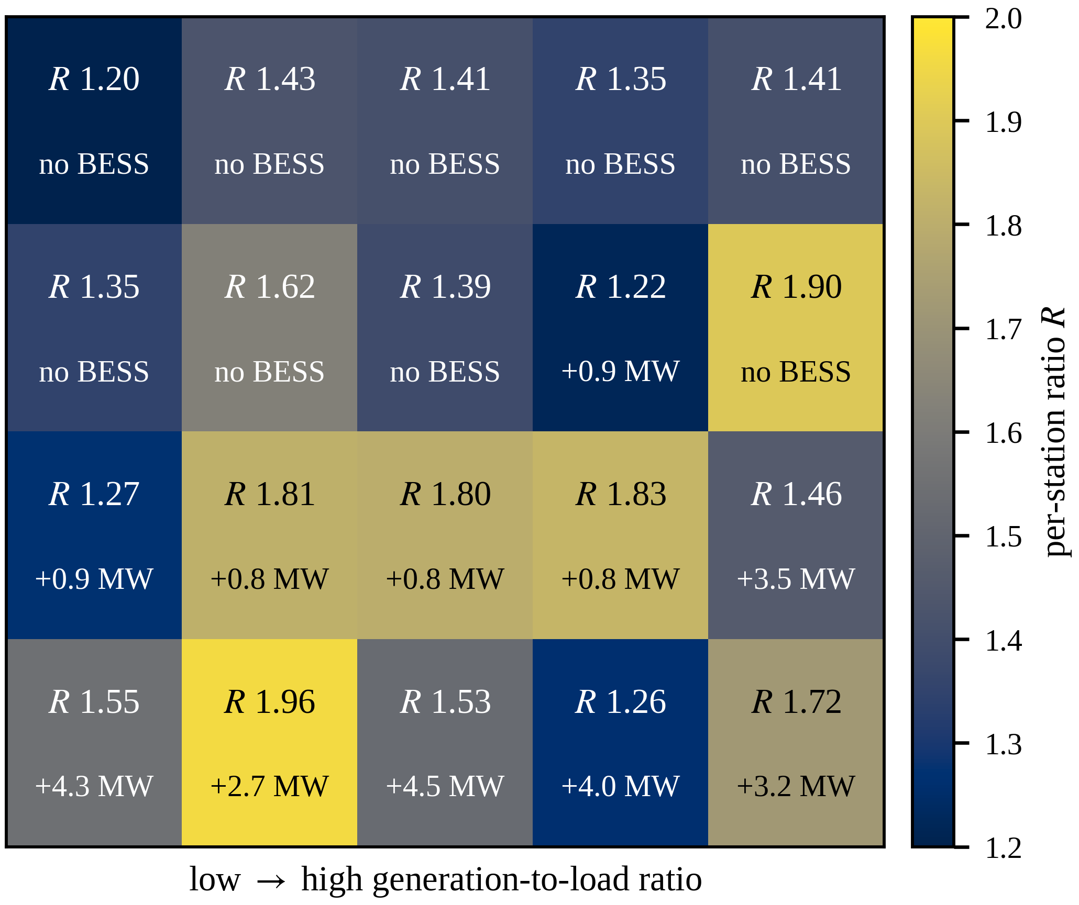
Fig. 1. Elastic planning configuration for the synthetic county case.
IV. CONCLUSION
EPG-NSGA-II combines feasibility-aware initialization and repair projection for elastic capacity-load ratio planning under high PV penetration. The synthetic cases show a lower cost index under equal EENS and improved search efficiency compared with plain NSGA-II. Future work will consider real-grid calibration, energy-limited storage, and statistical testing.
REFERENCES
[1] J. Xiao, R. Liu, and M. Long, "Relationship between substation capacity-load ratio and the next-level medium-voltage distribution network," Electric Power Construction, vol. 36, no. 11, pp. 45-50, 2015 (in Chinese).
[2] K. Wang, Z. He, J. Ye, Y. Lin, and Y. Ma, "Capacity-load-ratio optimal configuration for coordinated planning of multi-voltage-level grids," Southern Power System Technology, vol. 19, no. 7, pp. 131-139, 2025 (in Chinese).
[3] Q. Hou, N. Zhang, E. Du, M. Miao, F. Peng, and C. Kang, "Probabilistic duck curve in high PV penetration power system," Applied Energy, 2019.
[4] T. Lin, G. Wu, S. Lai, H. Hu, and Z. Hu, "Calculation of distribution network PV hosting capacity considering source-load uncertainty and active management," Electronics, vol. 13, art. 4048, 2024.
[5] M. Nicolini, "Multi-objective genetic algorithms in designing redundant water distribution systems," in Proc. 2025 IEEE Int. Conf. MIND, 2025.
[6] K. Deb, A. Pratap, S. Agarwal, and T. Meyarivan, "A fast and elitist multiobjective genetic algorithm: NSGA-II," IEEE Trans. Evol. Comput., vol. 6, no. 2, pp. 182-197, 2002.
[7] M. E. Baran and F. F. Wu, "Network reconfiguration in distribution systems for loss reduction and load balancing," IEEE Trans. Power Del., vol. 4, no. 2, pp. 1401-1407, 1989.
[8] European Commission, Joint Research Centre, “JRC Photovoltaic Geographical Information System (PVGIS),” [Online]. Available: https://re.jrc.ec.europa.eu/pvg_tools/en/. [Accessed: Jul. 6, 2026].

