Engineering-Prior-Guided NSGA-II for Differentiated Capacity-Load Ratio Optimization in County 110-kV Grids under High Distributed PV Penetration
Heng Xu
School of Electrical Engineering
China University of Mining and Technology
Xuzhou, Jiangsu, China
ts24230188p31@cumt.edu.cn

Abstract—High penetration of distributed photovoltaic (PV) generation makes county-level 110-kV grids bidirectional, causing reverse power flow and affecting supply adequacy under N-1 contingencies. This study formulates a multiobjective model that coordinates a county's 110-kV substations and optimizes differentiated capacity-load ratios (CLRs) and storage power ratings under a load-weighted aggregate CLR band and reverse-power-flow constraints, minimizing annualized cost and expected energy not supplied (EENS). Engineering-Prior-Guided NSGA-II (EPG-NSGA-II) adds feasibility-preserving warm-start sampling and a repair projection. On a public-data-informed synthetic county test system, it cuts annualized cost by 13.1% versus the uniform R=2.0 baseline at the same EENS level; across K=10–40 its converged hypervolume reaches +4.8% over standard NSGA-II at K=40.
Index Terms—Capacity-load ratio, distributed photovoltaic generation, multiobjective optimization, reverse power flow, substation planning.
I. INTRODUCTION
High penetration of distributed PV generation is turning county-level 110-kV grids bidirectional: midday PV can exceed local demand, causing reverse power flow and shifting supply adequacy under N-1 contingencies [1]. A uniform capacity-load ratio over-invests at moderate-PV stations and under-constrains reverse power flow at substations with high distributed-PV penetration [2], [3]. Existing planning uses fixed or empirical rules, while evolutionary optimization searches the cost-risk trade-off directly [2], [3], [4], [5], with knowledge transfer further improving search efficiency [6]. Random initialization and variation then yield many infeasible individuals.
This study proposes EPG-NSGA-II, which keeps nondominated sorting unchanged and adds two engineering-prior operators: warm-start sampling within engineering bounds and repair projection after variation. Contributions: a multiobjective model with differentiated capacity-load ratios under an aggregate-CLR band, reverse-power-flow constraints, and an EENS-based supply-adequacy objective; the EPG-NSGA-II strategy; and a public-data-informed synthetic county test system with ablation.
II. ENGINEERING-PRIOR-GUIDED NSGA-II
A. Planning Model
The model considers a set of 110 kV substations. Each station is assigned two planning variables: a capacity-load ratio and a storage power rating for absorbing reverse power flow. Current peak loads are projected to the planning year with a 5% annual growth rate over a five-year horizon. The projected load of station $\text{j}$, denoted by ${\text{L}}_{\text{j}}^{\text{p}}$, is used consistently in the capacity, reverse-power, and N-1 risk terms.
The pre-storage midday reverse injection at station $\text{j}$ is denoted by $r_{\text{j}}^{\text{0}}$. After storage absorption, the residual reverse power flow is given by
 | $${\tilde{r}}_{j}(P_{j})=max\{0,r_{j}^{0}−P_{j}\} .$$ | (1)
Here, ${\text{P}}_{\text{j}}$ denotes the storage power rating assigned to station $\text{j}$ . ${\tilde{r}}_{j}(P_{j})$ is the residual reverse power after storage absorption. The capacity-load ratio R_{j} is bounded within [1.2, 3.0], and the storage power rating P_{j} is bounded within [0, 6] MW. The load-weighted aggregate capacity-load ratio is constrained by the planning band in (2),
 | $$\text{1.8≤}\sum_{\text{j}}{{\text{R}}_{\text{j}}}{\text{L}}_{\text{j}}^{\text{p}}\text{/(}\sum_{\text{j}}{{\text{L}}_{\text{j}}^{\text{p}}}\text{)≤2.2}\text{ .}$$ | (2)
Residual reverse power flow is constrained at both station and upstream levels,
 | $${\tilde{\text{r}}}_{\text{j}}\text{(}{\text{P}}_{\text{j}}\text{)}\text{≤}\text{β}{\text{R}}_{\text{j}}{\text{L}}_{\text{j}}^{\text{p}}$$  $$\text{η}\sum_{\text{j}}{{\tilde{\text{r}}}_{\text{j}}}\text{(}{\text{P}}_{\text{j}}\text{)}\text{≤}\text{β}{\text{R}}_{\text{220}}\text{δ}\sum_{\text{j}}{{\text{L}}_{\text{j}}^{\text{p}}} .$$ | (3)
where β = 0.85 is the transformer reverse-loading limit, ${\text{R}}_{\text{220}}$ = 1.8 the upper-level capacity-load ratio, δ = 0.85 the upstream coincidence factor, and η = 1.0 the reverse coincidence factor.
The optimization minimizes two conflicting objectives: annualized cost and N-1 supply risk,
 | $$\text{min (}{\text{f}}_{\text{1}}\text{,} {\text{f}}_{\text{2}}\text{)}$$  $${\text{f}}_{\text{1}}\text{=}\sum_{\text{j}}{\text{(}}{\text{c}}_{\text{R}}{\text{R}}_{\text{j}}{\text{L}}_{\text{j}}^{\text{p}}\text{+}{\text{c}}_{\text{P}}{\text{P}}_{\text{j}}\text{+}{\text{C}}_{\text{j}}^{\text{loss}}\text{+}{\text{C}}_{\text{j}}^{\text{om}}\text{)}$$  f2=j​EENSj(Rj,Tj,Ljp) . | (4)
Here, ${\text{f}}_{\text{1}}$ is the annualized cost objective and ${\text{f}}_{\text{2}}$ is the N-1 risk objective. The parameters ${\text{c}}_{\text{R}}$ and ${\text{c}}_{\text{P}}$ are annualized unit costs, while ${\text{C}}_{\text{j}}^{\text{loss}}$ and ${\text{C}}_{\text{j}}^{\text{om}}$ denote annualized loss and O&M costs. The N-1 risk ${\text{f}}_{\text{2}}$ is the total EENS,
 | $${\text{EENS}}_{\text{j}}\text{=}\sum_{\text{s}\text{∈}Ω_{\text{j}}}{{\text{p}}_{\text{s}}}{\text{h}}_{\text{s}}\text{max}\text{\{0,}{\text{L}}_{\text{j}}^{\text{p}}\text{−}{\text{S}}_{\text{j}\text{,}\text{s}}\text{\}}\text{ .}$$ | (5)
In (5), $Ω_{\text{j}}$ is the outage-state set, ${\text{p}}_{\text{s}}$ and ${\text{h}}_{\text{s}}$ are the probability and duration of state $\text{s}$, and ${\text{S}}_{\text{j}\text{,}\text{s}}$ is the available supply determined by transformer capacity and fixed tie-line support.
Storage only absorbs reverse power flow, not credited as firm N-1 backup. The optimization is subject to the variable bounds, the aggregate-ratio band, and the reverse-power-flow constraints.
B. EPG-NSGA-II Procedure
EPG-NSGA-II retains the NSGA-II backbone [5] and applies warm-start sampling and repair projection before objective evaluation: the warm start seeds a near-feasible population, repair follows every variation step.
Algorithm 1 EPG-NSGA-II
Input: D, bounds, ratio band, reverse-power parameters, N, G.
Output: feasible nondominated set A.
1: P ← Warm-start sampling(D, N)
2: P ← Repair projection(P)
3: Evaluate f1 and f2 for all individuals in P
4: for t = 1 to G do
5: Q ← Variation(P)
6: Q ← Repair projection(Q)
7: Evaluate f1 and f2 for all individuals in Q
8: U ← P ∪ Q
9: P ← nondominated sort + crowding select (U, N)
10: end for
11: A ← feasible nondominated individuals in P
12: return A
WarmStartSampling draws each ratio Rj in [1.2, 3.0], projects the aggregate into band (2), and allocates storage by descending residual reverse-power-flow pressure.
RepairProjection clips Rj to [1.2, 3.0] and Pj to [0, 6] MW, rescales the aggregate into band (2), enforces the station and upstream reverse-power-flow constraints (3), and runs a final feasibility check.
III. EXPERIMENTS
A. Setup
The benchmark is a public-data-informed synthetic county test system constructed from scaled IEEE 33-bus feeders [7] and PVGIS irradiance [8], with county sizes K=10, 20, 30, 40, population 100, and three seeds per setting. The baselines, standard NSGA-II and NSGA-III [9], run 800 generations as a longer-budget reference; EPG-NSGA-II runs 400.
B. Efficiency and Ablation
TABLE I. NORMALIZED HYPERVOLUME RESULTS
Method | K=10 | K=20 | K=30 | K=40
NSGA-II | 1.000 | 1.000 | 1.000 | 1.000
NSGA-III | 0.998 | 0.991 | 0.979 | 0.985
Warm-start-only | 0.996 | 0.991 | 0.988 | 0.998
Repair-only | 1.004 | 1.006 | 1.008 | 1.048
EPG-NSGA-II | 1.007 | 1.007 | 1.009 | 1.048
Table I reports converged HV normalized to standard NSGA-II = 1.000. EPG-NSGA-II is at or above the baseline for every K, widening to +4.8% at K=40; Repair-only tracks it almost exactly (repair drives most of the converged gain), Warm-start-only stays near the baseline (early acceleration), and NSGA-III stays below on this bi-objective problem.
At K=40, EPG-NSGA-II reaches standard NSGA-II's converged HV in about 84 generations, roughly 9.5× fewer evaluations.
C. County-Level Application at K=20
K=20 is a representative county size. Its knee solution has a load-weighted aggregate capacity-load ratio of 1.80, an annualized cost of 188.82 million CNY/yr, and EENS of 114 MWh/yr. High generation-to-load substations receive storage, low-ratio ones rely on tie-line support (Fig. 1). Versus the uniform R=2.0 baseline, the differentiated design cuts annualized cost by 13.1% at the same EENS level.
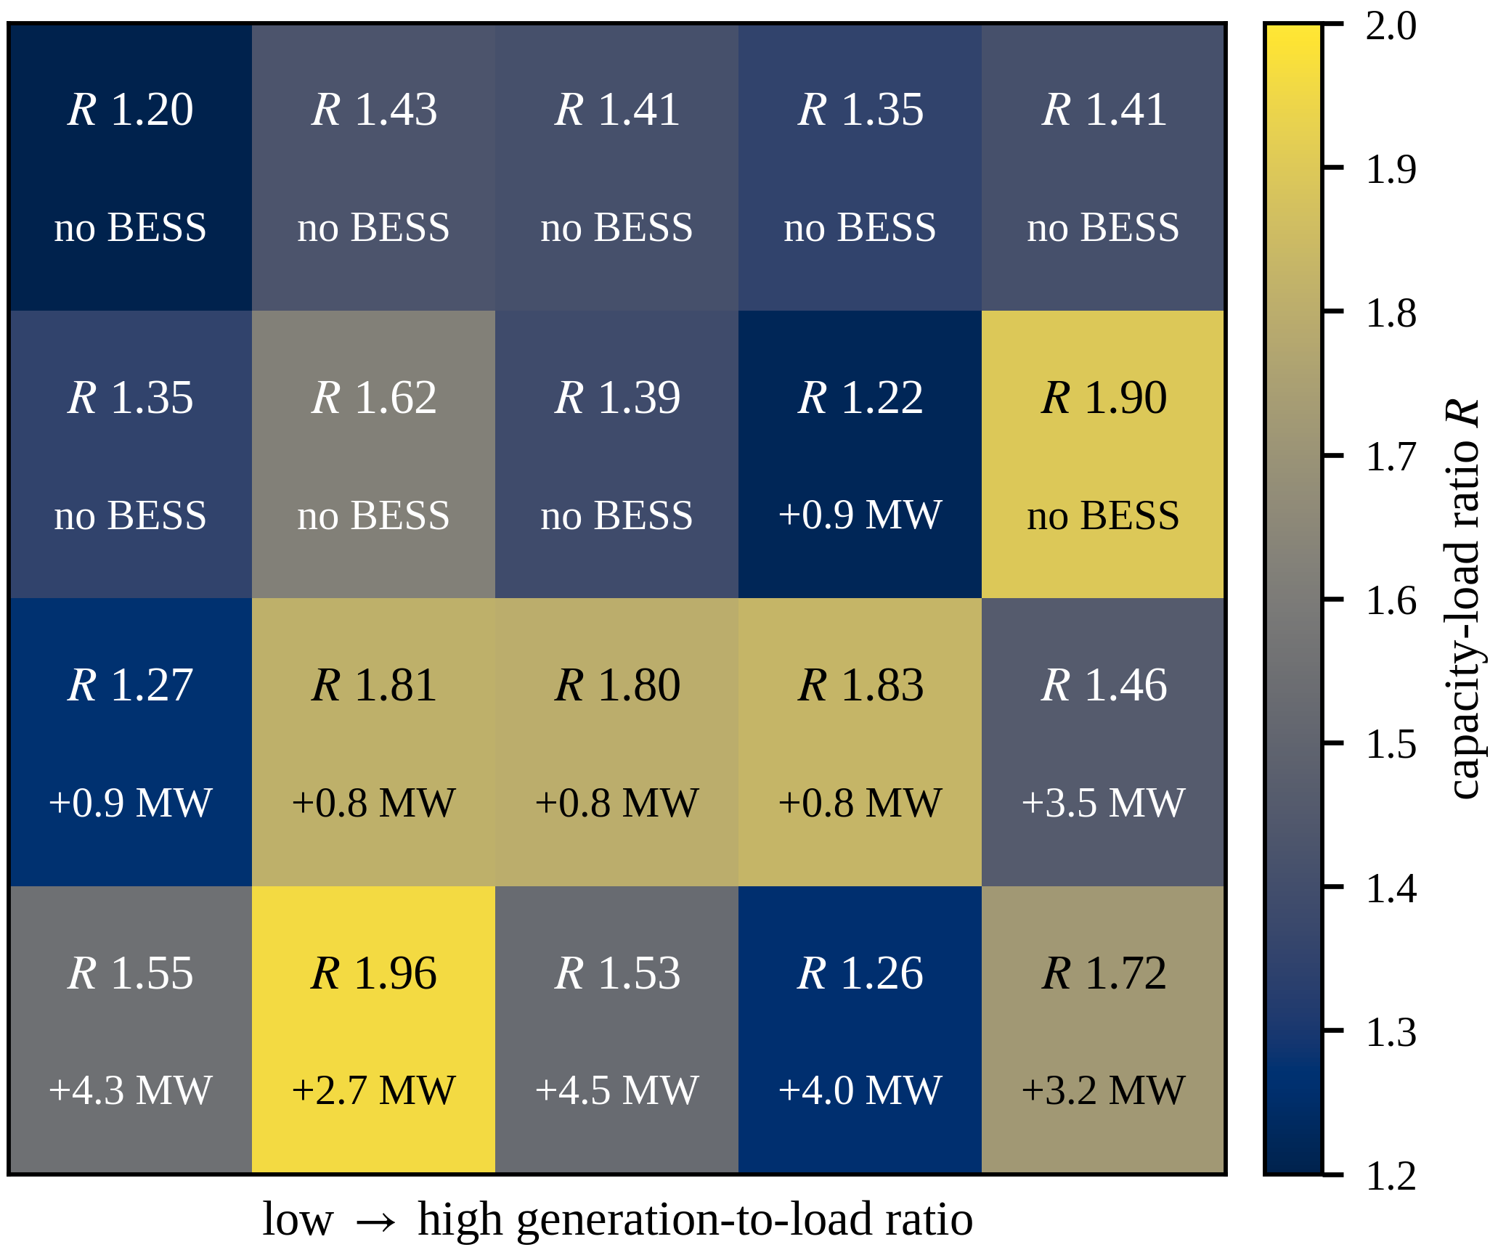
Fig. 1. Differentiated planning configuration on the synthetic county test system (K=20).
IV. CONCLUSION
EPG-NSGA-II's feasibility-preserving warm-start sampling and repair projection enable differentiated capacity-load ratio optimization under high distributed-PV penetration. It lowers annualized cost at the same EENS level and improves converged hypervolume over standard NSGA-II, widening to +4.8% at K=40. Future work: real-grid calibration, energy-limited storage, and statistical testing.
REFERENCES
[1] Q. Hou, N. Zhang, E. Du, M. Miao, F. Peng, and C. Kang, "Probabilistic duck curve in high PV penetration power system," Applied Energy, 2019.
[2] J. Xiao, R. Liu, and M. Long, "Relationship between substation capacity-load ratio and the next-level medium-voltage distribution network," Electric Power Construction, vol. 36, no. 11, pp. 45-50, 2015 (in Chinese).
[3] K. Wang, Z. He, J. Ye, Y. Lin, and Y. Ma, "Capacity-load-ratio optimal configuration for coordinated planning of multi-voltage-level grids," Southern Power System Technology, vol. 19, no. 7, pp. 131-139, 2025 (in Chinese).
[4] M. Nicolini, "Multi-objective genetic algorithms in designing redundant water distribution systems," in Proc. 2025 IEEE Int. Conf. MIND, 2025.
[5] K. Deb, A. Pratap, S. Agarwal, and T. Meyarivan, "A fast and elitist multiobjective genetic algorithm: NSGA-II," IEEE Trans. Evol. Comput., vol. 6, no. 2, pp. 182-197, 2002.
[6] X. Xue, C. Yang, Y. Hu, et al., “Evolutionary sequential transfer optimization for objective-heterogeneous problems,” IEEE Trans. Evol. Comput., vol. 26, no. 6, pp. 1424-1438, 2022.
[7] M. E. Baran and F. F. Wu, "Network reconfiguration in distribution systems for loss reduction and load balancing," IEEE Trans. Power Del., vol. 4, no. 2, pp. 1401-1407, 1989.
[8] European Commission, Joint Research Centre, “JRC Photovoltaic Geographical Information System (PVGIS),” [Online]. Available: https://re.jrc.ec.europa.eu/pvg_tools/en/. [Accessed: Jul. 6, 2026].
[9] K. Deb and H. Jain, "An evolutionary many-objective optimization algorithm using reference-point-based nondominated sorting approach, part I: solving problems with box constraints," IEEE Trans. Evol. Comput., vol. 18, no. 4, pp. 577-601, 2014.

