Engineering-Prior-Guided NSGA-II for Differentiated Capacity-Load Ratio Optimization in a County-Level 110-kV Grid under High Distributed PV Penetration
1st Heng Xu  School of Electrical Engineering  China University of Mining and Technology  Xuzhou, China  ts24230188p31@cumt.edu.cn | 2nd Second Author  School of Electrical Engineering  China University of Mining and Technology  Xuzhou, China  coauthor2@cumt.edu.cn | 3rd Third Author  School of Electrical Engineering  China University of Mining and Technology  Xuzhou, China  coauthor3@cumt.edu.cn
4th Fourth Author  School of Electrical Engineering  China University of Mining and Technology  Xuzhou, China  coauthor4@cumt.edu.cn | 5th Fifth Author  School of Electrical Engineering  China University of Mining and Technology  Xuzhou, China  coauthor5@cumt.edu.cn | 6th Sixth Author  School of Electrical Engineering  China University of Mining and Technology  Xuzhou, China  coauthor6@cumt.edu.cn

Abstract—High penetration of distributed photovoltaic (PV) generation can cause reverse power flow in county-level 110-kV grids and alter supply adequacy under N-1 contingencies. This study jointly optimizes differentiated capacity-load ratios (CLRs) and storage ratings by minimizing annualized cost and expected energy not supplied (EENS). Engineering-Prior-Guided NSGA-II (EPG-NSGA-II) introduces engineering-prior population seeding and feasibility repair to improve constrained search. On a public-data-informed county-level test system, a selected Pareto solution reduces annualized cost by 13.1% at the same EENS. For $K=40$, EPG-NSGA-II achieves a 4.8% higher mean final hypervolume than standard NSGA-II and reaches the latter's 800-generation final level in about 84 generations.
Index Terms—Capacity-load ratio, distributed photovoltaic generation, multiobjective optimization, reverse power flow, 110-kV grid planning.
I. INTRODUCTION
High distributed-PV penetration can cause midday export and reverse power flow at 110-kV substations, altering supply adequacy under N-1 contingencies [1]. A uniform CLR may overinvest at substations with moderate generation-to-load ratios yet fail to reflect reverse-flow limits at substations with high PV penetration [2], [3]. Evolutionary multiobjective optimization directly searches the cost–adequacy trade-off [2]–[4], and prior search knowledge can further improve its efficiency [5]. Under coupled engineering constraints, however, random initialization and variation generate many infeasible solutions.
EPG-NSGA-II retains the standard variation, non-dominated sorting, and crowding-distance selection of NSGA-II while adding two problem-specific operators: engineering-prior population seeding and feasibility repair. The bi-objective model optimizes station-specific CLRs and storage ratings under aggregate-CLR and reverse-flow constraints, with EENS measuring N-1 supply inadequacy. Comparative and ablation studies are conducted on a public-data-informed county-level test system.
II. ENGINEERING-PRIOR-GUIDED NSGA-II
A. Planning Model
The county-level grid contains $K$ 110-kV substations. At station $j$, $R_{j}$ is the CLR, defined as planned transformer capacity divided by forecast peak load; $P_{j}$ is the storage power rating; and $L_{j}^{p}$ is the five-year forecast peak load obtained using 5% annual growth. CLRs vary across substations but satisfy the load-weighted aggregate band.
The pre-storage midday reverse injection at station $\text{j}$ is denoted by $r_{\text{j}}^{\text{0}}$. After storage absorption, the residual reverse power flow is given by
 | $${\tilde{r}}_{j}(P_{j})=max\{0,r_{j}^{0}−P_{j}\} .$$ | (1)
Here ${\tilde{r}}_{j}(P_{j})$ is the residual reverse power flow after storage, and the load-weighted aggregate CLR is constrained by band (2),
 | 1.8≤j​RjLjp / (δj​Ljp)≤2.2 | (2)
Here $δ=0.85$ is the county load-coincidence factor. Residual reverse power flow is limited at the station and upstream levels,
 | $${\tilde{\text{r}}}_{\text{j}}\text{(}{\text{P}}_{\text{j}}\text{)}\text{≤}\text{β}{\text{R}}_{\text{j}}{\text{L}}_{\text{j}}^{\text{p}}$$  $$\text{η}\sum_{\text{j}}{{\tilde{\text{r}}}_{\text{j}}}\text{(}{\text{P}}_{\text{j}}\text{)}\text{≤}\text{β}{\text{R}}_{\text{220}}\text{δ}\sum_{\text{j}}{{\text{L}}_{\text{j}}^{\text{p}}} .$$ | (3)
where $β=0.85$ is the transformer reverse-loading limit, $R_{220}=1.8$ the upper-level CLR, and $η=1.0$ the reverse-power coincidence factor.
The two conflicting objectives are annualized cost and expected energy not supplied under N-1 contingencies,
 | $$\text{min (}{\text{f}}_{\text{1}}\text{,} {\text{f}}_{\text{2}}\text{)}$$  $${\text{f}}_{\text{1}}\text{=}\sum_{\text{j}}{\text{(}}{\text{c}}_{\text{R}}{\text{R}}_{\text{j}}{\text{L}}_{\text{j}}^{\text{p}}\text{+}{\text{c}}_{\text{P}}{\text{P}}_{\text{j}}\text{+}{\text{C}}_{\text{j}}^{\text{loss}}\text{+}{\text{C}}_{\text{j}}^{\text{om}}\text{)}$$  f2=j​EENSj | (4)
Here, $c_{R}$ and $c_{P}$ are annualized unit costs, and $C_{j}^{loss}$ and $C_{j}^{om}$ are annual loss and O&M costs; $f_{2}$ is the total EENS under N-1 contingencies,
 | $${\text{EENS}}_{\text{j}}\text{=}\sum_{\text{s}\text{∈}Ω_{\text{j}}}{{\text{p}}_{\text{s}}}{\text{h}}_{\text{s}}\text{max}\text{\{0,}{\text{L}}_{\text{j}}^{\text{p}}\text{−}{\text{S}}_{\text{j}\text{,}\text{s}}\text{\}}\text{ .}$$ | (5)
In (5), $Ω_{j}$ is the outage-state set, $p_{s}$ and $h_{s}$ the probability and duration of state $s$, and $S_{j,s}$ the available transformer and tie-line supply.
Storage mitigates reverse power flow but is not credited as firm capacity under N-1 contingencies.
B. EPG-NSGA-II Procedure
EPG-NSGA-II retains the standard variation, non-dominated sorting, and crowding-distance selection of NSGA-II [4]. It introduces engineering-prior population seeding for initialization and feasibility repair for both the initial and offspring populations. Let $\text{clip}(x,a,b)=\text{min}\{b,\text{max}\{a,x\}\}$ and $[x]_{+}=\text{max}\{0,x\}$.
Algorithm 1 Engineering-Prior Seeding and Feasibility Repair
Input: planning data $D$, population size $N$, and variable bounds.
Output: repaired initial population $P_{0}$.
1: $P_{0}←⌀$
2: for $i=1,…,N$ do
3: ${\tilde{R}}_{i}∼U([R_{\text{min}},R_{\text{max}}])$
4: $R_{i}←$ AggregateCLRAdjust(${\tilde{R}}_{i}$)
5: $P_{i}←0$ (storage sized in FeasibilityRepair)
6: $x_{i}←$ FeasibilityRepair($R_{i},P_{i}$)
7: $P_{0}←P_{0}∪\{x_{i}\}$
8: end for
9: return $P_{0}$
FeasibilityRepair($R,P$):
10: $R←$ AggregateCLRAdjust($\text{clip}(R,R_{\text{min}},R_{\text{max}})$)
11: $P_{j}←[r_{j}^{0}−βR_{j}L_{j}^{p}]_{+}$ (capped at $P_{\text{max}}$)
12: Repair the upstream reverse-flow constraint in descending residual-injection order
13: return $(R,P)$
AggregateCLRAdjust rescales the CLR vector multiplicatively so that the load-weighted aggregate CLR enters band (2), adding a top-up on the stations with headroom when the lower bound is still unmet, and clips the result to $[R_{\text{min}},R_{\text{max}}]$.
FeasibilityRepair clips the variables, applies AggregateCLRAdjust, and raises storage — then $R_{j}$ — to meet the per-station reverse-flow gate; residual upstream violations are repaired by allocating storage to substations in descending order of residual reverse injection, and any infeasibility at the variable bounds is passed to the total constraint violation.
III. EXPERIMENTS
A. Setup
The public-data-informed county-level test system is built from scaled IEEE 33-bus feeder data [6] and PVGIS irradiance [7], with $K∈\{10,20,30,40\}$ 110-kV substations and population $N=100$, each setting run three times. Standard NSGA-II and NSGA-III [8] run 800 generations as longer-budget references; EPG-NSGA-II and its ablations run 400.
B. Efficiency and Ablation
TABLE I. NORMALIZED FINAL HV (MEAN OF THREE RUNS)
Method | K=10 | K=20 | K=30 | K=40
NSGA-II | 1.000 | 1.000 | 1.000 | 1.000
NSGA-III | 0.998 | 0.991 | 0.979 | 0.985
Seeding-only | 0.996 | 0.991 | 0.988 | 0.998
Repair-only | 1.004 | 1.006 | 1.008 | 1.048
EPG-NSGA-II | 1.007 | 1.007 | 1.009 | 1.048
Table I normalizes the mean final HV by standard NSGA-II for each $K$. EPG-NSGA-II matches or exceeds the baseline for all sizes, reaching $+4.8\%$ at $K=40$, while NSGA-III stays at or below standard NSGA-II. Repair-only nearly matches the full method, whereas Seeding-only mainly accelerates early search.
At $K=40$, the mean EPG-NSGA-II curve reaches the 800-generation standard-NSGA-II final HV at about generation 84 — roughly one-tenth of the evaluations.
C. County-Level Application at K=20
For $K=20$, a selected Pareto solution has a load-weighted aggregate CLR of 1.80, an annualized cost of 188.82 million CNY/yr, and an EENS of 114 MWh/yr. Storage concentrates at substations with higher generation-to-load ratios (Fig. 1), reducing cost by 13.1% versus the uniform $R=2.0$ baseline at equal EENS.
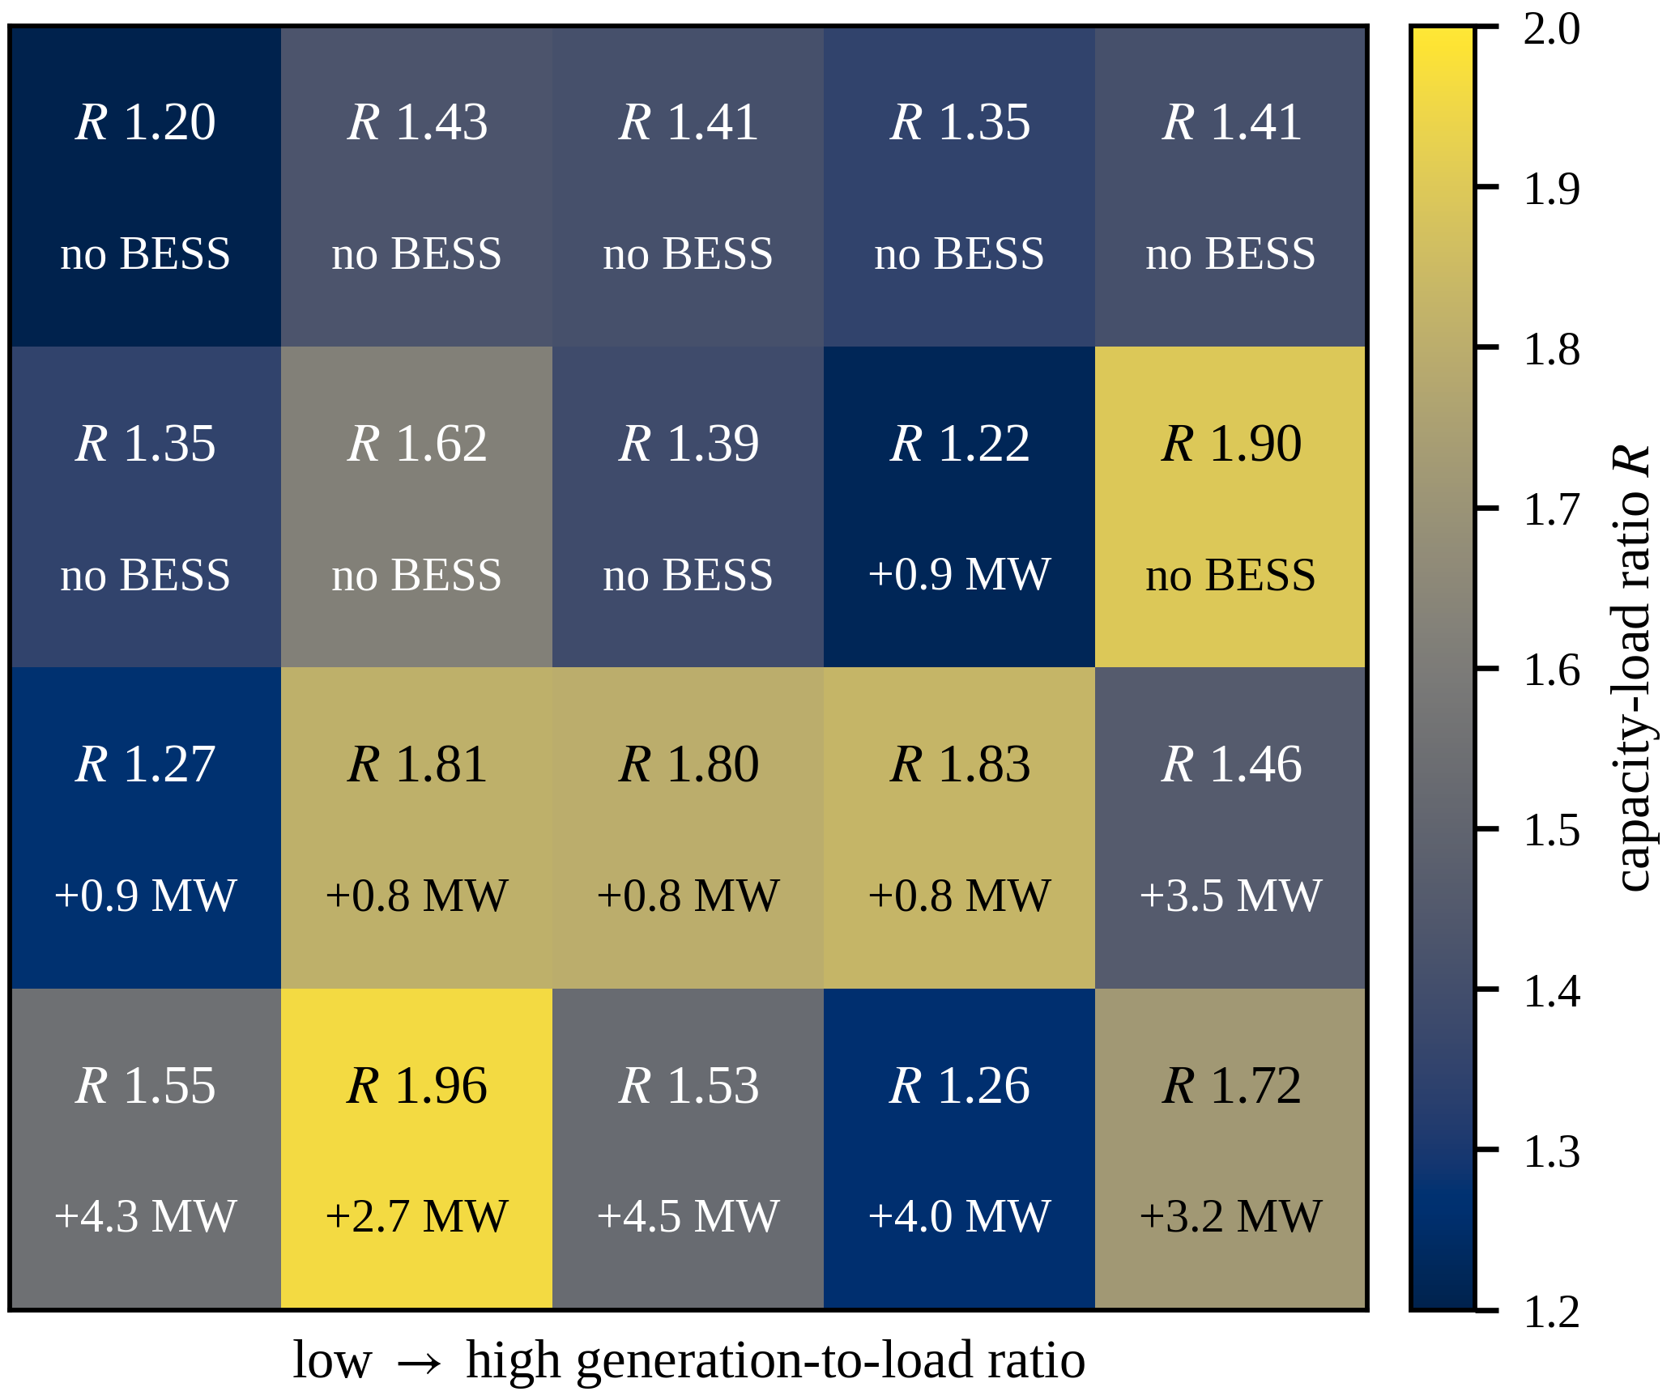
Fig. 1. $K=20$ differentiated CLR and storage allocation.
IV. CONCLUSION
EPG-NSGA-II combines engineering-prior population seeding and feasibility repair for differentiated CLR optimization. In the county-level test cases, it reduces cost at equal EENS and achieves up to 4.8% higher mean final HV than standard NSGA-II. Future work will address real-grid calibration and energy-limited storage.
REFERENCES
[1] Q. Hou, N. Zhang, E. Du, M. Miao, F. Peng, and C. Kang, “Probabilistic duck curve in high PV penetration power system: Concept, modeling, and empirical analysis in China,” Applied Energy, vol. 242, pp. 205–215, 2019, doi: 10.1016/j.apenergy.2019.03.067.
[2] J. Xiao, R. Liu, and M. Long, "Relationship between substation capacity-load ratio and the next-level medium-voltage distribution network," Electric Power Construction, vol. 36, no. 11, pp. 45-50, 2015 (in Chinese).
[3] K. Wang, Z. He, J. Ye, Y. Lin, and Y. Ma, "Capacity-load-ratio optimal configuration for coordinated planning of multi-voltage-level grids," Southern Power System Technology, vol. 19, no. 7, pp. 131-139, 2025 (in Chinese).
[4] K. Deb, A. Pratap, S. Agarwal, and T. Meyarivan, "A fast and elitist multiobjective genetic algorithm: NSGA-II," IEEE Trans. Evol. Comput., vol. 6, no. 2, pp. 182-197, 2002.
[5] X. Xue, C. Yang, Y. Hu, et al., “Evolutionary sequential transfer optimization for objective-heterogeneous problems,” IEEE Trans. Evol. Comput., vol. 26, no. 6, pp. 1424-1438, 2022.
[6] M. E. Baran and F. F. Wu, "Network reconfiguration in distribution systems for loss reduction and load balancing," IEEE Trans. Power Del., vol. 4, no. 2, pp. 1401-1407, 1989.
[7] European Commission, JRC, “Photovoltaic Geographical Information System (PVGIS),” 2026. [Online]. Available: https://re.jrc.ec.europa.eu/pvg_tools/en/. [Accessed: Jul. 2026].
[8] K. Deb and H. Jain, "An evolutionary many-objective optimization algorithm using reference-point-based nondominated sorting approach, part I: solving problems with box constraints," IEEE Trans. Evol. Comput., vol. 18, no. 4, pp. 577-601, 2014.

