网络配置菜单增加：

IPv6配置

6to4配置项：

增加6to4接口：

加载sit模块：

modprobe sit 作用是连接 ipv4 与 ipv6网络的模块

创建接口

/sbin/ip tunnel add $SIT mode sit ttl 64 remote $RADDRESS4 local $LADDRESS4

|  |  |
| --- | --- |
| $SIT | 接口名称 |
| $RADDRESS4 | 对面接口的IPv4地址 |
| $LADDRESS4 | 本地接口的IPv4地址 |

为接口设置IPv6地址：

生过程如：

IPv4地址：$LADDRESS4 如：1.2.3.4

固定前缀：

|  |
| --- |
| 2002:0102:0304:: |

生成的地址为：

|  |
| --- |
| 2002:0102:0304::1 |

自动生成:

|  |
| --- |
| ipv4="1.2.3.4"; printf "2002:%02x%02x:%02x%02x::1" `echo $ipv4 | tr "." " "` |

设置IPv6生效,前缀一定是16位。

/sbin/ip -6 addr add ${SITADDR} dev $SIT

如：ip -6 addr add 2002:0102:0304::1/16 dev sit1

|  |  |
| --- | --- |
| ${SITADDR} | ipv6 地址：2002:0102:0304::1/16 |
| $SIT | 6to4接口名 |

启用

/sbin/ip link set dev $SIT up

设置路由：

/sbin/ip -6 route add default via fe80::1.2.3.5 dev $SIT metric 1

|  |  |
| --- | --- |
| $GATEWAY | ipv6网关 |
| $SIT | 6to4接口名 |

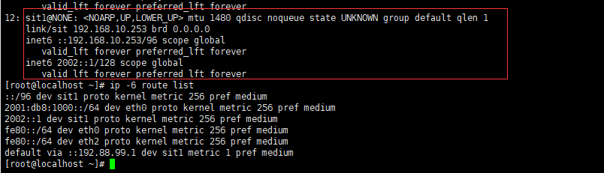

参考：

### 6to4

选择【IPv6配置】，点击“6to4”标签，进入6to4隧道编辑界面，如图9-5-2-1所示。

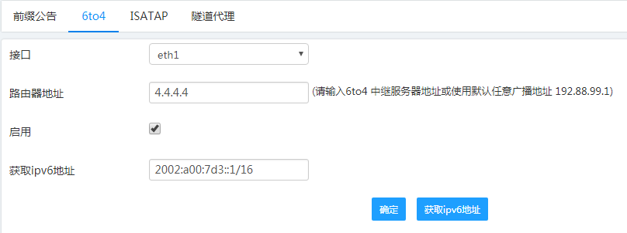

图9-5-2-1 6to4隧道编辑界面

其中6to4隧道各项参数描述如表9-45所示。

表9-45 6to4隧道参数描述

| **域名** | **说明** |
| --- | --- |
| 接口 | 选择建立6to4隧道的接口 |
| 服务器地址 | 6to4中继服务器地址 |
| 获取IPV6地址 | 显示获取的该模块对应接口的IPV6地址 |
| 启用 | 是否启用6to4隧道 |
| 获取IPV6地址按钮 | 获取该模块对应接口的IPV6地址 |

知识点：http://shorewall.net/6to4.htm

网上找的脚本：

链接：http://shorewall.net/pub/shorewall/contrib/IPv6/ipv6

#!/bin/sh

#

# This program is under GPL [http://www.gnu.org/copyleft/gpl.htm]

#

# (c) 2008 2009 - Tom Eastep (teastep@shorewall.net)

#

# On most distributions, this file should be called /etc/init.d/shorewall.

#

# Complete documentation is available at http://shorewall.net

#

# This program is free software; you can redistribute it and/or modify

# it under the terms of Version 2 of the GNU General Public License

# as published by the Free Software Foundation.

#

# This program is distributed in the hope that it will be useful,

# but WITHOUT ANY WARRANTY; without even the implied warranty of

# MERCHANTABILITY or FITNESS FOR A PARTICULAR PURPOSE. See the

# GNU General Public License for more details.

#

# You should have received a copy of the GNU General Public License

# along with this program; if not, write to the Free Software

# Foundation, Inc., 675 Mass Ave, Camipv6, MA 02139, USA

#

# If an error occurs while starting or restarting the firewall, the

# firewall is automatically stopped.

#

# Commands are:

#

# ipv6 start Starts ipv6

# ipv6 restart Restarts ipv6

# ipv6 reload Restarts ipv6

# ipv6 stop Stops ipv6

# ipv6 status Displays ipv6 status

#

# chkconfig: 2345 4 99

# description: Configure a 6to4 tunnel

### BEGIN INIT INFO

# Provides: ipv6

# Required-Start: boot.udev

# Required-Stop:

# Default-Start: 2 3 5

# Default-Stop: 0 1 6

# Description: starts and stops ipv6

### END INIT INFO

################################################################################

# Interfaces to be configured

#

# External Interface

#

SIT="sit1"

#

# If the external interface is a 6to4 tunnel (sit device) then specify the

# IPv4 address here. Otherwise, leave this variable enpty

#

ADDRESS4=206.124.146.180

#

# Internal interfaces of the firewall -- space separated

#

INTERFACES="eth0"

#

# Bits 48-63 of the first internal interface address. Will be incremented

# for each additional internal interface.

#

SLA=1

#

# Default Gateway -- for 6to4, this is ::192.88.99.1

#

GATEWAY=::192.88.99.1

#

# For 6to4 configurations, the ADDRESS6 variable is calculated as follows.

#

# For other configurations, you need to specify ADDRESS6.

#

# ADDRESS6 is assumed to be a 48-bit prefix. If not, then the logic for

# addressing on the internal networks needs to be replaced below.

#

ADDRESS6=$(printf 2002:%02x%02x:%02x%02x $(echo $ADDRESS4 | tr '.' ' '))

#

# The global address of $SIT

#

SITADDR=${ADDRESS6}::1

################################################################################

# Give Usage Information #

################################################################################

usage() {

echo "Usage: $0 start|stop|reload|restart|status"

exit 1

}

################################################################################

# Start IPv6

################################################################################

do_start()

{

local interface

if [ -n "$SIT" ]; then

if [ -n "$ADDRESS4" ]; then

#

# 6to4 -- create tunnel

#

modprobe sit

/sbin/ip tunnel add $SIT mode sit ttl 64 remote any local $ADDRESS4

fi

#

# Configure the external IP address

#

/sbin/ip -6 addr add ${SITADDR} dev $SIT

[ -n "$ADDRESS4" ] && /sbin/ip link set dev $SIT up

[ -n "$GATEWAY" ] && /sbin/ip -6 route add default via $GATEWAY dev $SIT metric 1

fi

for interface in $INTERFACES ; do

/sbin/ip -6 addr add ${ADDRESS6}:$SLA::1/64 dev $interface

SLA=$(($SLA + 1 ))

done

}

################################################################################

# Stop IPv6

################################################################################

do_stop()

{

local interface

local device

device=1

local original_sla

original_sli=$SLA

if [ -n "$SIT" ]; then

if [ -n "$ADDRESS4" ]; then

/sbin/ip link set $SIT down

else

/sbin/ip -6 addr del ${SITADDR} dev $SIT

[ -n "$GATEWAY" ] && /sbin/ip -6 route del default via $GATEWAY dev $SIT metric 1

fi

[ -n "$ADDRESS4" ] && /sbin/ip tunnel del $SIT

fi

for interface in $INTERFACES; do

/sbin/ip -6 addr del ${ADDRESS6}:$SLA::1/64 dev $interface

SLA=$(($SLA + 1 ))

done

SLA=$original_sla #In case this is a restart/reload

}

################################################################################

# E X E C U T I O N B E G I N S H E R E #

################################################################################

command="$1"

case "$command" in

start)

do_start

;;

stop)

do_stop

;;

restart|reload)

do_stop

do_start

;;

status)

/sbin/ip -6 addr list

/sbin/ip -6 route list

;;

*)

usage

;;

esac