导入运价流程

数据维护原型介绍:

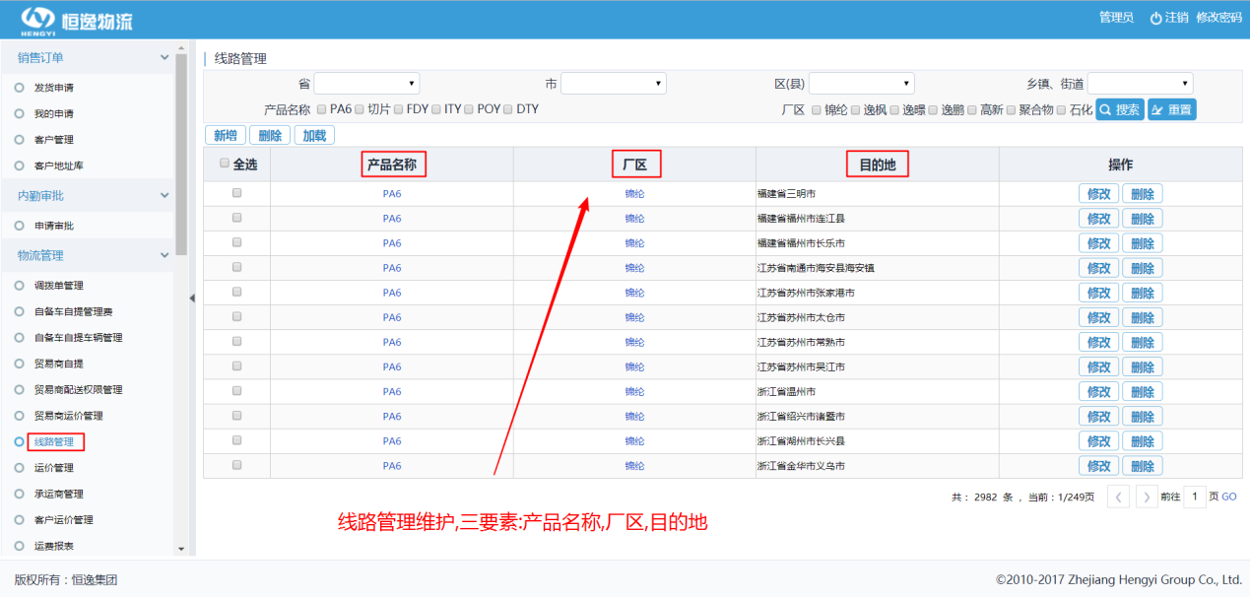

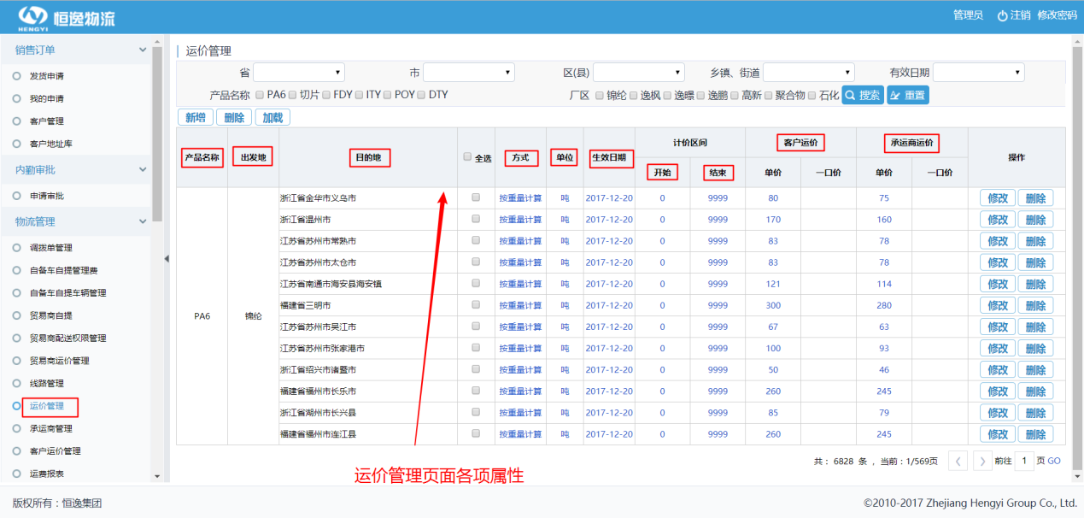

1.进入plsql,连接数据库

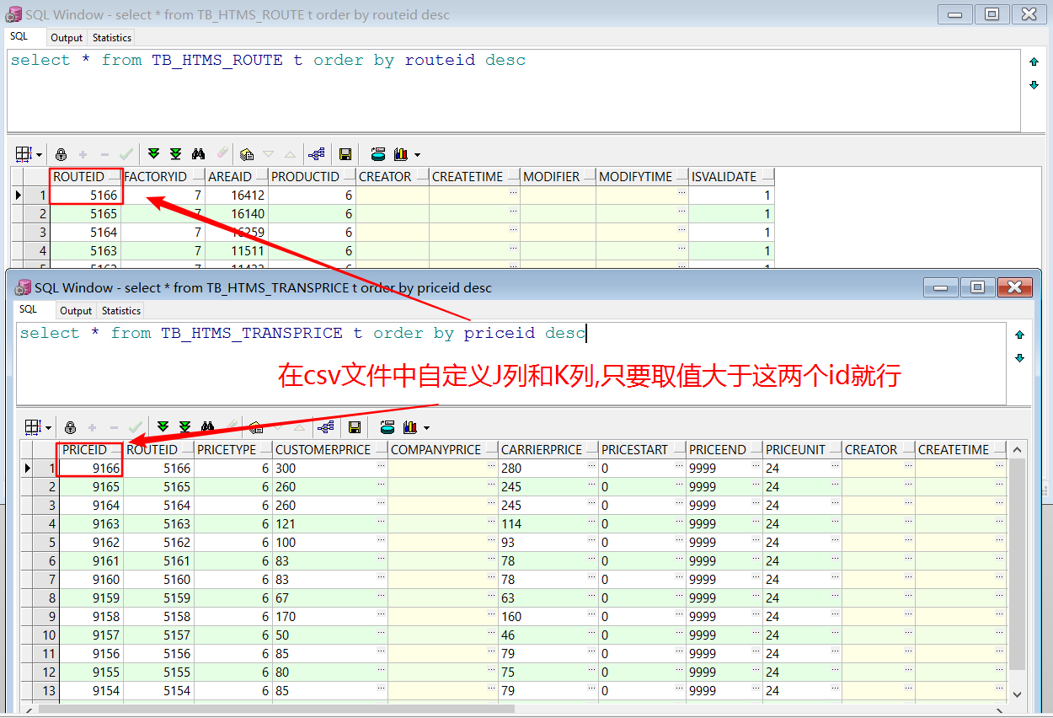

2.获得运价单文件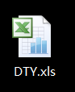,创建空白txt文件,改扩展名为csv,复制数据,重命名为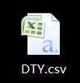

注:解释每列数据含义,AB为目的地,C为厂区,D为产品,E为计费模式,F为开始区间,G为结束区间,H为承运商运价,I为客户运价,增加J列:routeid,增加K列:priceid

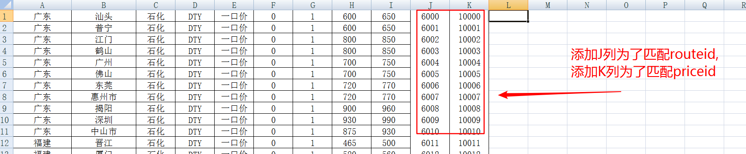

3.在plsql中导入数据

位于工具栏tools-->text importor

前提保持TB_HTMS_TRANSPRICE_DTY没有数据,

有的话删除,delete from TB_HTMS_TRANSPRICE_DTY,然后commit

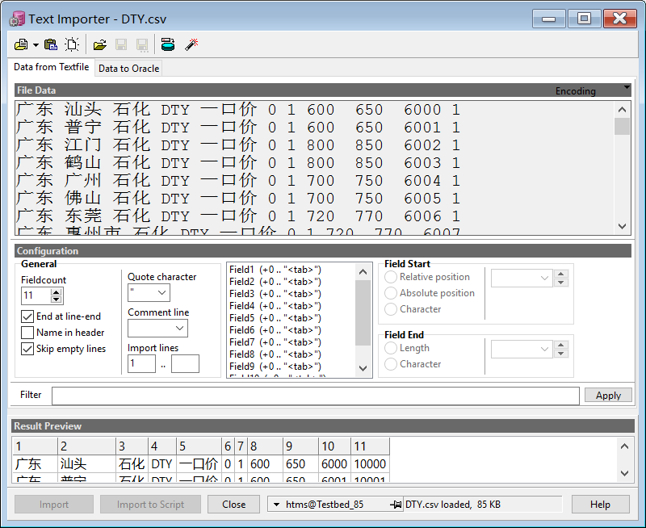

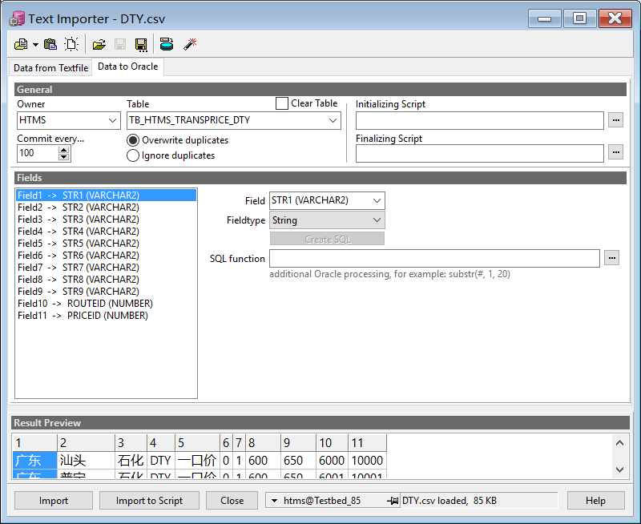



根据响应sql语句操作:

(1)给厂区id赋值

Update tb_htms_transprice_dty d Set d.factoryid = (Select f.factoryid From tb_htms_factory f Where d.str3= f.factoryname );

注:tb_htms_factory 厂区表

|  |  |  |  |  |
| --- | --- | --- | --- | --- |
| 名称 | 数据类型 | 注释 | 是否 必填 | 备注 |
| factoryId | numeric | 厂区ID | 是 | 主键 |
| factoryName | varchar(100) | 厂区名称 |  |  |
| factoryCode | varchar(100) | 厂区编码 |  |  |
| factoryDesc | varchar(1000) | 厂区描述 |  |  |
| factoryAddress | varchar(300) | 厂区地址 |  |  |
| factoryContactor | varchar(30) | 厂区联系人 |  |  |
| factoryTelphone | varchar(30) | 厂区联系电话 |  |  |
| isVlidate | numeric | 是否有效 |  |  |

(2)给产品id赋值

Update tb_htms_transprice_dty d Set d.productid = (Select f.productid From tb_htms_product f Where d.str4= f.productname );

注: tb_htms_product产品表

|  |  |  |  |  |
| --- | --- | --- | --- | --- |
| 名称 | 数据类型 | 注释 | 是否 必填 | 备注 |
| productId | numeric | 产品ID | 是 | 主键 |
| typeId | numeric | 类型ID |  |  |
| productName | varchar(100) | 产品名称 |  |  |
| productCode | varchar(100) | 产品编码 |  |  |
| productDesc | varchar(300) | 产品描述 |  |  |
| sapNo | varchar(100) | SAP物料号 |  |  |
| isValidate | numeric | 是否有效 |  |  |

(3)给开始区间,结束区间,客户运价,承运商运价,计价单位,计价方式,运费模式,生效日期赋值

Update tb_htms_transprice_dty d Set pricestart= Trim(str6),priceend=Trim(str7),customerprice=Trim(str9),carrierprice=Trim(str8),

priceunit=24,pricetype=6,freightmodel=1 ,validatedate ='2017-12-28'

Where str5='按单价';

Update tb_htms_transprice_dty d Set pricestart= Trim(str6),priceend=Trim(str7),customeroneprice=Trim(str9),carrieroneprice=Trim(str8),

priceunit=24,pricetype=6,freightmodel=2 ,validatedate ='2017-12-28'

Where str5='一口价';

注: tb_htms_transprice客户运价表

|  |  |  |  |  |
| --- | --- | --- | --- | --- |
| 名称 | 数据类型 | 注释 | 是否  必填 | 备注 |
| priceId | numeric | 运价ID | 是 | 主键 |
| routeId | numeric | 线路ID |  | 外键 |
| priceType | numeric | 计价方式 |  |  |
| customerPrice | double | 客户运价 |  |  |
| carrierPrice | double | 承运商运价 |  |  |
| priceStart | double | 计价起点数 |  |  |
| priceEnd | double | 计价终点数 |  |  |
| freightModel | numeric | 运费模式 |  |  |
| priceUnit | varchar(30) | 计价单位 |  |  |
| customerOnePrice | double | 客户一口价 |  |  |
| carrierOnePrice | double | 承运商一口价 |  |  |
| validateDate | varchar(30) | 生效日期 |  |  |
| priceNotice | varchar(300) | 备注 |  |  |
| creator | numeric | 创建人 |  |  |
| createTime | varchar(30) | 创建时间 |  |  |
| modifier | numeric | 修改人 |  |  |
| modifyTime | varchar(30) | 修改时间 |  |  |
| isValidate | numeric | 是否有效 |  |  |

注:

计价单位

priceunit=24表示吨

priceunit=25 表示千克

计价方式

pricetype=6 按重量计算

pricetype=9 按包计算

计费模式

freightmodel=1 按单价计算

freightmodel=2 按一口价计算

这些信息从增加运价时候的框架源代码可以查询到value值

(4) str1,或者str1加省,加市,加区能跟地址库的地址名称完全重合,就给地址编码1,地址名称1,地址id1赋值

Update tb_htms_transprice_dty d Set d.areacode1= (Select areacode From tb_htms_area a Where a.areaname=d.str1)，

d.areacname1= (Select areaname From tb_htms_area a Where a.areaname=d.str1)，

d.areaid1= (Select areaid From tb_htms_area a Where a.areaname=d.str1)

where d.areaid1 is null ;

Update tb_htms_transprice_dty d Set d.areacode1= (Select areacode From tb_htms_area a Where a.areaname=d.str1||'省')，

d.areacname1= (Select areaname From tb_htms_area a Where a.areaname=d.str1||'省')，

d.areaid1= (Select areaid From tb_htms_area a Where a.areaname=d.str1||'省')

where d.areaid1 is null ;

Update tb_htms_transprice_dty d Set d.areacode1= (Select areacode From tb_htms_area a Where a.areaname=d.str1||'市')，

d.areacname1= (Select areaname From tb_htms_area a Where a.areaname=d.str1||'市')，

d.areaid1= (Select areaid From tb_htms_area a Where a.areaname=d.str1||'市')

where d.areaid1 is null ;

Update tb_htms_transprice_dty d Set d.areacode1= (Select areacode From tb_htms_area a Where a.areaname=d.str1||'区')，

d.areacname1= (Select areaname From tb_htms_area a Where a.areaname=d.str1||'区')，

d.areaid1= (Select areaid From tb_htms_area a Where a.areaname=d.str1||'区')

where d.areaid1 is null

注:TB_HTMS_AREA 地址库表

|  |  |  |  |  |
| --- | --- | --- | --- | --- |
| 名称 | 数据类型 | 注释 | 是否  必填 | 备注 |
| areaId | numeric | 地址ID | 是 | 主键 |
| parentAreaId | numeric | 地址父级ID |  |  |
| areaCode | varchar(10) | 地址编码 |  |  |
| parentAreaCode | varchar(10) | 上级编码 |  |  |
| areaName | varchar(100) | 地址名称 |  |  |
| areaLevel | numeric | 地址层次 |  |  |
| areaRoute | varchar(100) | 地址寻址编码 |  |  |
| areaLongtitue | varchar(30) | 经度 |  |  |
| areaLatitue | varchar(30) | 纬度 |  |  |
| isLeaf | numeric | 是否末级 |  |  |
| isValidate | numeric | 是否有效 |  |  |

(5) str2,或者str2加市,加镇,加区,加县,加街道能跟地址库的地址名称完全重合,就给地址编码2,地址名称2,地址id2赋值

Update tb_htms_transprice_dty d Set d.areacode2 = (Select areacode From tb_htms_area a Where a.areaname=d.str2 And areacode Like d.areacode1||'%')，

d.areacname2 = (Select areaname From tb_htms_area a Where a.areaname=d.str2 And areacode Like d.areacode1||'%')，

d.areaid2 = (Select areaid From tb_htms_area a Where a.areaname=d.str2 And areacode Like d.areacode1||'%')

where d.areaid2 is null And str2 Is not Null ;

Update tb_htms_transprice_dty d Set d.areacode2 = (Select areacode From tb_htms_area a Where a.areaname=d.str2||'市' And areacode Like d.areacode1||'%')，

d.areacname2 = (Select areaname From tb_htms_area a Where a.areaname=d.str2||'市' And areacode Like d.areacode1||'%')，

d.areaid2 = (Select areaid From tb_htms_area a Where a.areaname=d.str2||'市' And areacode Like d.areacode1||'%')

where d.areaid2 is null And str2 Is not Null ;

Update tb_htms_transprice_dty d Set d.areacode2 = (Select areacode From tb_htms_area a Where a.areaname=d.str2||'镇' And areacode Like d.areacode1||'%')，

d.areacname2 = (Select areaname From tb_htms_area a Where a.areaname=d.str2||'镇' And areacode Like d.areacode1||'%')，

d.areaid2 = (Select areaid From tb_htms_area a Where a.areaname=d.str2||'镇' And areacode Like d.areacode1||'%')

where d.areaid2 is null And str2 Is not Null ;

Update tb_htms_transprice_dty d Set d.areacode2 = (Select areacode From tb_htms_area a Where a.areaname=d.str2||'区' And areacode Like d.areacode1||'%')，

d.areacname2 = (Select areaname From tb_htms_area a Where a.areaname=d.str2||'区' And areacode Like d.areacode1||'%')，

d.areaid2 = (Select areaid From tb_htms_area a Where a.areaname=d.str2||'区' And areacode Like d.areacode1||'%')

where d.areaid2 is null And str2 Is not Null ;

Update tb_htms_transprice_dty d Set d.areacode2 = (Select areacode From tb_htms_area a Where a.areaname=d.str2||'县' And areacode Like d.areacode1||'%')，

d.areacname2 = (Select areaname From tb_htms_area a Where a.areaname=d.str2||'县' And areacode Like d.areacode1||'%')，

d.areaid2 = (Select areaid From tb_htms_area a Where a.areaname=d.str2||'县' And areacode Like d.areacode1||'%')

where d.areaid2 is null And str2 Is not Null ;

Update tb_htms_transprice_dty d Set d.areacode2 = (Select areacode From tb_htms_area a Where a.areaname=d.str2||'街道' And areacode Like d.areacode1||'%')，

d.areacname2 = (Select areaname From tb_htms_area a Where a.areaname=d.str2||'街道' And areacode Like d.areacode1||'%')，

d.areaid2 = (Select areaid From tb_htms_area a Where a.areaname=d.str2||'街道' And areacode Like d.areacode1||'%')

where d.areaid2 is null And str2 Is not Null ;

(6) -- 查询无数据再执行下一步

select * from tb_htms_transprice_dty t Where areaid2 Is Null And str2 Is Not Null ;

举例:

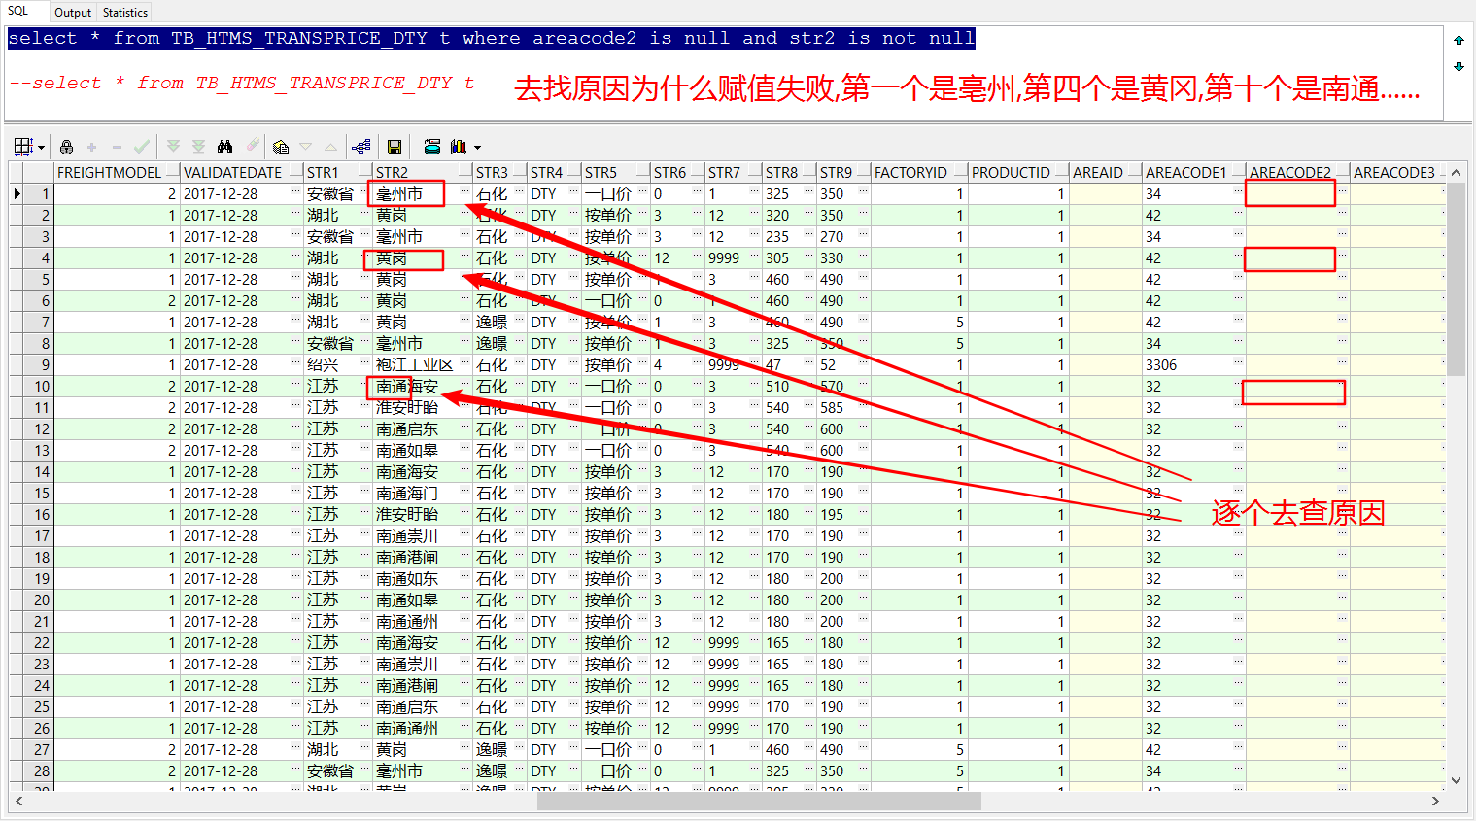

如果有数据,优化查询出的数据,再执行一遍(5)中update语句

举例:

Update tb_htms_transprice_dty d Set str2 = '亳州市' where str2 = '毫州市';

Update tb_htms_transprice_dty d Set str2 = '黄冈' where str2 = '黄岗';

Update tb_htms_transprice_dty d Set str2 = '袍江工业园区' where str2 = '袍江工业区';

如果要在查询数据上直接编辑,在查询语句中后输入 for update ,比较方便:

select * from TB_HTMS_TRANSPRICE_DTY t where areacode2 is null and str2 is not null for update

以下语句是对’南通’打头的地址进行赋值优化,(市,县,区,街道等,其他区域同理):

Update tb_htms_transprice_dty d Set d.areacode2 = (Select areacode From tb_htms_area a Where '南通'||a.areaname=d.str2||'市' And areacode Like d.areacode1||'%')，

d.areacname2 = (Select areaname From tb_htms_area a Where '南通'||a.areaname=d.str2||'市' And areacode Like d.areacode1||'%')，

d.areaid2 = (Select areaid From tb_htms_area a Where '南通'|| a.areaname=d.str2||'市' And areacode Like d.areacode1||'%')

where d.areaid2 is null And str2 Is not Null ;

Update tb_htms_transprice_dty d Set d.areacode2 = (Select areacode From tb_htms_area a Where '南通'||a.areaname=d.str2||'县' And areacode Like d.areacode1||'%')，

d.areacname2 = (Select areaname From tb_htms_area a Where '南通'||a.areaname=d.str2||'县' And areacode Like d.areacode1||'%')，

d.areaid2 = (Select areaid From tb_htms_area a Where '南通'|| a.areaname=d.str2||'县' And areacode Like d.areacode1||'%')

where d.areaid2 is null And str2 Is not Null ;

Update tb_htms_transprice_dty d Set d.areacode2 = (Select areacode From tb_htms_area a Where '南通'||a.areaname=d.str2||'区' And areacode Like d.areacode1||'%')，

d.areacname2 = (Select areaname From tb_htms_area a Where '南通'||a.areaname=d.str2||'区' And areacode Like d.areacode1||'%')，

d.areaid2 = (Select areaid From tb_htms_area a Where '南通'|| a.areaname=d.str2||'区' And areacode Like d.areacode1||'%')

where d.areaid2 is null And str2 Is not Null ;

Update tb_htms_transprice_dty d Set d.areacode2 = (Select areacode From tb_htms_area a Where '南通'||a.areaname=d.str2||'街道' And areacode Like d.areacode1||'%')，

d.areacname2 = (Select areaname From tb_htms_area a Where '南通'||a.areaname=d.str2||'街道' And areacode Like d.areacode1||'%')，

d.areaid2 = (Select areaid From tb_htms_area a Where '南通'|| a.areaname=d.str2||'街道' And areacode Like d.areacode1||'%')

where d.areaid2 is null And str2 Is not Null ;

Update tb_htms_transprice_dty d Set d.areacode2 = (Select areacode From tb_htms_area a Where '南通'||a.areaname=d.str2 And areacode Like d.areacode1||'%')，

d.areacname2 = (Select areaname From tb_htms_area a Where '南通'||a.areaname=d.str2 And areacode Like d.areacode1||'%')，

d.areaid2 = (Select areaid From tb_htms_area a Where '南通'|| a.areaname=d.str2 And areacode Like d.areacode1||'%')

where d.areaid2 is null And str2 Is not Null ;

最终只剩下这几个:

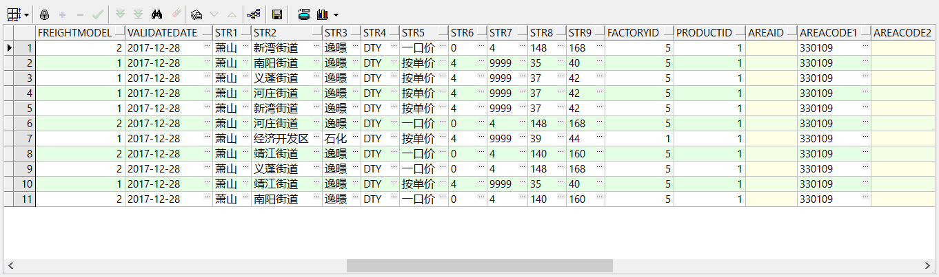

地址库是镇,这边是街道,修改导入数据

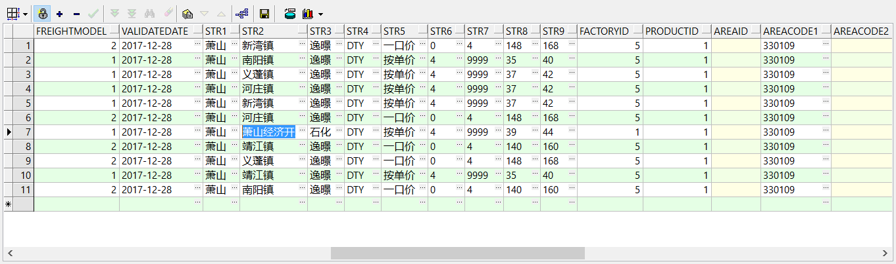

接着查询无数据,进行下一步

(7)给areaid赋值,由范围小的地址开始,到范围大的地址结束

Update tb_htms_transprice_dty Set areaid = areaid2 Where areaid2 Is Not Null ;

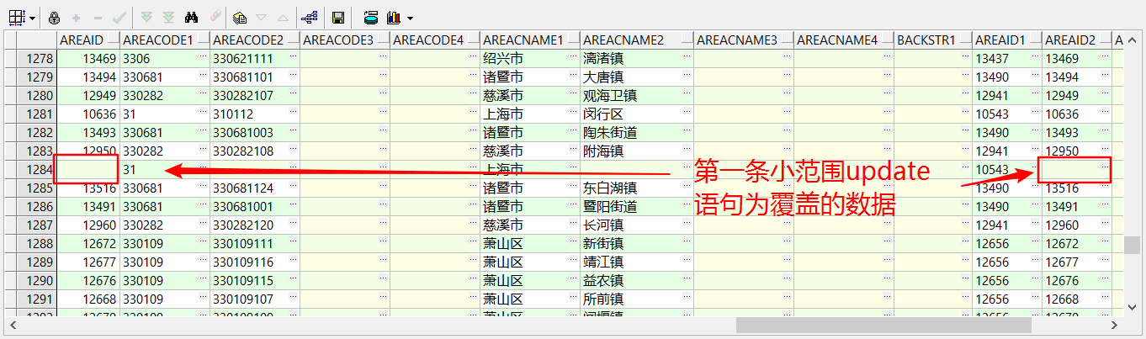

Update tb_htms_transprice_dty Set areaid = areaid1 Where areaid Is Null ;



查询无数据再执行下一步

select * from tb_htms_transprice_dty t Where areaid Is Null ;

(8)给backstr1赋值routeid,当去除重复路线后,backstr1的值即为新线路

update tb_htms_transprice_dty set backstr1 = routeid ;

(9)如果以下语句执行失败则操作:去除重复路线

update tb_htms_transprice_dty d set d. remark=1 ,d.routeid =

(select routeid from tb_htms_route r where r.areaid=d.areaid

and r.factoryid =d.factoryid and r.productid =d.productid);

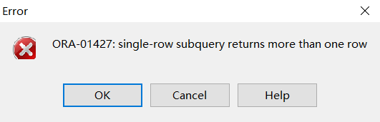

这个错误一般是由于你select中嵌套的select子查询返回不止一条数据导致的

--如果执行不了上述语句,出现以上报错情况那么要加上以下语句 and routeid not in (?,?...)

进行筛选,上面的?要查出来具体数字

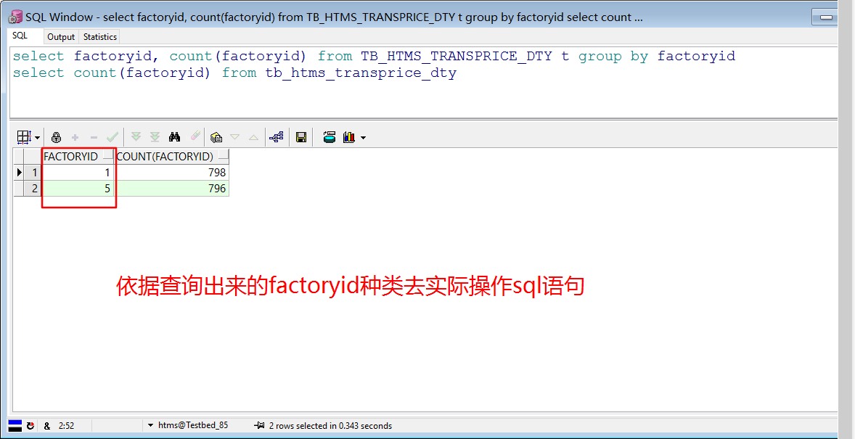

select factoryid, count(factoryid) from TB_HTMS_TRANSPRICE_DTY t group by factoryid

例子:有重复的解决方法

问题:tb_htms_route表格中有重复数据:





查询原来的数据是否有重复数据(其中factoryid与productid按照实际情况):

select * from (

select areaid,count(areaid) as countnum from tb_htms_route r where factoryid=1 and productid =1 group by areaid

) t where t.countnum>1 ;

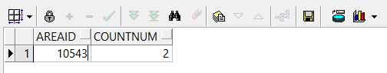

select * from tb_htms_route where areaid in (10543) and factoryid=1 and productid =1 order by areaid

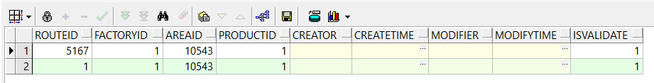

routeid在5167和1中随便晒选一个

(10)还原把backstr1的值赋值到routeid,该赋值的均为新线路

select * from tb_htms_transprice_dty d where routeid is null(直到该语句无数据为止)

update tb_htms_transprice_dty set routeid = backstr1 where routeid is null ;

(11)插入线路

Insert Into tb_htms_route (routeid ,productid ,factoryid ,areaid ,isvalidate)

Select Distinct routeid ,productid ,factoryid ,areaid ,isvalidate From tb_htms_transprice_dty Where routeid > 5167

And areaid Is Not Null and routeid not in (

select routeid from tb_htms_route

) Order By areaid ;

(12)插入运价

Insert Into Tb_Htms_Transprice( Priceid, Routeid, Pricetype, Customerprice, Companyprice, Carrierprice, Pricestart, Priceend, Priceunit, Creator,

Createtime, Modifier, Modifytime, Isvalidate, Customeroneprice, Carrieroneprice, Freightmodel, Validatedate)

Select Priceid, Routeid, Pricetype, Customerprice, Companyprice, Carrierprice, Pricestart, Priceend, Priceunit, Creator,

Createtime, Modifier, Modifytime, Isvalidate, Customeroneprice, Carrieroneprice, Freightmodel, Validatedate

From Tb_Htms_Transprice_Dty d

Where d.Areaid Is Not Null And d.Routeid Is Not Null;

(13)更新两张表

Insert Into caiid_routeid(caiid )

Select routeid As caiid From tb_htms_route Where routeid Not In (Select caiid From caiid_routeid )

Insert Into caiid_priceid(caiid )

Select priceid As caiid From Tb_Htms_Transprice Where priceid Not In (Select caiid From caiid_priceid )