**FORM 1**



**FACULTY OF COMPUTING AND INFORMATION TECHNOLOGY**

## AACS3103 DATABASE DEVELOPMENT AND APPLICATIONS

## Assignment

**Semester JAN 2021**

|  |  |  |
| --- | --- | --- |
| Programme | : | DSC |
| Tutorial Group | : | 7 |
| Date Submitted | : | /2021 |

Team members:

|  |  |  |  |  |
| --- | --- | --- | --- | --- |
| No | Name (Block Letters) | Registration No. | Signature | Marks |
| 1 | Lee Siak Yen | 20WMD04148 | Lee | 100 |
| 2 | Lim Xin Le | 20WMD04239 | ler | 100 |
| 3 | Phang Wan Qi | 20WMD04579 | *wan* | 100 |
| 4 | Ricky Hwong Yu Jun | 20WMD04518 | Ricky | 100 |

   

Lee Siak Yen Lim Xin Le Phang Wan Qi Ricky Hwong Yu Jun

**FORM 2**



**FACULTY OF COMPUTING AND INFORMATION TECHNOLOGY**

## Plagiarism Statement and Guideline for Late Submission of Coursework

Read, complete, and sign this statement to be submitted with the written report.

**We confirm that we have read and shall comply with all the terms and conditions of TAR University College’s plagiarism policy.**

**We declare that this assignment is free from all forms of plagiarism and for all intents and purposes is my own properly derived work.**

Declaration Statement Acknowledged by

|  |  |  |  |  |
| --- | --- | --- | --- | --- |
| **No** | **Name (Block Letters)** | **Registration No.** | **Signature** | **Date** |
| 1 | Lee Siak Yen | 20WMD04148 | Lee | 29/1/2020 |
| 2 | Lim Xin Le | 20WMD04239 | ler | 29/1/2020 |
| 3 | Phang Wan Qi | 20WMD04579 | *wan* | 29/1/2020 |
| 4 | Ricky Hwong Yu Jun | 20WMD04518 | Ricky | 29/1/2020 |

   

Lee Siak Yen Lim Xin Le Phang Wan Qi Ricky Hwong Yu Jun



Assignment Assessment Form (CLO2, CLO3)

Programme (Group): DCS (7)

**Member Name**:  
 1. Lee Siak Yen ,  
 2. Lim Xin Le ,   
 3. Phang Wan Qi ,  
 4. Ricky Hwong Yu Jun

|  |  |  |  |  |  |  |  |  |  |
| --- | --- | --- | --- | --- | --- | --- | --- | --- | --- |
| **Task**  **No.** | **Task Descriptions** | **Weightage** | **Criteria** | **1** | **2** | **3** | **4** | **5** | **Comment** |
| 1 | Develop Business rules | 10% | * Include the required and relevant pairs of business rules. * All business rules must be clearly defined, precise, and reflect the policies and procedures of the organization’s operational environment. |  | | | | |  |
| 2 | Develop ERD | 10% | * Transform business rules to a relational database model correctly. * Correct use of Crow’s Foot notations. * Include all necessary entities, attribute & relationships. |  | | | | |  |
| 3 | Develop DBDL | 10% | * Correct use of DBDL format as required * All required entities, attributes and relationships correctly shown * Indicate Primary key and Foreign key clearly |  | | | | |  |
| 4 | Database Design  20% | 10% | * Correct tables, records and fields designed according to the ERD developed. |  | | | | |  |
| 10% | * Enforcement of entity integrity rule & referential integrity rule * Appropriate data types, default values and check constraints. |  | | | | |  |
| 5 | Records (Entries) | 10% | * Provide sufficient and quality data records * Well-designed records for adequate and logical choices of queries to be performed |  | | | | |  |
| 6 | Queries Design  30% | 10% | * Flexible query for variety of inputs. Clear & proper identification of information needs. * Apply Accept, Prompt and variable substitution in queries. Flexible query to cater for variety of inputs, use of multiple tables. * Apply Report Formatting features. Meaningful report handlings. Data values formatted accordingly. * **Only SELECT statements.** |  |  |  |  |  |  |
| 10% |  |  |  |  |  |  |
| 10% |  |  |  |  |  |  |
| 7 | Assignment Report | 10% | * Comprehensive, clarity and completeness coverage * Quality of report presented * Presentation and Q & A |  |  |  |  |  |  |
| **Assignment Marks / 100** | | |  |  |  |  |  |  |  |

## 

## 

## **Table of Content Page**

Declaration

Assignment Assessment Form 2

(Note: This form is to be included in your hardcopy/softcopy submission so that the marks can be recorded during your presentation.)

**Task 1: Business Rules of the System** 6

1.1 Business Rules 6

1.2 Assumptions 6

**Task 2: Entity-Relationship Modelling**

2.1 Entity-Relationship Diagram 7

**Task 3: Normalization**  8

3.1 Attributes of entities with keys

**Task 4: Create Databases in Oracle** 10

4.1 Payment Table

4.2 Customer Table

4.3 Shipment Table

4.4 Inventory Table

4.5 Ordered Table

4.6 Salesman Table

4.7 Product Table

4.8 Order Details Table

**Task 5: Sample Data / Records** 12

5.1 Customer

5.2 Payment

5.3 Salesman

5.4 Inventory

5.5 Shipment

5.6 Ordered

5.7 Order Details

5.8 Product

**Task 6: SQL Queries and Reports** 22

6.1 (Lee Siak Yen) 22

6.1.1 Report 1:Total Sales Monthly In Year

6.1.2 Query 2:Salesman Product

6.1.3 Query 3:Customer Payment Details

6.2 (Lim Xin Le) 27

6.2.1 Query 1 OR Report 1: Customer Orders

6.2.2 Query 2 OR Report 2: Product Details

6.2.3 Query 3 OR Report 3: Customer Personal Info

6.3 (Ricky Hwong Yu Jun) 30

6.3.1 Query 1 OR Report 1: Shipment details.

6.3.2 Query 2 OR Report 2: Products in the inventory

6.3.3 Query 3 OR Report 3: Quantity left

6.4 (Phang Wan Qi) 34

6.4.1 Query 1 OR Report 1: Payment in a month of that year

6.4.2 Query 2 OR Report 2: Shipment made in a year

6.4.3 Query 3 OR Report 3: Product sold by a salesman

**Task 7: Extra Effort Highlights** 40

(list group and/or individual effort)

7.1 (Student 1)

7.1.1 Views

7.1.2 Sequence

7.2 (Student 2)

7.2.1 Views

7.2.2 Sequence

Reference section (Students are required to use Harvard Referencing System format) x

Appendices (e.g. Website Snapshots or other related images/photos) x

**SALES ORDER SYSTEM  
  
Task 1: Business Rules of the System**

**Business Rules:**

1. Each customer can place one or many orders and each order will be placed by one and only one customer.

2. Each order can consist of one or many products and each product can exist in one or many orders.

3. Each product can have one or many inventory and each inventory can have one and only one product.

4. Business operation hours start from 9:00 am to 6:00 pm everyday except Sunday and public holiday.

5. Online business operation 24 hours every day.

6. Defect items can be returned within 7 days based on order date.

7. Once the order is made, the customer can't cancel the order.

8. Staff must be present by 8am and work 10 hours per day.

9. Shipment will happen after payment is done.

10. The ship date of any order can’t be earlier than the order date.

**Assumptions**   
  
1. Each customer can option to collect the purchase items on the spot or wait for shipment service.

2. Each item must go through quality control checking before it can be sold.

3. Each order needs to double check to confirm it is the same item as the customer wants.  
  
4. If the item is damaged when the customer receives it, the customer can complain and get a new item.

**Task 2: Entity-Relationship Modelling**

Entity-Relationship Diagram

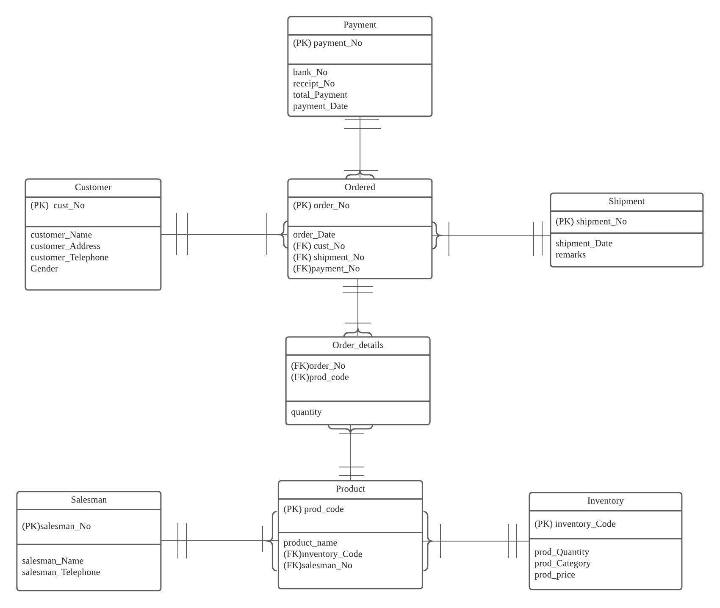

**Task 3: Normalization**

**3.1 Attributes of entities with keys**

**Customer**cust_No, customer_Name, customer_Address, customer_Telephone, Gender

**Payment**payment_No, bank_No, receipt_No, payment_date,total_payment

**Shipment**shipment_No, shipment_Date, remarks

**Ordered**order_No, order_Date, cust_No*, shipment_No*, payment_No*

**Order_details**  
OrderNo*, prod_Code*, quantity

**Product**prod_Code, product_Name, inventory_Code*, salesman_No*

**Salesman**salesman_No, salesman_Name, salesman_Telephone

**Inventory**inventory_Code, prod_Quantity, prod_Category, prod_Price

***Underline as primary keys and ‘*’ as foreign keys***

**3NF**   
  
**Shipment**

|  |  |  |
| --- | --- | --- |
| shipment_No | shipment_Date | remark |

**Order_details**

|  |  |  |
| --- | --- | --- |
| order_No | prod_Code | quantity |

**Salesman**

|  |  |  |
| --- | --- | --- |
| salesman_No | salesman_Name | salesman_Telephone |

**Payment**

|  |  |  |  |  |
| --- | --- | --- | --- | --- |
| payment_No | bank_No | receipt_No | payment_date | total_payment |

**Customer**

|  |  |  |  |  |
| --- | --- | --- | --- | --- |
| cust_No | customer_Name | customer_Address | customer_Telephone | Gender |

**Inventory**

|  |  |  |  |
| --- | --- | --- | --- |
| inventory_Code | prod_Quantity | prod_Category | prod_Price |

**Ordered**

|  |  |  |  |  |
| --- | --- | --- | --- | --- |
| order_No | order_Date | cust_No | shipment_No | payment_No |

**Product**

|  |  |  |  |
| --- | --- | --- | --- |
| prod_Code | product_Name | inventory_Code | salesman_No |

**Task 4: Create Databases in Oracle**  
------------------------------------------------------------------------------------------------------------------------  
 ALTER SESSION SET NLS_DATE_FORMAT = 'DD/MM/YYYY';  
**4.1 PAYMENT**CREATE TABLE Payment(  
 payment_No CHAR(10) NOT NULL,  
 bank_No VARCHAR(15) NOT NULL,  
 recepit_No VARCHAR(15) NOT NULL,  
 payment_Date DATE NOT NULL,  
 total_Payment NUMBER(5) NOT NULL,  
PRIMARY KEY (payment_No)  
);  
  
**4.2 CUSTOMER**

CREATE TABLE Customer(

cust_No CHAR(7) NOT NULL,

customer_Name VARCHAR(30) NOT NULL,

customer_Address VARCHAR(30) NOT NULL,

customer_Telephone VARCHAR(18) NOT NULL,

Gender CHAR(6) CHECK(Gender IN ('F','M')),

PRIMARY KEY(cust_No)

);

**4.3 SHIPMENT**

CREATE TABLE Shipment(

shipment_No CHAR(11) NOT NULL,

shipment_Date DATE NOT NULL,

remarks VARCHAR(100),

PRIMARY KEY (shipment_No)

);

**4.4 INVENTORY**

CREATE TABLE Inventory(

inventory_Code VARCHAR(8) NOT NULL,

prod_Quantity NUMBER(4) DEFAULT 1,

prod_Category VARCHAR(20) NOT NULL,

prod_Price VARCHAR(100) NOT NULL,

PRIMARY KEY(inventory_Code)

);

**4.5 ORDERED**

CREATE TABLE Ordered(

order_No CHAR(8) NOT NULL,

order_Date DATE NOT NULL,

cust_No CHAR(7 NOT NULL,

shipment_No CHAR(11) NOT NULL,

payment_No CHAR(10) NOT NULL,

PRIMARY KEY(order_No),

FOREIGN KEY (cust_No) REFERENCES Customer (cust_No),

FOREIGN KEY (shipment_No) REFERENCES Shipment (shipment_No),

FOREIGN KEY(payment_No) REFERENCES Payment(payment_No)

);

**4.6 SALESMAN**

CREATE TABLE Salesman(

salesman_No VARCHAR(10) NOT NULL,

salesman_Name VARCHAR(30) NOT NULL,

salesman_Telephone VARCHAR(18) NOT NULL,

PRIMARY KEY(salesman_No),

CONSTRAINT sales_Telephone CHECK (salesman_Telephone not like '%[^0-9]%')

);  
  
**4.7 PRODUCT**

CREATE TABLE Product (

prod_Code CHAR(9) NOT NULL,

product_Name VARCHAR(30) NOT NULL,

inventory_Code VARCHAR(8) NOT NULL,

salesman_No VARCHAR(10) NOT NULL,

PRIMARY KEY(prod_Code),   
FOREIGN KEY (salesman_No) REFERENCES Salesman(salesman_No),

FOREIGN KEY (inventory_Code) REFERENCES Inventory(inventory_Code)

);

**4.8 ORDER DETAILS**

CREATE TABLE Order_details (

order_No CHAR(8) NOT NULL,

prod_Code CHAR(9) NOT NULL,

quantity NUMBER(2) DEFAULT 1,

FOREIGN KEY (prod_Code) REFERENCES Product(prod_Code),

FOREIGN KEY (order_No) REFERENCES Ordered(order_No)  
);

**Task 5: Sample Data / Records**  
-------------------------------------------------------------------------------------------------------------------------  
  
**5.1 CUSTOMER**  
INSERT INTO customer VALUES ('C00001', 'Fonzie Shipperbottom', '758 Dennis Terrace', '018-204-8489','F');

INSERT INTO customer VALUES ('C00002', 'Fania Moncrief', '08971 Beilfuss Parkway', '018-456-9362','F');

INSERT INTO customer VALUES ('C00003', 'Wilfred Bramsen', '8009 Sherman Drive', '016-356-7348','F');

INSERT INTO customer VALUES ('C00004', 'Marigold Denny', '35472 Sachs Way', '018-481-4582','F');

INSERT INTO customer VALUES ('C00005', 'Amelina Bangs', '37 Granby Place', '017-501-6138','F');

INSERT INTO customer VALUES ('C00006', 'Leigh Arckoll', '02436 Carioca Drive', '012-386-9031','F');

INSERT INTO customer VALUES ('C00007', 'Klaus Hebblethwaite', '01473 Brown Plaza', '016-885-5554','M');

INSERT INTO customer VALUES ('C00008', 'Johan Huckel', '35 Schlimgen Road', '017-567-0831','M');

INSERT INTO customer VALUES ('C00009', 'Dorise Riddick', '2 Colorado Plaza', '017-423-7800','M');

INSERT INTO customer VALUES ('C00010', 'Leigh Vasyunichev', '89 East Junction', '012-474-1111','M');

**5.2 PAYMENT**

INSERT INTO payment VALUES ('PY00001', '1245-2234-9485 ', 'R00001', '19/12/2018','1920');

INSERT INTO payment VALUES ('PY00002', '3265-3982-9837 ', 'R00002', '08/01/2019','1230');

INSERT INTO payment VALUES ('PY00003', '9379-2719-3719 ', 'R00003', '02/02/2019','990');

INSERT INTO payment VALUES ('PY00004', '4639-3619-2649 ', 'R00004', '28/02/2019','2200');

INSERT INTO payment VALUES ('PY00005', '4618-2462-3619 ', 'R00005', '03/03/2019','1200');

INSERT INTO payment VALUES ('PY00006', '4729-3472-7392 ', 'R00006', '14/03/2019','4400');

INSERT INTO payment VALUES ('PY00007', '4739-3739-0383 ', 'R00007', '28/03/2019','5600');

INSERT INTO payment VALUES ('PY00008', '0283-2873-0271 ', 'R00008', '08/04/2019','1800');

INSERT INTO payment VALUES ('PY00009', '4629-6607-4820 ', 'R00009', '28/05/2019','1600');

INSERT INTO payment VALUES ('PY00010', '6478-2947-2900 ', 'R00010', '29/05/2019','2100');

INSERT INTO payment VALUES ('PY00011', '0280-3729-4028 ', 'R00011', '24/06/2019','1400');

INSERT INTO payment VALUES ('PY00012', '4739-2038-2720 ', 'R00012', '30/06/2019','1500');

INSERT INTO payment VALUES ('PY00013', '4839-7008-3730 ', 'R00013', '18/07/2019','1500');

INSERT INTO payment VALUES ('PY00014', '4820-0948-3820 ', 'R00014', '19/07/2019','1119');

INSERT INTO payment VALUES ('PY00015', '4639-0382-3802 ', 'R00015', '25/07/2019','2019');

INSERT INTO payment VALUES ('PY00016', '0382-2038-1391 ', 'R00016', '08/08/2019','1900');

INSERT INTO payment VALUES ('PY00017', '3820-0872-2830 ', 'R00017', '14/08/2019','4200');

INSERT INTO payment VALUES ('PY00018', '0392-2830-9372 ', 'R00018', '16/08/2019','9212');

INSERT INTO payment VALUES ('PY00019', '4629-6607-8820 ', 'R00019', '20/08/2019','2200');

INSERT INTO payment VALUES ('PY00020', '6478-3957-7180 ', 'R00020', '26/08/2019','2200');  
INSERT INTO payment VALUES ('PY00021', '1266-5235-1495 ', 'R00021', '31/08/2019','1699');

INSERT INTO payment VALUES ('PY00022', '3525-9882-9967 ', 'R00022', '02/09/2019','2999');

INSERT INTO payment VALUES ('PY00023', '9889-2788-3129 ', 'R00023', '08/09/2019','1299');

INSERT INTO payment VALUES ('PY00024', '4639-3619-1129 ', 'R00024', '15/09/2019','1320');

INSERT INTO payment VALUES ('PY00025', '4618-2462-3239 ', 'R00025', '20/09/2019','1111');

INSERT INTO payment VALUES ('PY00026', '4729-3472-7122 ', 'R00026', '25/09/2019','4021');

INSERT INTO payment VALUES ('PY00027', '4739-3739-0113 ', 'R00027', '27/09/2019','1230');

INSERT INTO payment VALUES ('PY00028', '0283-2873-0211 ', 'R00028', '13/10/2019','3220');

INSERT INTO payment VALUES ('PY00029', '4629-6607-4130 ', 'R00029', '28/10/2019','4404');

INSERT INTO payment VALUES ('PY00030', '6478-2947-2120 ', 'R00030', '03/11/2019','9900');  
INSERT INTO payment VALUES ('PY00031', '1245-2234-9215 ', 'R00031', '19/11/2019','3720');

INSERT INTO payment VALUES ('PY00032', '3265-3982-9997 ', 'R00032', '26/11/2019','2700');

INSERT INTO payment VALUES ('PY00033', '9379-2719-3889 ', 'R00033', '30/11/2019','1223');

INSERT INTO payment VALUES ('PY00034', '4639-3619-2649 ', 'R00034', '05/12/2019','5432');

INSERT INTO payment VALUES ('PY00035', '4618-2462-3659 ', 'R00035', '09/12/2019','1253');

INSERT INTO payment VALUES ('PY00036', '4729-3472-7152 ', 'R00036', '15/12/2019','9524');

INSERT INTO payment VALUES ('PY00037', '4739-3739-0143 ', 'R00037', '27/12/2019','3902');

INSERT INTO payment VALUES ('PY00038', '0283-2873-0131 ', 'R00038', '31/12/2019','3400');

INSERT INTO payment VALUES ('PY00039', '4629-6607-4120 ', 'R00039', '05/01/2020','1230');

INSERT INTO payment VALUES ('PY00040', '6478-2947-2310 ', 'R00040', '08/01/2020','1256');

INSERT INTO payment VALUES ('PY00041', '1245-2234-9143 ', 'R00041', '15/01/2020','7611');

INSERT INTO payment VALUES ('PY00042', '3265-3982-9127 ', 'R00042', '19/01/2020','4902');

INSERT INTO payment VALUES ('PY00043', '9379-2719-3239 ', 'R00043', '31/01/2020','4050');

INSERT INTO payment VALUES ('PY00044', '4639-3619-2669 ', 'R00044', '05/02/2020','2000');

INSERT INTO payment VALUES ('PY00045', '4618-2462-3239 ', 'R00045', '18/02/2020','3500');

INSERT INTO payment VALUES ('PY00046', '4729-3472-7232 ', 'R00046', '23/02/2020','1400');

INSERT INTO payment VALUES ('PY00047', '4739-3739-0233 ', 'R00047', '15/03/2020','1500');

INSERT INTO payment VALUES ('PY00048', '0283-2873-0231 ', 'R00048', '18/03/2020','2650');

INSERT INTO payment VALUES ('PY00049', '4629-6607-4230 ', 'R00049', '22/03/2020','1780');

INSERT INTO payment VALUES ('PY00050', '6478-2947-2435 ', 'R00050', '31/03/2020','3910');

INSERT INTO payment VALUES ('PY00051', '1245-2234-9775 ', 'R00051', '15/04/2020','8820');

INSERT INTO payment VALUES ('PY00052', '3265-3982-9345 ', 'R00052', '19/04/2020','1109');

INSERT INTO payment VALUES ('PY00053', '9379-2719-3779 ', 'R00053', '23/04/2020','1232');

INSERT INTO payment VALUES ('PY00054', '4639-3619-2559 ', 'R00054', '30/04/2020','3350');

INSERT INTO payment VALUES ('PY00055', '4618-2462-3129 ', 'R00055', '05/05/2020','4500');

INSERT INTO payment VALUES ('PY00056', '4729-3472-7222 ', 'R00056', '12/05/2020','5000');

INSERT INTO payment VALUES ('PY00057', '4739-3739-0333 ', 'R00057', '15/05/2020','3320');

INSERT INTO payment VALUES ('PY00058', '0283-2873-0451 ', 'R00058', '18/06/2020','2040');

INSERT INTO payment VALUES ('PY00059', '4629-6607-4890 ', 'R00059', '29/06/2020','5600');

INSERT INTO payment VALUES ('PY00060', '6478-2947-2450 ', 'R00060', '03/07/2020','7850');

INSERT INTO payment VALUES ('PY00061', '1245-2234-9455 ', 'R00061', '28/08/2020','1350');

INSERT INTO payment VALUES ('PY00062', '3265-3982-9777 ', 'R00062', '26/09/2020','5400');

INSERT INTO payment VALUES ('PY00063', '9379-2719-3349 ', 'R00063', '13/10/2020','3200');

INSERT INTO payment VALUES ('PY00064', '4639-3619-2339 ', 'R00064', '24/11/2020','1000');

INSERT INTO payment VALUES ('PY00065', '4618-2462-3459 ', 'R00065', '24/11/2020','900');

INSERT INTO payment VALUES ('PY00066', '4729-3472-7562 ', 'R00066', '25/12/2020','8500');

INSERT INTO payment VALUES ('PY00067', '4739-3739-0563 ', 'R00067', '26/12/2020','1200');

INSERT INTO payment VALUES ('PY00068', '0283-2873-0651 ', 'R00068', '27/12/2020','3450');

INSERT INTO payment VALUES ('PY00069', '4629-6607-4150 ', 'R00069', '28/12/2020','3800');

INSERT INTO payment VALUES ('PY00070', '6478-2947-2110 ', 'R00070', '29/12/2020','5200');

INSERT INTO payment VALUES ('PY00071', '1245-2234-9555 ', 'R00071', '01/01/2021','4000');

INSERT INTO payment VALUES ('PY00072', '3265-3982-9127 ', 'R00072', '12/01/2021','1950');

INSERT INTO payment VALUES ('PY00073', '9379-2719-3539 ', 'R00073', '13/012021','1223');

INSERT INTO payment VALUES ('PY00074', '4639-3619-2129 ', 'R00074', '14/01/2021','1232');

INSERT INTO payment VALUES ('PY00075', '4618-2462-3219 ', 'R00075', '15/01/2021','9271');

INSERT INTO payment VALUES ('PY00076', '4729-3472-7122 ', 'R00076', '22/01/2021','2327');

INSERT INTO payment VALUES ('PY00077', '4739-3739-0523 ', 'R00077', '23/01/2021','1542');

INSERT INTO payment VALUES ('PY00078', '0283-2873-0551 ', 'R00078', '24/01/2021','1232');

INSERT INTO payment VALUES ('PY00079', '4629-6607-4150 ', 'R00079', '28/01/2021','1932');

INSERT INTO payment VALUES ('PY00080', '6478-2947-2130 ', 'R00080', '3/02/2021','2876');

INSERT INTO payment VALUES ('PY00081', '1245-2234-9185 ', 'R00081', '19/02/2021','4732');

INSERT INTO payment VALUES ('PY00082', '3265-3982-9157 ', 'R00082', '26/03/2021','321');

INSERT INTO payment VALUES ('PY00083', '9379-2719-3159 ', 'R00083', '3/03/2021','3212');

INSERT INTO payment VALUES ('PY00084', '4639-3619-2119 ', 'R00084', '22/03/2021','3120');

INSERT INTO payment VALUES ('PY00085', '4618-2462-3139 ', 'R00085', '29/03/2021','2130');

INSERT INTO payment VALUES ('PY00086', '4729-3472-7152 ', 'R00086', '1/04/2021','2942');

INSERT INTO payment VALUES ('PY00087', '4739-3739-0153 ', 'R00087', '2/04/2021','4836');

INSERT INTO payment VALUES ('PY00088', '0213-2463-0121 ', 'R00088', '3/2/2020','2842');

INSERT INTO payment VALUES ('PY00089', '4159-6607-4820 ', 'R00089', '28/2/2020','1243');

INSERT INTO payment VALUES ('PY00090', '6278-2947-2900 ', 'R00090', '3/3/2020','1215');

INSERT INTO payment VALUES ('PY00091', '1545-2234-9485 ', 'R00091', '19/1/2020','1237');

INSERT INTO payment VALUES ('PY00092', '1665-3982-9837 ', 'R00092', '26/4/2020','2825');

INSERT INTO payment VALUES ('PY00093', '9279-2719-3719 ', 'R00093', '3/7/2020','1372');

INSERT INTO payment VALUES ('PY00094', '1939-3619-2159 ', 'R00094', '22/11/2020','4520');

INSERT INTO payment VALUES ('PY00095', '1218-2462-3195 ', 'R00095', '18/11/2020','1120');

INSERT INTO payment VALUES ('PY00096', '6629-3122-7242 ', 'R00096', '23/12/2020','3200');

INSERT INTO payment VALUES ('PY00097', '4722-1139-6483 ', 'R00097', '27/1/2020','1320');

INSERT INTO payment VALUES ('PY00098', '0244-2873-4171 ', 'R00098', '3/2/2020','1382');

INSERT INTO payment VALUES ('PY00099', '4629-6607-4120 ', 'R00099', '28/2/2020','2832');

INSERT INTO payment VALUES ('PY00100', '6178-2241-2910 ', 'R00100', '3/3/2020','1200');

**5.3 SALESMAN**  
INSERT INTO salesman VALUES ('SA00001','Jojo Hackney','018-936-0891');

INSERT INTO salesman VALUES ('SA00002','Catalina Bodycote','016-556-1507');

INSERT INTO salesman VALUES ('SA00003','Elyn Fricker','012-899-2090');

INSERT INTO salesman VALUES ('SA00004','Adrianna Stonehouse','018-968-8146');

INSERT INTO salesman VALUES ('SA00005','Tess Trolley','012-489-2959');

INSERT INTO salesman VALUES ('SA00006','Almeta Hartzogs','017-666-9313');

INSERT INTO salesman VALUES ('SA00007','Nancie Anslow','012-679-6089');

INSERT INTO salesman VALUES ('SA00008','Baxie Purslow','016-435-87402');

INSERT INTO salesman VALUES ('SA00009','Shelly Tribbeck','017-790-7771');

INSERT INTO salesman VALUES ('SA00010','Kalila Dellenbrok','019-464-9395');

**5.4 INVENTORY**  
INSERT INTO inventory VALUES ('I00001',20,'Metal Chair','RM399');

INSERT INTO inventory VALUES ('I00002',20,'Wood Chair','RM199');

INSERT INTO inventory VALUES ('I00003',40,'Gold Chair','RM1399');

INSERT INTO inventory VALUES ('I00004',35,'Diamond Table','RM1599');

INSERT INTO inventory VALUES ('I00006',30,'Coffee Table','RM1499');

INSERT INTO inventory VALUES ('I00005',35,'MedDesk','RM429');

INSERT INTO inventory VALUES ('I00007',30,'Gold Desk','RM449');

INSERT INTO inventory VALUES ('I00008',25,'Refectory Wardrobe','RM1299');

INSERT INTO inventory VALUES ('I00009',25,'Lift chair','RM129');

INSERT INTO inventory VALUES ('I00010',35,'Bean bag','RM213');

**5.5 SHIPMENT**  
INSERT INTO shipment VALUES ('SH00001','20/01/2001',null);

INSERT INTO shipment VALUES ('SH00002','11/01/2020', null);

INSERT INTO shipment VALUES ('SH00003', '21/06/2010', 'Please be careful during delivery');

INSERT INTO shipment VALUES ('SH00004', '12/04/2013', 'Please delivery the product as soon as possible');

INSERT INTO shipment VALUES ('SH00005', '21/03/2010', null);

INSERT INTO shipment VALUES ('SH00006', '11/01/2013', 'Please pack the product tightly');

INSERT INTO shipment VALUES ('SH00007', '14/04/2010', null);

INSERT INTO shipment VALUES ('SH00008', '09/07/2020', null);

INSERT INTO shipment VALUES ('SH00009', '07/06/2010', null);

INSERT INTO shipment VALUES ('SH00010', '07/06/2012', 'Please inform me before delivery');

INSERT INTO shipment VALUES ('SH00011', '03/03/2014', null);

INSERT INTO shipment VALUES ('SH00012', '05/02/2015', null);

INSERT INTO shipment VALUES ('SH00013', '06/04/2016', null);

INSERT INTO shipment VALUES ('SH00014', '07/05/2017', null);

INSERT INTO shipment VALUES ('SH00015','20/01/2012',null);  
INSERT INTO shipment VALUES ('SH00016','11/01/2043', null);

INSERT INTO shipment VALUES ('SH00017', '21/06/2010', 'Please be careful during delivery');

INSERT INTO shipment VALUES ('SH00018', '12/04/2013', 'Please delivery the product as soon as possible');

INSERT INTO shipment VALUES ('SH00019', '21/03/2010', null);

INSERT INTO shipment VALUES ('SH00020', '11/01/2013', 'Please pack the product tightly');

INSERT INTO shipment VALUES ('SH00021', '14/04/2010', null);

INSERT INTO shipment VALUES ('SH00022', '09/07/2020', null);

INSERT INTO shipment VALUES ('SH00023', '07/03/2010', null);

INSERT INTO shipment VALUES ('SH00024', '27/06/2012', 'Please inform me before delivery');

INSERT INTO shipment VALUES ('SH00025', '10/12/2011', null);

INSERT INTO shipment VALUES ('SH00026', '05/02/2012', null);

INSERT INTO shipment VALUES ('SH00027', '06/10/2009', null);

INSERT INTO shipment VALUES ('SH00028', '07/05/2014', null);

INSERT INTO shipment VALUES ('SH00029','10/01/2003',null);

INSERT INTO shipment VALUES ('SH00030','11/01/2020', null);

INSERT INTO shipment VALUES ('SH00031', '21/06/2010', 'Please be careful during delivery');

INSERT INTO shipment VALUES ('SH00032', '12/04/2013', 'Please delivery the product as soon as possible');

INSERT INTO shipment VALUES ('SH00033', '21/03/2010', null);

INSERT INTO shipment VALUES ('SH00034', '11/01/2013', 'Please pack the product tightly');

INSERT INTO shipment VALUES ('SH00035', '14/04/2010', null);

INSERT INTO shipment VALUES ('SH00036', '09/07/2020', null);

INSERT INTO shipment VALUES ('SH00037', '07/06/2010', null);

INSERT INTO shipment VALUES ('SH00038', '07/06/2012', 'Please inform me before delivery');

INSERT INTO shipment VALUES ('SH00039', '05/03/2012', null);

INSERT INTO shipment VALUES ('SH00040', '05/02/2012', null);

INSERT INTO shipment VALUES ('SH00041', '06/04/2012', null);

INSERT INTO shipment VALUES ('SH00042', '07/05/2012', null);

INSERT INTO shipment VALUES ('SH00043','20/01/2001',null);

INSERT INTO shipment VALUES ('SH00044','11/01/2020', null);

INSERT INTO shipment VALUES ('SH00045', '21/06/2010', 'Please be careful during delivery');

INSERT INTO shipment VALUES ('SH00046', '12/04/2013', 'Please delivery the product as soon as possible');

INSERT INTO shipment VALUES ('SH00047', '21/03/2010', null);

INSERT INTO shipment VALUES ('SH00048', '11/01/2013', 'Please pack the product tightly');

INSERT INTO shipment VALUES ('SH00049', '14/04/2010', null);

INSERT INTO shipment VALUES ('SH00050', '09/07/2020', 'Please pack the product tightly');

INSERT INTO shipment VALUES ('SH00051', '07/06/2010', null);

INSERT INTO shipment VALUES ('SH00052', '07/06/2012', 'Please inform me before delivery');

INSERT INTO shipment VALUES ('SH00053', '05/03/2012', null);

INSERT INTO shipment VALUES ('SH00054', '05/02/2012', null);

INSERT INTO shipment VALUES ('SH00055', '06/04/2012', 'Please delivery the product as soon as possible');

INSERT INTO shipment VALUES ('SH00056', '07/05/2012', null);

INSERT INTO shipment VALUES ('SH00057','20/01/2001',null);

INSERT INTO shipment VALUES ('SH00058','11/01/2020', null);

INSERT INTO shipment VALUES ('SH00059', '21/06/2010', 'Please be careful during delivery');

INSERT INTO shipment VALUES ('SH00060', '12/04/2013', 'Please delivery the product as soon as possible');

INSERT INTO shipment VALUES ('SH00061', '21/03/2010', null);

INSERT INTO shipment VALUES ('SH00062', '11/01/2013', 'Please pack the product tightly');

INSERT INTO shipment VALUES ('SH00063', '14/04/201', null);

INSERT INTO shipment VALUES ('SH00064', '09/07/2019', null);

INSERT INTO shipment VALUES ('SH00065', '07/06/2019', null);

INSERT INTO shipment VALUES ('SH00066', '07/06/2019', 'Please inform me before delivery');

INSERT INTO shipment VALUES ('SH00067', '05/03/2019', null);

INSERT INTO shipment VALUES ('SH00068', '05/02/2019', null);

INSERT INTO shipment VALUES ('SH00069', '06/04/2019', null);

INSERT INTO shipment VALUES ('SH00070', '07/05/2020', null);

INSERT INTO shipment VALUES ('SH00071','20/01/2020',null);

INSERT INTO shipment VALUES ('SH00072','11/01/2020', null);

INSERT INTO shipment VALUES ('SH00073', '21/06/2020', 'Please be careful during delivery');

INSERT INTO shipment VALUES ('SH00074', '12/04/2020', 'Please delivery the product as soon as possible');

INSERT INTO shipment VALUES ('SH00075', '21/03/2020', null);

INSERT INTO shipment VALUES ('SH00076', '11/01/2021', 'Please pack the product tightly');

INSERT INTO shipment VALUES ('SH00077', '14/04/2021', null);

INSERT INTO shipment VALUES ('SH00078', '09/07/2021', null);

INSERT INTO shipment VALUES ('SH00079', '07/06/2021', null);

INSERT INTO shipment VALUES ('SH00080', '07/06/2021', 'Please inform me before delivery');

INSERT INTO shipment VALUES ('SH00081', '05/03/2021', null);

INSERT INTO shipment VALUES ('SH00082', '05/02/2021', null);

INSERT INTO shipment VALUES ('SH00083', '06/04/2021', null);

INSERT INTO shipment VALUES ('SH00084', '07/05/2021', null);

INSERT INTO shipment VALUES ('SH00085','20/01/2021',null);

INSERT INTO shipment VALUES ('SH00086','11/01/2021', null);

INSERT INTO shipment VALUES ('SH00087', '21/06/2021', 'Please be careful during delivery');

INSERT INTO shipment VALUES ('SH00088', '12/04/2021', 'Please delivery the product as soon as possible');

INSERT INTO shipment VALUES ('SH00089', '21/03/2021', null);

INSERT INTO shipment VALUES ('SH00090', '11/01/2021', 'Please pack the product tightly');

INSERT INTO shipment VALUES ('SH00091', '14/04/2021', null);

INSERT INTO shipment VALUES ('SH00092', '09/07/2020', null);

INSERT INTO shipment VALUES ('SH00093', '07/06/2010', null);

INSERT INTO shipment VALUES ('SH00094', '07/06/2012', 'Please inform me before delivery');

INSERT INTO shipment VALUES ('SH00095', '05/03/2012', null);

INSERT INTO shipment VALUES ('SH00096', '05/02/2012', null);

INSERT INTO shipment VALUES ('SH00097', '06/04/2012', null);

INSERT INTO shipment VALUES ('SH00098', '07/05/2012', null);

INSERT INTO shipment VALUES ('SH00099','20/01/2001',null);

INSERT INTO shipment VALUES ('SH00100','11/01/2020', null);

**5.6 ORDERED**  
INSERT INTO ordered VALUES ('O00001','19/01/2020','C00001','SH00001','PY00001');

INSERT INTO ordered VALUES ('O00002','26/01/2020','C00002','SH00002','PY00007');

INSERT INTO ordered VALUES ('O00003','03/02/2020','C00003','SH00003','PY00012');

INSERT INTO ordered VALUES ('O00004','22/02/2020','C00004','SH00004','PY00017');

INSERT INTO ordered VALUES ('O00005','18/03/2020','C00005','SH00005','PY00022');

INSERT INTO ordered VALUES ('O00006','23/03/2018','C00006','SH00006','PY00026');

INSERT INTO ordered VALUES ('O00007','27/03/2018','C00007','SH00007','PY00030');

INSERT INTO ordered VALUES ('O00008','03/04/2018','C00008','SH00008','PY00035');

INSERT INTO ordered VALUES ('O00009','28/04/2018','C00009','SH00009','PY00008');

INSERT INTO ordered VALUES ('O00010','03/05/2018','C00010','SH00010','PY00010');

INSERT INTO ordered VALUES ('O00011','23/05/2018','C00001','SH00011','PY00001');

INSERT INTO ordered VALUES ('O00012','03/06/2018','C00002','SH00012','PY00007');

INSERT INTO ordered VALUES ('O00013','30/06/2018','C00003','SH00013','PY00012');

INSERT INTO ordered VALUES ('O00014','12/07/2018','C00004','SH00014','PY00017');  
INSERT INTO ordered VALUES ('O00015','18/07/2018','C00005','SH00015','PY00023');

INSERT INTO ordered VALUES ('O00016','23/07/2018','C00006','SH00016','PY00027');

INSERT INTO ordered VALUES ('O00017','27/07/2018','C00007','SH00017','PY00030');

INSERT INTO ordered VALUES ('O00018','03/08/2018','C00008','SH00018','PY00035');

INSERT INTO ordered VALUES ('O00019','29/08/2018','C00009','SH00019','PY00041');

INSERT INTO ordered VALUES ('O00020','04/09/2018','C00010','SH00020','PY00045');

INSERT INTO ordered VALUES ('O00021','28/09/2018','C00001','SH00021','PY00001');

INSERT INTO ordered VALUES ('O00022','30/09/2018','C00002','SH00022','PY00008');

INSERT INTO ordered VALUES ('O00023','22/10/2018','C00003','SH00023','PY00012');

INSERT INTO ordered VALUES ('O00024','13/11/2018','C00004','SH00024','PY00018');  
INSERT INTO ordered VALUES ('O00025','25/11/2018','C00005','SH00025','PY00023');

INSERT INTO ordered VALUES ('O00026','11/12/2018','C00006','SH00026','PY00027');

INSERT INTO ordered VALUES ('O00027','12/12/2018','C00007','SH00027','PY00031');

INSERT INTO ordered VALUES ('O00028','13/12/2018','C00008','SH00028','PY00036');

INSERT INTO ordered VALUES ('O00029','15/12/2018','C00009','SH00029','PY00041');

INSERT INTO ordered VALUES ('O00030','25/12/2018','C00010','SH00030','PY00046');

INSERT INTO ordered VALUES ('O00031','04/01/2019','C00001','SH00031','PY00002');

INSERT INTO ordered VALUES ('O00032','01/02/2019','C00002','SH00032','PY00008');

INSERT INTO ordered VALUES ('O00033','02/02/2019','C00003','SH00033','PY00013');

INSERT INTO ordered VALUES ('O00034','01/03/2019','C00004','SH00034','PY00018');  
INSERT INTO ordered VALUES ('O00035','22/03/2019','C00005','SH00035','PY00023');

INSERT INTO ordered VALUES ('O00036','06/04/2019','C00006','SH00036','PY00027');

INSERT INTO ordered VALUES ('O00037','28/04/2019','C00007','SH00037','PY00032');

INSERT INTO ordered VALUES ('O00038','09/05/2019','C00008','SH00038','PY00036');

INSERT INTO ordered VALUES ('O00039','18/05/2019','C00009','SH00039','PY00042');

INSERT INTO ordered VALUES ('O00040','02/06/2019','C00010','SH00040','PY00007');

INSERT INTO ordered VALUES ('O00041','18/06/2019','C00001','SH00041','PY00046');

INSERT INTO ordered VALUES ('O00042','24/06/2019','C00002','SH00042','PY00009');

INSERT INTO ordered VALUES ('O00043','30/06/2019','C00003','SH00043','PY00014');

INSERT INTO ordered VALUES ('O00044','12/07/2019','C00004','SH00044','PY00018');  
INSERT INTO ordered VALUES ('O00045','18/07/2019','C00005','SH00045','PY00023');

INSERT INTO ordered VALUES ('O00046','23/07/2019','C00006','SH00046','PY00028');

INSERT INTO ordered VALUES ('O00047','27/07/2019','C00007','SH00047','PY00032');

INSERT INTO ordered VALUES ('O00048','03/08/2019','C00008','SH00048','PY00036');

INSERT INTO ordered VALUES ('O00049','28/08/2019','C00009','SH00049','PY00042');

INSERT INTO ordered VALUES ('O00050','03/09/2019','C00010','SH00050','PY00046');

INSERT INTO ordered VALUES ('O00051','23/09/2019','C00001','SH00051','PY00002');

INSERT INTO ordered VALUES ('O00052','03/10/2019','C00002','SH00052','PY00009');

INSERT INTO ordered VALUES ('O00053','30/10/2019','C00003','SH00053','PY00014');

INSERT INTO ordered VALUES ('O00054','12/11/2019','C00004','SH00054','PY00019');  
INSERT INTO ordered VALUES ('O00055','18/11/2019','C00005','SH00055','PY00024');

INSERT INTO ordered VALUES ('O00056','23/11/2019','C00006','SH00056','PY00028');

INSERT INTO ordered VALUES ('O00057','27/11/2019','C00007','SH00057','PY00032');

INSERT INTO ordered VALUES ('O00058','03/12/2019','C00008','SH00058','PY00036');

INSERT INTO ordered VALUES ('O00059','28/12/2019','C00009','SH00059','PY00042');

INSERT INTO ordered VALUES ('O00060','03/01/2020','C00010','SH00060','PY00047');

INSERT INTO ordered VALUES ('O00061','23/01/2020','C00001','SH00061','PY00002');

INSERT INTO ordered VALUES ('O00062','03/02/2020','C00002','SH00062','PY00010');

INSERT INTO ordered VALUES ('O00063','28/02/2020','C00003','SH00063','PY00015');

INSERT INTO ordered VALUES ('O00064','12/03/2020','C00004','SH00064','PY00020');  
INSERT INTO ordered VALUES ('O00065','18/03/2020','C00005','SH00065','PY00024');

INSERT INTO ordered VALUES ('O00066','23/03/2020','C00006','SH00066','PY00029');

INSERT INTO ordered VALUES ('O00067','27/03/2020','C00007','SH00067','PY00033');

INSERT INTO ordered VALUES ('O00068','03/04/2020','C00008','SH00068','PY00038');

INSERT INTO ordered VALUES ('O00069','28/04/2020','C00009','SH00069','PY00043');

INSERT INTO ordered VALUES ('O00070','03/05/2020','C00010','SH00070','PY00048');

INSERT INTO ordered VALUES ('O00071','23/05/2020','C00001','SH00071','PY00002');

INSERT INTO ordered VALUES ('O00072','03/06/2020','C00008','SH00072','PY00039');

INSERT INTO ordered VALUES ('O00073','30/06/2020','C00001','SH00073','PY00003');

INSERT INTO ordered VALUES ('O00074','12/07/2020','C00001','SH00074','PY00003');  
INSERT INTO ordered VALUES ('O00075','18/07/2020','C00004','SH00075','PY00020');

INSERT INTO ordered VALUES ('O00076','23/07/2020','C00001','SH00076','PY00004');

INSERT INTO ordered VALUES ('O00077','27/07/2020','C00005','SH00077','PY00025');

INSERT INTO ordered VALUES ('O00078','03/08/2020','C00003','SH00078','PY00015');

INSERT INTO ordered VALUES ('O00079','28/08/2020','C00002','SH00079','PY00011');

INSERT INTO ordered VALUES ('O00080','03/09/2020','C00002','SH00080','PY00011');

INSERT INTO ordered VALUES ('O00081','23/09/2020','C00001','SH00081','PY00004');

INSERT INTO ordered VALUES ('O00082','03/10/2020','C00001','SH00082','PY00005');

INSERT INTO ordered VALUES ('O00083','30/10/2020','C00003','SH00083','PY00016');

INSERT INTO ordered VALUES ('O00084','12/11/2020','C00004','SH00084','PY00020');  
INSERT INTO ordered VALUES ('O00085','18/11/2020','C00005','SH00085','PY00025');

INSERT INTO ordered VALUES ('O00086','23/11/2020','C00008','SH00086','PY00039');

INSERT INTO ordered VALUES ('O00087','27/11/2020','C00007','SH00087','PY00033');

INSERT INTO ordered VALUES ('O00088','03/12/2020','C00008','SH00088','PY00039');

INSERT INTO ordered VALUES ('O00089','28/12/2020','C00007','SH00089','PY00034');

INSERT INTO ordered VALUES ('O00090','03/01/2021','C00006','SH00090','PY00029');

INSERT INTO ordered VALUES ('O00091','23/01/2021','C00001','SH00091','PY00005');

INSERT INTO ordered VALUES ('O00092','03/02/2021','C00001','SH00092','PY00005');

INSERT INTO ordered VALUES ('O00093','24/02/2021','C00003','SH00093','PY00016');

INSERT INTO ordered VALUES ('O00094','12/03/2021','C00010','SH00094','PY00048');  
INSERT INTO ordered VALUES ('O00095','18/03/2021','C00009','SH00095','PY00043');

INSERT INTO ordered VALUES ('O00096','20/03/2021','C00002','SH00096','PY00011');

INSERT INTO ordered VALUES ('O00097','24/03/2021','C00001','SH00097','PY00006');

INSERT INTO ordered VALUES ('O00098','28/03/2021','C00008','SH00098','PY00040');

INSERT INTO ordered VALUES ('O00099','01/04/2021','C00009','SH00099','PY00044');

INSERT INTO ordered VALUES ('O00100','03/04/2021','C00010','SH00100','PY00048');

INSERT INTO ordered VALUES ('O00101','13/07/2019','C00004','SH00004','PY00021');

INSERT INTO ordered VALUES ('O00102','14/07/2019','C00005','SH00004','PY00025');

INSERT INTO ordered VALUES ('O00103','28/07/2019','C00004','SH00004','PY00021');

INSERT INTO ordered VALUES ('O00104','19/07/2019','C00005','SH00004','PY00025');

INSERT INTO ordered VALUES ('O00105','21/07/2019','C00004','SH00004','PY00021');

INSERT INTO ordered VALUES ('O00106','13/07/2019','C00005','SH00004','PY00025');

**5.7 ORDER_DETAILS**  
INSERT INTO order_details VALUES ('O00001','P00001',2);

INSERT INTO order_details VALUES ('O00002','P00002',4);

INSERT INTO order_details VALUES ('O00003','P00003',1);

INSERT INTO order_details VALUES ('O00004','P00004',2);

INSERT INTO order_details VALUES ('O00005','P00005',5);

INSERT INTO order_details VALUES ('O00006','P00006',9);

INSERT INTO order_details VALUES ('O00007','P00007',5);

INSERT INTO order_details VALUES ('O00008','P00008',1);

INSERT INTO order_details VALUES ('O00009','P00009',3);

INSERT INTO order_details VALUES ('O00010','P00010',5);

INSERT INTO order_details VALUES ('O00011','P00011',8);

INSERT INTO order_details VALUES ('O00012','P00012',4);

INSERT INTO order_details VALUES ('O00013','P00013',1);

INSERT INTO order_details VALUES ('O00014','P00014',2);

INSERT INTO order_details VALUES ('O00015','P00015',4);

INSERT INTO order_details VALUES ('O00016','P00016',9);

INSERT INTO order_details VALUES ('O00017','P00017',6);

INSERT INTO order_details VALUES ('O00018','P00018',12);

INSERT INTO order_details VALUES ('O00019','P00019',5);

INSERT INTO order_details VALUES ('O00020','P00020',8);

INSERT INTO order_details VALUES ('O00021','P00021',6);

INSERT INTO order_details VALUES ('O00022','P00022',4);

INSERT INTO order_details VALUES ('O00023','P00023',10);

INSERT INTO order_details VALUES ('O00024','P00024',1);

INSERT INTO order_details VALUES ('O00025','P00025',6);

INSERT INTO order_details VALUES ('O00026','P00026',3);

INSERT INTO order_details VALUES ('O00027','P00027',1);

INSERT INTO order_details VALUES ('O00028','P00028',1);

INSERT INTO order_details VALUES ('O00029','P00029',8);

INSERT INTO order_details VALUES ('O00030','P00030',5);

INSERT INTO order_details VALUES ('O00031','P00031',5);

INSERT INTO order_details VALUES ('O00032','P00032',4);

INSERT INTO order_details VALUES ('O00033','P00033',1);

INSERT INTO order_details VALUES ('O00034','P00034',5);

INSERT INTO order_details VALUES ('O00035','P00035',5);

INSERT INTO order_details VALUES ('O00036','P00036',8);

INSERT INTO order_details VALUES ('O00037','P00037',5);

INSERT INTO order_details VALUES ('O00038','P00038',2);

INSERT INTO order_details VALUES ('O00039','P00039',3);

INSERT INTO order_details VALUES ('O00040','P00040',5);

INSERT INTO order_details VALUES ('O00041','P00041',4);

INSERT INTO order_details VALUES ('O00042','P00042',8);

INSERT INTO order_details VALUES ('O00043','P00043',6);

INSERT INTO order_details VALUES ('O00044','P00044',4);

INSERT INTO order_details VALUES ('O00045','P00045',2);

INSERT INTO order_details VALUES ('O00046','P00046',1);

INSERT INTO order_details VALUES ('O00047','P00047',5);

INSERT INTO order_details VALUES ('O00048','P00048',3);

INSERT INTO order_details VALUES ('O00049','P00049',8);

INSERT INTO order_details VALUES ('O00050','P00040',4);

INSERT INTO order_details VALUES ('O00051','P00051',1);

INSERT INTO order_details VALUES ('O00052','P00052',5);

INSERT INTO order_details VALUES ('O00053','P00053',3);

INSERT INTO order_details VALUES ('O00054','P00054',1);

INSERT INTO order_details VALUES ('O00055','P00055',6);

INSERT INTO order_details VALUES ('O00056','P00056',3);

INSERT INTO order_details VALUES ('O00057','P00057',1);

INSERT INTO order_details VALUES ('O00058','P00058',1);

INSERT INTO order_details VALUES ('O00059','P00059',8);

INSERT INTO order_details VALUES ('O00060','P00060',5);

INSERT INTO order_details VALUES ('O00061','P00061',5);

INSERT INTO order_details VALUES ('O00062','P00062',4);

INSERT INTO order_details VALUES ('O00063','P00063',1);

INSERT INTO order_details VALUES ('O00064','P00064',5);

INSERT INTO order_details VALUES ('O00065','P00065',5);

INSERT INTO order_details VALUES ('O00066','P00066',8);

INSERT INTO order_details VALUES ('O00067','P00067',5);

INSERT INTO order_details VALUES ('O00068','P00068',2);

INSERT INTO order_details VALUES ('O00069','P00069',3);

INSERT INTO order_details VALUES ('O00070','P00070',5);

INSERT INTO order_details VALUES ('O00071','P00071',4);

INSERT INTO order_details VALUES ('O00072','P00072',8);

INSERT INTO order_details VALUES ('O00073','P00073',6);

INSERT INTO order_details VALUES ('O00074','P00074',4);

INSERT INTO order_details VALUES ('O00075','P00075',2);

INSERT INTO order_details VALUES ('O00076','P00076',1);

INSERT INTO order_details VALUES ('O00077','P00077',5);

INSERT INTO order_details VALUES ('O00078','P00078',3);

INSERT INTO order_details VALUES ('O00079','P00079',8);

INSERT INTO order_details VALUES ('O00080','P00080',4);

INSERT INTO order_details VALUES ('O00081','P00081',1);

INSERT INTO order_details VALUES ('O00082','P00082',5);

INSERT INTO order_details VALUES ('O00083','P00083',3);

INSERT INTO order_details VALUES ('O00084','P00084',5);

INSERT INTO order_details VALUES ('O00085','P00085',5);

INSERT INTO order_details VALUES ('O00086','P00086',8);

INSERT INTO order_details VALUES ('O00087','P00087',5);

INSERT INTO order_details VALUES ('O00088','P00088',2);

INSERT INTO order_details VALUES ('O00089','P00089',3);

INSERT INTO order_details VALUES ('O00090','P00090',5);

INSERT INTO order_details VALUES ('O00091','P00091',4);

INSERT INTO order_details VALUES ('O00092','P00092',8);

INSERT INTO order_details VALUES ('O00093','P00093',6);

INSERT INTO order_details VALUES ('O00094','P00094',4);

INSERT INTO order_details VALUES ('O00095','P00095',2);

INSERT INTO order_details VALUES ('O00096','P00096',1);

INSERT INTO order_details VALUES ('O00097','P00097',5);

INSERT INTO order_details VALUES ('O00098','P00098',3);

INSERT INTO order_details VALUES ('O00099','P00099',8);

INSERT INTO order_details VALUES ('O00100','P00100',4);

**5.8 PRODUCT**   
INSERT INTO product VALUES ('P00001', 'King Size Bed', 'I00001','SA00001');

INSERT INTO product VALUES ('P00002', 'Queen Size Bed', 'I00002','SA00002');

INSERT INTO product VALUES ('P00003', 'Sofa Chair','I00003','SA00003');

INSERT INTO product VALUES ('P00004', 'Bar Table','I00004','SA00004');

INSERT INTO product VALUES ('P00005', 'Dining Table','I00005','SA00005');

INSERT INTO product VALUES ('P00006', 'Computer Desk','I00006','SA00006');

INSERT INTO product VALUES ('P00007', 'Writing Desk','I00007','SA00007');

INSERT INTO product VALUES ('P00008', 'Wooden Wardrobe','I00008','SA00008');

INSERT INTO product VALUES ('P00009', 'Sliding Door Wardrobe','I00009','SA00009');

INSERT INTO product VALUES ('P00010', 'Kitchen Cabinet','I00010','SA00010');

INSERT INTO product VALUES ('P00011', 'Wall Cabinet','I00001','SA00001');

INSERT INTO product VALUES ('P00012', 'TV Cabinet','I00002','SA00002');

INSERT INTO product VALUES ('P00013', 'Bedside Lamp','I00003','SA00003');  
INSERT INTO product VALUES ('P00014', 'Buffet Lamp','I00004','SA00004');  
INSERT INTO product VALUES ('P00015', 'Trundle Bed','I00005','SA00005');

INSERT INTO product VALUES ('P00016', 'Cellarette','I00006','SA00006');

INSERT INTO product VALUES ('P00017', 'Court Cupboard','I00007','SA00007');

INSERT INTO product VALUES ('P00018', 'Sideboard','I00008','SA00008');

INSERT INTO product VALUES ('P00019', 'Vargueno','I00009','SA00009');

INSERT INTO product VALUES ('P00020', 'Barcelona Chair','I00010','SA00010');

INSERT INTO product VALUES ('P00021', 'Basket Chair','I00001','SA00001');

INSERT INTO product VALUES ('P00022', 'Bath Chair','I00002','SA00002');

INSERT INTO product VALUES ('P00023', 'Bench','I00003','SA00003');  
INSERT INTO product VALUES ('P00024', 'Brewster Chair','I00004','SA00004');  
INSERT INTO product VALUES ('P00025', 'Carver Chair','I00005','SA00005');

INSERT INTO product VALUES ('P00026', 'Cathedra','I00006','SA00006');

INSERT INTO product VALUES ('P00027', 'Chaise Longue','I00007','SA00007');

INSERT INTO product VALUES ('P00028', 'Cockfighting Chair','I00008','SA00002');

INSERT INTO product VALUES ('P00029', 'Couch','I00009','SA00003');

INSERT INTO product VALUES ('P00030', 'Cromwellian Chair','I00010','SA00003');

INSERT INTO product VALUES ('P00031', 'Love Seat','I00001','SA00001');

INSERT INTO product VALUES ('P00032', 'Bookcase','I00002','SA00002');

INSERT INTO product VALUES ('P00033', 'Console','I00003','SA00003');  
INSERT INTO product VALUES ('P00034', 'Drop-leaf Table','I00004','SA00004');  
INSERT INTO product VALUES ('P00035', 'Drum Table','I00005','SA00005');

INSERT INTO product VALUES ('P00036', 'Parsons Table','I00006','SA00006');

INSERT INTO product VALUES ('P00037', 'Pembroke Table','I00007','SA00007');

INSERT INTO product VALUES ('P00038', 'Highboy','I00008','SA00008');

INSERT INTO product VALUES ('P00039', 'Lowboy','I00009','SA00009');

INSERT INTO product VALUES ('P00040', 'Gueridon','I00010','SA00009');

INSERT INTO product VALUES ('P00041', 'Tilt-top Table','I00001','SA00001');

INSERT INTO product VALUES ('P00042', 'Washstand','I00002','SA00002');

INSERT INTO product VALUES ('P00043', 'Bean Bag','I00003','SA00003');  
INSERT INTO product VALUES ('P00044', 'Lift Chair','I00004','SA00004');  
INSERT INTO product VALUES ('P00045', 'Bar Stool','I00005','SA00005');

INSERT INTO product VALUES ('P00046', 'Rocking Chair','I00006','SA00006');

INSERT INTO product VALUES ('P00047', 'Tuffet','I00007','SA00007');

INSERT INTO product VALUES ('P00048', 'Stool','I00008','SA00008');

INSERT INTO product VALUES ('P00049', 'Canopy Bed','I00009','SA00009');

INSERT INTO product VALUES ('P00050', 'Canopy Bed','I00010','SA00010');

INSERT INTO product VALUES ('P00051', 'Platform Bed','I00001','SA00001');

INSERT INTO product VALUES ('P00052', 'Water Bed','I00002','SA00002');

INSERT INTO product VALUES ('P00053', 'Sofa Bed','I00003','SA00003');  
INSERT INTO product VALUES ('P00054', 'Toddler Bed','I00004','SA00004');  
INSERT INTO product VALUES ('P00055', 'Chess Table','I00005','SA00005');

INSERT INTO product VALUES ('P00056', 'Countertop','I00006','SA00006');

INSERT INTO product VALUES ('P00057', 'Changing Table','I00007','SA00007');

INSERT INTO product VALUES ('P00058', 'Drawing Board','I00008','SA00008');

INSERT INTO product VALUES ('P00059', 'Writing Desk','I00009','SA00009');

INSERT INTO product VALUES ('P00060', 'Game Table','I00010','SA00010');

INSERT INTO product VALUES ('P00061', 'Coffee Table','I00001','SA00001');

INSERT INTO product VALUES ('P00062', 'End Table','I00002','SA00002');

INSERT INTO product VALUES ('P00063', 'Poker Table','I00003','SA00003');  
INSERT INTO product VALUES ('P00064', 'Gateleg Table','I00004','SA00004');  
INSERT INTO product VALUES ('P00065', 'Wine Table','I00005','SA00005');

INSERT INTO product VALUES ('P00066', 'Bakers Rack','I00006','SA00006');

INSERT INTO product VALUES ('P00067', 'Bathroom Cabinet','I00007','SA00007');

INSERT INTO product VALUES ('P00068', 'Closet','I00008','SA00008');

INSERT INTO product VALUES ('P00069', 'Hoosier Cabinet','I00009','SA00009');

INSERT INTO product VALUES ('P00070', 'Liquor Cabinet','I00010','SA00010');

INSERT INTO product VALUES ('P00071', 'Pantry','I00001','SA00001');

INSERT INTO product VALUES ('P00072', 'Drawer','I00002','SA00002');

INSERT INTO product VALUES ('P00073', 'Sectional Sofa','I00003','SA00003');  
INSERT INTO product VALUES ('P00074', 'Settee Sofa','I00004','SA00004');  
INSERT INTO product VALUES ('P00075', 'Armchairs','I00005','SA00005');

INSERT INTO product VALUES ('P00076', 'Reading Chair','I00006','SA00006');

INSERT INTO product VALUES ('P00077', 'Desk Chair','I00007','SA00007');

INSERT INTO product VALUES ('P00078', 'Double-decker Bed','I00008','SA00008');

INSERT INTO product VALUES ('P00079', 'Open Shelving','I00009','SA00009');

INSERT INTO product VALUES ('P00080', 'Side Chairs','I00001','SA00001');

INSERT INTO product VALUES ('P00081', 'Headboards','I00001','SA00001');

INSERT INTO product VALUES ('P00082', 'Dressers','I00002','SA00002');

INSERT INTO product VALUES ('P00083', 'Mirrors','I00003','SA00003');  
INSERT INTO product VALUES ('P00084', 'Bookshelf','I00004','SA00004');  
INSERT INTO product VALUES ('P00085', 'Carpet','I00005','SA00005');

INSERT INTO product VALUES ('P00086', 'Clothes Valet','I00008','SA00006');

INSERT INTO product VALUES ('P00087', 'China Cabinet','I00008','SA00007');

INSERT INTO product VALUES ('P00088', 'Curtains','I00008','SA00008');

INSERT INTO product VALUES ('P00089', 'Deck Chair','I00008','SA00009');

INSERT INTO product VALUES ('P00090', 'Display Cabinet','I00009','SA00009');

INSERT INTO product VALUES ('P00091', 'Easy Chair','I00001','SA00001');

INSERT INTO product VALUES ('P00092', 'Folding Chair','I00009','SA00002');

INSERT INTO product VALUES ('P00093', 'File Cabinet','I00001','SA00003');  
INSERT INTO product VALUES ('P00094', 'Garden Bench','I00004','SA00004');  
INSERT INTO product VALUES ('P00095', 'Highchair','I00005','SA00005');

INSERT INTO product VALUES ('P00096', 'Kitchen Island','I00009','SA00006');

INSERT INTO product VALUES ('P00097', 'Light','I00007','SA00007');

INSERT INTO product VALUES ('P00098', 'Lintel','I00008','SA00008');

INSERT INTO product VALUES ('P00099', 'Lounger','I00009','SA00009');

INSERT INTO product VALUES ('P00100', 'Sleeper Bed','I00001','SA00001');

**Task 6: SQL Queries and Reports**

6.1.1 Total Sales Monthly In Year (Lee Siak Yen)

------------------------------------------------------------------------------------------------------------------------------

By using this query,the user can enter the month and year to view for the total sales in our company.

So that the user can understand the situation of the total sales and have some tactics or strategy to increase our total sales by organising some event like promotion,discount in our company.

------------------------------------------------------------------------------------------------------------------------------  
SET linesize 100

SET pagesize 100

ACCEPT month PROMPT 'Enter month to check total sales in a month (1-12): ';

ACCEPT year PROMPT 'Enter year to check total sales in that year : ';

ALTER SESSION SET NLS_DATE_FORMAT = 'DD/MM/YYYY';

COLUMN order_Date FORMAT A25 HEADING "Order Date";

COLUMN order_No FORMAT A25 HEADING "Order No";

COLUMN total_payment FORMAT A25 HEADING "Sales";

COLUMN payment_No FORMAT A25 HEADING "Payment No";

TTITLE CENTER 'Total Sales Monthly for &month in &year ' RIGHT 'Page No: ' FORMAT 999 SQL.PNO SKIP 2

BREAK ON REPORT

COMPUTE SUM LABEL 'Total Sales (RM) : ' OF “Sales (RM)" ON REPORT

SELECT O.order_Date , o.order_No,P.payment_No,SUM(P.total_Payment) AS “Sales (RM)”

FROM ordered O,payment P

WHERE O.payment_No=P.payment_No AND

EXTRACT(month FROM order_date)=&month AND EXTRACT(year FROM order_date)=&year

GROUP BY O.order_Date , o.order_No,P.payment_No,P.total_Payment

ORDER BY O.order_Date;

CLEAR COLUMNS

CLEAR BREAKS

CLEAR COMPUTES

TTITLE OFF

SQL> SET linesize 100

SQL> SET pagesize 100

SQL> ACCEPT month PROMPT 'Enter month to check total sales in a month (1-12): ';

Enter month to check total sales in a month (1-12): 7

SQL> ACCEPT year PROMPT 'Enter year to check total sales in that year : ';

Enter year to check total sales in that year : 2019

SQL> ALTER SESSION SET NLS_DATE_FORMAT = 'DD/MM/YYYY';

Session altered.

SQL>

SQL> COLUMN order_Date FORMAT A25 HEADING "Order Date";

SQL> COLUMN order_No FORMAT A25 HEADING "Order No";

SQL> COLUMN total_payment FORMAT A25 HEADING "Sales";

SQL> COLUMN payment_No FORMAT A25 HEADING "Payment No";

SQL>

SQL> TTITLE CENTER 'Total Sales Monthly for &month in &year ' RIGHT 'Page No: ' FORMAT 999 SQL.PNO SKIP 2

SQL>

SQL> BREAK ON REPORT

SQL> COMPUTE SUM LABEL 'Total Sales (RM) : ' OF "Sales (RM)" ON REPORT

SQL>

SQL> SELECT O.order_Date , o.order_No,P.payment_No,SUM(P.total_Payment) AS "Sales (RM)"

2 FROM ordered O,payment P

3 WHERE O.payment_No=P.payment_No AND

4 EXTRACT(month FROM order_date)=&month AND EXTRACT(year FROM order_date)=&year

5 GROUP BY O.order_Date , o.order_No,P.payment_No,P.total_Payment

6 ORDER BY O.order_Date;

old 4: EXTRACT(month FROM order_date)=&month AND EXTRACT(year FROM order_date)=&year

new 4: EXTRACT(month FROM order_date)=7 AND EXTRACT(year FROM order_date)=2019

Total Sales Monthly for 7 in 2019 Page No: 1

Order Date Order No Payment No Sales (RM)

------------------------- ------------------------- ------------------------- ----------

12/07/2019 O00044 PY00018 9212

13/07/2019 O00101 PY00021 1699

13/07/2019 O00106 PY00025 1111

14/07/2019 O00102 PY00025 1111

18/07/2019 O00045 PY00023 1299

19/07/2019 O00104 PY00025 1111

21/07/2019 O00105 PY00021 1699

23/07/2019 O00046 PY00028 3220

27/07/2019 O00047 PY00032 2700

28/07/2019 O00103 PY00021 1699

----------

Total Sales (RM) : 24861

10 rows selected.

SQL>

SQL> CLEAR COLUMNS

columns cleared

SQL> CLEAR BREAKS

breaks cleared

SQL> CLEAR COMPUTES

computes cleared

SQL> TTITLE OFF

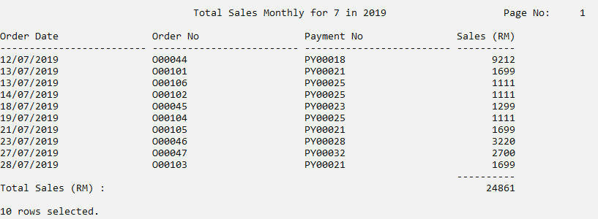

6.1.2 Salesman Product (Lee Siak Yen)

------------------------------------------------------------------------------------------------------------------------------

By using this query,our company can understand the product that is handled by which salesman. Through this query we also can know the ability of the salesman because this query shows the quantity that the total sales based on the product handled.

------------------------------------------------------------------------------------------------------------------------------

SET linesize 100

SET pagesize 100

ACCEPT sr_salesman CHAR FORMAT 'A11' PROMPT 'Enter the Salesman No : ';

COLUMN salesman_No FORMAT A16 HEADING "Salesman No";

COLUMN salesman_Name FORMAT A20 HEADING "Salesman Name";

COLUMN prod_code FORMAT A20 HEADING "Product Code";

COLUMN product_Name FORMAT A25 HEADING "Product Name";

TTITLE CENTER '&sr_salesman Salesman Product'-

RIGHT 'Page No:' FORMAT 999 SQL.PNO SKIP 2

BREAK ON REPORT

COMPUTE SUM LABEL 'Total Sales' OF quantity ON report;

SELECT S.salesman_No,S.salesman_Name,P.prod_code,product_Name,OD.quantity

FROM salesman S,product P,order_details OD

WHERE S.salesman_No = P.salesman_No AND

P.prod_code = OD.prod_code

AND S.salesman_No = '&sr_salesman';

CLEAR COLUMNS

CLEAR BREAKS

CLEAR COMPUTES

TTITLE OFF

SQL> SET linesize 100

SQL> SET pagesize 100

SQL> ACCEPT cst_No PROMPT 'Enter the customer number to check the payment detail : '

Enter the customer number to check the payment detail : C00002

SQL> COLUMN customer_Name FORMAT A30 HEADING "Customer Name";

SQL> COLUMN order_No FORMAT A25 HEADING "Order No";

SQL> COLUMN payment_No FORMAT A25 HEADING "Payment No";

SQL> COLUMN total_Payment FORMAT $999999.99

SQL>

SQL>

SQL> TTITLE CENTER 'Customer &cst_No Payment Detail ' RIGHT 'Page No: ' FORMAT 999 SQL.PNO SKIP 2

SQL> RIGHT 'Page No:' FORMAT 999 SQL.PNO SKIP 2

SP2-0734: unknown command beginning "RIGHT 'Pag..." - rest of line ignored.

SQL>

SQL> BREAK ON REPORT

SQL> COMPUTE SUM LABEL 'Total Payment' OF total_Payment ON report;

SQL>

SQL>

SQL> SELECT C.customer_Name, O.order_No, P.payment_No, P.total_Payment

2 FROM customer C, ordered O, payment P

3 WHERE C.cust_NO = O.cust_No AND

4 O.payment_No = P.payment_No AND

5 C.cust_No='&cst_No'

6 ORDER BY O.order_No;

old 5: C.cust_No='&cst_No'

new 5: C.cust_No='C00002'

Customer C00002 Payment Detail Page No: 1

Customer Name Order No Payment No TOTAL_PAYMENT

------------------------------ ------------------------- ------------------------- -------------

Fania Moncrief O00002 PY00007 $5600.00

Fania Moncrief O00012 PY00007 $5600.00

Fania Moncrief O00022 PY00008 $1800.00

Fania Moncrief O00032 PY00008 $1800.00

Fania Moncrief O00042 PY00009 $1600.00

Fania Moncrief O00052 PY00009 $1600.00

Fania Moncrief O00062 PY00010 $2100.00

Fania Moncrief O00079 PY00011 $1400.00

Fania Moncrief O00080 PY00011 $1400.00

Fania Moncrief O00096 PY00011 $1400.00

-------------

Total Payment $24300.00

10 rows selected.

SQL>

SQL> CLEAR COLUMNS

columns cleared

SQL> CLEAR BREAKS

breaks cleared

SQL> CLEAR COMPUTES

computes cleared

SQL> TTITLE OFF

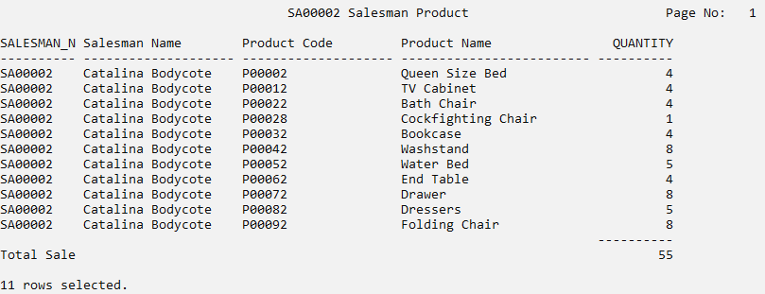

6.1.3 Customer Payment Details (Lee Siak Yen)

------------------------------------------------------------------------------------------------------------------------------

By using this query,the user able to understand the payment made by the customer.Through this query,the user can see the payment history based on the customer id that user enter.When user want to make refund or have payment error,we can use this query to prove the customer did made the payment.

------------------------------------------------------------------------------------------------------------------------------

SET linesize 100

SET pagesize 100

ACCEPT cst_No PROMPT 'Enter the customer number to check the payment detail : '

COLUMN customer_Name FORMAT A30 HEADING "Customer Name";

COLUMN order_No FORMAT A25 HEADING "Order No";

COLUMN payment_No FORMAT A25 HEADING "Payment No";

COLUMN total_Payment FORMAT $999999.99

TTITLE CENTER 'Customer &cst_No Payment Detail ' RIGHT 'Page No: ' FORMAT 999 SQL.PNO SKIP 2  
RIGHT 'Page No:' FORMAT 999 SQL.PNO SKIP 2

BREAK ON REPORT

COMPUTE SUM LABEL 'Total Payment' OF total_Payment ON report;

SELECT C.customer_Name, O.order_No, P.payment_No, P.total_Payment

FROM customer C, ordered O, payment P

WHERE C.cust_NO = O.cust_No AND

O.payment_No = P.payment_No AND  
 C.cust_No='&cst_No'

ORDER BY O.order_No;  
CLEAR COLUMNS  
CLEAR BREAKS  
CLEAR COMPUTES

TTITLE OFF

SQL> SET linesize 100

SQL> SET pagesize 100

SQL> ACCEPT cst_No PROMPT 'Enter the customer number to check the payment detail : '

Enter the customer number to check the payment detail : C00002

SQL> COLUMN customer_Name FORMAT A30 HEADING "Customer Name";

SQL> COLUMN order_No FORMAT A25 HEADING "Order No";

SQL> COLUMN payment_No FORMAT A25 HEADING "Payment No";

SQL> COLUMN total_Payment FORMAT $999999.99

SQL>

SQL>

SQL> TTITLE CENTER 'Customer &cst_No Payment Detail ' RIGHT 'Page No: ' FORMAT 999 SQL.PNO SKIP 2

SQL> RIGHT 'Page No:' FORMAT 999 SQL.PNO SKIP 2

SP2-0734: unknown command beginning "RIGHT 'Pag..." - rest of line ignored.

SQL>

SQL> BREAK ON REPORT

SQL> COMPUTE SUM LABEL 'Total Payment' OF total_Payment ON report;

SQL>

SQL>

SQL> SELECT C.customer_Name, O.order_No, P.payment_No, P.total_Payment

2 FROM customer C, ordered O, payment P

3 WHERE C.cust_NO = O.cust_No AND

4 O.payment_No = P.payment_No AND

5 C.cust_No='&cst_No'

6 ORDER BY O.order_No;

old 5: C.cust_No='&cst_No'

new 5: C.cust_No='C00002'

Customer C00002 Payment Detail Page No: 1

Customer Name Order No Payment No TOTAL_PAYMENT

------------------------------ ------------------------- ------------------------- -------------

Fania Moncrief O00002 PY00007 $5600.00

Fania Moncrief O00012 PY00007 $5600.00

Fania Moncrief O00022 PY00008 $1800.00

Fania Moncrief O00032 PY00008 $1800.00

Fania Moncrief O00042 PY00009 $1600.00

Fania Moncrief O00052 PY00009 $1600.00

Fania Moncrief O00062 PY00010 $2100.00

Fania Moncrief O00079 PY00011 $1400.00

Fania Moncrief O00080 PY00011 $1400.00

Fania Moncrief O00096 PY00011 $1400.00

-------------

Total Payment $24300.00

10 rows selected.

SQL>

SQL> CLEAR COLUMNS

columns cleared

SQL> CLEAR BREAKS

breaks cleared

SQL> CLEAR COMPUTES

computes cleared

SQL> TTITLE OFF

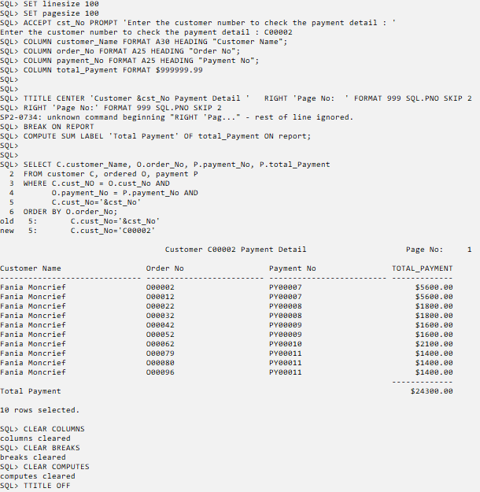

Accept customer number to show the product did he/she ordered(Lim Xin Le)

-------------------------------------------------------------------------------------------------------------------------------

This query is a searching function for users to search the customer’s order. Through this query, users can know the products that are ordered by the customer. This query will show out the customer no, customer name, order number and order date. This can help the user to check whether the orders of the customer have been completed.

-------------------------------------------------------------------------------------------------------------------------------

SET linesize 105

SET pagesize 100

ALTER SESSION SET NLS_DATE_FORMAT = 'DD/MM/YYYY';

ACCEPT cust_No FORMAT A20 PROMPT 'Enter customer number to check his/her order: '

TTITLE CENTER 'Customer Orders' RIGHT 'Page No: ' FORMAT 999 SQL.PNO SKIP 2

COLUMN cust_No FORMAT A20 HEADING "Customer Number";

COLUMN customer_Name FORMAT A40 HEADING "Customer Name";

COLUMN order_No FORMAT A20 HEADING "Order Number";

COLUMN order_Date FORMAT A20 HEADING "Order Date";

SELECT C.customer_Name, O.cust_No, O.order_No, O.order_Date

FROM customer C, ordered O

WHERE O. cust_No = C. cust_No AND O.cust_No = '&cust_No'

GROUP BY O.cust_No, customer_Name, O.order_No, order_Date

ORDER BY order_Date;

CLEAR COLUMNS

CLEAR BREAKS

CLEAR COMPUTES

TTITLE OFF

SQL> SET linesize 105

SQL> SET pagesize 100

SQL> ALTER SESSION SET NLS_DATE_FORMAT = 'DD/MM/YYYY';

Session altered.

SQL>

SQL> ACCEPT cust_No FORMAT A20 PROMPT 'Enter customer number to check his/her order: '

Enter customer number to check his/her order: C00004

SQL> TTITLE CENTER 'Customer Orders' RIGHT 'Page No: ' FORMAT 999 SQL.PNO SKIP 2

SQL>

SQL> COLUMN cust_No FORMAT A20 HEADING "Customer Number";

SQL> COLUMN customer_Name FORMAT A40 HEADING "Customer Name";

SQL> COLUMN order_No FORMAT A20 HEADING "Order Number";

SQL> COLUMN order_Date FORMAT A20 HEADING "Order Date";

SQL>

SQL> SELECT C.customer_Name, O.cust_No, O.order_No, O.order_Date

2 FROM customer C, ordered O

3 WHERE O. cust_No = C. cust_No AND O.cust_No = '&cust_No'

4 GROUP BY O.cust_No, customer_Name, O.order_No, order_Date

5 ORDER BY order_Date;

old 3: WHERE O. cust_No = C. cust_No AND O.cust_No = '&cust_No'

new 3: WHERE O. cust_No = C. cust_No AND O.cust_No = 'C00004'

Customer Orders Page No: 1

Customer Name Customer Number Order Number Order Date

---------------------------------------- -------------------- -------------------- --------------------

Marigold Denny C00004 O00014 12/07/2018

Marigold Denny C00004 O00024 13/11/2018

Marigold Denny C00004 O00034 01/03/2019

Marigold Denny C00004 O00044 12/07/2019

Marigold Denny C00004 O00101 13/07/2019

Marigold Denny C00004 O00105 21/07/2019

Marigold Denny C00004 O00103 28/07/2019

Marigold Denny C00004 O00054 12/11/2019

Marigold Denny C00004 O00004 22/02/2020

Marigold Denny C00004 O00064 12/03/2020

Marigold Denny C00004 O00075 18/07/2020

Marigold Denny C00004 O00084 12/11/2020

12 rows selected.

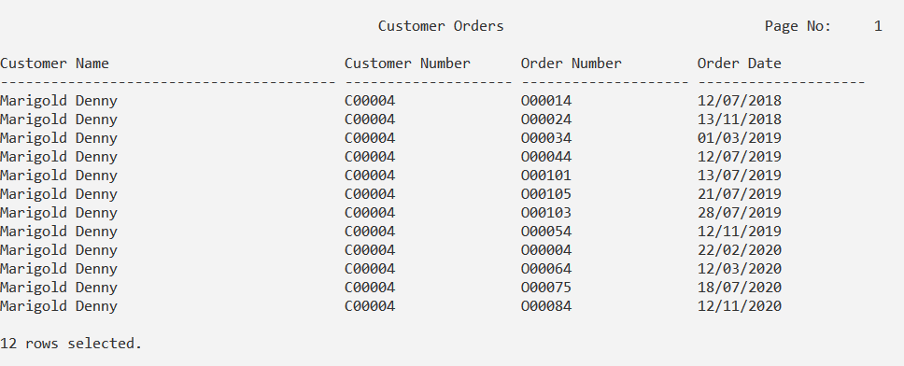

SQL>

SQL> CLEAR COLUMNS

columns cleared

SQL> CLEAR BREAKS

breaks cleared

SQL> CLEAR COMPUTES

computes cleared

SQL> TTITLE OFF

Accept product_code from user to show the product from xxx to xxx(Lim Xin Le)

-------------------------------------------------------------------------------------------------------------------------------

This query is a searching function for users to show the product details. Through this query users can know the specific product details of the products that are keyed in by the users. This query will show the product code, product name, inventory code, product quantity and product category. This can help users to recognise the product in the inventory.

-------------------------------------------------------------------------------------------------------------------------------  
SET linesize 120

SET pagesize 100

ACCEPT sprod_Code FORMAT A20 PROMPT 'Enter product code to list out the product details (from ): '

ACCEPT eprod_Code FORMAT A20 PROMPT 'Enter product code to list out the product details (until): '

TTITLE CENTER 'Product Details from &sprod_Code until &eprod_Code' RIGHT 'Page No: ' FORMAT 999 SQL.PNO SKIP 2

COLUMN prod_Code FORMAT A20 HEADING "Product Code";

COLUMN product_Name FORMAT A40 HEADING "Product Name";

COLUMN inventory_Code FORMAT A20 HEADING "Inventory Code";

COLUMN prod_Quantity FORMAT '9999' HEADING "Product Quantity";

COLUMN prod_Category FORMAT A20 HEADING "Product Category";

SELECT P.prod_Code, P.product_Name, P.inventory_Code, I.prod_Quantity, I.prod_Category

FROM product P, inventory I

WHERE P.inventory_Code = I.inventory_Code AND

prod_Code between '&sprod_Code' AND '&eprod_Code'

GROUP BY P.prod_Code, P.inventory_Code, product_Name, prod_Category, prod_Quantity

ORDER BY P.inventory_Code;

CLEAR COLUMNS

CLEAR BREAKS

CLEAR COMPUTES

TTITLE OFF

SQL> SET linesize 120

SQL> SET pagesize 100

SQL>

SQL> ACCEPT sprod_Code FORMAT A20 PROMPT 'Enter product code to list out the product details (from ): '

Enter product code to list out the product details (from ): P00003

SQL> ACCEPT eprod_Code FORMAT A20 PROMPT 'Enter product code to list out the product details (until): '

Enter product code to list out the product details (until): P00014

SQL> TTITLE CENTER 'Product Details from &sprod_Code until &eprod_Code' RIGHT 'Page No: ' FORMAT 999 SQL.PNO SKIP 2

SQL>

SQL> COLUMN prod_Code FORMAT A20 HEADING "Product Code";

SQL> COLUMN product_Name FORMAT A40 HEADING "Product Name";

SQL> COLUMN inventory_Code FORMAT A20 HEADING "Inventory Code";

SQL> COLUMN prod_Quantity FORMAT '9999' HEADING "Product Quantity";

SQL> COLUMN prod_Category FORMAT A20 HEADING "Product Category";

SQL>

SQL> SELECT P.prod_Code, P.product_Name, P.inventory_Code, I.prod_Quantity, I.prod_Category

2 FROM product P, inventory I

3 WHERE P.inventory_Code = I.inventory_Code AND

4 prod_Code between '&sprod_Code' AND '&eprod_Code'

5 GROUP BY P.prod_Code, P.inventory_Code, product_Name, prod_Category, prod_Quantity

6 ORDER BY P.inventory_Code;

old 4: prod_Code between '&sprod_Code' AND '&eprod_Code'

new 4: prod_Code between 'P00003' AND 'P00014'

Product Details from P00003 until P00014 Page No: 1

Product Code Product Name Inventory Code Product Quantity Product Category

-------------------- ---------------------------------------- -------------------- ---------------- --------------------

P00011 Wall Cabinet I00001 20 Metal Chair

P00012 TV Cabinet I00002 20 Wood Chair

P00003 Sofa Chair I00003 40 Gold Chair

P00013 Bedside Lamp I00003 40 Gold Chair

P00004 Bar Table I00004 35 Diamond Table

P00014 Buffet Lamp I00004 35 Diamond Table

P00005 Dining Table I00005 35 MedDesk

P00006 Computer Desk I00006 30 Coffee Table

P00007 Writing Desk I00007 30 Gold Desk

P00008 Wooden Wardrobe I00008 25 Refectory Wardrobe

P00009 Sliding Door Wardrobe I00009 25 Lift chair

P00010 Kitchen Cabinet I00010 35 Bean bag

12 rows selected.

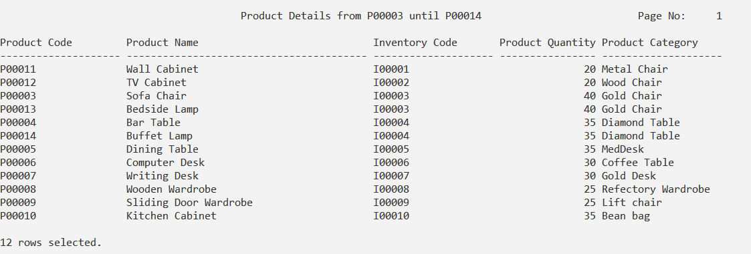

SQL>

SQL> CLEAR COLUMNS

columns cleared

SQL> CLEAR BREAKS

breaks cleared

SQL> CLEAR COMPUTES

computes cleared

SQL> TTITLE OFF

Accept customer number from the user to check the personal info.(Lim Xin Le)

-------------------------------------------------------------------------------------------------------------------------------

This query is a searching function for users to show the personal info. Through this query users can know the personal info of the customer that is keyed in by the users. This query will show the customer number, customer name, customer address, customer telephone, payment number, order number and shipment number. This can help users to deliver the products to the customers more easier as users can easily know the customer's address and telephone through this query.

-------------------------------------------------------------------------------------------------------------------------------

SET linesize 200

SET pagesize 100

ACCEPT cust_No FORMAT A20 PROMPT 'Enter customer number to check his/her details: ';

TTITLE CENTER 'Customer Details' RIGHT 'Page No: ' FORMAT 999 SQL.PNO SKIP 2

COLUMN cust_No FORMAT A20 HEADING "Customer Number";

COLUMN customer_Name FORMAT A40 HEADING "Customer Name";

COLUMN customer_Address FORMAT A40 HEADING "Customer Address";

COLUMN customer_Telephone FORMAT A20 HEADING "Customer Telephone";

COLUMN payment_No FORMAT A20 HEADING "Payment Number";

COLUMN order_No FORMAT A20 HEADING "Order Number";

COLUMN shipment_No FORMAT A20 HEADING "Shipment Number";

SELECT O.cust_No, C.customer_Name, C.customer_Address, C.customer_Telephone, O.payment_No, O. order_No, O.shipment_No

FROM customer C, ordered O, payment P, shipment S

WHERE O.cust_No = C. cust_No AND

O.payment_No = P.payment_No AND

O.shipment_No = S.shipment_No AND

O.cust_No = '&cust_No'

GROUP BY O.cust_No, customer_Name, customer_Telephone, customer_Address, O.order_No, O.shipment_No,O.payment_No;

CLEAR COLUMNS

CLEAR BREAKS

CLEAR COMPUTES

TTITLE OFF

SQL> SET linesize 200

SQL> SET pagesize 100

SQL>

SQL> ACCEPT cust_No FORMAT A20 PROMPT 'Enter customer number to check his/her details: ';

Enter customer number to check his/her details: C00006

SQL> TTITLE CENTER 'Customer Details' RIGHT 'Page No: ' FORMAT 999 SQL.PNO SKIP 2

SQL>

SQL> COLUMN cust_No FORMAT A20 HEADING "Customer Number";

SQL> COLUMN customer_Name FORMAT A40 HEADING "Customer Name";

SQL> COLUMN customer_Address FORMAT A40 HEADING "Customer Address";

SQL> COLUMN customer_Telephone FORMAT A20 HEADING "Customer Telephone";

SQL> COLUMN payment_No FORMAT A20 HEADING "Payment Number";

SQL> COLUMN order_No FORMAT A20 HEADING "Order Number";

SQL> COLUMN shipment_No FORMAT A20 HEADING "Shipment Number";

SQL>

SQL> SELECT O.cust_No, C.customer_Name, C.customer_Address, C.customer_Telephone, O.payment_No, O. order_No, O.shipment_No

2 FROM customer C, ordered O, payment P, shipment S

3 WHERE O.cust_No = C. cust_No AND

4 O.payment_No = P.payment_No AND

5 O.shipment_No = S.shipment_No AND

6 O.cust_No = '&cust_No'

7 GROUP BY O.cust_No, customer_Name, customer_Telephone, customer_Address, O.order_No, O.shipment_No,O.payment_No;

old 6: O.cust_No = '&cust_No'

new 6: O.cust_No = 'C00006'

Customer Details Page No: 1

Customer Number Customer Name Customer Address Customer Telephone Payment Number Order Number Shipment Number

-------------------- ---------------------------------------- ---------------------------------------- -------------------- -------------------- -------------------- --------------------

C00006 Leigh Arckoll 02436 Carioca Drive 012-386-9031 PY00027 O00016 SH00016

C00006 Leigh Arckoll 02436 Carioca Drive 012-386-9031 PY00028 O00056 SH00056

C00006 Leigh Arckoll 02436 Carioca Drive 012-386-9031 PY00027 O00026 SH00026

C00006 Leigh Arckoll 02436 Carioca Drive 012-386-9031 PY00029 O00090 SH00090

C00006 Leigh Arckoll 02436 Carioca Drive 012-386-9031 PY00026 O00006 SH00006

C00006 Leigh Arckoll 02436 Carioca Drive 012-386-9031 PY00027 O00036 SH00036

C00006 Leigh Arckoll 02436 Carioca Drive 012-386-9031 PY00028 O00046 SH00046

C00006 Leigh Arckoll 02436 Carioca Drive 012-386-9031 PY00029 O00066 SH00066

8 rows selected.

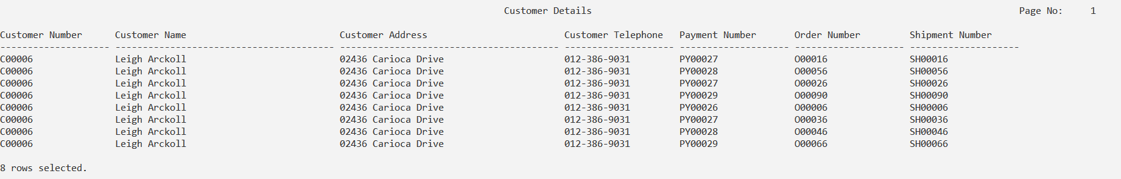

SQL>

SQL> CLEAR COLUMNS

columns cleared

SQL> CLEAR BREAKS

breaks cleared

SQL> CLEAR COMPUTES

computes cleared

SQL> TTITLE OFF

Accept customer number from the user to check the shipment details. (Ricky Hwong Yu Jun)

-------------------------------------------------------------------------------------------------------------------------------

This query is a search function for the users to check the shipment details. This query will show the customer number,customer name, shipment number,shipment date and remarks. This query is very important in the company because it makes the users easier to check the remark of the product.

-------------------------------------------------------------------------------------------------------------------------------

SET linesize 180

SET pagesize 100

ALTER SESSION SET NLS_DATE_FORMAT = 'DD/MM/YYYY';

ACCEPT cust_No FORMAT A20 PROMPT 'Enter customer number to check the shipment details: ';

COLUMN cust_No FORMAT A13 HEADING "Customer No.";

COLUMN shipment_No FORMAT A13 HEADING "Shipment No.";

COLUMN customer_Name FORMAT A30 HEADING "Customer Name";

COLUMN shipment_Date FORMAT A14 HEADING "Shipment Date";

COLUMN remarks FORMAT A100 HEADING "Remarks";

TTITLE CENTER 'Shipment Details:' RIGHT 'Page No: ' FORMAT 999 SQL.PNO SKIP 2

SELECT C.cust_No, customer_Name, O.shipment_No, shipment_Date, remarks

FROM Ordered O, Shipment S, Customer C

WHERE O.shipment_No = S.shipment_No AND C.cust_No = O.cust_No AND O.cust_No = '&cust_No'

GROUP BY C.cust_No, customer_Name, O.shipment_No, shipment_Date, remarks

ORDER BY C.cust_No;

CLEAR COLUMNS

CLEAR BREAKS

CLEAR COMPUTES

TTITLE OFF

SQL> SET linesize 180

SQL> SET pagesize 100

SQL> ALTER SESSION SET NLS_DATE_FORMAT = 'DD/MM/YYYY';

Session altered.

SQL>

SQL> ACCEPT cust_No FORMAT A20 PROMPT 'Enter customer number to check the shipment details: ';

Enter customer number to check the shipment details: C00006

SQL> COLUMN cust_No FORMAT A13 HEADING "Customer No.";

SQL> COLUMN shipment_No FORMAT A13 HEADING "Shipment No.";

SQL> COLUMN customer_Name FORMAT A30 HEADING "Customer Name";

SQL> COLUMN shipment_Date FORMAT A14 HEADING "Shipment Date";

SQL> COLUMN remarks FORMAT A100 HEADING "Remarks";

SQL>

SQL> TTITLE CENTER 'Shipment Details:' RIGHT 'Page No: ' FORMAT 999 SQL.PNO SKIP 2

SQL>

SQL> SELECT C.cust_No, customer_Name, O.shipment_No, shipment_Date, remarks

2 FROM Ordered O, Shipment S, Customer C

3 WHERE O.shipment_No = S.shipment_No AND C.cust_No = O.cust_No AND O.cust_No = '&cust_No'

4 GROUP BY C.cust_No, customer_Name, O.shipment_No, shipment_Date, remarks

5 ORDER BY C.cust_No;

old 3: WHERE O.shipment_No = S.shipment_No AND C.cust_No = O.cust_No AND O.cust_No = '&cust_No'

new 3: WHERE O.shipment_No = S.shipment_No AND C.cust_No = O.cust_No AND O.cust_No = 'C00006'

Shipment Details: Page No: 1

Customer No. Customer Name Shipment No. Shipment Date Remarks

------------- ------------------------------ ------------- -------------- ----------------------------------------------------------------------------------------------------

C00006 Leigh Arckoll SH00006 11/01/2013 Please pack the product tightly

C00006 Leigh Arckoll SH00016 11/01/2043

C00006 Leigh Arckoll SH00026 05/02/2012

C00006 Leigh Arckoll SH00036 09/07/2020

C00006 Leigh Arckoll SH00046 12/04/2013 Please delivery the product as soon as possible

C00006 Leigh Arckoll SH00056 07/05/2012

C00006 Leigh Arckoll SH00066 07/06/2019 Please inform me before delivery

C00006 Leigh Arckoll SH00090 11/01/2021 Please pack the product tightly

8 rows selected.

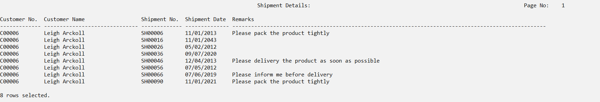

SQL>

SQL> CLEAR COLUMNS

columns cleared

SQL> CLEAR BREAKS

breaks cleared

SQL> CLEAR COMPUTES

computes cleared

SQL> TTITLE OFF

Accept inventory_code from the user to show the products in the inventory.(Ricky Hwong Yu Jun)

-------------------------------------------------------------------------------------------------------------------------------This query is a search function for users to show the product in the inventory. This query will show that inventory code, product quantity,product quantity , product price, product code and a product name. This query is very important in the company because users can check the inventory details anytime. ------------------------------------------------------------------------------------------------------------------------------

SET linesize 110

SET pagesize 100

ACCEPT inventory_Code FORMAT A10 PROMPT 'Enter inventory code to check the product in the inventory : ';

COLUMN inventory_Code FORMAT A10 HEADING "Inventory Code";

COLUMN prod_Quantity FORMAT 999 HEADING "Product Quantity ";

COLUMN prod_Price FORMAT A14 HEADING "Product Price ";

COLUMN prod_Code FORMAT A14 HEADING "Product Code";

COLUMN prod_Name FORMAT A50 HEADING "Product Name";

TTITLE CENTER ' Product Details :' RIGHT 'Page No: ' FORMAT 999 SQL.PNO SKIP 2

SELECT I.inventory_code, prod_Quantity, prod_Category, prod_Price, P.prod_Code, product_Name

FROM Inventory I , Product P

WHERE I.inventory_Code = P.inventory_Code AND I.inventory_Code = '&inventory_Code'

GROUP BY I.inventory_code, prod_Quantity, prod_Category, prod_Price, P.prod_Code, product_Name

ORDER BY P.prod_Code;

CLEAR COLUMNS

CLEAR BREAKS

CLEAR COMPUTES

TTITLE OFF

SQL> SET linesize 110

SQL> SET pagesize 100

SQL>

SQL> ACCEPT inventory_Code FORMAT A10 PROMPT 'Enter inventory code to check the product in the inventory : ';

Enter inventory code to check the product in the inventory : I00006

SQL> COLUMN inventory_Code FORMAT A10 HEADING "Inventory Code";

SQL> COLUMN prod_Quantity FORMAT 999 HEADING "Product Quantity ";

SQL> COLUMN prod_Price FORMAT A14 HEADING "Product Price ";

SQL> COLUMN prod_Code FORMAT A14 HEADING "Product Code";

SQL> COLUMN prod_Name FORMAT A50 HEADING "Product Name";

SQL>

SQL> TTITLE CENTER ' Product Details :' RIGHT 'Page No: ' FORMAT 999 SQL.PNO SKIP 2

SQL>

SQL> SELECT I.inventory_code, prod_Quantity, prod_Category, prod_Price, P.prod_Code, product_Name

2 FROM Inventory I , Product P

3 WHERE I.inventory_Code = P.inventory_Code AND I.inventory_Code = '&inventory_Code'

4 GROUP BY I.inventory_code, prod_Quantity, prod_Category, prod_Price, P.prod_Code, product_Name

5 ORDER BY P.prod_Code;

old 3: WHERE I.inventory_Code = P.inventory_Code AND I.inventory_Code = '&inventory_Code'

new 3: WHERE I.inventory_Code = P.inventory_Code AND I.inventory_Code = 'I00006'

Product Details : Page No: 1

Inventory Product Quantity PROD_CATEGORY Product Price Product Code PRODUCT_NAME

---------- ----------------- -------------------- -------------- -------------- ------------------------------

I00006 30 Coffee Table RM1499 P00006 Computer Desk

I00006 30 Coffee Table RM1499 P00016 Cellarette

I00006 30 Coffee Table RM1499 P00026 Cathedra

I00006 30 Coffee Table RM1499 P00036 Parsons Table

I00006 30 Coffee Table RM1499 P00046 Rocking Chair

I00006 30 Coffee Table RM1499 P00056 Countertop

I00006 30 Coffee Table RM1499 P00066 Bakers Rack

I00006 30 Coffee Table RM1499 P00076 Reading Chair

8 rows selected.

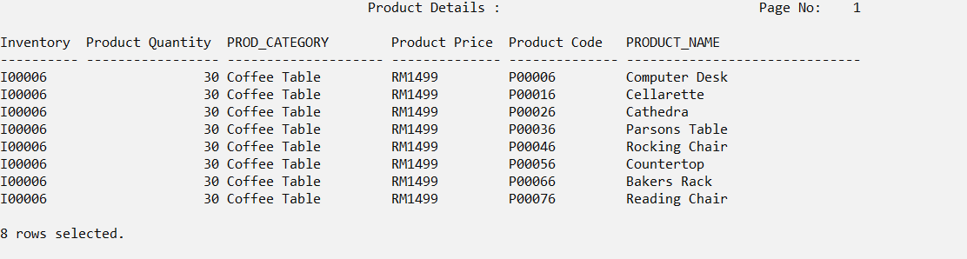

SQL>

SQL> CLEAR COLUMNS

columns cleared

SQL> CLEAR BREAKS

breaks cleared

SQL> CLEAR COMPUTES

computes cleared

SQL> TTITLE OFF

Accept inventory code from the user to show how many quantity left(Ricky Hwong Yu Jun)

-------------------------------------------------------------------------------------------------------------------------------This query is a search function for users to search the quantity left of the product in the company. In this query will show the product code, product name, inventory code and the quantity. This query is very important in the company because it can make it easier for users to search the product quantity left anytime. Besides that, customers will be able to know faster if the product is out of stock. -------------------------------------------------------------------------------------------------------------------------------

SET linesize 80

SET pagesize 100

ACCEPT inventory_Code FORMAT A10 PROMPT 'Enter inventory code to search how many quantity left : ';

COLUMN inventory_Code FORMAT A14 HEADING "Inventory Code";

COLUMN prod_Code FORMAT A13 HEADING "Product Code.";

COLUMN prod_Name FORMAT A50 HEADING "Product Name";

COLUMN prod_Quantity FORMAT 999 HEADING "Product Quantity";

TTITLE CENTER 'Product Quantity : ' RIGHT 'Page No: ' FORMAT 999 SQL.PNO SKIP 2

SELECT P.prod_Code ,P.product_Name, P.inventory_Code,I.prod_Quantity

FROM Product P, Inventory I

WHERE P.inventory_Code= I.inventory_Code AND P.inventory_Code = '&inventory_Code'

GROUP BY P.inventory_Code, P.prod_Code, P.product_Name, I.prod_Quantity

ORDER BY P.prod_Code;

CLEAR COLUMNS

CLEAR BREAKS

CLEAR COMPUTES

TTITLE OFF

SQL> SET linesize 80

SQL> SET pagesize 100

SQL>

SQL> ACCEPT inventory_Code FORMAT A10 PROMPT 'Enter inventory code to search how many quantity left : ';

Enter inventory code to search how many quantity left : I00001

SQL> COLUMN inventory_Code FORMAT A14 HEADING "Inventory Code";

SQL> COLUMN prod_Code FORMAT A13 HEADING "Product Code.";

SQL> COLUMN prod_Name FORMAT A50 HEADING "Product Name";

SQL> COLUMN prod_Quantity FORMAT 999 HEADING "Product Quantity";

SQL>

SQL> TTITLE CENTER 'Product Quantity : ' RIGHT 'Page No: ' FORMAT 999 SQL.PNO SKIP 2

SQL>

SQL> SELECT P.prod_Code ,P.product_Name, P.inventory_Code,I.prod_Quantity

2 FROM Product P, Inventory I

3 WHERE P.inventory_Code= I.inventory_Code AND P.inventory_Code = '&inventory_Code'

4 GROUP BY P.inventory_Code, P.prod_Code, P.product_Name, I.prod_Quantity

5 ORDER BY P.prod_Code;

old 3: WHERE P.inventory_Code= I.inventory_Code AND P.inventory_Code = '&inventory_Code'

new 3: WHERE P.inventory_Code= I.inventory_Code AND P.inventory_Code = 'I00001'

Product Quantity : Page No: 1

Product Code. PRODUCT_NAME Inventory Code Product Quantity

------------- ------------------------------ -------------- ----------------

P00001 King Size Bed I00001 20

P00011 Wall Cabinet I00001 20

P00021 Basket Chair I00001 20

P00031 Love Seat I00001 20

P00041 Tilt-top Table I00001 20

P00051 Platform Bed I00001 20

P00061 Coffee Table I00001 20

P00071 Pantry I00001 20

P00080 Side Chairs I00001 20

P00081 Headboards I00001 20

P00091 Easy Chair I00001 20

P00093 File Cabinet I00001 20

P00100 Sleeper Bed I00001 20

13 rows selected.

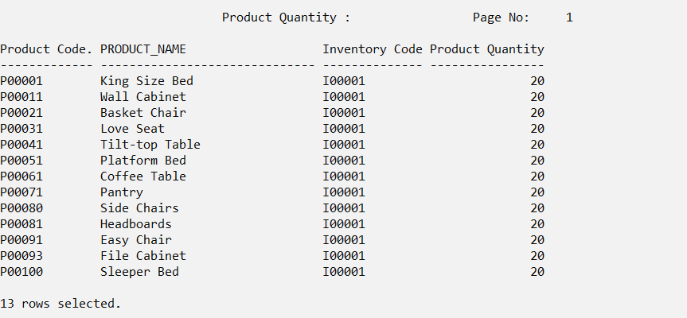

SQL>

SQL>

SQL> CLEAR COLUMNS

columns cleared

SQL> CLEAR BREAKS

breaks cleared

SQL> CLEAR COMPUTES

computes cleared

SQL> TTITLE OFF

Accept the month value (1-12) from the user to show how many people make a payment by a month?(Phang Wan Qi)

-------------------------------------------------------------------------------------------------------------------------------

This query is a summary of the payment made by customers in the selected month in that year. This query helps company can reduce time-consuming searching for the payment received date, the payment number, order number and the total payment.

-------------------------------------------------------------------------------------------------------------------------------

SET linesize 120

SET pagesize 100

ACCEPT month number FORMAT '99' PROMPT 'Enter month to check total payment make in a month (1-12): ';

ACCEPT year number FORMAT '9999' PROMPT 'Enter year to check total payment make in that year : ';

ALTER SESSION SET NLS_DATE_FORMAT = 'DD/MM/YYYY';

COLUMN payment_Date FORMAT A30 HEADING "Payment Date";

COLUMN payment_No FORMAT A12 HEADING "Payment No.";

COLUMN order_No FORMAT A13 HEADING "Order No.";

COLUMN total_Payment FORMAT '9999' HEADING "Total Payment";

TTITLE CENTER 'Payment for &month in &year ' RIGHT 'Page No: ' FORMAT 999 SQL.PNO SKIP 2

SELECT P.payment_Date, P.payment_No, O.order_No, P.total_Payment

FROM Payment P, Ordered O

WHERE P.payment_No = O.payment_No AND EXTRACT(month FROM payment_Date)=&month AND EXTRACT(year FROM payment_Date)=&year

GROUP BY P.payment_Date, P.payment_No, O.order_No, P.total_Payment

ORDER BY P.payment_No;

CLEAR COLUMNS

CLEAR BREAKS

CLEAR COMPUTES

TTITLE OFF

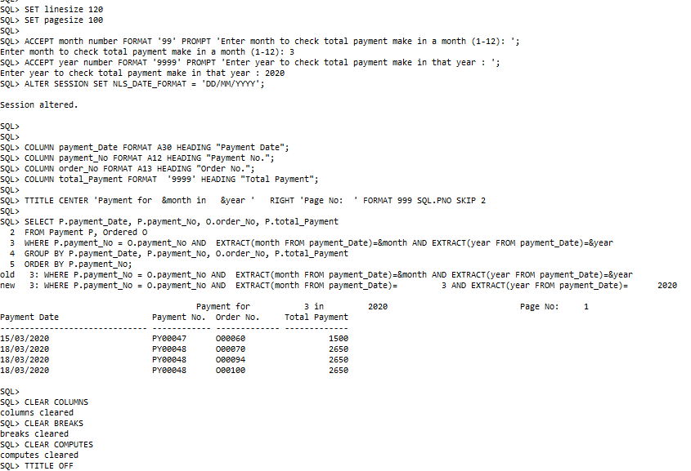

Accept year from user to show how many shipment made in a year(Phang Wan Qi)

-------------------------------------------------------------------------------------------------------------------------------

This query is a summary of yearly shipment records. This query will show the shipment delivery date in the whole year and also the shipment number and order number ordered by customers. This query help the company know when the date of the shipment will be delivered the ordered products.

-------------------------------------------------------------------------------------------------------------------------------

SET linesize 120

SET pagesize 100

ACCEPT year number FORMAT '9999' PROMPT 'Enter year to check total shipment make in that year : ';

ALTER SESSION SET NLS_DATE_FORMAT = 'DD/MM/YYYY';

COLUMN shipment_Date FORMAT A40 HEADING "Shipment Date";

COLUMN shipment_No FORMAT A40 HEADING "Shipment No.";

COLUMN order_No FORMAT A20 HEADING "Order No.";

TTITLE CENTER 'Shipment Made in &year ' RIGHT 'Page No: ' FORMAT 999 SQL.PNO SKIP 2

BREAK ON REPORT

SELECT shipment_Date, S.shipment_No, O.order_No

FROM Shipment S, Ordered O  
WHERE S.shipment_No = O.shipment_No AND EXTRACT(year FROM shipment_Date)= &year

GROUP BY shipment_Date, S.shipment_No, O.order_No

ORDER BY shipment_Date;

CLEAR COLUMNS

CLEAR BREAKS

CLEAR COMPUTES

TTITLE OFF

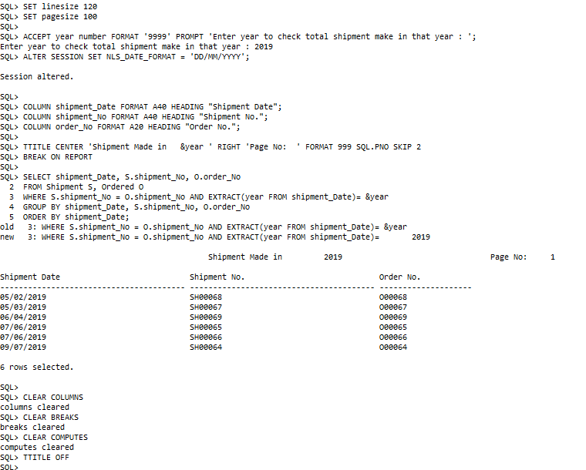

Accept a salesman from a user to show how many products he sells?(Phang Wan Qi)

-------------------------------------------------------------------------------------------------------------------------------

This query is a report of a salesman who has sold the products and the product’s price. This query can help the company reduce time-consuming to search the salesman number to know what product he sold and the price of the product.

-------------------------------------------------------------------------------------------------------------------------------

SET linesize 120

SET pagesize 100

ACCEPT salesman_No FORMAT A20 PROMPT 'Enter a salesman to show the products he sells : ';

ALTER SESSION SET NLS_DATE_FORMAT = 'DD/MM/YYYY';

COLUMN salesman_No FORMAT A15 HEADING "Salesman No.";

COLUMN prod_Code FORMAT A15 HEADING "Product Code";

COLUMN product_Name FORMAT A30 HEADING "Product Name";

COLUMN inventory_Code FORMAT A15 HEADING "Inventory Code";

COLUMN prod_Price FORMAT A15 HEADING "Product Price";

TTITLE CENTER 'Products Sold by A Salesman' RIGHT 'Page No: ' FORMAT 999 SQL.PNO SKIP 2

SELECT S.salesman_No, P.prod_Code, product_Name, P.inventory_Code, prod_Price

FROM Salesman S, Product P, Inventory I  
WHERE S.salesman_No = P.salesman_No AND P.inventory_Code = I.inventory_Code AND S.salesman_No = '&salesman_No'

GROUP BY S.salesman_No, P.prod_Code, product_Name, P.inventory_Code, prod_Price

ORDER BY P.prod_Code;

CLEAR COLUMNS

CLEAR BREAKS

CLEAR COMPUTES

TTITLE OFF

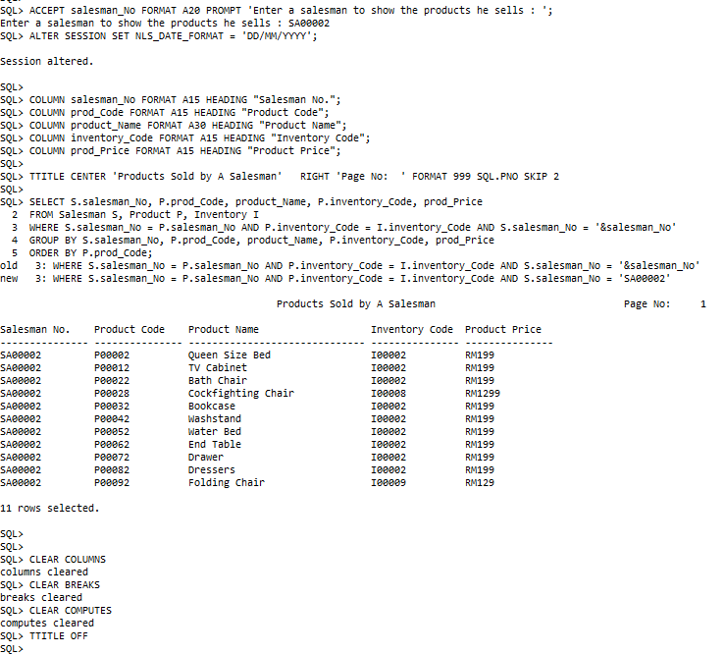

**References**

Common database keys explained(16 Dec 2020) Edited by Mark Whitehorn

<<https://searchdatamanagement.techtarget.com/answer/Definition-of-primary-super-foreign-and-candidate-key-in-the-DBMS>>

DBMS Normalization (28 Apr 2020) Edited by Aman Goel

<<https://hackr.io/blog/dbms-normalization>>

**Appendices**

