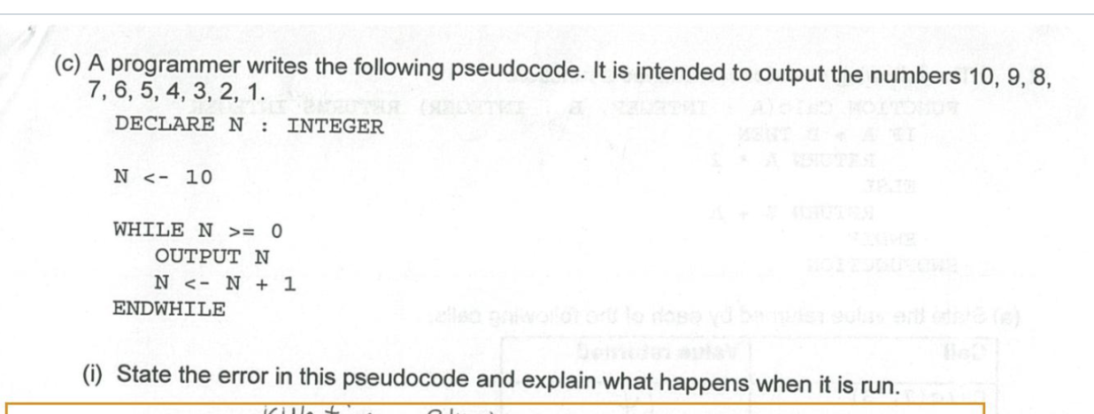

It is a logic error.
The while loop never ends when it is run as N is always larger than zero.

