Curriulum Vitae

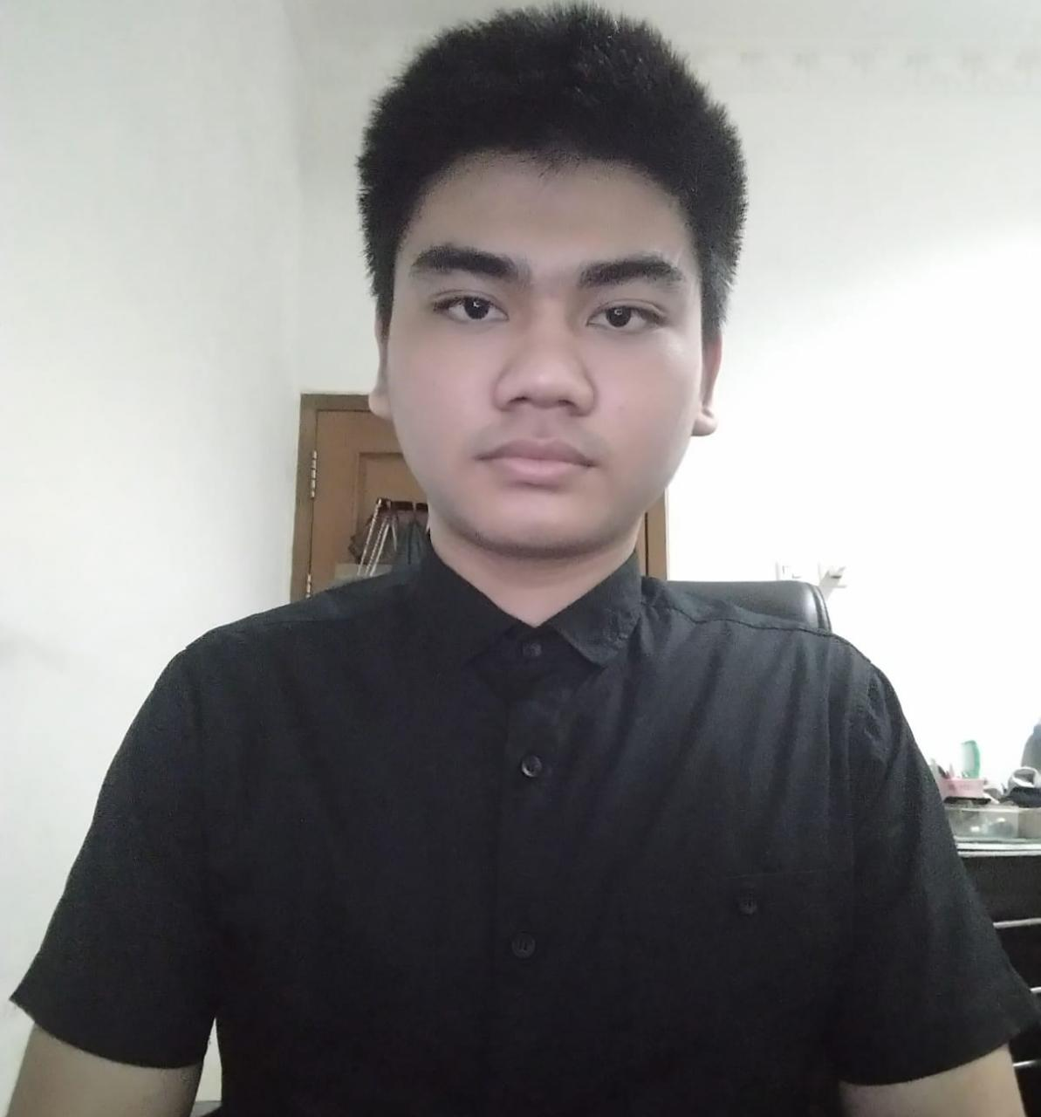

# Personal Data

|  |  |  |
| --- | --- | --- |
| Name | | : Hengky Darmawan |
| Place/Date Of Birth | | : Singkawang, 22 Febuari 2001 |
| Address |  | : Jalan Jembatan Besi 5 RT.008 RW.004 No.50f, |
|  |  | Jakarta-Indonesia |
| Zip Code |  | : 11320 |
| Religion |  | : Buddha |
| Nationality |  | : Indonesia |
| Gender |  | : Male |
| No.Telpon |  | : 082186629996 (Hp) |
| Email |  | : hengkydarmawan66@gmail. com |
| Marital Status |  | : Single |

# Education

* Formal Education

SMP Kartika jaya, Pontianak, Indonesia

SD 46 jawai , Tebas, Indonesia

Paket C

Universitas Dian Nusantara 2019 - Recent

* Informal Education

Web Master at Dumet Shool Nov 2017 – 2019

Basic Intensive English Program at LC Bogor 8 Nov 2021 - 4 Des 2021

Recent Skills

* HTML
* CSS
* Bootstrap
* Java Script
* Figma

Link Github

https://hengkydarmawan.github.io/

# Certificate

