# Curriulum Vitae

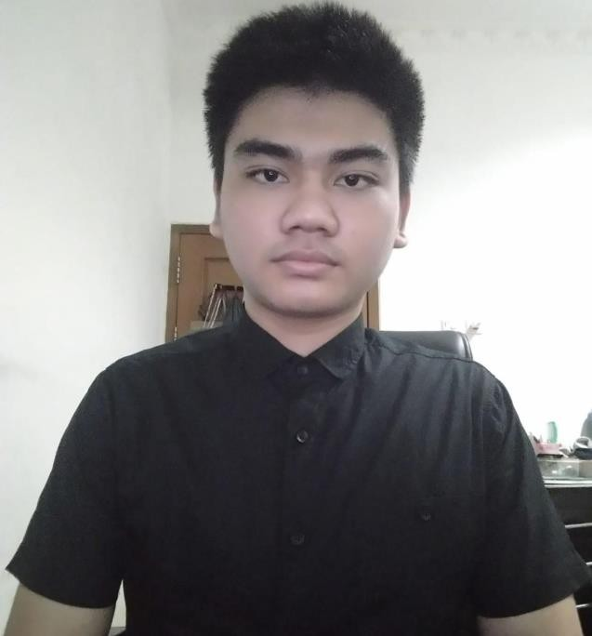

Personal Data

|  |  |
| --- | --- |
| Name | : Hengky Darmawan |
| Place/Date Of Birth | : Singkawang, 22 Febuari 2001 |
| Address | : Jalan Jembatan Besi 5 RT.008 RW.004 No.50f, |
|  | Jakarta-Indonesia |
| No.Telpon | : 082186629996 (Hp) |
| Email | : hengkydarmawan66@gmail. com |

Link Github : https://hengkydarmawan.github.io/

# Education

## Formal Education

Universitas Dian Nusantara 2019 - Recent

## Informal Education

Web Master at Dumet Shool Nov 2017 – 2019 Basic Intensive English Program at LC Bogor 8 Nov 2021 - 4 Des 2021

Learn UI/UX prototyping Design With Figma 27 Mar 2022

# Recent Skills

* + HTML
  + CSS
  + Bootstrap
  + Java Script
  + Figma
  + PHP
  + Mysql