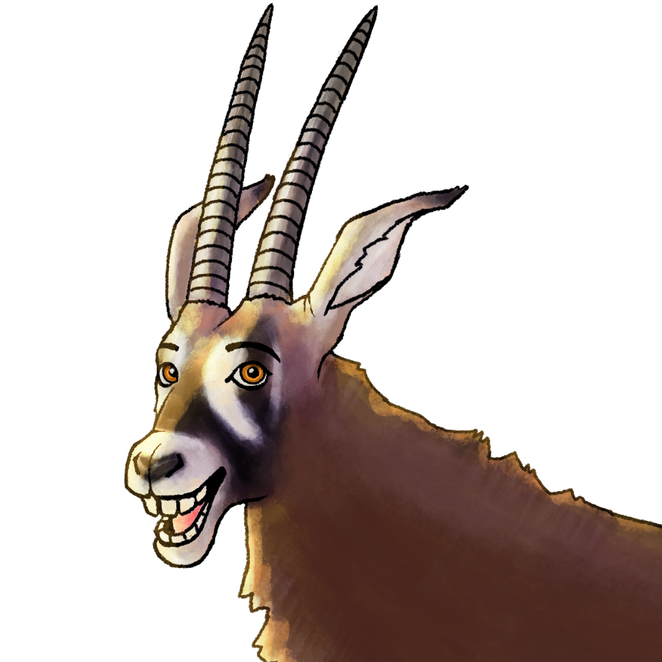

“Antelope UP” Game Design Document

Version .02

© 2017 Rhizome Publishing. All Rights Reserved.

V.02 edited by Matt Hunter

Table of Contents

- Design History
- Section I - Game Overview
  - Game Concept
  - Feature Set
  - Genre
  - Target Audience
  - Game Flow Summary
  - Look and Feel
  - Project Scope
    - Number of locations
    - Number of levels
    - Number of NPC’s
    - Number of cards
- Section II - Gameplay and Mechanics
  - Gameplay
    - Game Progression
    - Mission/challenge Structure
    - Puzzle Structure
    - Objectives
    - Play Flow
  - Mechanics
    - Physics
    - Reading
    - Conflict
    - Economy
    - Special Abilities
  - Screen Flow
    - Screen Flow Chart
    - Demo Loop
      - Splash Screen (Main Menu)
      - Credits (Main Menu)
      - Leaderboard (Main Menu)
  - Game Options – What are the options and how do they affect game play and mechanics?
  - Replaying and Saving
  - Cheats
  - Easter Eggs
- Section III – Setting and Character
  - Game World
    - Northern Africa
    - Western Africa
    - Central Africa
    - Eastern Africa
    - Southern Africa
  - Characters
    - Characters on Cards
- Section IV – Help
  - Tutorial
  - Instructions
- Section V - Audio
  - Voice Talent
  - Music
  - Sound Effects
- Section VII – Technical
  - Target Hardware
  - Development hardware and software
  - Development procedures and standards
  - Game Engine
  - Network
  - Scripting Language
  - etc.
- Section IX - Secondary Software
  - Editor
  - Installer
  - Update software
- Section X - Management
  - Detailed Schedule
  - Budget
  - Risk Analysis
  - Localization Plan
  - Test Plan
- Appendices
  - Asset List

- Design History – This is a change listing quickly describing each major version and changes.

Enter details here...

- Section I - Game Overview
  - Game Concept
Discover the many antelopes of Africa through this fresh take on card matching, where the matched animals jump out of the cards and come to life!
  - Feature Set (Goals)
Complete every region of Africa and unlock all of the antelopes by winning each card matching challenge.
  - Genre
Puzzle, Educational
  - Target Audience
Kids, ages 3+ (especially 3 - 7)
  - Game Flow Summary – How does the player move through the game. Both through framing interface and the game itself.
Player selects any region of Africa (Non-Linear) by tapping(mobile) or clicking (pc). This region will have various places to travel to. The player then clicks on one of these places to begin card matching. Once the card matching is over, the player will return to choose a place to card match again. For more advanced players, there is a menu button(the typical 3 lines with the word menu) that brings up a traditional menu of settings such as, “Return to Map”, “Options”, “animal compendium”, and “Quit”.
  - Look and Feel – What is the basic look and feel of the game? What is the visual style?
The feel is showing how something flat and ordinary can come to life. The look of the game is a semi-realistic cartoon style of outlines and human-like expressive animals. The animal anatomy style is only slightly exaggerated to maintain educational value. The locations are based on real world places in Africa and have less emphasis on their outlines than the characters.
  - Project Scope – A summary of the scope of the game.
    - Number of locations
5 Main regions of Africa as defined by the U.N.
    - Number of levels
25 levels: 5 levels per region.
    - Number of NPC’s
* Hyena
* Tribesman
* Cheetah(Paka)
* hippo
* giraff
* lion
* zebra(with paint bucket)
* duck
* rat
* ranger
* tourist
* tour guide
* safari truck
* villager
    - Number of cards
23: 22 antelopes and 1 lioness
- Section II - Gameplay and Mechanics
  - Gameplay
Tap a card to turn it over. Tap another card to match it.
    - Game Progression
Win a level to move on to the next level. Any places that the player completed will be different on the map(grayed out), but these areas will still be selectable and the player can return to attempt to get a higher score if they want to.
    - Mission/challenge Structure
The game begins on easiest (no matter what region or level is selected). Levels get harder by adding more lioness cards, having more similar looking antelopes, and having male and female variety.
1-5 = easiest
6-10 = easier
11-15 = easy
16-20 = medium
21-25 = hard
26-30 = harder
    - Puzzle Structure
1-5 = 4 cards, no lioness, 10 tries
6-10 = 6 cards, no lioness, 10 tries
11-15 = 8 cards, low chance of lioness, 5 tries
16-20 = 9 cards, low chance of lioness, 5 tries
21-25 = 10 cards, high chance of lioness, 5 tries
26-30 = 12 cards, high chance of lioness, 5 tries
    - Objectives – What are the objectives of the game?
Match the antelopes
    - Play Flow – How does the game flow for the game player
Non-linear: player chooses what region to play and what level in the region. Once the camera zooms into the selected region, photos of places will fly into the frame. These photos are interactive icons for level select. Once a photo is clicked or tapped on, the photos fly out of the frame of view and the camera zooms into the country of that photo. During this zoom, the camera fades out to black. If needed, there would be a load screen and then the level would begin.
  - Mechanics – What are the rules to the game, both implicit and explicit. This is the model of the universe that the game works under. Think of it as a simulation of a world, how do all the pieces interact? This actually can be a very large section.
    - Physics – How does the physical universe work?
The camera and cards do all the movement. It is a point and click(pc) or tap(mobile) puzzle game. No gravity for cards or characters in the cards. Animals run off the cards to the side of the screen, ignoring the ground plane. All things that are in the background including NPC characters are tied to standard real world physics.
    - Reading
Every antelope the player encounters and matches will be added to the animal compendium. The player can browse through the animal compendium to learn about antelopes and help them study the differences to be faster and better at matching if desired.
    - Conflict – If there is combat or even conflict, how is this specifically modeled?
Lioness will try to eat the antelopes the player is working so hard to match. The lioness chases away one set of antelopes(based on whichever antelope card the player selects next).
    - Economy – What is the economy of the game? How does it work?
Player earns points which add to their total score as seen on the splash screen leaderboard. The leaderboard accesses the data of all users scores and usernames.
    - Special Abilities
Rare Antelopes will be easier for the player to remember and develop appreciation for if matching the antelope gives the player something in return. The player can use a special once per level.
* Rare Antelope 1: unlocks new special: Scare off any lioness
* Rare Antelope 2: unlocks new special: Automatically match a random set of antelopes
* Rare Antelope 3: unlocks new special: Reveal all cards again for one second
* Rare Antelope 4: unlocks new special: Add an extra try
* Rare Antelope 5: unlocks new special: Double score values
  - Screen Flow
    - Screen Flow Chart – A graphical description of how each screen is related to every other
* Splash screen: Game opens to a splash screen after showing the company logo and tools logos.
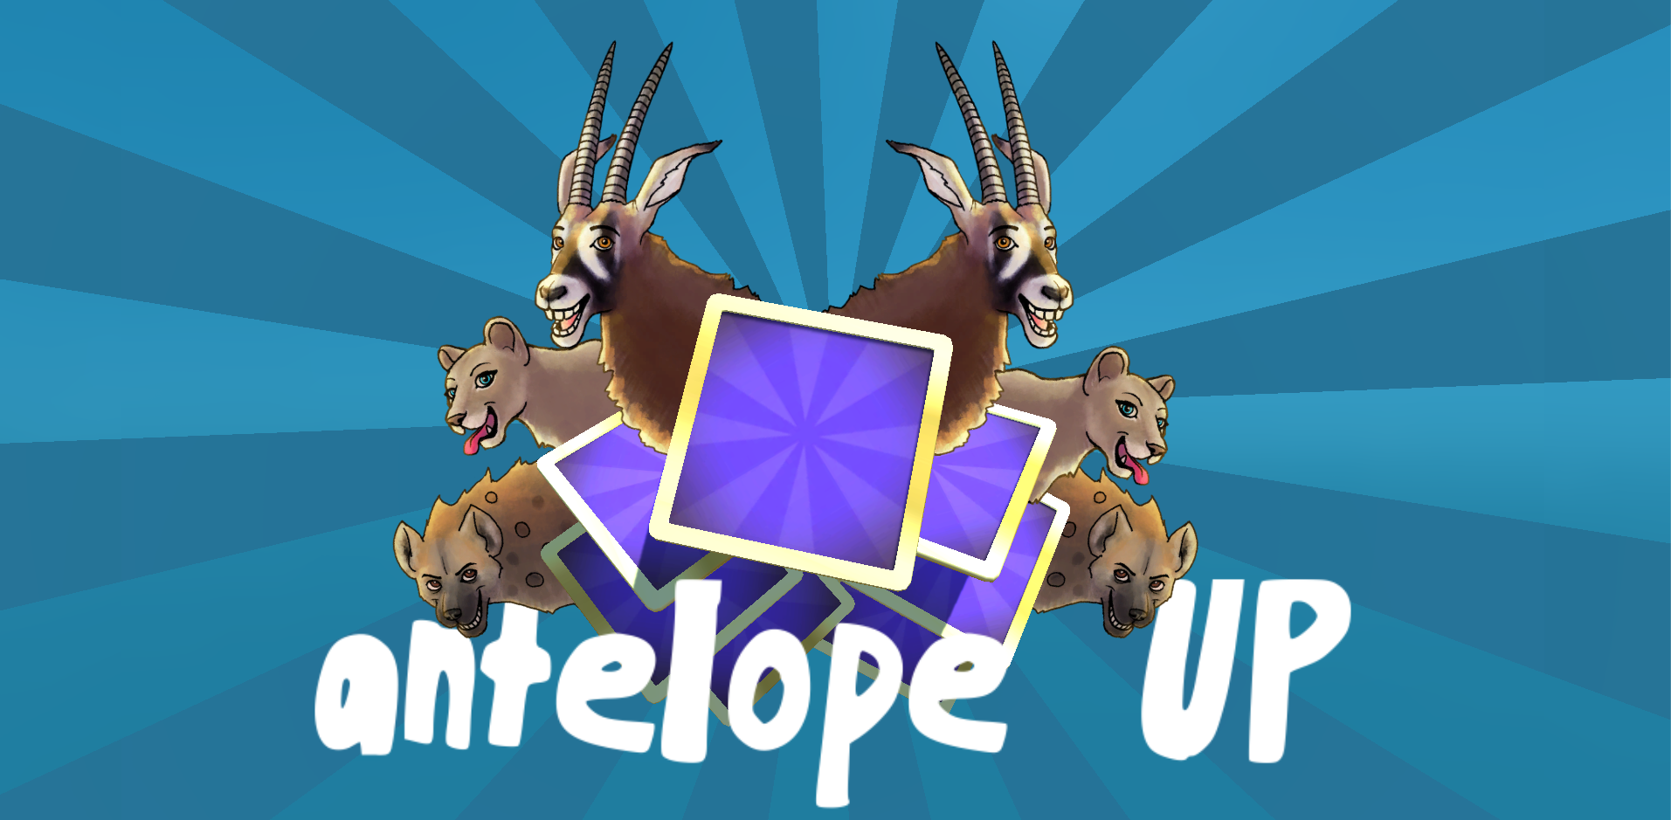
* Settings Screen: This screen is accessed at any time and is just text surrounded by 50% grayed out back ground.

* Map Screen: is on top of the splash screen and can be zoomed into when a region is selected.
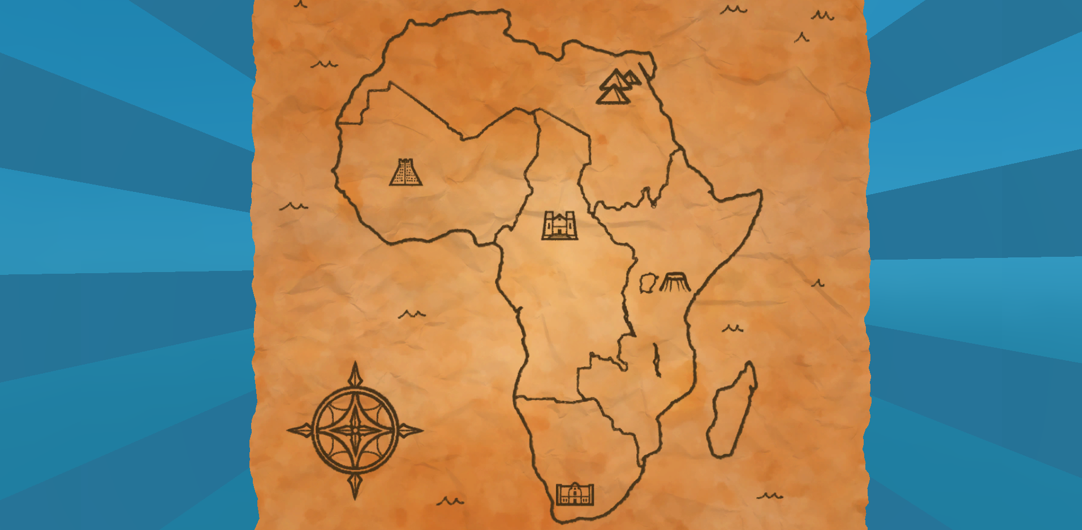
* Win Screen: If the player wins, a new screen congratulating the player is displayed briefly. Tapping or clicking will transition the player back to the map screen with the camera already zoomed into the region that was last selected.

* Fail Screen:If the player fails, a new screen feeling empathy for the player is displayed briefly. Tapping or clicking will transition the player back to the map screen with the camera already zoomed into the region that was last selected.

* Info Screen: If the player goes to the animal compendium through the settings, the player can see a list of antelopes they have matched so far. The list is on the left, the picture and details are on the right side of the screen.

    - Demo Loop – What is the purpose of each screen?
      - Splash Screen (Main menu)

Main menu screen loops between 3 modes (if the player does nothing):
* Splashscreen Animation/Title
* Leaderboard (High Scores)
* Credits
      - Leaderboard (Main menu)
The leaderboard accesses the data of all users scores and user initials and lists them in order of highest to lowest score. There is a cap off at the top 10. (The list does not allow bad words). If two or more users have the same initials, each player has a unique id number which will be small and at the end of their initials. For example: 1. MJH(id325) 47800
      - Credits (Main menu)
Include credits of:
* Crew: Karen,Greg,Kurt,Matt,Lucian,Jeff
* Talent: Maya, David
* Tools: Unity,Gimp,Blender,Github?,Lucian's audio tools
* Special thanks to....

  - Game Options – What are the options and how do they affect game play and mechanics?
If a player finds the game too easy or hard, they can change the difficulty settings. This will change the frequency of lioness, amount of tries, and amount of cards per level.
  - Replaying and Saving
Game autosaves and in the settings there is an option to reset game save file.
  - Cheats
The game starts on easy mode, but the player can make it even easier if they disable lioness or enable “freeplay”, which is not counted on leaderboards and gives the player infinite tries. There is also hardcore mode that gives the player a higher score, but less tries and more lioness frequency. The player can choose to disable the hyena.
  - Easter Eggs
Some levels feature special characters like Paka.
- Section III – Setting and Character
  - Game World
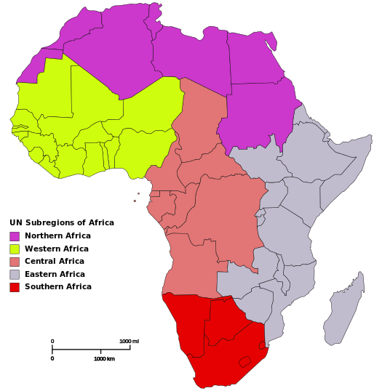
(Image from internet, site unknown)
    - Northern Africa
* Level 1:aït benhaddou(across in dense shrubs)
* Level 2:al-radom national park
* Level 3:Mount Issa (Djebel Aïssa)
* Level 4:
* Level 5:
    - Western Africa
* Level 1:
* Level 2:
* Level 3:
* Level 4:
* Level 5:
    - Central Africa
* Level 1:Akagera National Park
* Level 2:
* Level 3:
* Level 4:
* Level 5:
    - Eastern Africa
* Level 1:Amboseli National Park(Mount Kilimanjaro)
* Level 2:Ngorongoro Crater
* Level 3:Serengetti
* Level 4:Victoria Falls
* Level 5:Avenue of the Baobabs
    - Southern Africa
* Level 1:Okavango Delta
* Level 2:Fish River Canyon
* Level 3:The Big Hole(The Kimberley Diamond Mine)
* Level 4:Sossusvlei (Sand Dunes)
* Level 5:Kruger National Park

  - Characters
    - Characters on cards
* Addax
* Ader's Duiker
* Blesbok
* Blue Wildebeest
* Bohor Reedbuck
* Bongo
* Cuvier's Gazelle
* Dama Gazelle
* Dorcas Gazelle
* Giant Eland
* Greater Kudu
* Hunter's Antelope
* Impala
* Klipspringer
* Mountain Nyala
* Nile Lechwe
* Oribi
* Puku
* Red-fronted Gazelle
* Red Hartebeest
* Roan Antelope
* Sable Antelope
* Slender-horned Gazelle
* Thomson's Gazelle
* Topi
* Waterbuck

* Lioness

- Section IV – Help
  - Tutorial
Easy example level walk through, explained by voice talent
4 card tutorial level with unlimited tries
Easy example level walk through, explained by voice talent with a lioness
4 card tutorial level with unlimited tries
Easy example level walk through, explained by voice talent with a lioness and using a special
4 card tutorial level with unlimited tries
  - Instructions
Easy to read, small document with pictures!
Link to website

- Section V - Audio
  - Voice Talent
Maya: Animal voices
* Lioness roar
* Lioness rejected (if special used)
* Antelope may require voice to be lowered through tools
* 4 types of Antelope acknowledged sounds (surprised to be clicked on)
* 4 types of Antelope happy sounds (relieved to be matched successfully)
David: Narrator
* Win dialog
* Fail dialog
* Tutorial explained
* Animal names

  - Music
Short splash screen theme (transitions into a menu music loop)
Short level success tune
Short level failed tune
Short level start tune
Northern Africa levels song
Western Africa levels song
Central Africa levels song
Eastern Africa levels song
Southern Africa levels song

  - Sound Effects
Tap button
Card flip sound
Card shuffle sound
Footstep loop for animals running off screen
Successful card match chime
Failed card match chime
Splash image swoosh toward camera (animation not implemented yet)
Splash image stop? (animation not implemented yet)
Camera zoom into map region
Opening the paper map
Closing the paper map
Tap on map Region
Region rise out of paper
Ambient bird or other animal sounds
Hyena hit by fruit
Fruit falling off branch
Hyena falls and hits the dirt
Antelope rearing and landing
Use special ability

- Section VII – Technical – This may be abbreviated with most in the Technical Bible.
  - Target Hardware
Windows
OSX
Android
iOS

  - Development hardware and software
Kurt enter details here...
  - Development procedures and standards
Kurt enter details here...
  - Game Engine
Kurt enter details here...
  - Network
Kurt enter details here...
  - Scripting Language
Kurt enter details here...
  - etc.

- Section IX - Secondary Software
  - Editor
Kurt enter details here...
  - Installer
Kurt enter details here...
  - Update software
Kurt enter details here...

- Section X - Management
  - Detailed Schedule
Enter details here...
  - Budget
Enter details here...
  - Risk Analysis
Enter details here...
  - Localization Plan
Enter details here...
  - Test Plan
Enter details here...
- Appendices
Enter details here...
  - Asset List
Details kept in project DesignDocuments folder, “AntelopeUP_Art_Schedule.ods”

