**Mining Battle**

Game Design Document

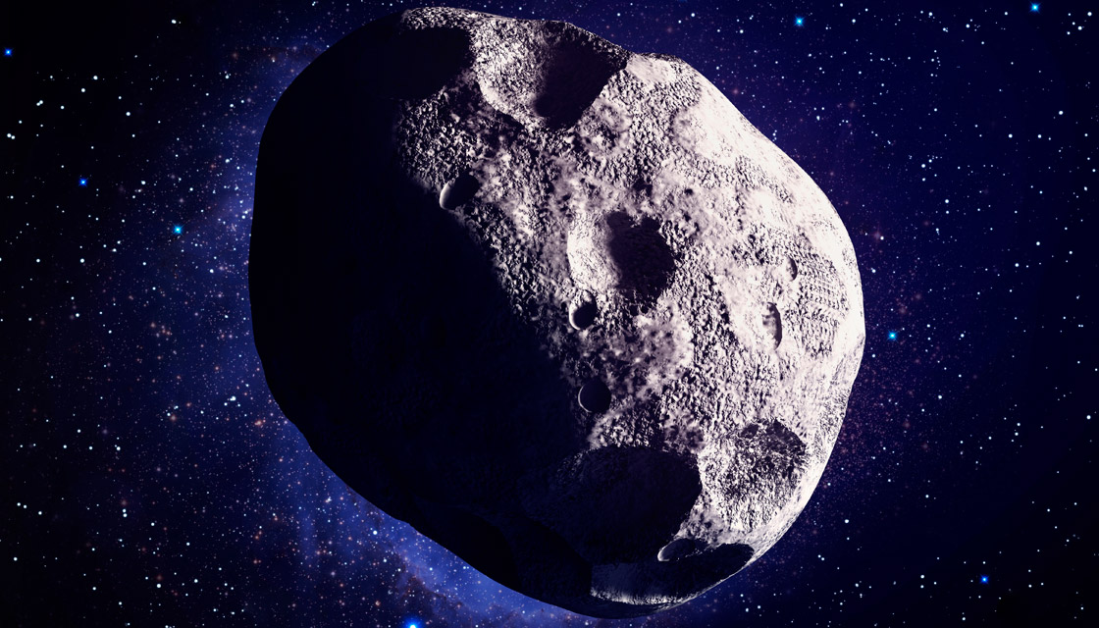

**Intended game system:** PC

**Target age of players:** 12+

**ESRB:** General audience

**Ship date:** Third week of December

|  |  |  |  |
| --- | --- | --- | --- |
| **Alexandre SACHS** | **Charles DESCOUST** | **Damien COSSON** | **Kellian CIPIERRE** |
| 7001420 | 7001459 | 7001440 | 7001471 |

Summary

Story 3

Game flow 4

Characters 5

Attack spaceship 5

Defence spaceship 6

Mining spaceship 7

Controls 8

Used keys 8

Game Play 9

Game World 11

The spawn 11

The asteroid 11

The fog 12

Player’s view 12

Game Experience 13

Feelings, emotions and moods 13

Player first vision 13

Music 13

HUD 14

Activity diagram 15

Game Play Mechanics 16

Minerals 16

Drill mode 16

Construction queue 16

Automatic back to base 17

Economy system 17

Achievements 17

# Story

There is a legend where, long time ago, when humans were still living on Earth, a mineral called “**Daegunium**” could be found in space and that this mineral would be the most powerful energy source we ever discovered… After years of research and dedication, you finally found an asteroid containing this famous mineral!

Now is the time to mine it and bring back this resource many people didn’t think existed!

You just arrived on the asteroid and you found out that **you were not alone…**

**Dig** through this gigantic asteroid, **sell** all your minerals to the biggest space marketplace. The more minerals you sell the more money you can get to dig even deeper into this massive block of various rocks…  
**Buy and expand your unbreakable defences around your mining area and deploy your powerful waves of space war ships!**

You promised yourself that you will be the first to mine this legendary mineral, even if you need to **fight for it!**

Depending on your choices and actions, the battle issue won’t be the same!

Your either will fulfil your dream and dig the “Daegunium” first. Or be beaten by your enemies that will take this precious mineral away from you!

# Game flow

In this **Action - RTS** *(Real Time Strategy)* **multiplayer game**, the player plays against 1 to 3 other players.

The player’s goal is to reach the centre of an asteroid which contains a rare mineral called “**Daegunium”**.  
The **first player to reach the centre, and so the “Daegunium”, wins**.  
The player will use 3 different spaceships to reach his goal:

* An **attack** spaceship, to attack and slow down his enemies;
* A **defence** spaceship, to protect his ships and his mining area;
* A **mining** spaceship, to mine into the asteroid.

The asteroid is full of different minerals with different rarity. The price of every mineral changes with rarity, **the rarer the mineral is, the more money the player earn**.

During the game, every player will grow, and earn always more money. So, every player will have to **adapt his strategy against his enemies**.

When a player arrives near the centre of the asteroid, he will encounter **layers of diamonds**, this will be the hardest part to mine, and it will take a **lot of time**.

Because of that, every player has a chance to attack and slow down the closest player to the centre and steal the precious “**Daegunium**”.

This will guarantee some **very tense end of games**:

* Is it better to spend more money to mine faster and fulfil your goal before the other closer players?
* Or maybe by sending waves of attack spaceships against the other player to slow him down?
* Why not create a bunker around your mining area with you defence spaceships?
* Lastly, you can maybe, mix all these strategies at once, or even create your own?

**Every game will be different because other players will not use the same strategies than before.**

# Characters

There are 3 types of spaceships which constitute all the characters in the game.

## Attack spaceship

*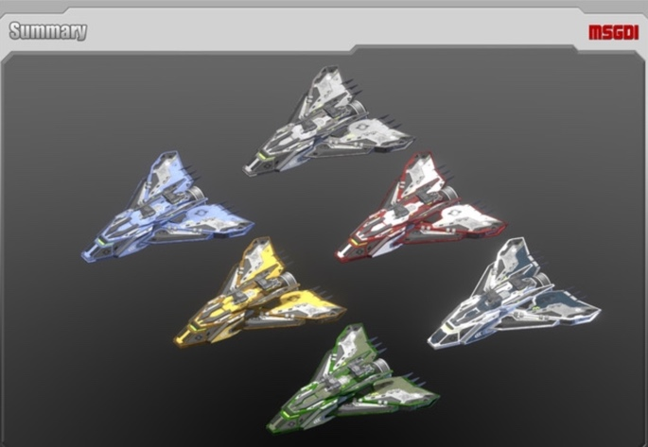Concept art:* **Triangle ship with rocket launchers;**

*Cost:* **100 $;**

*Construction time:* **1 second;**

*Destruction reward:* **35 $;**

*Health:* **1 HP;**

*Speed:* **5 blocks/second;**

*FOV (Field of View):* **15 blocks;**

*Weapon:* **Rocket launchers;**

*Ability:* **Shoot**. **Shoot a rocket toward an enemy**, maximum every \***Ability Cooldown*;**

* The rocket is **teleguided** to the selected enemy. So, it will follow the enemy even if he moves.
* This rocket **deals 1 damage** to any enemy spaceship.

*Ability range:* **5 blocks** *(Can shoot if a spaceship is within 5 blocks of him)***;**

*Ability Cooldown:* **1 second;**

*Basic behaviour:* **Automatically attacks** enemies in his \***Ability Range*.** Otherwise, does nothing;

## Defence spaceship

*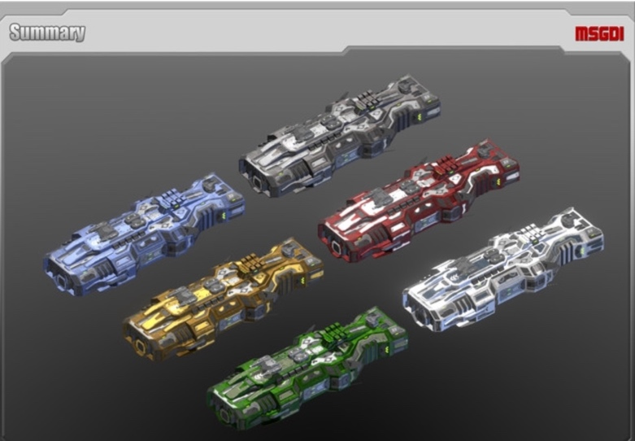Concept art:* **Curved spaceship which looks like a wall;**

*Cost:* **100 $;**

*Construction time:* **1 second;**

*Destruction reward:* **35 $;**

*Health:* **3 HP;**

*Speed:* **1 block/second;**

*FOV:* **15 blocks;**

*Weapon:* **None;**

*Ability:* **Block. Blocks every enemy entity;**

* If an **enemy missile** hits a defence spaceship, the defence spaceship **will lose 1 HP**.
* If an **enemy spaceship** hits a defence spaceship, both spaceships **will cause to the other one his current health in damage**.

**Example:** If a defence spaceship with 2 HP flies into a full life defence spaceship (3 HP), the first one will lose 3 HP and die because he had only 2 HP. The second one will lose 2 HP and lives with 1 remaining HP because he had 3 HP.

*Ability range:* **0 block;**

*Ability Cooldown:* **None;**

*Basic behaviour:* **Does nothing;**

## Mining spaceship

*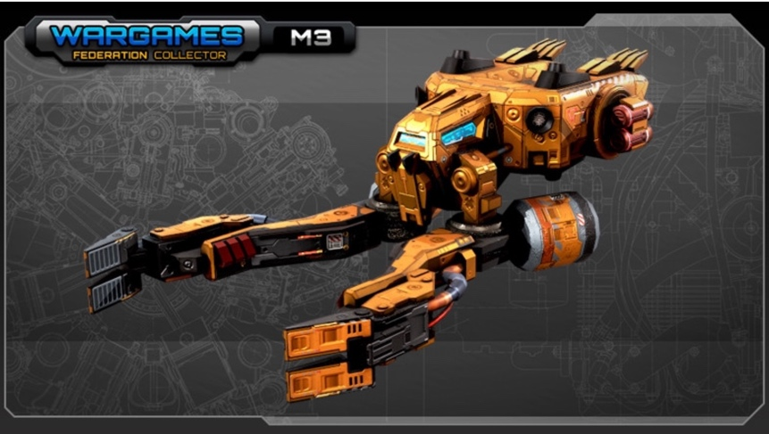Concept art:* **Spaceship with a drill in front of it;**

*Cost*: **100 $;**

*Construction time:* **1 second;**

*Destruction reward:* **35 $;**

*Health:* **1 HP;**

*Speed:* **3 blocks/second;**

*FOV:* **5 blocks;**

*Weapon:* **None;**

*Ability:* **Drill.** **Allows to drill the asteroid and its minerals;**

* A mineral, when drilled, will **give money equal to** **the defined cost of that mineral** to the owner of the mining spaceship.
* **Radar.** **Temporally detects minerals around itself for “Ability Range”**. When the mining spaceship leaves the area, minerals detected by the Radar ability do not appear on the map. **Unlike the FOV does.**
* **Stockage. Allows the mining spaceship to carry up to 5 trashes**. A trash is picked up for every material it drills. When full, if “Return to base” option is enabled, gets back to the base to empty its storage. Otherwise does nothing.

*Ability range:* **9 blocks for radar ability;**

*Ability Cooldown:*

* None for drill ability, drills every time he can.
* None for radar ability, detects minerals all the time.
* None for stockage ability.

*Basic behaviour:* **Automatically drill** the nearest “To drill” block part of a drillable zone and not being drilled by another mining spaceship;

# Controls

* *Select an entity:* **Mouse Left Click;**
  + *Create a select zone:* **Mouse Left Click + Drag;**
  + *Create a select zone for the attack spaceships:* **SHIFT + Mouse Left Click;**
  + *Create a select zone for the defence spaceships:* **CTRL + Mouse Left Click;**
  + *Create a select zone for the mining spaceships:* **ALT + Mouse Left Click;**
* *Give a destination to all selected spaceships:* **Mouse Right Click;**
* *Zoom in / Zoom out:* **Mouse Wheel;**
* *Camera Forward:* **W;**
* *Camera Backward:* **S;**
* *Camera Left:* **A;**
* *Camera Right:* **D;**
* *Open/Close Shop:* **B;**
  + *Buy Mining Ship:* **1** (if shop is opened)**;**
  + *Buy Attack Ship:* **2** (if shop is opened)**;**
  + *Buy Defence Ship:* **3** (if shop is opened)**;**
* *Menu:* **ESC;**
* *Show players information:* **TAB;**
* *Centre the camera on the command centre:* **SPACE;**
* *Enable/Disable drill mode:* **G;**
  + *Create Drill Zone:* **Mouse Left Click;**
  + *Create Cancel Zone:* **Mouse Right Click;**
* *Display Map:* **M;**
* *Enable/Disable automatic back to base for mining ships when full:* **R;**

## Used keys

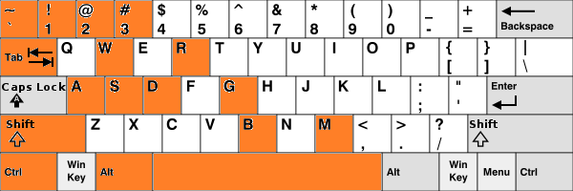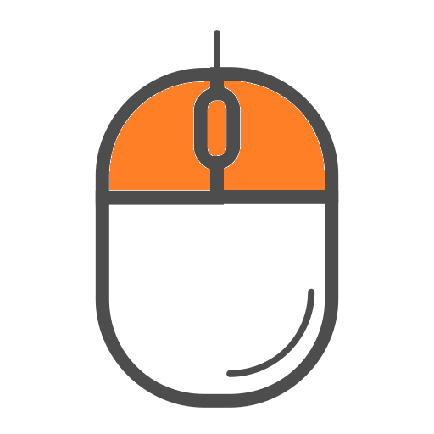

# Game Play

In this **Action - RTS - Multiplayer** **PC** game, the player begins by creating or searching for a lobby to connect to a game.

A game begins in space where each player can only find a **giant asteroid with his base**.  
Each player **only sees around the FOV of his base and spaceships**. During the game, the player can see on his map/mini map the default shape of the asteroid. A **fog** prevents the player to see enemies' activities like movements, ships creation, mining...  
The player’s map will **only be updated within the FOV** of the players’ ships and base. When an area of the map is not in the player’s FOV anymore, this area won’t be updated.

It’s up to the player to discover the map by sending spaceships to scout his enemies’ base and activities or discover parts of the asteroid.

Spaceships have different field of view (FOV) depending on their type:

* **Attack** and **Defence** spaceships have a **large** FOV;
* **Mining** spaceships have a **small** FOV but can **detect minerals** around them;

When detecting an enemy spaceship, a **red dot appears** on the map/mini map. However, when this spaceship is not in sight anymore *(because of retreat or destruction)*, the fog appears again, and you can’t see what is in this area.

Whereas when a mining spaceship discovers a mineral by detecting it with his FOV, the **mineral will be visible on the map** even with the fog.

But this discovery is not in real time, as explained before, the state of the material will be updated when one of the player’s spaceship will have the vision on it.  
*Example:* an enemy spaceship can come and steal a mineral discovered when the player is not here. If so, the player will still see the mineral and it will only update the map/mini map when one **mining** spaceship have the vision on this area ***(NB: only mining spaceships can detect minerals)***.

**Each type of spaceship must be bought and cost a different amount of money**.

At the start of the game, every player begins with **300 $ and a mining spaceship.**

To buy more spaceships, **players need to** **earn money**, either by:

* The money generated by the base continuously;
* The destruction of other spaceships;
* The mining of minerals.

The more spaceships a player has, **the less money his base will generate**.

Different types of minerals can be found within the asteroid. **Probability of finding rare minerals increases with the proximity to the core** of the asteroid.  
So, the closer minerals are to the core, the more money the player will receive.

**Players can create their units strategically** but must be creative to prevent their enemies to reach the goal before them.  
Each player can choose to destroy enemies’ spaceships with attack ones or can use a more defensive strategy by creating mining and defence spaceships to be the fastest to reach the centre.

# Game World

## **The spawn**

At the generation of the game, each player will be placed randomly on a circle. The distance between players spawns will be at least 45° as shown on the figure 1.

Figure 1: minimal distance between spawn positions

## The asteroid

The asteroid is mainly composed of rock. At the middle there is the Daegunium and around it diamond. Then, iron, copper and gold are present randomly inside the stone part of the asteroid (cf. figure 2).

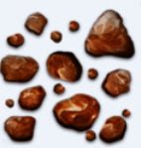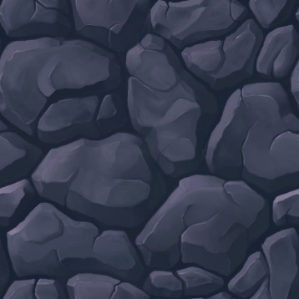

Rock Iron Copper

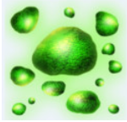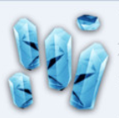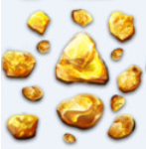

Gold Diamond Daegunium

## The fog

The fog of war hides some information to the player. It hides enemies’ spaceships, enemies’ base and the update of the asteroid. Ally base and allies’ spaceships can clear the fog inside their field of view.

## Player’s view

The player can zoom in and zoom out. The longest camera distance allows the player to see in height 50 blocks (the half of the radius of the asteroid). The shortest camera distance allows the player to see in height 5 blocks.

Figure 2: World representation

# Game Experience

## Feelings, emotions and moods

1. **Stress** about reaching the centre first.
2. **Satisfaction** about slowing down your enemies, collecting minerals and built an amazing fleet of spaceships.
3. **Afraid** about being slowed down by your enemies and losing the game.
4. **Scared** of other players.
5. **Competitiveness** against other players.
6. **Determination** about finishing first and wining. Or about restarting a game because the player wants to improve his strategy.

## Player first vision

First, the player can see a map with the deep cold space, a giant asteroid in the middle and his base. Also, he will have, his first spaceship: a mining one.

In this environment the player will feel a little bit of loneliness, being lost in this empty space with just his base and a little spaceship. Also, he will be afraid because of the fog preventing him to see what’s around him and hiding other players.

## Music

1. **For the menu:** a calm and futuristic music allowing the player to navigate the menus without rushing him.
2. **For the game:** a calm and futuristic music putting the player in an atmosphere of space battles.

# HUD

* **Progress bar** Players can see in real time the high-score of all players, but can’t know to which  
   enemy player it corresponds. Whenever a player reaches diamond level, everyone   
   can see their names on their high-score.
* **Wallet** Total money owned by the player.
* **Ships**  Number of spaceships owned by the player for each category.
* **Store**  
   When displayed, the player can see and click on the spaceship he wants to buy.  
   The construction queue displays the order of construction and how much.
* **Time**  
   The time elapsed since the beginning of the game.
* **Menu**  
   Displays the ingame menu.
* **Back to Base**  
   Enable/Disable automatic back to base for mining ships when full.
* **Dig**  
   Enable or disable the drill mode.
* **Map**  
   The map displays all accessible information to the player.

# Activity diagram

# Game Play Mechanics

## Minerals

Each mineral located in the asteroid has a different rarity and so a different value, here are all the minerals:

* 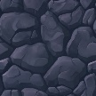**Rocks:**
  + Mining time: 2 seconds;
  + Reward: 100 golds;
* 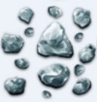**Iron:**
  + Mining time: 4 seconds;
  + Reward: 300 golds;
* 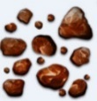**Copper:**
  + Mining time: 6 seconds;
  + Reward: 800 golds;
* 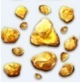**Gold:**
  + Mining time: 8 seconds;
  + Reward: 1 500 golds;
* 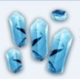**Diamonds:**
  + Mining time: 16 seconds;
  + Reward: 4 000 golds;
* 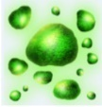**Daegunium:**
  + Mining time: 0 seconds;
  + Reward: **WIN THE GAME**;

## Drill mode

When drill mode is active, the player can draw a zone to mine with “Left Click” and can draw a zone to cancel mining with “Right Click”. Each block inside the selection is marked as “To mine”. When a mining spaceship is idle and in range of a “To mine” block, it will mine it automatically.

## Construction queue

**The buying queue determines the order of ships that will be build next**. For example, if the player buys 3 attack ships, 17 mining ships, then 13 attack ships and finally 8 defence ships, these 4 queues will appear on the screen, and the base will build, in order, 3 attack ships, then 17 mining ships, then 13 attack ships and finally 8 defence ships. **There can’t be more than 5 queues. 1 queue can only contain up to 99 spaceships**. If the player tries to buy when he has full queues, the buying will not happen. *(NB: a new queue will be added if the bought ship is not of the same type that the last created queue waiting)*.

## Automatic back to base

The “Automatic back to base” option is either enabled or disabled. It only affects mining spaceships. If this option is:

* **Enabled**:
  + **Every mining spaceship with a full storage will automatically get back to the base** and go back to mining when done emptying (if there is a selected dig area).
* **Disabled**:
  + **Once a mining spaceship’s storage is full, stops mining and stop moving**.

## Economy system

In the game, the player has **access to a shop**. In this shop they can buy spaceships.  
Indeed, the money earned with the **mining** in addition to the **passive money** earned by the base and the **rewards offered by the destruction of enemies’ spaceships** allow the players to increase their fortune.

The default amount of money earned by the base is **20$ per seconds minus 0.1$ per constructed ship**.  
That means that the player will earn 0 $ if his fleet contains 200 spaceships or more.

## Achievements

Achievements are collectables the player will be able to recover over the games he plays.

* Win in less than **75 /** **60 / 45/ 30 / 15** minutes.
* Build more than **1000 / 5000 / 10000 / 20000 / 50000** spaceships.
* Build more than **1 / 10 / 100 / 1000 / 10000** mining spaceships
* Build more than **1 / 10 / 100 / 1000 / 10000** defence spaceships
* Build more than **1 / 10 / 100 / 1000 / 10000** attack spaceships
* Destroy more than **1 / 100 / 500 / 5000 / 20000** ships.
* Win a game by always keeping more minors than attackers throughout the game.
* Win a game without creating a single defence spaceship.