Mining Battle

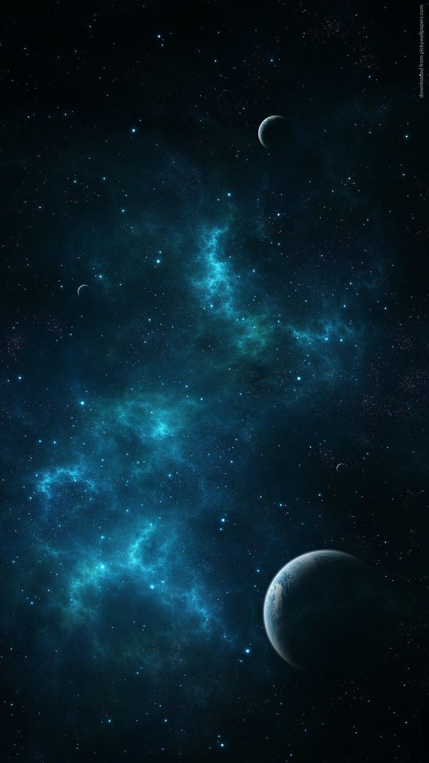One-page Game Design Document

Intended game systems: **PC**

Target age of players: **12+**

ESRB rating: **General Audience**

Distinct modes of gameplay: **Multiplayer (2 to 4)**

Game summary:

**There is a legend where, long time ago, when humans were still living on Earth, a mineral called “Daegunium” could be found in space and that this mineral would be the most powerful energy source we ever discovered… After years of research and dedication, you finally found an asteroid containing this famous mineral!**

**Now is the time to mine it and bring back this resource many people didn’t think existed!**

**You just arrived on the asteroid and you found out that you were not alone…**

**You promised yourself that you will be the first to mine this legendary mineral, even if you need to fight for it!**

Game outline:

**Each player got a spaceship base. Their goal is to reach the centre of an asteroid which contains a rare mineral called Daegunium. The first player to reach the centre wins. The player will use 3 different spaceships to reach his goal. An attack spaceship, a defence spaceship and a mining spaceship.**

**Each type of spaceship must be bought and cost a different amount of money.**

**For players to buy spaceships, they need to earn money, either by:**

* **The base which generates a small amount of money continuously;**
* **Destroying other spaceships;**
* **Mining minerals and bringing them back to the base.**

**Different types of minerals can be found within the asteroid found on the centre of the map. The closer minerals are to the core of the asteroid, the more money players will receive.**

**Each player can create his units strategically to prevent his enemies to reach the goal before him, either by destroying his mining spaceships with attack ones, or can use a more defensive strategy by creating mining and defence spaceships to be the fastest to reach the centre.**

Unique selling points:

* **RTS meets mining game.**



* **Find the perfect balance between mining, attack and defense!**
* **Up to 4 online players.**
* **Fast 4X game!**
* **Each type of spaceship has its own role and abilities!**

Competitive products:

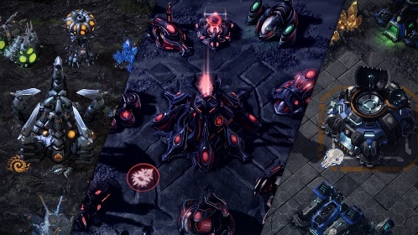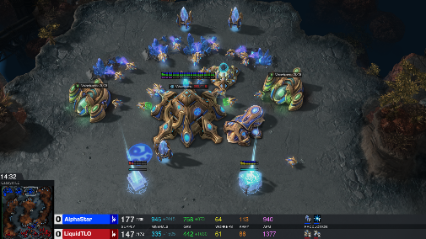

**StarCraft**

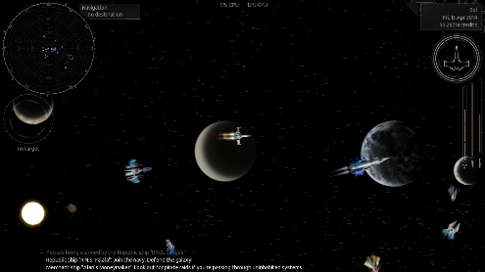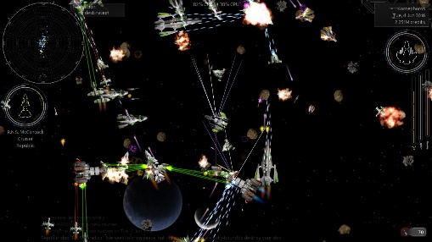

**Endless Sky**

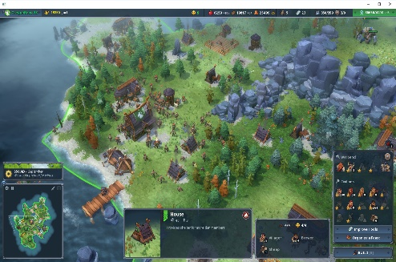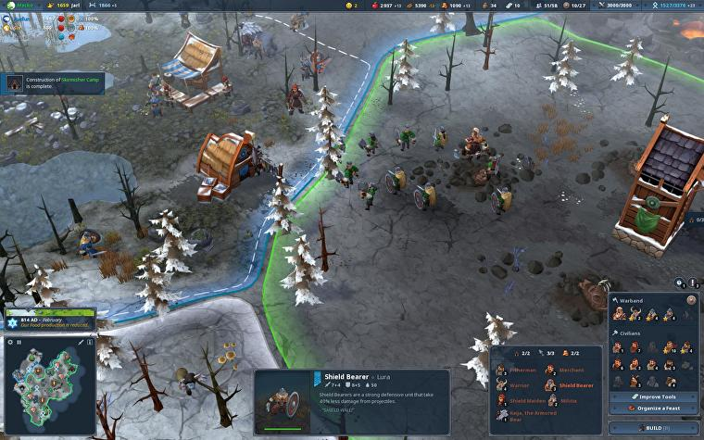

**Northgard**

**Kellian Cipierre 7001471**

**Alexandre Sachs 7001420**

**Charles Descoust 7001459**

**Cosson Damien 7001440**