Fire Emblem-like

## About:

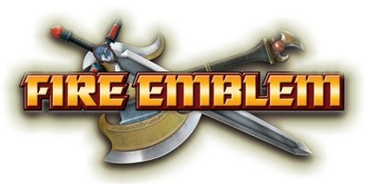

This is a test Fire Emblem-like engine for Unity. I will outline all the parts of the engine in this document, explaining the scope of the project in the process. This is not meant to be a full-fledged engine, as it’s simply a project for practice purposes.

## The essence of Fire Emblem:

The Fire Emblem series is a turn based strategy RPG series. For the sake of this practice project, a simplified version will be created.

The games contains these key elements:

* Map
* Units
* Unit interactions

The combination of these three elements are the absolute base of the series. If any of these components were removed, the games would not be playable.

The map is of a grid-like structure, each grid containing a space that a player may or may not use for travel.

The units are unique game pieces that have a variety of attributes that will aid them in movement or combat.

The unit interactions allow the units to take actions to help fulfil the goal conditions of the game. This includes movement, the use of items, battle and waiting.

Thus, you may consider the overall design of the game to be similar to a game of chess. You have a grid you can move game pieces on, with set conditions on movement and battle.

## Gameplay specifics:

### The map

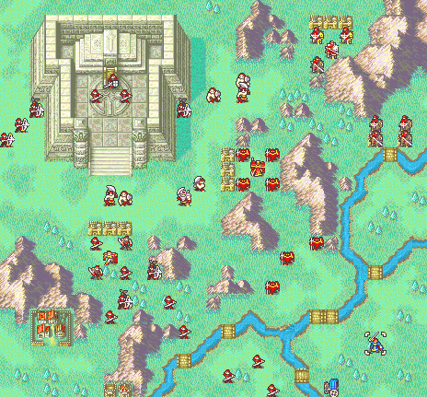

*Overview of the game board*

The map is the game board. The map is designed to be a grid of perfect squares, the overall shape of the map being either a square or rectangular shape.

Each square has a property associated with it. The property determines whether there are any restrictions regarding movement on or across the square. For instance, if the square has no restrictions, a unit may move onto, or move past the square with no interruption. However, conditions that restrict movement may only allow units to move to the square and not past, or may not even allow units to move onto the square itself. The square may also possess other properties that can affect units, such as battle effects that is favourable for the unit currently occupying the space, which may provide an advantage against units wishing to engage in combat.

### The units

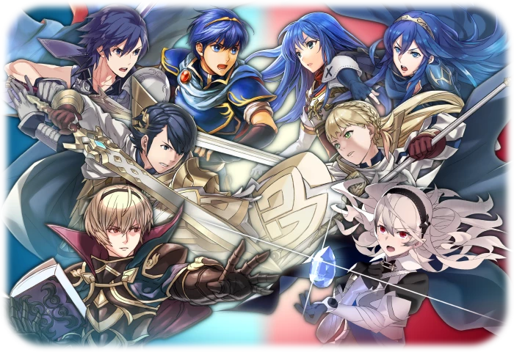

*Units come with their own unique strengths and weaknesses*

The units are what makes the game. They are game pieces that have their own unique attributes and items/equipment, with the ability to move across the game board, use items, battle enemies or wait. The units may be controlled either by a player or the enemy. Neither may control the actions of the other.

The attributes of a unit includes: Movement Points, Health Points, Strength, Magic, Agility, Defence, Resistance, Skill and Luck

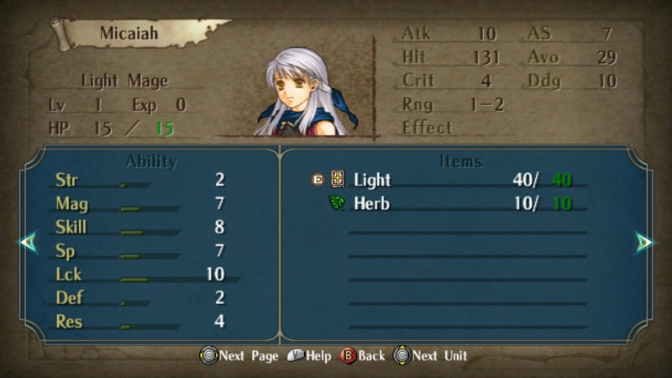

*Each attribute contributes to the outcome of battles (other than Movement Points)*

Movement points dictate the amount of spaces a unit may traverse on the game board. Generally, this number does not change.

Health points play the biggest role in the existence of a unit, as the points remaining after an exchange in battle is what determines whether the unit may continue to be used during the next available phase, or whether the unit is defeated and removed from the game board. Health points are lost when a unit has been attacked in battle, provided that their attributes do not prevent damage to the point of taking no damage. Health points can generally only be replenished through the use of items, support units (TBD if to be featured in this practice engine) or maybe even specific spaces on the game board.

Strength is the physical power a unit possesses. This determines the amount of physical damage a unit can cause to enemy units in battle. The amount of damage dealt depends on the defence attribute of the defending unit, and the attributes of the weapon used by the attacker.

Magic is the magical power a unit possesses. This determines the amount of magical damage a unit can cause to the enemy units in battle. The amount of damage dealt depends on the resistance attribute of the defending unit, and the attributes of the weapon used by the attacker.

Agility is an attribute that has two effects in battle. It determines whether the unit is able to attack an enemy unit once or twice during a battle and vice-versa. It also serves as a modifier that determines the probability of a unit entirely avoiding attack, which is based upon the agility/luck a unit has combined with the skill attribute of the attacking unit, the attributes of the weapon used by the attacking unit and potentially the space that the defending unit is currently occupying.

Defence is the physical defensive capabilities a unit possesses. This is the main attribute that determines the amount of physical damage a unit takes when attacked in battle.

Resistance is the magical defensive capabilities a unit possesses. This is the main attribute that determines the amount of magical damage a unit takes when attacked in battle.

Skill affects the probability of successfully attacking another unit in battle. This is further affected by the luck attribute, the weapon used and the defender’s agility/luck.

Luck is an attribute that affects battle situations that involve the use of probability. It also determines the probability of performing a critical attack, which does double the damage that would usually be inflicted during battle with a regular attack, and is a guaranteed hit.

Items will be kept very basic for the sake of this practice engine, where a unit may hold a Vulnerary item in their inventory. It can be used to replenish lost health points at the expense of not being able to engage in battle during that phase.

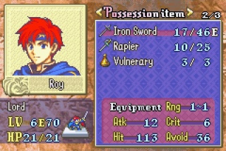

*Equipment and items*

Equipment is limited to the weapons a unit may use in battle. Weapons may cause physical or magical damage depending on the weapon type. Weapon types include: Sword, Lance, Axe, Red Tome, Blue Tome, Green Tome, Bow. A trademark of the Fire Emblem series is the “weapon triangle”, which gives a damage and hit advantage/disadvantage depending on which weapon the attacker and defender is using. Sword/Red tome is effective against Axe/Green tome, Lance/Blue tome is effective against Sword/Red tome, Axe/Green tome is effective against Lance/Blue Tome. Bows are an exception to the triangle, as they receive neither advantages nor disadvantages against other weapons. Weapons come with their own attributes: Might, Hit, Critical and Durability

Might is the attribute that determines the amount of damage that can be done in battle, when combined either with the strength or the magic attribute of the unit possessing the weapon.

Hit is one of the attributes that affect whether an attack will successfully hit or not. It mainly influences the skill attribute of the unit performing an attack.

Critical is the base probability the weapon has of performing a critical attack during battle. This is further affected by the luck attribute of the unit using the weapon and the defender’s luck attribute.

Durability is a set amount of points a weapon has that depletes every time a weapon is used for an attack, including double attacks. When the points reach zero, the weapon is discarded and may not be used any longer. The next available weapon in the unit’s inventory will automatically be equipped, if it exists.

### Unit interactions

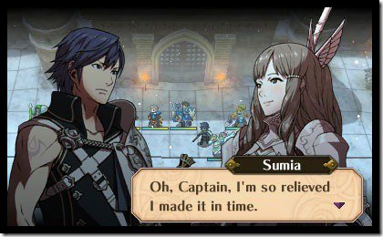

*The interaction of units is the trademark of Fire Emblem games*

As explained, units can perform four different actions during the phase in which they can be controlled. This includes: Move, Battle, Item and Wait

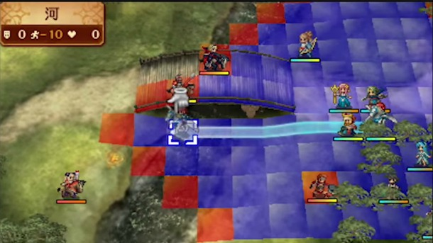

*A selected unit being moved across several spaces on the map*

Move is the act of selecting a unit, then moving a unit to a different space within the restrictions of their own movement points and the space(s) the unit traverses or wishes to occupy. Two units can not occupy the same space. Player units may only pass player units, and likewise for enemy units.

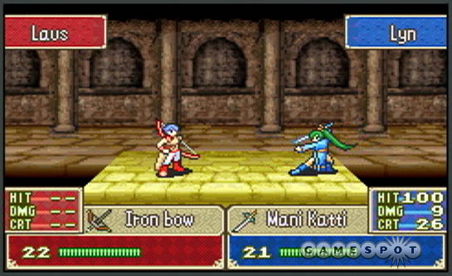

*The battle screen, illustrating the actual outcome of the battle*

Battle is the main interaction that dictates the game progression, where victory or defeat can bring one closer to winning or losing the game. In order to initiate battle, a unit must approach another unit first. In the case of close range physical weapons, the attacking unit must be adjacent to the defending unit in order to attack. In the case of long range weapons, such as tomes and bows, the defending unit must be two spaces away from the attacking unit. Before battle begins, the weapons chosen are taken into account for the battle, where an advantage or disadvantage may be given depending on the match up. A display will show the expected outcome of the battle, along with the probabilities of causing a hit or a critical attack and whether a unit has an advantage or not.

At this point, the game view is shifted to focus on the two units in battle, which overlays the map for the duration of the battle. The attacking unit attempts an attack first, where the unit either misses or hits, resulting in the defending unit taking no damage or losing health points equivalent to the relevant offensive/defensive attributes and weapon used during the exchange. If the defending unit has a weapon that also fulfils the criteria of initiating battle with the attacking unit, the defending unit will perform a counter-attack, which is evaluated the same way as the attacking unit’s attempt but according to the defending unit’s parameters. Once this initial exchange has passed, depending on the agility attribute of either unit, the battle ends, or a unit performs a follow-up attack. If either unit has five more points in speed than the other, they will perform a follow-up attack, regardless of whether they’re the attacking or the defending unit. Note: Every individual attack is evaluated separately, making it possible for a unit to miss one attack, and hit with another. Or perform a critical attack, then miss with the second attack etc.

Once the exchange has finished, the units either vanish or remain depending on the amount of health points they have remaining. The attacking unit may not take any further action until the next player/enemy phase, whichever it belongs to.

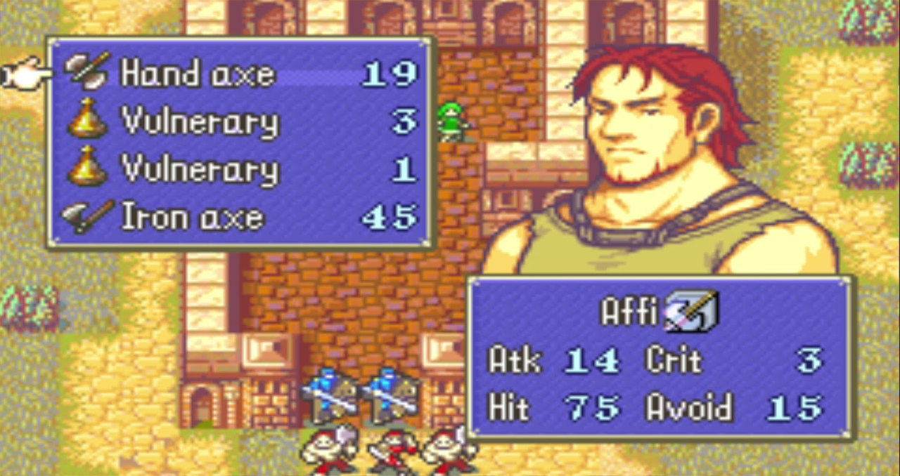

*Selecting an item to use, or a weapon to equip*

Item interactions are simply the act of selecting a unit, and selecting an item in their inventory to use after movement, or staying on the same space they started on. For simplicity’s sake, there will only be one item for health point recovery, which can only be used if health points have been lost. The unit may not take any further actions during the phase after using an item.

Wait is the act of ending the actions of the unit for the rest of its phase. This is performed by selecting the unit, then either selecting wait on the same space they started on, or move the unit first before selecting wait.

## Game progression:

|Start level

||Player phase

||Start of turn

||Movement/Item/Battle/Wait

||End of turn

|||Enemy phase

|||Start of turn

|||Movement/Item/Battle/Wait

|||End of turn

||||Victory/Defeat

## Explanation of phase progression:

Start level: The map, with all terrain details and unit positions will be revealed at this point.

Player phase: Player control will be granted during player phase. Enemies have no control during this phase.

Start of turn: During the start of the turn, various effects may be applied or removed depending on previous conditions that may affect the start of the turn. Player control is granted afterwards.

Movement: You may move a chosen unit according to the amount of Movement Points they possess. This involves selecting a unit, then selecting an eligible tile on the map to transport your unit to. You may perform three different actions upon finishing movement, including using an item, engaging in battle or waiting.

Item: You may use an item in your inventory during player phase. This action can be performed with or without movement. You may take no further action after using an item.

Battle: You may engage in battle with an enemy provided you have the means to do so. This includes being in range of the enemy, having a weapon equipped and potential other conditions. This action can be performed with or without movement. You may take no further action after engaging in battle.

Wait: This action effectively makes your unit do nothing for the rest of the phase. This action can be performed with or without movement. You may take no further action after waiting.

Enemy phase: Enemy control will be granted during enemy phase. Player has no control during this phase.

End of turn: The respective end of player or enemy phase, if actions taken during the phase lead to no other action being available. The end of turn transitions in to either player or enemy phase depending on which phase the game was in.

Victory/Defeat: Conditions that fulfil either victory or defeat can vary, but the most common case includes the defeat of all of your own, or your enemies’ units. Victory/defeat conditions are evaluated at the end of turns.

## Goal:

Although the source material allows for a variety of different ways to achieve objectives, for the sake of this test, the defeat of all enemy units is considered the goal.