EXPERIMENT # 5
I-V Characteristics of The BJT

BJT
-BJT stands for Bipolar Junction Transistor
-Like MOSFET, it is another type of transistor with three terminals:
Base (B), Collector (C) and Emitter (E).

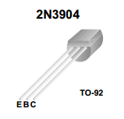
Fig. B-1 BJT 2N3904 Pin Configuration

-The BJT can either be an NPN or a PNP. Following is the general configuration and the circuit symbol of both of the type of BJTs

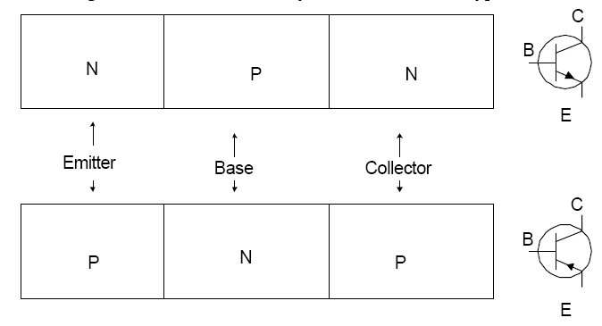

Fig. B-2 PNP and NPN BJT Electrical Symbol

-Unlike MOSFET transistors, the total current in BJTs consist of both Electron and Hole currents.
-BJT is regarded as a Current-controlled device where the base current controls the collector current
(Remember MOSFET is a voltage-controlled device)

BJT Regions of Operations:
There are three regions of operations:

1. Cutoff Region: When B-E ands B-C junction are reverse biased it is in cutoff region. Practically no current flows in this case, except for a very small (μA range) reverse saturation current.

2. Active Region: There can be two configurations of active region:

a. Forward Active: When B-E junction is forward biased and BC junction is reverse biased. The characteristic of this region is that the collector current IC is directly proportional to the base current IB:

I_{C} = β_{f} * I_{B}.

The constant of proportionality β_{f} is known as the Current amplification factor. The base-emitter voltage V_{BE} is equal to the turn on voltage of a diode (around 0.60-0.75V).

b. Reverse Active: When B-C junction is forward biased and B-E junction is reverse biased. The relation between the collector current and the base current is still the same with the exception that now the emitter junction is working as a collector junction and collector junction as an emitter junction. The constant of proportionality is βr, which if transistor is symmetric (E and C are same) is equal to βf. Usually the emitter junction of BJT is highly doped with n-type electrons and collector junction is lightly doped with n-type electrons, hence the transistor is not symmetrical and βf is much larger than βr. Hence transistor is usually operated in forward active region.

3. Saturation Region: is the region where the B-E and B-C junctions are both forward biased. The characteristic of this region is that the collector current is no longer proportional to the base current and the voltage between the collector and emitter junction V_{CE} =0.2V, and V_{BE} = 0.75. Keep in mind that the values given are theoretical. The experimental values of voltages and currents may be a little different.

BJTs are used for amplification or switching purposes. Amplification takes place in forward active region, while for switching purposes; the BJT goes from cutoff region to saturation region.

Pre-Lab
Make sure you read about the different regions of operation for the BJT transistor from your textbooks before attempting this simulation. Simulate the following circuit below using MULTISIM. Use 2N3904 Transistor in the circuit. Connect a DC_CURRENT source to the circuit as shown

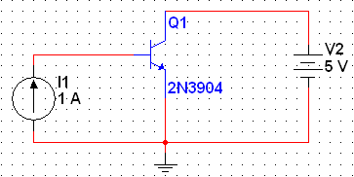
For this simulation you will be performing a DC sweep analysis. The diagram below shows how to find the DC sweep simulation option

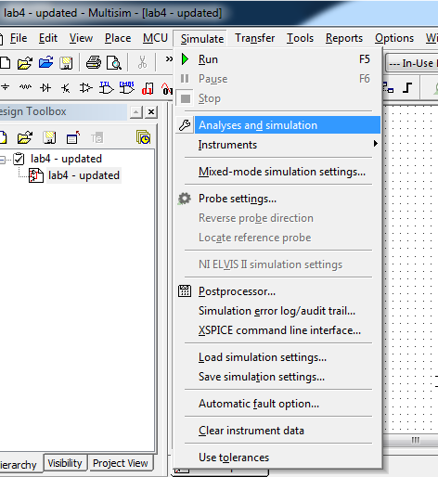

Once the DC sweep has been selected configure the parameters as shown below

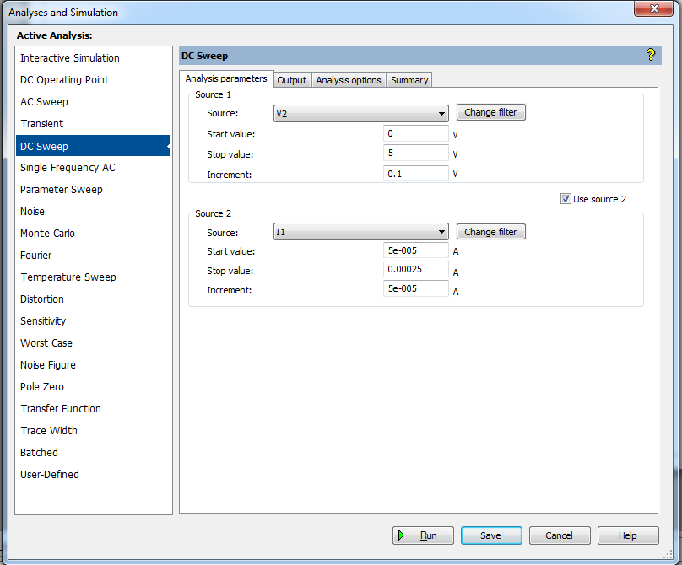

After changing the analysis parameters click on the Output tab and make sure you select the I(Q1[IC]) (the collector current) variable as shown below. Then click simulate.
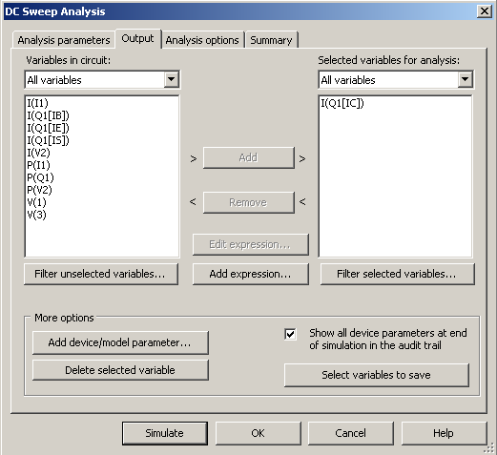

Click on the “Show Cursors” option in the toolbar make sure you move the cursor to the active region, read off the current value I_{c} when the voltage is about 5V off each curve. Using the equation I_{C} = β_{f}*I_{B} calculate the value of β_{f} for each curve. Remember I_{B} was varied from 50µA to 250 µA with 50µA intervals. Include these calculations and your plot in your lab notebooks.

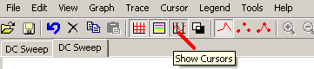

Procedure
- Design the circuit as shown in the circuit diagram below. Connect the 0-25V to V_{BB} and the 0-6V power supply to V_{CC}.

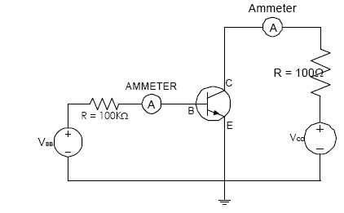
- By adjusting V_{BB,} set I_{B} = 50, 100, 150, 200 and 250 µA, one at a time. For each I_{B} measure and record 10 readings of V_{CE} and the corresponding I_{C}. Increase V_{CE} by adjusting V_{CC} from 0 – 5V in steps of 0.5V.

3. Draw the I-V characteristic curves, i.e. I_{C} Vs V_{CE}, in your lab report indicating the three regions of operation. Also from your graph, calculate the value of B_{f}, the current gain, using the equation

I_{C} = B_{f}*I_{B}

Note that this equation is only valid in the active region.

4. In your lab report answer the following questions:

- What is the purpose of the R=100 and R=100K resistors?
- How is the circuit affected if R=100K becomes 50K, or 200K?
How is the circuit affected if R=100 becomes 10K?
- How is the power dissipated by the transistor calculated? Give the formula used, explain your answer.

----------------------------------------------------------------------------------
Your Lab Report for next week:

- Lab reports should be submitted the following week at the beginning of the lab period.
- 10 points will be deducted per day, for late submission of the report
- Should be a neatly typed report with tables, graphs and circuits printed out
- Do not submit an identical report as your lab partner.
- Introduction should contain purpose of experiment in a couple of sentences and an introduction to the experiment. Include also the circuit diagram.
- Background Information on:
- BJTs and their regions of operations
- Discuss the behavior of the circuit.
- Procedure: Summarize laboratory procedure in point form
- Experimental results can be shown along with the expected results. Include all the data and graphs taken during the lab (using the oscilloscope).
- Discussion: Analyze the data and compare it with the expected results. Explain discrepancies if any. In your analysis, also answer any questions asked in the manual.
- Conclusion: Give a thoughtful conclusion of the experiment. Do not at any point use statements like “I really learned a lot…” “This helped me learn…” Each student should include his/her own, individual conclusion.

