

WorkBridge

A PROJECT REPORT SUBMITTED IN PARTIAL FULFILLMENT OF THE REQUIREMENT
FOR THE AWARD OF THE DEGREE OF

SCHOOL OF ENGINEERING RK UNIVERSITY, RAJKOT

SUBMITTED BY

NAME: ENROLLMENT NO:
Henil Mungapara 25SOECA21060

UNDER THE GUIDANCE OF

Prof. Parvez Belim Sir Prof. Paresh Tanna
Assistant Professor, HOD(Head of Department),
School of Engineering, School of Engineering,
RK University RK University
Rajkot. Rajkot.



SCHOOL OF ENGINEERING, RK UNIVERSITY, RAJKOT



DECLARATION

I am here to certify that I am the sole author of this project work and that neither any part of this project work nor the whole of the project work has been submitted for a degree to any other University or Institution. I certify that, to the best of our knowledge, my project work does not infringe upon anyone’s copyright nor violate any proprietary rights and that any ideas, techniques, quotations, or any other material from the work of other people included in my project document, published or otherwise, is fully acknowledged in accordance with the standard referencing practices. I declare that this is a true copy of my project work, including any final revisions, as approved by my project review committee.

Project By

Henil Mungapara [ 25SOECA21060 ]

Date: - 20/04/2026
TABLE OF CONTENTS

ACKNOWLEDGEMENT
ABSTRACT
1. INTRODUCTION | 1
1.1 PROJECT SUMMARY | 1
1.2 PURPOSE | 2
1.3 TECHNOLOGY: HTML, CSS, BOOTSTRAP, PHP | 3
2. PROJECT MANAGEMENT | 4
2.1 PROJECT PLANNING AND SCHEDULING | 4
2.1.1 PROJECT DEVELOPMENT APPROACH | 5
2.1.2 PROJECT PLAN | 6
2.1.3 SCHEDULE REPRESENTATION | 7
3. SYSTEM REQUIREMENTS STUDY | 8
3.1 USER CHARACTERISTICS | 8
3.2 HARDWARE | 9
4. SYSTEM ANALYSIS | 10
4.1 STUDY OF CURRENT SYSTEM | 10
4.2 PROBLEM & WEAKNESS OF CURRENT SYSTEM | 11
4.3 FEASIBILITY STUDY | 12
4.4 REQUIREMENT VALIDATION | 13
4.5 FUNCTION SYSTEM | 14
4.5.1 E-R DIAGRAM | 14
4.5.2 USE CASE DIAGRAM | 15
4.5.3DATA FLOW DIAGRAM | 16
4.6 DATA MODELING | 18

4.7 MAIN MODULES OF NEW SYSTEM | 20
5. SYSTEM DESIGN | 21
5.1 FLOW CHART | 21
6. TESTING | 22
6.1 TEST PLAN | 22
6.2 TESTING STRATEGY | 23
6.3 TESTING METHODS | 25
6.4 TESTING CASES | 26
7. SCREEN SHOTS | 29
8. LIMITATION & FUTURE ENHANCEMENT | 41
9. CONCLUSION AND DISCUSSION | 42
10 REFERENCES | 43

ACKNOWLEDGEMENT

The success and outcome of this project required a lot of guidance and assistance from many people, and We are extremely fortunate to have got this all along the completion of my project work. Whatever we have done is only due to such guidance and assistance and we will not forget to thank them.

We respect and thank RK University for giving us an opportunity to do the project work in MCA and providing us with all support and guidance which make us complete the project on time. We are extremely grateful to the university for providing such nice support and guidance though he had busy schedule managing the company affairs.

We also thank our internal project guide, Prof. Parvez Belim Sir, RK University Rajkot, for his guidance and suggestions during this project work.

We are thankful to and fortunate enough to get constant encouragement, support and guidance from all Teaching staff of Department of Master of Computer Application which helped us in successfully completing our project work.

ABSTRACT

The WorkBridge system is a mobile-based attendance management application developed using Flutter and Firebase technologies. The primary objective of this system is to digitize and automate the traditional attendance process, which is often time-consuming, error-prone, and inefficient when handled manually.

The application provides a smart and secure way to mark attendance using QR code technology. In this system, faculty members generate a unique QR code for each session, and students mark their attendance by scanning the code through the mobile application. This approach ensures real-time attendance recording while minimizing proxy attendance and manual errors.

The system is designed with three main user roles: Admin, Faculty, and Student. The Admin manages the overall system, including departments, classes, subjects, students, and faculty data. Faculty members are responsible for generating QR codes and monitoring attendance records, while students can scan QR codes and view their attendance history.

The backend is powered by Firebase, which provides real-time database management, authentication, and secure data storage. The user-friendly interface developed in Flutter ensures smooth navigation and cross-platform compatibility.

Overall, the WorkBridge system enhances efficiency, accuracy, and transparency in attendance management. It reduces paperwork, saves time, and provides a scalable solution suitable for educational institutions.

INTRODUCTION

PROJECT SUMMARY

WorkBridge is a mobile-based attendance management application developed to simplify and digitize the traditional attendance process in educational institutions. The system provides a centralized platform where administrators, faculty members, and students can interact efficiently. Students can securely mark their attendance using QR code scanning, while faculty members can generate session-based QR codes and monitor attendance records. The primary purpose of WorkBridge is to automate the attendance process, reduce manual effort, eliminate errors, and ensure a faster and more transparent system.

The system is built using Flutter to create a modern and responsive user interface that enhances the overall user experience for both students and faculty members. Firebase is used as the backend technology to handle authentication, real-time database management, and secure data storage. The application ensures smooth communication between different modules and manages essential data such as user details, attendance records, departments, and subjects efficiently.

WorkBridge offers essential features such as QR-based attendance marking, real-time attendance tracking, user authentication, role-based access control, and attendance report generation. The system is designed with a focus on ease of use, security, and accessibility, ensuring that all users can navigate and utilize the platform effectively without technical complexity.

In addition to its current features, WorkBridge provides a strong foundation for future enhancements such as face recognition attendance, AI-based analytics, automated notifications, and integration with institutional systems. These advancements would further improve the system’s efficiency and make attendance management more intelligent and reliable. Overall, WorkBridge represents a modern solution to the challenges of traditional attendance systems by offering a secure, scalable, and user-friendly digital approach.

PURPOSE

The purpose of WorkBridge is to provide a convenient and efficient digital platform that simplifies and automates the attendance process in educational institutions. The system eliminates the need for traditional manual methods such as paper-based registers and roll calls by introducing a smart QR code-based attendance mechanism. It aims to modernize attendance management by offering an easy-to-use mobile application where faculty members can generate QR codes and students can mark their attendance instantly using their smartphones.
The system enables administrators to efficiently manage institutional data, including departments, classes, subjects, students, and faculty members. Faculty members can monitor attendance records in real-time, while students can easily track their attendance history from anywhere. The platform ensures that all operations are performed in a structured and organized manner, improving overall system efficiency.
This project is designed to:
- Reduce manual effort by providing an on-demand digital platform for home services.
- Save time for customers by enabling instant matching with available local providers.
- Ensure reliability through verified provider profiles and secure authentication.
- Provide centralized data management using Firebase for accurate and secure storage.
- Improve transparency by allowing real-time tracking of bookings and service status.
- Ensure secure authentication using Firebase Auth and safe handling of user data.
- Enhance overall productivity and convenience for local household service ecosystems.
Overall, the purpose of this project is to deliver a smart, secure, and user-friendly attendance management system that benefits administrators, faculty members, and students by making the attendance process faster, more accurate, and more accessible.

TECHNOLOGY: FLUTTER

The development of WorkBridge is based on modern mobile application technology, with Flutter as the primary framework used to build the system. Flutter provides a powerful platform for creating high-quality, cross-platform mobile applications. It ensures that the system is user-friendly and capable of delivering smooth performance across different devices.

Flutter is used to design and develop the complete user interface of the WorkBridge application. It provides pre-built widgets to create responsive screens such as login pages, dashboards, QR scanning interfaces, and attendance reports. Flutter allows developers to maintain consistent design and functionality across both Android and iOS using a single codebase.

Dart is the programming language used by Flutter to implement the application logic. It handles user interactions, navigation between screens, and data processing within the application. Dart supports asynchronous programming, which is useful for real-time operations such as fetching and updating attendance data.

Firebase is used as the backend service for the WorkBridge system. It provides functionalities such as authentication, real-time database, and secure cloud storage. Firebase ensures secure login for users and stores attendance records and user data with real-time synchronization.

Flutter easily integrates with Firebase, making the system more powerful and efficient. This combination allows WorkBridge to handle real-time attendance marking, secure data storage, and fast data retrieval with high reliability.

Overall, Flutter, Dart, and Firebase together form a strong and efficient technology stack that makes WorkBridge a modern, secure, and scalable attendance management system.

PROJECT MANAGEMENT

PROJECT PLANNING AND SCHEDULING

Project planning and scheduling for WorkBridge were carried out to ensure systematic development and timely completion of the project. The entire project was divided into multiple phases, and each phase was assigned a specific timeline. This helped in managing the workload effectively and ensured that all tasks were completed in an organized manner.

The planning phase included requirement gathering, where the system needs and functionalities were identified. After that, the design phase focused on creating the system architecture, user interface layouts, and database structure. The development phase involved coding using Flutter and integrating Firebase for backend services.

Scheduling was done to allocate time for each activity, such as coding, testing, and debugging. Regular testing was performed to identify and fix errors, ensuring the reliability of the system. Finally, the deployment phase ensured that the application was ready for use with all functionalities working properly.

Proper planning and scheduling helped in completing the WorkBridge project efficiently, minimizing errors, and ensuring that the system meets user requirements within the given timeframe.

    - PROJECT DEVELOPMENT APPROACH

The development of WorkBridge followed a structured and systematic approach to ensure efficient and high-quality application development. The project was developed using a step-by-step methodology that included requirement analysis, system design, implementation, testing, and deployment. This approach helped in maintaining clarity throughout the development process and ensured that all functionalities were implemented correctly.

In the initial phase, requirements were gathered by analyzing the needs of students, faculty members, and administrators. Based on these requirements, the system design was created, including user interface layouts and overall architecture. The development phase involved coding the application using Flutter and integrating Firebase for backend services such as authentication and real-time database management.

Testing was performed at different stages of development to identify and fix errors, ensuring that the system functions properly without issues. Each module, including Admin, Faculty, and Student functionalities, was tested individually as well as collectively. After successful testing, the system was prepared for deployment and made ready for practical use.

This structured development approach ensured that the WorkBridge system was reliable, efficient, and capable of meeting user requirements effectively.

    - PROJECT PLAN

The project plan for WorkBridge outlines the major activities and steps required to complete the system within the given time frame. The development process was divided into smaller, manageable tasks to ensure smooth progress and timely completion. Each task was assigned a duration, and work was carried out in a logical sequence to avoid delays.

The project plan includes the following main activities:

- Requirement Collection
Understanding the needs of students, faculty members, and administrators, and preparing a detailed list of system requirements.
- System Design
Designing system architecture, UI layouts, database structure, and overall workflow of the application.
- Frontend Development
Creating the mobile application interface using Flutter, including screens like login, dashboard, QR scanner, and reports.
- Backend Development
Integrating Firebase services for authentication, database management, and real-time data handling.
- Database Development
Creating and managing data structures in Firebase for users, attendance records, classes, and subjects.
- Testing and Debugging
Testing each module, fixing errors, validating data, and ensuring smooth functioning of the application.
- Documentation
Preparing SRS, project report, screenshots, diagrams, and other required documents for final submission.

2.1.3 Schedule Representation

The schedule representation of the WorkBridge project defines the timeline and sequence of activities required for successful project completion. It provides a clear overview of how different phases of the project are organized over time, ensuring proper task management and timely delivery. A well-defined schedule helps in tracking progress, managing resources, and avoiding delays during development.

In the WorkBridge project, the schedule was prepared by dividing the entire development process into multiple phases such as Requirement Analysis, System Design, Implementation, Testing, and Deployment. Each phase was assigned a specific time duration based on its complexity and importance. The tasks were arranged in a logical sequence to ensure a smooth workflow throughout the project lifecycle.

By following a structured schedule representation, the development of the WorkBridge system remained organized, efficient, and easy to monitor, resulting in timely completion of the project.

3.1 SYSTEM REQUIREMENTS STUDY

3.1 USER CHARACTERISTICS

The WorkBridge system is designed for three main types of users: Students, Faculty, and Admin. Each user has different needs, skills, and responsibilities within the system.

Students :
Customers use the application to discover and book household services. They require basic smartphone knowledge to log in, browse service categories, create bookings, schedule preferred dates/times, and track assigned providers live on the map. The interface is intuitive and user-friendly.

Employers :
Faculty members are responsible for managing attendance sessions. They generate QR codes for each lecture and monitor student attendance records. They should have basic knowledge of using mobile applications and handling simple system operations. Faculty do not need programming knowledge; they only interact with attendance-related features.

Admin :
The admin is a technical user who manages the entire WorkBridge system. The admin should have a good understanding of application management, data handling, and system monitoring. The admin handles tasks such as managing users, departments, classes, and subjects, and ensures the smooth operation of the system.

3.2 HARDWARE AND SOFTWARE REQUIREMENTS

The WorkBridge system requires specific hardware and software components to ensure smooth development and proper functioning of the application. These requirements are divided into Hardware Requirements and Software Requirements.

Hardware Requirements :
The hardware requirements define the physical components needed to develop and run the WorkBridge application efficiently.
- Processor : Minimum Intel i3 or higher
- RAM : Minimum 4 GB (8 GB recommended for better performance)
- Storage : At least 10 GB free disk space
- Mobile Device : Android smartphone for testing and running the application
- Internet Connection : Required for Firebase connectivity and real-time data access

Software Requirements :
The software requirements include the tools and technologies used for developing and executing the WorkBridge system.
- Operating System : Windows 10/11, macOS, or Linux
- Development Tools : Android Studio or Visual Studio Code
- Programming Language : Dart
- Framework : Flutter
- Backend Service : Firebase (Authentication, Firestore/Realtime Database)
- Version Control (Optional) : Git / GitHub

These hardware and software requirements ensure that the WorkBridge system can be developed, tested, and deployed efficiently with proper performance and reliability.

4 SYSTEM ANALYSIS

4.1 STUDY OF CURRENT SYSTEM

In the traditional home service sector, finding skilled local workers relies on word-of-mouth referrals, paper classifieds, or personal contacts. This process is time-consuming, unstructured, and unpredictable. Customers struggle to find available providers quickly, compare prices, or verify worker skills. Service quality is uncertain and there is no tracking mechanism for arrival or job progress.

There is no centralized system where attendance data is stored and managed efficiently in real-time. Maintaining and tracking attendance records manually becomes difficult, especially when dealing with a large number of students. It also becomes challenging for faculty and administrators to generate accurate reports or analyze attendance patterns. Data may get lost or damaged, and there is a lack of transparency in the overall process.

Communication gaps, delays in updating records, and lack of proper monitoring make the traditional system inefficient. Students do not have easy access to their attendance records, and faculty members have to spend extra time managing and verifying data.

These limitations highlight the need for a digital solution that automates the attendance process and ensures accuracy and transparency. The WorkBridge system addresses these issues by providing a structured, mobile-based, and QR code-enabled attendance management system.

4.2 PROBLEM AND WEAKNESSES OF CURRENT SYSTEM

A detailed analysis of the existing traditional home service systems reveals the following problems:

For Customers :
- Finding providers depends on informal referrals, leading to delays and uncertainty.
- Limited access to verified provider profiles, service histories, or transparent pricing.
- Risk of unverified workers, inconsistent pricing, and lack of quality assurance.
- No real-time status updates or instant confirmation when booking a service.
- No automated location-based matching or live GPS tracking for service arrival.

For Service Providers :
- Providers must rely on informal networking to find customers, limiting earning potential.
- Managing schedules, customer communications, and payments manually is cumbersome.
- High rate of last-minute cancellations without clear communication channels.
- No automated dispatch system to receive nearby job requests based on skill categories.
- Managing bookings across different locations without route visibility causes delays.

System-Level Weaknesses :
- Absence of an automated real-time booking dispatch and matching mechanism.
- No advanced features like QR-based or contactless attendance systems.
- Absence of structured provider verification and secure role-based access.
- Disconnected solutions that do not combine booking, tracking, and management.
- Lack of centralized analytics for booking volume, provider activity, and performance.

4.3 FEASIBILITY STUDY

The Feasibility Study of the WorkBridge system is conducted to evaluate whether the proposed system is practical, cost-effective, and technically possible to implement. It helps in analyzing different aspects of the project to ensure successful development and deployment.

The feasibility of the WorkBridge system is analyzed under the following categories:

1. Technical Feasibility
The WorkBridge system is technically feasible as it is developed using modern technologies such as Flutter, Dart, and Firebase, which are widely used and well-supported. These technologies provide high performance, real-time data handling, and secure authentication. The system can be easily developed using available tools like Android Studio or VS Code, and it runs efficiently on standard smartphones with internet connectivity.

2. Operational Feasibility
The WorkBridge system is user-friendly and easy to operate for all types of users, including Admin, Faculty, and Students. The application requires only basic smartphone knowledge, making it easy to adopt without special training. It improves efficiency by automating attendance marking through QR Code Technology.

3. Economic Feasibility
The development of the WorkBridge system is cost-effective as it uses open-source frameworks like Flutter and free-tier services of Firebase. There is no need for expensive hardware or software. The system reduces manual effort, paperwork, and time consumption, which ultimately lowers operational costs for institutions.

4. Schedule Feasibility
WorkBridge was completed within the planned timeline by adhering to structured development sprints covering requirements, UI design, Firebase backend, GPS tracking, and testing, confirming schedule feasibility.

4.4 REQUIREMENTS VALIDATION

The Requirements Validation process of the WorkBridge system ensures that all identified requirements are correct, complete, and aligned with user needs. This step is important to confirm that the system will function as expected and meet the expectations of all users, including Admin, Faculty, and Students.

In the WorkBridge project, the requirements were validated by reviewing the system functionalities such as QR Code-based Attendance, User Authentication, Real-time Data Management, and Attendance Reporting. Each requirement was carefully analyzed to ensure that it is feasible, clearly defined, and can be implemented using the selected technologies like Flutter and Firebase.

Validation confirmed that WorkBridge resolves real-world home service issues: eliminating referral delays, providing verified worker profiles, offering live ETA tracking, and preventing booking race conditions through atomic Firestore transactions.

Hands-on iterative testing verified that implemented screens and services matched user flows, identifying and refining edge cases such as offline detection, location permissions, and concurrency control.

Overall, the Requirements Validation process ensured that the WorkBridge system is reliable, meets user expectations, and is ready for successful implementation.

4.5 FUNCTIONS OF SYSTEM
4.5.1 ER Diagram

    - User Case Diagram

    - Data Flow Diagram (0 and 1 level)

Level 0

Level 1: Admin

DATA MODELING

4.7 MAIN MODULES OF NEW SYSTEM

The new WorkBridge system is divided into three major modules: Customer Module, Service Provider Module, and Admin Module. Each module contains specific features designed to ensure smooth operation and interaction within the system.

1. Customer Module
Designed for end users seeking home services. Key capabilities include:
- Student Login: securely access the system.
- Profile Management: Update personal information.
- QR Code Scanning: Scan QR codes generated by faculty for attendance marking.
- Attendance Tracking: View attendance records and attendance history.
- Subject & Class Details: Access subject, class, and division information.
- Real-Time Attendance Status: Instantly verify attendance submission.

2. Service Provider Module
Designed for skilled workers (Karigars) managing incoming service jobs. Features include:
- Faculty Login & Authentication: Secure access to faculty dashboard.
- QR Code Generation: Generate unique QR codes for attendance sessions.
- Attendance Session Management: Create and manage attendance sessions for classes and subjects.
- Attendance Monitoring: View and manage student attendance records.
- Class & Subject Management: Manage assigned classes, divisions, and subjects.
- Attendance Reports: Generate and monitor attendance reports for students.

3. Admin Module
Provides complete administrative governance and platform data management:
- Manage Users: Add, update, approve, or remove students and faculty accounts.
- Manage Colleges & Departments: Handle colleges, departments, classes, and divisions.
- Manage Subjects: Add and manage subject details.
- Attendance Record Management: Monitor attendance records and attendance sessions.
- System Monitoring: Ensure database security, resolve issues, and maintain system stability.
- Dashboard Overview: Track users, attendance sessions, classes, and system activities.

SYSTEM DESIGN
5.1 FLOW CHART

TESTING

TESTING PLAN

The testing plan for WorkBridge defines the overall approach used to verify that the system works correctly and meets all specified requirements. The purpose of the testing plan is to identify errors, ensure reliability, and confirm that each module functions as expected before the system is deployed.

The WorkBridge system is divided into multiple modules such as Admin, Faculty, Student, QR Code Attendance, and Authentication. Each module is tested individually and then combined to test the system as a whole. The testing plan covers functional testing, interface testing, database testing, and usability testing to ensure complete system validation.

The main objectives of the testing plan are:
- To ensure that all features work according to the requirements.
- To detect and fix errors at an early stage.
- To verify that inputs are properly validated and incorrect data is rejected.
- To confirm that service booking, atomic dispatch, and GPS tracking work correctly with Firebase.
- To ensure the system performs well under normal usage conditions.
- To check that the system is secure, stable, and user-friendly.

  - TESTING STRATEGY

The testing strategy for WorkBridge defines the methods and techniques used to ensure that the system performs correctly, reliably, and securely. This strategy focuses on identifying defects, verifying system functionality, and validating that all modules meet the expected requirements.

To achieve effective testing, a combination of black-box testing, white-box testing, and integration testing strategies is used. Each strategy plays an important role in ensuring the quality of the system.

1. Black-Box Testing
Black-box testing is used to test the system without looking at the internal code. Testers provide input and check the output to ensure the system behaves correctly.
This method is mainly used to test:
- Login and registration
- Service booking creation and dispatch mode selection
- Provider job acceptance and status transitions
- Form validation and error messages
It helps ensure that the user interface and system functions work properly.

2. White-Box Testing
White-box testing focuses on testing the internal logic of the system. Developers check the code structure and logic to ensure correct functionality.
Developers check:
- Application logic written in Dart
- Conditions and loops
- Firebase Firestore transactions and Realtime Database sync
- Error handling
This ensures that backend logic and data processing work correctly and efficiently.

3. Integration Testing
Integration testing checks how different modules interact with each other. In WorkBridge, it ensures smooth data flow between modules.
Integration testing ensures:
- Customer login and dashboard category navigation
- Customer booking creation → Provider notification feed
- Provider acceptance → Customer live GPS tracking map
- Admin category management and provider verification
This helps identify issues that occur when modules are connected.

4. System Testing
System testing ensures that the entire WorkBridge system works as a complete application.
This includes:
- Overall system performance
- User interface consistency
- Database stability
- Security testing
- Error handling

5. User Acceptance Testing (UAT)
User Acceptance Testing (UAT) is performed to check whether the system meets user expectations. Admin, Faculty, and Students test the system and provide feedback.

TESTING METHODS

- Black-Box Testing
• No code visibility required.
• Focuses on input/output behavior of the system.
• Validates UI workflows like booking submission, provider acceptance, and live map navigation.

- White-Box Testing
• Internal code validation of the system.
• Validates Dart business logic, Firestore security rules, and concurrency transaction handling.

.
- Unit Testing
• Small individual functions are tested separately.
• Validates core units such as phone validators, coordinate math, and model serialization.

- Integration Testing
• Tests interactions between combined modules.
• Ensures seamless data synchronization between Customer, Provider, and Admin roles via Firebase.

- System Testing
• Full end-to-end testing of the WorkBridge system.
• Ensures complete system functionality and readiness.

- User Acceptance Testing (UAT)
• Tested by actual users such as Admin, Faculty, and Students.
• Confirms system usability, accuracy, and correctness.

TEST CASES (Purpose, Required output, Expected Result)

Test Case 1: User Login (Valid Credentials)

Purpose | To verify that a user can successfully log in with correct credentials
Required Input | Valid email and password
Expected Result | User is redirected to the appropriate dashboard (Admin/Faculty/Student)

Test Case 2: User Login (Invalid Credentials)

Purpose | To ensure that invalid login attempts are handled correctly
Required Input | Incorrect email or password
Expected Result | System displays an error message “Invalid Login Details”

Test Case 3: Registration Form Validation

Purpose | To verify that the registration form validates required fields
Required Input | Missing required fields (e.g., name, email, password)
Expected Result | System shows error messages and prevents submission

Test Case 4: Service Booking Creation

Purpose | To ensure customers can create a service booking
Required Input | Customer clicks on “Book Service”
Expected Result | Service request is created successfully

Test Case 5: Service Request Acceptance

Purpose | To test whether providers can accept incoming requests
Required Input | Provider taps “Accept Job” in mobile app
Expected Result | Service request is successfully assigned

Test Case 6: Duplicate Booking Prevention

Purpose | To ensure providers cannot claim already assigned jobs
Required Input | Provider attempts to accept an assigned request
Expected Result | System prevents duplicate booking assignment

Test Case 7: Live GPS Tracking View

Purpose | To check whether provider location is displayed on map
Required Input | User opens live tracking screen
Expected Result | System displays correct live GPS location

Test Case 8: Admin Category Management

Purpose | To ensure admin can manage service categories
Required Input | Admin selects category → Update
Expected Result | Category record is updated in the database

Test Case 9: Form Error Handling

Purpose | To test proper error messages for invalid input
Required Input | Empty fields or invalid data
Expected Result | System shows error messages and prevents action

Test Case 10: Database Connection Test

Purpose | To ensure system connects successfully with Firebase
Required Input | Load app or perform any operation
Expected Result | System loads data without any connection error

SCREENSHOTS

Flash Screen | Login Screen
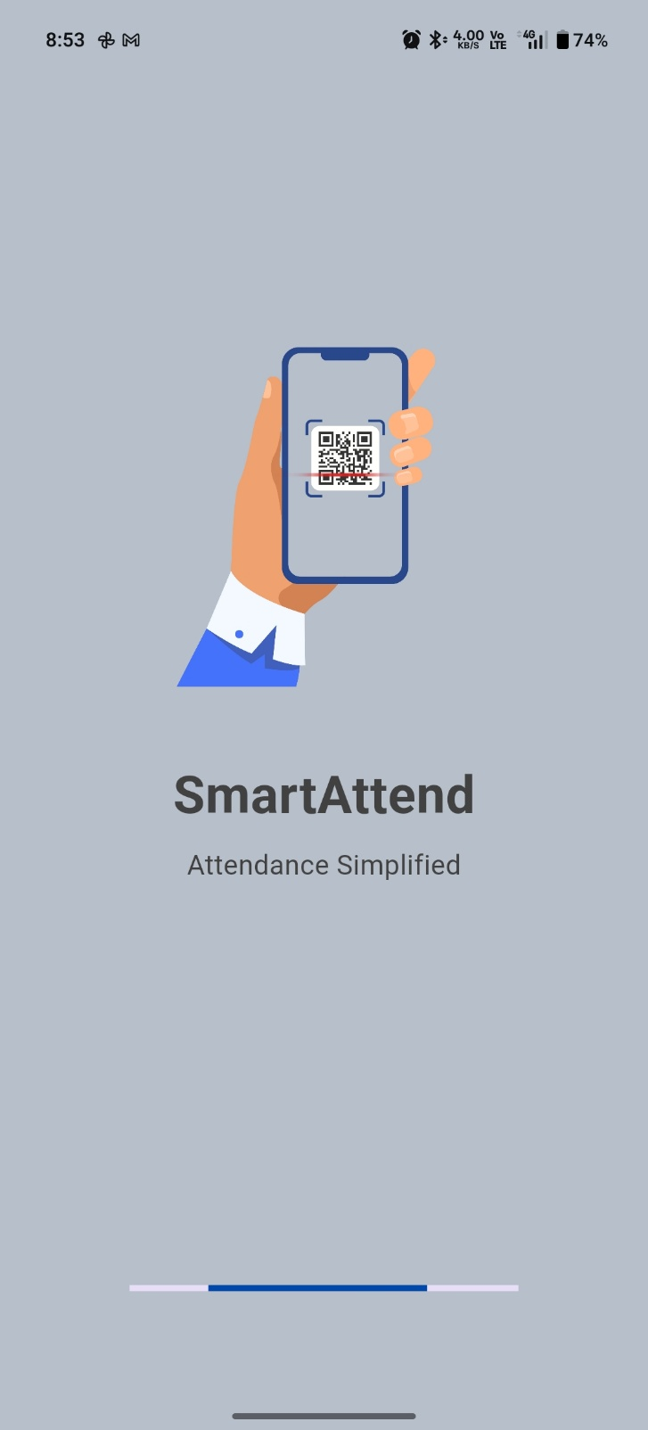 | 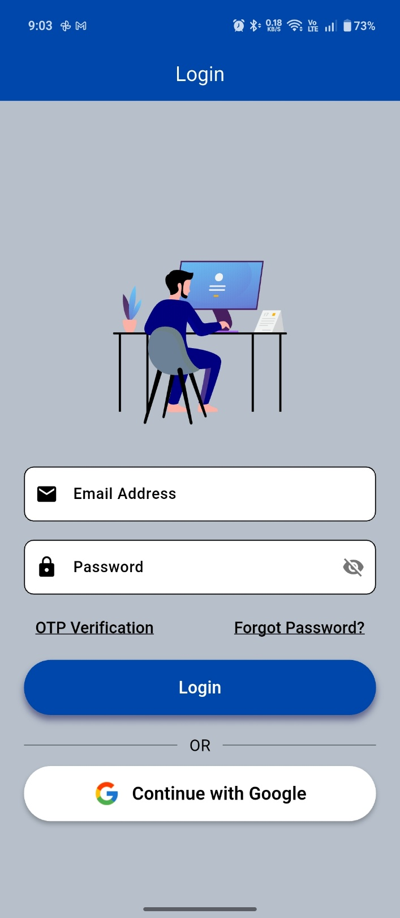

ADMIN Screens

Dashboard screen | Service Provider screen
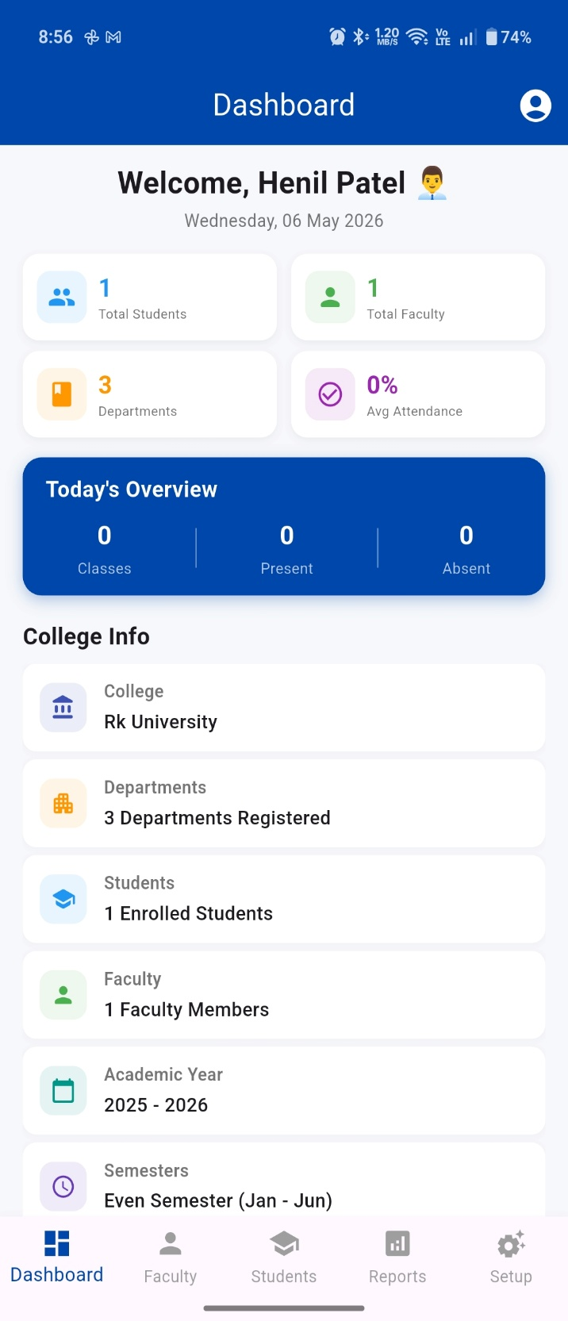 | 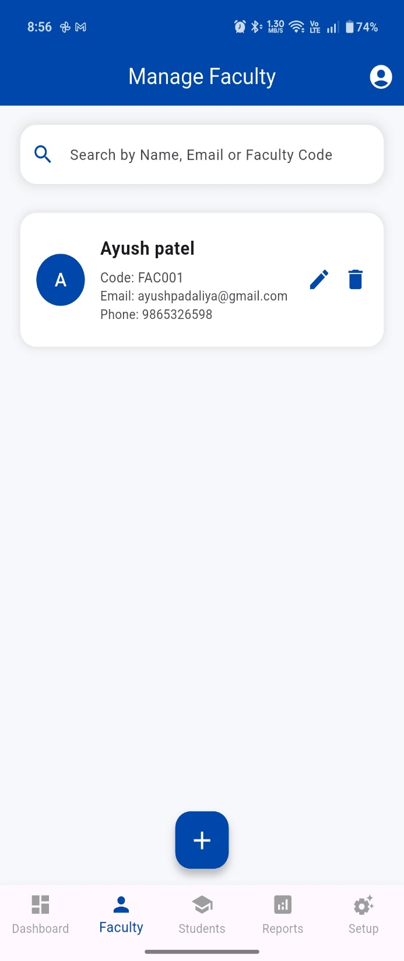

ADMIN Screens

Add provider screen | Customer screen
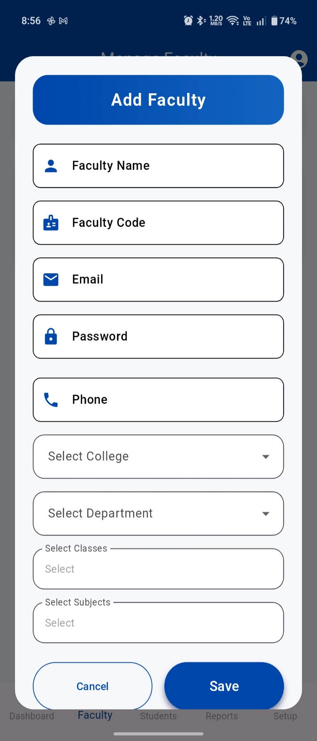 | 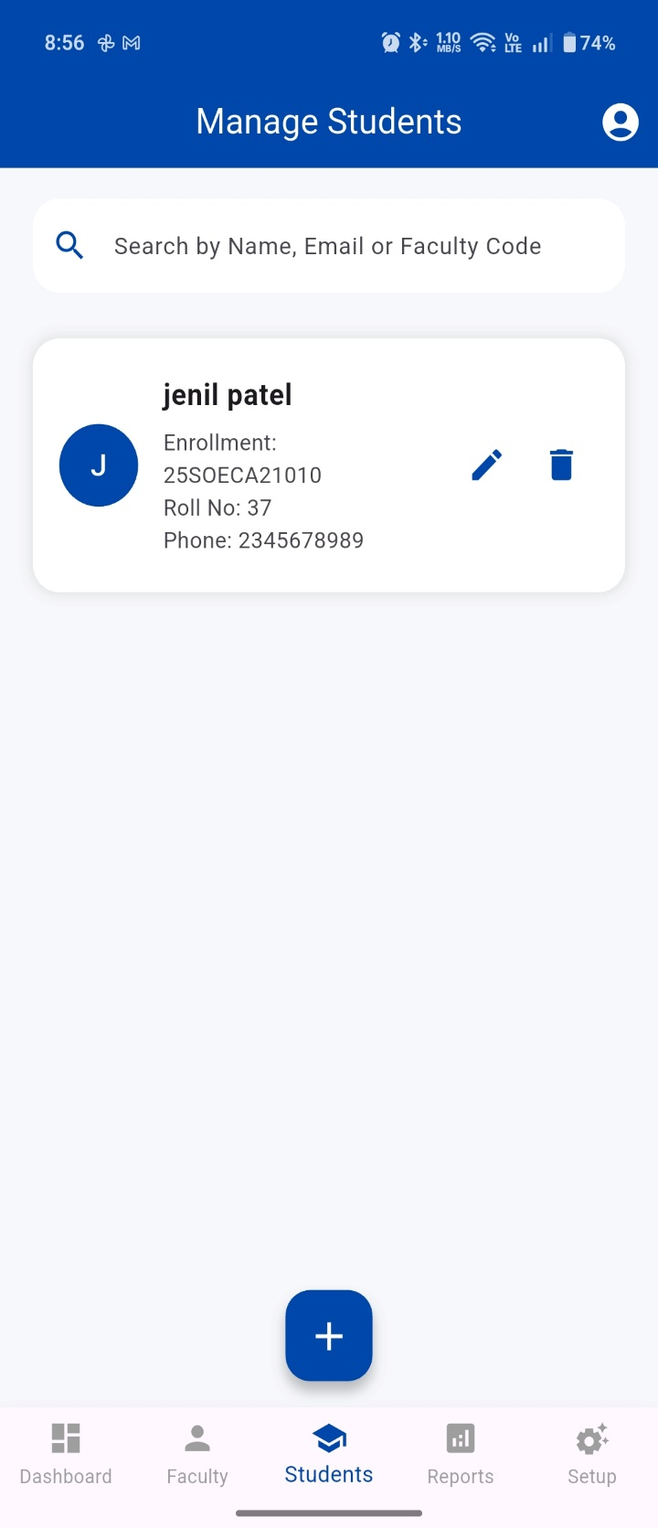

ADMIN Screens

Add student screen | Reports screen
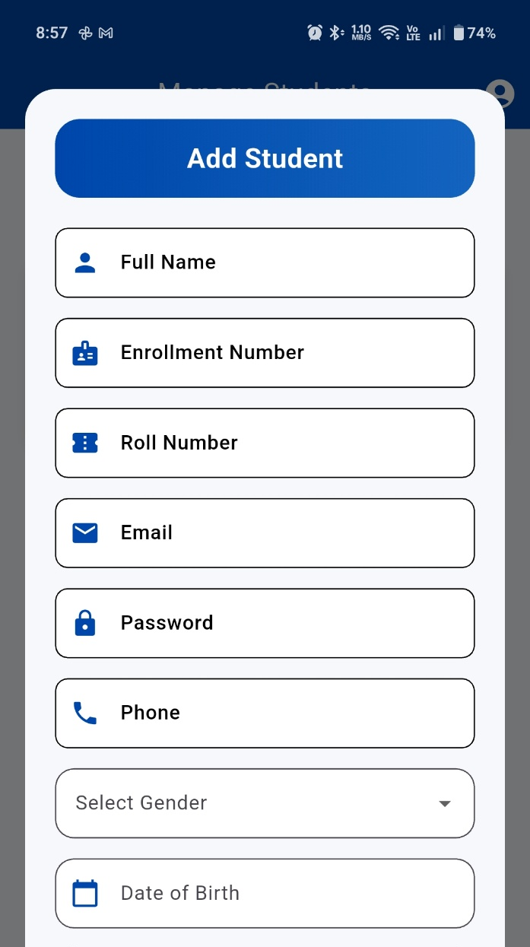  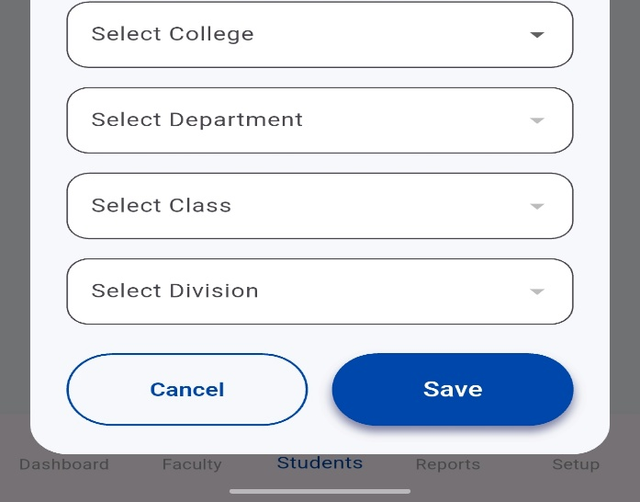 | 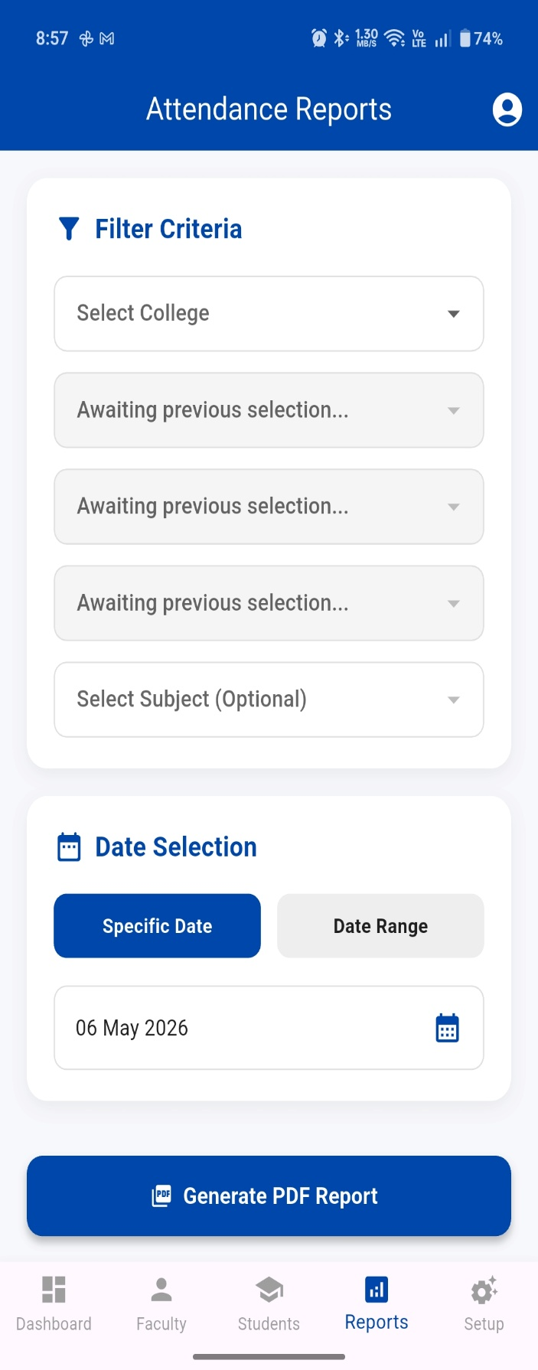

ADMIN Screens

setup screen | Profile page
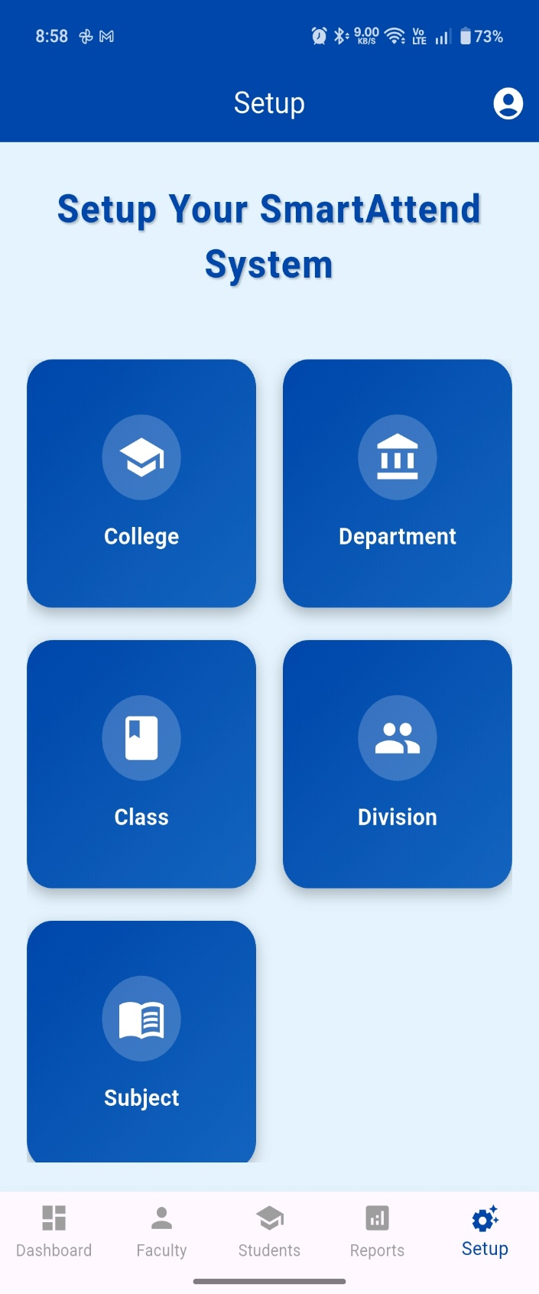 | 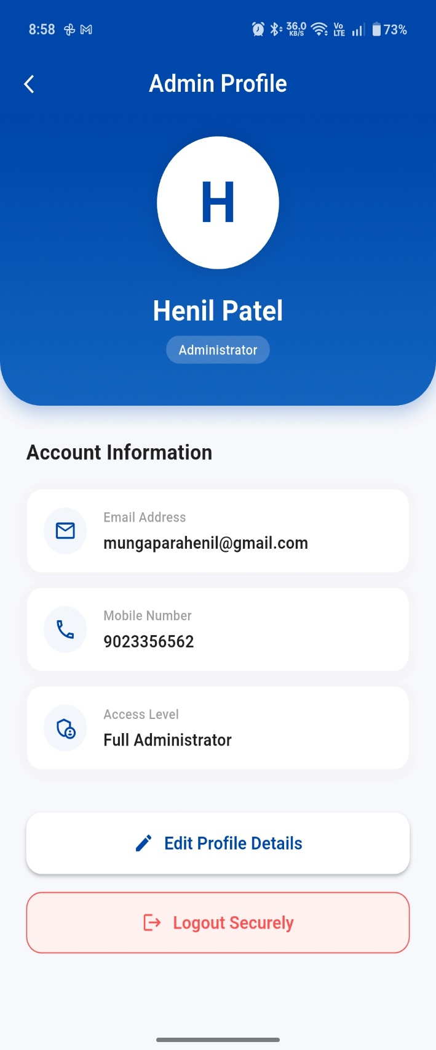

FACULTY Screens

Dashboard screen | Profile screen
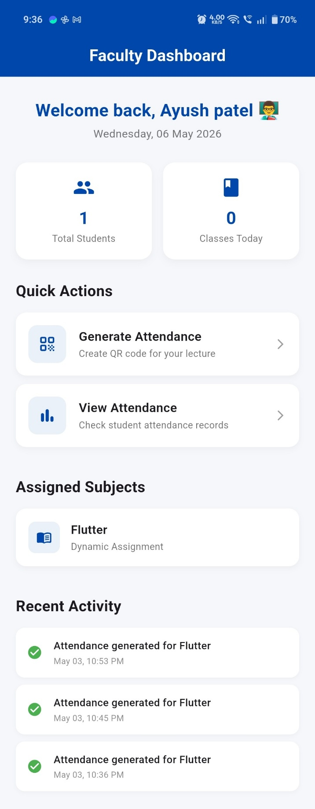 | 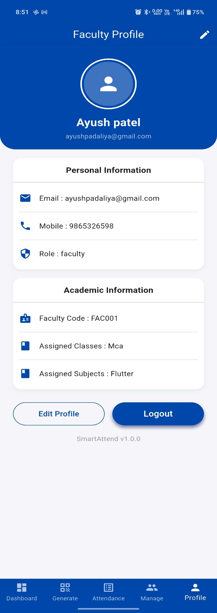

FACULTY Screens

QR screen | Generate QR screen
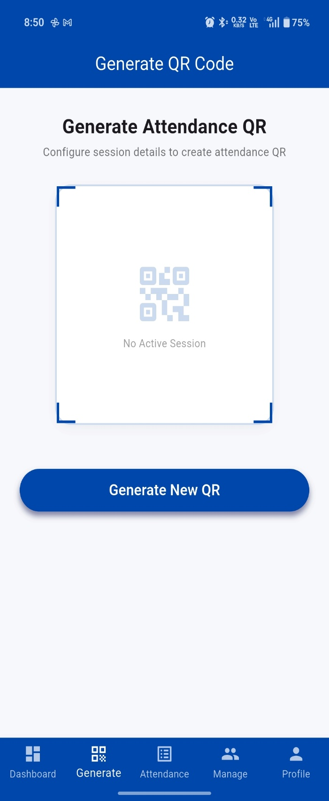 | 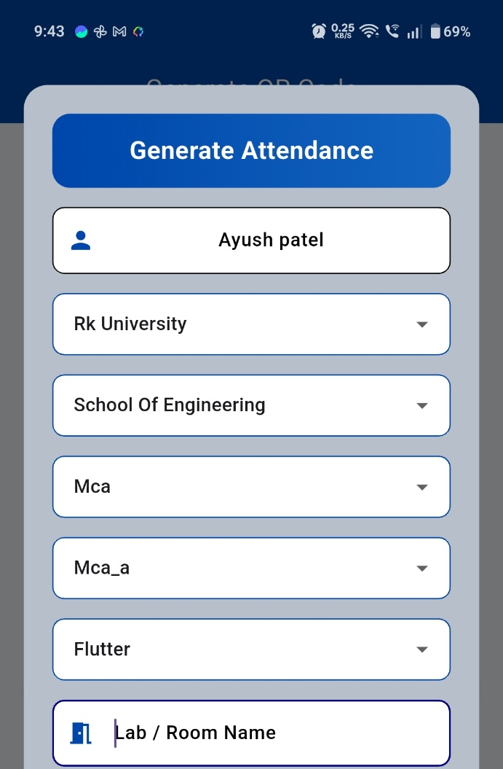  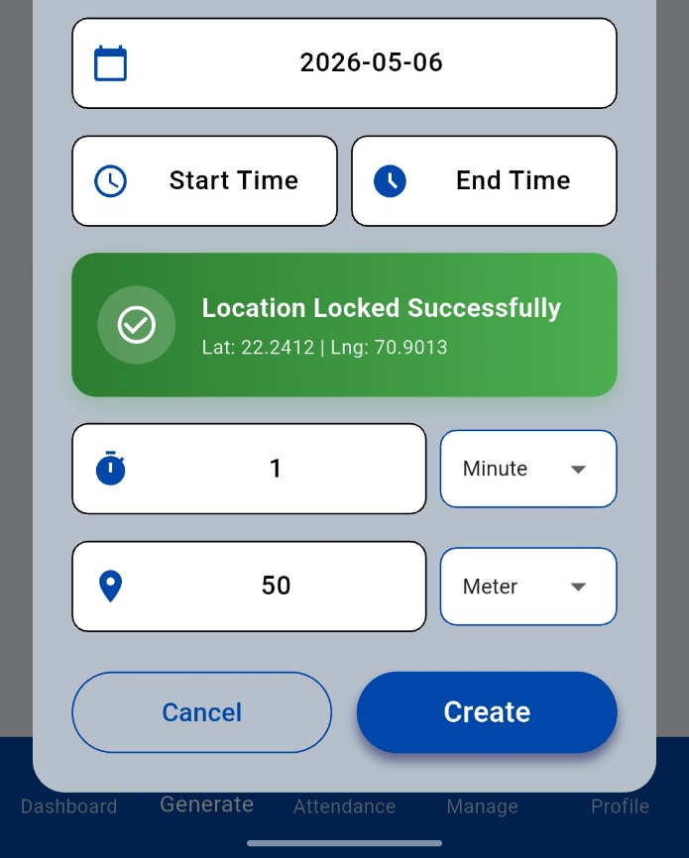  0

FACULTY Screens

Report screen | Manage student screen
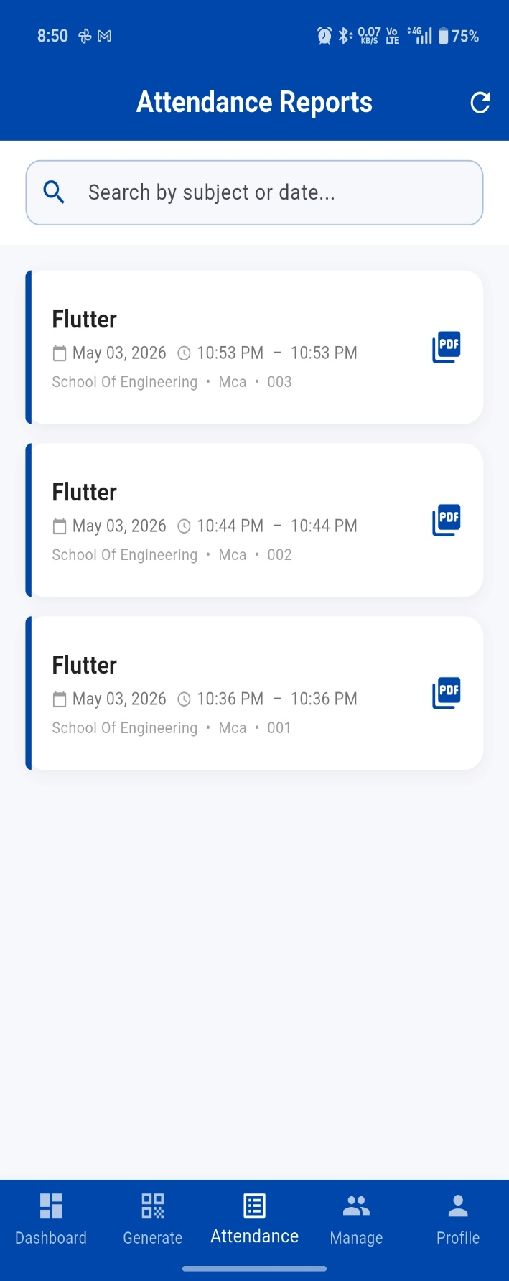 | 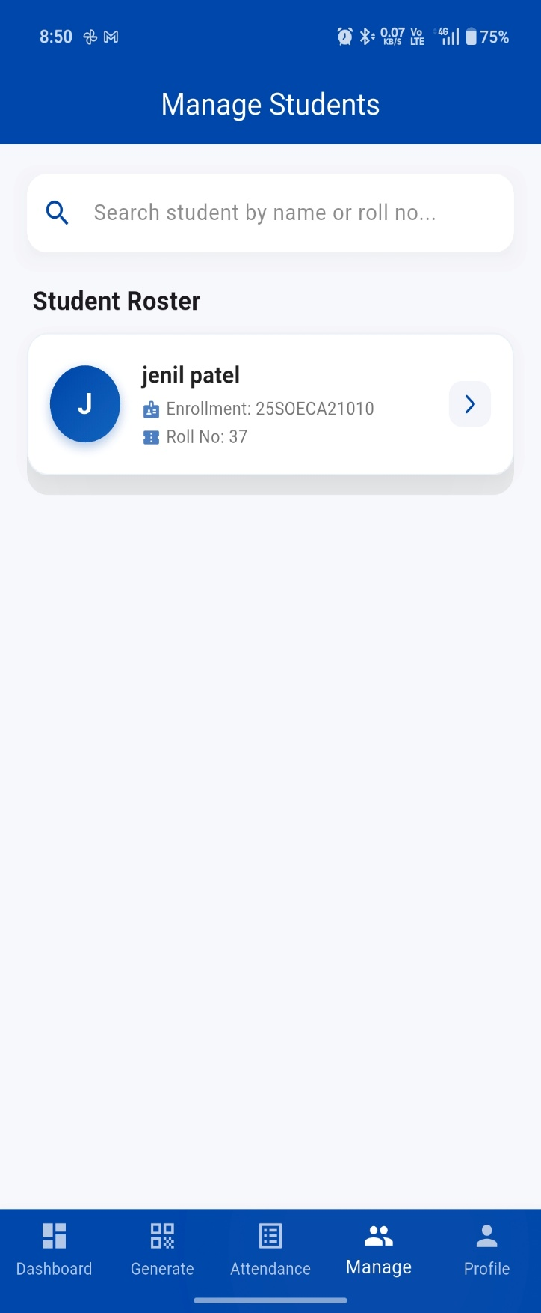

STUDENT Screens

Dashboard screen | Profile screen
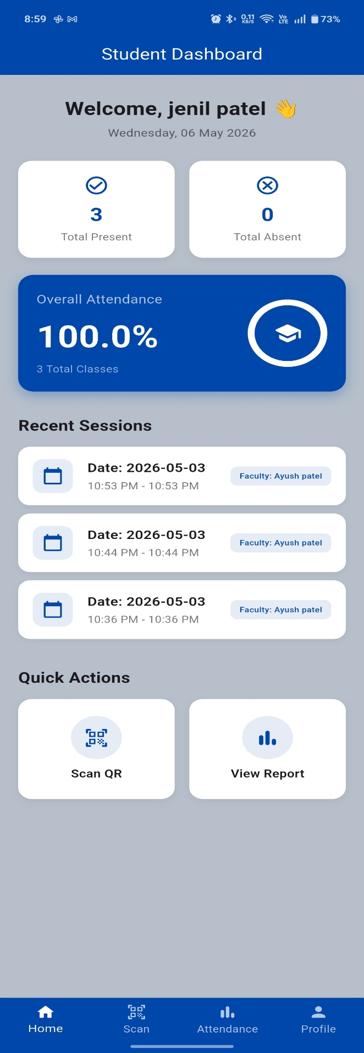 | 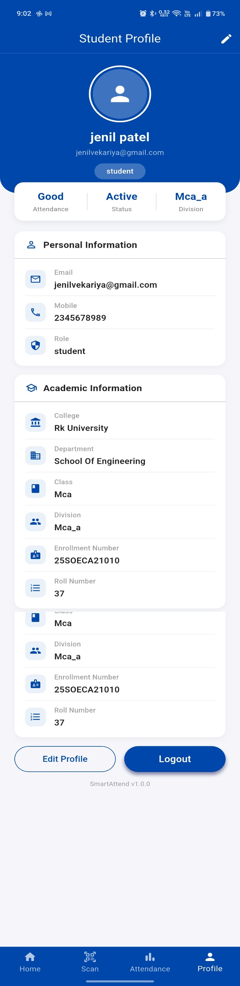  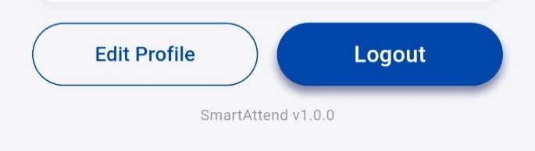  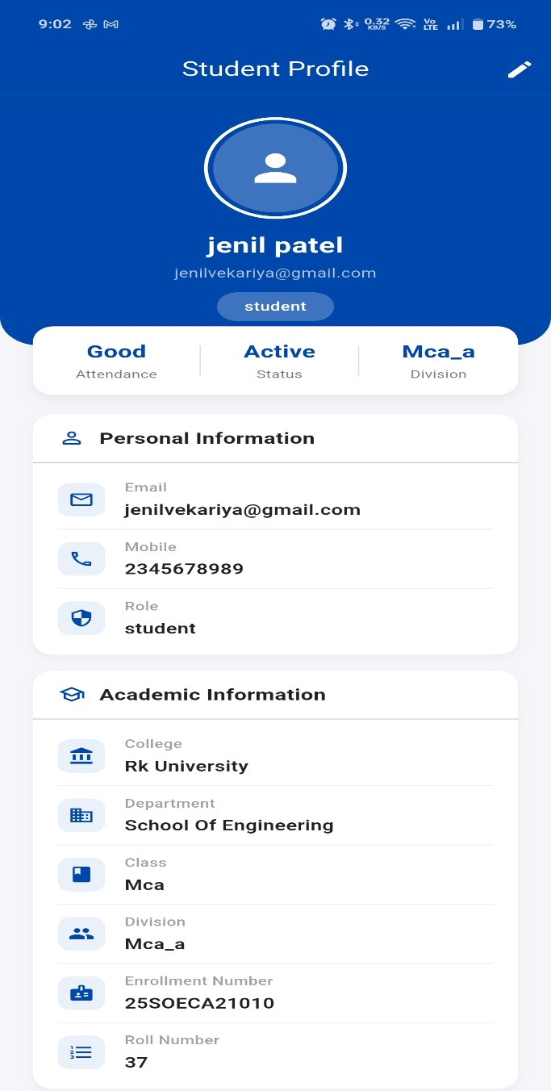

FACULTY Screens

Scan QR screen | Attendance screen
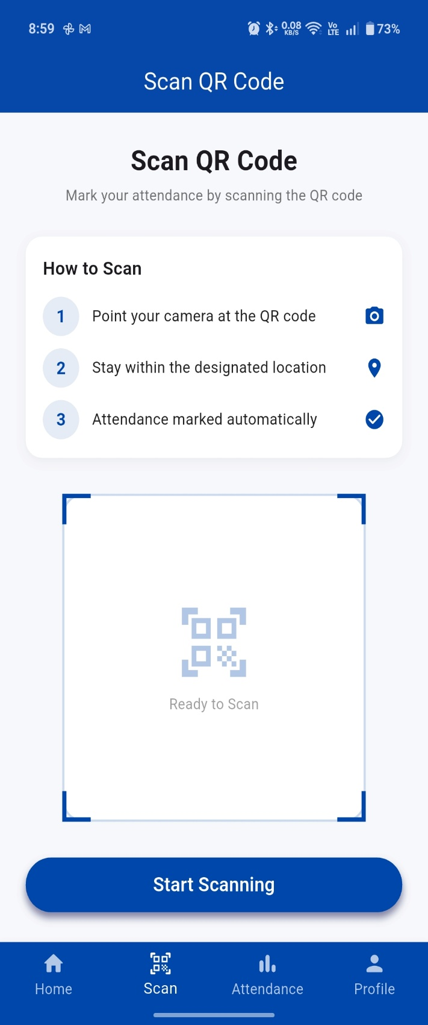 | 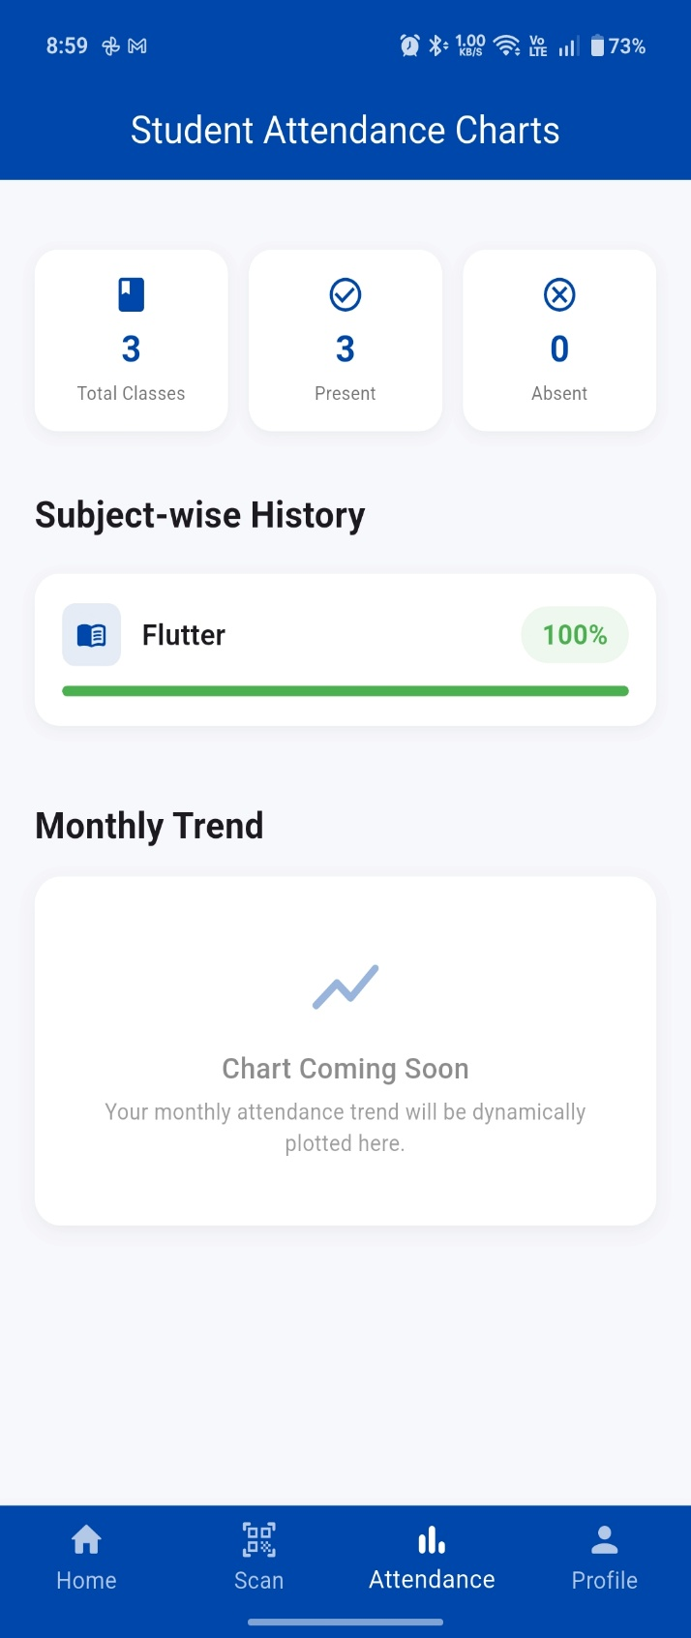

LIMITATION AND FUTURE ENHANCEMENT

Limitations
- Requires a stable internet connection for real-time attendance using Firebase.
- No offline attendance marking feature available.
- Lacks real-time notifications for attendance updates.

Future Enhancements
- Integration of Face Recognition Technology for more secure attendance.
- Implementation of real-time notifications for attendance updates.
- Enhanced security features to prevent proxy attendance.
- Integration with college management systems for better efficiency.

CONCLUSION AND DISCUSSION

The WorkBridge system successfully provides a modern and efficient solution for attendance management in educational institutions. By replacing traditional and semi-manual methods, the system introduces a QR Code-based attendance mechanism that ensures accuracy, reduces time consumption, and minimizes human errors.

The use of technologies such as Flutter, Dart, and Firebase enables the system to deliver a fast, secure, and user-friendly experience. The application supports multiple users including Admin, Faculty, and Students, each with specific roles and functionalities. Features like QR Code Generation, QR Scanning, and Real-time Attendance Tracking make the system highly effective and reliable.

From a discussion perspective, the WorkBridge system addresses many limitations of existing attendance systems by providing automation, transparency, and centralized data management. It improves efficiency for faculty members and offers students easy access to their attendance records. The system also demonstrates scalability, allowing future enhancements such as advanced analytics, notifications, and improved security features.

In conclusion, WorkBridge is a practical and scalable solution that enhances the overall attendance management process. With further improvements and feature additions, it has the potential to become a complete and intelligent attendance management system for modern educational institutions.

10 REFERENCES

1. Flutter – Official Documentation
https://flutter.dev/
Flutter documentation was used to understand mobile app development, UI design, and widget implementation. It helped in building the frontend of the WorkBridge system efficiently.

2. Firebase – Backend Services Documentation
https://firebase.google.com/
Firebase was referred for implementing authentication, real-time database, and cloud storage. It played a key role in managing data and backend operations of the WorkBridge system.

3. Dart Programming Language
https://dart.dev/
Dart documentation was used to understand programming concepts, syntax, and application logic used in developing the WorkBridge system.

4. GitHub – Code Reference Platform
https://github.com/
GitHub was used for exploring sample projects, code structures, and implementation ideas related to Flutter and Firebase.

5. YouTube – Learning Resources
Various YouTube tutorials were referred to learn Flutter development, Firebase integration, and QR code implementation for the WorkBridge system.

