Q-1. What are the benefits of using CSS ?
ANS : the following benefit of using CSS are :-
1. Separation of Contant and Style
One of the most significcant advantages of CSS is its ability to separate content from presentation. this separation enhances the maintainability of web pages as changes to the styling can be made without altering the underlying HTML structure. This also promotes a cleaner,more organized codebase.
2. Consistency
CSS enables consistent styling across an entire website or multiple pages. this is one of the many advantages of using CSS. By creating a single external CSS file and linking it to muliple web pages, you ensure a uniform look and feel . This reduces redundancy and makes it easier to update styling element globally.
3. Faster Loading Times
External CSS files can be cached by web browsers,allowing them to load faster on subsequent visits. This results in a better user experience,especially for returning visitors.
4. Responsive design
With CSS,you can create responsive web designs that adapt to different screen sizes and devices. this is Crucial in the era of mobile browsing . as it ensures your website looks and functions well on various platforms.
5. Ease of Maintenance
Modifiying the appearance of a website is more straightforward with CSS. You can quickly make changes to fonts, colors, and layout by updating a few lines of code in the CSS file,rather than manually editing each HTML element.
6. Accessibility
CSS allows developers to improve web accessibility by controlling the presentation of content.properly structured CSS can make a website more accessible to individules with disabilities.
7.CSS Minification and Page Load Efficiency
Minimizing CSS file sizes leads to quicker page load times,essentinal for retaining visitors and delivering a seamless browsing experience.
8. Global Styling
External CSS files can be linked to multiple web pages, making it easy to apply consistent styling across an entire website. this saves time and ensures acohesive design.
9. Cascade,Inheritance, and Class/ID Usage
CSS empowers you to create versatile design through cascading styles,inheritance,and precise class/ID usage, allowing for efficient styling and layout control.
10. Animatons and Effects
CSS allows for animations and transitions,enhancing the user experience. You can create interactive elements without relying on JavaScript or other scripting languages.

Q-2. What are the disadvantages of CSS?
ANS :
1. Browser Compatibility
CSS may render differently in various web browsers. leading to inconsistencies in the visual presentation. Developers often need to write browser-specific CSS code or use vendor prefixes to ensure compatibility.
2. Learing Curve
One among the main disadvantages of cascading style sheets is that while it is essential for web development, it can be complex, especially for beginners. Mastering CSS requires understanding selectors,properties ,values,and the box model, which can be overwhelming.
3. Lack of Security
CSS itself not offer security features, and it can be cautious when implementing CSS to prevent security risks.
4. Limited Layout Control
CSS has limitations when it comes to controlling complex layout. Achieving specific layouts, such as equal-height columns, can be challenging without resorting to workrounds or additional technologies like Flexbox or Grid.
5. performance impact
Extensive or poorly optimized CSS files can slow down page load times. It's essential to minimize and optimize CSS to maintain optimal website performance.
6. Overriding styles
The "cascading" nature of CSS can sometimes lead to unexpected styling conflicts. Specificity and the order in which styles are applied can result in unintended consequences.
7.Maintenance Challenges
As website grow and evolve, maintaining and refactoring CSS can become complex and time-consuming. It's crucial to follow best practices and use naming conventions to keep styles manageable.
While there are advantages to using inline CSS,such as the ability to apply unique sytles to individual elements directly within the HTML, It's essential to strike a balance and consider the trade-offs in terms of code maintainability and efficiency. However, it's equally important to recognize the disadvantages of inline CSS,which can clutter your HTML code, make updates less efficient, and hinder the overall readability and maintainablility of your web pages.

Q-3. What is the difference between CSS2 and CSS3 ?
ANS :
S.NO | CSS | CSS3
1. | CSS splits up different sections of the code into modules | Both CSS and HTML were put into a single file, there was no concept of modules before.
2. | Responsive designing is not supported in CSS | CSS3 is the latest version, hence it supports responsive design.
3. | There are new ways you can write CSS rules with a bunch of CSS | there were no new ways of writing the CSS rules.
4. | Using CSS, we cannot build 3D animation and transformation. | But in CSS3 we can perform all kinds of animation and transformations as it supports animation and 3D transformations.
5. | CSS is very slow as compared to CSS3 | Whereas CSS3 is faster than CSS.
6. | In CSS we have set of standard colours and it uses basic colour schemes only. | Whereas CSS3 has a good collection of HSL RGBA, HSLA, and gradient colours.
7. | there is no backward compatibility with CSS2. | There is backward compatibility maintained with CSS 3
8. | CSS does not support media queries. | But CSS3 supports media queries
9. | CSS codes are not supported by all types of modern browsers. | Being the latest version, CSS3 codes are supported by all modern browsers.
10. | With CSS2 the concept of simple selectors were present | With CSS3 the selectors were called as asequence of simple selectors.com

Q-4. Name a few CSS style components
ANS :
<style>
.cls{
background-color: brown;
color: aqua;
font-size:35px;
font-family: italic;
font-wight:150px;
}
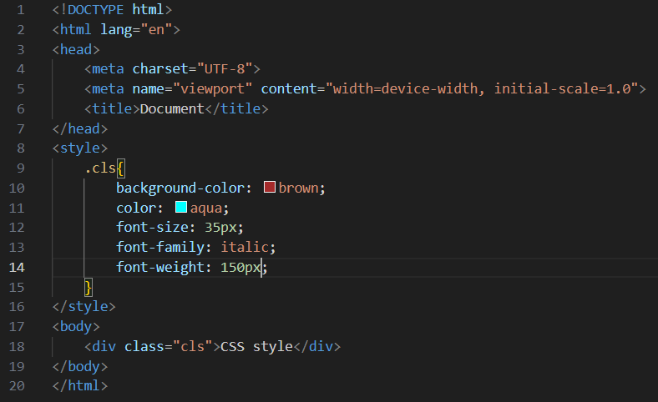

Q-5. What do you understand by CSS opacity ?
ANS :
The CSS opacity property is used to specify the transparency of an element, In simple word, you can say that it specifies the clarity of the image. In rechnical terms,Opacity is defined as degree in which light is allowed to travel through an object.
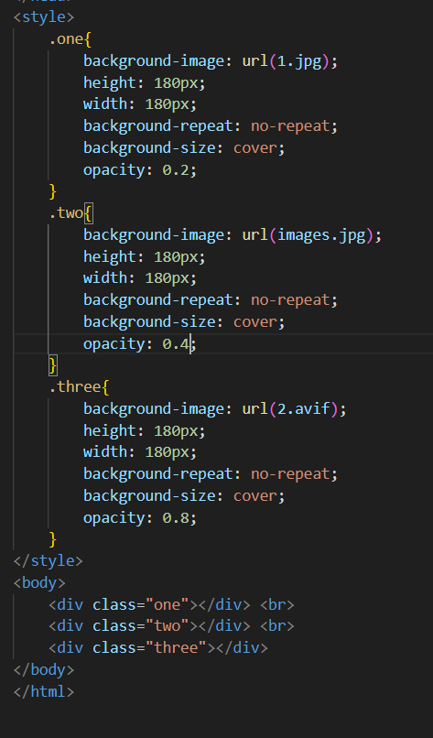
OUTPUT :-
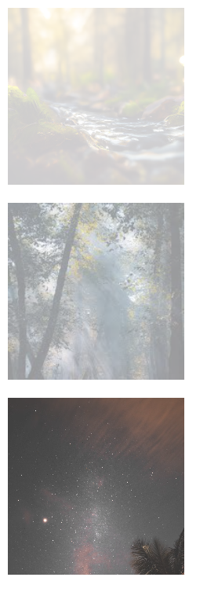

Q-6. How can the background color of an element be change ?
ANS :
To add background color in HTML, use the CSS background-color property. set it to the color name or code you want and place it inside a style attribute..
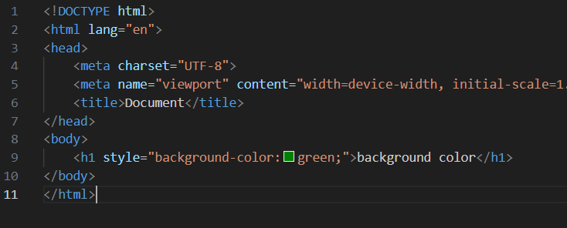


Q-7. How can image repetition of the backup be controlled ?
ANS :
Using the background-repeat property that will help us to control the repetition of the image. The background-repeat property in CSS is used to repeat the background image both horizontally and vertically.
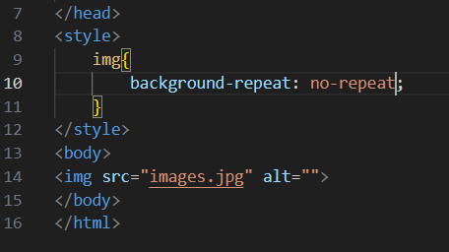
Q-8. What is the use of the background-position property ?
ANS :
- background-position: left top; this property is used to set the image at the left top.
- background-position: left center; this property is used to set the image at the left center.
- background-position: left bottom; this property is used to set the image at the left bottom.
- background-position: center top; this property is used to set the image at the center top position.
- background-position: center center; this property is used to set the image at the center center position.
- background-position: center bottom; this property is used to set the image at the center bottom position.
- background-position: right top; this property is used to set the image at the right top position.
- background-position: right center; this property is used to set the image at the right center position.
- background-position: right bottom; this property is used to set the image at the right bottom position.
- background-position: 25% 75%; this property is used to set the image at 25% from the left and 75% from the top.
- Note :For x%y% notation ,here x% denotes the horizontal position & y% denotes the vertical position with respect to the initial position i.e, left top.
- background-position : 30px 80px ; this property is used to set the image at the 30px from left and 80px from top.
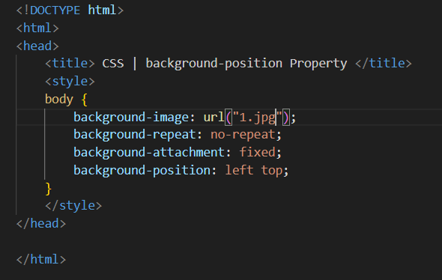

Q-9. Which property control the image scroll in the background ?
ANS :
the background-attachment property sets whether a background image scrolls with the rest of the page, or is fixed.
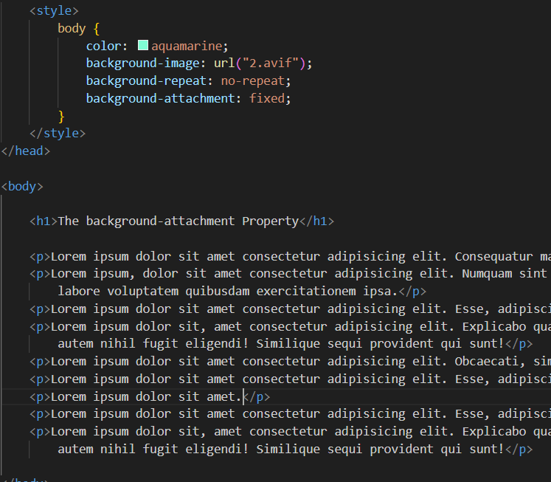

Q-10. Why should background and color be used as separate properties ?
ANS :
The color property in CSS is used to set the color of text, the background of the webpage, and also to set the color of borders, and the CSS background properties are used to add background effects for element.
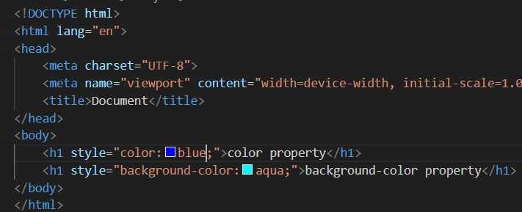
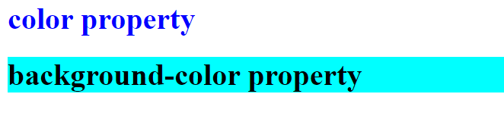

Q-11. How to center block elements using CSS1 ?
ANS :
We have seen that how tihs block element behaves. the text-align property is used to set the horizontal alignment of a text. Aterxt can be left or right aligned ,or justified .
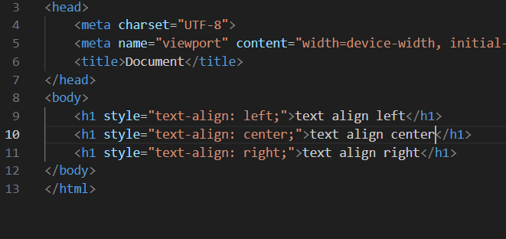
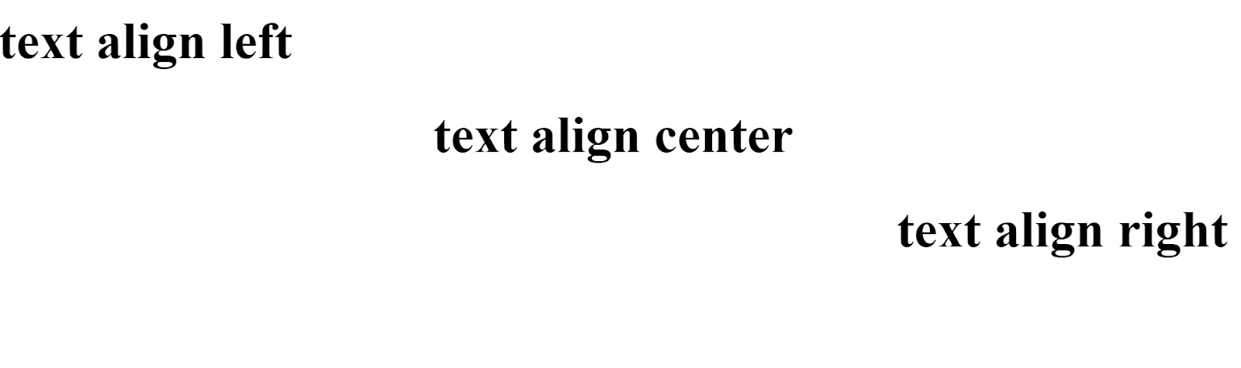

Q-12. How to maintain the CSS specifications ?
ANS :
The CSS specification are maintained by the World Wide Web Consortium (W3C) the maintain the css specifiaction by using internal,inline,external selector,pseudo calss and element..
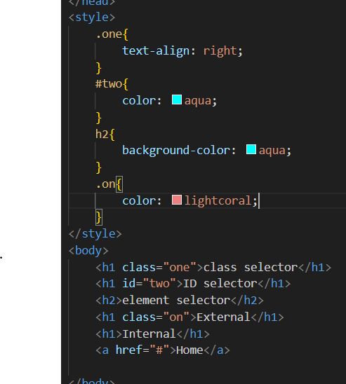

Q-13. What are the ways to integrated CSS as a web page ?

ANS :

1. Inline CSS : The inline styles will only affect the HTML element to which the style attribute with CSS-property values is applied. The first paragraph in the example below will be styled in red with a 20px font size. The properties apply just to the first line of the code, not the full code.

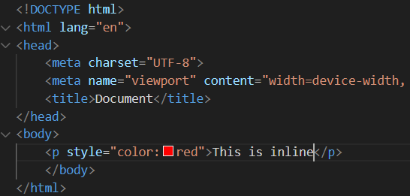

2. internal CSS : Internal CSS is one of the most popular CSS forms for updating, customizing, and modifying a single web page's unique styles. You can use the internal CSS by integrating the <style> element in the <head> section of a HTML web page.

Internal CSS can be used to style a single web page, but not multiple web pages, and we can style numerous web pages with the same code.

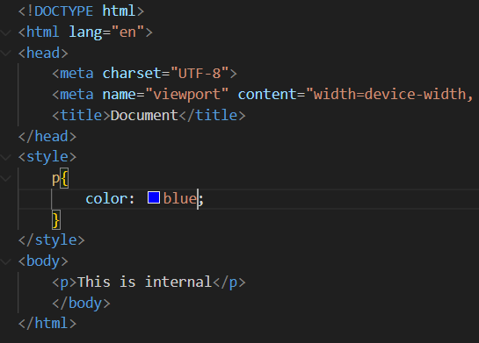

3. external CSS : External CSS is one of the most often used CSS forms for updating, styling, and adjusting the different styles in a large number of HTML web pages at the same time. There are two ways to include an external style sheet in an HTML document. One method is to use the <link> tag in the HTML document head. Another option is to use a combination of external CSS functions and integrated CSS.

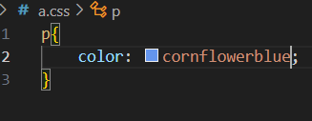

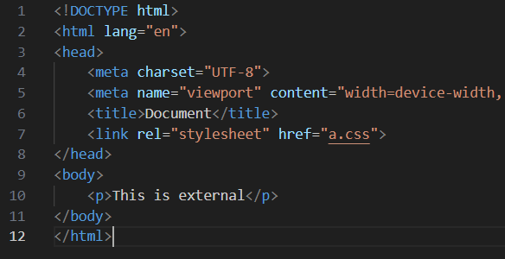

Q-14. What is embedded style sheets ?

ANS :

It allows you to define styles for a particular HTML document as a whole in one place. this is done by embedding the <style></style> tags containing the CSS properties in the head of your document. Embedded style sheets are particularly useful for HTML document that have unique style requirements from the rest of the document in your project.

However,if the styles need to be applied across multiple document. you should link to an external style sheet instead of using individual embedded style sheets. Using embedded stylesheets holds a distinct advantage over inline styles which only allow you to address one HTML element at a time.

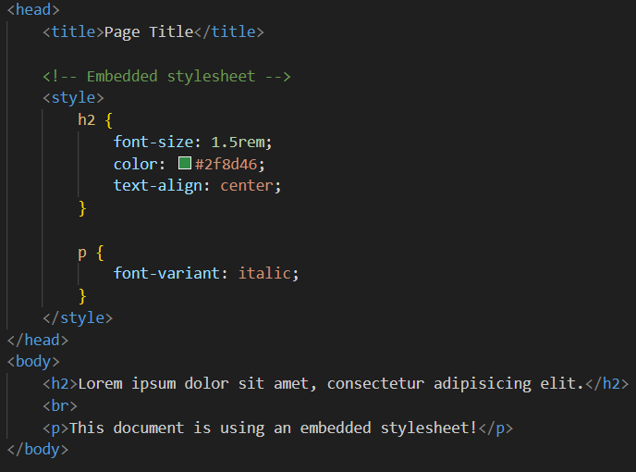

Q-15. What are the external style sheets ?
ANS :
An external style sheet is a separate CSS file that can be accessed by creating a link within the head section of the webpage. Multiple webpages can use the same link to access the stylesheet. the link to an external style sheet is placed within the head section of the page.

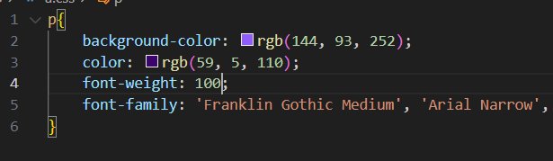
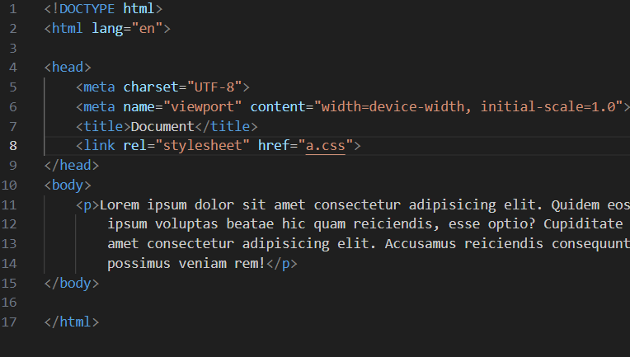

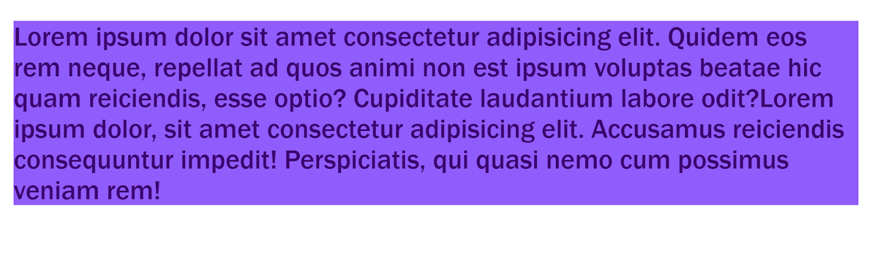

Q-16. What are the advantages and disadvantages of using external style sheets ?
ANS :
Advantages of External stylesheet :
- With the help of external style sheets, the styles of numerous documents can be organized from one single file.
- In external style sheets, Classes can be made for use on numerous HTML element style in many forms of the site.
- In complex contexts, Methods like selectoer and grouping can be implemented to apply styles.
Disadvantages of External stylesheet :
- An extra download is essential to import style information for each file.
- The execution of the file may be deferred till the external style sheet is loaded.
- While implementing style sheets. we need to test web pages with multiple browsere in order to check compatibility issues.

Q-17. What is the meaning of the CSS selector?
ANS :
CSS selectors are used to "find" (or select) the HTML element you want to style. we can divide CSS selectors into five categories : simple selectors (select elements based on name ,id ,class) Combinator selector( select element based on a specific relationship between them)
- Simple selector : it is used to select the HTML element based on their element name, id, attributes, etc.
- Element Selector
- ID selecotr
- Class selector
- Group Selector :
- Universal selector
- Attribute selector
- Pseudo-class selector
- Pseudo-element selector

Q-18. What are the media types allowed by CSS ?
ANS :
Media Types | Description
all | Default media types, used for all devices
screen | Devices with screens,such as desktops,laptops,phone,and more
print | Styles are applied when the document is printed
speech | For devices used in speech synthesis and screen reading
projection | Devices like projectors,and presentation screens
tv | Specific for TV screens

Q-19. What is the rule set?
ANS :
A CSS rule set contains one or more selectors and one or more declarations. The selector(s),which in this example in h1,points to an HTML element. The declaration(s),which in this example are color:blue and text-align: center style the element with a property and value.
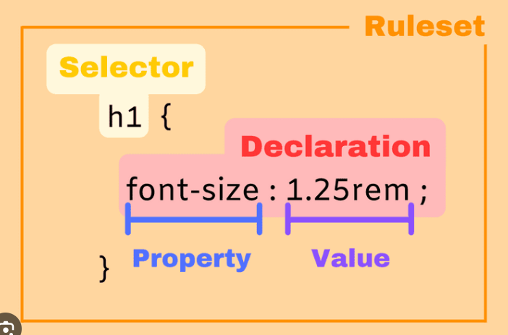

Q-20. Create Layouts
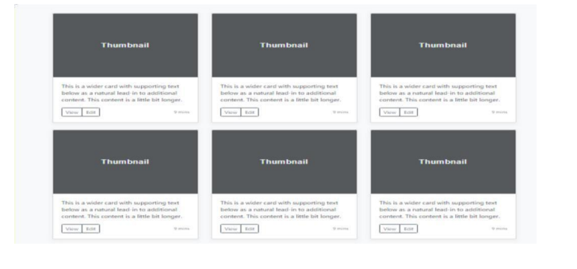
ANS :
CODE :
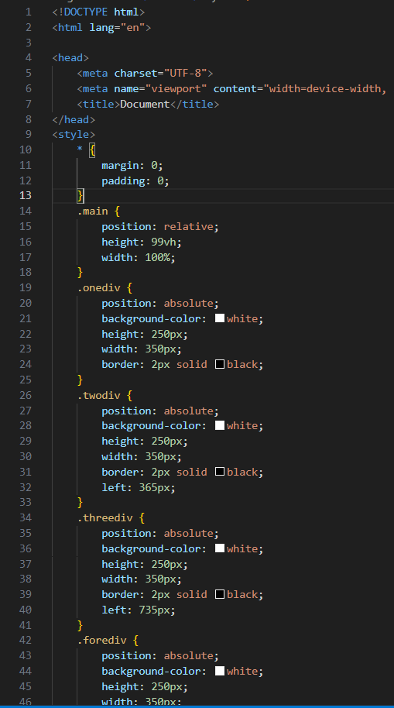
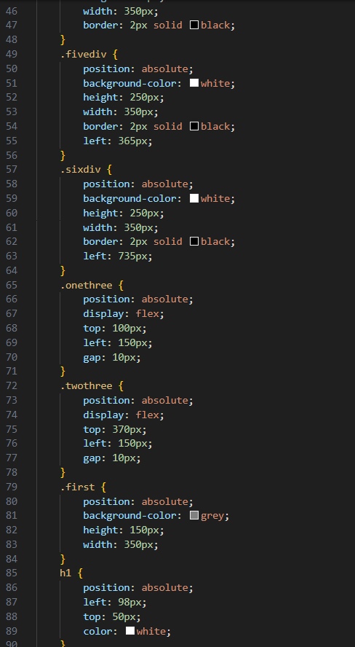
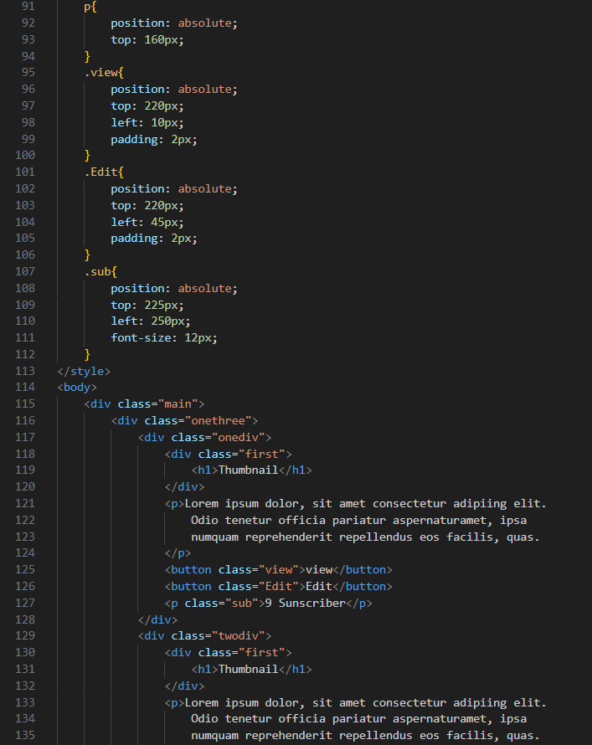
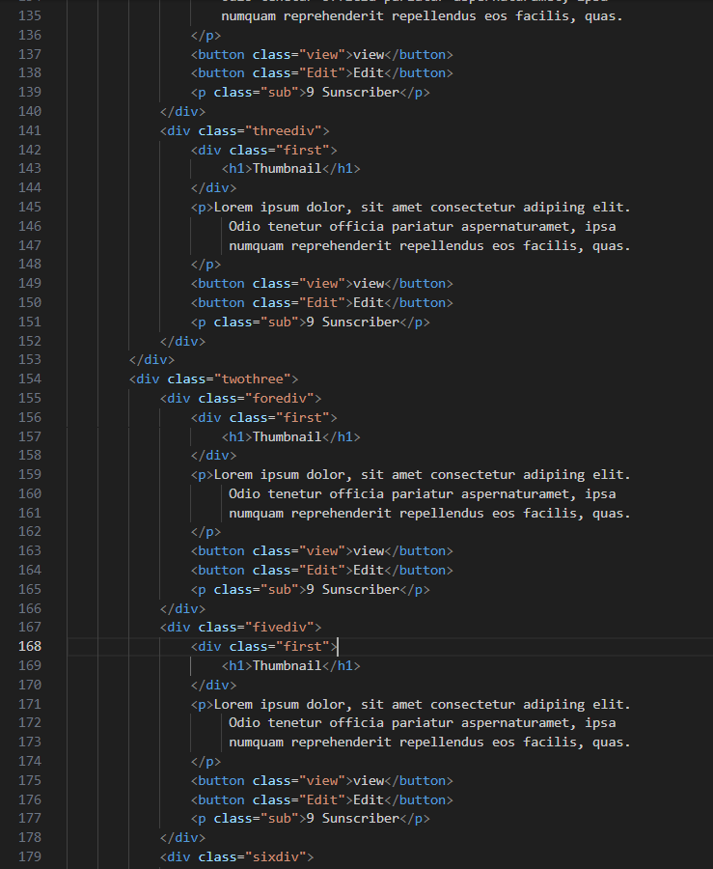
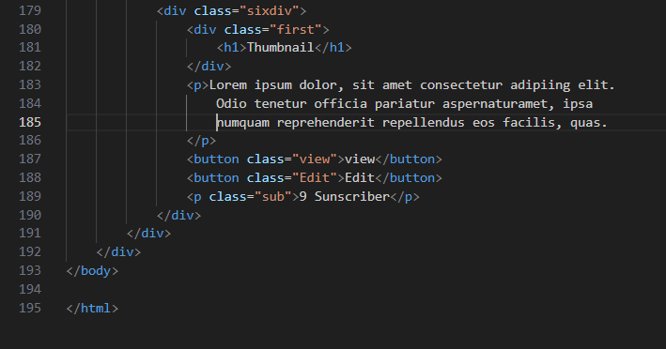

OUT PUT :

