Q1- what are the new tags added in HTML5?

ANS :

1<article> : the article tag is used to represent an article. more specifically ,the content within the article tag is independent of the other content of the site.

2<canvas> : the canvas tag is HTML is used to draw graphics on a web pade using javascript. it can be used draw paths, texts, image and gradients.

3<details> : the details tag is used for the content/information which is initially hidden but colud be displayed if the user wishes to see it close.the content of the details tag is visible when opening the set attributes.

4<section> : the section tag defines the section of documents such as chapters,headers,footers and any other section .the main advantage of the section tag is , it is a semantic element, which describes its meaning to both browser and developer. the section tag used when requiretments of two headers or footers or any other section of documents are needed.

5<time> : the time tag is used to display the human-readable date/time . it also be used to encode dates in a machine-redable from. the main advantage for users is that they can offer to add birthday reminders or scheduled events in their calender's and search engines can produce smarter search results.

6<audio> : the audio tag is used to insert an audio into an HTML webpage.

7<video> : the video tag is used to embed video content in a documnet , such as a movie clip or other video stream.

8<embed> : the embed tag in HTML is used for embedding external applications which are generally mutimedia content like audio or video into an HTML document. it is used as a container for embedding plug-in such as flash animations. this tag is a new tag in HTML5 and it requires only starting tag.

9<progress> : it is used to represent the progress of a task. it is also defined how much work is done and how much is left to download a thing . it is not used represent the disk space or relevant query.

10<mark> : the mark tag in HTML is used to define the marked text . it is used to highlight the path of text in a paragraph. the mark tag is new in HTML5.

Q2- How toembed audio and vedio in a webpage?

ANS :

embed audio : -

to embed audio in HTML , we use the audio tag.before HTML5, audio cannot be added to web pages in the internal explore . to play audio ,we used web pluging like flash. after the release of HTML5. it is possible . this tag supports chrome, firefox ,safari, opera and edge in three audio formats - MP3,WAV,OGG. only safari browser doesn't support OGG audio format.  
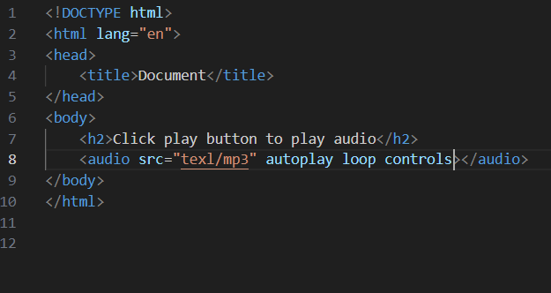

Video :-

the HTML5 video element tells the browser to load a video files from another source by specifying the video file's location, similar to the way a browser loads an image file. the image itself is not stored in the HTML file the browser pulls it from somewhere else.

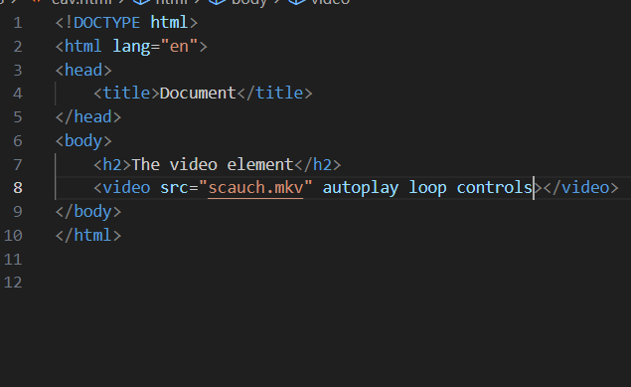

Q3- Semantic element in HTML5?

ANS :

A semantic element clearly describes its meaning to both the browser and the developer.

* <article>
* <aside>
* <deatila>
* <figcaption>
* <figure>
* <footer>
* <header>
* <main>
* <nav>
* <section>
* <summary>
* <time>

Q4-Canvas and SVG tags

ANS :

<canvas> tag :

the canvas element is used for drawing graphics,animations and other visual element using javascript it provides a bitmap drawing surface where javascript can be used for shapes,images and manipulation pixels directly.

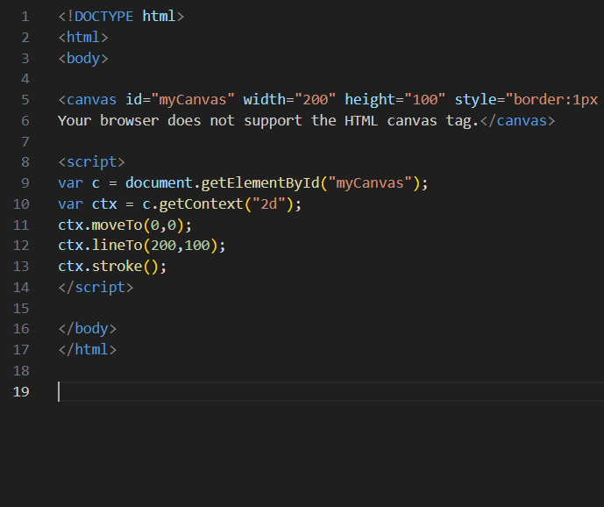

<SVG> tag :

the svg tag defines a container for SVG graphics. SVG has several methods for drawing paths,boxes,circles,text and graphic images.

