**Q1. Are the HTML tags and elements the same thing ?**

**ANS :- HTML tags and HTML element are not same thing**

**Because HTML tags are building block of html page. HTML**

**Element are components that are used in html page.**

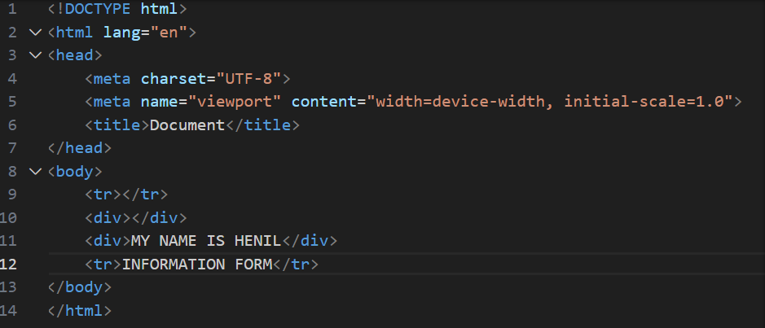

**<tr></tr> and <div></div> that are a tags.**

**Eg:-<tr></tr>**

**<div></div>**

**We can write in tags that called elements**

**Eg:-<div>MY NAME IS HENIL</div>**

**<tr>INFORMATION FORM</tr>**

**Q2. What are the tags and Attributes in HTML ?**

**ANS: -HTML tags are used in work starting or closing.**

**TAG: -**

**HTML tags are what defines where an HTML element starts and where it ends. There is usually an opening bracket followed by the element’s. name and, finally, closing bracket.**

**<title>, <p>, <b>**

**ATTRIBUTS: -**

**In simple words, an HTML attribute is what modifies an HTML element. It is usually in the form of unique words that one inserts inside the opening tag.**

**<element attribute=** **"value">element content</element>**

**This are HTML Tags**

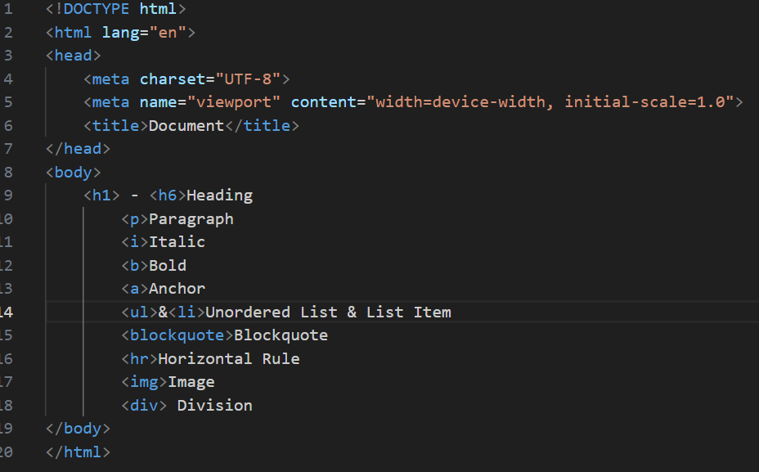

**This is HTML Elements**

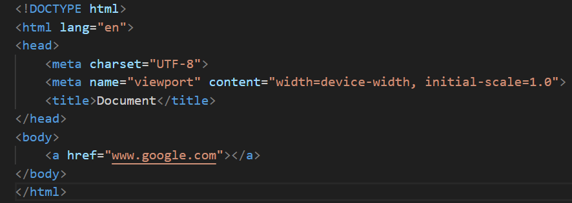

**Q3. What are void element in HTML? With example.**

**ANS: - An element that has only opening tag they have not**

**Closing tag that called void element.**

**<img>tag and <br> tag. that tag is only start the tag are not an end so that are avoid element.**

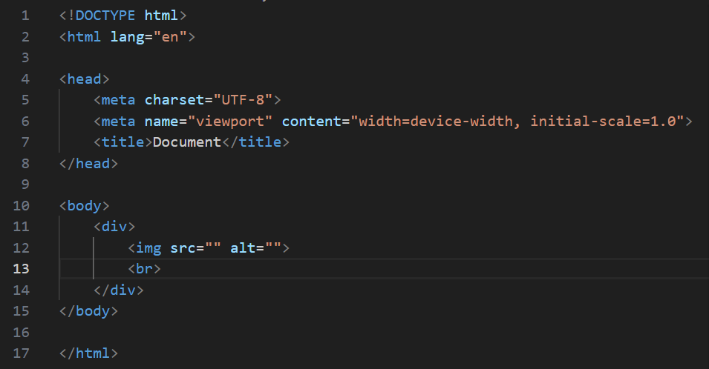

**Q4 What are the HTML entities? With example.**

**ANS: - AN HTML entity is used to display invisible characters and reserved characters that would otherwise be interpreted as HTML code. It is a piece**

**Of text, or string, that begins with an ampersand (&) and ends with a**

**Semicolon (;).**

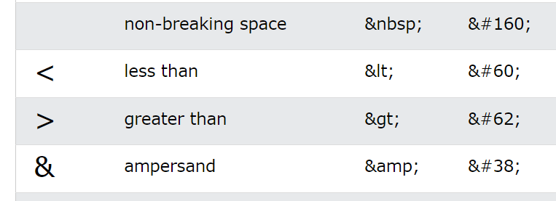

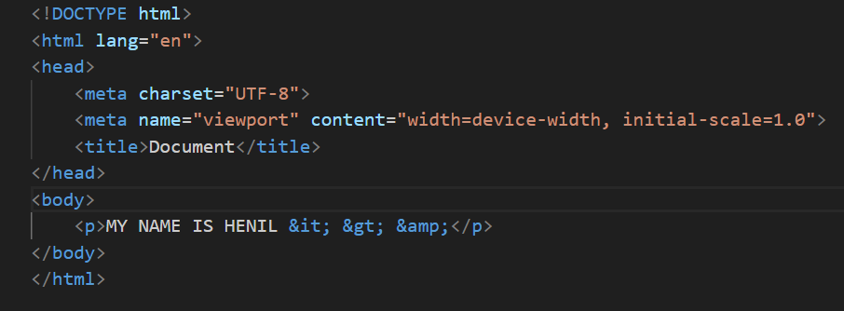

**Q5. What are the different types of lists in HTML? With example.**

**ANS: - There are mainly three types of list in html.**

1. **ORDER LIST 2. UNORDER LIST 3. DEFINE LIST**

**ORDER LIST: -** The <ol> tag defines an ordered list.

**1.one**

**2.two**

**3.three**

**4.four**

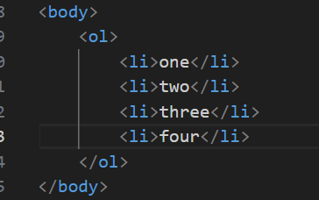

**UNORDER LIST: -** The <ul> tag defines an unordered (bulleted) list.

* **One**
* **Two**
* **Three**

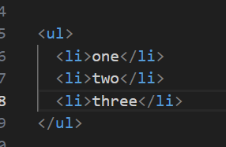

**DEFINE LIST:-**Define lists (dl) are used to group terms with their definitions.

Coffee

Black hot drink

Milk

White cold drink

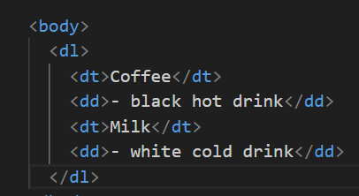

**Q6. What is the ‘class’ attribute in HTML? With example.**

**ANS: - Class attribute are variables of a class that are shared between all of its instances.**

**Use class attribute for storing class contents, track data across**

**All instances, and setting default values for all instances of the class.**

**EXAMPLE: -**

Header 1

A paragraph.

Lorem ipsum dolor sit amet.

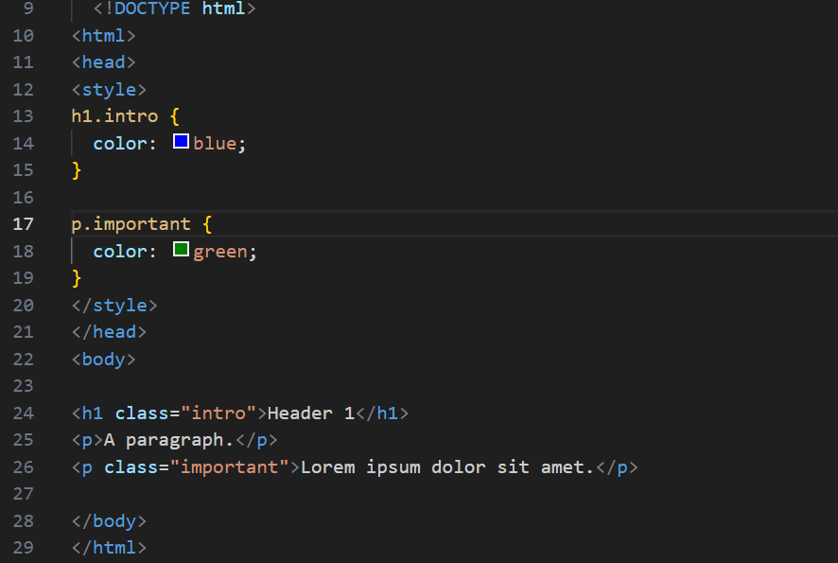

**Q7 What is the difference between “id” attribute and “class” attribute in HTML? With example.**

**ANS: - The only difference between them is that “id” is unique in a page**

**And can only apply to at most one element, while “class” selector can apply**

**To multiple elements.**

**While an id name must only be used by one HTML element within the page.**

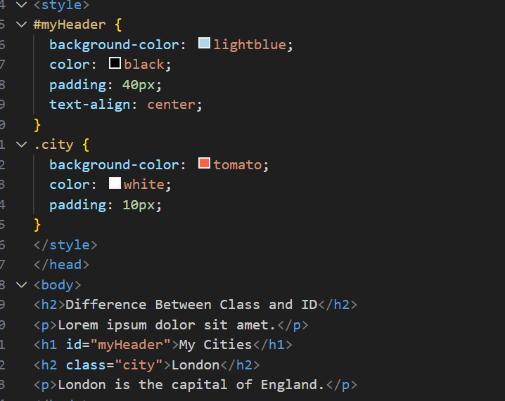

**Q8. What are the various formatting tags in HTML?**

**ANS: - HTML tags are the keywords that are used to produce web pages in various formats. Opening tags and closing tags are found in the majority of tags.**

**EXAMPLE: -**

* <B> - Bold text
* <strong> - Important text
* <I> - Italic text
* <em> - Emphasized text
* <mark> - Marked text
* <small> - Smaller text
* <del> - Deleted text
* <ins> - Inserted text
* <sub> - Subscript text
* <sup> - Superscript text

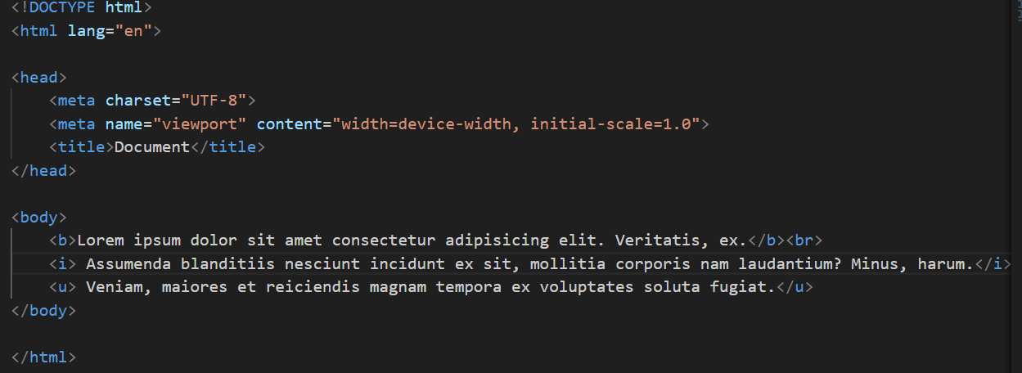

Lorem ipsum dolor sit amet consectetur adipisicing elit. Veritatis, ex.

*Assumenda blanditiis nesciunt incident ex sit, mollitia cororis nam laudantium? Minus, harum.*

**Veniam, maiores et reiciendis magnam tempoa ex voluptates solute fugiat.**

**Q9. How is cell padding different from cell spacing? with example.**

**ANS: -**

**Cell padding: - Cell padding defines the space between the content and border of the cell.**

**Cell spacing: -** The **HTML <table> cell spacing attribute** is used to specify the space between the cells. The cell spacing attribute is set in terms of pixels.

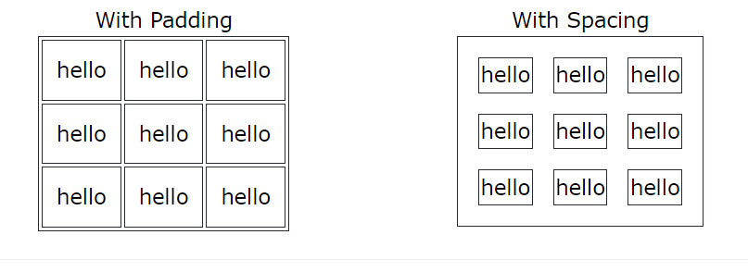

**Q10. How can we club two or more rows or columns into a single row or column an HTML table? With example.**

**AND: -With the help of rowspan we could club the columns and with the help of colspan we could club the row.**

**ROWSPAN: - the rowspan attribute HTML specifies the number of rows a cell should span.**

**COLSPAN: - the colspan attribute HTML specifies the number of columns a cell should span.**

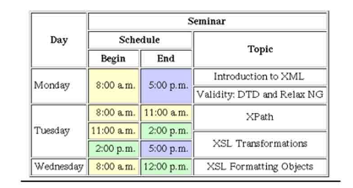

**Q11. What is the difference between block element and inline element?**

**ANS: -**

**BLOCK ELEMENT: -**

**Block element always start from a new line. Block element cover space from left to right as far as it can go.**

**INLINE ELEMNET: -**

**Inline element never start from a new line. Inline element only cover the space as bounded by the tags in the HTML element.**

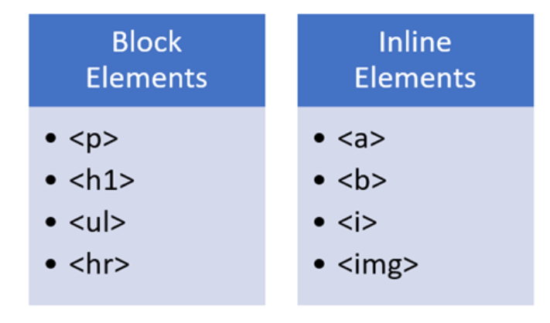

**Q12. How to create a hyperlink in HTML? With example.**

**ANS: - A hyperlink, also called a link or web link, contains an address for a destination and acts as a reference to data.**

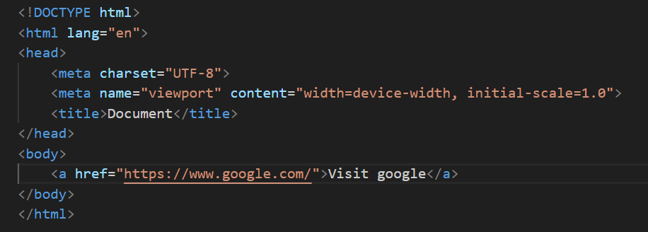

**Q13. What is the use of iframe tags in HTML? With example.**

**ANS: - The iframe in HTML stands for inline frame. The “iframe” tag**

**Defines a rectangular region within the document in which the browser can display a separate document, including scrollbars and borders.**

**<iframe scr=”**[**https://www.w3schools.com**](https://www.w3schools.com)**“ title=”w3school free online Web**

**Tutorials”></iframe>**

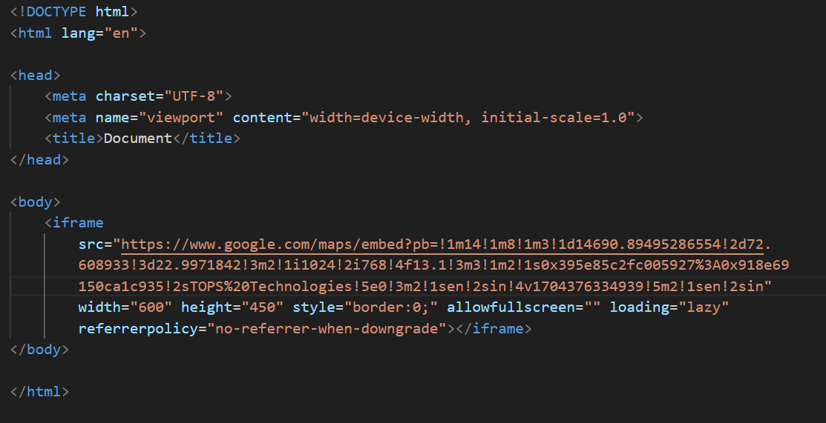

**Q14. What is the span tag? With example.**

**ANS:-The <span> tag is an inline container used to mark up a part of a**

**Text, or a part of a document.**

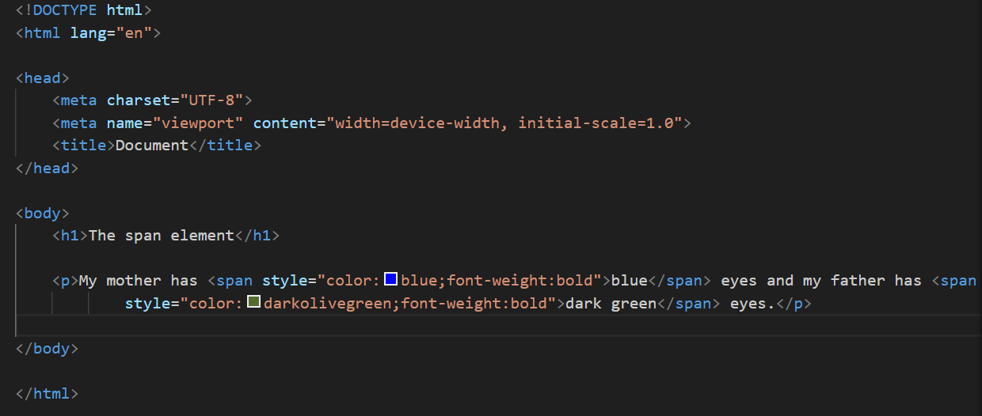

**Q15. How to insert a picture into a background image of web page?**

**with example.**

**ANS:-Use the background image in <div> tag and make a**

**New <div> tag in image tag.**

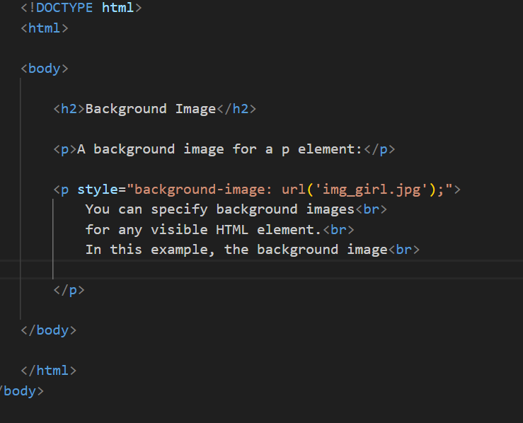

**Q16. How are active link different from normal links?**

**ANS: -Active link are currently functional and lead to live pages while normal link can refer to any link functional or broken.**

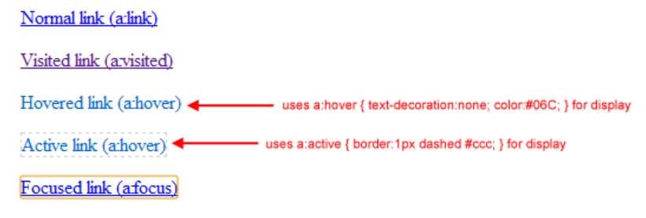

**Q17.What are the different tags to separate section of text?**

**ANS:- These all tags are using for separate a section**

1. **<br> tag-it used to separate the line of text. It breaks the current**

**Line and shifts the flow of the text to a new line.**

1. **<p> tag-this tag is used to write a paragraph of text.**
2. **<blockquote> tag-this tag is used to define larger quoted sections.**

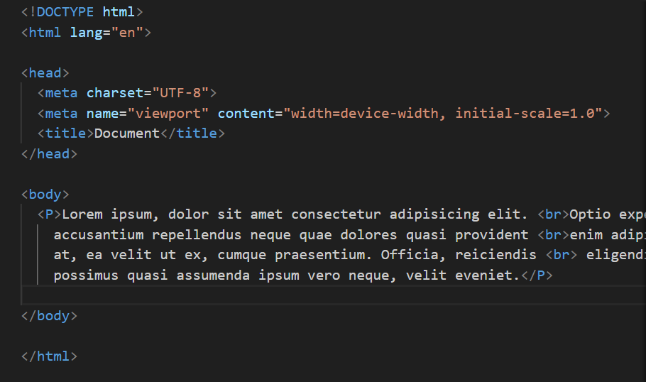

**Q18. What is svg?**

**ANS: -SVG is used to define vector-based graphics for the web**

**Every element and every attribute in SVG files can be animation.**

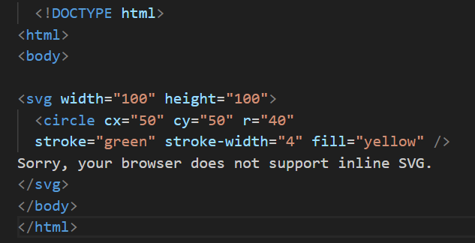

**SVG has some predefined shape elements that can be used by developers: Rectangle <rect> Circle <circle>Ellipse <ellipse> Line**

**<line>**

**Q19. What is difference between HTML and XHTML?**

**ANS: -The main difference between them is the syntax and structure:**

**HTML is more lenient in its syntax, while XHTML has a stricter syntax and follows XML rules.**

**XHTML is considered the successor to HTML, and its strict syntax makes it more suitable for future technologies and advancements.**

**HTML is SGML based, whereas XHTML is an XML-based language.**

**Q20. What are logical and physical tags in HTML?**

**ANS:-Logical tags are used to tell the browser what kind of text is written inside the tags. They are different from physical tags because physical tags are used to decide the appearance of the text and do not provide information about the text.**

**: physical tag: -these tags are used to provide the visual appearance to the text.**

**: Logical tag: -these tags are used to add some logical or semantic value to the text.**

