Use Case Overview for TwitterNethack  
Assignment in the course PA1415 Programvarudesign <2017-04-11>  
Author: Morgan Lexander, Henrik Nilsson, Magnus Nyqvist och Victor Olsson.

|  |  |  |  |
| --- | --- | --- | --- |
| Author Name | Social Security Number | Thinking | Writing |
| Morgan L. | 971107-xxxx | 25% | 25% |
| Henrik N. | 970416-xxxx | 25% | 25% |
| Magnus N. | 940429-xxxx | 25% | 25% |
| Victor O. | 970612-xxxx | 25% | 25% |

**System description**  
The system is going to be based around the classic game NetHack but in 2D graphics. NetHack is a sort of adventure and roleplaying game where you create a character and goes through random generated dungeons. In the dungeons you can meet various different monsters and collect items. The final goal is to find the amulet of Yendor and escape with it alive.

Nethack is a very advanced game and because of this and the limited time we are given, our version of NetHack is not going to include all of the features that the original have. The functionalities we are aiming to implement:

* An opening screen where you can start a new game or join an existing one.
* A screen where you can setup the character.
* Monsters and creatures that freely move around the dungeons.
* Different items to pick up and drop.
* Multiplayer support.
* Generate dungeons with help of twitter.

The dungeons in our NetHack version is going to be generated by the Twitter API. Its job is to read certain keywords in Twitter posts and use these to create specific types of monsters and items for every room in the game. When you enter a new cave, your system shall briefly display information about the “owner” of the cave.

**Use Case Diagram** 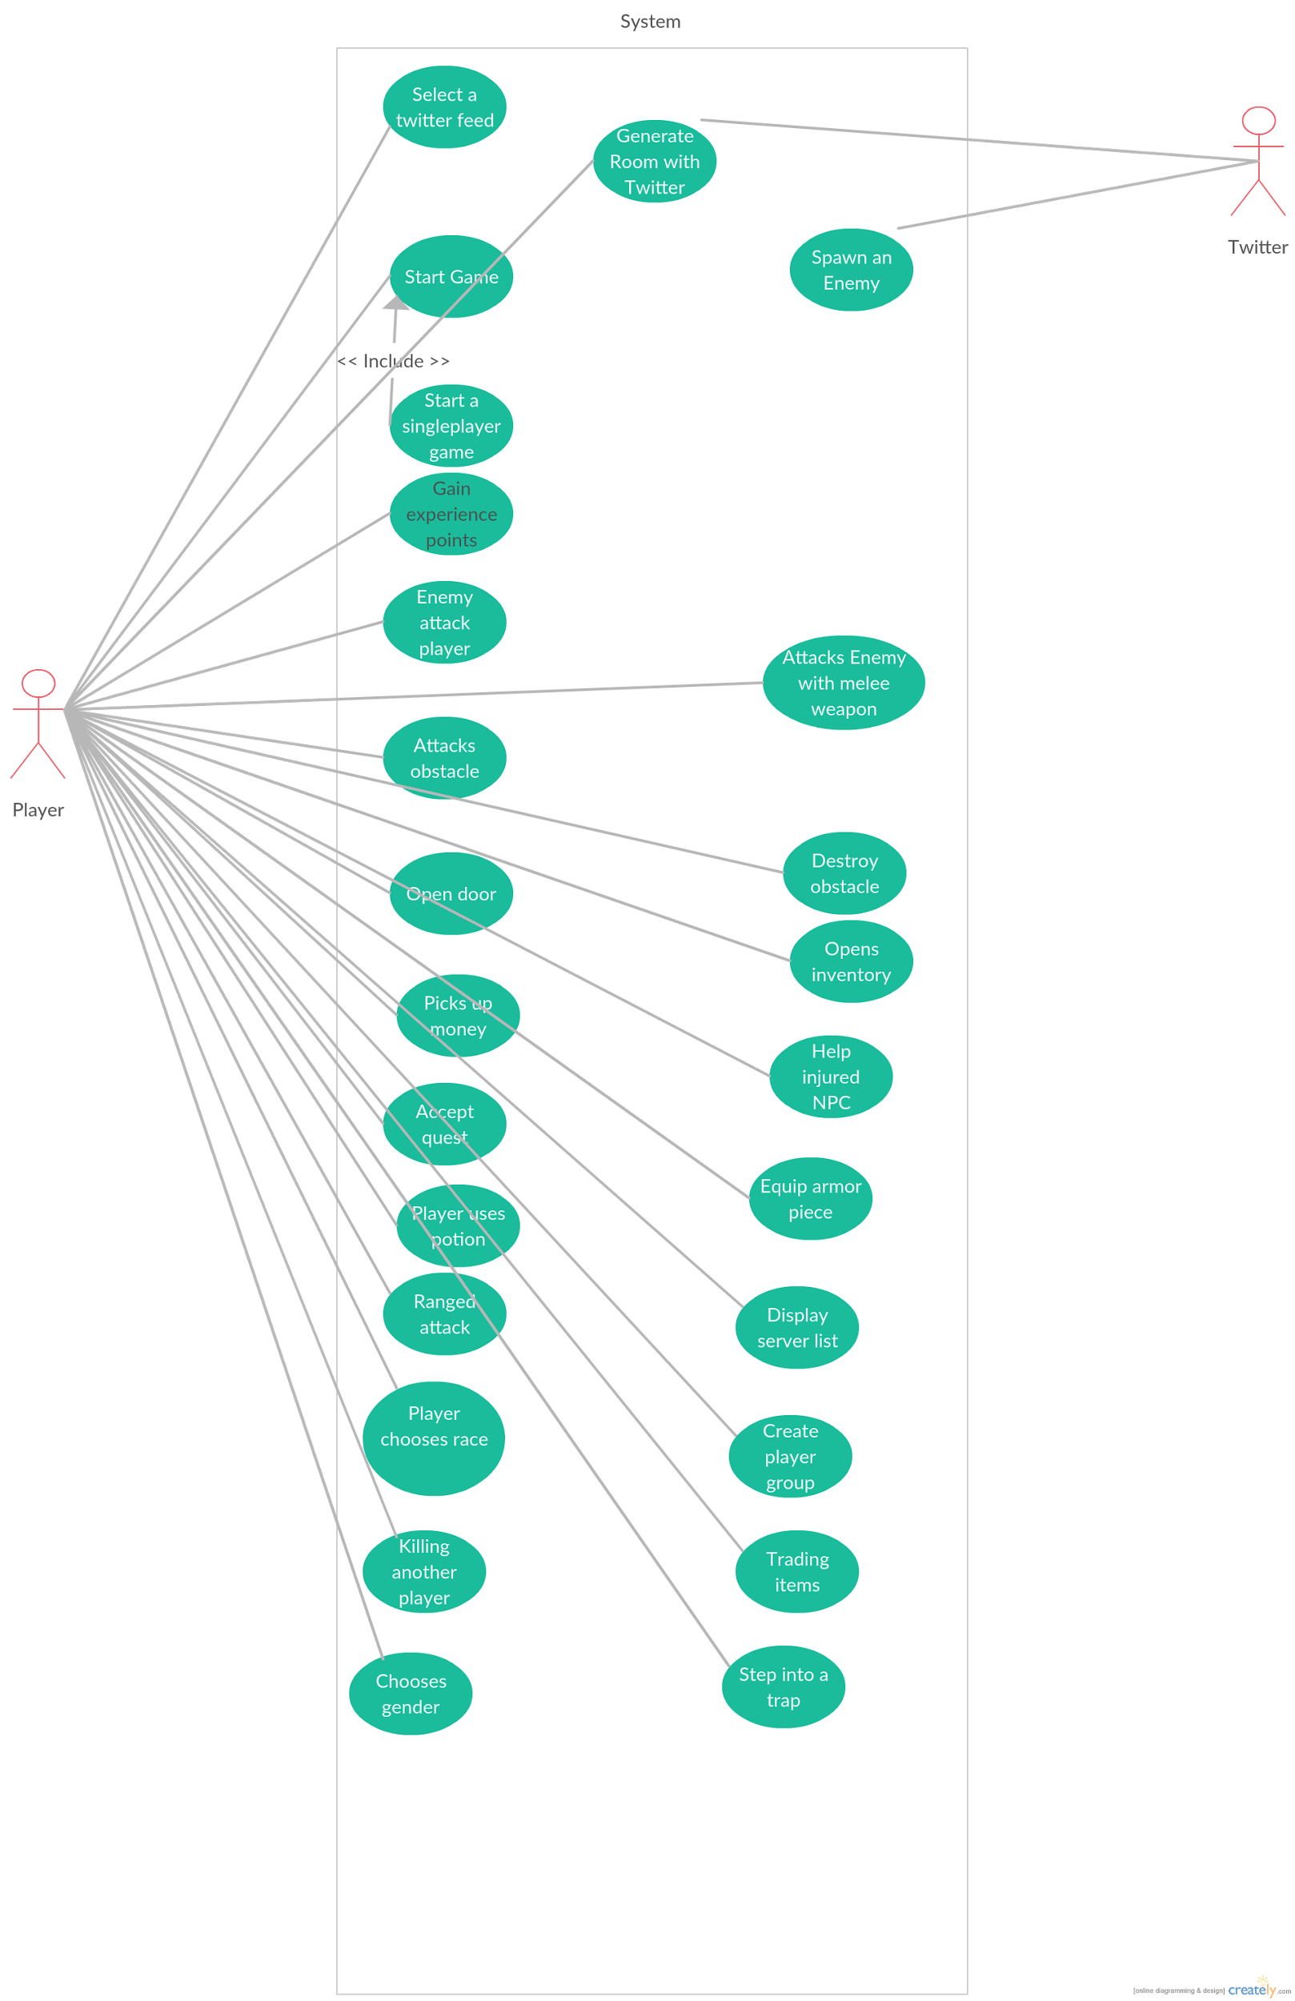

**Description of Actors**

* **Player:** The player is the user who is interacting with the system such as moving the main character.
* **Other player:** Other player is describing a player which is interacting with the system from another computer, seen from the players perspective.
* **Twitter:** With the use of the Twitter API, tweets will be read and used.

**High-Level Use Cases**

|  |
| --- |
| **Use Case:** Select a Twitter feed |
| **Actor:** Player |
| **Description:** The Player is inputting someone’s Twitter profile URL and the system will monitor the tweets and use the data to generate rooms. |
| **Concerned User Stories:** gameplay.map.generation |

|  |
| --- |
| **Use Case:** Generate Room with Twitter |
| **Actors:** Player, Twitter |
| **Description:** A Twitter feed is read and certain keywords will influence the generation of rooms in the game. |
| **Concerned User Stories:** gameplay.map.generation |

|  |
| --- |
| **Use Case:** Start a singleplayer game |
| **Actor:** Player |
| **Description:** The Player chooses to start a singleplayer game session. No other players are able to join. |
| **Concerned User Stories:** client.offline |

|  |
| --- |
| **Use Case:** Start game |
| **Actor:** Player |
| **Description:** The player starts the game and the rooms in the game are generated and the player is placed in a room. |
| **Concerned User Stories:** client.offline |

|  |
| --- |
| **Use Case:** Gain experience points |
| **Actor:** Player |
| **Description:** The player gains experience points and these are added to the total of the corresponding skill. |
| **Concerned User Stories:** customize.attributes |

|  |
| --- |
| **Use Case:** Spawn an enemy |
| **Actor:** Twitter |
| **Description:** A Twitter profile is read and a certain keyword will influence what type of enemy will spawn. |
| **Concerned User Stories:** gameplay.characters.enemies |

|  |
| --- |
| **Use Case:** Enemy attack player |
| **Actor:** Player |
| **Description:** Enemy attack the player and deals damage. The damage is based of the enemy's attributes levels. |
| **Concerned User Stories:** gameplay.characters.enemies |

|  |
| --- |
| **Use Case:** Attacks obstacle |
| **Actor:** Player |
| **Description:** The player gets in range of an obstacle and hits it with their weapon. |
| **Concerned User Stories:** item.weapon.melee, item.weapon.ranged |

|  |
| --- |
| **Use Case:** Attacks enemy with melee weapon |
| **Actor:** Player |
| **Description:** The player hits the enemy with a melee weapon. The damage is based of the players attributes levels. |
| **Concerned User Stories:** item.weapon.melee |

|  |
| --- |
| **Use Case:** Attack other player with melee weapon |
| **Actors:** Player, Other player |
| **Description:** The player hits the Other player with a melee weapon. The damage dealt is based of the players attributes levels and the damage taken is based on the other players attributes levels. |
| **Concerned User Stories:** item.weapon.melee |

|  |
| --- |
| **Use Case:** Destroy obstacle |
| **Actor:** Player |
| **Description:** The player is walking up to a obstacle and *attacks obstacle*. This will destroy the obstacle and enable the player to walk over. |
| **Concerned User Stories:** gameplay.map.interact |

|  |
| --- |
| **Use Case:** Opens door |
| **Actor:** Player |
| **Description:** The player is standing next to a door and press ‘E’. The door opens and reveals a new undiscovered room. |
| **Concerned User Stories:** gameplay.map.interact |

|  |
| --- |
| **Use Case:** Opens inventory |
| **Actor:** Player |
| **Description**: The player presses the inventory button and opens up the inventory. |
| **Concerned User Stories:** item.resources |

|  |
| --- |
| **Use Case:** Picks up money |
| **Actor:** Player |
| **Description:** The player walks up to a pile of money on the floor. The player now walks over it and picks up the money. |
| **Concerned User Stories:** item.resources |

|  |
| --- |
| **Use Case:** Help injured NPC |
| **Actor:** Player |
| **Description:** A NPC is indicating that it’s injured. The player approaches the NPC and choose to heal the injury. |
| **Concerned User Stories:** gameplay.characters.friendly |

|  |
| --- |
| **Use Case:** Accept a quest |
| **Actor:** Player |
| **Description:** A NPC is indicating that there is a quest to accept. The player walks towards that NPC and accepts the quest. |
| **Concerned User Stories:** gameplay.characters.friendly |

|  |
| --- |
| **Use Case:** Equip armor piece |
| **Actor:** Player |
| **Description:** The player equips an armor piece and the defence gets raised. |
| **Concerned User Stories:** item.armor |

|  |
| --- |
| **Use Case:** Player Uses Potion |
| **Actor:** Player |
| **Description:** Player uses a potion from the inventory and gets buffed for a certain amount of time. |
| **Concerned User Stories:** item.buffs |

|  |
| --- |
| **Use Case:** Ranged attack |
| **Actor:** Player |
| **Description:** The player chooses a direction to shoot in and fires a projectile in that direction. |
| **Concerned User Stories:** item.weapon.ranged |

|  |
| --- |
| **Use Case:** Player Chooses Race |
| **Actor:** Player |
| **Description:** The player chooses the race for its character at the start of the game. |
| **Concerned User Stories:** customize.raceclass |

|  |
| --- |
| **Use Case:** Display server list |
| **Actor:** System |
| **Description:** A server list is displayed and shows all the currently active game sessions. Each item in the list also comes with a description with related information. |
| **Concerned User Stories:** client.serverlist |

|  |
| --- |
| **Use Case:** Create player group |
| **Actor:** Player, other player |
| **Description:** The player chooses to group up with other player. The other player accepts the group requests. |
| **Concerned User Stories:** multiplayer.group |

|  |
| --- |
| **Use Case:** Killing another player |
| **Actor:** Player, other player |
| **Description:** The player walks up to the other player and *attacks other player* which kills it. The other player then drops it’s items on the floor. |
| **Concerned User Stories:** multiplayer.kill |

|  |
| --- |
| **Use Case:** Trading items |
| **Actor:** Player, other player |
| **Description:** The player walks up to another player and *opens inventory*, selects an item and gives the item to the other player. |
| **Concerned User Stories:** multiplayer.trade |

|  |
| --- |
| **Use Case:** Chooses gender |
| **Actor:** Player |
| **Description:** The player is creating a new character and selects what gender it should be. |
| **Concerned User Stories:** customize.gender |

|  |
| --- |
| **Use Case:** Step into a trap |
| **Actor:** Player |
| **Description:** The player is walking on the ground and randomly steps onto a trap, this will damage and stun the player. |
| **Concerned User Stories:** gameplay.map.random |