Внешний вид приложения:

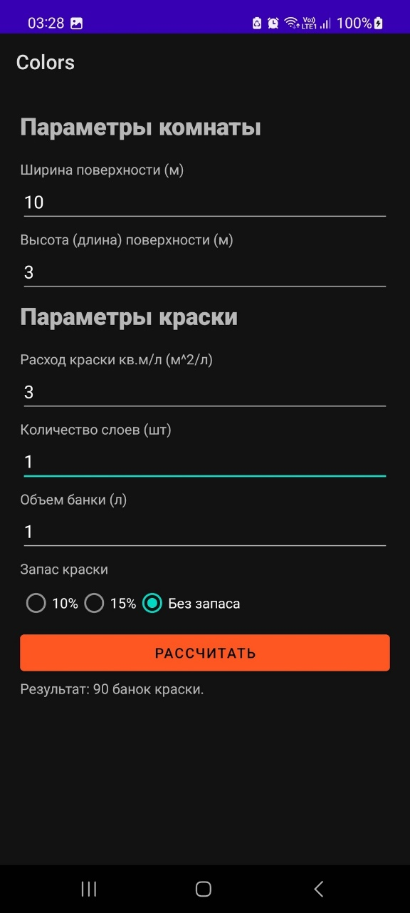 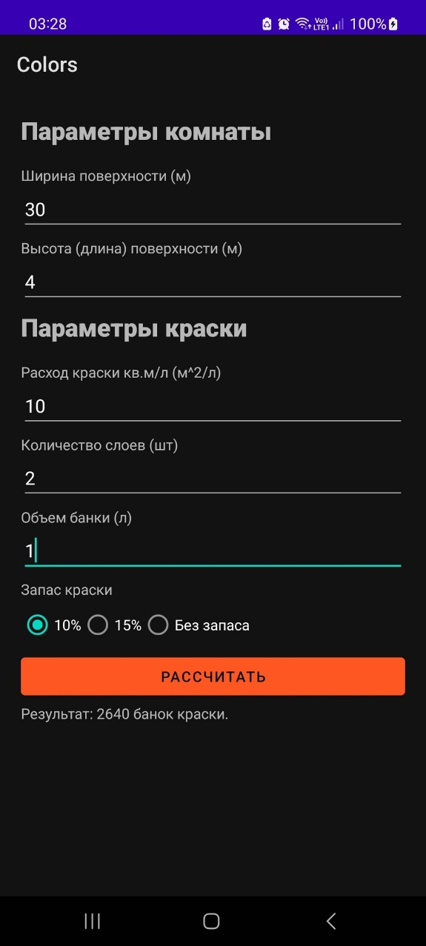

Код:

Activity_main.xml:

<?xml version="1.0" encoding="utf-8"?>  
<androidx.constraintlayout.widget.ConstraintLayout xmlns:android="http://schemas.android.com/apk/res/android"  
 xmlns:app="http://schemas.android.com/apk/res-auto"  
 xmlns:tools="http://schemas.android.com/tools"  
 android:layout_width="match_parent"  
 android:layout_height="match_parent"  
 tools:context=".MainActivity">  
  
 <RelativeLayout  
 android:layout_height="match_parent"  
 android:layout_width="match_parent"  
 android:layout_margin="20dp"  
 >  
  
 <TextView  
 android:id="@+id/textViewParamsRoom"  
 android:layout_width="match_parent"  
 android:layout_height="wrap_content"  
 android:fontFamily="sans-serif-black"  
 android:text="Параметры комнаты"  
 android:textSize="24sp" />  
  
 <TextView  
 android:id="@+id/textViewWidth"  
 android:layout_width="match_parent"  
 android:layout_height="wrap_content"  
 android:layout_marginTop="50dp"  
 android:text="Ширина поверхности (м)" />  
  
 <EditText  
 android:id="@+id/editTextWidth"  
 android:layout_width="match_parent"  
 android:layout_height="wrap_content"  
 android:layout_marginTop="70dp"  
 android:inputType="numberDecimal" />  
  
 <TextView  
 android:id="@+id/textViewHeight"  
 android:layout_width="match_parent"  
 android:layout_height="wrap_content"  
 android:layout_marginTop="120dp"  
 android:text="Высота (длина) поверхности (м)" />  
  
 <EditText  
 android:id="@+id/editTextHeight"  
 android:layout_width="match_parent"  
 android:layout_height="wrap_content"  
 android:layout_marginTop="140dp"  
 android:inputType="numberDecimal" />  
  
 <TextView  
 android:layout_width="match_parent"  
 android:layout_height="wrap_content"  
 android:fontFamily="sans-serif-black"  
 android:layout_marginTop="190dp"  
 android:text="Параметры краски"  
 android:textSize="24sp" />  
  
 <TextView  
 android:id="@+id/textViewPaintConsumption"  
 android:layout_width="match_parent"  
 android:layout_height="wrap_content"  
 android:layout_marginTop="240dp"  
 android:text="Расход краски кв.м/л (м^2/л)" />  
  
 <EditText  
 android:id="@+id/editTextPaintConsumption"  
 android:layout_width="match_parent"  
 android:layout_height="wrap_content"  
 android:layout_marginTop="260dp"  
 android:inputType="numberDecimal" />  
  
 <TextView  
 android:id="@+id/textViewLayers"  
 android:layout_width="match_parent"  
 android:layout_height="wrap_content"  
 android:layout_marginTop="310dp"  
 android:text="Количество слоев (шт)" />  
  
 <EditText  
 android:id="@+id/editTextLayers"  
 android:layout_width="match_parent"  
 android:layout_height="wrap_content"  
 android:layout_marginTop="330dp"  
 android:inputType="number" />  
  
 <TextView  
 android:id="@+id/textViewCanVolume"  
 android:layout_width="match_parent"  
 android:layout_height="wrap_content"  
 android:layout_marginTop="380dp"  
 android:text="Объем банки (л)" />  
  
 <EditText  
 android:id="@+id/editTextCanVolume"  
 android:layout_width="match_parent"  
 android:layout_height="wrap_content"  
 android:layout_marginTop="400dp"  
 android:inputType="numberDecimal" />  
  
 <TextView  
 android:id="@+id/textViewReserve"  
 android:layout_width="match_parent"  
 android:layout_height="wrap_content"  
 android:layout_marginTop="450dp"  
 android:text="Запас краски" />  
 <RadioGroup  
 android:id="@+id/radioGroupReserve"  
 android:layout_width="match_parent"  
 android:layout_height="wrap_content"  
 android:layout_marginTop="470dp"  
 android:orientation="horizontal">  
  
 <RadioButton  
 android:id="@+id/radioButton10Percent"  
 android:layout_width="wrap_content"  
 android:layout_height="wrap_content"  
 android:text="10%" />  
  
 <RadioButton  
 android:id="@+id/radioButton15Percent"  
 android:layout_width="wrap_content"  
 android:layout_height="wrap_content"  
 android:text="15%" />  
  
 <RadioButton  
 android:id="@+id/radioButtonNoReserve"  
 android:layout_width="wrap_content"  
 android:layout_height="wrap_content"  
 android:text="Без запаса" />  
 </RadioGroup>  
  
 <Button  
 android:id="@+id/buttonCalculate"  
 android:backgroundTint="#FF5722"  
 android:layout_width="match_parent"  
 android:layout_height="wrap_content"  
 android:layout_marginTop="520dp"  
 android:text="Рассчитать" />  
  
 <TextView  
 android:id="@+id/textViewResult"  
 android:layout_width="match_parent"  
 android:layout_height="wrap_content"  
 android:layout_marginTop="570dp"  
 android:text="Результат: " />  
  
 </RelativeLayout>  
  
</androidx.constraintlayout.widget.ConstraintLayout>

MainActivity.java:

package com.example.colors;  
  
import androidx.appcompat.app.AppCompatActivity;  
  
import android.os.Bundle;  
import android.text.TextUtils;  
import android.view.View;  
import android.widget.Button;  
import android.widget.EditText;  
import android.widget.RadioButton;  
import android.widget.TextView;  
  
public class MainActivity extends AppCompatActivity {  
  
 private EditText editTextWidth, editTextHeight, editTextPaintConsumption, editTextLayers, editTextCanVolume;  
 private TextView textViewResult;  
 private RadioButton radioButton10Percent, radioButton15Percent, radioButtonNoReserve;  
 private Button buttonCalculate;  
  
 @Override  
 protected void onCreate(Bundle savedInstanceState) {  
 super.onCreate(savedInstanceState);  
 setContentView(R.layout.*activity_main*);  
  
 editTextWidth = findViewById(R.id.*editTextWidth*);  
 editTextHeight = findViewById(R.id.*editTextHeight*);  
 editTextPaintConsumption = findViewById(R.id.*editTextPaintConsumption*);  
 editTextLayers = findViewById(R.id.*editTextLayers*);  
 editTextCanVolume = findViewById(R.id.*editTextCanVolume*);  
 textViewResult = findViewById(R.id.*textViewResult*);  
 radioButton10Percent = findViewById(R.id.*radioButton10Percent*);  
 radioButton15Percent = findViewById(R.id.*radioButton15Percent*);  
 radioButtonNoReserve = findViewById(R.id.*radioButtonNoReserve*);  
 buttonCalculate = findViewById(R.id.*buttonCalculate*);  
 buttonCalculate.setOnClickListener(new View.OnClickListener() {  
 @Override  
 public void onClick(View v) {  
 if (checkFieldsNotEmpty()) {  
 calculatePaint();  
 }  
 }  
 });  
 }  
  
 private boolean checkFieldsNotEmpty() {  
 if (TextUtils.*isEmpty*(editTextWidth.getText().toString())) {  
 editTextWidth.setError("Введите ширину");  
 return false;  
 }  
 if (TextUtils.*isEmpty*(editTextHeight.getText().toString())) {  
 editTextHeight.setError("Введите высоту");  
 return false;  
 }  
 if (TextUtils.*isEmpty*(editTextPaintConsumption.getText().toString())) {  
 editTextPaintConsumption.setError("Введите расход краски");  
 return false;  
 }  
 if (TextUtils.*isEmpty*(editTextLayers.getText().toString())) {  
 editTextLayers.setError("Введите количество слоев");  
 return false;  
 }  
 if (TextUtils.*isEmpty*(editTextCanVolume.getText().toString())) {  
 editTextCanVolume.setError("Введите объем банки");  
 return false;  
 }  
 return true;  
 }  
  
 private void calculatePaint() {  
  
 double width = Double.*parseDouble*(editTextWidth.getText().toString());  
 double height = Double.*parseDouble*(editTextHeight.getText().toString());  
 double paintConsumption = Double.*parseDouble*(editTextPaintConsumption.getText().toString());  
 int layers = Integer.*parseInt*(editTextLayers.getText().toString());  
 double canVolume = Double.*parseDouble*(editTextCanVolume.getText().toString());  
  
 double paintNeeded;  
 if (radioButton10Percent.isChecked()) {  
 paintNeeded = width * height * paintConsumption * layers * 1.1;  
 } else if (radioButton15Percent.isChecked()) {  
 paintNeeded = width * height * paintConsumption * layers * 1.15;  
 } else {  
 paintNeeded = width * height * paintConsumption * layers;  
 }  
  
 int cansNeeded = (int) Math.*ceil*(paintNeeded / canVolume);  
  
 textViewResult.setText("Результат: " + cansNeeded + " банок краски.");  
 }  
}